Company | Antibody name | Antibody number
Cell Signaling Technology | β-actin | #4970
Abcam | AdipoR1 | ab70362
Cell Signaling Technology | p-AMPK | #50081
Cell Signaling Technology | AMPK | #5831
Abcam | p-ULK1 | ab229909
Abcam | ULK1 | ab177472
Cell Signaling Technology | LC3B | #43566s
Immumono-Biological-Labotatory | sAPPα | 11088
Immumono-Biological-Labotatory | sAPPβ | 18957
Cell Signaling Technology | BACE1 | #5606
Cell Signaling Technology | P62 | #23214
Cell Signaling Technology | p-mTOR | #5536
Cell Signaling Technology | mTOR | #2983
Cell Signaling Technology | Presenilin 1(PS1) | #5643
Cell Signaling Technology | Lamp1 | #15665
Cell Signaling Technology | Cathepsin D(CTSD) | #74089
Cell Signaling Technology | ATG5 | #12994
Cell Signaling Technology | Beclin1 | #3495
Table S1. Information of primary antibodies

Drug dose of ARC-18 (mg/kg) | Number of animals | Number of deaths | mortality rate
200 | 10 | 0 | 0%
400 | 10 | 0 | 0%
600 | 10 | 1 | 10%
800 | 10 | 3 | 30%
1000 | 10 | 5 | 50%
1200 | 10 | 6 | 60%
1400 | 10 | 8 | 80%
1600 | 10 | 10 | 100%
Table S2. Acute toxicity of ARC-18 in C57 mice

ARC-18-PO-35.0 mg/kg
ATG-blood concentration-ng/ml
Time (h) | 201a | 202a | 203a | Mean | SD
0.25 | 5.95083 | 20.4308 | 10.7491 | 12.38 | 7.38
0.5 | 16.6284 | 23.4087 | 20.5783 | 20.21 | 3.41
1 | 21.3998 | 27.9299 | 23.1376 | 24.16 | 3.38
2 | 15.6329 | 18.1646 | 16.8468 | 16.88 | 1.27
4 | 7.9571 | 9.3714 | BLQ | 8.66 | 1.00
6 | BLQ | 3.40577 | BLQ | NA | NA
8 | BLQ | BLQ | BLQ | NA | NA
24 | BLQ | BLQ | BLQ | NA | NA

Table S3. Drug concentration of ATG in plasma of SD rats after oral administration of ARC-18 by single gavage

ATG-PO-21.6 mg/kg
ATG-blood concentration-ng/ml
Time (h) | 201 | 202 | 203 | Mean | SD
0.25 | 2.74 | 4.31 | 13.43 | 6.83 | 5.77
0.5 | 1.97 | 7.97 | 13.80 | 7.91 | 5.92
1 | 1.58 | 10.63 | 13.36 | 8.52 | 6.17
2 | 13.18 | 14.96 | 16.27 | 14.80 | 1.55
4 | 0.63 | 6.08 | 7.32 | 4.68 | 3.56
6 | 0.70 | BLQ | 6.56 | 3.63 | 4.14
8 | 1.15 | 3.42 | 2.08 | 2.21 | 1.14
24 | 1.10 | 2.56 | 2.82 | 2.16 | 0.93

Table S4. Drug concentration in plasma of SD rats after single oral administration of ATG by gavage

Abbreviation
AD, Alzheimer's disease; ATG, arctigenin; Aβ. amyloid beta; APP, amyloid precursor protein;3-MA, 3-Methyladenine; CQ, chloroquine; AdipoR1, adiponectin receptor 1;AdipoR2, Adiponectin receptor protein 2; AMPK, AMP-activated protein ; CTSD, Cathepsin D; LC3B,Microtubule-associated proteins light chain 3B; ATG5, Autophagy protein 5; ; Lamp1, Lysosome-associated membrane glycoprotein 1;mTOR, mammalian target of rapamycin; ULK1, UNC-51-like kinase 1;P62, Sequestosome 1;BACE1, β-secretase 1; PS1, Presenilin 1;sAPPα, Soluble amyloid precursor protein alpha; sAPPβ, Soluble amyloid precursor protein beta.

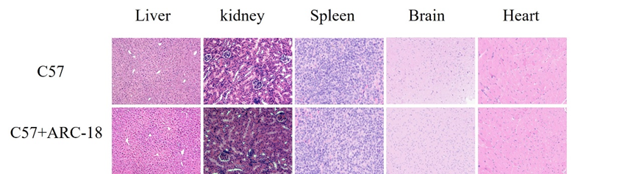

Fig S1. HE staining results of ARC-18 in various organism under a microscope at 100× magnification.

Fig S2. ARC-18 alleviated neuroinflammation in 5xFAD mice. (a) Western blots of GFAP and IBA1 (b) The quantitative analysis of the expression of IBA1 (c) The quantitative analysis of the expression of GFAP. Data are expressed as mean ± SEM. **P< 0.01 and ***P< 0.001 vs. Wild type mice; #P< 0.05, ##P< 0.01 and ###P< 0.001 vs. 5xFAD mice.

Fig S3. ARC-18 alleviated neuroinflammation in 5xFAD mice. (a) GFAP immunofluorescence results (b) The quantitative analysis of GFAP in the hippocampus. (c) The quantitative analysis of GFAP in the cortex. Data are expressed as mean ± SEM. ****P< 0.0001 vs. Wild type mice; #P< 0.05, ##P< 0.01 and ###P< 0.001 vs. 5xFAD mice.

