Figure 6A

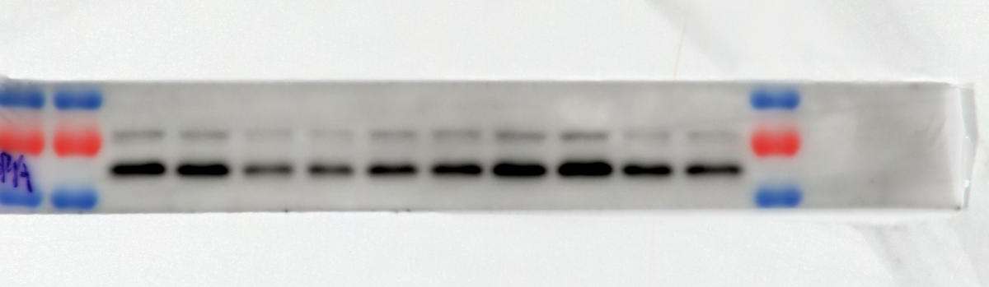
p-AMPK 62KDa
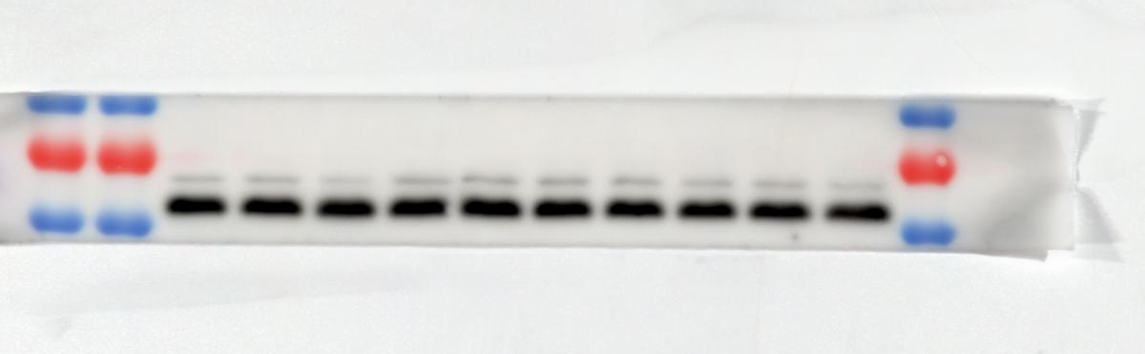
AMPK 62KDa
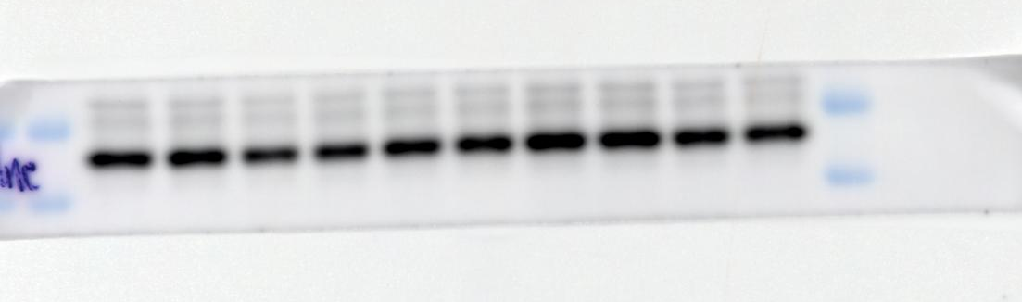
APN 26KDa

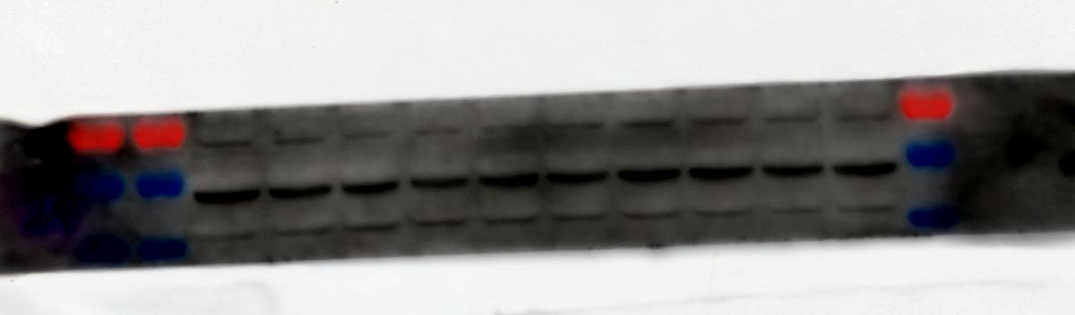
AdipoR1 43KDa
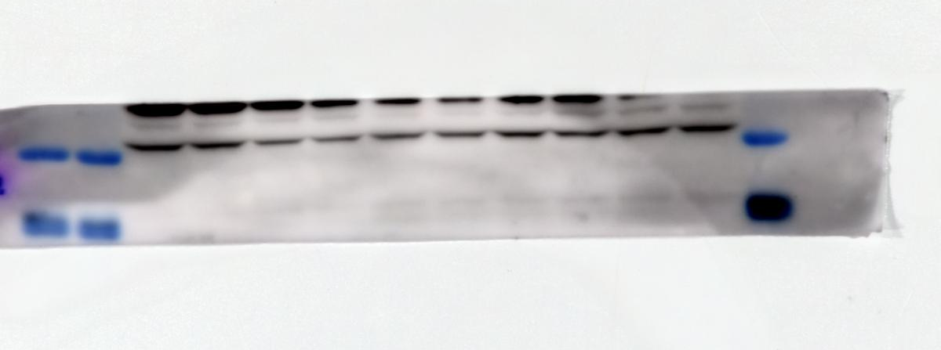

AdipoR2 43KDa

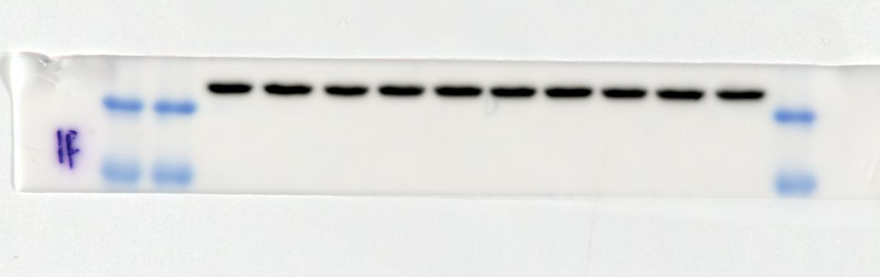
β-actin 42KDa

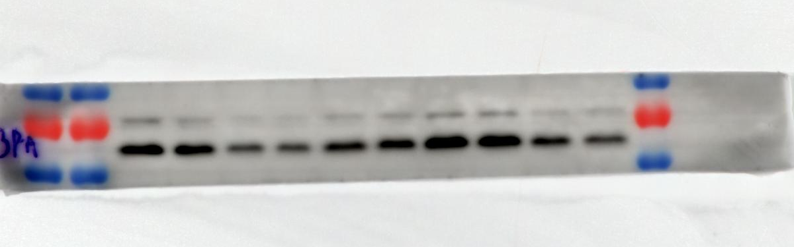
p-AMPK 62KDa

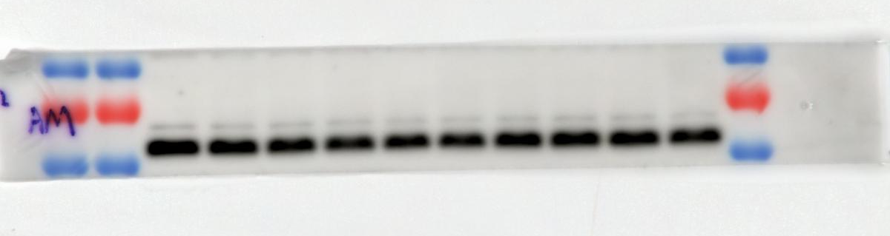
AMPK 62KDa

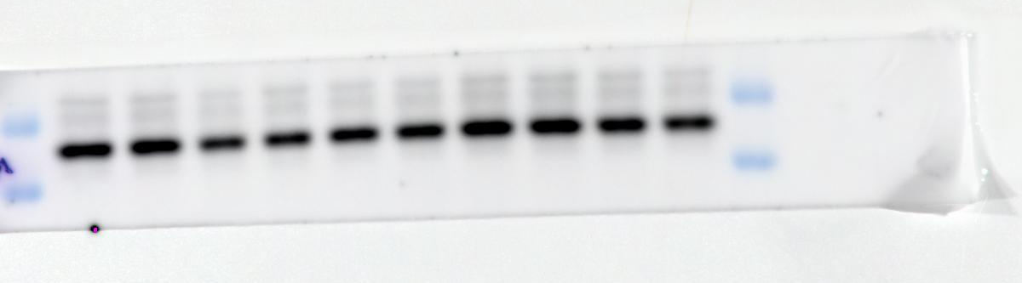
APN 26KDa

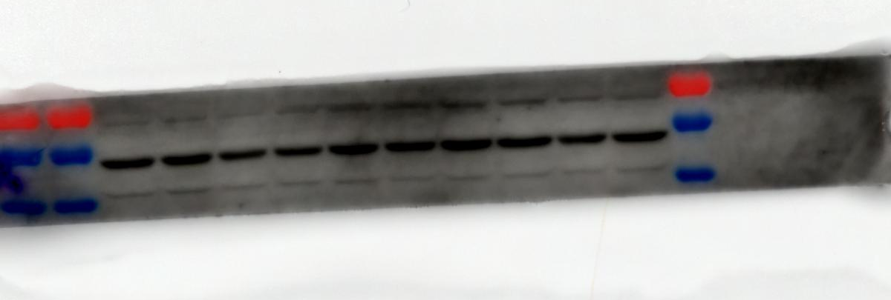
AdipoR1 43KDa

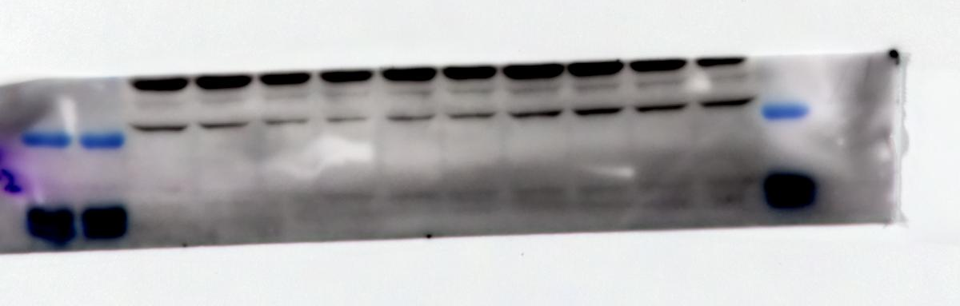
AdipoR2 43KDa

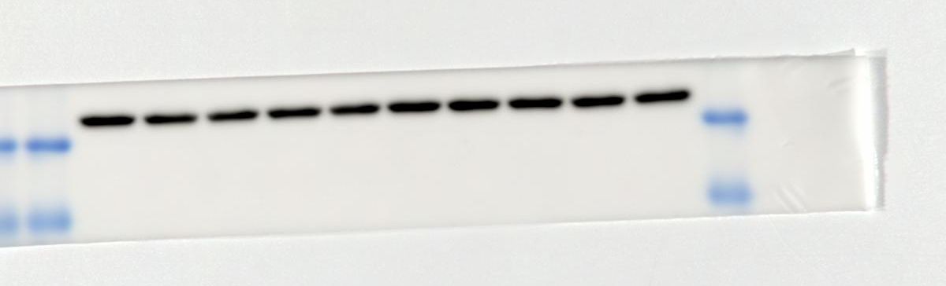
β-actin 42KDa

Fig.6 Silencing of AdipoR1 abrogates autophagy promotion by ARC-18. (A) Original strip of western blot for adiponectin receptor-associated proteins in 5xFAD mice. Please refer to the manuscript for specific grouping and experimental conditions (n=4).

Figure 6B
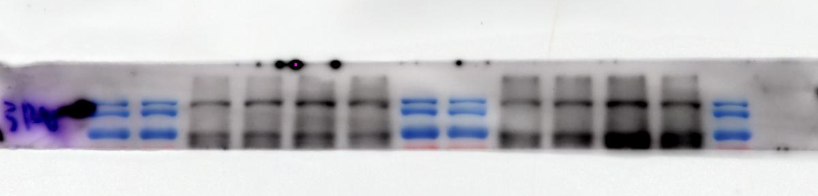
p-ULK1 140KDa
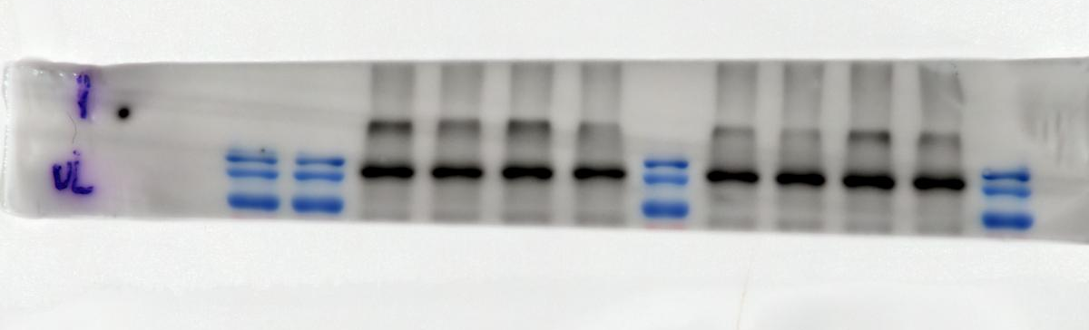
ULK1 140KDa

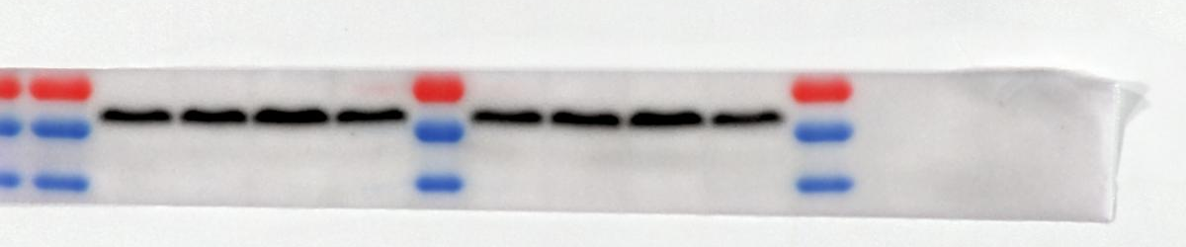
p-AMPK 62KDa
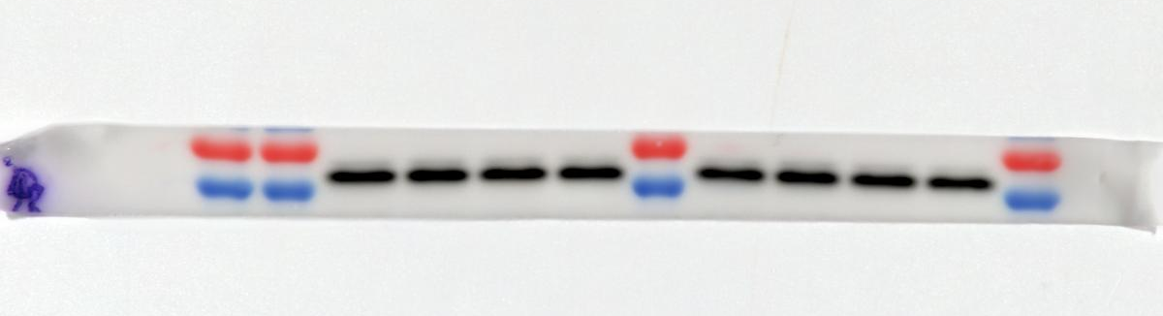

AMPK 62KDa

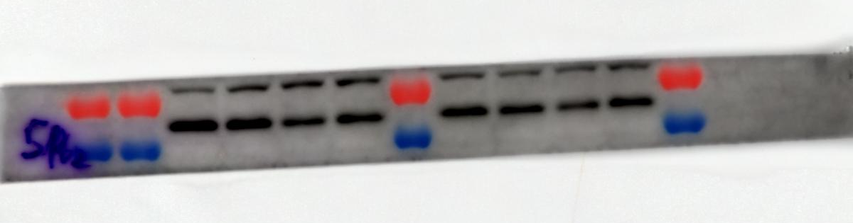
P62 62KDa

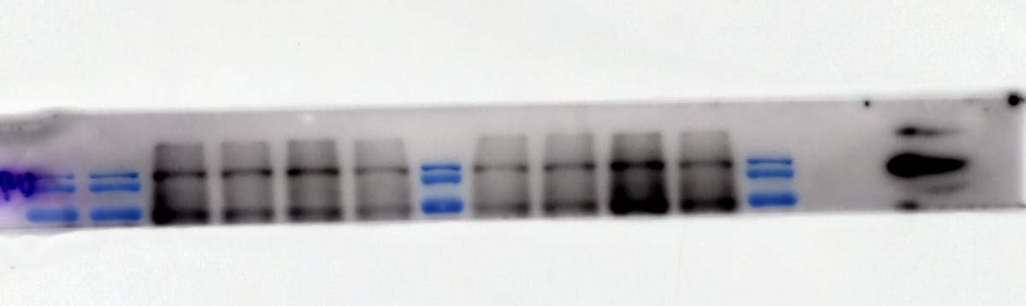

p-ULK1 140KDa
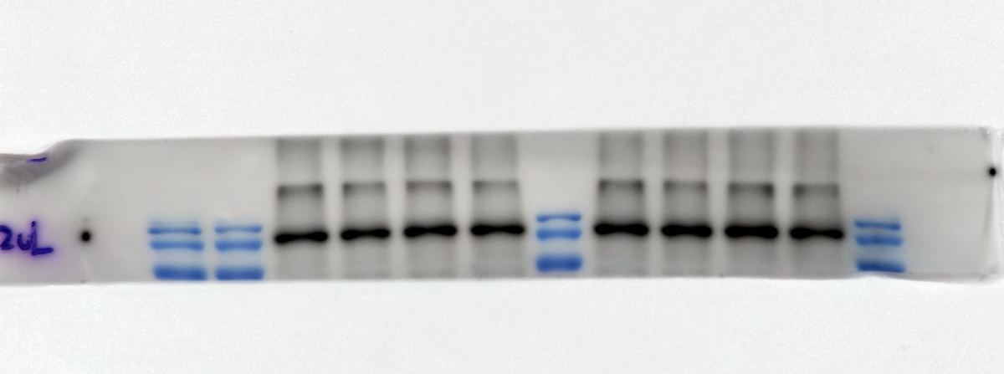

ULK1 140KDa

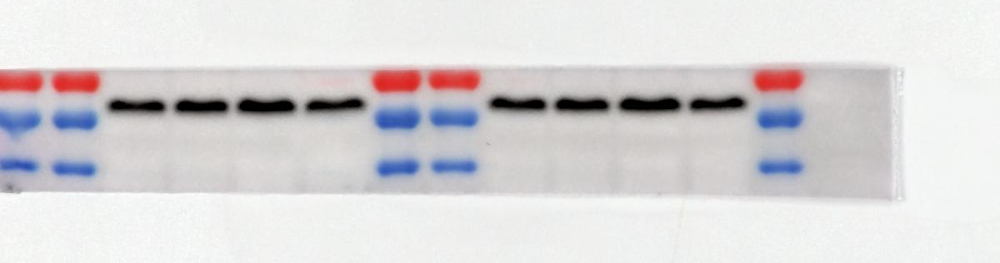
p-AMPK 62KDa
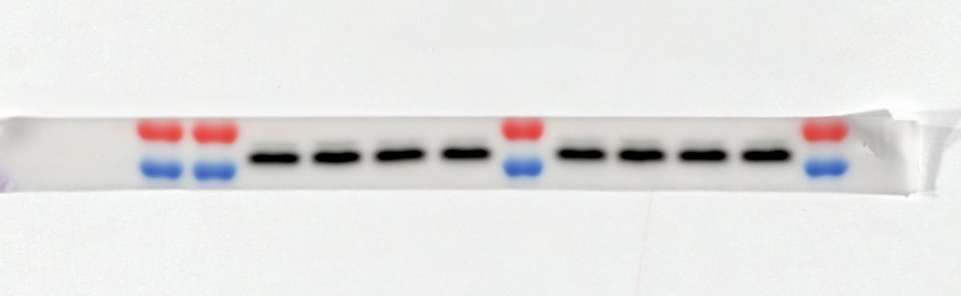

AMPK 62KDa

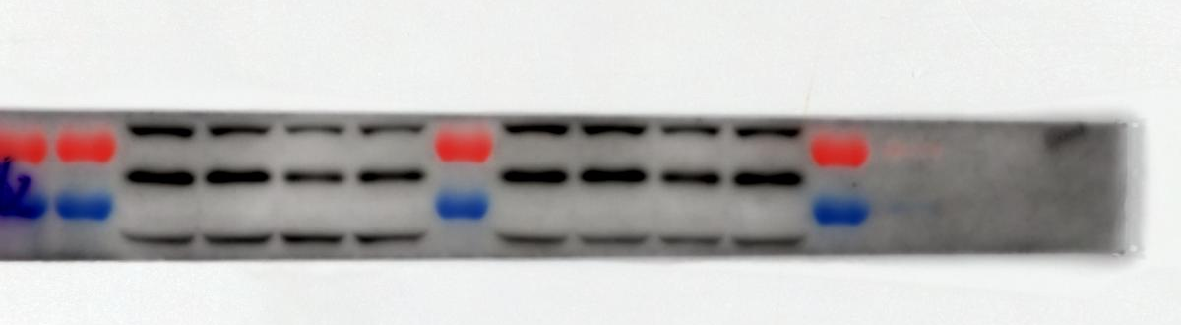
P62 62KDa

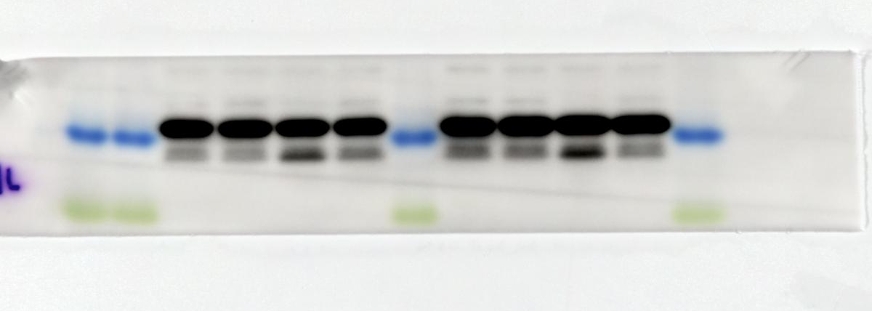
LC3B 14KDa

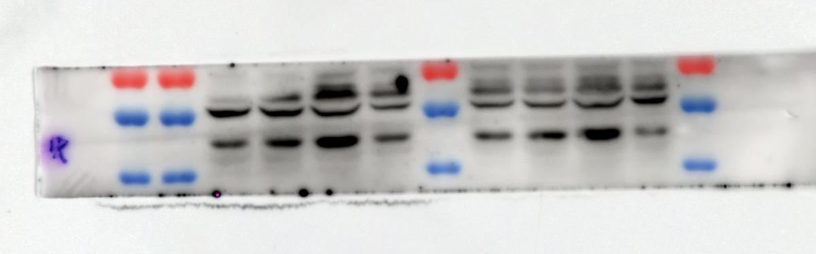
AdipoR1 43 KDa

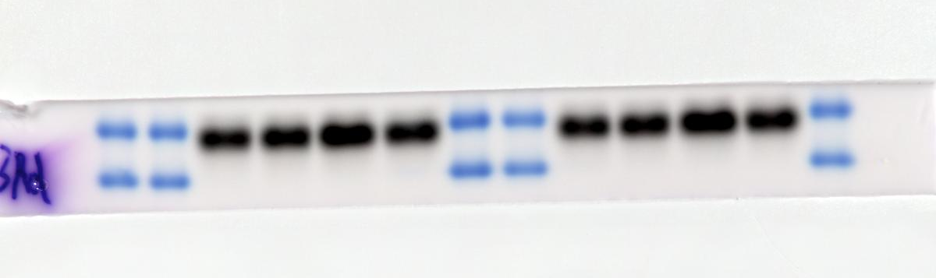

APN 26KDa

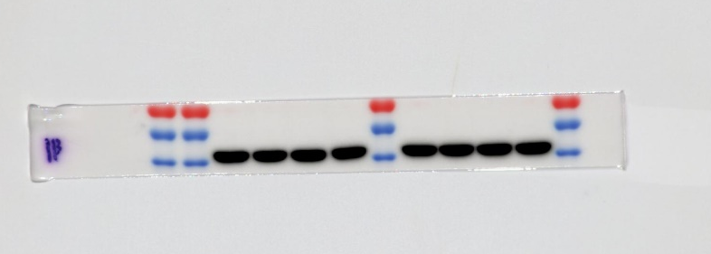

β-actin 42KDa

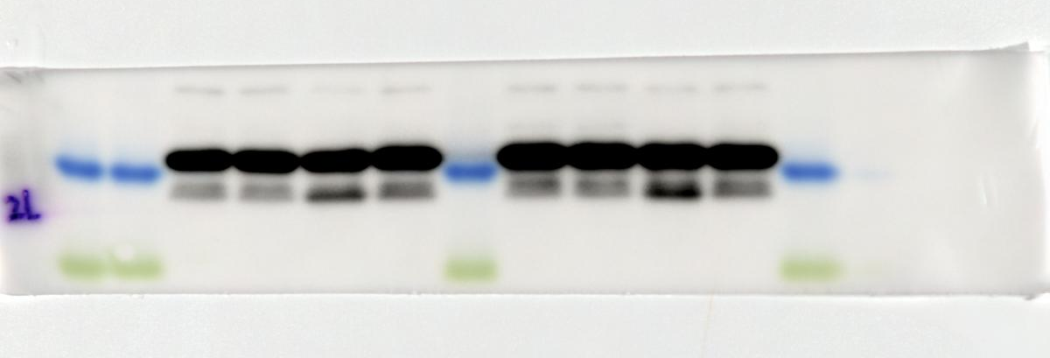
LC3B 14KDa

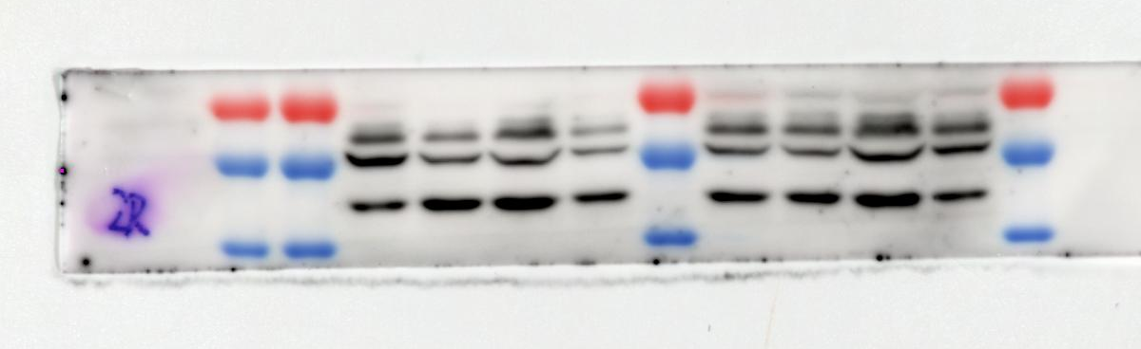
AdipoR1 42KDa

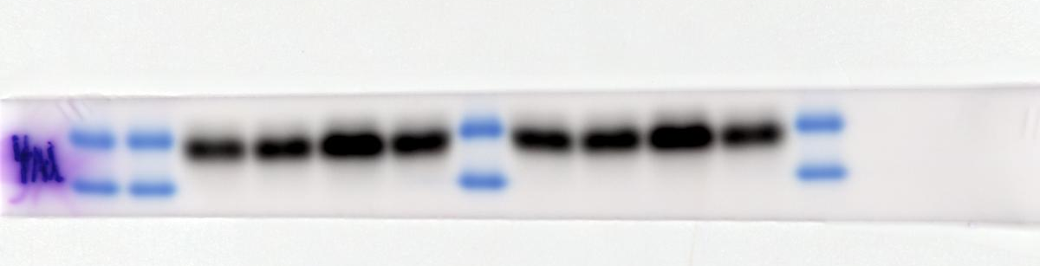
APN 26KDa

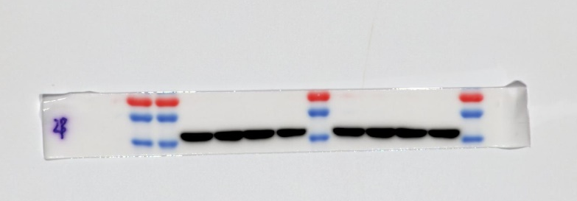

β-actin 42KDa

Fig.6 Silencing of AdipoR1 abrogates autophagy promotion by ARC-18. (B) Original strip of western blot for p-AMPK/AMPK, p-ULK1/ULK1, P62, LC3B/ LC3A, APN and AdipoR1 in N2a/APPswe cells.Please refer to the manuscript for specific grouping and experimental conditions (n=4).

