Toward 30×30: Mapping in-situ Climate Refugia for Biodiversity Conservation across Mainland China
Supplementary materials

- Parameters for threat intensity, distance decay, and habitat sensitivity in InVEST modelling
Table S1
Sensitivity of various land cover to threat factors.
Land use type | Habitat quality | Threat Sensitivity
Land use type | Habitat quality | Paddy field | Dry land | Urban land | Rural settlements | Other construction land
Forest land | 1.0 | 0.5 | 0.7 | 0.9 | 0.8 | 0.8
Shrub land | 0.8 | 0.5 | 0.7 | 0.9 | 0.7 | 0.8
Open forest land | 0.8 | 0.6 | 0.7 | 0.9 | 0.7 | 0.8
Other wooded land | 0.7 | 0.5 | 0.7 | 0.8 | 0.7 | 0.7
High-coverage grassland | 0.8 | 0.5 | 0.7 | 0.7 | 0.5 | 0.6
Medium-coverage grassland | 0.7 | 0.5 | 0.7 | 0.7 | 0.5 | 0.6
Low-coverage grassland | 0.6 | 0.6 | 0.7 | 0.7 | 0.5 | 0.5
Water area | 0.9 | 0.6 | 0.6 | 0.6 | 0.6 | 0.7
Unused land | 0.3 | 0.3 | 0.4 | 0.6 | 0.5 | 0.5

Table S2
Information of threats parameter.
Threats | Maximum impact distance | Weight | Decay type
Paddy fields | 1 | 0.5 | Linear attenuation
Dry farmland | 1 | 0.5 | Linear attenuation
Urban land | 9 | 1.0 | Exponential Decay
Rural settlements | 6 | 0.7 | Exponential Decay
Other construction land | 6 | 0.7 | Exponential Decay

- Key bioclimatic variables identified for four taxonomic groups

Table S3
Key bioclimatic variables identified for Mammals.
Species | Pearson correlation analysis（p<0.75） |  | MaxEnt cumulative contribution rate analysis （≥90%） |  | Bioclimatic variables
Ailuropoda Melanoleuca | BIO1, BIO2 |  | BIO2 |  | BIO1, BIO2,  BIO3, BIO4,  BIO7, BIO11,  BIO12, BIO13, BIO14, BIO15, BIO17
Ailurus Fulgens | BIO1, BIO3, BIO7, BIO12,  BIO15, BIO17 |  | BIO7, BIO12
Aonys Cinereus | BIO1, BIO4, BIO7, BIO15,  BIO18 |  | BIO7, BIO4
Axis Porcinus | BIO1, BIO2, BIO4 |  | BIO4
Cricetus Cricetus | BIO1, BIO2, BIO3, BIO11,  BIO17 |  | BIO17, BIO11
Elephas Maximus | BIO1, BIO3, BIO7, BIO15 |  | BIO3, BIO1, BIO7
Equus Ferus | BIO1, BIO5, BIO6, BIO8,  BIO9, BIO12, BIO13,  BIO15 |  | BIO3, BIO1
Gazella Subgutturosa | BIO1, BIO2, BIO4, BIO11,  BIO12, BIO17 | BIO12, BIO11, BIO4
Hydropotes Inermis | BIO1, BIO2, BIO4, BIO9,  BIO12, BIO14, BIO18 | BIO4, BIO14
Lutrogale Persicillata | BIO1, BIO3, BIO4, BIO7,  BIO12, BIO14 | BIO12, BIO3, BIO4
Manis Pentadactyla | BIO1, BIO2, BIO7, BIO12,  BIO18 | BIO12, BIO7
Naemorhedus Caudatus | BIO1, BIO3, BIO7, BIO11,  BIO13, BIO14, BIO15 | BIO7, BIO13, BIO14, BIO15
Ochotona Argentata | BIO1, BIO3, BIO15, BIO17 | BIO3, BIO17, BIO15
Ochotona Iliensis | BIO1, BIO2, BIO3, BIO14,  BIO15 | BIO3, BIO1, BIO2
Panthera Tigris | BIO1, BIO2, BIO6, BIO7,  BIO12, BIO15, BIO17 | BIO12, BIO17, BIO2
Panthera Uncia | BIO1, BIO3, BIO7, BIO12,  BIO15, BIO17 | BIO1
Pteropus Dasymallus | BIO1, BIO8 | BIO1
Note: The 19 bioclimatic variables were derived from monthly temperature and precipitation data and obtained from the WorldClim database (www.worldclim.org).

Table S4
Key bioclimatic variables identified for Amphibians.
Species | Pearson correlation analysis（p<0.75） | MaxEnt cumulative contribution rate analysis （≥90%） | Bioclimatic variables
Amolops minutus | BIO1, BIO2, BIO7, BIO12,  BIO15 | BIO7, BIO12 | BIO1, BIO2,  BIO3, BIO4,  BIO6, BIO7,  BIO12, BIO13,  BIO14, BIO15,  BIO17, BIO18,  BIO19
Batrachuperus karlschmidti | BIO1, BIO2, BIO4, BIO7,  BIO12, BIO14 | BIO12
Echinotriton chinhaiensis | BIO1, BIO2, BIO8, BIO14 | BIO14, BIO2, BIO1
Gracixalus sapaensis | BIO1, BIO4, BIO15 | BIO4
Hynobius maoershanensis | BIO1, BIO3, BIO13, BIO14,  BIO17 | BIO17, BIO3
Megophrys cheni | BIO1, BIO2, BIO3 | BIO2, BIO1
Megophrys fansipanensis | BIO1, BIO2, BIO7, BIO12,  BIO15, BIO17 | BIO7, BIO12
Megophrys hoanglienensis | BIO1, BIO3, BIO7, BIO14,  BIO19 | BIO7, BIO3, BIO19
Nidirana hainanensis | BIO1, BIO2, BIO12, BIO15,  BIO16, BIO18, BIO19 | BIO1, BIO18
Pachytriton airobranchiatus | BIO1, BIO3 | BIO1
Pachytriton feii | BIO1, BIO2, BIO8, BIO13,  BIO14 | BIO14, BIO1
Pachytriton moi | BIO1, BIO2, BIO3, BIO13,  BIO14, BIO15, BIO19 | BIO14
Pachytriton wuguanfui | BIO1, BIO2, BIO13, BIO14,  BIO15 | BIO14
Pachytriton xanthospilos | BIO1, BIO3 | BIO1, BIO3
Pelophylax tenggerensis | BIO1, BIO2, BIO6, BIO12,  BIO13 | BIO6, BIO12, BIO13
Rana asiatica | BIO1, BIO3, BIO14 | BIO1, BIO3, BIO14
Ranodon sibiricus | BIO1, BIO3, BIO7, BIO17 | BIO17, BIO1
Scutiger maculatus | BIO1, BIO2, BIO4, BIO12,  BIO14, BIO15 | BIO12, BIO14
Tylototriton hainanensis | BIO1, BIO2, BIO15 | BIO2, BIO15, BIO1
Tylototriton pseudoverrucosus | BIO1, BIO2, BIO3, BIO13,  BIO14, BIO17 | BIO3, BIO14, BIO13, BIO17
Zhangixalus dorsoviridis | BIO1, BIO3, BIO7, BIO12,  BIO14, BIO15 | BIO3, BIO12
Zhangixalus duboisi | BIO1, BIO7, BIO12, BIO19 | BIO7, BIO12, BIO19
Zhangixalus yinggelingensis | BIO1, BIO3, BIO12, BIO18 | BIO12, BIO3
Note: The 19 bioclimatic variables were derived from monthly temperature and precipitation data and obtained from the WorldClim database (www.worldclim.org).

Table S5
Key bioclimatic variables identified for Reptiles.
Species | Pearson correlation analysis（p<0.75） | MaxEnt cumulative contribution rate analysis （≥90%） | Bioclimatic variables
Caretta caretta | BIO1, BIO2, BIO12, BIO13 | BIO2 | BIO1, BIO2,  BIO12, BIO14,  BIO19
Dermochelys coriacea | BIO1, BIO2, BIO5, BIO12, BIO13, BIO15 | BIO2 | BIO1, BIO2,  BIO12, BIO14,  BIO19
Eretmochelys imbricata | BIO1, BIO2, BIO5, BIO12, BIO13 | BIO2 | BIO1, BIO2,  BIO12, BIO14,  BIO19
Lepidochelys olivacea | BIO1, BIO2, BIO5, BIO12, BIO13 | BIO2 | BIO1, BIO2,  BIO12, BIO14,  BIO19
Pelochelys cantorii | BIO1, BIO2, BIO3, BIO13, BIO15, BIO19 | BIO19, BIO2, BIO1 | BIO1, BIO2,  BIO12, BIO14,  BIO19
Platysternon megacephalum | BIO1, BIO2, BIO4, BIO8, BIO12, BIO15, BIO18 | BIO12 | BIO1, BIO2,  BIO12, BIO14,  BIO19
Rafetus swinhoei | BIO1, BIO2, BIO5, BIO12, BIO13, BIO14 | BIO14, BIO12 | BIO1, BIO2,  BIO12, BIO14,  BIO19

Table S6
Key bioclimatic variables identified for Birds.
Species | Pearson correlation analysis（p<0.75） | MaxEnt cumulative contribution rate analysis （≥90%） | Bioclimatic variables
Aceros nipalensis | BIO1, BIO15 | BIO1, BIO15 | BIO1, BIO2, BIO3, BIO4,  BIO7, BIO12,  BIO13, BIO14,  BIO15, BIO16,  BIO17, BIO19
Arborophila ardens | BIO1, BIO2, BIO3, BIO4,  BIO12 | BIO4, BIO2
Arborophila rufipectus | BIO1, BIO2, BIO14 | BIO14
Buceros bicornis | BIO1, BIO3, BIO4, BIO7,  BIO12, BIO14 | BIO12, BIO3
Clanga clanga | BIO1, BIO3, BIO7, BIO12,  BIO15 | BIO3, BIO7, BIO1, BIO15, BIO12
Corvus pectoralis | BIO1, BIO3, BIO7, BIO8,  BIO12, BIO13 | BIO13, BIO1, BIO7
Falco vespertinus | BIO1, BIO12, BIO19 | BIO19, BIO1
Grus antigone | BIO1, BIO2, BIO15 | BIO2, BIO1
Gyps bengalensis | BIO1, BIO2, BIO3, BIO7,  BIO15, BIO19 | BIO3, BIO7
Halcyon pileata | BIO1, BIO3, BIO7, BIO12,  BIO15 | BIO12, BIO7, BIO1
Ianthocincla bieti | BIO1, BIO4, BIO12, BIO15 | BIO12, BIO4
Liocichla omeiensis | BIO1, BIO3 | BIO1
Lophophorus lhuysii | BIO1, BIO2, BIO12, BIO14,  BIO15 | BIO12
Mulleripicus pulverulentus | BIO1, BIO2, BIO4, BIO17 | BIO4, BIO17
Nipponia nippon | BIO1, BIO3, BIO12 | BIO12, BIO3
Oroanassa magnifica | BIO1, BIO2, BIO4, BIO8,  BIO12, BIO15 | BIO12
Pavo muticus | BIO1, BIO3, BIO4, BIO7,  BIO12, BIO14, BIO15 | BIO3, BIO14
Phylloscopus hainanus | BIO1, BIO2, BIO3, BIO4,  BIO12 | BIO4, BIO3
Polyplectron katsumatae | BIO1, BIO2, BIO3, BIO4,  BIO12 | BIO4
Saxicola insignis | BIO1, BIO2, BIO14 | BIO1, BIO14
Sitta formosa | BIO1, BIO2, BIO3, BIO14,  BIO15 | BIO3, BIO14
Sitta magna | BIO1, BIO3, BIO7, BIO12,  BIO14, BIO16 | BIO3, BIO14
Spelaeornis kinneari | BIO1, BIO3, BIO14,  BIO19 | BIO3, BIO19
Stachyris nonggangensis | BIO1, BIO12, BIO16 | BIO12, BIO16, BIO1
Sterna acuticauda | BIO1, BIO3, BIO7, BIO12,  BIO17 | BIO3, BIO12
Suthora zappeyi | BIO1, BIO4, BIO12, BIO15 | BIO12
Syrmaticus humiae | BIO1, BIO3, BIO7, BIO12,  BIO15, BIO17 | BIO17, BIO3
Syrmaticus reevesii | BIO1, BIO3, BIO4, BIO6,  BIO12,  BIO14, BIO15, BIO18 | BIO12, BIO4, BIO14
Tragopan blythii | BIO1, BIO3, BIO7, BIO14,  BIO15 | BIO3, BIO14, BIO7
Tragopan caboti | BIO1, BIO3, BIO7, BIO8,  BIO12,  BIO14 | BIO14
Note: The 19 bioclimatic variables were derived from monthly temperature and precipitation data and obtained from the WorldClim database (www.worldclim.org).

- Climate niche widths (CNWs) for four taxonomic groups.

Table S7
Threat categories, primary habitat type and climatic niche width of mammals.
Species | Degree of endangerment | Habitat type | Climatic niche width
Ailuropoda melanoleuca | Vulnerable | Forest Land | 1.00
Ailurus fulgens | Endangered | Forest Land | 1.69
Aonyx cinereus | Vulnerable | Water Area | 5.15
Arctictis binturong | Vulnerable | Forest Land | 4.30
Arctonyx collaris | Vulnerable | Forest Land | 1.52
Axis porcinus | Endangered | Forest Land | 1.16
Bos gaurus | Vulnerable | Forest Land | 2.99
Bos javanicus | Critical Endangered | Forest Land | 1.05
Bos mutus | Vulnerable | Grass Land | 0.89
Budorcas taxicolor | Vulnerable | Forest Land | 1.91
Camelus ferus | Critical Endangered | Unused Land | 0.38
Capricornis rubidus | Vulnerable | Forest Land | 1.34
Capricornis sumatraensis | Vulnerable | Forest Land | 2.34
Cervus albirostris | Vulnerable | Forest Land | 1.28
Chrotogale owstoni | Endangered | Forest Land | 1.16
Cricetus cricetus | Critical Endangered | Grass Land | 0.80
Cuon alpinus | Endangered | Forest Land | 2.47
Elephas maximus | Endangered | Forest Land | 1.83
Equus ferus | Endangered | Grass Land | 0.25
Felis bieti | Vulnerable | Grass Land | 1.62
Gazella subgutturosa | Vulnerable | Grass Land | 1.47
Helarctos malayanus | Vulnerable | Forest Land | 2.21
Hoolock hoolock | Endangered | Forest Land | 1.54
Hoolock tianxing | Endangered | Forest Land | 1.29
Hydropotes inermis | Vulnerable | Forest Land | 0.74
Hylobates lar | Endangered | Forest Land | 0.65
Lepus hainanus | Endangered | Grass Land | 0.25
Lutrogale perspicillata | Vulnerable | Water Area | 1.64
Macaca arctoides | Vulnerable | Forest Land | 3.25
Macaca leonina | Vulnerable | Forest Land | 2.44
Macaca leucogenys | Endangered | Forest Land | 1.86
Macaca munzala | Endangered | Forest Land | 1.31
Manis javanica | Critical Endangered | Forest Land | 0.88
Manis pentadactyla | Critical Endangered | Forest Land | 3.34
Marmota sibirica | Endangered | Grass Land | 0.68
Moschus anhuiensis | Endangered | Forest Land | 0.59
Moschus berezovskii | Endangered | Forest Land | 2.04
Moschus chrysogaster | Endangered | Forest Land | 1.68
Moschus fuscus | Endangered | Forest Land | 1.84
Moschus leucogaster | Endangered | Forest Land | 2.24
Moschus moschiferus | Vulnerable | Forest Land | 0.71
Muntiacus crinifrons | Vulnerable | Forest Land | 1.15
Myotis pilosus | Vulnerable | Forest Land | 2.53
Naemorhedus baileyi | Vulnerable | Forest Land | 1.47
Naemorhedus caudatus | Vulnerable | Forest Land | 0.44
Neofelis nebulosa | Vulnerable | Forest Land | 2.63
Neohylomys hainanensis | Endangered | Forest Land | 0.70
Nomascus concolor | Critical Endangered | Forest Land | 0.79
Nomascus hainanus | Critical Endangered | Forest Land | 0.38
Nomascus leucogenys | Critical Endangered | Forest Land | 0.98
Nomascus nasutus | Critical Endangered | Forest Land | 0.52
Nycticebus bengalensis | Endangered | Forest Land | 3.34
Nycticebus pygmaeus | Endangered | Forest Land | 0.93
Ochotona argentata | Endangered | Unused Land | 0.27
Ochotona iliensis | Endangered | Unused Land | 1.20
Ochotona koslowi | Endangered | Unused Land | 0.30
Panthera pardus | Vulnerable | Forest Land | 1.84
Panthera tigris | Endangered | Forest Land | 1.59
Panthera uncia | Vulnerable | Unused Land | 1.88
Procapra przewalskii | Endangered | Grass Land | 0.19
Proedromys bedfordi | Vulnerable | Forest Land | 0.44
Pteropus lylei | Vulnerable | Forest Land | 0.34
Rhinolophus rex | Endangered | Forest Land | 2.72
Rhinopithecus bieti | Endangered | Forest Land | 0.88
Rhinopithecus brelichi | Critical Endangered | Forest Land | 0.41
Rhinopithecus roxellana | Endangered | Forest Land | 1.17
Rucervus eldii | Endangered | Unused Land | 0.52
Rusa unicolor | Vulnerable | Forest Land | 2.95
Tadarida latouchei | Endangered | Forest Land | 0.37
Trachypithecus crepusculus | Endangered | Forest Land | 0.94
Trachypithecus francoisi | Endangered | Forest Land | 0.98
Trachypithecus leucocephalus | Critical Endangered | Unused Land | 0.37
Trachypithecus pileatus | Vulnerable | Forest Land | 2.27
Trachypithecus shortridgei | Endangered | Forest Land | 1.17
Ursus thibetanus | Vulnerable | Forest Land | 2.04
Viverra megaspila | Endangered | Forest Land | 1.62
Vormela peregusna | Vulnerable | Grass Land | 1.53

Table S8
Threat categories, primary habitat type and climatic niche width of Amphibians.
Species | Degree of endangerment | Habitat type | Climatic niche width
Amolops albispinus | Vulnerable | Forest Land | 0.82
Amolops hainanensis | Endangered | Forest Land | 1.02
Amolops hongkongensis | Endangered | Forest Land | 0.31
Amolops loloensis | Vulnerable | Forest Land | 2.15
Amolops medogensis | Endangered | Forest Land | 1.54
Amolops minutus | Endangered | Forest Land | 0.49
Amolops monticola | Endangered | Forest Land | 1.53
Amolops ottorum | Endangered | Forest Land | 0.29
Amolops splendissimus | Vulnerable | Forest Land | 0.47
Amolops torrentis | Vulnerable | Forest Land | 0.83
Amolops tuberodepressus | Vulnerable | Forest Land | 0.73
Andrias davidianus | Critical Endangered | Water Area | 1.37
Andrias sligoi | Critical Endangered | Water Area | 1.30
Batrachuperus karlschmidti | Vulnerable | Water Area | 0.78
Batrachuperus londongensis | Endangered | Water Area | 1.41
Batrachuperus pinchonii | Vulnerable | Water Area | 1.67
Batrachuperus tibetanus | Vulnerable | Water Area | 0.98
Batrachuperus yenyuanensis | Endangered | Water Area | 1.19
Bombina fortinuptialis | Vulnerable | Water Area | 0.59
Bombina lichuanensis | Vulnerable | Water Area | 0.31
Buergeria oxycephala | Vulnerable | Forest Land | 0.99
Bufo aspinius | Endangered | Forest Land | 0.56
Bufo luchunnicus | Critical Endangered | Forest Land | 0.13
Bufo tuberospinius | Critical Endangered | Forest Land | 0.26
Echinotriton chinhaiensis | Critical Endangered | Forest Land | 0.18
Glandirana minima | Endangered | Forest Land | 0.90
Gracixalus jinggangensis | Critical Endangered | Forest Land | 0.21
Gracixalus nonggangensis | Endangered | Forest Land | 0.35
Gracixalus sapaensis | Endangered | Forest Land | 0.65
Hylarana spinulosa | Vulnerable | Forest Land | 1.00
Hynobius amjiensis | Endangered | Water Area | 0.43
Hynobius guabangshanensis | Critical Endangered | Water Area | 0.13
Hynobius maoershanensis | Critical Endangered | Water Area | 0.14
Hypselotriton chenggongensis | Critical Endangered | Water Area | 0.12
Hypselotriton cyanurus | Vulnerable | Water Area | 0.49
Hypselotriton fudingensis | Critical Endangered | Water Area | 0.58
Hypselotriton glaucus | Critical Endangered | Water Area | 0.30
Hypselotriton orphicus | Endangered | Water Area | 0.12
Hypselotriton yunnanensis | Vulnerable | Water Area | 0.92
Leptobrachella bourreti | Vulnerable | Forest Land | 0.69
Leptobrachella laui | Vulnerable | Forest Land | 0.41
Leptobrachella pluvialis | Endangered | Forest Land | 0.43
Leptobrachella tengchongensis | Endangered | Forest Land | 0.41
Leptobrachium boringii | Endangered | Forest Land | 1.65
Leptobrachium guangxiense | Vulnerable | Forest Land | 0.44
Leptobrachium hainanense | Vulnerable | Forest Land | 1.05
Leptobrachium leishanense | Endangered | Forest Land | 0.40
Leptobrachium promustache | Endangered | Forest Land | 0.68
Leptobrachium tengchongense | Endangered | Forest Land | 0.65
Limnonectes fragilis | Vulnerable | Water Area | 0.84
Limnonectes quangninhensis | Vulnerable | Water Area | 0.46
Liua tsinpaensis | Vulnerable | Water Area | 0.37
Liuixalus hainanus | Vulnerable | Forest Land | 1.08
Liuixalus ocellatus | Vulnerable | Forest Land | 0.95
Liuixalus romeri | Endangered | Forest Land | 0.46
Liurana xizangensis | Vulnerable | Forest Land | 1.11
Megophrys acuta | Critical Endangered | Forest Land | 0.27
Megophrys baolongensis | Critical Endangered | Forest Land | 0.25
Megophrys binchuanensis | Vulnerable | Forest Land | 0.91
Megophrys binlingensis | Vulnerable | Forest Land | 0.05
Megophrys brachykolos | Endangered | Forest Land | 0.43
Megophrys caudoprocta | Endangered | Forest Land | 0.35
Megophrys cheni | Vulnerable | Forest Land | 0.38
Megophrys fansipanensis | Endangered | Forest Land | 0.56
Megophrys hoanglienensis | Endangered | Forest Land | 0.56
Megophrys lini | Endangered | Forest Land | 0.60
Megophrys medogensis | Endangered | Forest Land | 1.48
Megophrys nankiangensis | Vulnerable | Forest Land | 0.51
Megophrys obesa | Critical Endangered | Forest Land | 0.24
Megophrys rubrimera | Endangered | Forest Land | 0.52
Megophrys sangzhiensis | Critical Endangered | Forest Land | 0.13
Megophrys tuberogranulata | Endangered | Forest Land | 0.29
Microhyla beilunensis | Critical Endangered | Water Area | 0.21
Nanorana kangxianensis | Endangered | Water Area | 0.28
Nanorana maculosa | Vulnerable | Water Area | 0.80
Nanorana medogensis | Endangered | Water Area | 1.66
Nanorana sichuanensis | Vulnerable | Water Area | 2.00
Nanorana unculuanus | Vulnerable | Water Area | 0.89
Nanorana yunnanensis | Vulnerable | Water Area | 2.59
Nasutixalus yingjiangensis | Endangered | Forest Land | 0.57
Nidirana hainanensis | Critical Endangered | Water Area | 0.11
Odorrana anlungensis | Endangered | Forest Land | 0.35
Odorrana cangyuanensis | Endangered | Forest Land | 0.48
Odorrana geminata | Vulnerable | Forest Land | 0.14
Odorrana grahami | Vulnerable | Forest Land | 2.19
Odorrana hainanensis | Vulnerable | Forest Land | 0.84
Odorrana hejiangensis | Vulnerable | Forest Land | 0.99
Odorrana jingdongensis | Vulnerable | Forest Land | 1.05
Odorrana kuangwuensis | Vulnerable | Forest Land | 0.45
Odorrana kweichowensis | Vulnerable | Forest Land | 0.56
Odorrana lipuensis | Vulnerable | Forest Land | 2.13
Odorrana wuchuanensis | Vulnerable | Forest Land | 0.19
Oreolalax chuanbeiensis | Endangered | Forest Land | 0.98
Oreolalax jingdongensis | Vulnerable | Forest Land | 0.67
Oreolalax liangbeiensis | Critical Endangered | Forest Land | 0.16
Oreolalax multipunctatus | Endangered | Forest Land | 1.23
Oreolalax nanjiangensis | Vulnerable | Forest Land | 0.59
Oreolalax omeimontis | Endangered | Forest Land | 0.55
Oreolalax pingii | Endangered | Forest Land | 0.48
Oreolalax puxiongensis | Endangered | Forest Land | 0.77
Oreolalax rhodostigmatus | Vulnerable | Forest Land | 1.19
Pachyhynobius shangchengensis | Vulnerable | Forest Land | 0.44
Pachytriton airobranchiatus | Critical Endangered | Water Area | 0.42
Pachytriton changi | Endangered | Forest Land | 0.71
Pachytriton feii | Vulnerable | Forest Land | 0.70
Pachytriton moi | Endangered | Forest Land | 0.47
Pachytriton wuguanfui | Endangered | Forest Land | 0.39
Pachytriton xanthospilos | Critical Endangered | Forest Land | 0.54
Paramesotriton aurantius | Vulnerable | Water Area | 0.51
Paramesotriton fuzhongensis | Vulnerable | Water Area | 0.67
Paramesotriton guangxiensis | Vulnerable | Water Area | 0.54
Paramesotriton labiatus | Critical Endangered | Water Area | 0.16
Paramesotriton longliensis | Vulnerable | Water Area | 0.30
Paramesotriton qixilingensis | Vulnerable | Water Area | 0.19
Paramesotriton yunwuensis | Endangered | Water Area | 0.20
Paramesotriton zhijinensis | Endangered | Water Area | 0.12
Parapelophryne scalpta | Vulnerable | Forest Land | 0.71
Pelophylax chosenicus | Vulnerable | Water Area | 0.18
Pelophylax tenggerensis | Endangered | Water Area | 0.17
Pseudohynobius flavomaculatus | Vulnerable | Forest Land | 0.33
Pseudohynobius jinfo | Endangered | Forest Land | 0.19
Pseudohynobius kuankuoshuiensis | Critical Endangered | Forest Land | 0.14
Pseudohynobius puxiongensis | Critical Endangered | Forest Land | 0.24
Pseudohynobius shuichengensis | Critical Endangered | Forest Land | 0.06
Quasipaa acanthophora | Vulnerable | Forest Land | 0.18
Quasipaa boulengeri | Vulnerable | Forest Land | 1.86
Quasipaa jiulongensis | Vulnerable | Forest Land | 1.08
Quasipaa shini | Endangered | Forest Land | 1.82
Quasipaa spinosa | Vulnerable | Forest Land | 1.30
Quasipaa yei | Vulnerable | Forest Land | 0.70
Rana asiatica | Vulnerable | Forest Land | 1.15
Rana chevronta | Critical Endangered | Forest Land | 0.26
Ranodon sibiricus | Endangered | Water Area | 0.64
Rhacophorus vanbanicus | Vulnerable | Forest Land | 0.83
Scutiger chintingensis | Vulnerable | Forest Land | 1.25
Scutiger jiulongensis | Endangered | Forest Land | 1.33
Scutiger liupanensis | Endangered | Forest Land | 0.32
Scutiger maculatus | Critical Endangered | Forest Land | 0.72
Scutiger muliensis | Endangered | Forest Land | 0.79
Scutiger pingwuensis | Endangered | Forest Land | 0.67
Scutiger spinosus | Critical Endangered | Forest Land | 0.51
Scutiger tuberculatus | Vulnerable | Forest Land | 1.02
Scutiger wanglangensis | Vulnerable | Forest Land | 0.69
Tylototriton anhuiensis | Critical Endangered | Forest Land | 0.18
Tylototriton broadoridgus | Vulnerable | Forest Land | 0.79
Tylototriton dabienicus | Endangered | Forest Land | 0.38
Tylototriton hainanensis | Endangered | Forest Land | 0.38
Tylototriton kweichowensis | Vulnerable | Forest Land | 0.82
Tylototriton liuyangensis | Endangered | Forest Land | 0.55
Tylototriton pseudoverrucosus | Endangered | Forest Land | 0.90
Tylototriton shanjing | Vulnerable | Forest Land | 1.57
Tylototriton taliangensis | Vulnerable | Forest Land | 1.41
Tylototriton vietnamensis | Vulnerable | Forest Land | 1.07
Tylototriton wenxianensis | Vulnerable | Forest Land | 0.99
Tylototriton yangi | Endangered | Forest Land | 0.87
Tylototriton ziegleri | Vulnerable | Forest Land | 0.88
Zhangixalus dorsoviridis | Vulnerable | Forest Land | 0.62
Zhangixalus duboisi | Vulnerable | Forest Land | 1.30
Zhangixalus hongchibaensis | Endangered | Forest Land | 0.16
Zhangixalus hungfuensis | Endangered | Forest Land | 0.99
Zhangixalus wui | Vulnerable | Forest Land | 0.09
Zhangixalus yinggelingensis | Vulnerable | Forest Land | 0.44

Table S9
Threat categories, primary habitat type and climatic niche width of reptiles.
Species | Degree of endangerment | Habitat type | Climatic niche width
Achalinus hainanus | Vulnerable | Forest Land | 0.42
Alligator sinensis | Critical Endangered | Water Area | 0.36
Caretta caretta | Vulnerable | Water Area | 1.49
Chelonia mydas | Endangered | Water Area | 1.05
Cuora galbinifrons | Critical Endangered | Forest Land | 0.60
Cuora mouhotii | Endangered | Forest Land | 2.98
Cuora trifasciata | Critical Endangered | Forest Land | 1.28
Deinagkistrodon acutus | Vulnerable | Forest Land | 2.07
Dermochelys coriacea | Vulnerable | Water Area | 1.15
Elaphe moellendorffi | Vulnerable | Forest Land | 2.26
Elaphe taeniura | Vulnerable | Forest Land | 1.11
Eretmochelys imbricata | Critical Endangered | Water Area | 0.74
Euprepiophis perlacea | Endangered | Forest Land | 1.11
Gekko swinhonis | Vulnerable | Forest Land | 0.81
Geoemyda spengleri | Endangered | Forest Land | 0.81
Goniurosaurus araneus | Endangered | Forest Land | 0.17
Goniurosaurus bawanglingensis | Endangered | Forest Land | 0.20
Goniurosaurus liboensis | Endangered | Forest Land | 0.13
Goniurosaurus luii | Vulnerable | Forest Land | 0.34
Goniurosaurus zhelongi | Endangered | Forest Land | 0.50
Indotestudo elongata | Critical Endangered | Forest Land | 2.20
Indotyphlops lazelli | Critical Endangered | Forest Land | 0.25
Lepidochelys olivacea | Vulnerable | Water Area | 0.74
Manouria impressa | Endangered | Forest Land | 1.53
Mauremys mutica | Critical Endangered | Forest Land | 1.01
Mauremys sinensis | Critical Endangered | Forest Land | 1.33
Naja atra | Vulnerable | Forest Land | 2.00
Oligodon lacroixi | Vulnerable | Forest Land | 0.35
Ophiophagus hannah | Vulnerable | Forest Land | 3.23
Palea steindachneri | Critical Endangered | Forest Land | 1.51
Pelochelys cantorii | Critical Endangered | Water Area | 1.65
Physignathus cocincinus | Vulnerable | Forest Land | 2.38
Platysternon megacephalum | Critical Endangered | Forest Land | 1.51
Protobothrops mangshanensis | Endangered | Forest Land | 0.34
Protobothrops trungkhanhensis | Endangered | Forest Land | 0.12
Python bivittatus | Vulnerable | Forest Land | 3.15
Rafetus swinhoei | Critical Endangered | Water Area | 0.64
Sacalia quadriocellata | Critical Endangered | Forest Land | 0.69
Scincella huanrenensis | Critical Endangered | Forest Land | 0.17
Shinisaurus crocodilurus | Endangered | Water Area | 0.49
Thermophis zhaoermii | Endangered | Forest Land | 0.65
Trachischium guentheri | Vulnerable | Forest Land | 0.52

Table S10
Threat categories, primary habitat type and climatic niche width of birds.
Species | Degree of endangerment | Habitat type | Climatic niche width
Aceros nipalensis | Vulnerable | Forest Land | 3.71
Arborophila ardens | Vulnerable | Forest Land | 1.25
Arborophila rufipectus | Vulnerable | Forest Land | 1.03
Buceros bicornis | Vulnerable | Forest Land | 1.59
Clanga clanga | Vulnerable | Forest Land | 0.95
Corvus pectoralis | Vulnerable | Forest Land | 1.28
Falco vespertinus | Vulnerable | Grass Land | 0.78
Grus antigone | Vulnerable | Unused Land | 2.94
Gyps bengalensis | Critical Endangered | Grass Land | 2.30
Halcyon pileata | Vulnerable | Water Area | 1.44
Ianthocincla bieti | Vulnerable | Forest Land | 1.17
Liocichla omeiensis | Vulnerable | Forest Land | 1.24
Lophophorus lhuysii | Vulnerable | Forest Land | 0.71
Mulleripicus pulverulentus | Vulnerable | Forest Land | 3.28
Nipponia nippon | Endangered | Unused Land | 0.29
Oroanassa magnifica | Endangered | Forest Land | 2.81
Pavo muticus | Endangered | Forest Land | 2.04
Phylloscopus hainanus | Vulnerable | Forest Land | 1.24
Polyplectron katsumatae | Endangered | Forest Land | 0.83
Saxicola insignis | Vulnerable | Grass Land | 1.47
Sitta formosa | Vulnerable | Forest Land | 3.92
Sitta magna | Endangered | Forest Land | 1.73
Spelaeornis kinneari | Vulnerable | Forest Land | 0.76
Stachyris nonggangensis | Vulnerable | Forest Land | 1.09
Sterna acuticauda | Endangered | Water Area | 1.02
Suthora zappeyi | Vulnerable | Forest Land | 1.11
Syrmaticus humiae | Vulnerable | Forest Land | 1.72
Syrmaticus reevesii | Vulnerable | Forest Land | 1.69
Tragopan blythii | Vulnerable | Forest Land | 2.51
Tragopan caboti | Vulnerable | Forest Land | 1.80

- The results of climate stability, habitat suitability and habitat quality

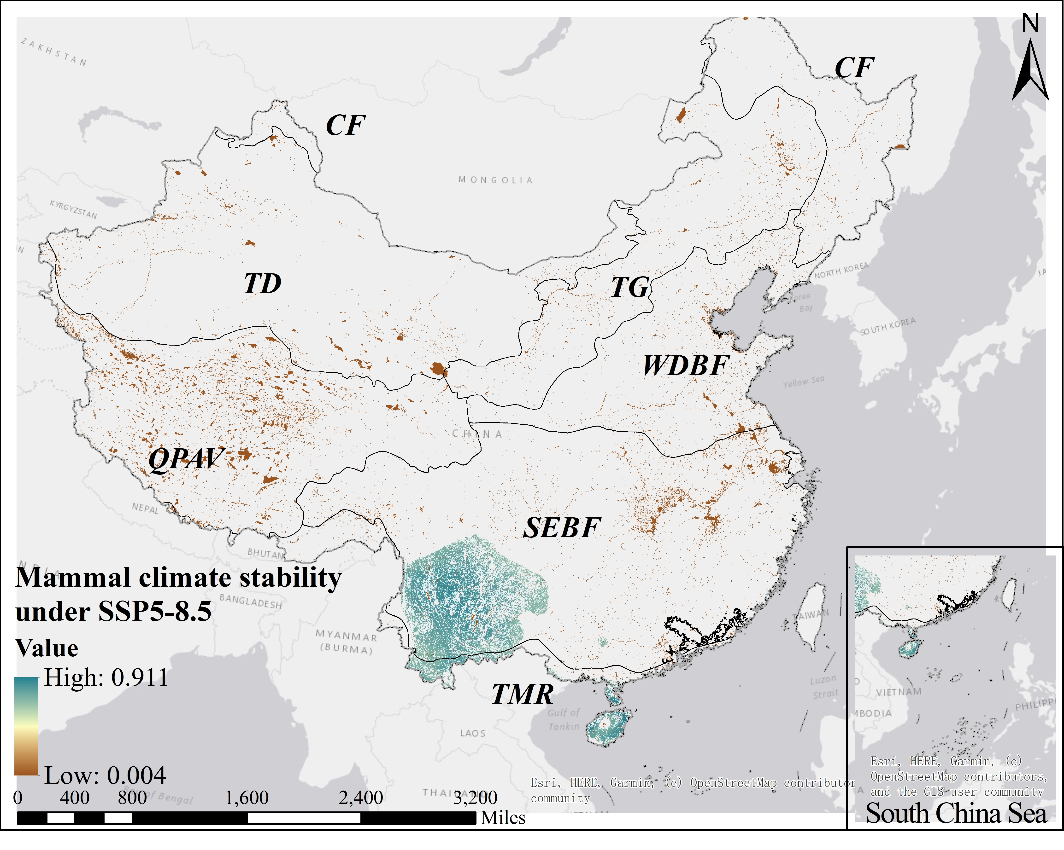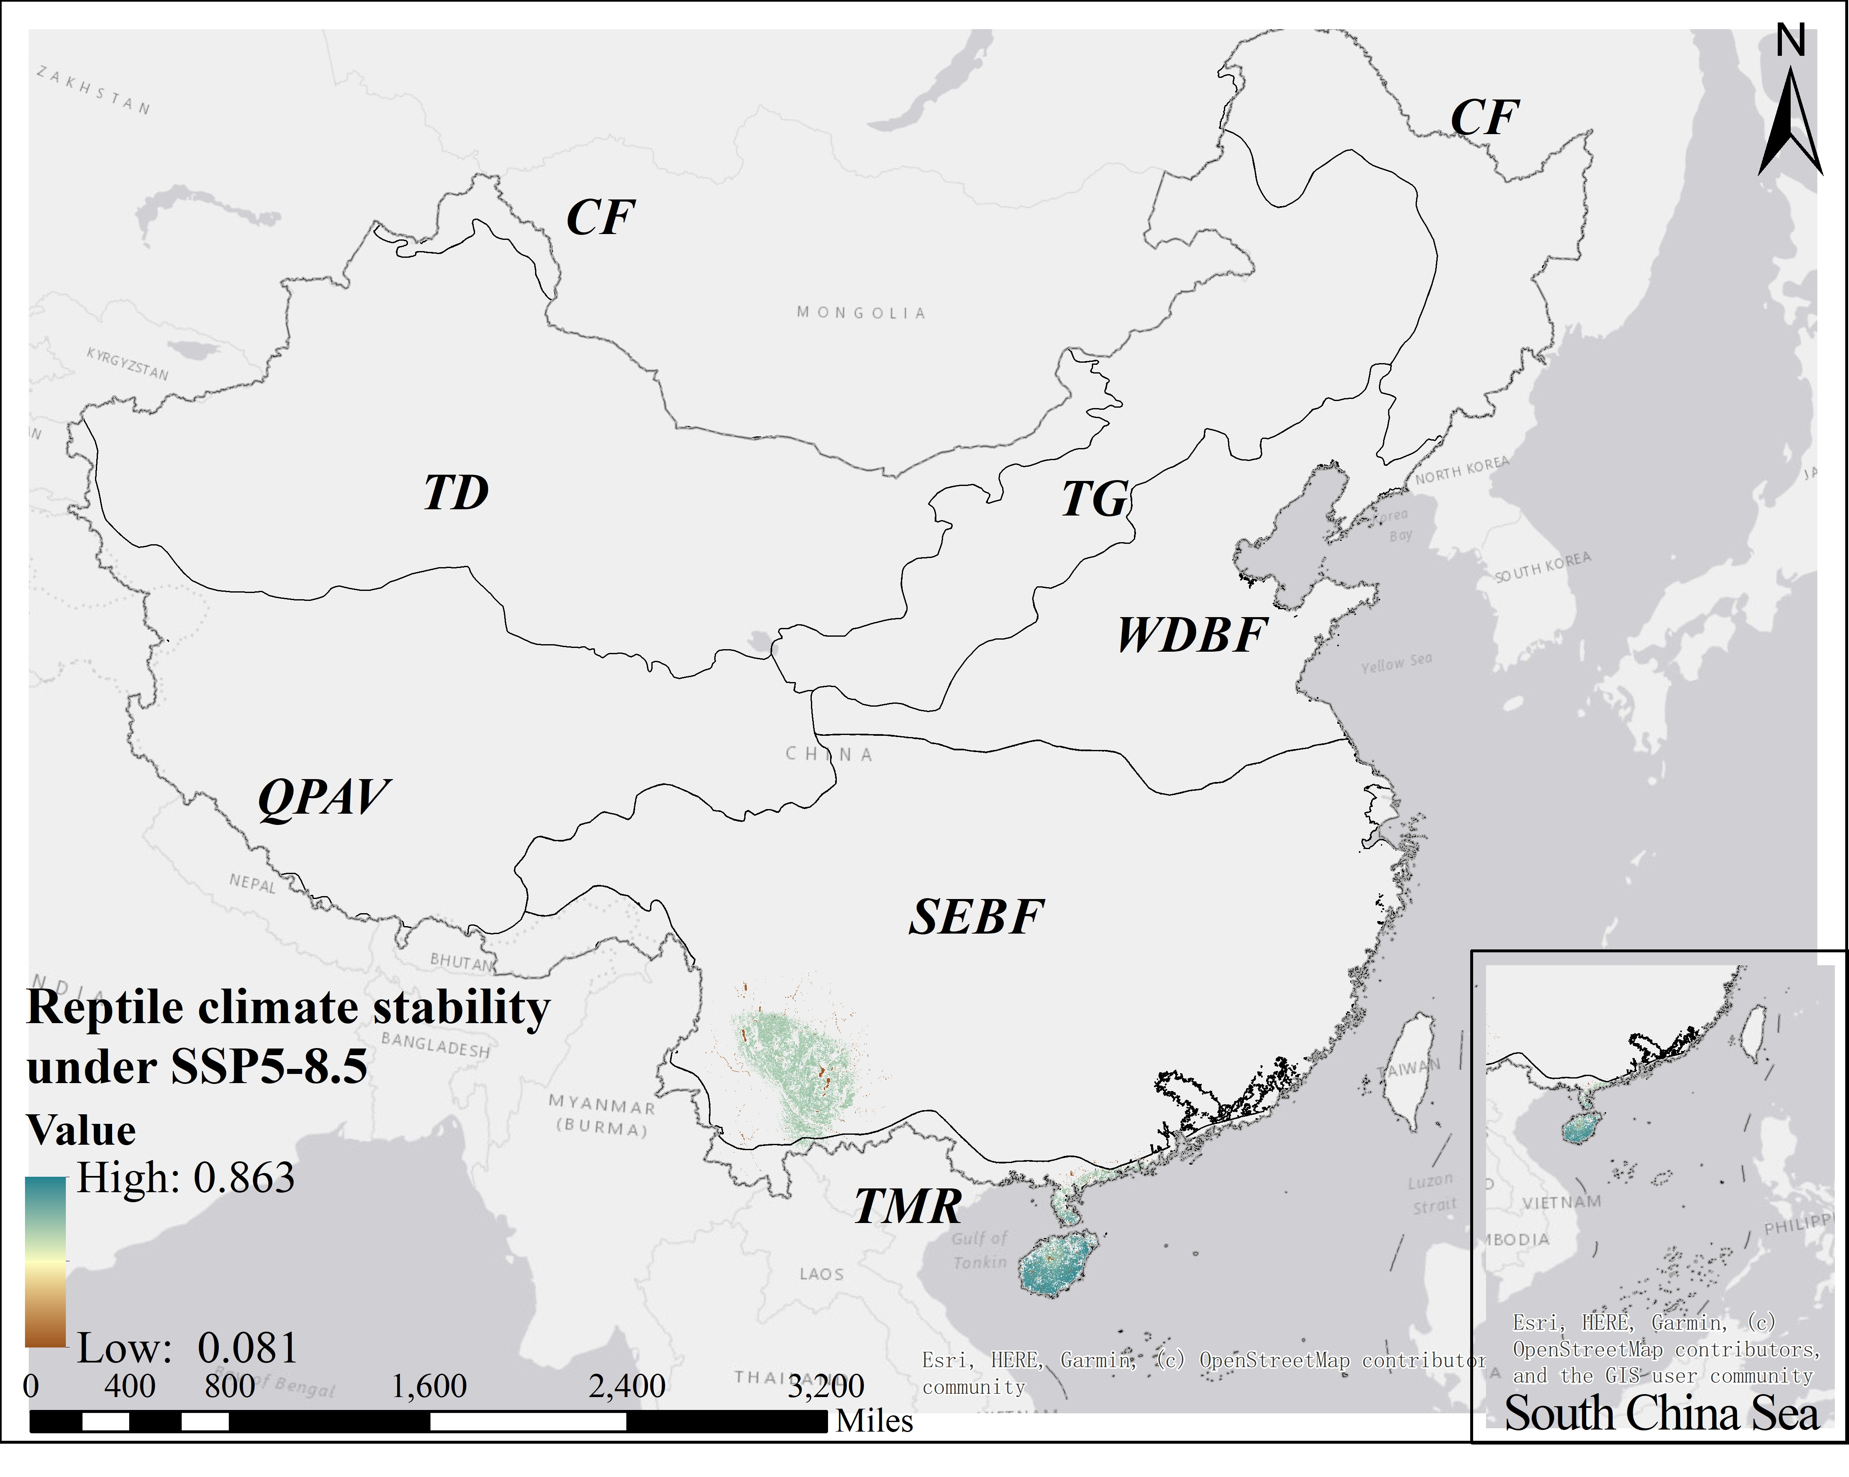
(b)
(a)
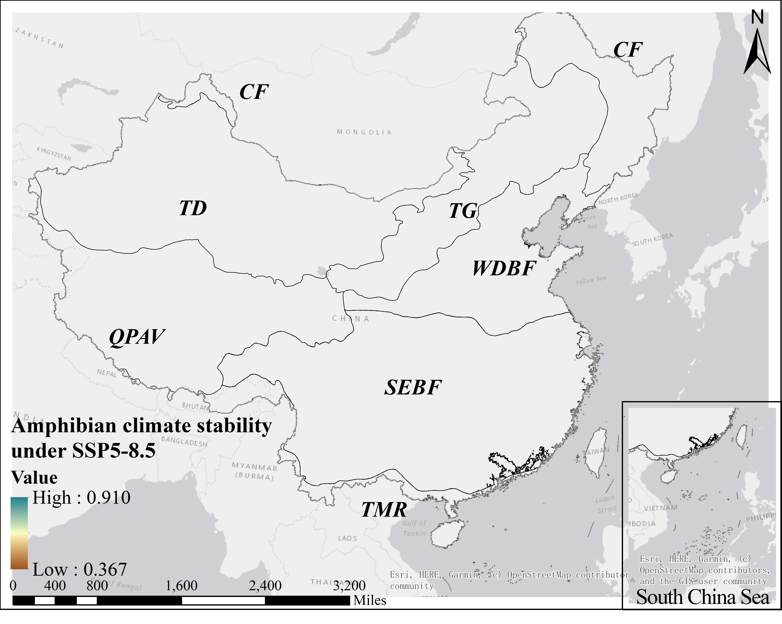
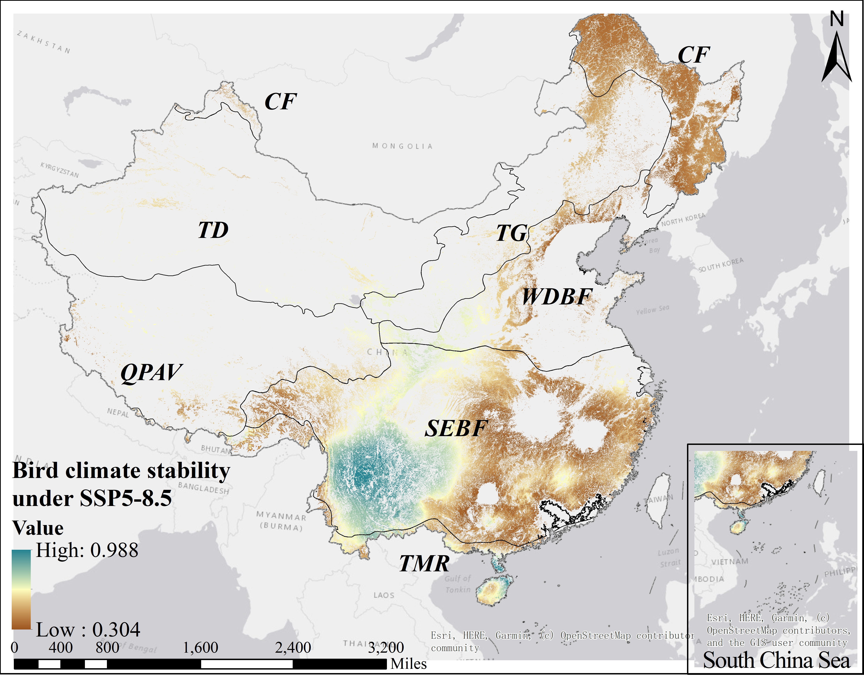
(d)
(c)
Fig. S1. Spatial patterns of climate stability for four taxa—a. mammals, b. reptiles, c. non-migratory birds, and d. amphibians—in China under the SSP5–8.5 scenario. A higher value indicates stronger climatic stability. Biomes: TMF—tropical monsoon forest, TCDBF—temperate coniferous & deciduous broadleaf forest, WDBF—warm-temperate deciduous broadleaf forest, CF—cold-temperate coniferous forest, SEBF—subtropical evergreen broadleaf forest, TD—temperate desert, TG—temperate grassland.

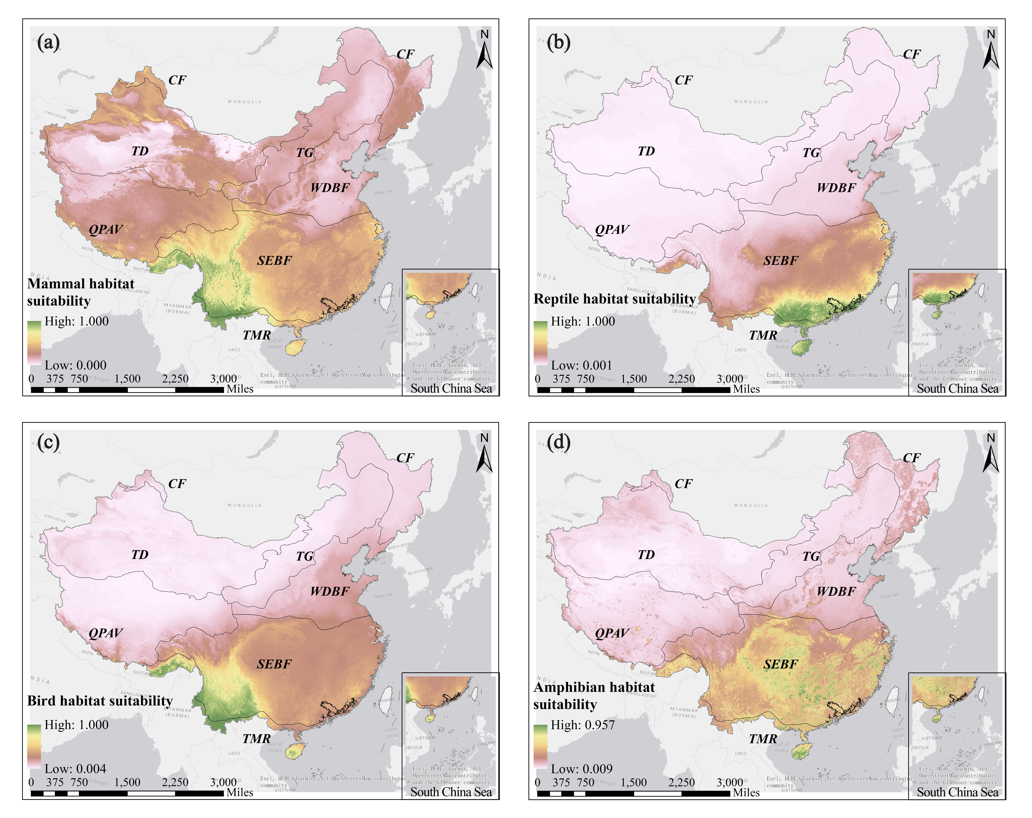
Fig. S2. Spatial patterns of habitat suitability (HS) for four taxa (mammals, reptiles, non-migratory birds, and amphibians) in China. Biomes: TMF—tropical monsoon forest, TCDBF—temperate coniferous & deciduous broadleaf forest, WDBF—warm-temperate deciduous broadleaf forest, CF—cold-temperate coniferous forest, SEBF—subtropical evergreen broadleaf forest, TD—temperate desert, TG—temperate grassland.

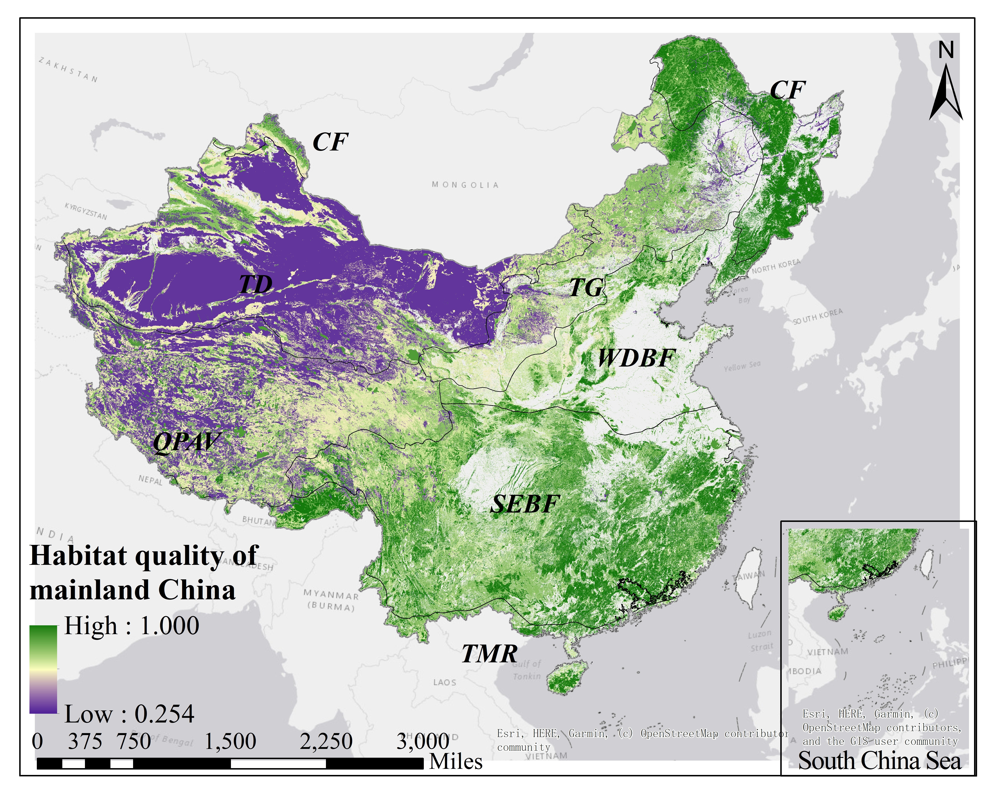
Fig. S3. Spatial patterns of habitat quality (HQ) across mainland China. Biomes: TMF—tropical monsoon forest, TCDBF—temperate coniferous & deciduous broadleaf forest, WDBF—warm-temperate deciduous broadleaf forest, CF—cold-temperate coniferous forest, SEBF—subtropical evergreen broadleaf forest, TD—temperate desert, TG—temperate grassland.

Table S11
Area (million hectares) of Potential Climate Refugia across Mainland China under SSP2-4.5 and SSP5-8.5.
Vegetation Zone | Area of Climate Refugia（ha）
Vegetation Zone | Low-potential | Medium-potential | High-potential
SEBF | 6.81 | 103.13 | 15.93
WDBF | 2.49 | 14.22 | 0
QPAV | 10.59 | 5.85 | 0
TMR | 0.63 | 10.78 | 1.01
TG | 2.20 | 11.02 | 0
TD | 3.13 | 3.65 | 0
CF | 0.15 | 35.49 | 0
Total | 26.01 | 184.15 | 16.94
Total | 227.10

