Supporting Information: Figure S2 – S12

Figure S2. Maerl growth forms found in St Mawes, Falmouth.
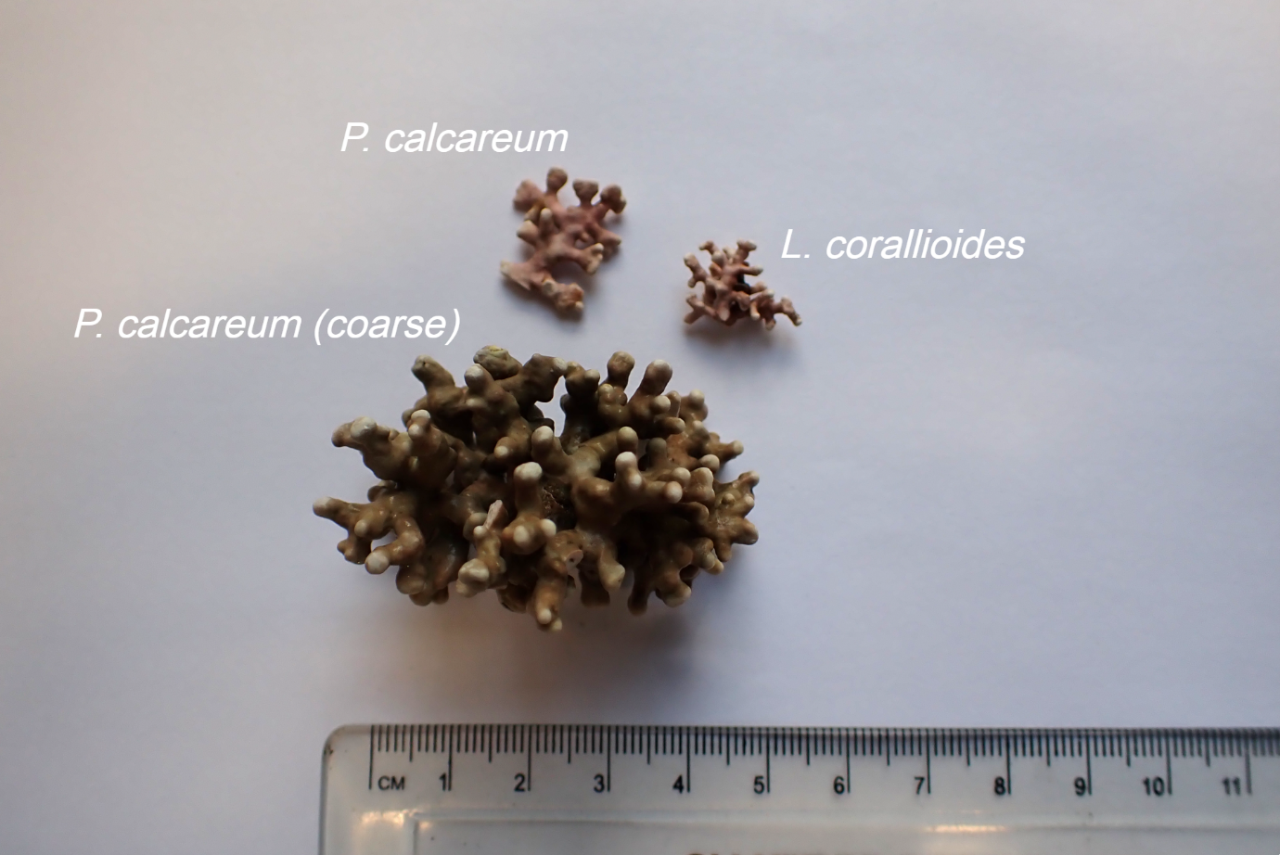

Figure S3. Phymatolithon calcareum PopCluster statistics (D_{LK2} and F_{STIS}). 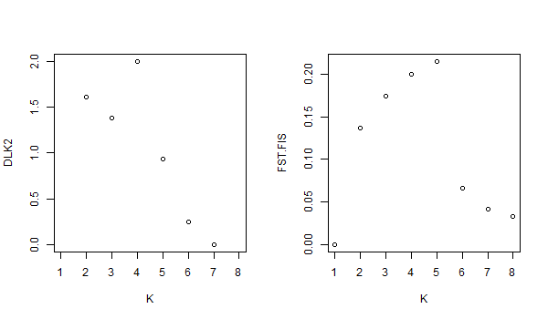

Figure S4. Phymatolithon calcareum PopCluster admixture results K2-K9.
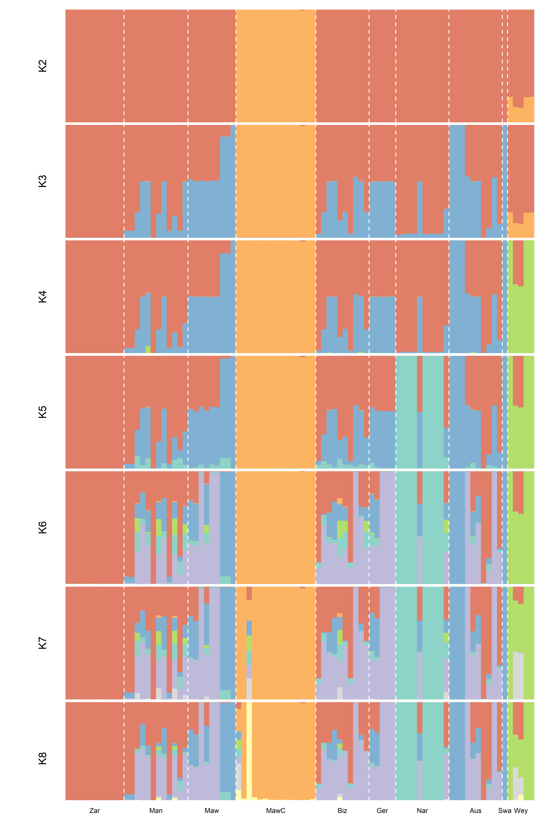
Figure S5. Phymatolithon calcareum principal component analysis (PCA). On the left, PC1 is plotted against PC2. On the right, PC2 is plotted against PC3.
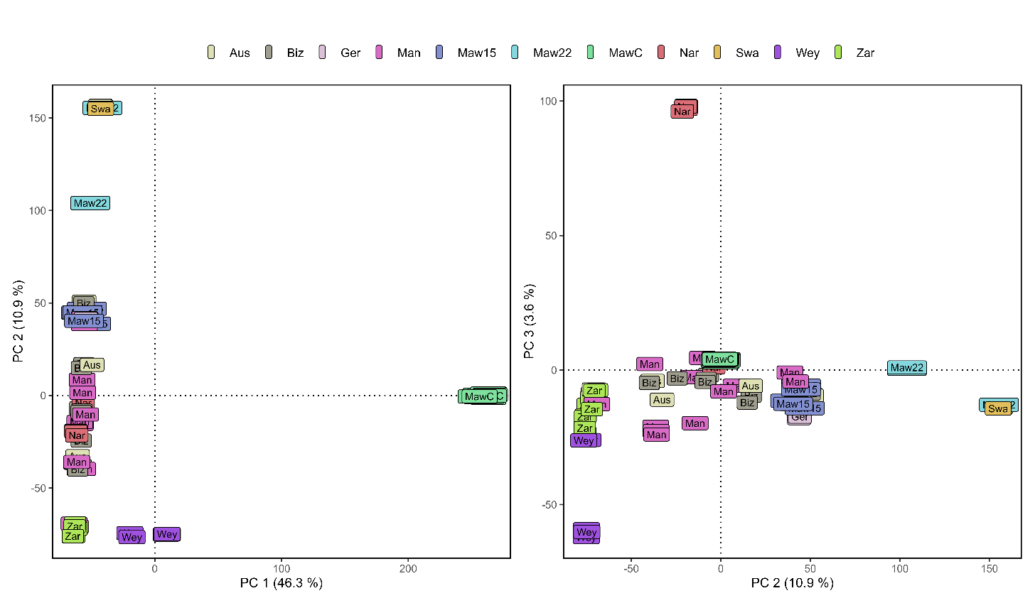

Figure S6. Phymatolithon calcareum PopCluster K9 admixture results for all European sites.
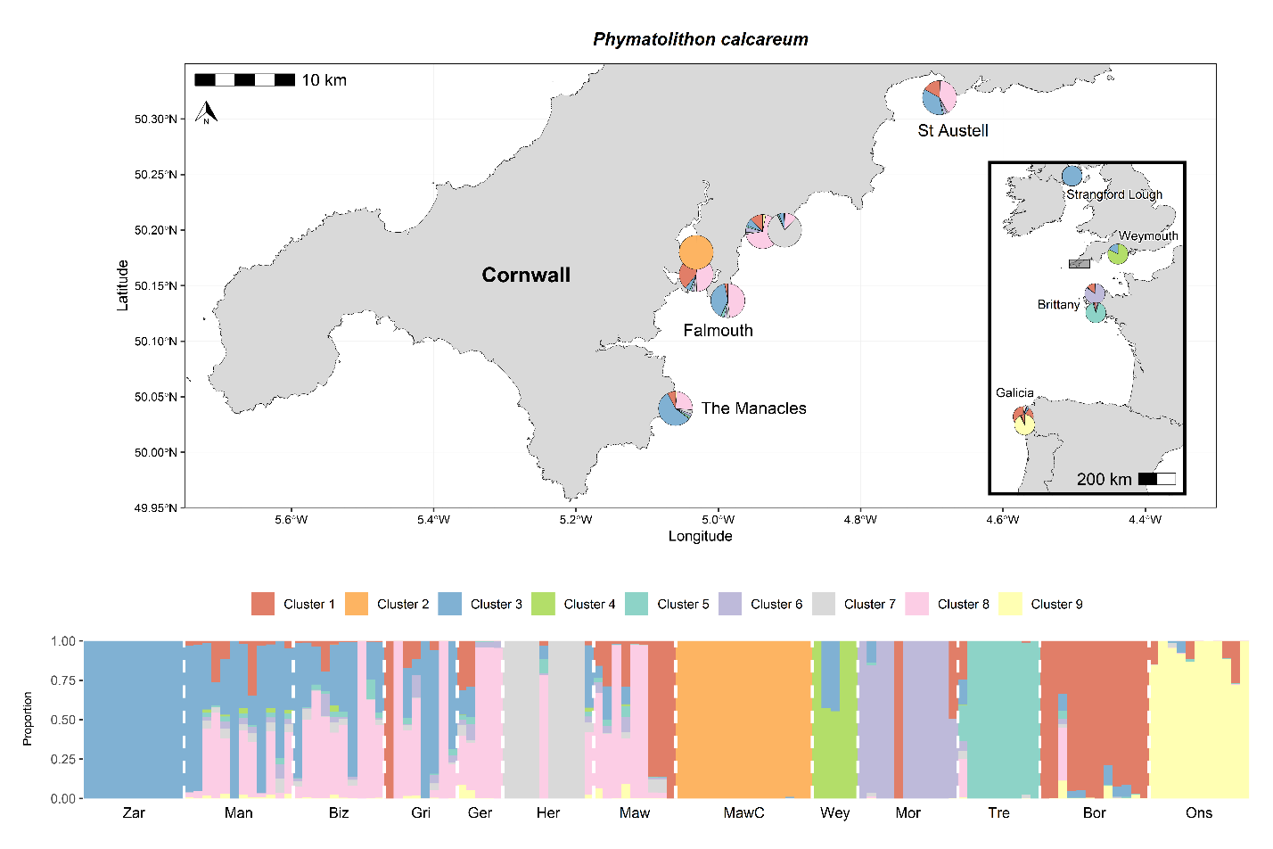

Figure S7. Lithothamnion corallioides PopCluster statistics (D_{LK2} and F_{STIS}).
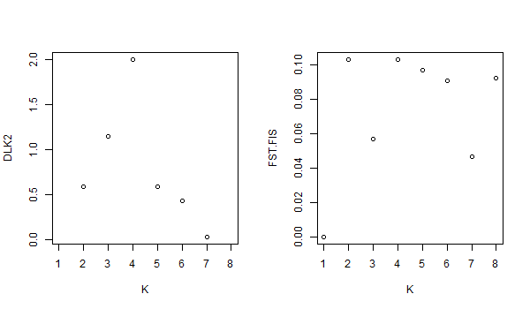

Figure S8. Lithothamnion corallioides PopCluster admixture results K2-K9.
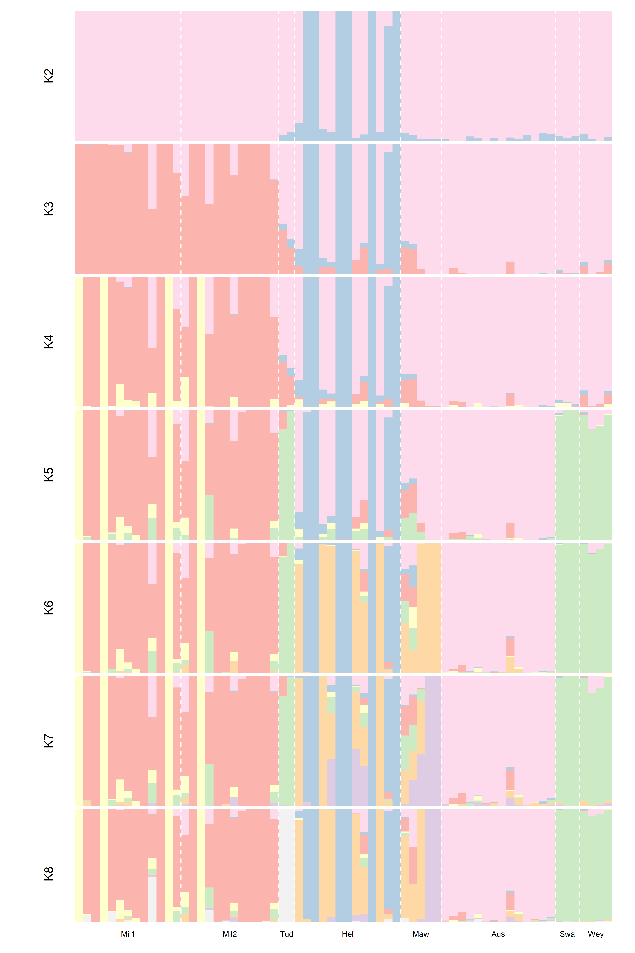
Figure S9. Lithothamnion corallioides principal component analysis (PCA). On the left, PC1 is plotted against PC2. In the middle, PC2 is plotted against PC3. On the right, PC3 is plotted against PC4.
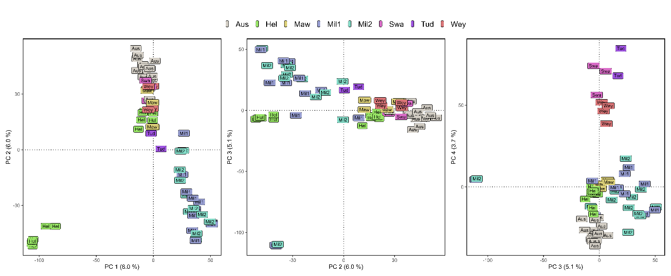

Figure S10. Pairwise genetic differentiation measures of F_{ST.}

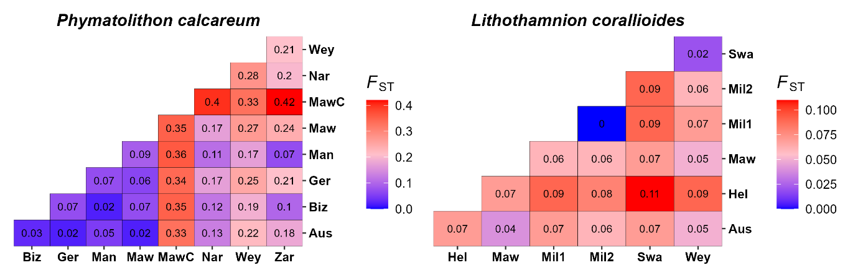

Figure S11. Phymatolithon calcareum histogram of Prevosti’s genetic distances. The vertical red line denotes the clone cut-off threshold.
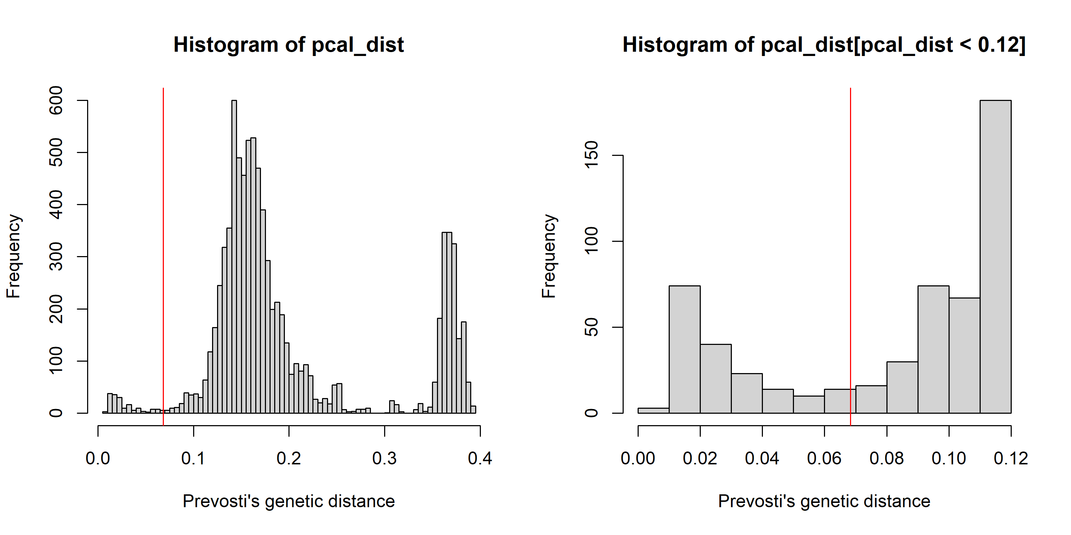

Figure S12. Lithothamnion corallioides histogram of Prevosti’s genetic distances. The vertical red line denotes the clone cut-off threshold.
