Table 1. Baseline characteristics of 65 AML patients with the proportion of MSCs available at the end of intensive chemotherapy treatment. Abbreviations: MSCs, mesenchymal cells; FAB, French American-British; ELN, European Leukemia Net

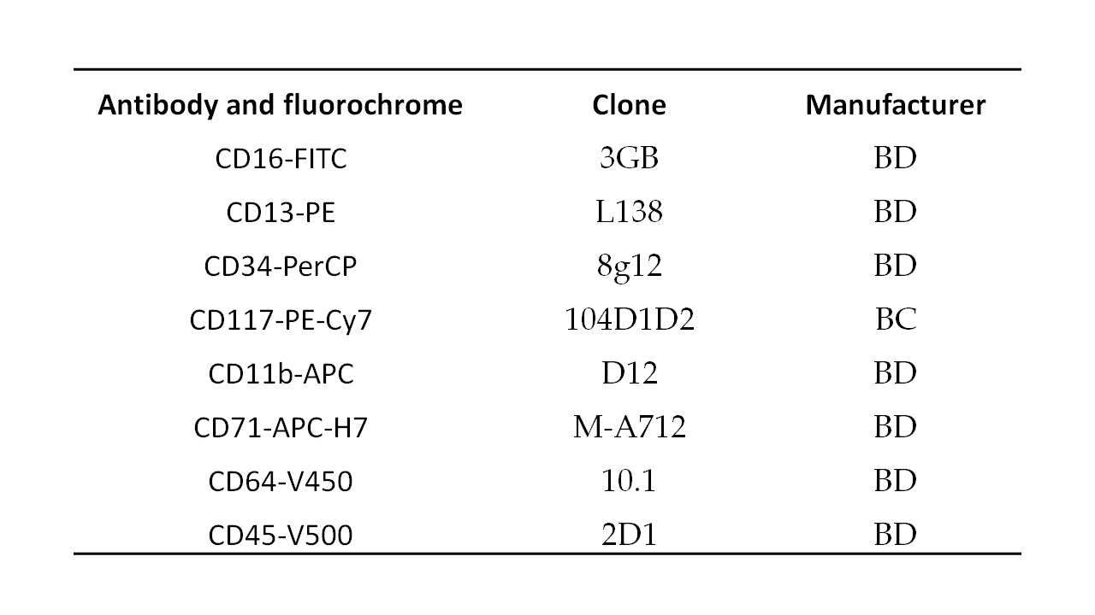
Table 2. Markers used for the screening of MSCs by flow cytometry. Abbreviations:

CD: clusters of differentiation; FITC: fluorescein isothiocyanate; PE, phycoerythrin; PerCP, Peridinin-Chlorophyll-protein; APC, Allophycocyanin; BD, Becton Dickinson; BC, Beckman Coulter.

