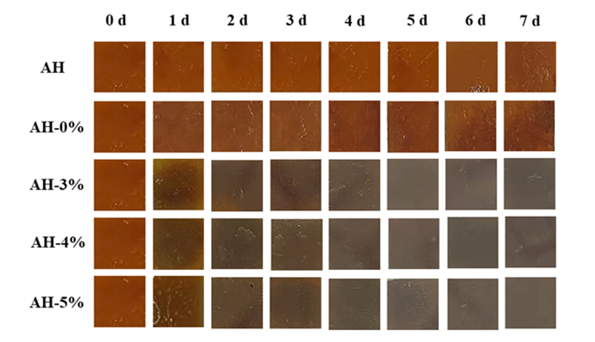
Fig. S1 Changes in the color of AgNP hydrogels in contact with braised chicken during storage.
Table S1 The solubility product constant of silver compounds in water.
silver compounds | K_{sp} | silver compounds | K_{sp}
AgCl | 1.8*10⁻¹⁰ | AgNO₃ | 122 g/100 mL water
Ag(CH₃COO) | 1.02 g/100 mL water | Ag₂SO₄ | 1.4*10⁻⁵
AgOH | 2.0*10⁻⁸ | AgNO₂ | 0.34g/100 mL water

Table S2 Effect of NaCl on the main constituents.
Contents | zeta-potential (mV) | particle size( nm)
NaCl-free gelatin | -1.34±0.22^{g} | 27.37±3.86^{ef}
NaCl-containing gelatin | -0.57±0.03^{ef} | 34.27±3.59^{d}
NaCl-free PVP | -0.04±0.01de | 15.87±2.41^{h}
NaCl-containing PVP | -0.04±0.02de | 25.63±2.60^{ef}
NaCl-free AgNO3 | 30.82±0.41ª | 56.80±2.01^{c}
NaCl-containing AgNO3 | 7.45±0.43^{c} | 88.30±0.36ª
NaCl-free gelatin and PVP | -0.54±0.55^{h} | 23.43±1.74^{fg}
NaCl-containing gelatin and PVP | -1.02±0.10^{fg} | 31.67±5.24de
NaCl-free mixed group of gelatin and PVP | -0.59±0.03^{ef} | 18.77±5.61^{gh}
NaCl-containing mixed group of gelatin and PVP | -1.28±0.08^{g} | 27.23±3.04^{ef}
NaCl-free AgNP | 13.38±0.35^{b} | 23.80±3.54^{fg}
NaCl-containing AgNP | 0.56±0.50^{d} | 64.87±0.11^{b}
Note：The data is expressed as mean ± SD, lowercase letters (a-f) indicate significant differences within the same column (P < 0.05).

