ATGL-LC3B-Lipid Complexes Mediate Lipophagy-Driven Radioprotection Against Metabolic Liver Injury in Adolescents
Yu Feng Zhang ^{a, 1}, Ze Lin Xu^{a, 1}, Chen Wangª, Ji Yu Xu ª, Yu Xu ª, Yi Qi Yiª, Po Bian ^{a*}, Ting Wang ^{a *}
ª Teaching and Research Section of Nuclear Medicine, School of Basic Medical Sciences, Anhui Medical University, Hefei 230032, China.
¹ Equal contribution.
* Corresponding Author. To whom correspondence should be addressed to wangting@ahmu.edu.cn, bianpo@ahmu.edu.cn.
Correspondence to: Teaching and Research Section of Nuclear Medicine, School of Basic Medical Sciences, Anhui Medical University, Hefei 230032, China.
Affiliation of author(s): Teaching and Research Section of Nuclear Medicine, School of Basic Medical Sciences, Anhui Medical University, Hefei 230032, China.
Clinical trial number: not applicable.
Supplementary materials include: Figure S1, S2, Table1, Table2, original drawing of WB
Figure S1. (A) Representative fluorescence co-localization picture of LC3B and ATGL in mouse liver. Scale bar: 50 μm; LC3B is red, ATGL is green. (B) Representative fluorescence co-localization picture of ATGL and LDs in mouse liver. Scale bar: 50 μm; Scale bar: 50 μm; ATGL is red, LDs is green. Data were shown as MEAN ± SD. * P < 0.05 vs. Ctrl mice. # P < 0.05 vs. IR mice.
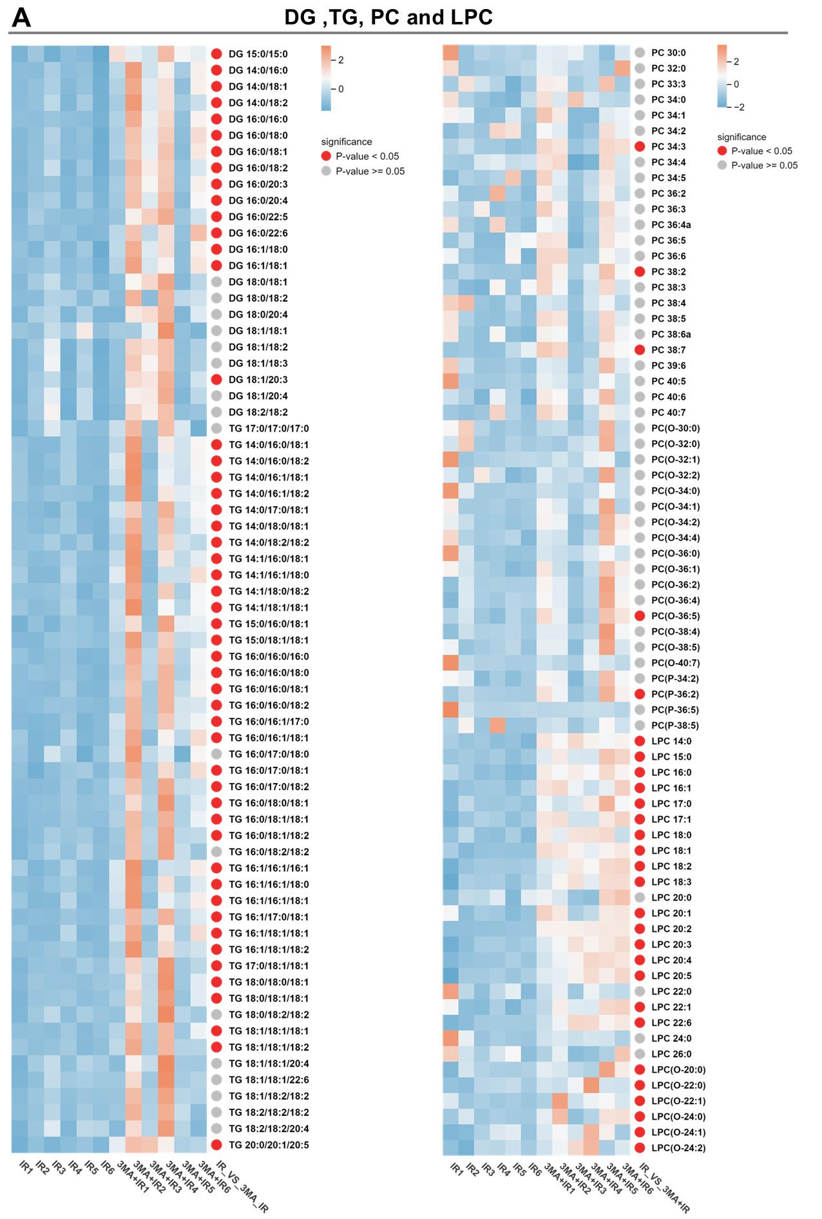
Figure S2. (A and B) Heatmap of DG, TG, PC and LPC lipid content in mouse liver (n=6).
Figure S3. (A) Representative Western blot images of ATG5 and ATGL in the mouse liver. (B and C) Quantification of ATG5 and ATGL proteins. (D) Representative immunofluorescence images of LC3B in the mouse liver. Scale bar: 20 μm; LC3B is red. (E) Representative Western blot images of ATG5 and ATGL in the mouse liver. (F and G) Quantification of ATG5 and ATGL proteins. (H) Representative immunofluorescence images of LC3B in the mouse liver. Scale bar: 20 μm; LC3B is red. (I and J) LC3B in the mouse liver with the ratio of positive area. Data were shown as MEAN ± SD. * P < 0.05 vs. Ctrl mice. # P < 0.05 vs. IR mice.
Figure S4. (A and B) Heatmap of DG, TG, PC and LPC lipid content in mouse liver (n=6).
Table 1 Main chemical reagents and antibodies
Reagent name | Company name | Art.No.
3-Methyladenine  Rapamycin | Med Chem Express  Med Chem Express | 19312  10219
BODIPY | Med Chem Express | 216434-81-0
Atgl | Abcam | ab207799
Atg5 | Abcam | ab108327
p62 | Cell Signaling Technology | 5114s
LC3B-I/II | Abcam | ab48394
β-Actin | Cell Signaling Technology | 4970s

Table 2 A list of primers related to lipophagy genes.
Gene | Sequence (5’-3’) | Species | Company name
Atgl  (F)  (R) | GGATGGCGGCATTTCAGACA  CAAAGGGTTGGGTTGGTTCAG | mice | Gene pharma
Atg5  (F)  (R) | TGTGCTTCGAGATGTGTGGTT  GTCAAATAGCTGACTCTTGGCAA | mice | Gene pharma
Atg8  (F)  (R) | TTATAGAGCGATACAAGGGGGAG  CGCCGTCTGATTATCTTGATGAG | mice | Gene pharma

ATG5
ATGL
P62
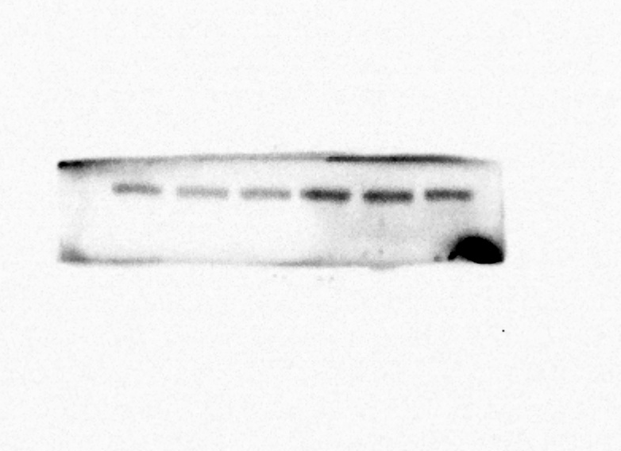
LC3B
Actin
