Supplementary Information
Engineered vesicles enhance oral antibiotic absorption in proximal small intestine and mitigate gut dysbiosis

Yinglan Yu¹, Yongfeng Xu¹, Zehui Yu¹, Xinrui Liu¹, Jiayue Guo¹, Min Xiang¹, Junmeng Chen^{1,2}, Riyanto Teguh Widodo², Lei Luo^{1*}

¹College of Pharmaceutical Sciences, Southwest University, Chongqing 400715, China.
²Department of Pharmaceutical Technology, Faculty of Pharmacy, University of Malaya, Kuala Lumpur 50603, Malaysia
* Corresponding Author
E-mail: drluolei@swu.edu.cn

1. Results
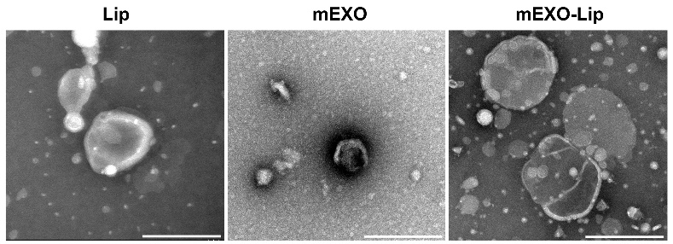
Supplementary Fig. 1 The transmission electron microscope (TEM) images of Lip, mEXO, and mEXO-Lip. Scale bars, 200 nm.

Supplementary Fig. 2 Particle size and zeta potential of different vesicles. All values are presented as the mean ± SD (n = 3).

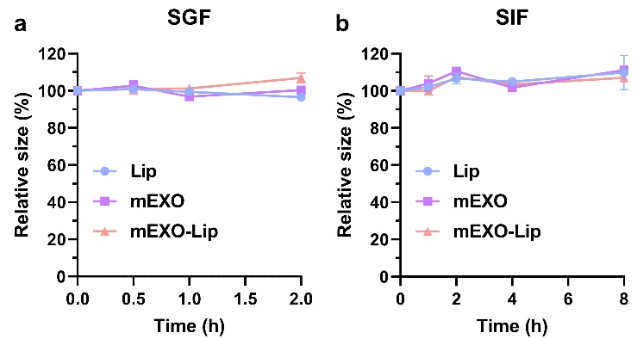
Supplementary Fig. 3 Particle size changes of different vesicles after incubation with simulated gastric fluid (SGF, a) and simulated intestinal fluid (SIF, b). All values are presented as the mean ± SD (n = 3).

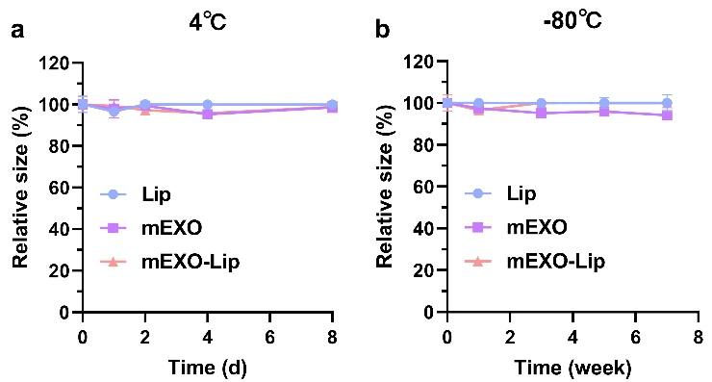
Supplementary Fig. 4 Particle size changes of different vesicles stored at 4℃ (a) and -80℃ (b) for 7 days. All values are presented as the mean ± SD (n = 3).

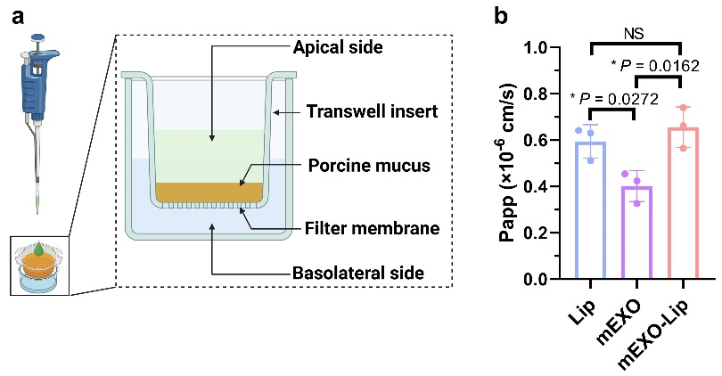
Supplementary Fig. 5 a, Schematic diagram of the Tanswell-mucus 3D system. b, Quantitative results of different vesicles passing through the Tanswell system. All values are presented as the mean ± SD (n = 3). Statistical significance was determined using one-way ANOVA with a Tukey post hoc test. * P < 0.05. NS, not significant.

Supplementary Fig. 6 Quantitative endocytosis of cells incubated with various vesicles. All values are presented as the mean ± SD (n = 3). Statistical significance was determined using one-way ANOVA with a Tukey post hoc test. *** P < 0.0001.

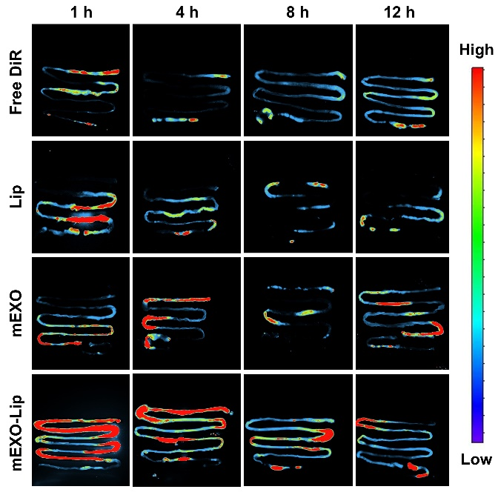
Supplementary Fig. 7 Representative images of in vivo imaging system of intestine from mice orally administered with DiR-loaded vesicles.

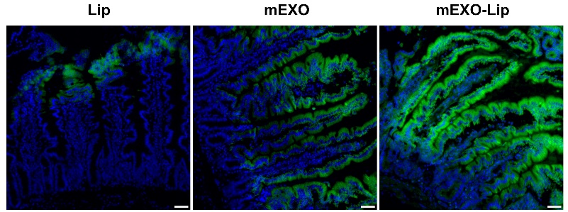
Supplementary Fig. 8 Representative images of coumarin 6 (C6)-loaded vesicles in the proximal small intestine at 4 h post administered. Blue: nucleus; Green: C6-labeled vesicles. Scale bars, 50 μm.

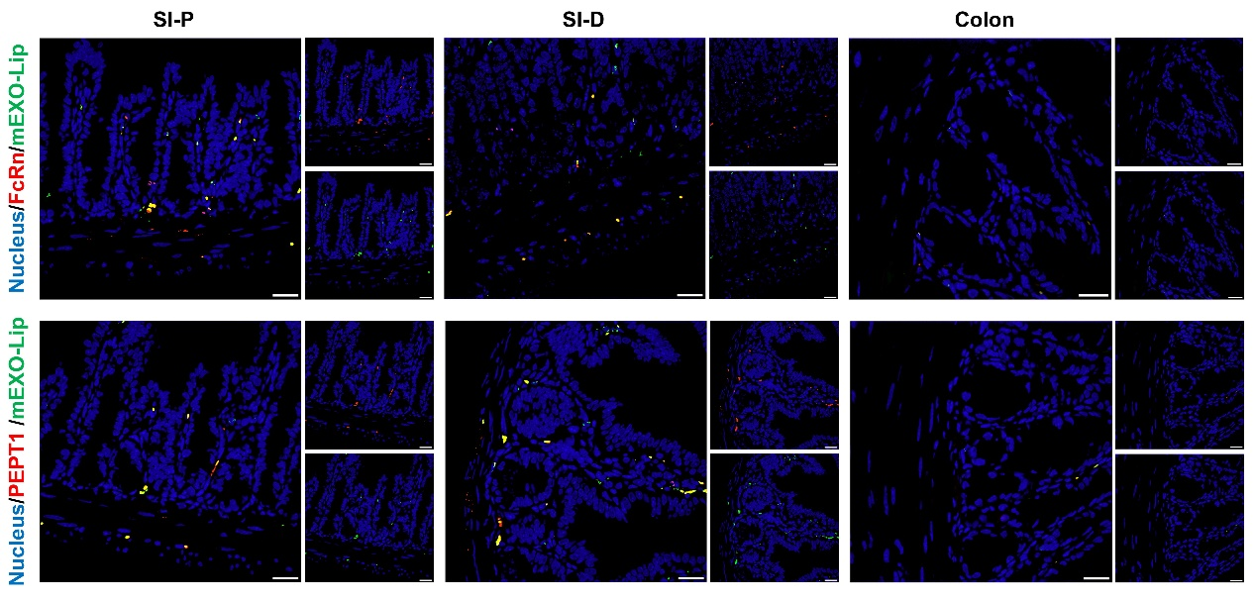
Supplementary Fig. 9 Representative images of C6-labeled vesicles, FcRn, and PEPT1 in intestine. Blue: nucleus; Green: C6-labeled vesicles; Red: FcRn/PEPT1. Scale bars, 20 μm.

Supplementary Table 1. Characterization of Cef-loaded vesicles. Mean ± SD (n = 3).
Samples | Size (nm) | PDI | Zeta potential (mV) | Encapsulation efficiency (%)
Lip@Cef | 156.89 ± 3.61 | 0.24 ± 0.02 | -18.74 ± 1.80 | 50.27 ± 4.68^{***P=0.0006}
mEXO@Cef | 128.30 ± 3.12 | 0.14 ± 0.02 | -9.95 ± 1.13 | 11.29 ± 3.26
mEXO-Lip@Cef | 168.92 ± 2.64 | 0.23 ± 0.02 | -19.78 ± 2.06 | 56.02 ± 3.16^{***P=0.0002}
Statistical significance was determined using one-way ANOVA with a Tukey post hoc test. *** P＜0.001 versus mEXO@Cef.

Supplementary Table 2. Pharmaco kinetic parameters of Cef in mice. Mean ± SD (n = 5).
Pharmacokinetic parameters | Free Cef | Lip@Cef | mEXO@Cef | mEXO-Lip@Cef
T_{1/2} (h) | 89.94 ± 49.15 | 81.74 ± 25.39 | 80.52 ± 31.45 | 67.71 ± 33.73
T_{max} (h) | 36.00 ± 12.00 | 36.00 ± 12.00 | 54.00 ± 12.00 | 36.00 ± 12.00
C_{max} (μg/mL) | 3.31 ± 0.95 | 6.25 ± 1.65^{*P =0.0153} | 7.95 ± 0.68^{****P<0.0001} | 11.52 ± 1.73^{****P<0.0001}
AUC_{0-t} (μg/mL*min) | 408.68 ± 136.13 | 716.40 ± 54.46^{*P=0.0460} | 1000.69 ± 105.38^{***P=0.0001} | 1323.68 ± 242.44^{***P=0.0002}
Statistical significance was determined using one-way ANOVA with a Tukey post hoc test. * P < 0.05, *** P < 0.001, **** P < 0.0001 versus free Cef.

