Protocol – Gibson cloning of SHP2 mutants into pLX304

Overview
The protocol consists of 3 PCR steps and 1 Gibson reaction
PCR 1: Amplifies part 1 of the pLX304 backbone
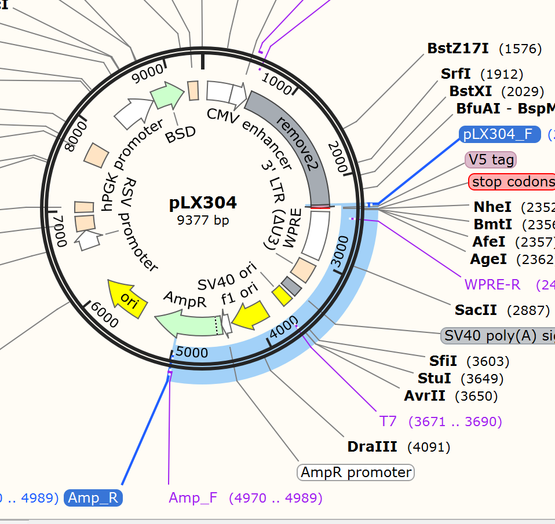

PCR 2: Amplifies part 2 of the pLX304 backbone
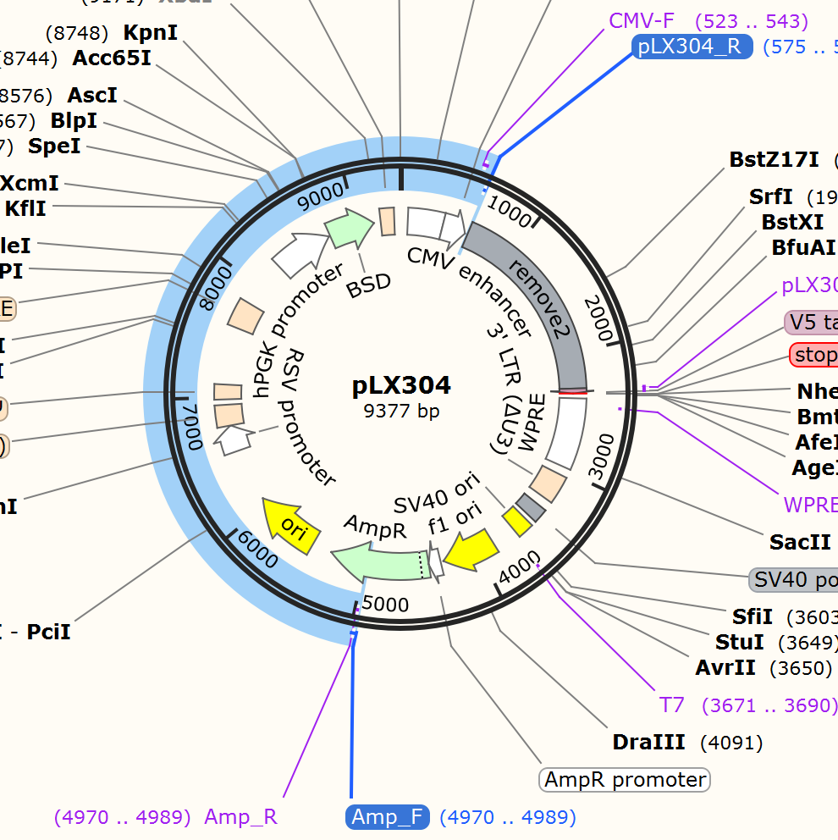

PCR 3: Amplifies the SHP2 variants of the pGEX vectors
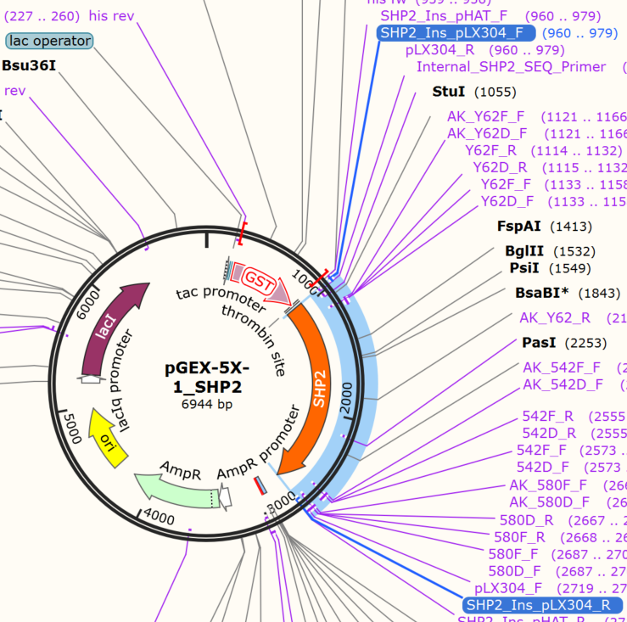
Materials
Gibson 2x MM
Primers
- Amp_F
- Amp_R
- pLX304_F
- pLX304_R
- SHP2_Ins_pLX304_F
- SHP2_Ins_pLX304_R
Plasmids
- pLX304
- pGEX_SHP2_WT
- pGEX_SHP2_Y62F
- pGEX_SHP2_Y542F
- pGEX_SHP2_Y580F
- pGEX_SHP2_Y62F_Y542F
- pGEX_SHP2_Y62F_Y580F
- pGEX_SHP2_Y542F_Y580F
- pGEX_SHP2_Y62F_Y542F_Y580F
1% Agarose gel
DpnI
PCR clean up kit
Gibson 2x HIFI MM
E. coli Dh5alpha

Methods
PCR 1 – 200 µL – 2690 bp – 68 degrees annealing

Prepare in a PCR tube:

97 uL Nuclease Free Water
1 uL pLX304_F (100 µM)
1 uL Amp_R (100 µM)
1 uL pLX304 S (~200 ng/µL)
100 uL Q5 2x MM

Vortex – spin down – Divide 100 µL over 2 PCR tubes
PCR: 30 cycles of step 2-4
98 30 seconds
98 10 seconds
68 15 seconds
72 1.5 minutes
72 2 minutes
10 hold

PCR 2 – 200 uL – 5000 bp – 68 degrees annealing

Prepare in a PCR tube:

97 µL Nuclease Free Water
1 µL pLX304_R (100 µM)
1 µL Amp_F (100 µM)
1 µL pLX304 S (~200 ng/µL)
100 µL Q5 2x MM

*Really watch that you are adding the 1 µL!

Vortex – spin down – Devide 100 µL over 2 PCR tubes
PCR: 30 cycles of step 2-4
98 30 seconds
98 10 seconds
68 15 seconds
72 5 minutes
72 10 minutes
10 hold
PCR 3 – 8x 100 µL – 1783 bp – 68 degrees annealing
Prepare MM in a 1.5 mL tube:

388 µL Nuclease Free Water
4 µL SHP2_Ins_pLX304_F (100 µM)
4 µL SHP2_Ins_pLX304_R (100 µM)
400 µL Q5 2x MM

Vortex – spin down - Devide over 8 PCR tubes: 98 µL each (just to make sure you don’t have to little for the last one)

Add 0.5 µL of each pGEX SHP2 plasmid to a tube – watch closely.

pGEX_SHP2_WT = 1
pGEX_SHP2_Y62F = 2
pGEX_SHP2_Y542F = 3
pGEX_SHP2_Y580F = 4
pGEX_SHP2_Y62F_Y542F = 5
pGEX_SHP2_Y62F_Y580F = 6
pGEX_SHP2_Y542F_Y580F = 7
pGEX_SHP2_Y62F_Y542F_Y580F = 8

Vortex – spin down
PCR: 30 cycles of step 2-4
98 30 seconds
98 10 seconds
67 15 seconds
72 1 minutes
72 2 minutes
10 hold

1% Agarose gel control
Take 5 µL of each unique sample (so for PCR 1 and PCR2 only 1 check, for PCR 3 all 8 samples) to a gel – check if the size is roughly correct.

5 µL PCR
5 µL H2O
2 µL 6x Loading dye

Left over 95 µL PCR can be stored at 4 degrees if not immediately continuing to DpnI treatment.

DpnI digestion

To each PCR tube, add 1 µL DpnI
Incubate at 37 degrees in the PCR machine for 30 minutes

PCR clean up

Immediately following DpnI digest – clean up the PCR/DpnI samples
Use Nucleaspin Gel and PCR clean up

For PCR 1/2
Add 400 µL yellow binding buffer to a 1.5 mL tubes
Combine and add 200 µL PCR reaction

For PCR 3
Add 200 µL yellow binding buffer to a 1.5 mL tubes (1 for each PCR tube)
Add 100 µL PCR reaction

Follow protocol. Elute with nuclease free water. Elute 20 µL for PCR 1 and 2, 15 µL for each PCR 3.

Measure concentrations – can be stored at -20.

Gibson

*Volumes depend on concentrations of DNA – lets decide when you know.

In PCR tube

1 µL Backbone PCR1
2 µL Backbone PCR2
1 µL SHP2 Insert DNA
5 µL 2x HIFI MM

Incubate for 1 hour at 50 degrees Celsius (lid at 80 degrees).

Gibson can be stored at -20 if not immediately continuing to transformation.

Transformation
Transform 2.5 µL to 50 µL dh5x cells
As per protocol (30 seconds at 42 heatshock)
Plate all cells to ampicillin plates.

