Supplementary Figure 1. Validation of injection placement and CNO dose response. (A) Energy expenditure (EE) in Lepr^{Cre} mice expressing AAV5-hSyn-DIO-hM3D(Gq) in POA neurons following intraperitoneal (i.p.) injection of PBS (n = 8) or varying CNO concentrations (0.003 mg/kg, n = 4; 0.015mg/kg, n = 8; 0.01 mg/kg, n = 8; 0.03 mg/kg, n = 4; 0.3 mg/kg, n = 4) at room temperature (RT). Injections were administered at 09:00. (B) Total locomotor activity (LA) in Lepr^{Cre} mice following PBS or CNO administration. (C) Correlation between locomotor activity and food intake (FI) at the 0.01 mg/kg CNO dose. Data are presented as mean ± SEM.
Supplementary Figure 2. CNO drinking-water dose response. (A) Energy expenditure (EE) in Lepr^{Cre} mice expressing AAV5-hSyn-DIO-hM3D(Gq) in POA neurons following CNO administration via drinking water at varying concentrations (0 mg/ml, n = 5; 0.00025 mg/ml, n = 5; 0.000005 mg/ml, n = 2; 0.00005 mg/ml, n = 3; 0.0005 mg/ml, n = 3; 0.00125 mg/ml, n = 2) at RT. (B) Locomotor activity (LA) in Lepr^{Cre} mice following PBS or CNO administration. Data are presented as mean ± SEM.
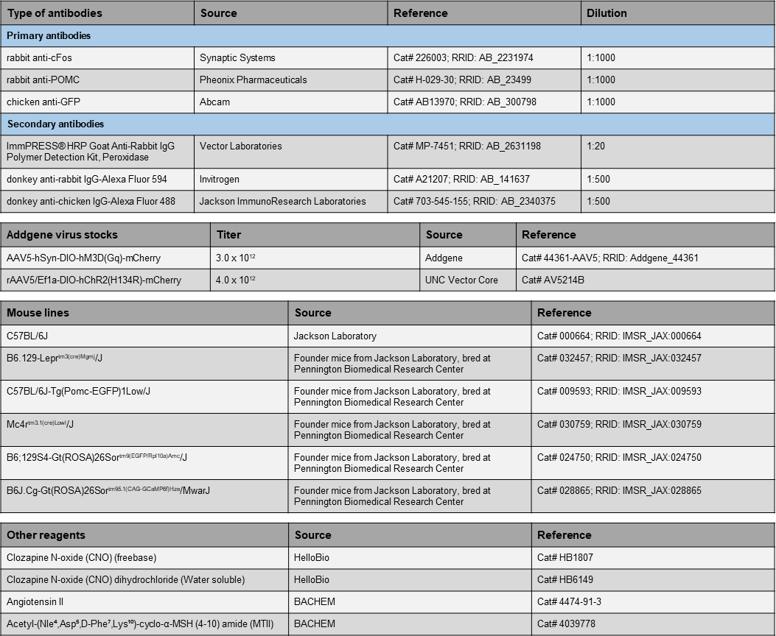
Supplementary Figure 3.

