Supplementary

VI-OCR: "Visually Impaired" Optical Character Recognition Pipeline for Text Accessibility Assessment

Qingying Gao^{1,2}, Roberto Manduchi³, Pradeep Y. Ramulu², Gordon E. Legge⁴, Yingzi Xiong^{2,+}

1. Department of Computer Science, Johns Hopkins University, Baltimore, MD 21218
2. Wilmer Eye Institute, Johns Hopkins University, Baltimore, MD 21218
3. Department of Computer Science and Engineering, University of California, Santa Cruz, CA 95064, USA
4. Department of Psychology, University of Minnesota, Minneapolis, MN 55455, USA
+ yxiong36@jh.edu10

Appendix 1. Model Selection
We selected various open-source and closed-source OCR specific models and VLMs for our experiments. Closed-source models often outperform open-source models due to proprietary training data and advanced post correction techniques, but their internal architectures are often not accessible. In Experiment 1, we evaluated the performance of OCR-specific models with different architectures. In Experiment 2, we introduced additional closed-source models like Seeing AI and several VLMs for comparison. The architectures of OCR specialized models and VLMs are illustrated in Figure S1.
OCR Specialized Models.
OCR specialized models refer to models designed for text detection and recognition tasks only (Figure S2.A). For closed-source models, we selected the most widely used APIs, Google Vison for comparison. Azure, Microsoft’s Read OCR engine was excluded due to image resolution limit that was smaller than x-height of some rows in letter and word reading tasks in Experiment 1. Depending on their architecture, the open-source models can be further subdivided into Two-Stage and End-to-End structures.
Two-Stage Series: Two stage models treat text detection and recognition as separate tasks. Detection model localizes potential text regions then feeds the cropped-out regions into recognition model. For our evaluation, we selected the best-performing combination for detection and recognition, DBNet++ & MAERecB, from a suite of polygon-based, two-stage models. (Detection: DBNet, DBNet++, FCENet; Recognition: MAERecS, MAERecB). DBNet++, trained on the TotalText dataset for 1200 epochs, achieves an F1 score of $0.833$ for detection, while MAERecB, initialized with a ViT-base backbone and trained on the Union14M-L dataset (with 4 million images), achieves an F1 score of $0.852$ for text recognition.
End-to-end: End-to-end models jointly integrate text detection and recognition, allowing the two tasks to improve each other’s performance by reducing detection false positives and leveraging visual features during training. We selected SPTSv2, the state-of-the-art point-based end-to-end text spotter, for comparison. SPTSv2 achieves over 0.85 F1 score for detection and recognition while using low-cost single-point annotations as input to accelerate computation.
Vision Language Models.
General VLMs are designed as general-purpose models to complete as many real-world tasks as possible, including OCR tasks, using an end-to-end encoder-decoder or decoder only architecture without OCR modules for text detection and recognition (Figure S1.B). Most of these VLMs follow a general architecture proposed by LLaVA that comprising a Vision Encoder to extract visual information, an adapter to align visual and linguistic features, and a visual language model to translate features into natural language. These large VLMs have 2 billion to 400 billion parameters and are trained on millions of images, while OCR specialized models only have 30-100 million parameters. Take DBNet for example, it only has 15-30 million parameters. We included large VLMs from closed source models, GPT, Gemini and Claude series, to open-source interleaved image-text models, CogAgent and Qwen series, and a VLM based software SeeingAI.

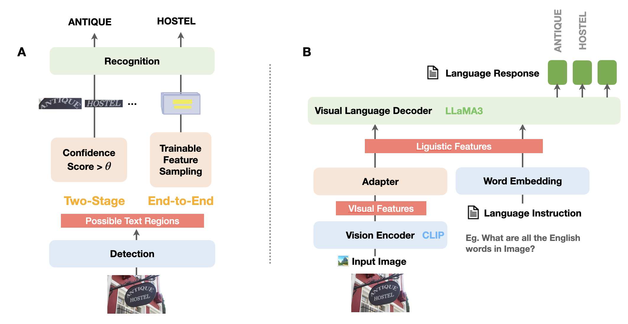
Figure S1. General architectures of OCR specialized models and VLMs. A. The difference between two-stage and end-to-end OCR specialized is whether the features of possible text regions are sampled and aligned in a trainable way. B. VLMs generally are developed based on LLaVA’s architecture that comprises three components: a Vision Encoder transforms discrete image into continuous visual features (CLIP is the most common ViT encoder), an adapter to align visual and linguistic features (LLaVA uses linear layer, QWen uses Q-former, CogAgent uses convolutional layer), and a language model to decode linguistic features into natural sentences. LLaMA3 (Dubey, Abhimanyu, et al.) is the most widely used language decoder.

Appendix 2. Table S1. Pixel resolution limit and F1 score of models under the baseline no-filter condition for letter, work and scene text recognition tasks, ordered by word acuity. Bold values indicate the best performance. Underlined models exhibit better letter acuity than word acuity, which is opposite to human trend.
Tasks | Letter Acuity  (Resolution Limit) | Word Acuity  (Resolution Limit) |  | Scene Text  (F1)
Gemini-1.5 Pro | 5.181 | 3.448 | 0.890
GPT4O | 4.376 | 3.467 | 0.939
Gemini-2 Flash | 4.654 | 3.528 | 0.885
Gemini-1.5 Flash | 5.262 | 3.548 | 0.890
Qwen2.5-VL-7B | 4.583 | 3.569 | 0.935
GPT4O Mini | 4.244 | 3.694 | 0.951
Qwen2.5-VL-32B | 4.799 | 3.737 | 0.953
Qwen2.5-VL-3B | 5.103 | 3.780 | 0.915
SeeingAI | 4.116 | 3.883 | 0.847
Claude3.7 Sonnet | 5.949 | 4.365 | 0.940
Claude3.5 Haiku | 5.103 | 4.571 | 0.901
Google Vision | 5.552 | 5.559 | 0.914
SPTS v2 | 82.121 | 8.512 | 0.876
CogAgent | 36.965 | 8.610 | 0.780
DBNet++ & MaeRec | 4.513 | 9.226 | 0.798

Appendix 3. Fine-tuning experiments for open-source two-stage OCR specialized model.
We conducted an ablation study on two-stage models changing either the detection or recognition part to select the best detection and recognition components (Figure S2). Text region cropped by detection model were filtered by IoU threshold 0.5, the recognized words were filtered by confidence threshold 0.85. The models, their variants, and main findings are described below.

Detection Model.
FCENet and DBNet series are the two state-of-the-art arbitrary-shaped detection models under unfilted TotalText that can box-out text regions using polygons.
- FCENet reconstructs smoother text contours via inverse Fourier Transformation and Non-Maximum Suppression (NMS).
- DBNet Series use differentiable binarization module to differentiate separated text regions from the background. DBNet is trained on ICDAR2015 for 1200 epochs using ResNet18 as backbone. DBNetT is the DBNet trained on training set of TotalText for 1200 epochs using ResNet18 as backbone.
- DBNet++ is the extension of DBNet that include Adaptive Scale Fusion module (ASF) to further merge different scales of text information to deal with both large and small texts better.

Recognition Model.
MAERec is the state-of-the-art scene text recognition model composed of a Vision Transformer (ViT) backbone to process visual information and an auto-regressive transformer decoder to generate text. MAERec is trained on the training set of Union14M-L that consists of 4 million images. -S and -B refer to the smaller backbone ViT-Small and larger backbone ViT-Base. -T refers to MAERecB finetuned on TotalText.

Results
The F1 score of each two-stage model variation across the low vision conditions were illustrated in Figure S2 and summarized in Table S1.
We found that when the recognition models were identical, DBNet and DBNet ++ outperformed FCENet. When comparing the two MAERec models (MAERecS and MAERecB), we expected that a larger model like MAERecB, with a larger number of parameters, would show better accuracy. The advantage of MAERecB over MAERecS was generally true across the two stage models, as shown in the higher F1 score for MAERecB than MAERecS.
We expected DBNetT and MAERecB-T, trained on Totaltext, would further improve the model performance as the models further adapt to the specific features of the training dataset, such as unique patterns. However, such fine-tuning could also result in poor generalization to images drastically different from the training set, such as in severe low vision conditions, due to overfitting of noise, and distributions of unfiltered data (e.g., varying text alignments, fonts, backgrounds, and contrasts). As shown in Figure S2A&B, this issue of “overfitting” was evident after fine-tuning either DBNet or MAERec on the unfiltered TotalText training set, leading to an improvement in the F1 scores under the unfiltered condition and milder low vision simulations, but reduced F1 scores under the more severe low vision simulations. This result further indicates that simply training the models to be more human-like under ideal situation may not be a valid approach for predicting low vision performance under various levels of low vision simulation.

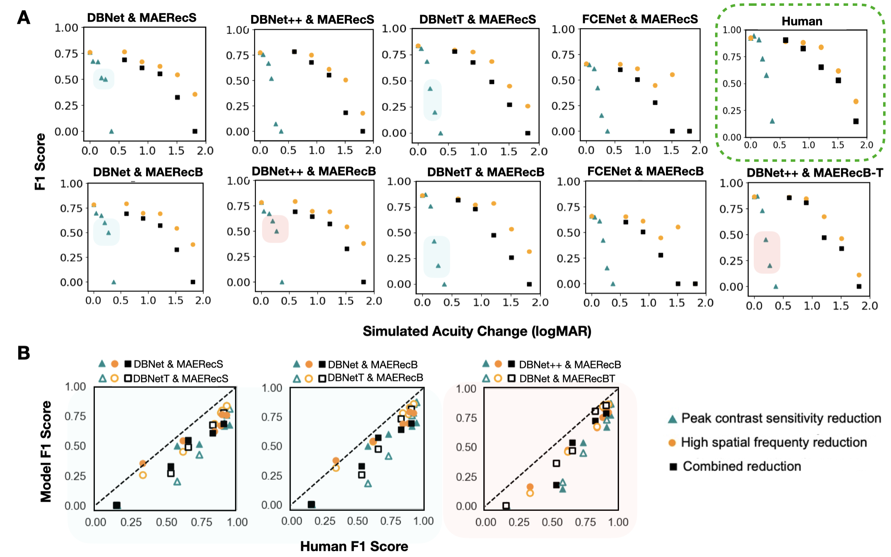
Figure S2. A. Scatter plots of performance of different combinations of detection and recognition models. B. After finetuning the DBNet and MAERec, F1 score increased on the unfiltered and milder low vision conditions but decreased on severe visual loss conditions, illustrated in blue and red boxes respectively.
Table S1. F1 Score comparison between human and two-stage model. The baseline represents the F1 score under the no-filter condition. Scores for the simulated low vision conditions are the average F1 scores across the five different filters applied under each reduction type. The highest F1 scores were in bold.
Vision Condition | Baseline | High spatial frequency loss | Peak contrast sensitivity loss | Combined loss
Human | 0.923 | 0.782 | 0.757 | 0.676
DBNet & MAERecB | 0.786 | 0.690 | 0.695 | 0.609
DBNet & MAERecS | 0.760 | 0.661 | 0.662 | 0.590
DBNetT & MAERecB | 0.864 | 0.733 | 0.754 | 0.664
DBNetT & MAERecS | 0.835 | 0.680 | 0.712 | 0.640
DBNet++ & MAERecB* | 0.798 | 0.664 | 0.682 | 0.664
DBNet++ & MAERecS | 0.776 | 0.651 | 0.663 | 0.651
DBNet++ & MAERecB-T | 0.867 | 0.723 | 0.745 | 0.737
FCENet & MAERecB | 0.729 | 0.679 | 0.649 | 0.695
FCENet & MAERecS | 0.659 | 0.598 | 0.573 | 0.588
* DBNet++ & MAERecB was reported in the main study.

Appendix 4. Detection vs. Recognition Tasks.
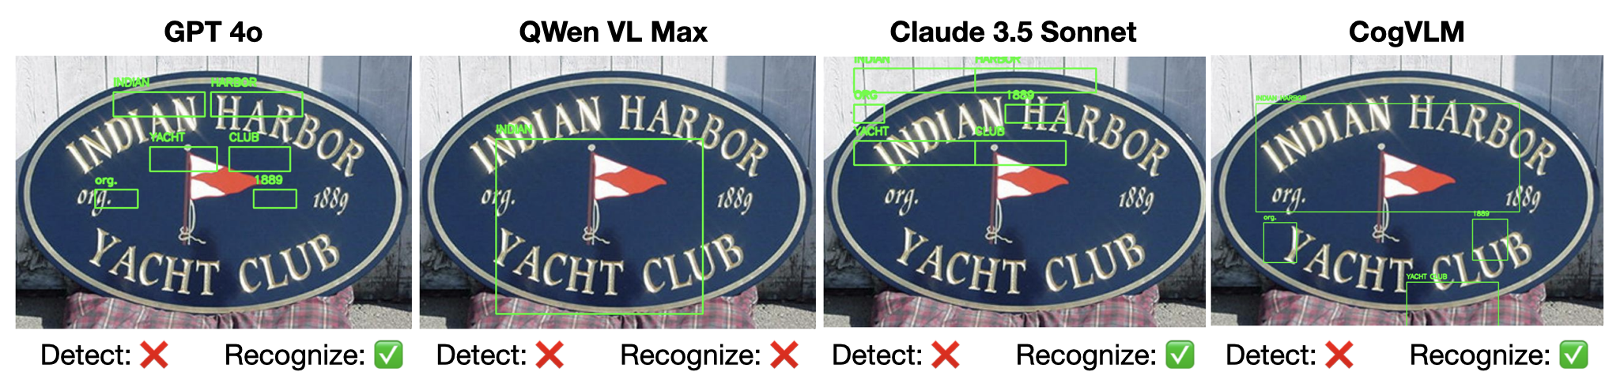
Figure S3. State-of-the-art VLMs perform well on recognition task but fail on detection task. For grounding task, we used the prompt “Please find all English words and their coordinates in [x,y,w,h] format.”

