Comparative genomics of Coffea species highlights expansion of gene families linked to adaptation and secondary metabolism

- Sunchung Park^{1*}, Ezekiel Ahn¹, Sookyung Oh², Dapeng Zhang¹, Lyndel W. Meinhardt¹
¹Sustainable Perennial Crops Laboratory, United States Department of Agriculture, Agriculture Research Service, Beltsville, MD, United States.
²Environmental Microbial & Food Safety Laboratory, United States Department of Agriculture, Agriculture Research Service, Beltsville, MD, United States.

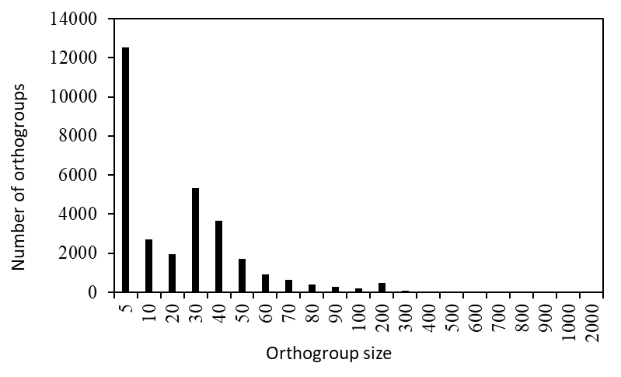
Fig. S1 Distribution of orthogroup sizes The histogram shows the frequency of orthogroups across different size categories, defined by the number of genes per orthogroup. Most orthogroups contain relatively few genes, while progressively fewer orthogroups exhibit larger gene counts.

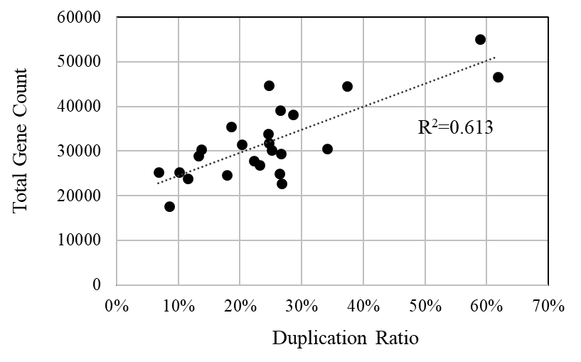

Fig. S2 Positive correlation between total gene count and duplication ratio across species. Each dot represents an individual species. The duplication ratio was calculated as the number of duplication events divided by the total gene count per species. A linear regression line is shown as a dotted line, with the coefficient of determination (R²) displayed on the plot.

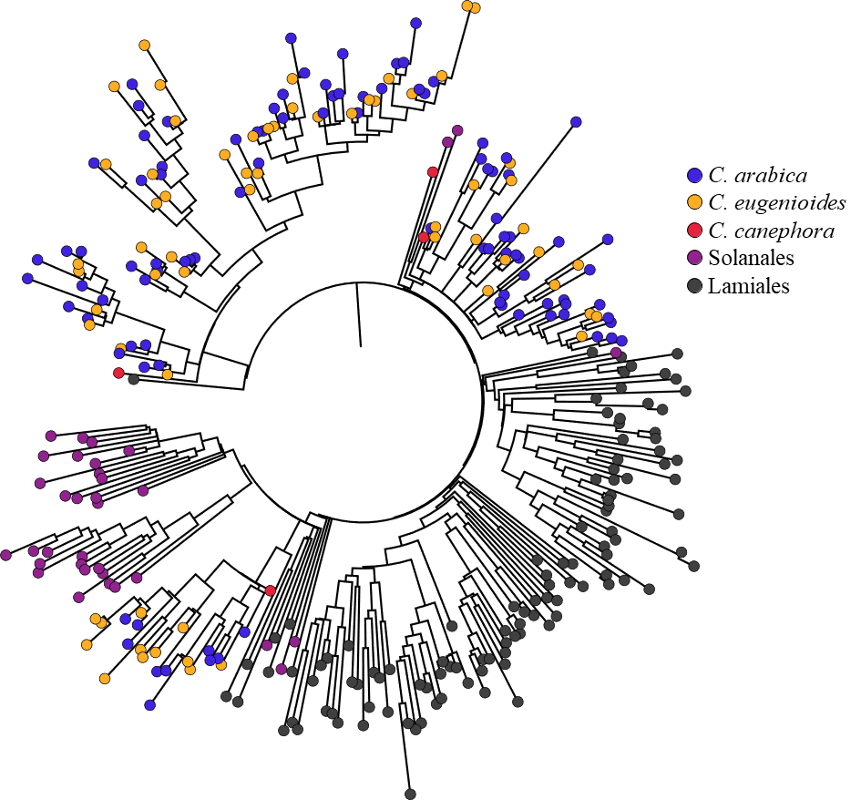

Fig. S3 Phylogenetic tree of the cytochrome P450 gene family (OG00085). The tree was generated using the maximum likelihood method in FastTree based on multiple protein sequence alignments. Genes are color-coded according to taxonomic origin: species-level resolution for Coffea species (C. arabica, C. canephora, and C. eugenioides) and Order-level resolution for species from Solanales and Lamiales.

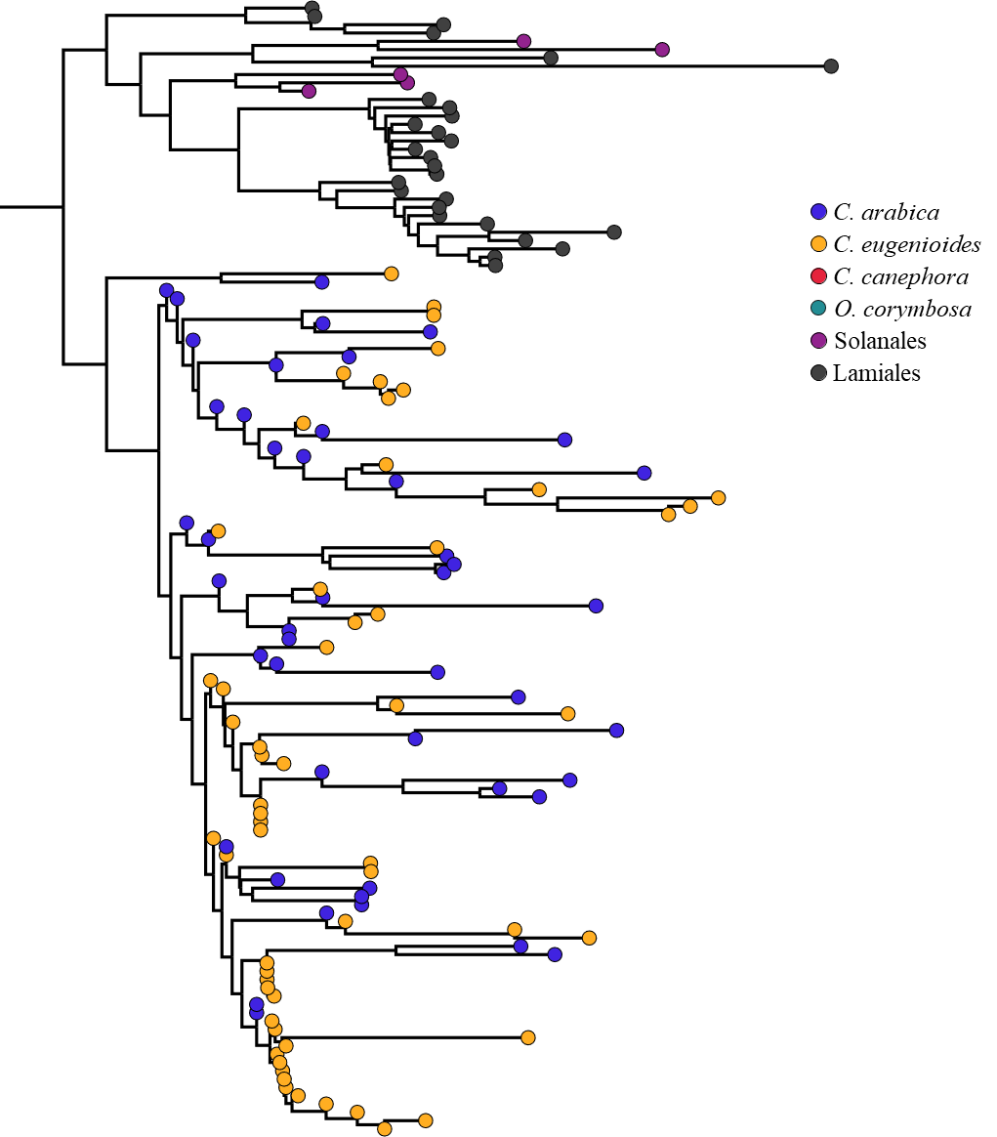

Fig. S4 Phylogenetic tree of the FAR1 gene family (OG00337). The tree was constructed using the maximum likelihood method in FastTree based on multiple protein sequence alignments. Genes are color-coded by taxonomic origin, with species-level resolution for Coffea species (C. arabica, C. canephora, and C. eugenioides) and Order-level resolution for species from Solanales and Lamiales.

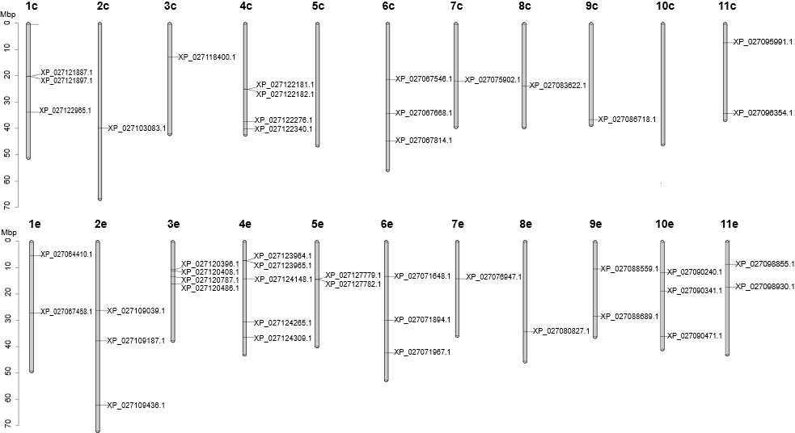

Fig. S5 Chromosomal distribution of FAR1 gene family members in C. arabica. Genes are mapped across 22 chromosomes of the C. arabica reference genome, which consists of two subgenomes derived from its progenitor species: C. canephora (designated as “c”) and C. eugenioides (designated as “e”). Each vertical bar represents a chromosome, with black ticks indicating the physical positions of FAR1 gene loci. The widespread presence of FAR1 genes across both subgenomes supports ancestral origin in both parental lineages.

