The role of cyclic diketopiperazine in the formation of polypeptides on silica surfaces

Ola El Samrout*, Rita Arnesi, Samuele Mistrali, Chiara Nannuzzi, Gloria Berlier*.
Department of Chemistry, NIS and INSTM Centers, University of Turin, via P. Giuria 7, 10125 Turin, Italy

Supporting information

DKP deposited on silica from liquid phase by IWI
Thermal activation
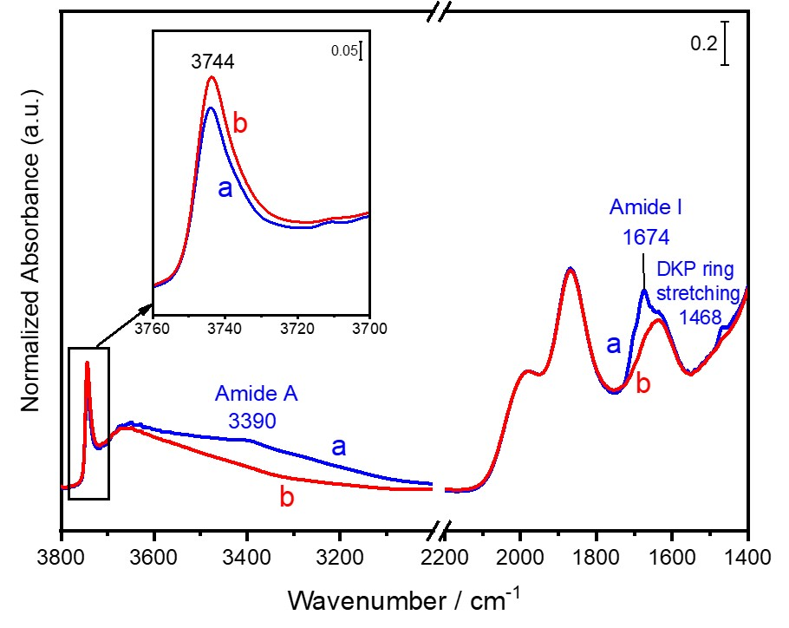
Figure S1. IR spectra of DKP_{2(IWI)}/A50 measured after (a) DKP deposition by IWI followed by outgas at 140 °C for 30 min, then after (b) a thermal heating at 140 °C for 2.5 h under vacuum. The intensity of the silanols OH stretching region is enhanced for the sake of clarity.

Wetting/drying cycles
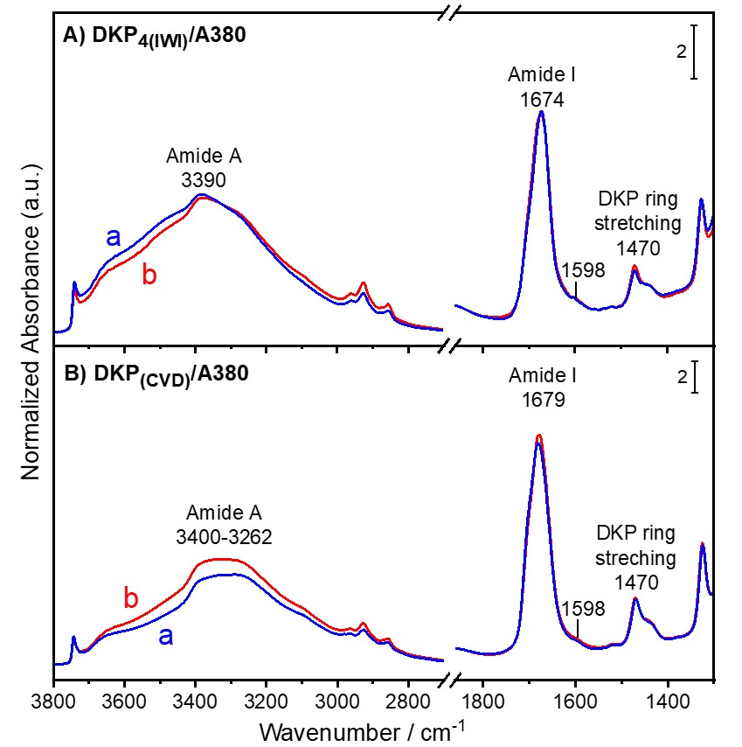
Figure S2. IR spectra of DKP_{4(IWI)}/A380 (Panel A) and DKP_{(CVD)}/A380 (Panel B) measured after (a) DKP deposition by IWI and outgas at rt, or after DKP sublimation by CVD for 2.5 h at 160 °C under vacuum, respectively. Spectra (b) in both panels represent each the last spectrum measured at the end of the wetting/drying cycles performed on both samples. The wetting/drying cycles done consist of an admission of water vapor for 20 min and a direct heating at 80 °C for 30 min while in contact with water vapor. This is followed by a drying step consisting of an outgas at rt then at 80 °C for 30 min. The cycles are repeated until invariance of spectra.

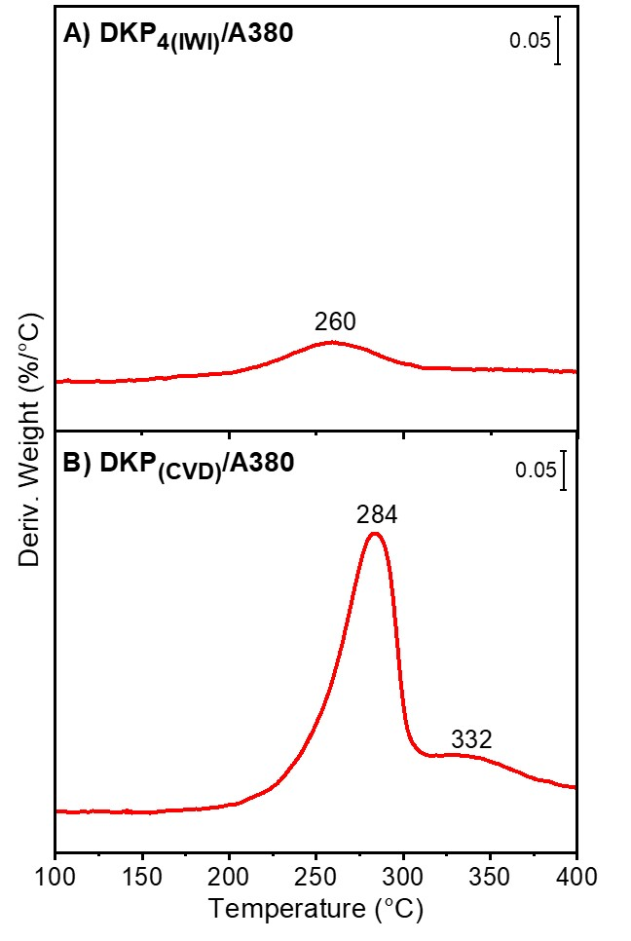
Figure S3. Derivative thermograms (DTG) measured directly after wetting/drying cycles performed on two samples prepared by (A) 4 wt% DKP deposition by IWI and outgas on silica A380, designated as DKP_{4(IWI)}/A380; or by (B) DKP sublimation by CVD for 2.5 h at 160 °C under vacuum, designated as DKP _{(CVD)}/A380.

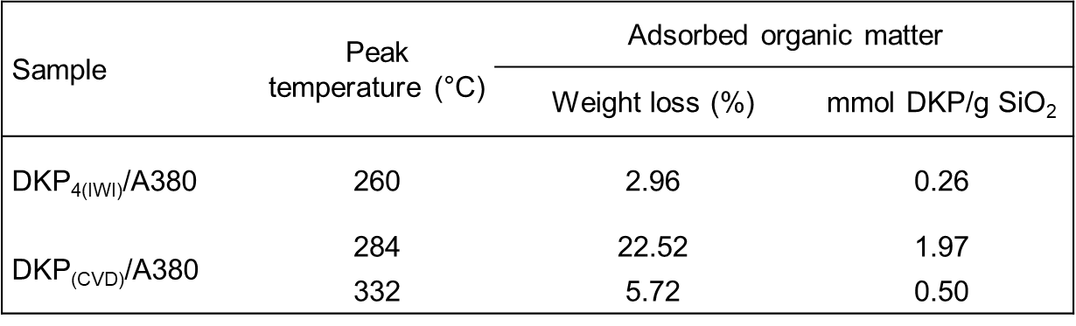
Table S1. Table presenting the adsorbed amount of organic matter (in terms of DKP) after wetting/drying cycles on both samples DKP_{4(IWI)}/A380 obtained after DKP deposition by IWI on silica A380; and DKP _{(CVD)}/A380 obtained after DKP sublimation by CVD for 2.5 h under vacuum. These values are calculated from the integration of DTG peaks of Figure S3 for the corresponding samples.

Reaction with Gly monomers dosed from the gas phase

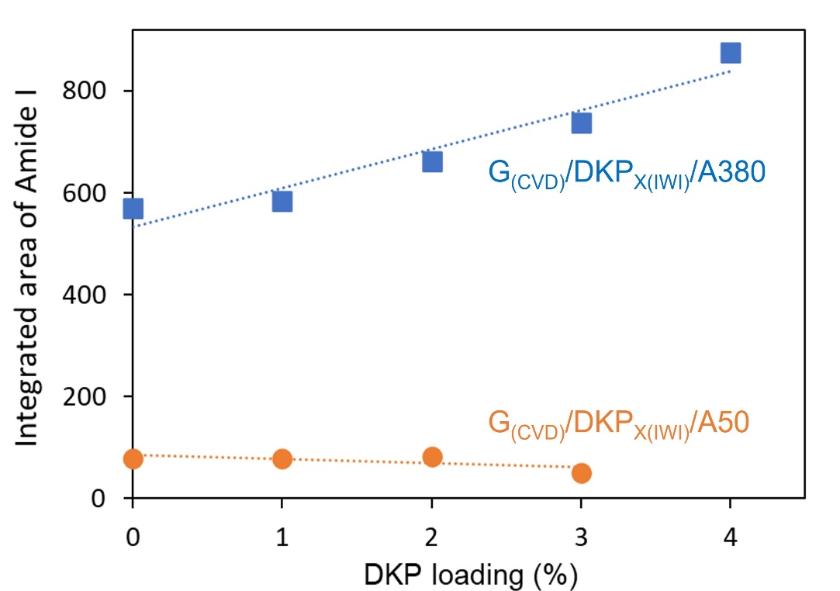
Figure S4: Evolution of the amide I band intensity obtained after 2.5 h Gly sublimation by CVD as function of DKP loading (%) for both series of samples: G_{(CVD)}/DKP_{x(IWI)}/A50 and G_{(CVD)}/DKP_{x(IWI)}/A380; where x refers to the different DKP loadings used.

DKP deposited on silica from gas phase by CVD
Reaction with Gly monomers dosed from the gas phase

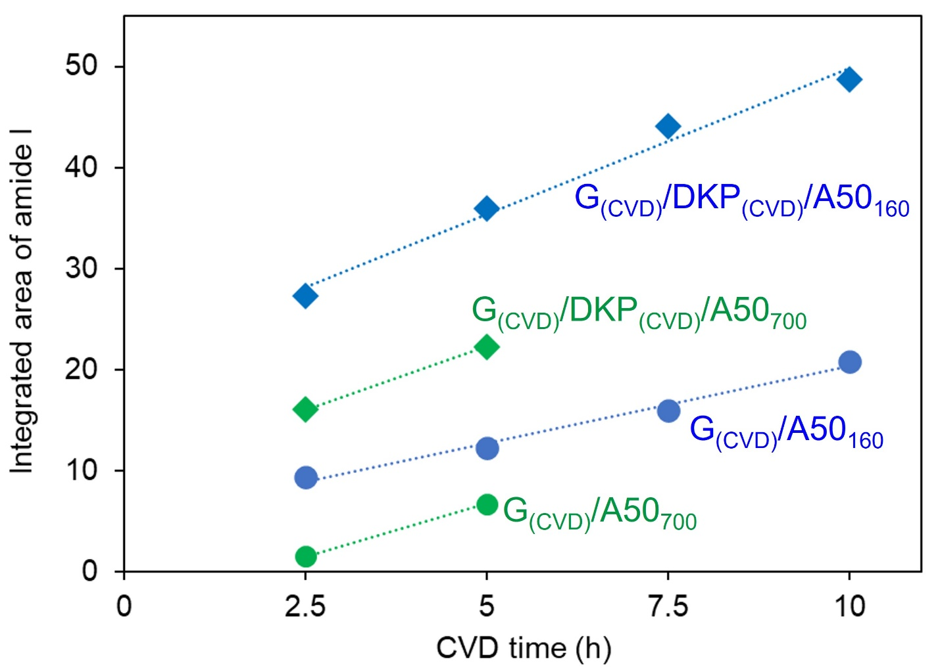
Figure S5: Evolution of the amide I band intensity as function of CVD time (h) for G_{(CVD)}/A50₁₆₀, G_{(CVD)}/DKP_{(CVD)}/A50₁₆₀, G_{(CVD)}/A50₇₀₀, and G_{(CVD)}/DKP_{(CVD)}/A50₇₀₀ samples prepared by in-situ CVD with or without a pre-deposition of DKP by sublimation. Two different silica supports are used: one outgassed at 160 °C for 2 h under vacuum and the other pre-treated at 700 °C for 2.5 h.

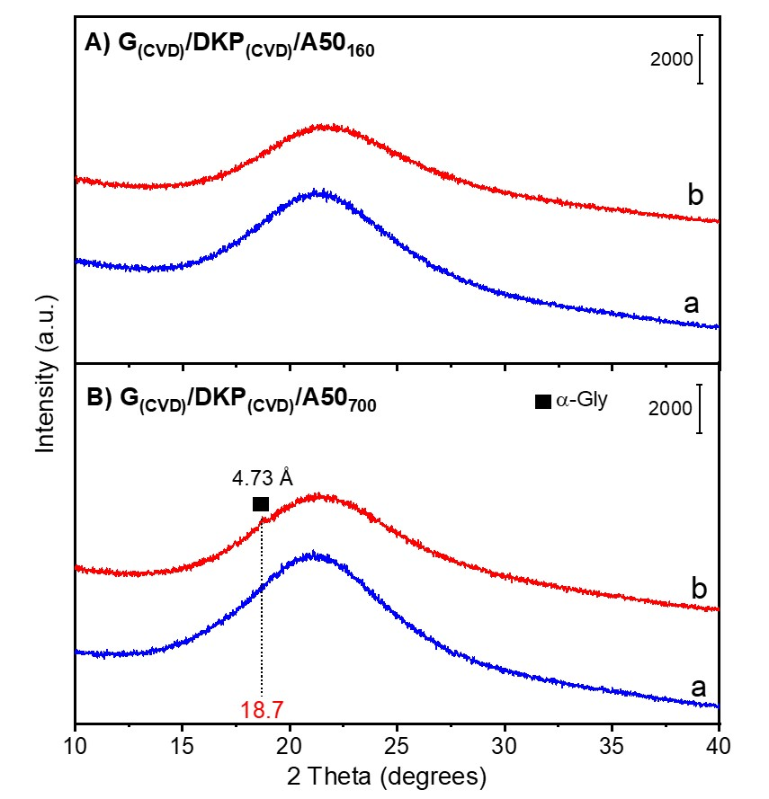
Figure S6: XRD profiles measured on (A) G_{(CVD)}/DKP_{(CVD)}/A50₁₆₀ and (B) G_{(CVD)}/DKP_{(CVD)}/A50₇₀₀: (a) after outgassing at 160 °C for 2 h under vacuum (Panel A) or pre-treatment in a muffle furnace at 700 °C for 2.5 h (Panel B); (b) after DKP deposition by CVD for 2.5 h under vacuum followed by Gly sublimation by CVD for 10 (Panel A) or 5 h (Panel B) and H/D exchange cycles.

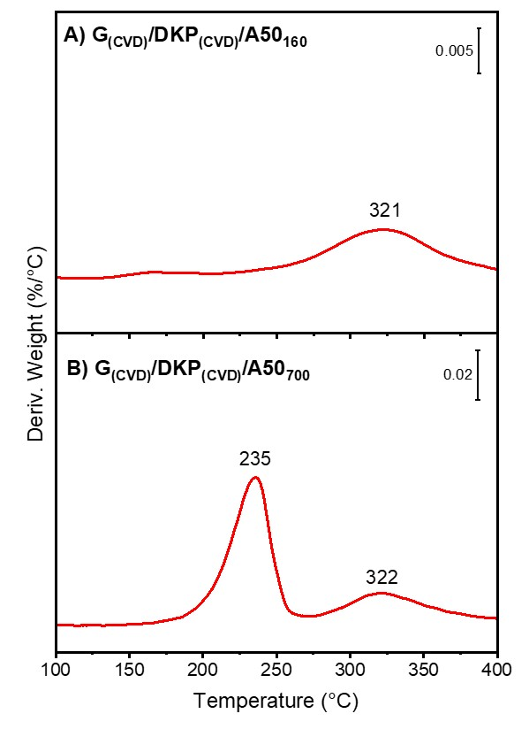
Figure S7: Derivative thermograms (DTG) for (A) G_{(CVD)}/DKP_{(CVD)}/A50₁₆₀ and (B) G_{(CVD)}/DKP_{(CVD)}/A50₇₀₀ samples measured after DKP deposition by CVD for 2.5 h under vacuum followed by Gly sublimation by CVD for 10 (Panel A) or 5 h (Panel B) and H/D exchange cycles.

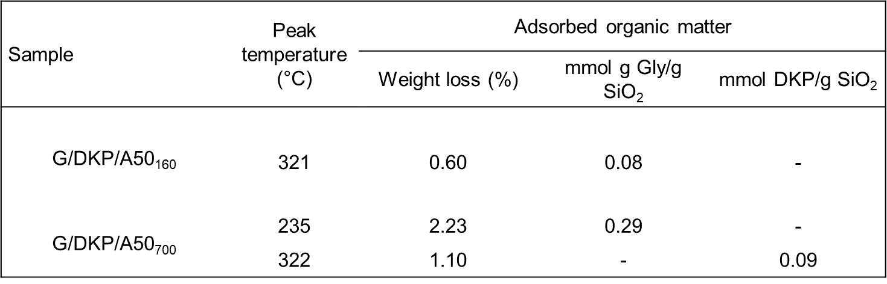
Table S2: Table presenting the adsorbed amount of organic matter (in terms of DKP or Gly) on both G_{(CVD)}/DKP_{(CVD)}/A50₁₆₀ and G_{(CVD)}/DKP_{(CVD)}/A50₇₀₀ samples. These values are calculated from the integration of DTG peaks of Figure S7 for the corresponding samples.
CVD of DKP on silica-grafted Gly oligomers
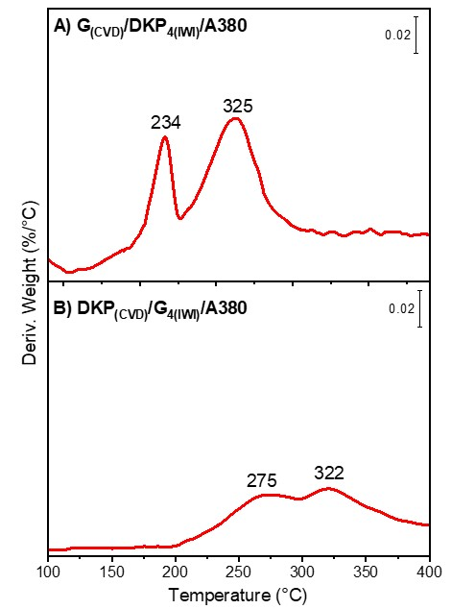
Figure S8. Derivative thermograms (DTG) for samples obtained after (A) 4 wt% DKP deposition by IWI and outgas on silica A380 followed by CVD sublimation of Gly monomers at 160 °C for 2.5 h under vacuum, designated by G_{(CVD)}/DKP_{4(IWI)}/A380; and after (B) 4 wt% Gly deposition by IWI and activation at 160 °C on silica A380 followed by DKP adsorption by CVD at 160 °C for 2.5 h under vacuum, designated by DKP_{(CVD)}/G_{4(IWI)}/A380.

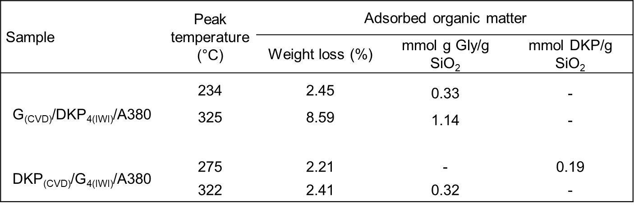
Table S3. Table presenting the adsorbed amount of organic matter (in terms of DKP or Gly) on both samples G_{(CVD)}/DKP_{4(IWI)}/A380 obtained after 4 wt% DKP deposition by IWI and outgas then Gly sublimation by CVD for 2.5 h; and DKP_{(CVD)}/G_{4(IWI)}/A380 obtained after 4 wt% Gly deposition by IWI and activation at 160 °C then DKP sublimation by CVD for 2.5 h at 160 °C under vacuum. These values are calculated from the integration of DTG peaks of Figure S6 for the corresponding samples.

Structural dynamics and secondary structures of peptides formed by DKP opening on silica

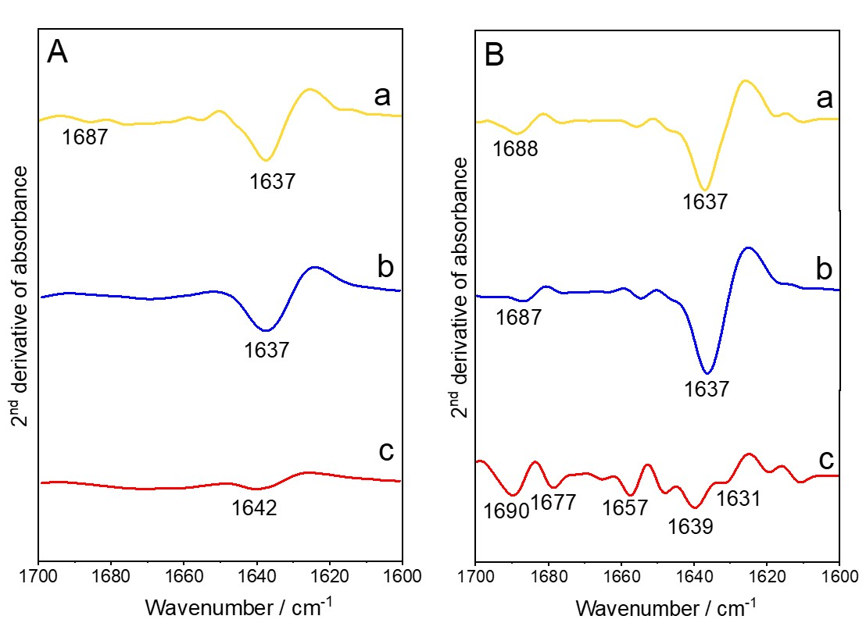
Figure S9. Second derivative in the amide I region of the IR spectra recorded directly after (Panel A) 2.5 h of Gly sublimation by CVD, and then after (Panel B) H/D exchange and outgassing of D₂O until invariance of spectra of (a) bare silica A50, (b) G_{(CVD)}/DKP_{1(IWI)}/A50, and (c) G_{(CVD)}/DKP_{3(IWI)}/A50.
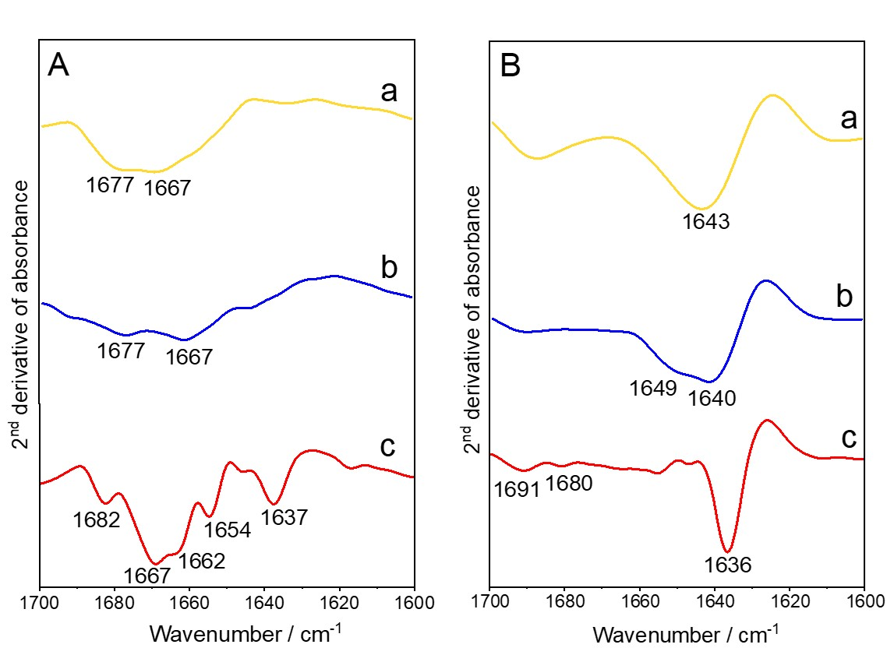
Figure S10. Second derivative in the amide I region of the IR spectra recorded directly after (Panel A) 2.5 h of Gly sublimation by CVD, and then after (Panel B) H/D exchange and outgassing of D₂O until invariance of spectra of (a) bare silica A380, (b) G_{(CVD)}/DKP_{1(IWI)}/A380, and (c) G_{(CVD)}/DKP_{4(IWI)}/A380.

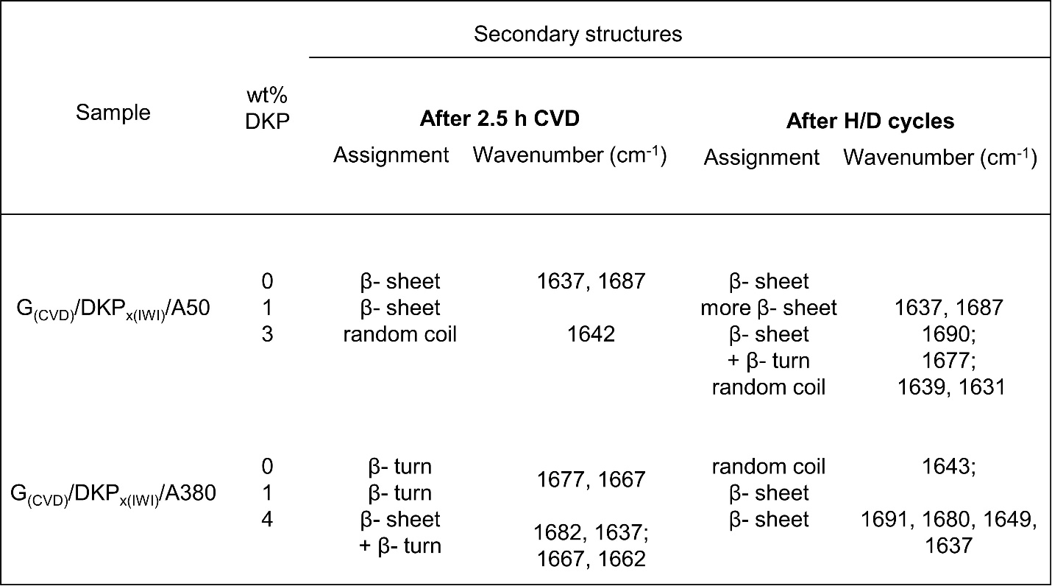
Table S4. Table presenting the different types of secondary structures formed after 2.5 h CVD then after H/D cycles for both sets of samples G_{(CVD)}/DKP_{x(IWI)}/A50 and G_{(CVD)}/DKP_{x(IWI)}/A380, deduced from the computation of the second derivative of the corresponding IR spectra in Figures S7 and S8.

