Table 1. List of bands assignments for IR spectra
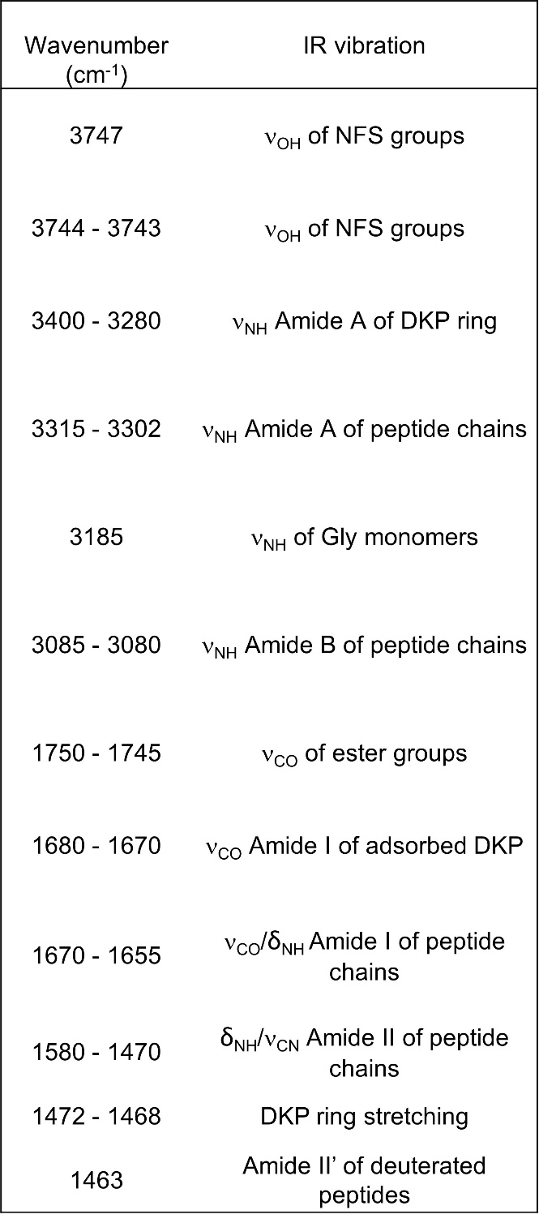

Table 2. Table presenting the adsorbed amount of organic matter (in terms of DKP or Gly) on all the samples DKP_{x(IWI)}/A50 obtained after DKP deposition by IWI and outgas; and subsequently on the samples G_{(CVD)}/DKP_{x(IWI)}/A50 after 2.5 h Gly sublimation by CVD. These values are calculated from the integration of DTG peaks of Figure 3 for the corresponding samples.
