Supplemental figures
Figure S1. PCA plot (full) 2
Figure S2. Eigenvalues for cas/control PCA plot 3
Figure S3. PCA plot (with 1KG samples) 4
Figure S4. Louvain clustering of samples using PCs 1-6 5
Figure S5. Mean 1000 genomes phase 3 supergroup probabilities per assigned sample cluster 6
Figure S6. Mean and standard deviation of N raw CNV per sample in each dataset before and after QC 7
Figure S7. Distribution of LRR SD per array group before and after QC 8
Figure S8. Mean and standard deviation of LRR SD per sample in each dataset after QC 9
Figure S9. Burden in cases versus controls of CNVs stratified by size 10
Figure S10. Burden in cases versus controls of CNVs stratified by frequency 11
Figure S11. Burden of non-genic and genic deletions and duplications in cases versus controls 12
Figure S12. Burden in cases versus controls of CNVs impacting putatively haplosensitive and triplosensitive genes 13
Figure S13. 17q12 CNV breakpoints……………………………………………………………...…………14
Figure S14. ACACA gene expression………………..……………………………………………………...15
Figure S15. ACACA Hi-C data…………………………………………………….………………………….16

Figure S1. PCA plot (full)
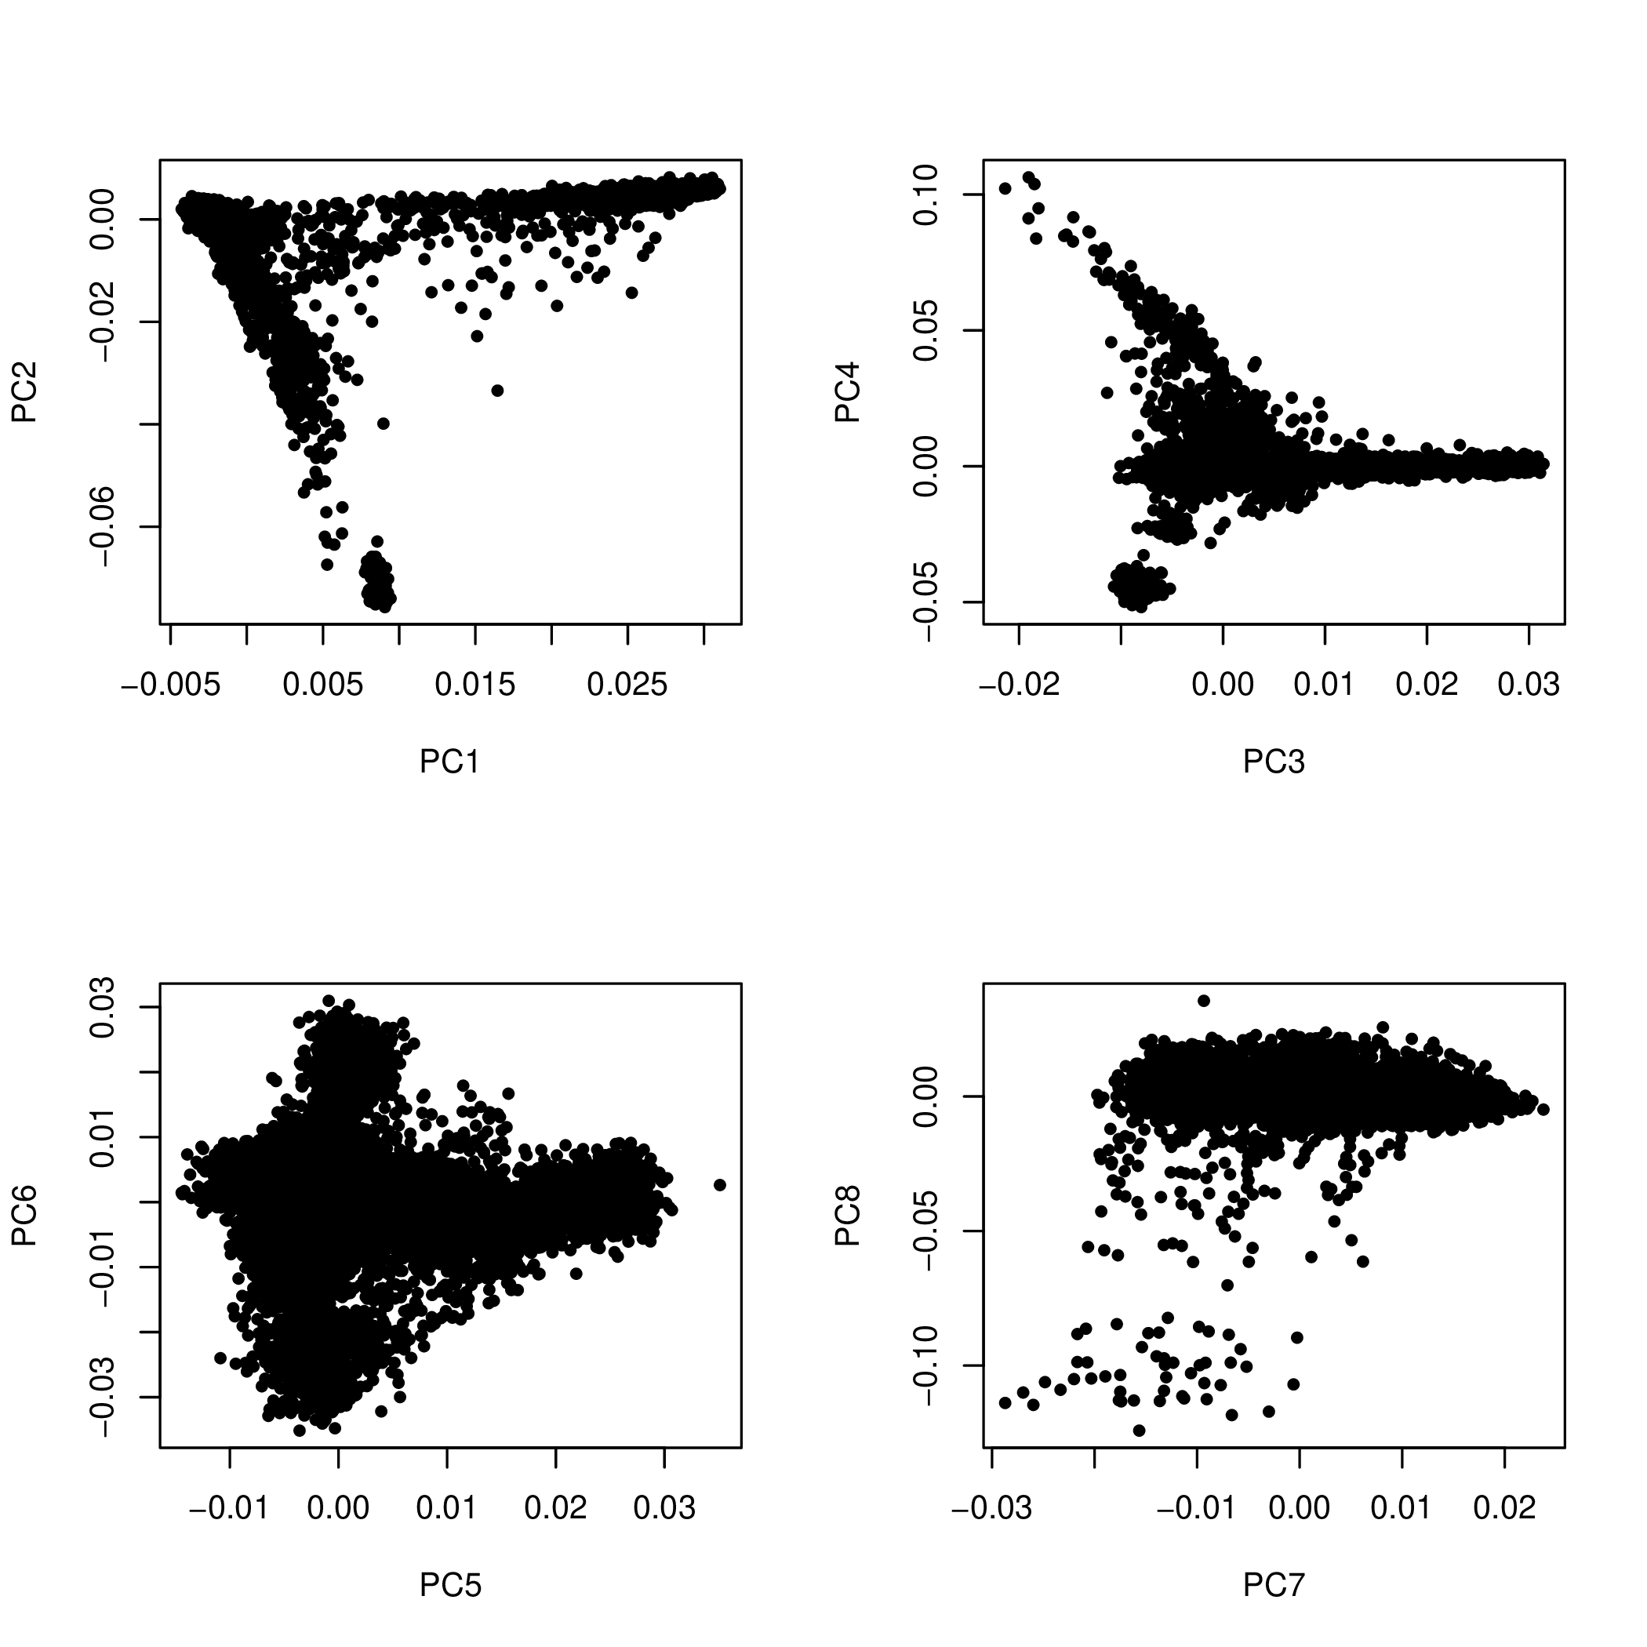
Figure S1. The first eight principal components of a common variant principal component analysis (PCA) conducted on 37,784 common variants genotyped across 5,201 cases and 8,667 controls included in the core dataset for this analysis. Although principal components nine through twenty were generated, they are not displayed here because they explain an insignificant amount of the total variance in the common variant genotype data (Figure S2).

Figure S2. Eigenvalues for cas/control PCA plot

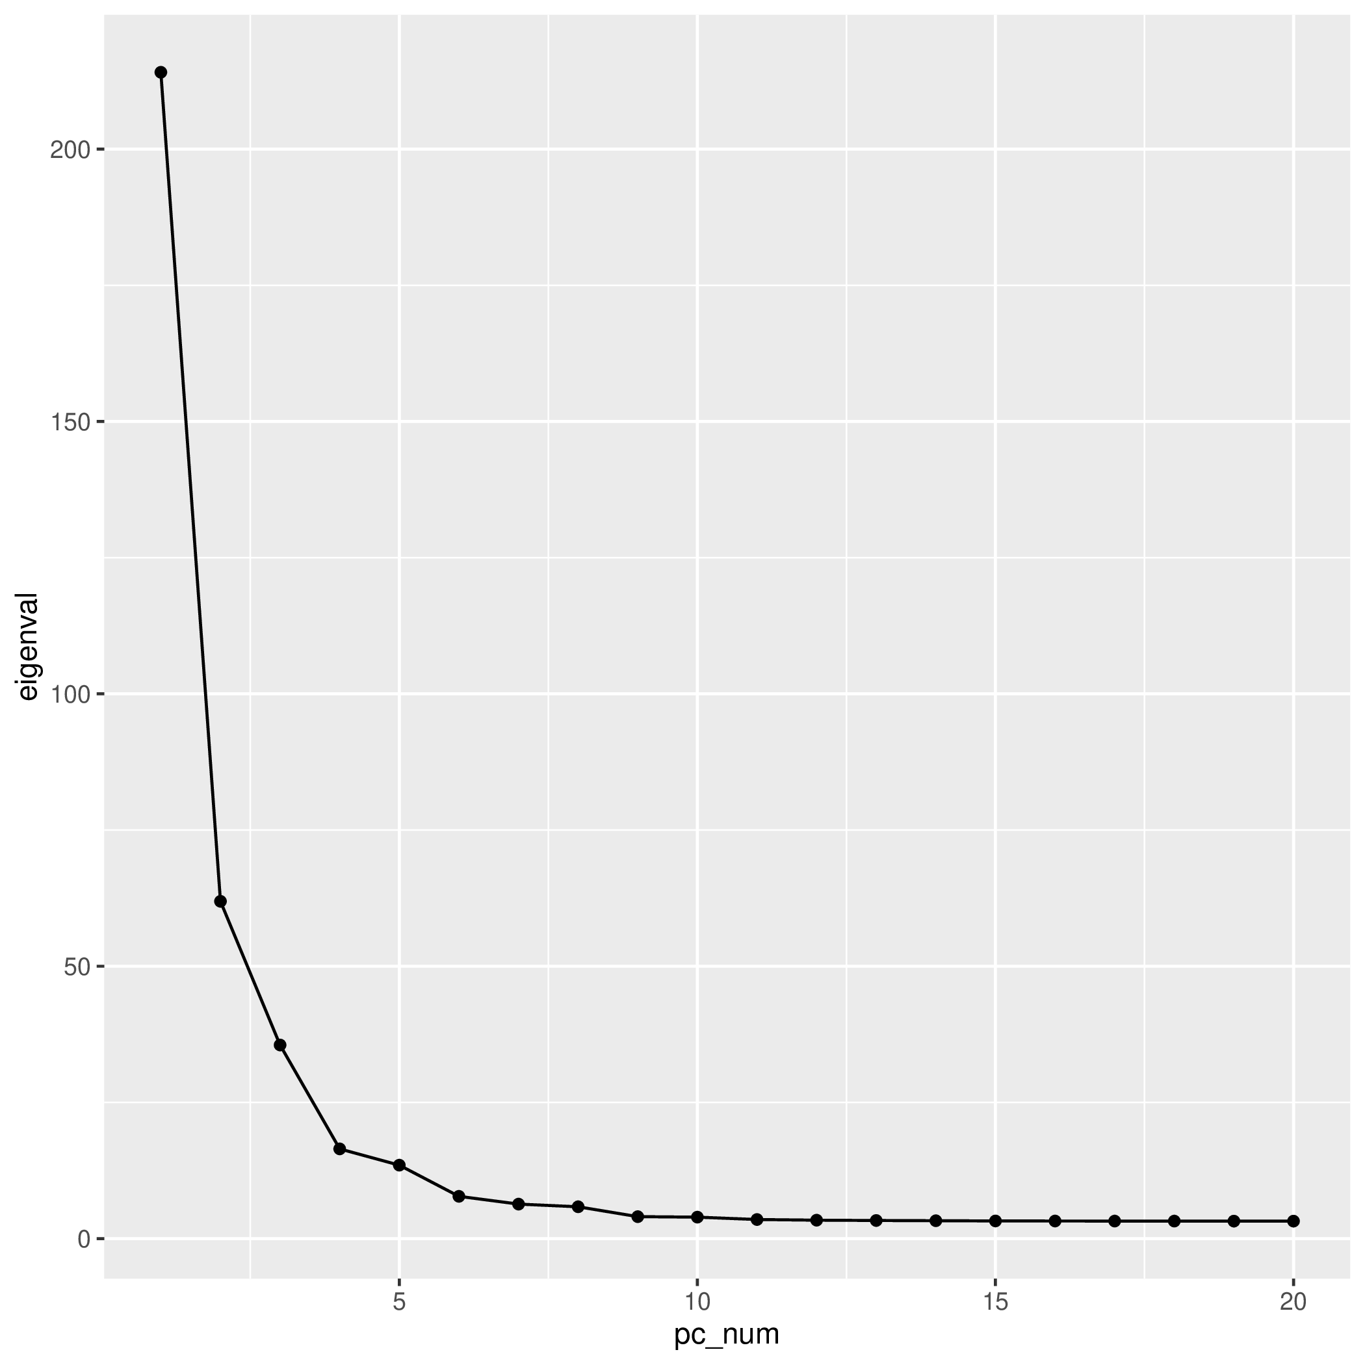
Figure S2. Eigenvalues from the first 20 principal components across common variant genotypes, as illustrated in Figure S1. Here, it is evident that the majority of the variance is accounted for by PCs 1-5. We employed PCs 1-6 for unsupervised clustering of samples (Figure S4).

Figure S3. PCA plot (with 1KG samples)

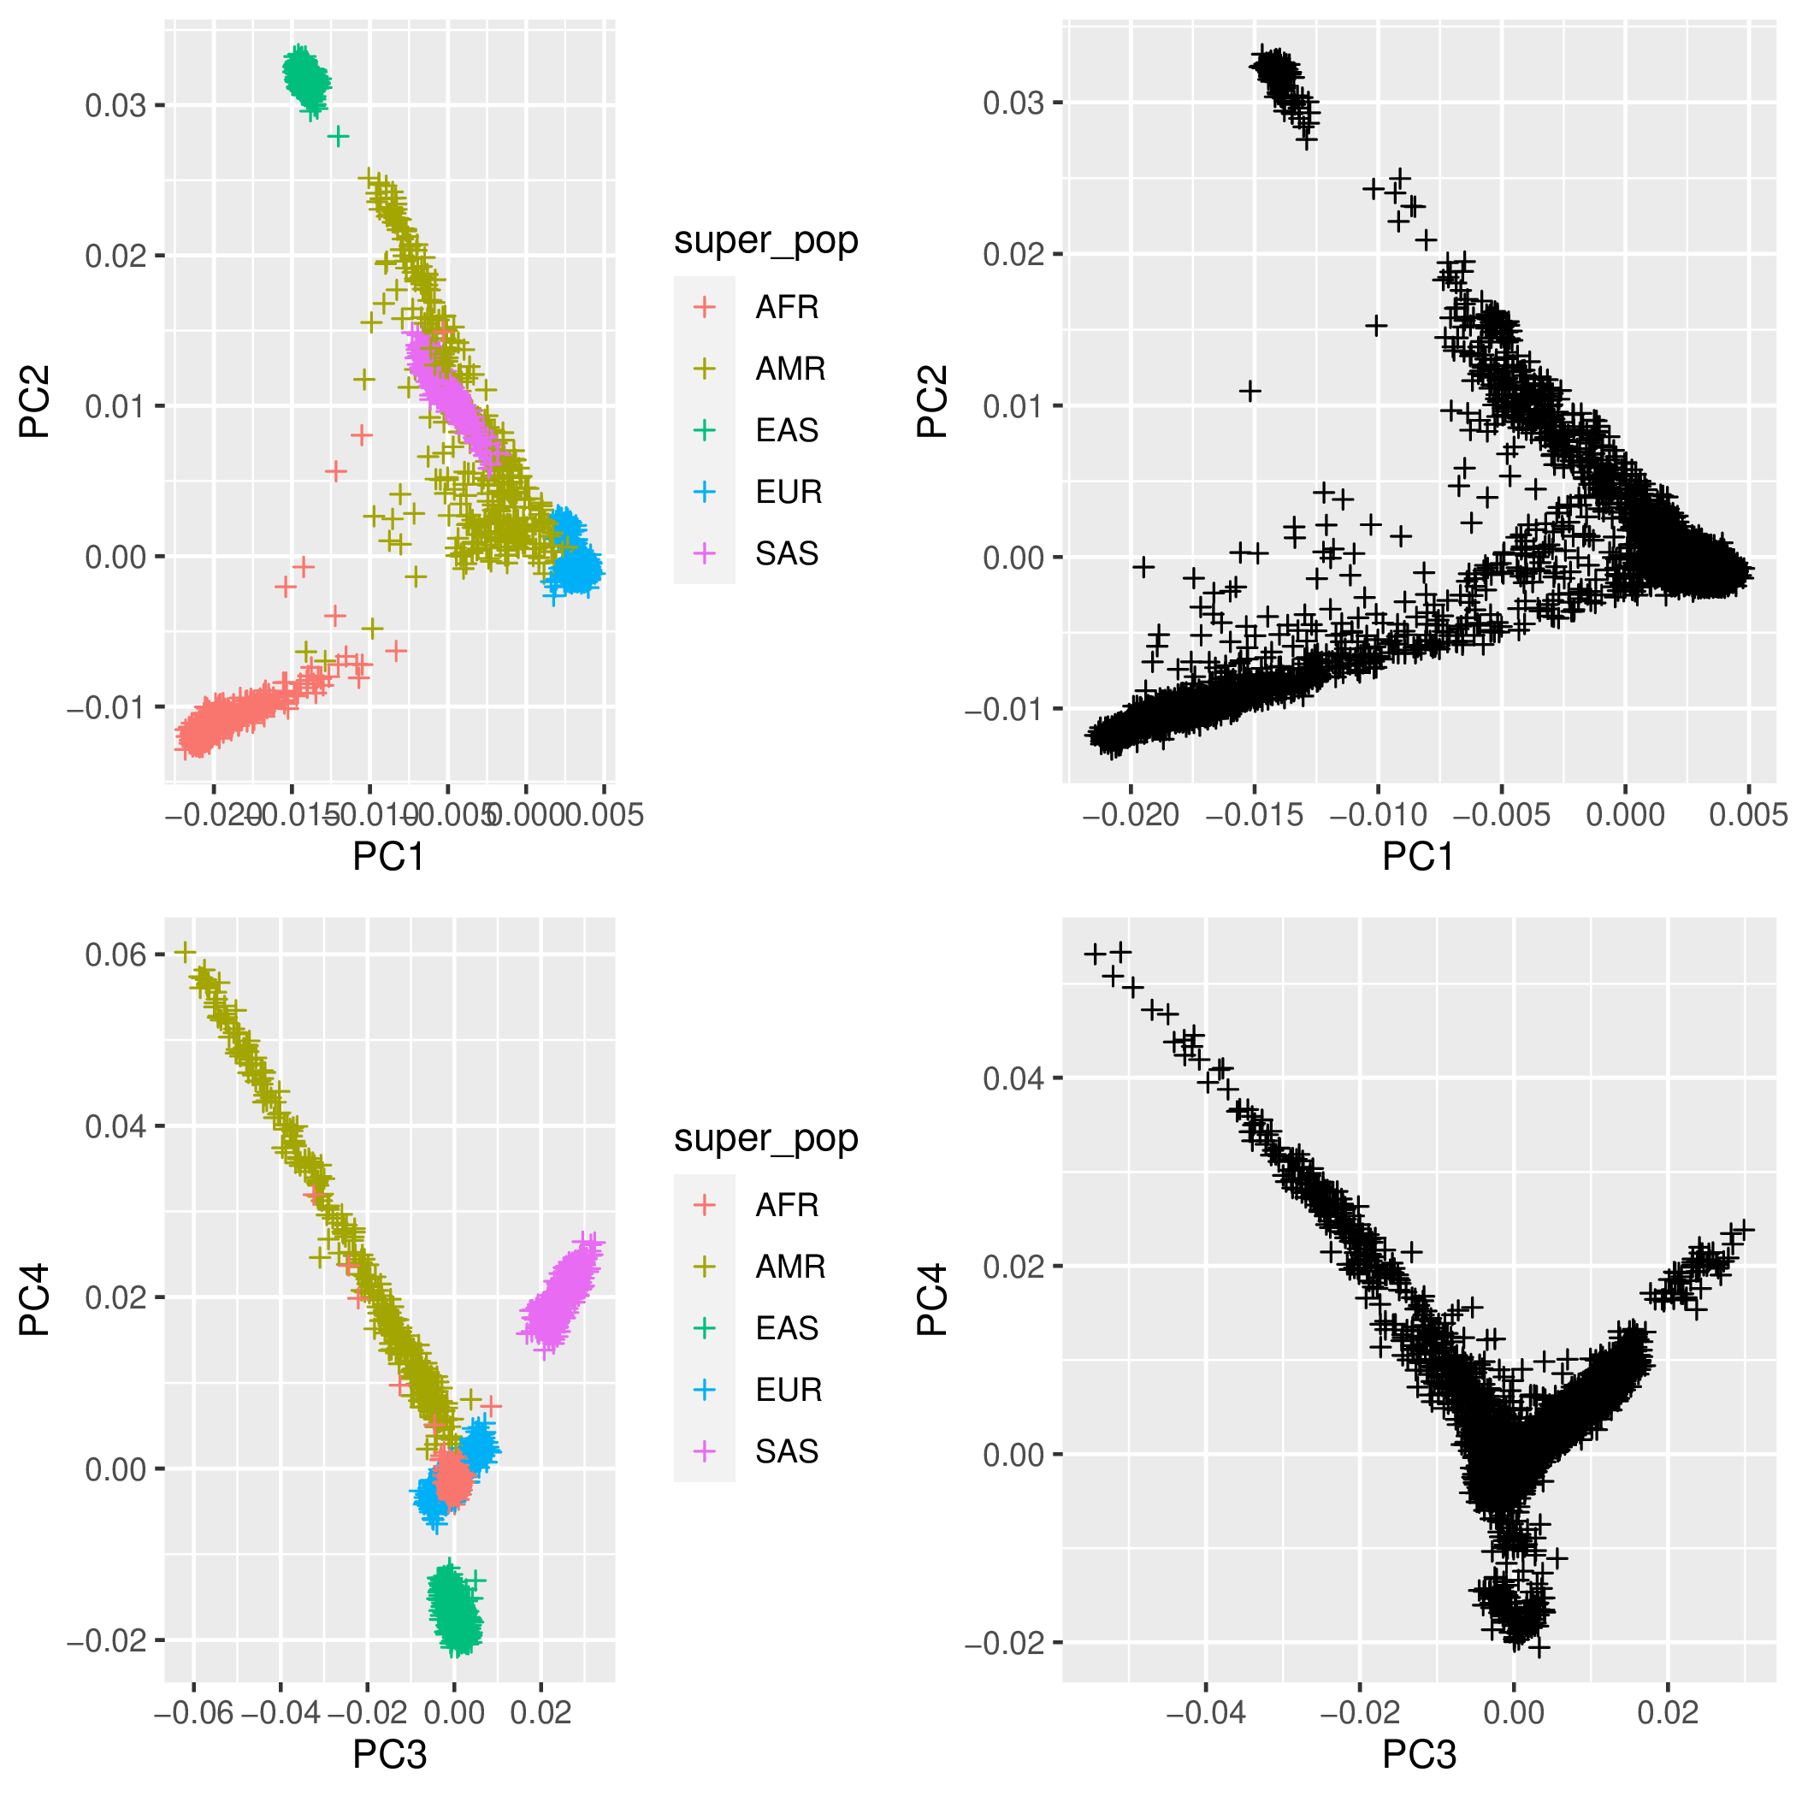
Figure S3. The first four principal components across 37,577 common variant genotypes shared between case/control samples and 1000 Genomes Phase 3 reference samples. The first four PCs for the 1000 Genomes Phase 3 samples are presented on the left, along with sample ancestry super-population classifications. Samples from the case/control cohort are displayed on the left. The clustering illustrated on the left clearly indicates that the separation across the major PCs is driven by ancestry differences that need to be controlled.

Figure S4. Louvain clustering of samples using PCs 1-6

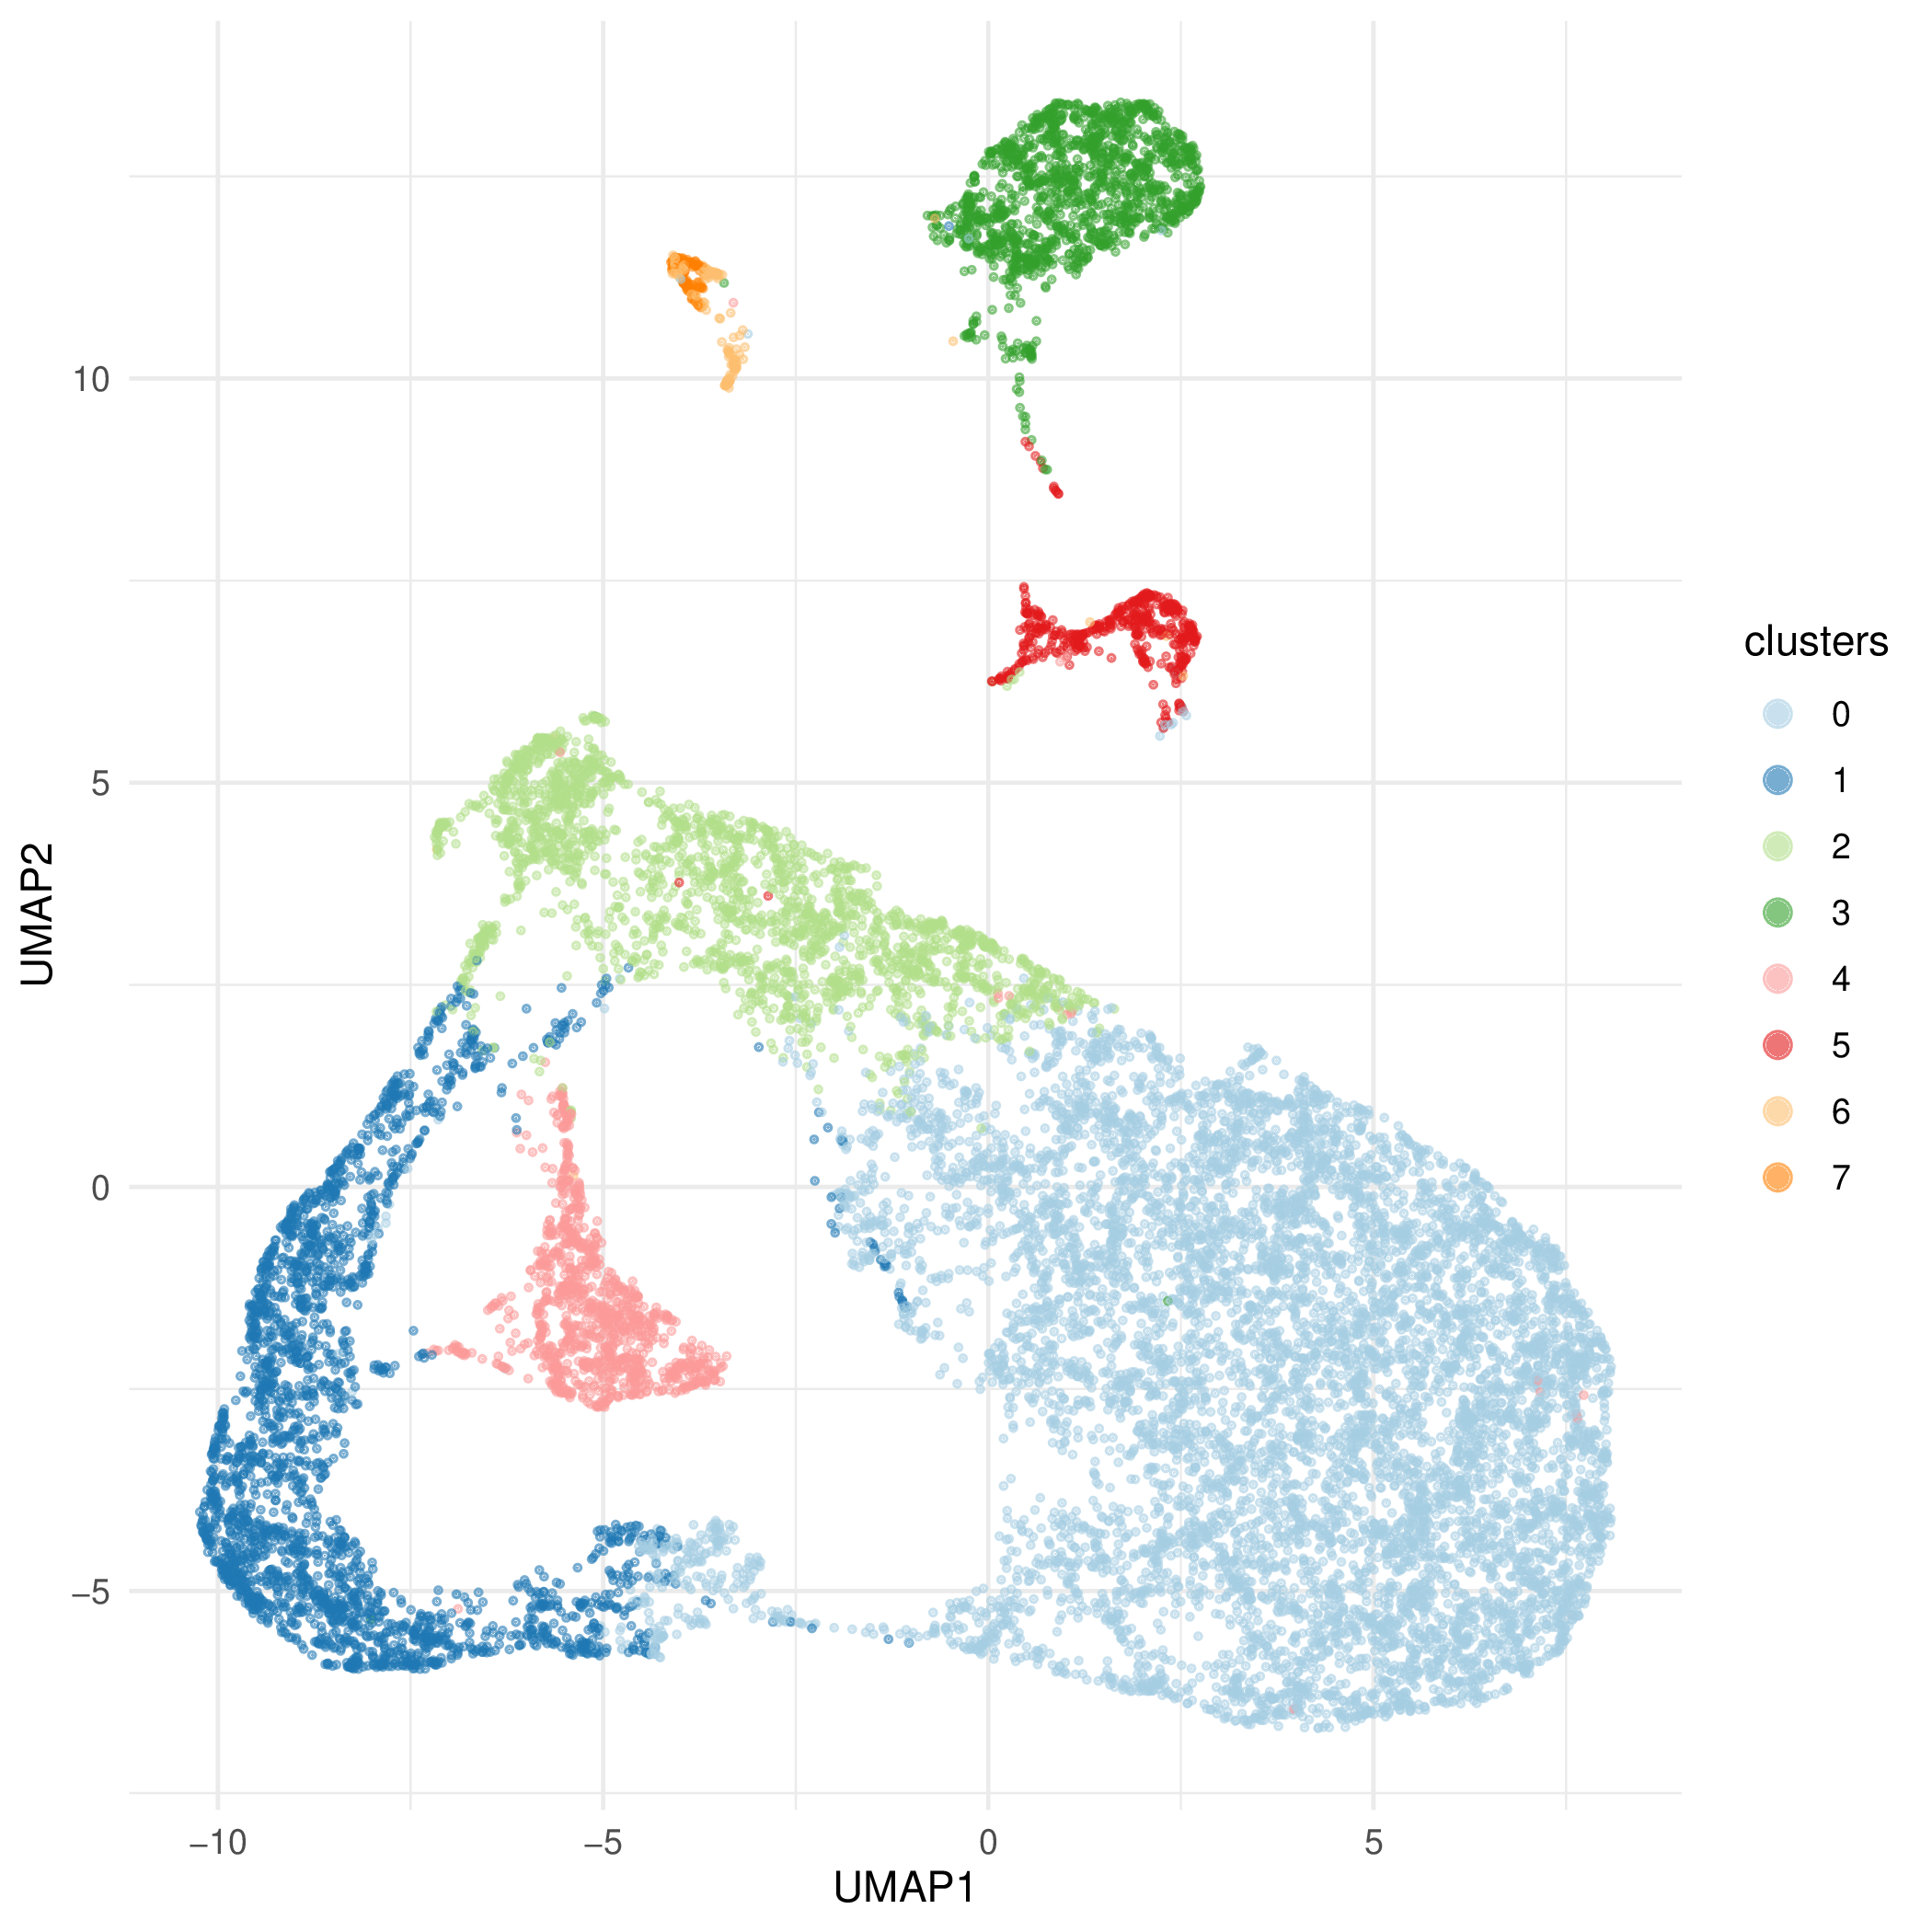
Figure S4. Results of Louvain clustering, an unsupervised method for grouping similar samples, based on the first six Principal Components from PCA illustrated in Figures S1 and S2. A total of eight clusters are formed. Two of the most populated clusters (identified here as clusters ‘0’ and ‘1’ but subsequently referred to as clusters ‘1’ and ‘2’) seem to correspond to European ancestry (see Figure S5).

Figure S5. Mean 1000 genomes phase 3 supergroup probabilities per assigned sample cluster
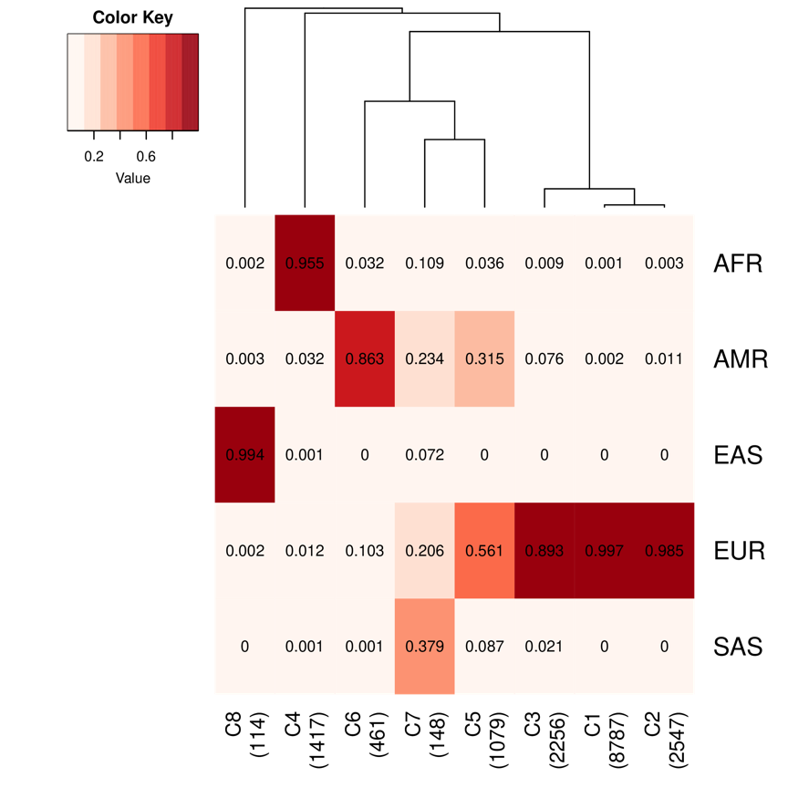
Figure S5. The mean probabilities of each sample within the eight clusters from Figure S4 belonging to the five 1000 Genomes Phase 3 supergroups. The probabilities were determined using a random forest model applied to the first six principal components of a PCA of common variations across our samples and 2500 1000 Genomes Phase 3 samples. The number of samples in each cluster is shown in parentheses on the X-axis below the cluster identity number. Clusters 1 and 2 consist of high-confidence European ancestry, while Cluster 3 appears to feature non-European admixture. Clusters 4, 6, and 8 consist of high-confidence East Asian, African, and admixed American (i.e., Hispanic) samples. Cluster 5 and Cluster 7 seem to fit ancestry profiles that do not align neatly with any of the 1000 Genomes supergroups.

Figure S6. Mean and standard deviation of N raw CNV per sample in each dataset before and after QC

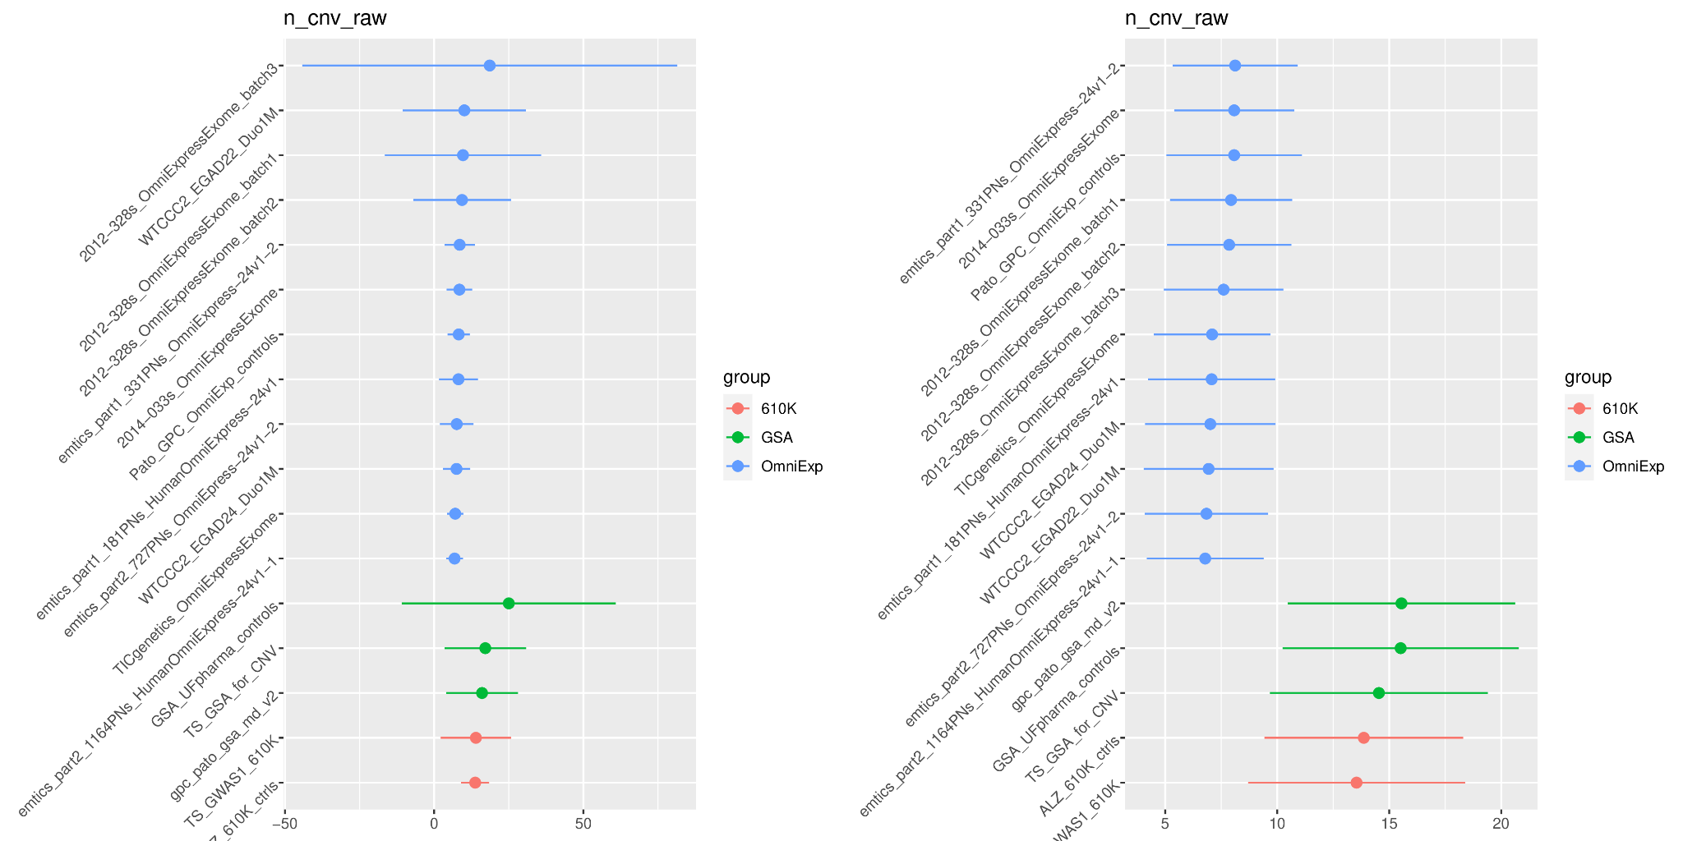
Figure S6. Mean (dots) and standard deviations (bars) of the number of raw CNVs per sample across each dataset included in the analysis. Before quality control (left), the variance in the number of raw CNVs per sample varies depending on the dataset considered. After quality control (right), the number of raw CNVs per sample is grouped by dataset, as these groups have different baseline numbers of probes from which CNV calls were made, leading to counts per dataset being much more comparable.

Figure S7. Distribution of LRR SD per array group before and after QC

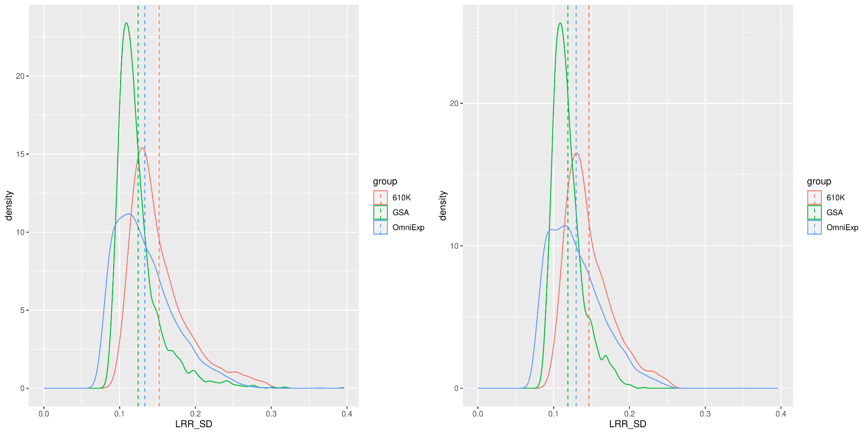
Figure S7 shows the distribution of Log R Ratio Standard Deviation (LRR-SD) metrics for each sample, with distributions created for each of the three array groups in the core genotype array dataset (610K, GSA, OmniExpress). Before quality control (left), these distributions have long tails, indicating the presence of low-quality samples with unusually high LRR-SD metrics still in the data. After quality control (right), these outliers are removed, but inherent differences in LRR-SD persist and should be controlled in the analysis by stratifying case/control comparisons according to array group.

Figure S8. Mean and standard deviation of LRR SD per sample in each dataset after QC

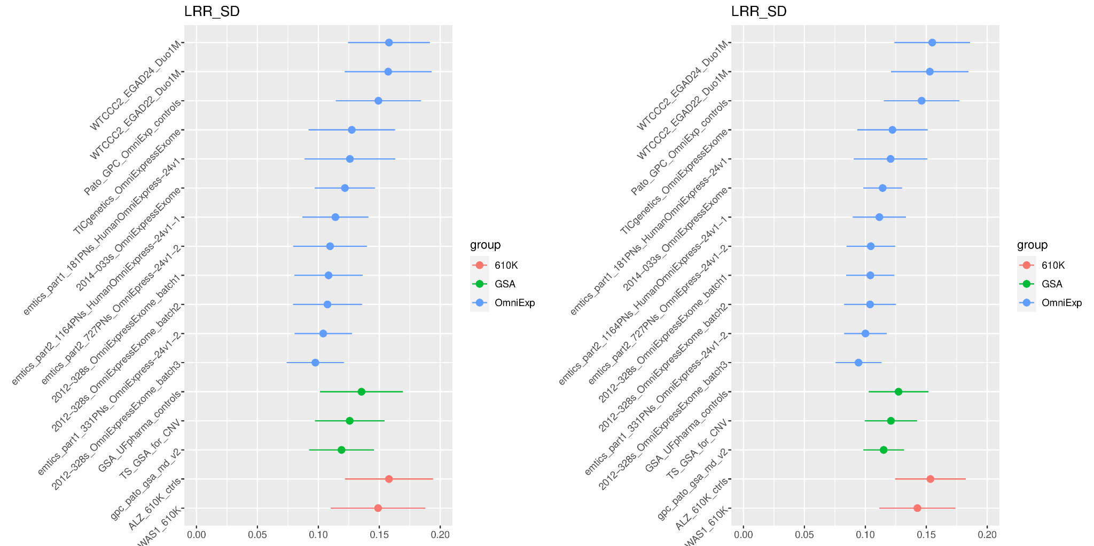
Figure S8. The mean (dots) and standard deviations (bars) for each included dataset concerning the Log R Ratio Standard Deviation (LRR-SD) metrics, which predict the ‘noisiness’ of data for each sample and the subsequent ability to accurately call CNVs. We generally observe that some datasets, such as WTCCC2, exhibit higher LRR-SD metrics than others. Additionally, we find that the Illumina 610K datasets tend to display higher LRR-SD metrics compared to others, which aligns with the fact that these arrays and their subsequent data are older and of lower quality.

Figure S9. Burden in cases versus controls of CNVs stratified by size

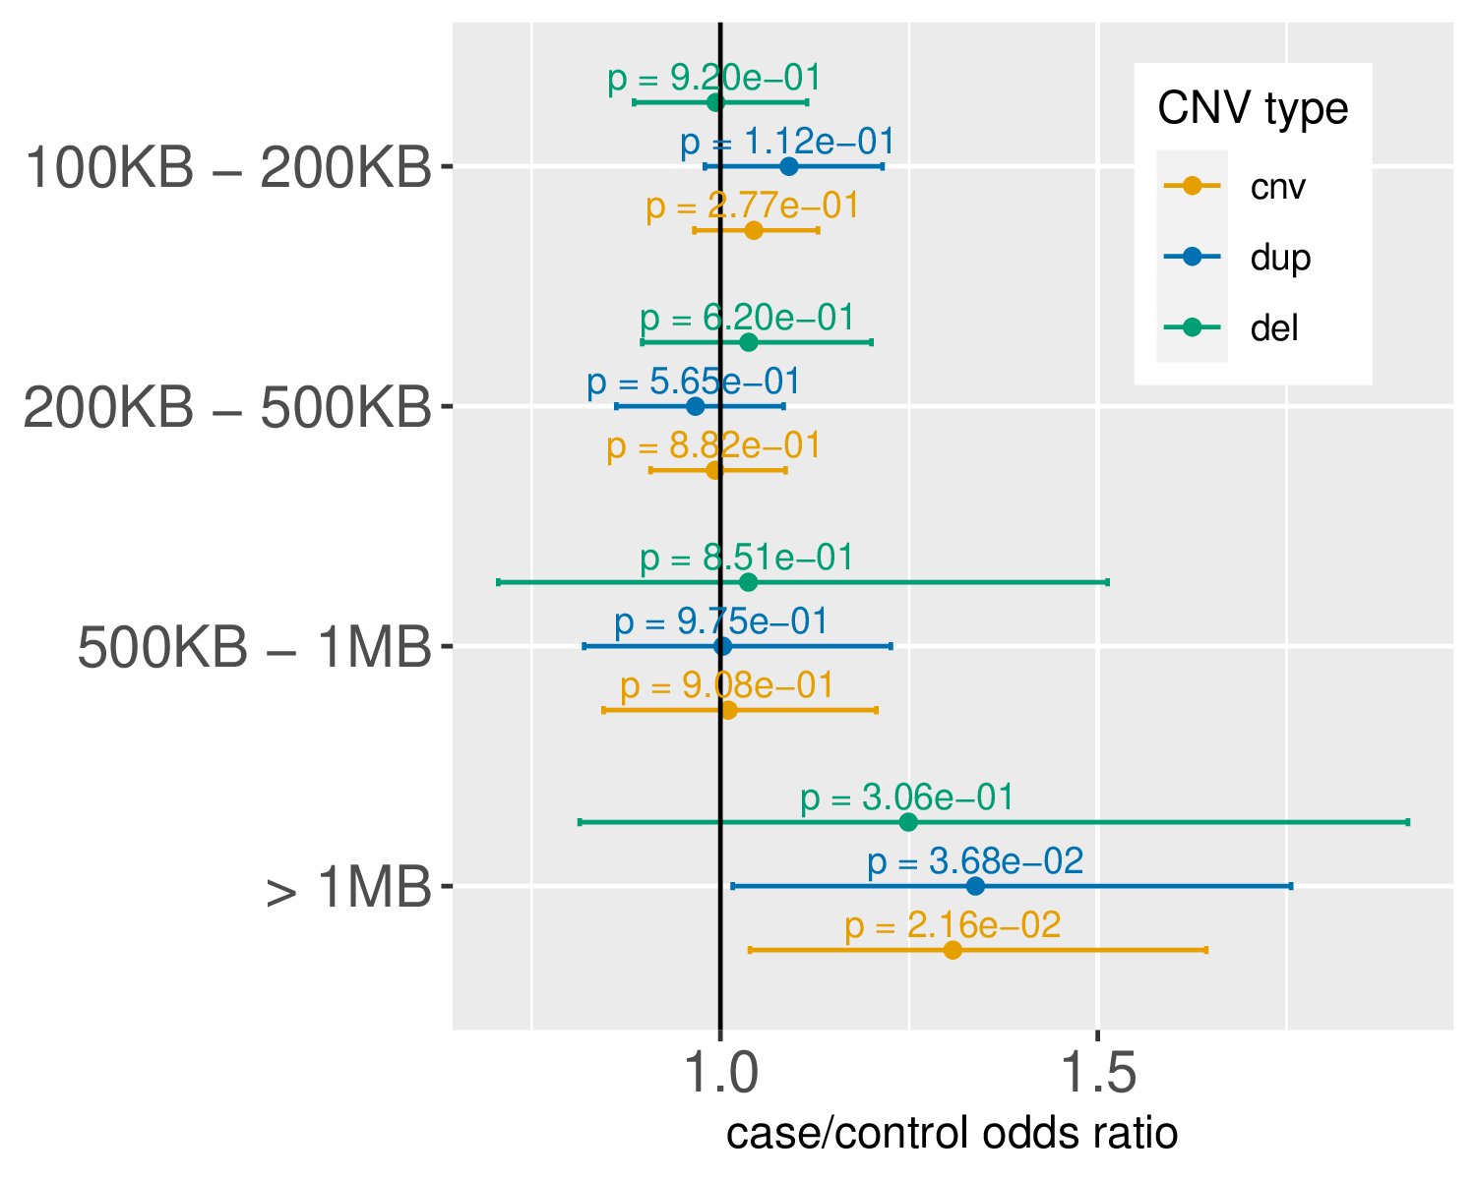
Figure S9. Association between CNV burden, categorized by CNV size, and TS case status. The odds ratio for the association test estimate is represented by dots and the 95% confidence interval for the estimate indicated by bars. Consistent with the findings described by Huang et al., cases exhibit an increased burden of CNVs larger than 1 MB in size.

Figure S10. Burden in cases versus controls of CNVs stratified by frequency

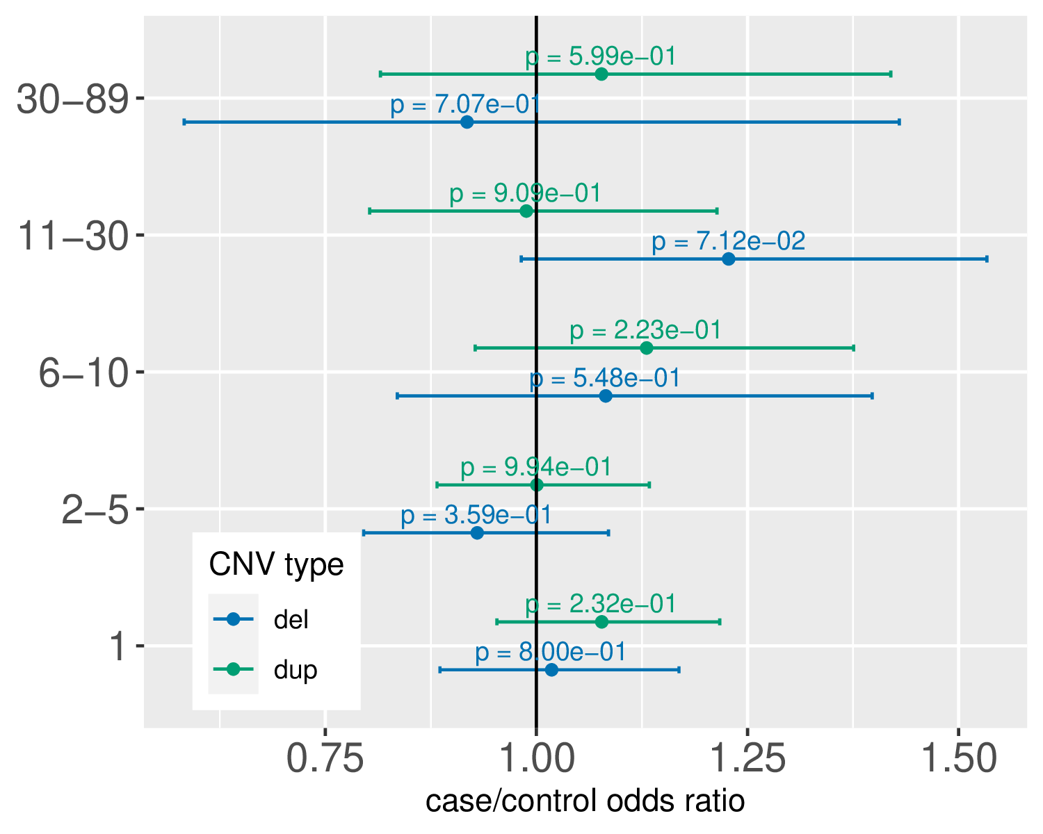
Figure S10. Association between TS case status and the burden of CNVs categorized by rarity. The points represent the odds ratio estimate from association tests, while the bars indicate the 95% confidence interval for the odds ratio estimate. We do not observe an increased burden in cases for singleton CNVs that exist in only one sample within the primary case/control cohort.

Figure S11. Burden of non-genic and genic deletions and duplications in cases versus controls
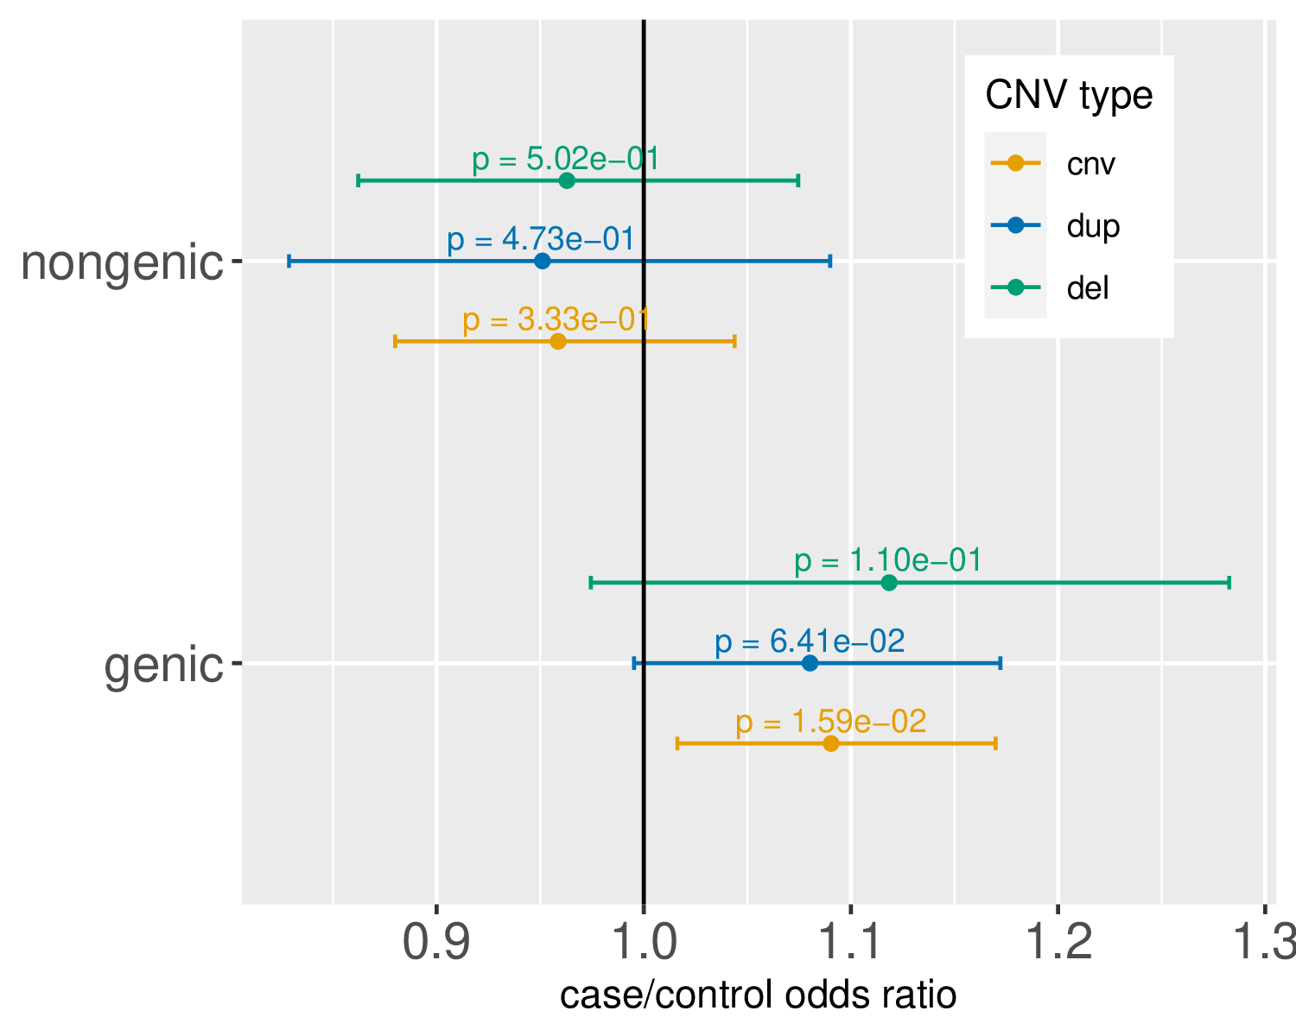

Figure S11. Association between case status and the burden of non-genic and genic CNVs. As with earlier figures, dots represent odds ratio estimates for the association, and bars illustrate the 95% confidence interval for these estimates. We define CNVs as genic if they overlap with at least one annotated protein-coding base and as non-genic if they do not overlap with any protein-coding base. Consistent with Huang et al., there is no evidence of a burden of non-genic CNVs in cases, but there is evidence of an excess of genic CNVs in cases compared to controls.

Figure S12. Burden in cases versus controls of CNVs impacting putatively haplosensitive and triplosensitive genes

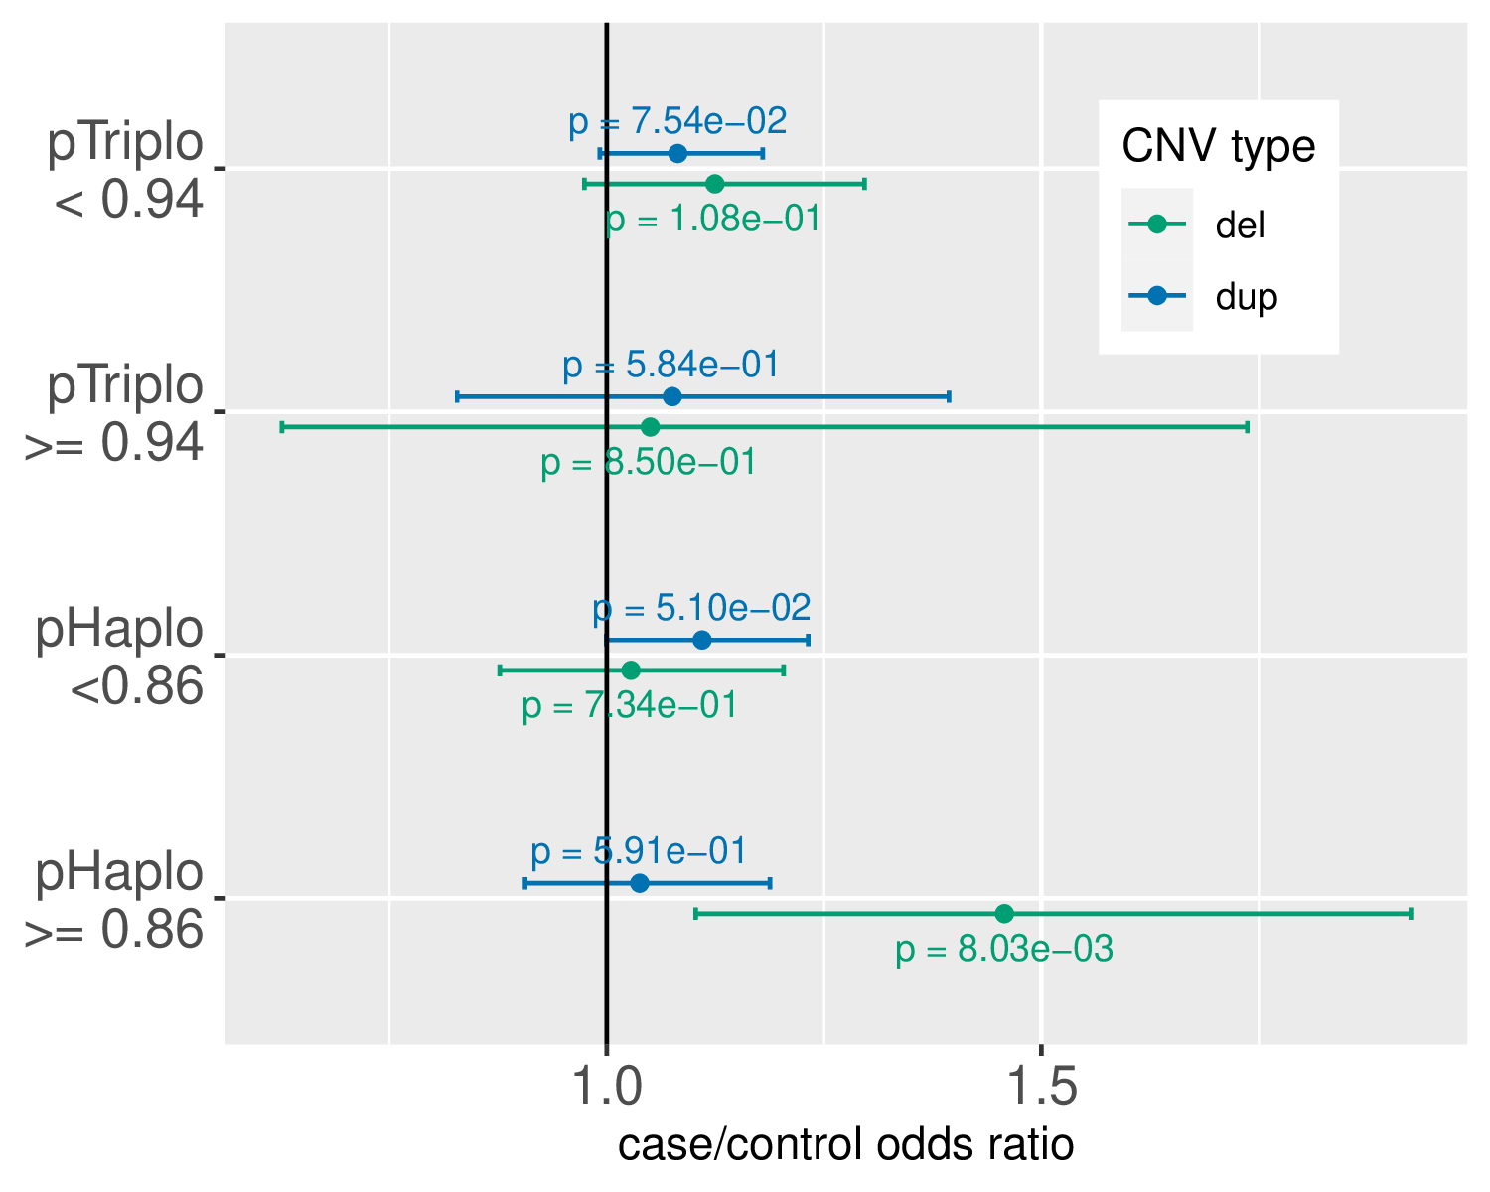
Figure S12. Association between case status and the burden of genic CNVs, categorized by the effect of haplosensitive and triplosensitive genes as defined by Collins et al. (PMID 35917817). As before, odds ratio estimates are represented with dots, while 95% confidence intervals for these estimates are indicated with bars. The most significant case excess arises specifically from the category of genic deletions affecting at least one haplosensitive gene, consistent with other findings that use pLI for categorization.

Figure S13. 17q12 CNV breakpoints

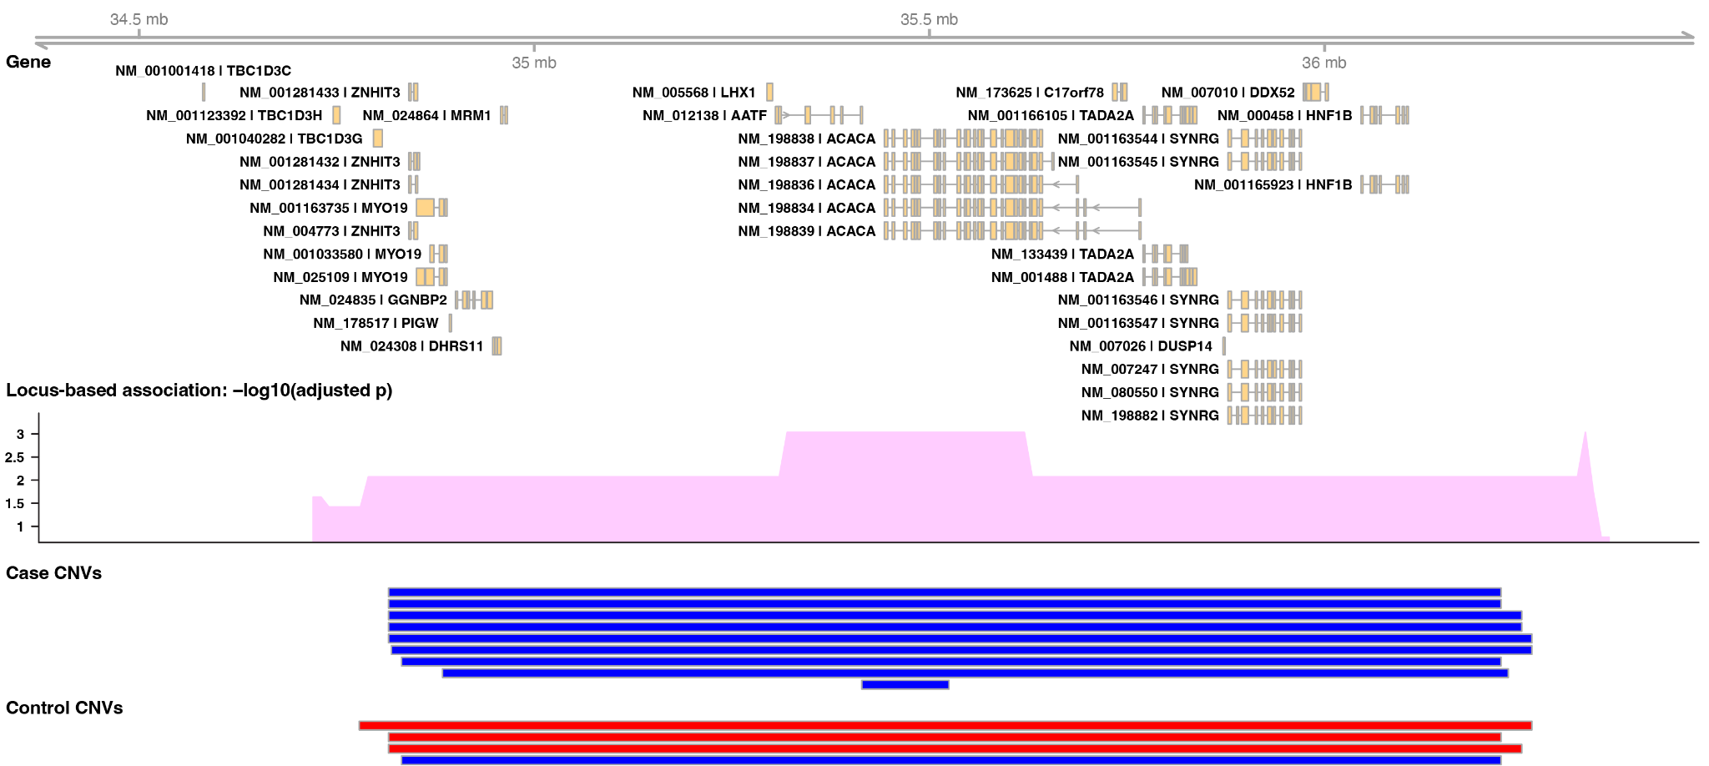
Figure S13. 17q12 CNV breakpoints and locus-based association test results. Blue bars represent the coordinates of duplications, while red bars represent deletions. One 110 kb duplication affects only the ACACA gene, resulting in slightly higher significance in gene-based tests compared to the other 14 surrounding genes.

Figure S14. ACACA gene expression
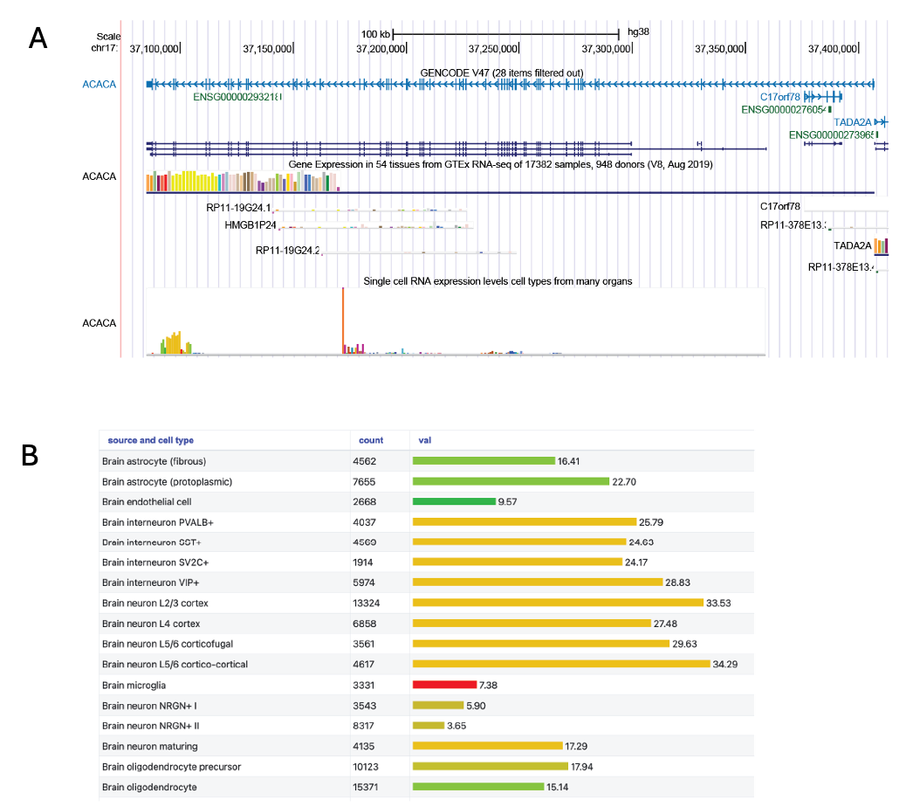
Figure S14. ACACA gene expression. A. GTEx single-cell data showing ACACA expression in brain cells. Genome build: hg38. Tracks (from top to bottom): GENCODE V47; GTEx expression; single cell RNA expression from cell types from many organs. B. Zoom in on single-cell data showing expression across a number of neuronal and non-neuronal cells from the brain.

Figure S15. ACACA Hi-C data

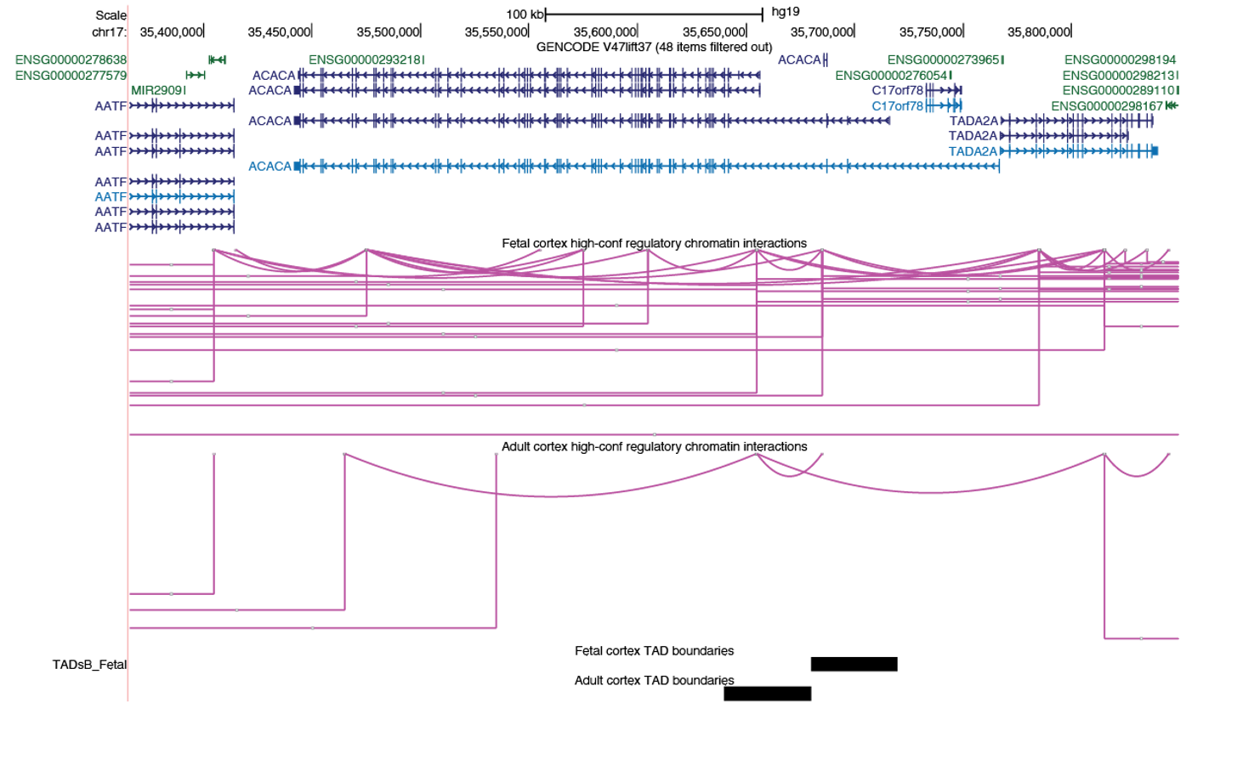
Figure S15. ACACA Hi-C data. Hi-C data from the fetal and adult cortex show overlaps in TAD boundaries with ACACA. Genome build: hg19. Tracks (from the top): GENCODE V47lift37; fetal high-confidence regulatory chromatin interactions; adult high-confidence regulatory chromatin interactions; fetal cortex TAD boundaries; adult cortex TAD boundaries.

