Figure S1. The role of interaction between two factors including age-period (A), age-cohort (B), and cohort-period (C) on the incidence of OC.
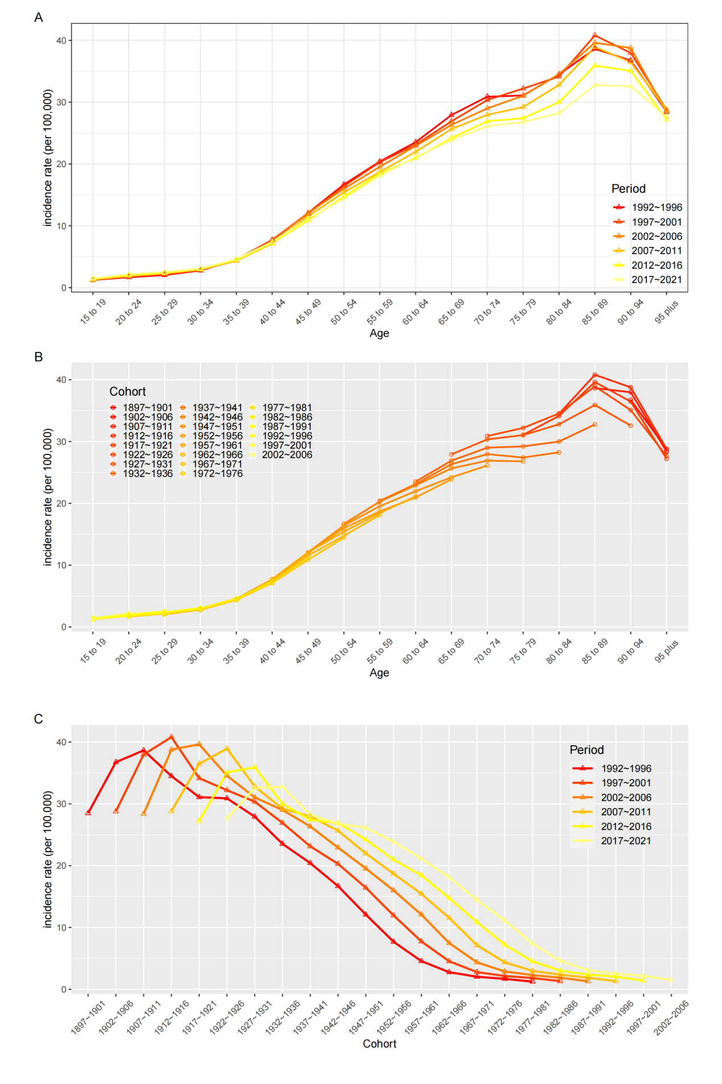
Abbreviations: OC, ovarian cancer.

Figure S2. The role of interaction between two factors including age-period (A), age-cohort (B), and cohort-period (C) on the prevalence of OC.
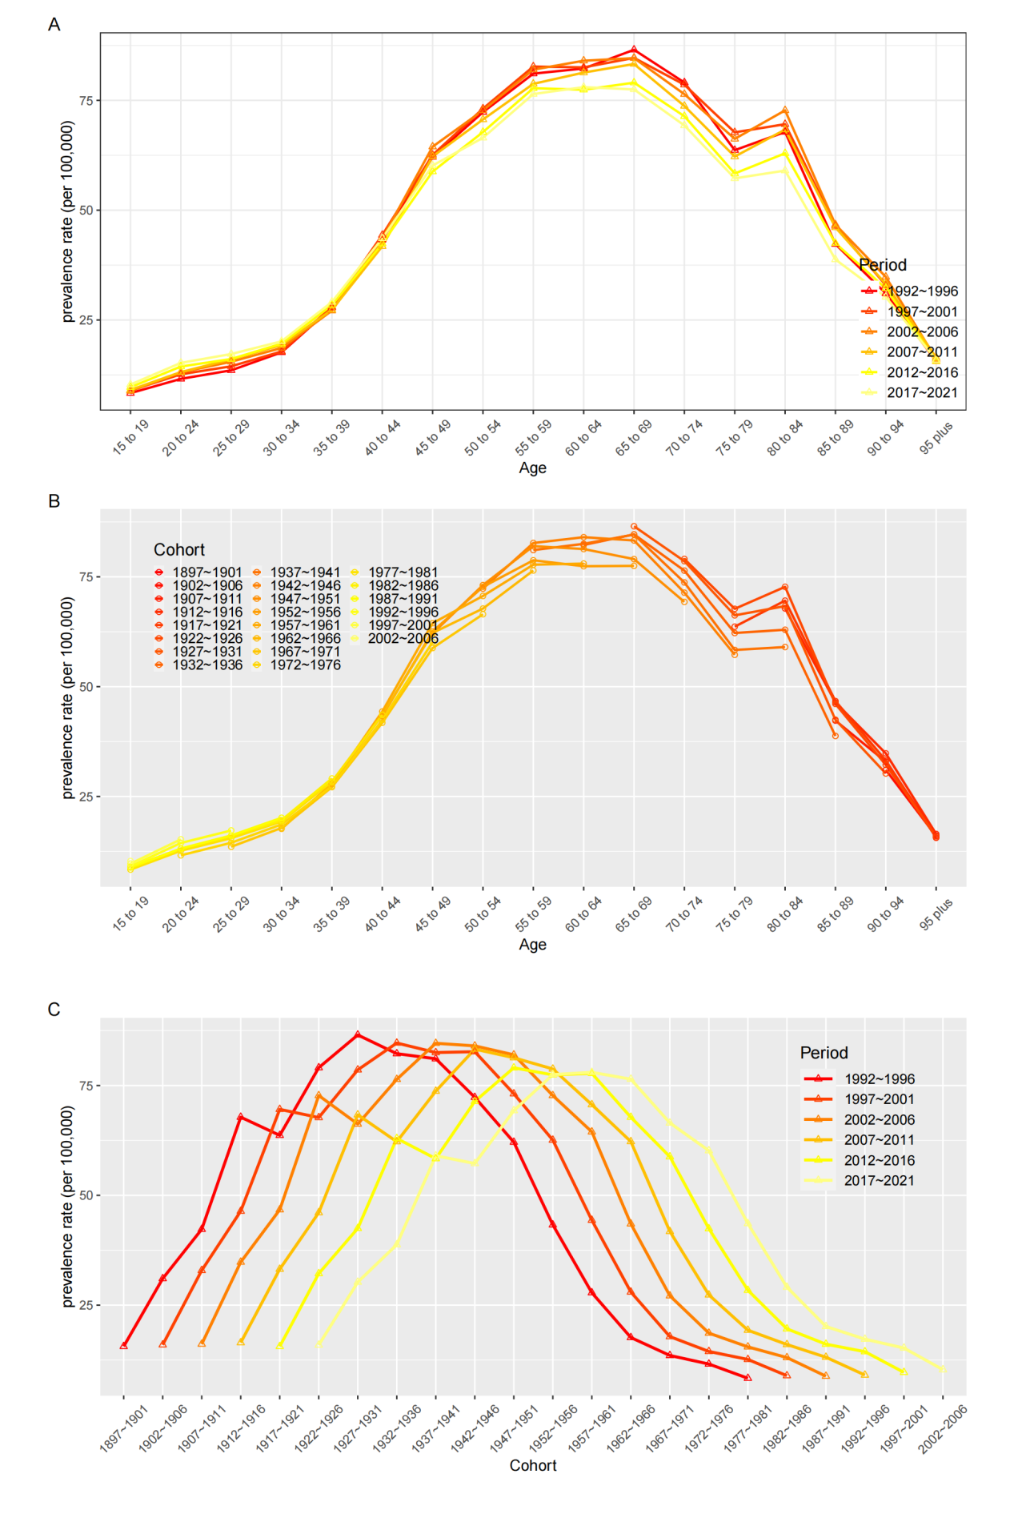
Abbreviations: OC, ovarian cancer.

Figure S3. The global trends of case number, crude rate and age-standardized rate of incidence, prevalence and DALYs of OC from 1990 to 2021.
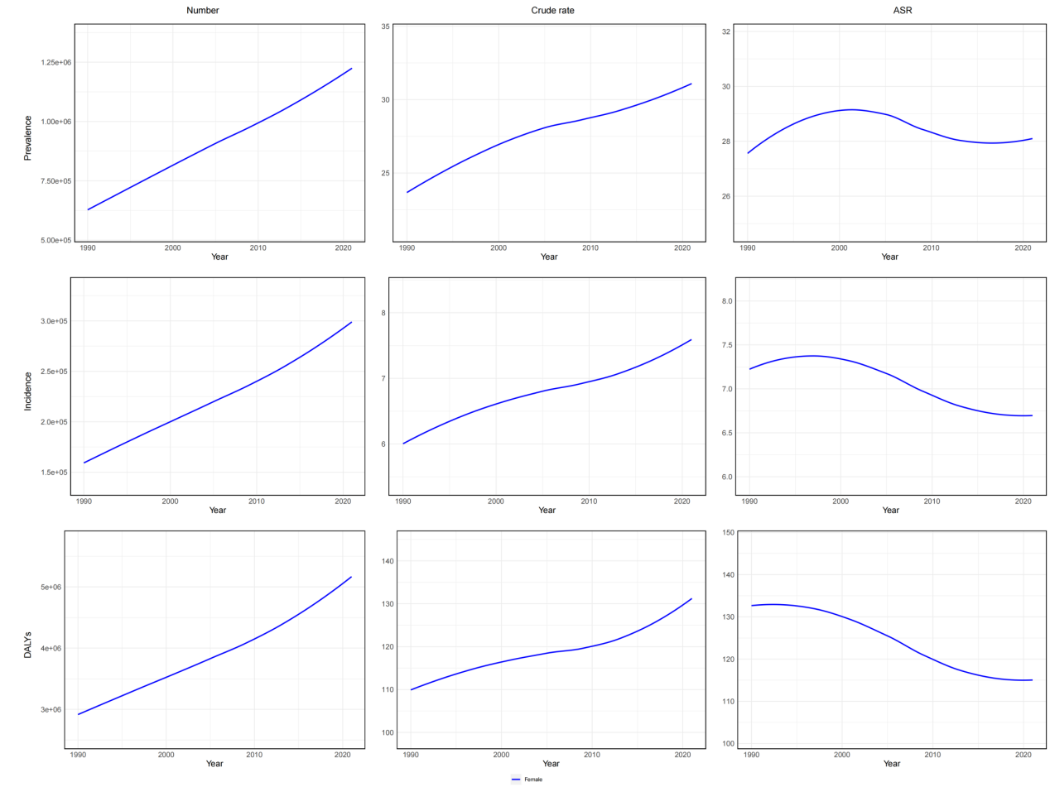
Abbreviations: DALYs, disability-adjusted life-years; OC,ovarian cancer.

