Supplemental Materials for
“Structural relaxation of ferroelectric phase in hard sodium lithium niobate solid solutions studied by Solid-State NMR”

Millena Logrado, Changhao Zhao, Hergen Breitzke, Jürgen Rödel, Gerd Buntkowsky

S1. Choice of delay recovery in ²³Na MAS NMR
Figure S1: Normalized single pulse ²³Na MAS under distinct relaxation delays for samples (a) LNN12 and (b) LNN18 aged for 8h at 800°C. A delay time of 3.8 s was used for MQMAS experiments.

S2. ²³Na 3QMAS spectra
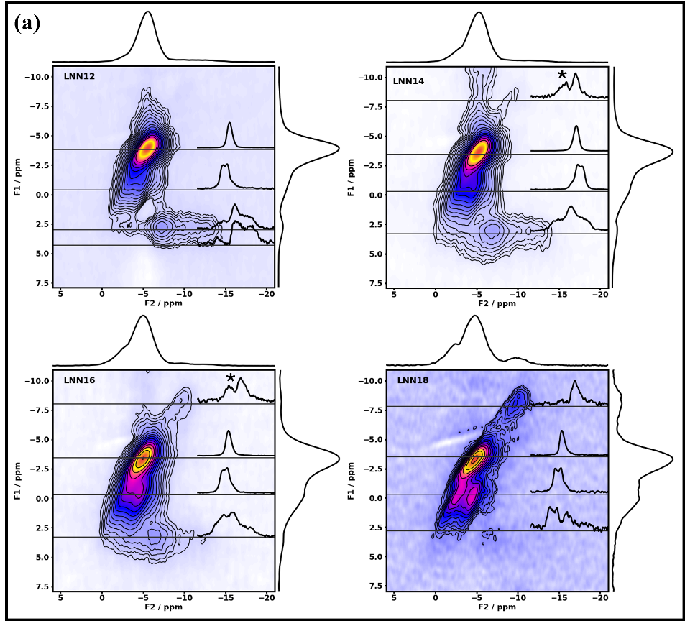
Figure S2: ²³Na TQMAS results for LNNx system with x є [12, 18].
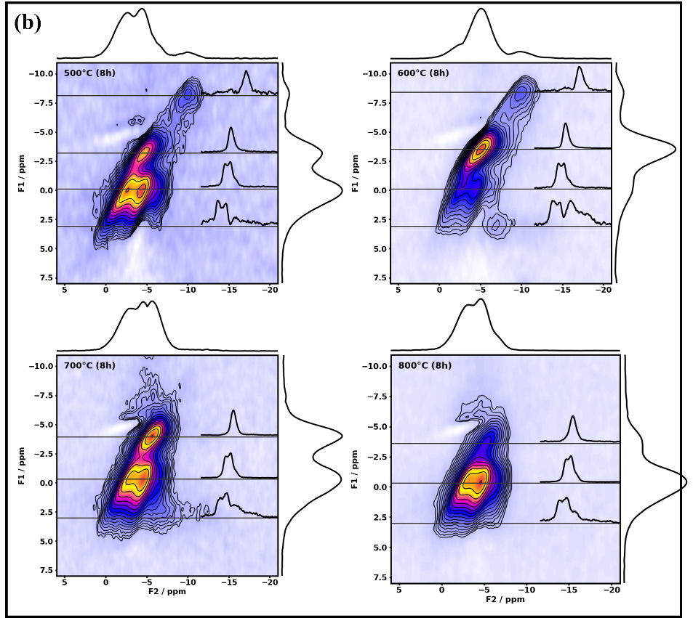
Figure S3: ²³Na TQMAS results for LNN18 aged at a temperature T for 8 hours, with T є [500, 800] °C.

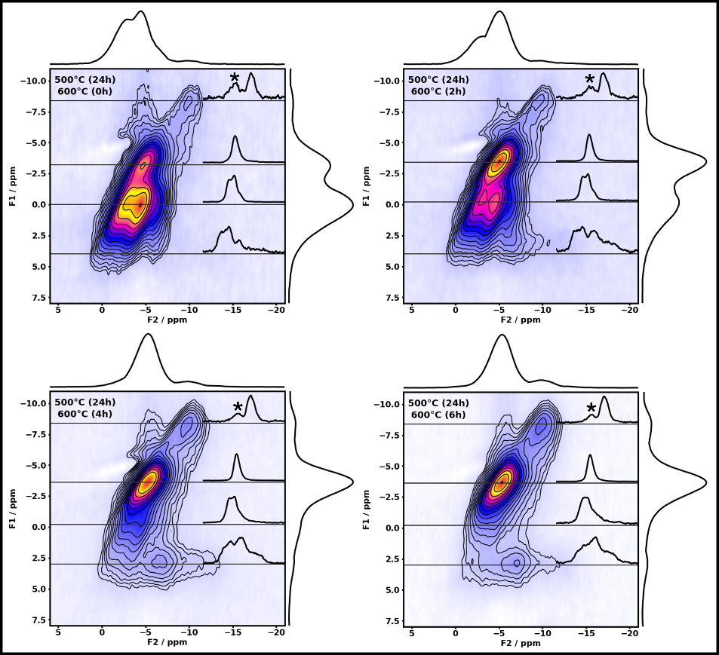
Figure S4: ²³Na TQMAS results for LNN18 aged at 500 °C for 24 h and at 600 °C for a time t, where t є [0,6] hours.

S3. Values used for the deconvolution of the single-pulse experiments and parameters obtained from the ²³Na 3QMAS spectra

Table S1: Quantitative parameters extracted from ²³Na single pulse experiment. For each site or phase, the percentage, isotropic chemical shift (δ₀), quadrupolar coupling constant (C_{Q}) and asymmetry parameter (η_{Q}) were measured using a single pulse experiment in a quantitative regime. The letters P, Q, R represent the orthorhombic antiferroelectric phase, the orthorhombic ferroelectric and the rhombohedral phases, respectively, while Am1 and Am2 represent two amorphous sites at higher and lower frequency, respectively. The error in the percentage was estimated as 10% of the corresponding percentage value. Values for absolute error less than 2 is unrealistic, therefore ± 2% is understood as the minimum error value.
Sample | Site/Phase | Percentage / % | δ₀ /  ±0.5 ppm | C_{Q} /  ±0.2 MHz | η_{Q} /  ±0.1
LNN12 | P | 3 | -4.9 | 2.3 | 0.0
LNN12 | Q | 24 | -1.9 | 2.0 | 1.0
LNN12 | R | 28 | -1.6 | 1.4 | 0.0
LNN12 | Am1 | 45 | -5.0 | 1.0 (σ=0.49) | -
LNN14 | Q | 24 | -1.2 | 2.31 | 1.0
LNN14 | R | 33 | -1.5 | 1.49 | 0.0
LNN14 | Am1 | 41 | -4.2 | 1.2 (σ=0.63) | -
LNN14 | Am2 | 2 | -8.0 | 1.3 (σ=0.70) | -
LNN16 | Q | 23 | 0.0 | 2.2 | 1.0
LNN16 | R | 42 | -1.2 | 1.4 | 0.0
LNN16 | Am1 | 34 | -4.3 | 1.0 (σ=0.50) | -
LNN16 | Am2 | 1 | -8.4 | 1.2 (σ=0.63) | -
LNN18 | Q | 21 | 0.3 | 2.2 | 1.0
LNN18 | R | 50 | -0.8 (0.7) | 1.6 | 0.0
LNN18 | Am1 | 34 | -3.4 | 1.3 (σ=0.66) | -
LNN18 | Am2 | 5 | -8.7 | 1.1 (σ=0.57) | -
LNN18  500°C  (8h) | Q | 12 | 0.3 | 2.2 | 1.0
LNN18  500°C  (8h) | R | 61 | -0.8 (0.7) | 1.6 | 0.1
LNN18  500°C  (8h) | Na1 | 23 | -3.7 | 1.3 (σ=0.54) | -
LNN18  500°C  (8h) | Am2 | 4 | -8.7 | 1.1 (σ=0.52) | -
LNN18  600°C(8h) | Q | 35 | 0.3 | 2.2 | 1.0
LNN18  600°C(8h) | R | 33 | -0.9 | 1.7 | 0.1
LNN18  600°C(8h) | Am1 | 27 | -3.4 | 1.2 (σ=0.65) | -
LNN18  600°C(8h) | Am2 | 5 | -8.5 | 1.2 (σ=0.63) | -
LNN18  700°C(8h) | Q | 21 | 0.9 | 2.3 | 1.0
LNN18  700°C(8h) | R | 66 | -1.1 (0.7) | 1.6 | 0.0
LNN18  700°C(8h) | Am1 | 13 | -3.6 | 1.0 (σ=0.52) | -
LNN18  800°C(8h) | Q | 7 | 1.0 | 2.2 | 1.0
LNN18  800°C(8h) | R | 77 | -1.0 (0.5) | 1.6 | 0.0
LNN18  800°C(8h) | Am1 | 16 | -5.0 | 1.2 (σ=0.63) | -
LNN18  500°C(24h)  600°C(0h) | Q | 10 | 0.3 | 2.2 | 1.0
LNN18  500°C(24h)  600°C(0h) | R | 66 | -0.6 | 1.6 | 0.1
LNN18  500°C(24h)  600°C(0h) | Am1 | 22 | -2.8 | 1.1 (σ=0.54) | -
LNN18  500°C(24h)  600°C(0h) | Am2 | 2 | -8.8 | 1.0 (σ=0.52) | -
LNN18  500°C(24h) 600°C(2h) | Q | 20 | 1.4 | 2.3 | 1.0
LNN18  500°C(24h) 600°C(2h) | R | 54 | -0.8 | 1.7 | 0.0
LNN18  500°C(24h) 600°C(2h) | Am1 | 24 | -3.1 | 1.2 (σ=0.63) | -
LNN18  500°C(24h) 600°C(2h) | Am2 | 2 | -8.3 | 1.2 (σ=0.62) | -
LNN18  500°C(24h) 600°C(4h) | Q | 33 | 1.0 | 2.3 | 1.0
LNN18  500°C(24h) 600°C(4h) | R | 38 | -1.6 | 1.6 | 0.0
LNN18  500°C(24h) 600°C(4h) | Am1 | 24 | -4.3 | 1.1 (σ=0.57) | -
LNN18  500°C(24h) 600°C(4h) | Am2 | 5 | -8.8 | 1.1 (σ=0.55) | -
LNN18  500°C(24h) 600°C(6h) | Q | 48 | 0.3 | 2.2 | 1.0
LNN18  500°C(24h) 600°C(6h) | R | 22 | -2.4 | 1.5 | 0.0
LNN18  500°C(24h) 600°C(6h) | Am1 | 23 | -4.6 | 1.0 (σ=0.50) | -
LNN18  500°C(24h) 600°C(6h) | Am2 | 7 | -9.2 | 0.9 (σ=0.40) | -

Table S2: Parameters extracted from ²³Na 3QMAS experiment. For each site or phase, the isotropic chemical shift (δ₀) and the quadrupolar product (P_{Q}) were measured. The letters P, Q, R represent the orthorhombic antiferroelectric, orthorhombic ferroelectric and rhombohedral phases, respectively, while Am1 and Am2 represent two amorphous sites at higher and lower frequency, respectively. Asterisk mark (*) represents the sites with poor signal-to-noise ratio. Due that, their parameters were not able to be extracted accurately.
Sample | Site/Phase | δ₀/ ±0.5 ppm | P_{Q}/ ±0.2 MHz
LNN12 | P | - | -
LNN12 | Q | -0.9 | 2.5
LNN12 | R | -2.4 | 1.4
LNN12 | Am1 | -4.3 | 1.0
LNN18 | Q | -0.3 | 2.5
LNN18 | R | -1.8 | 1.6
LNN18 | Am1 | -3.9 | 1.1
LNN18 | Am2 | -9.1 | 1.1
LNN18  500°C (8h) | Q | * | *
LNN18  500°C (8h) | R | -1.7 | 1.6
LNN18  500°C (8h) | Na1 | -4.1 | 1.1
LNN18  500°C (8h) | Am2 | -9.2 | 1.1
LNN18  800°C(8h) | Q | * | *
LNN18  800°C(8h) | R | -1.9 | 1.6
LNN18  800°C(8h) | Am1 | -4.5 | 1.0
LNN18  500°C(24h)  600°C(0h) | Q | * | *
LNN18  500°C(24h)  600°C(0h) | R | -1.6 | 1.6
LNN18  500°C(24h)  600°C(0h) | Am1 | -3.8 | 1.1
LNN18  500°C(24h)  600°C(0h) | Am2 | -8.9 | 1.2
LNN18  500°C(24h) 600°C(6h) | Q | -0.6 | 2.5
LNN18  500°C(24h) 600°C(6h) | R | * | *
LNN18  500°C(24h) 600°C(6h) | Am1 | -3.6 | 1.1
LNN18  500°C(24h) 600°C(6h) | Am2 | -9.0 | 1.1

S4. Correlation between the lattice parameter and the ²³Na chemical shift of the samples

Figure S5: Lattice parameter (d₂₀₀) as a function of the ²³Na chemical shift for (a) LNNx samples, where x є [12,16], and (b) LNN18 for a time t, where t є [0,4] hours.

Table S3: F-value and R² from the linear models shown in Figure S5(a) and (b). An F-value greater than the critical value (Fc) indicates that the model is statistically significant at the chosen significance level. An R² value closer to 1 indicates that the model explains the variability in the data more effectively.
 | Figure 6(a) | Figure 6(b) | F_{c}=F_{(1,1,S)}
F-value | 539.01265 | 191.47748 | F_{(1,1, 0.027)} = 539.01265  F_{(1,1,0.046)} = 191.47748
R² | 0.998 | 0.995 | -

