Supplementary Figure 1: Stacked bar chart showing proportion of patients reporting an impact of ITP on physical well-being (PWB) domain of FACIT score.

Supplementary Figure 2: Stacked bar chart showing proportion of patients reporting an impact of ITP on social well-being (SWB) domain of FACIT score.

Supplementary Figure 3: Stacked bar chart showing proportion of patients reporting an impact of ITP on emotional well-being (EWB) domain of FACIT score.

Supplementary Figure 4: Stacked bar chart showing proportion of patients reporting an impact of ITP on functional well-being (FWB) domain of FACIT score.

Supplementary Figure 5: Stacked bar chart showing proportion of patients reporting an impact of ITP on fatigue domain of FACIT score.

Supplementary Figure 6: Box and whisker plots showing median scores of total FACIT score among different groups of patients within the study population.
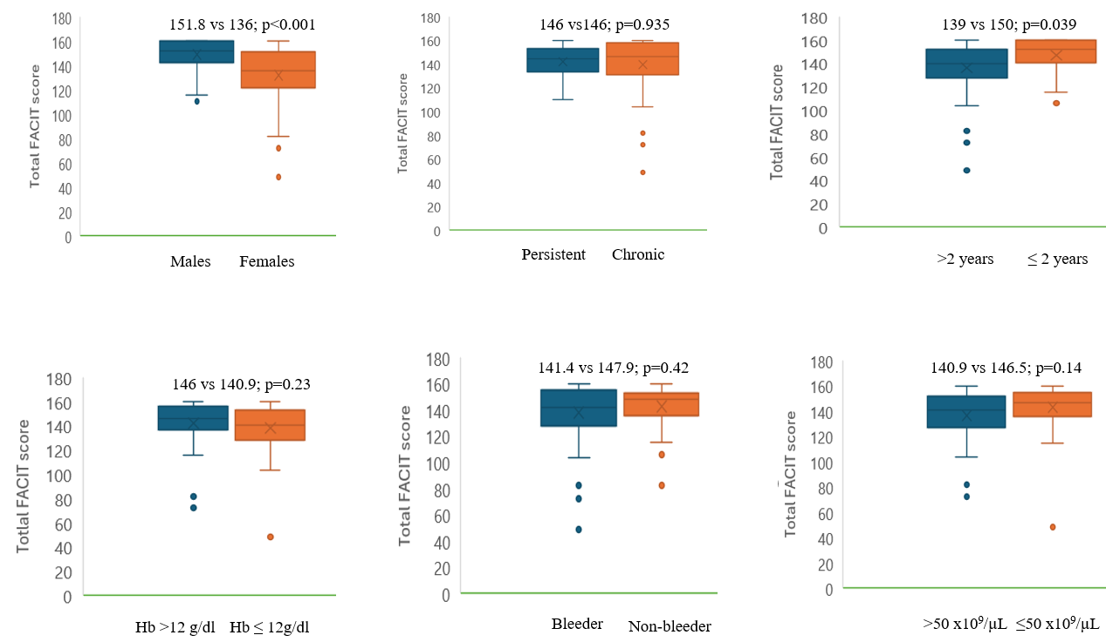

Supplementary Table 1: Comparison of different HRQoL sub scores and total score among patients and controls:
 | Patients (n=100) | Controls (n=50) | P value
PWB score, median (range) | 24 (8-28) | 26 (24-28) | <0.001
SWB score, median (range) | 27.84 (18-28) | 28 (26-28) | <0.001
EWB score, median (range) | 23 (4-24) | 24 (23-24) | <0.001
FWB score, median (range) | 27 (10-28) | 28 (25-28) | 0.007
FS score, median (range) | 45 (9-52) | 49 (44-52) | <0.001
Total FACIT score, median (range) | 146 (49-160) | 155 (149-159) | <0.001

Supplementary Table 2: Correlation of fatigue subscale score with other HRQoL sub scores and total score.

HRQoL domain | Correlation analysis | Fatigue subscale score
PWB score | Sperman correlation  Significance (p value) | 0.925  <0.001
SWB score | Spearman correlation  Significance (p value) | 0.495  <0.001
EWB score | Spearman correlation  Significance (p value) | 0.827  <0.001
FWB score | Spearman correlation  Significance (p value) | 0.747  <0.001
Total FACIT score | Spearman correlation  Significance (p value) | 0.967  <0.001

Supplementary Table 3: Comparison of median plasma interleukin levels (pg/ml) between patients and healthy controls.
Interleukin, median (range) | Patients | Controls | p-value
IL-2 | 11.8 (0.32-891.8) | 0.12 (0.06-256.21) | <0.001
IL-12 | 313.2 (12.26-1877.8) | 95.55 (37.7-262.2) | <0.001
Interferon-gamma | 9.57 (0.94-33.2) | 0.59 (0.44-217.27) | <0.001
IL-4 | 2.92 (0.92-12.86) | 0.07 (0.04-11.7) | <0.001
IL-10 | 1.56 (0.01-65.54) | 0.39 (0.24-147.8) | <0.001
IL-6 | 4.08 (2.12-38.96) | 2.47 (0.1-24.79) | 0.001
IL-17 | 6.12 (0.1-45.26) | 11.8 (3.75-82.86) | <0.001

Supplementary Table 4: Correlation analysis of FACIT subscale scores and Total FACIT score with cytokines in the patients with ITP.
FACIT | Interleukin | IL-2 | IL-12 | IFN-ϒ | IL-4 | IL-10 | IL-6 | IL-17
Fatigue subscale score | Spearman correlation | 0.074 | -0.248 | 0.036 | -0.014 | 0.110 | -0.107 | 0.020
Fatigue subscale score | Significance | 0.47 | 0.04 | 0.73 | 0.89 | 0.29 | 0.30 | 0.85
Physical well-being score | Spearman correlation | -0.032 | -0.191 | -0.001 | -0.029 | 0.113 | -0.080 | 0.010
Physical well-being score | Significance | 0.75 | 0.049 | 0.99 | 0.77 | 0.27 | 0.43 | 0.92
Social well-being score | Spearman correlation | 0.066 | -0.292 | 0.089 | -0.089 | 0.044 | -0.093 | -0.056
Social well-being score | Significance | 0.52 | 0.003 | 0.38 | 0.38 | 0.67 | 0.36 | 0.58
Emotional well-being score | Spearman correlation | 0.017 | -0.361 | -0.033 | 0.021 | 0.074 | -0.113 | 0.009
Emotional well-being score | Significance | 0.86 | <0.001 | 0.74 | 0.83 | 0.47 | 0.26 | 0.93
Functional well-being score | Spearman correlation | 0.059 | -0.194 | 0.014 | -0.075 | 0.073 | -0.155 | -0.066
Functional well-being score | Significance | 0.56 | 0.048 | 0.89 | 0.46 | 0.48 | 0.12 | 0.52
Total FACIT score | Spearman correlation | 0.044 | -0.272 | 0.030 | -0.032 | 0.101 | -0.115 | 0.005
Total FACIT score | Significance | 0.67 | 0.007 | 0.77 | 0.76 | 0.33 | 0.26 | 0.96

