Polymeric nanoparticles-loaded extracellular vesicles as biomimetic nucleic acid vaccines

Jennifer Fernandez-Alarcón¹, Alessandro Masoero^{1,2}, Ida Pagnotta¹, Raquel Vaya¹, Pau Castells-Colldeforns¹, Mar Losada¹, Mònica Guarro¹, Martí Lecina¹, Giovanni Sitia³, Gemma Gotor¹, Marta Guerra-Rebollo¹, Santiago Grijalvo⁴, Valentina Cauda², Salvador Borrós¹, Cristina Fornaguera¹*

SUPPLEMENTARY INFORMATION

INDEX
Explanation S1. Calculation of the overlapping analysis of the confocal images.
Figure S1. NTA analysis of the formulations.
Figure S2. CryoTEM analysis.
Figure S3. Controls of the labeling used to study complexation by confocal microscopy.
Figure S4. Hyperspectral images of THP-1 EVs, KH NPs, and KH NP@THP-1 EVs complexes.
Figure S5. Dark-field images and hyperspectral libraries.
Figure S6. FRET controls.
Figure S7. MTT viability assay.
Figure S8. Quantitative differentiation study.
Figure S9. THP-1 differentiation into iDCs
Figure S10. Expression level of CD209 in undifferentiated THP-1 cells
Figure S11. Uptake study in THP-1 cells
Figure S12. Dose test.
Figure S13. Protein enrichment in biological processes THP-1 EVs and JAWS EVs.
Figure S14. Ex vivo imaging of tumor-bearing mice treated with complex.
Figure S15. Cy3 signal in tumor-bearing mice treated with complex.
Figure S16. Cy5 signal in tumor-bearing mice treated with complex.
Figure S17. Pearson correlation from HC and SC of THP-1 EVs and KH NP@THP-1 EVs.
Figure S18. Jaccard similarity from HC and SC of THP-1 EVs and KH NP@THP-1 EVs.
Figure S19. Heatmap of HC and SC of THP-1 EVs and KH NP@THP-1 EVs depending on the biological function.
Figure S20. Protein enrichment by metabolic processes comparing SC of THP-1 EVs and KH NP@THP-1 EVs and comparing KH NP@THP-1 EVs HC and SC.
Figure S21. Protein enrichment in biological processes THP-1 EVs and THP-1 HC.

Explanation S1. Calculation of the overlapping analysis of the confocal images.

Colocalization analysis of EVs and NPs, respectively stained with NBD Cy5 fluorophores, on confocal images was performed with JACoP (Just Another Colocalization Plug/in [1]). The colocalization of the two fluorophores was estimated through two different coefficients: Pearson’s and Manders’ coefficients. Pearson’s coefficient (PC) value can range from 1 to -1, with 1 standing for complete positive correlation and -1 for a negative correlation, with zero standing for no correlation and it measures the linear correlation between two different fluorescent channels of the image. Manders’ coefficients (MC), instead, quantify the degree of overlap between two different fluorescent signals and it is not influenced by the relative intensity values of the two signals. It produces two coefficients: M1, the fraction of green overlapping with red; and M2, the fraction of red overlapping with green. It is particularly useful when the fluorophores have different intensity distributions. Coefficients were estimated to analyze seven different images of the sample to achieve statistical evidence of the analysis. PC average estimation was 0.508, while M1 and M2 were 0.431 and 0.418 respectively. The coefficient indicates a good colocalization of EVs and NPs, although not all the nanoparticles seem fully coated and not all the EVs seems to have encapsulated a nanoparticle.

[1] S. Bolte and F.P. Cordelières. «A guided tour into subcellular colocalization analysis in light microscopy». In: Journal of Microscopy 224.June (2006), pp. 213–232 (cit. on p. 26).

Figure S1. NTA analysis of the formulations. Mean and mode size of the different samples. ns = non-significant differences (p > 0.05); ** p<005; *** p<0.0005; **** p<0.0001

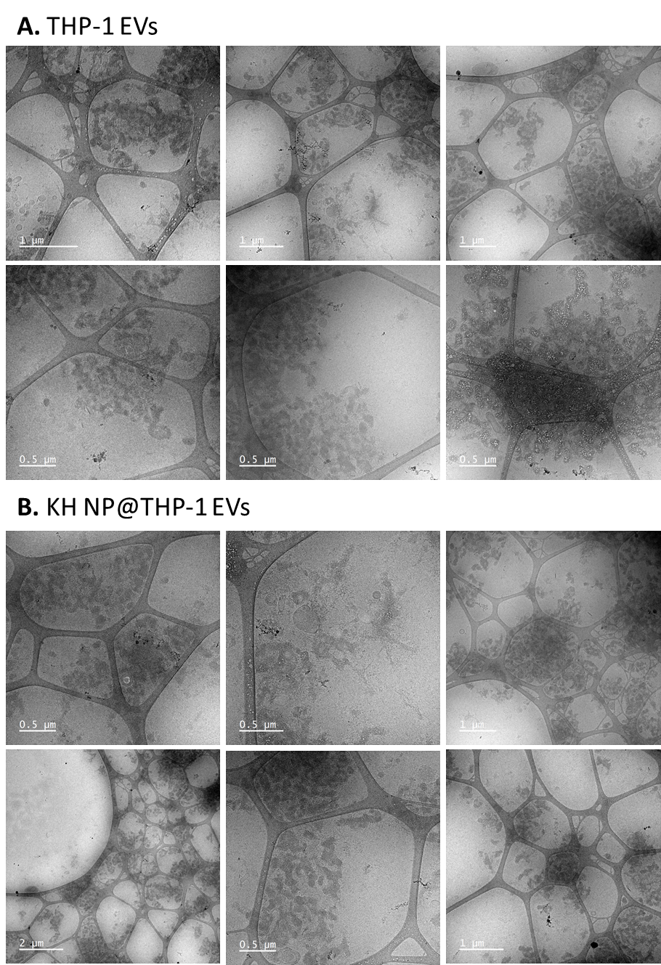
Figure S2. CryoTEM analysis. Extra images of the cryo-TEM analysis of: A) naked THP-1 EVs; and B) KH NP@THP-1 EVs.

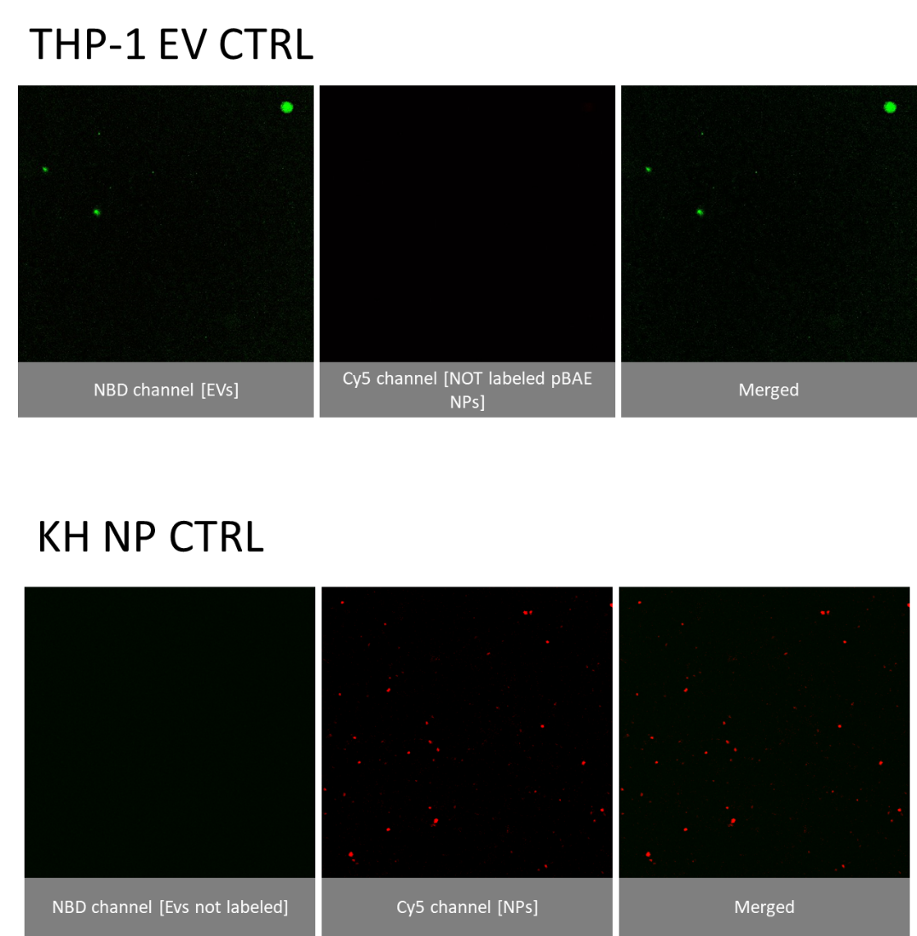

Figure S3. Controls of the labeling used to study complexation by confocal microscopy.

Figure S4. A. Hyperspectral images images of the THP-1 EVs, KH NPs, and KH NP@THP-1 EV complexes.

Figure S5. A. Dark-field images of the EVs, NPs, and NP@EV complexes, from where the hyperspectral were obtained. B—D. Hyperspectral libraries of: B – EV-NBD; C – NP-Cy5; and D – EV@NP.

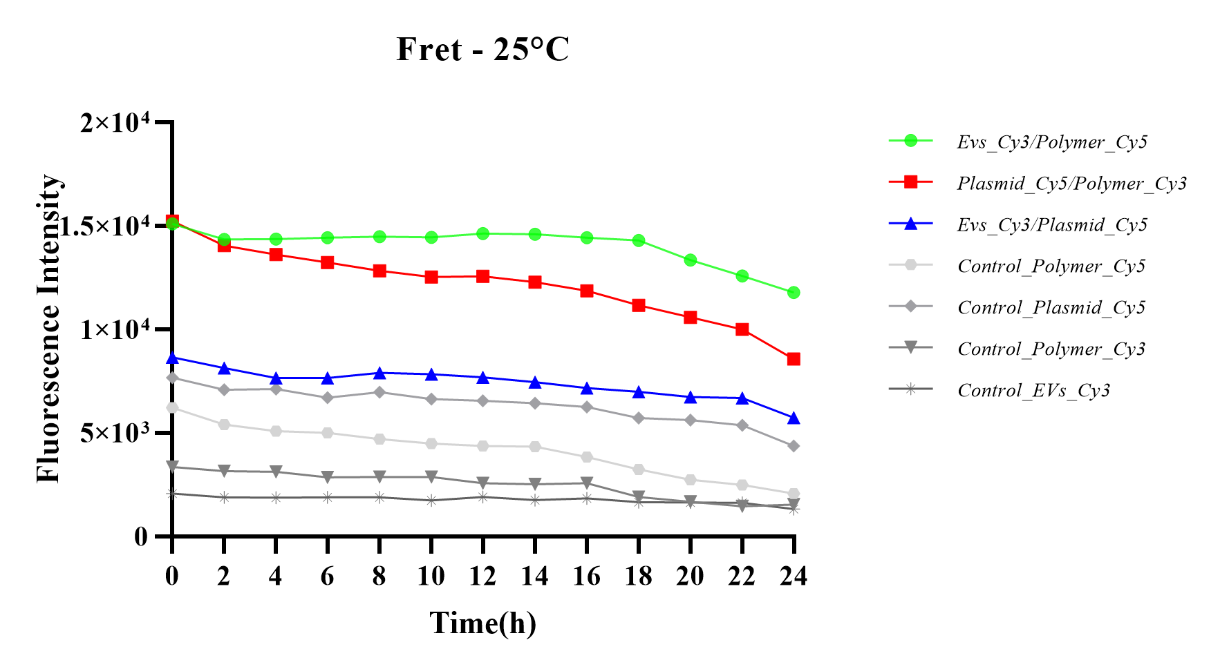
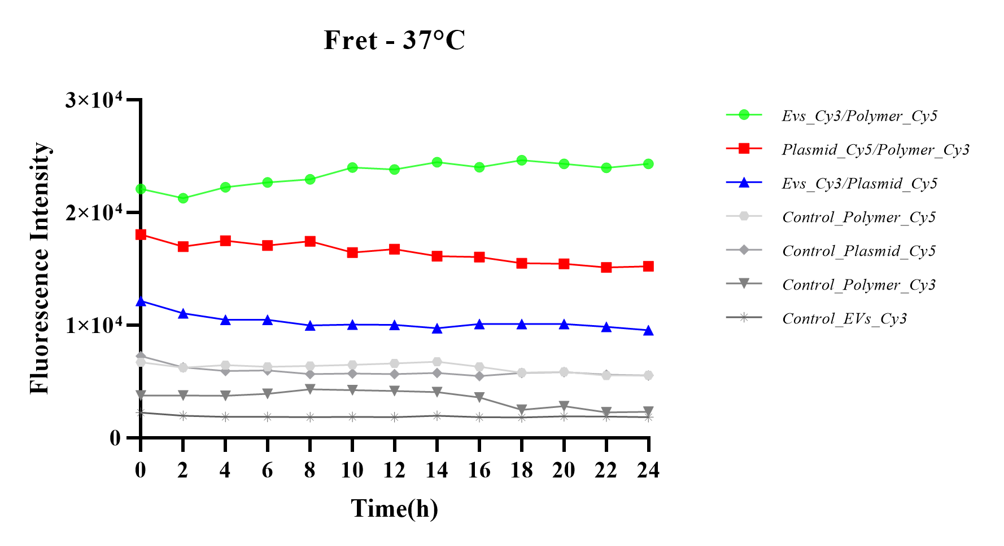

Figure S6. FRET controls.
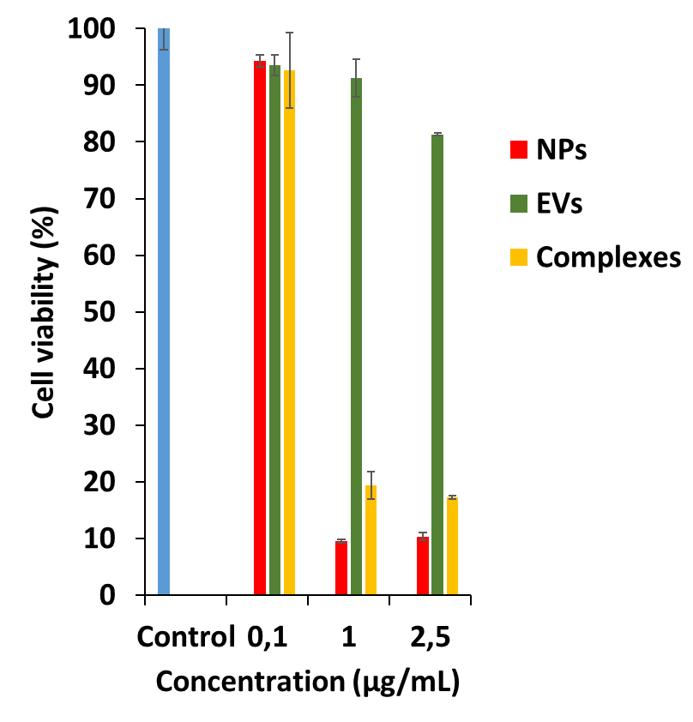

Figure S7. MTT viability assay. The plasmid concentration was tested for all the nanosystems, in THP1 cells, after 24h incubation with nanosystems.

Figure S8. Quantitative differentiation study. Expression level of CD209 marker after monocyte differentiation via cytokine treatment with IL-4 and PMA. Data are presented as mean ± SEM of n = 3. P values were determined by one-way ANOVA with Bonferroni’s correction ****P < 0.0001.

A
D
C
B

Figure S9. THP-1 differentiation into iDCs. Micrographs of A-C) undifferentiated THP-1 cells and B-C) iDCs cells differentiated via cytokine treatment with IL-1 and PMA. Scale bars = 50 µm (A-B), 100 µm (C-D).

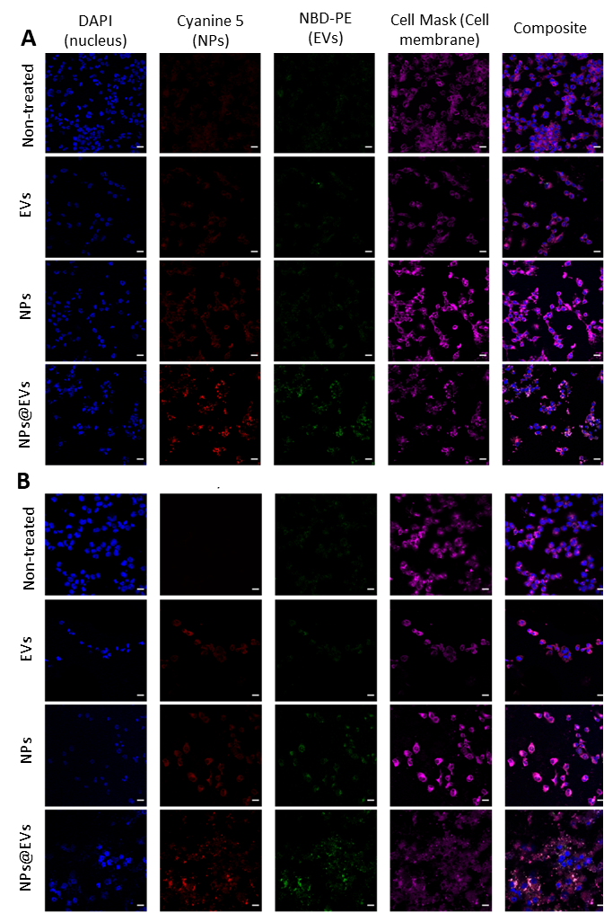

Figure S10. Uptake study in THP-1 cells. Confocal micrographs of EVs, NPs, and NP@EVs after: A) 6h, and B) 48h incubation with dTHP-1 cells. Scale bars = 20 mm. Markers: DAPI = nuclear marker (in blue); Cyanine 5 = polymer labelling of NPs (in red); NBD-PE = EV marker (in green); Cell mask = plasmatic membrane marker (in purple).
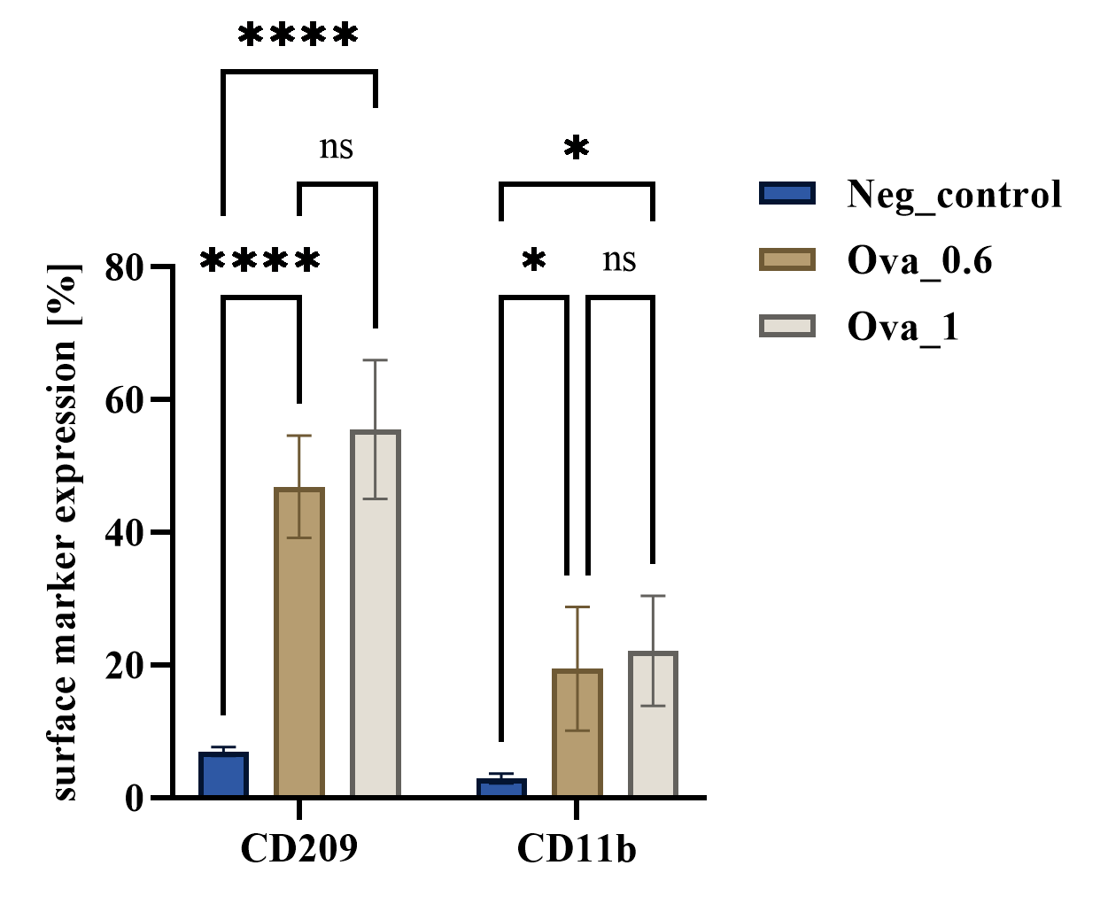
Figure S11. Dose test. Tests of two different concentrations on the efficacy of the mRNA treatment in non-differentiated cells. The treatment efficacy was tested by using two different concentrations of mRNA-OVA.: 0.6 µg per well and 1 µg per well, to determine the optimal concentration for subsequent experiments. CD209 marker expression was 46.8% at 0.6 µg per well and 55.5% at 1 µg per well, compared to 6.9% in the untreated control. For the CD11b marker, the percentages were 2.9% for the untreated control, 19.4% for 0.6 µg per well, and 22.2% for 1 µg per well. Both concentrations produced statistically significant effects compared to the negative CTRL, with no significant differences between the two, suggesting a plateau of efficiency. Thus, 0.6 µg per well of mRNA-OVA can be used effectively without excessive material wastage.

Figure S12. Expression level of CD209 in undifferentiated THP-1 cells. Expression levels of CD209 marker after transfection of undifferentiated THP-1 monocytes with KH NPs and KH NP@THP-1 EVs encapsulating OVA mRNA. Data are presented as mean ± SEM of n = 3. P values were determined by one-way ANOVA with Bonferroni’s correction and ****P < 0.0001.

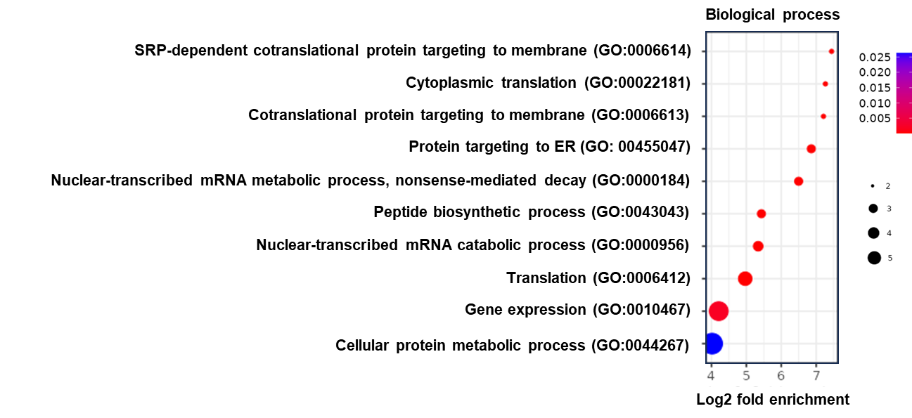

Figure S13. Protein enrichment in biological processes THP-1 EVs and JAWS EVs. Variable importance in projection (VIP) scores of all the proteins contributing to the clustering pattern.

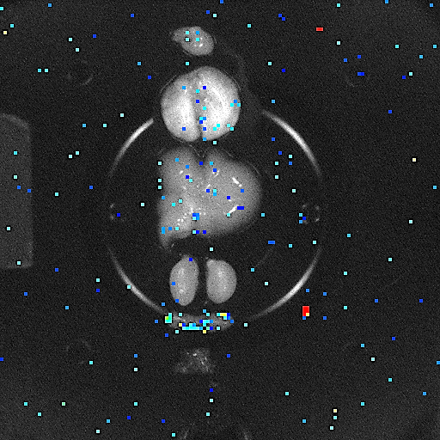
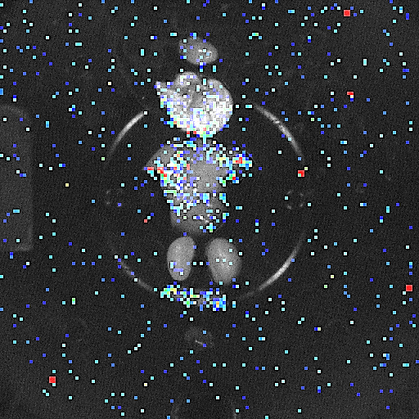
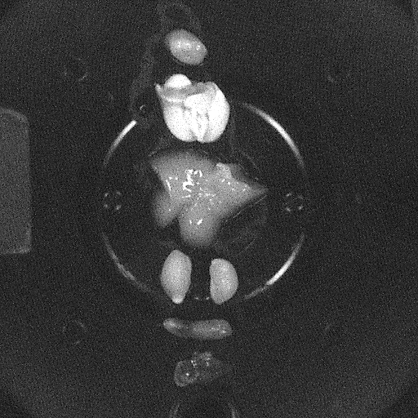
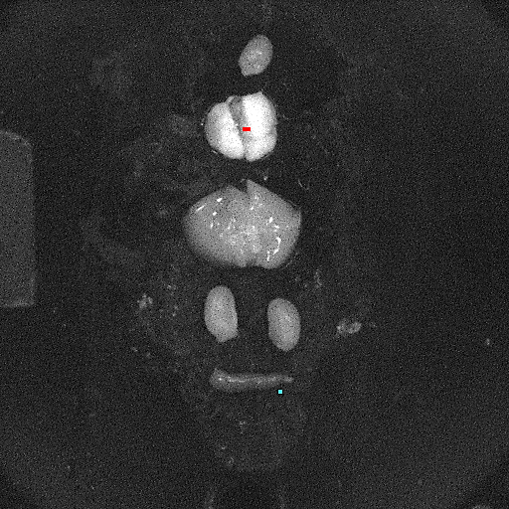
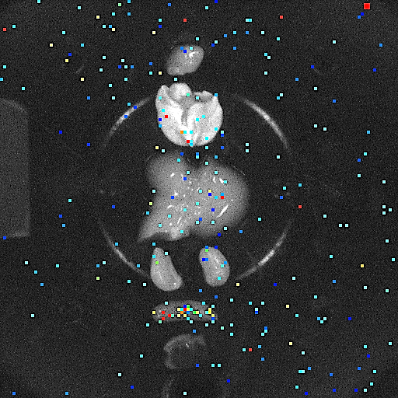
KH-JAWs
KH NPs
CTRL
JAWs EVs
KH-LLC1
Heart
Lung
Liver
Kidneys
Spleen
Tumor

Figure S14. Ex vivo imaging of tumor-bearing mice treated with complex.

Figure S15. Cy3 signal in tumor-bearing mice treated with complex. Cy3 fluorescent signal from lungs.

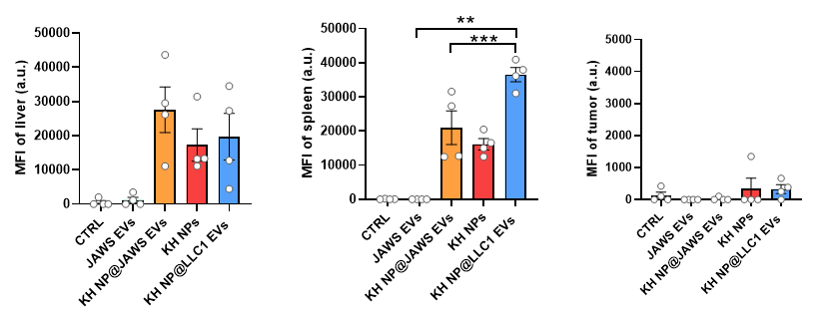

Figure S16. Cy5 signal in tumor-bearing mice treated with complex. Cy5 fluorescent signal from liver, spleen, and tumor.

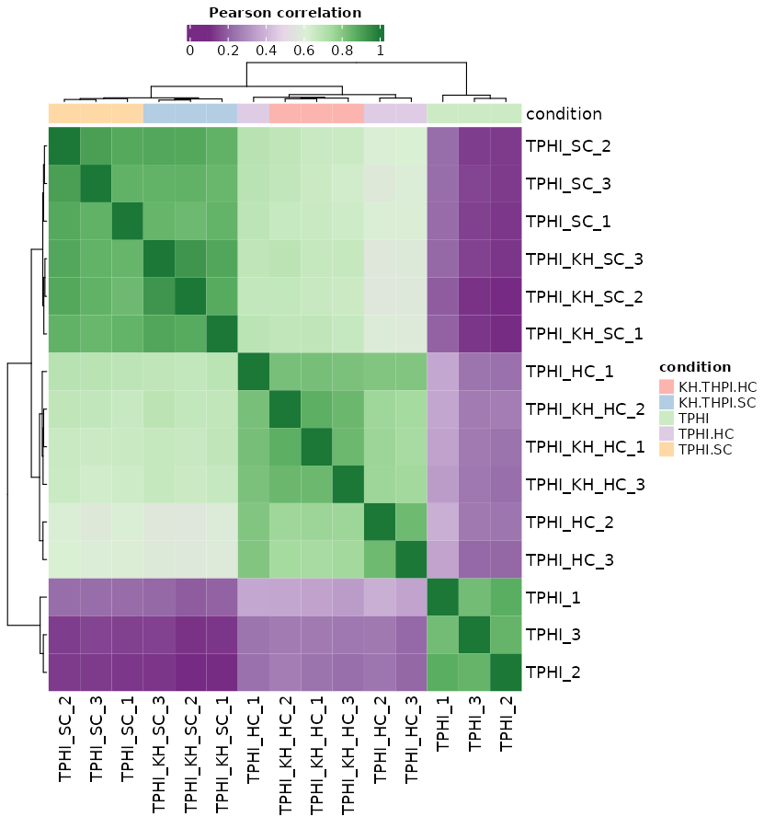

Figure S17. Pearson correlation from HC and SC of THP-1 EVs and KH NP@THP-1 EVs. Bivariate analysis to measure the strengths of association between variables.

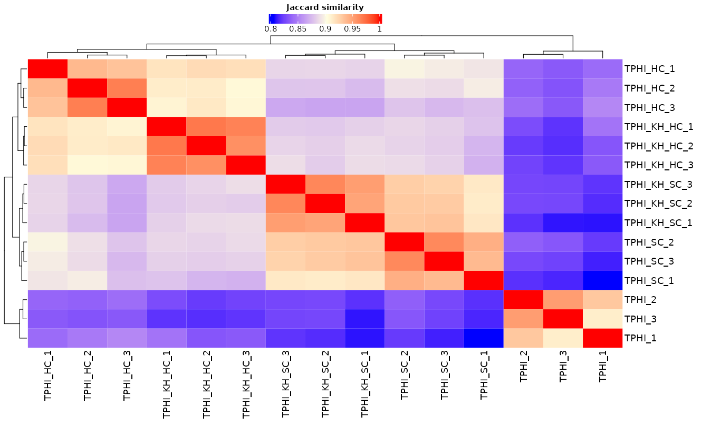

Figure S18. Jaccard similarity from HC and SC of THP-1 EVs and KH NP@THP-1 EVs. Correlation between samples.

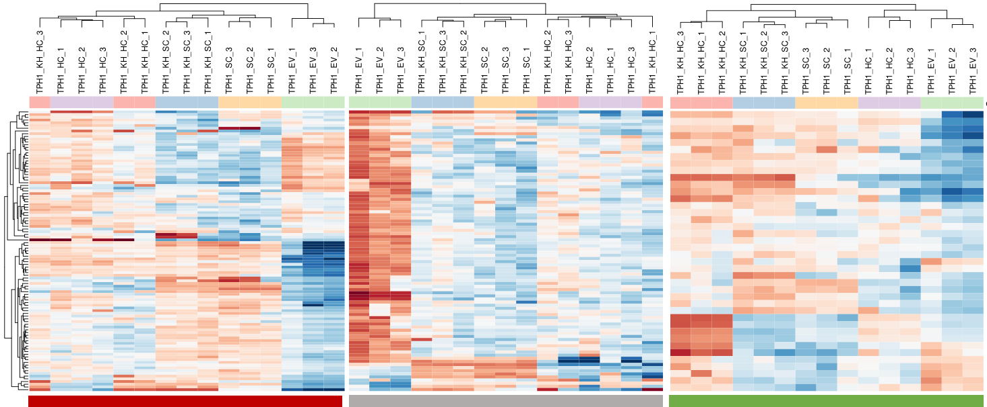

Figure S19. Heatmap of HC and SC of THP-1 EVs and KH NP@THP-1 EVs depending on the biological function. Red is immune system activation, grey is structural and green is cell adhesion.

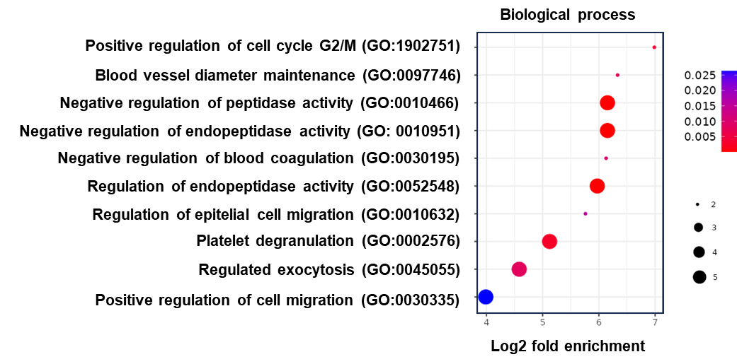

Figure S20. Protein enrichment in biological processes THP-1 EVs and KH@THP-1 EVs HC. Variable importance in projection (VIP) scores of all the proteins contributing to the clustering pattern.

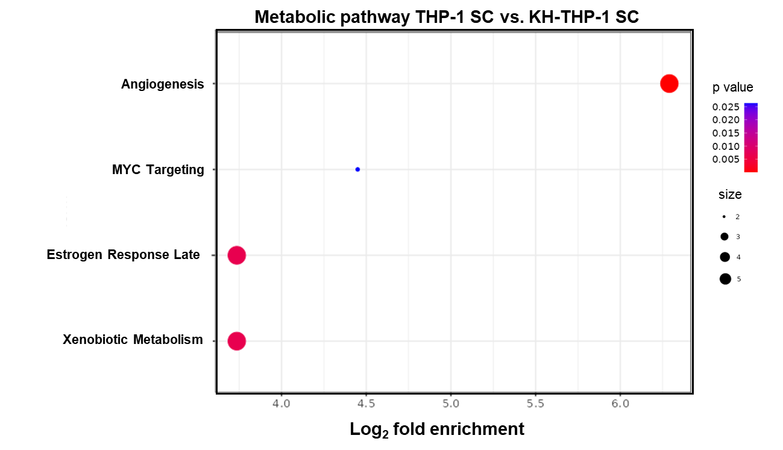
Figure S21. Protein enrichment by metabolic processes comparing SC of THP-1 EVs and KH NP@THP-1 EVs. Variable importance in projection (VIP) scores of all the proteins contributing to the clustering pattern.

