TABLE OF CONTENTS
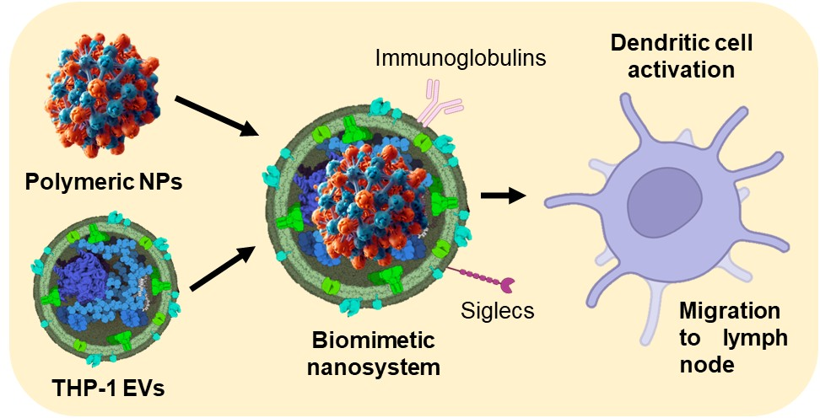
Schematic representation of the biomimetic complexes encapsulating polymeric nanoparticles in extracellular vesicles to target dendritic cells.

