Supplementary Material: Towards coexistence: evaluating the risk of collision of seals swimming within metres of operating tidal turbines

Collision Risk Interaction Scoring Protocol (CRISP) GUIDANCE NOTE

Glossary
Active swimming | Signs of swim behaviour, that the animal is alive. For example, undulating movements, change in direction, swim direction clearly off flowline.
Masked region | Areas of strong sonar reflection caused by seabed or turbine features (e.g. nacelle, ballast blocks) captured by the sonar that mask smaller and weaker animal detections.
Point detections | Detections captured by the movement detector as a series of points, as described in Gillespie et al (2023).
RPM | Unit of rotational speed for the blades on the turbine – revolutions per minute.
RSA | Area that the rotating blades cover in the water column – rotor swept area.
Track | Path an animal takes, where point detections confirm its position.
Trajectory | Path an animal may have taken, including extrapolation beyond the end of a track and interpolation between gaps within a track where a section is missing/not detected.

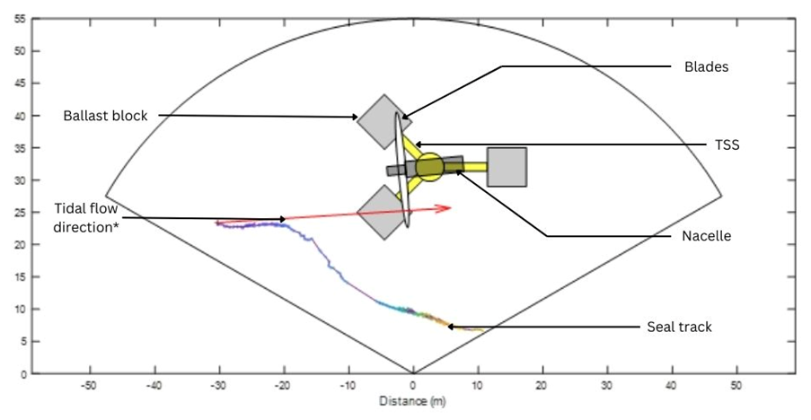
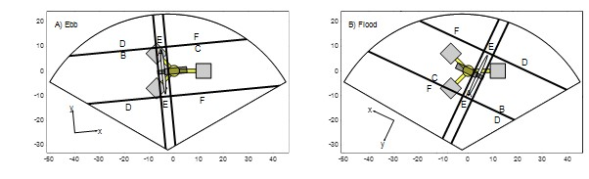
Figure 1: Plan view of an example seal track avoiding the turbine in the MATLAB interface during the ebb tide. The grey and yellow structure in the centre of the swath represents the turbine support structure. The direction of tidal flow is shown by the red arrow, the length of which is the distance that would have been travelled by the seal over the duration of the track were it passively drifting*. The track is colour coded to show the temporal progression of the movement where the blue dots represent the start of a track, and yellow the end. Turbine support structure schematic with the different risk zones, rotated according to a) ebb and b) flood tides.
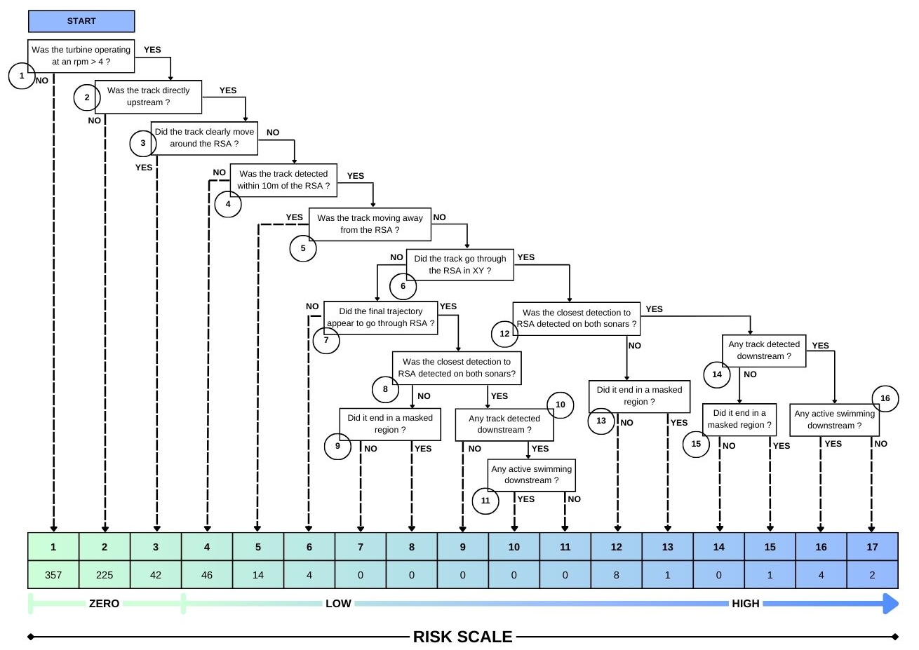
Figure 2: Schematic showing the Collision Risk Interaction Scoring Protocol (CRISP) flowchart. The flowchart is constituted of 17 risk categories, of ascending risk from left to right, CRISP 1 as the lowest risk and CRISP 17 as the highest risk of collision. Each step is defined by a question. Tracks present in CRISP 1 – 4 are processed automatically. Tracks ending in CRISP 5 and more required additional manual assessment. The numbers displayed below each CRISP score in the table correspond to the number of seal tracks categorised into the adjacent CRISP score. For example, 357 seal tracks were detected when the turbine was not operating at an rpm > 4 and categorised as CRISP 1. Note: a higher risk of collision does not mean that a collision occurred.

- Were the blades rotating more than 4 revolutions per minute (rpm)?
- Did the track start in boxes A or B and was it moving in a downstream direction?
- Did the track move clearly around the RSA in the horizontal plane with detection in D and/or E such that the animal has safely passed the turbine.
- Was the track detected within 10m of the RSA, clearly moving towards the RSA or not changing its course within 10m of the RSA? Some animals do not change swim direction (to avoid) or simply swim by the turbine at a distance greater than 10m but disappeared from the image.
- Some tracks were not detected in E or F, so it’s impossible to say that they passed the rotor safely. However, they had a trajectory when last detected that would take them out of danger.
- Were there any point detections in box A, where the RSA is located? As there is a lack of detailed Z (three dimensional) information in this monitoring set up, is there evidence that the track went through the RSA in the horizontal plane (XY)?
- If the track did not go through box A, did the last detected direction of movement suggest the animal could have gone through the RSA? Was there any track downstream that suggests the animal might have passed through the RSA? For example, detections in box B and F but part of the track undetected in between?
- If the closest detection of the track to the RSA was detected on both sonars, this means the animal is more likely to be at the water depth of the rotors.
- If there was no further track downstream, or the track disappeared suddenly, is it likely the track disappeared behind the nacelle, ballast blocks or was masked by strong seabed features visible on the lower sonar?
- Were there any point detections downstream of the RSA, in boxes C or F?
- If there are signs of active swimming in the track post RSA, this suggests the animal avoided collision and had the ability to swim off unharmed.
- If the closest detection of the track was detected on both sonars, this means the animal is approximately at the water depth of the rotors.
- If there was no further track downstream, or the track disappeared suddenly, is it likely the track disappeared behind the nacelle, ballast blocks or was masked by strong seabed features visible on the lower sonar?
- Were there any point detections downstream of the RSA, in boxes C or F?
- If there was no further track downstream, or the track disappeared suddenly, is it likely the track disappeared behind the nacelle, ballast blocks or was masked by strong seabed features visible on the lower sonar?
- If there are signs of active swimming in the track post RSA, this suggests the animal avoided collision and had the ability to swim off unharmed.

High Risk Seal Tracks Narrative

Table 1: Sixteen higher risk seal tracks (CRISP ≥ 12). Each seal track has its corresponding identifier in the database, the date and time of track detection, the tidal flow speed at first detection, the RPM speed the turbine was operating at, the confidence score (CS) associated with the track, the CRISP score, the sonars the track was detected on, whether the track was also detected downstream past the RSA, if the track entered a masked region and if the animal displayed signs of active swimming post RSA.
Hd/uid | Date/Time (UTC) | Flow speed (m/s) | RPM | CS | CRISP | Sonars | Track det DS | Masked region | Active swim
5/2790 | 2022-06-27 14:37:24 | -2.16 | 13.3 | 3 | 17 | Both | Yes | No | No
33/310 | 2023-01-11 22:09:07 | 2.1 | 13.5 | 2 | 17 | Both | Yes | No | No
12/683 | 2022-07-16 08:10:54 | 2.0 | 14.8 | 2 | 16 | Both | Yes | No | Yes
19/111 | 2022-08-16 22:55:54 | 3.4 | 15.0 | 4 | 16 | Both | Yes¹ | No | Yes
23/1988 | 2022-11-15 18:10:15 | -1.7 | 10.1 | 5 | 16 | Both | Yes | No | Yes
33/111 | 2023-01-05 02:36:06 | -1.9 | 12.1 | 3 | 16 | Both | Yes | No | Yes
31/727 | 2022-11-30 01:19:10 | 2.4 | 14.8 | 4 | 15 | Both | No | No | No
19/848 | 2022-08-27 00:34:06 | -1.8 | 13.8 | 4 | 13 | Upper* | Yes | No | No
19/657 | 2022-08-24 18:47:35 | 2.4 | 11.4 | 2 | 12 | Lower | Yes¹ | No | Yes
23/2926 | 2022-11-21 17:56:48 | 3.0 | 15.3 | 2 | 12 | Upper+ | Yes¹ | Yes | Yes
31/1112 | 2022-12-04 00:12:58 | -2.6 | 14.9 | 3 | 12 | Upper+ | Yes¹ | No | Yes
33/199 | 2023-01-08 04:47:27 | -1.7 | 8.1 | 3 | 12 | Upper+ | Yes | No | Unsure
33/389 | 2023-01-14 01:17:48 | 2.4 | 12.8 | 2 | 12 | Upper+ | Yes¹ | No | No
38/244 | 2023-03-31 05:33:42 | 1.3 | 7.0 | 4 | 12 | Lower+ | Yes¹ | No | No
38/755 | 2023-04-12 16:40:38 | -1.3 | 8.8 | 3 | 12 | Lower | Yes | No | No
38/1253 | 2023-04-21 06:04:16 | 0.3 | 6.1 | 5 | 12 | Lower | Yes¹ | No | Yes

Table key:
¹ manual review picked up track downstream, missed by movement detector
+ manual review deemed false detection on other sonar
* other sonar not working

Track plots, associated metadata, and descriptive narrative of the sixteen highest risk tracks, ordered from highest to lowest risk (CRISP 17 to 12).

Hd/uid | Date/Time (UTC) | Flow speed (m/s) | RPM | CS | CRISP | Sonars | Track det DS | Masked region | Active swim
5/2790 | 2022-06-27 14:37:24 | -2.16 | 13.3 | 3 | 17 | Both | Yes | No | No

Clear track that passes through the RSA in the horizontal plane at the far side of the nacelle, where resolution is relatively poor. Upstream, the track is clearly detected on both sonars, indicating that it is mid-water column. Downstream, the track appears to split into multiple targets and becomes lower intensity, which may be due to the animal orientating sideways. The track also appeared to slow down in the main direction of travel after passing the RSA.

Hd/uid | Date/Time (UTC) | Flow speed (m/s) | RPM |  | CS | CRISP | Sonars | Track det DS | Masked region | Active swim
33/310 | 2023-01-11 22:09:07 | 2.1 |  | 13.5 | 2 | 17 | Both | Yes | No | No

Track passes through the RSA in the horizontal plane. Upstream, the track is clearly detected on both sonars, indicating that it is mid-water column. Downstream, the track is primarily on the upper sonar, indicating that the animal has moved up in the water column. However, track detection on the lower sonar may have been masked by the ballast block, so this is uncertain. Closer inspection indicates that two separate objects were moving towards the RSA, indicating that this may be two smaller objects, and possibly isn’t a seal (CS = 2).

Hd/uid | Date/Time (UTC) | Flow speed (m/s) | RPM | CS | CRISP | Sonars | Track det DS | Masked region | Active swim
12/683 | 2022-07-16 08:10:54 | 2.0 | 14.8 | 2 | 16 | Both | Yes | No | Yes

Track passes through the RSA in the horizontal plane. Although detections are present on both sonars upstream, it is likely that those on the lower sonar are false detections from the turbine ballast blocks. Some points close to the RSA are also likely false detections. The swim direction at the end of the track is sufficiently off the flow line that it is likely to be actively swimming; there is also apparent movement in the hind flippers that suggests active swimming.

Hd/uid | Date/Time (UTC) | Flow speed (m/s) | RPM | CS | CRISP | Sonars | Track det DS | Masked region | Active swim
19/111 | 2022-08-16 22:55:54 | 3.4 | 15.0 | 4 | 16 | Both | Yes/manual | No | Yes

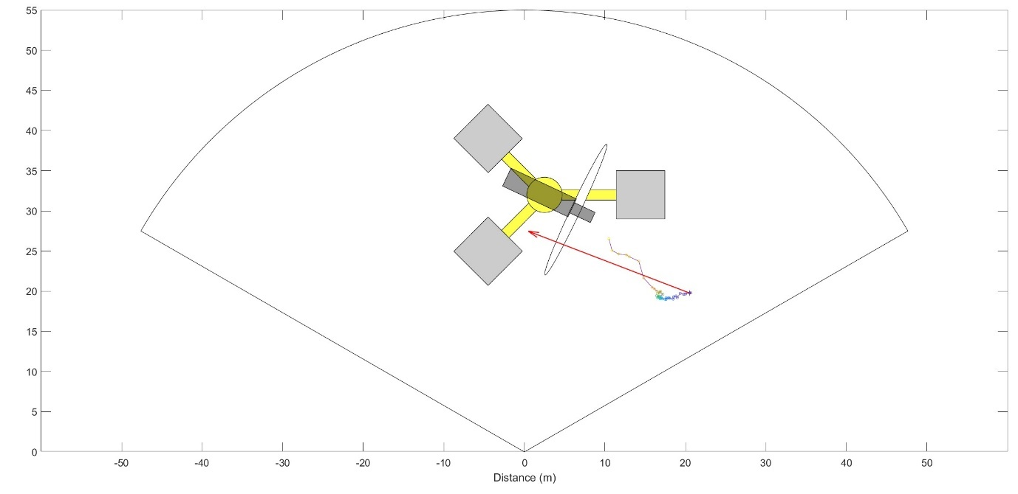
Track passes through the RSA in the horizontal plane. The movement detector did not detect this but it is visible on the raw sonar data. Track moves down in the water column immediately upstream of the RSA. The track moves through the RSA in the horizontal plane on the lower sonar then on the upper sonar downstream of the RSA. This latter part of the track visible on both sonars was picked up by the movement detector but was missed by the reviewer.

Hd/uid | Date/Time (UTC) | Flow speed (m/s) | RPM | CS | CRISP | Sonars | Track det DS | Masked region | Active swim
23/1988 | 2022-11-15 18:10:15 | -1.7 | 10.1 | 5 | 16 | Both | Yes | No | Yes

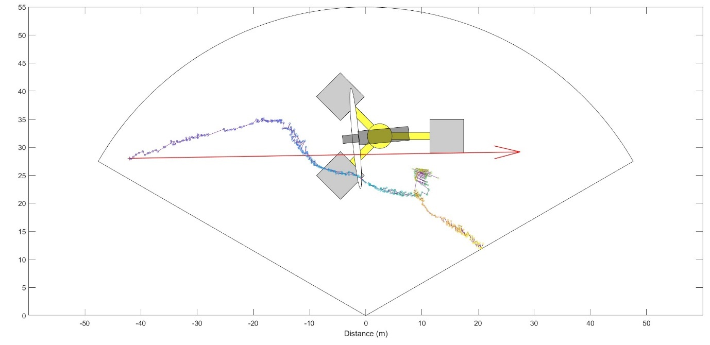
The animal is initially detected primarily on the upper sonar. It exhibits a clear change in swim direction 13 metres directly upstream of the RSA. It then moves down in the water column and is detected visible on the lower sonar. It moves through the RSA in the horizontal plane while being primarily detected on the lower sonar. Downstream of the RSA, it moves in a circle to become stationary oriented towards the turbine before actively swimming downstream.

Hd/uid | Date/Time (UTC) | Flow speed (m/s) | RPM | CS | CRISP | Sonars | Track det DS | Masked region | Active swim
33/111 | 2023-01-05 02:36:06 | -1.9 | 12.1 | 3 | 16 | Both | Yes | No | Yes

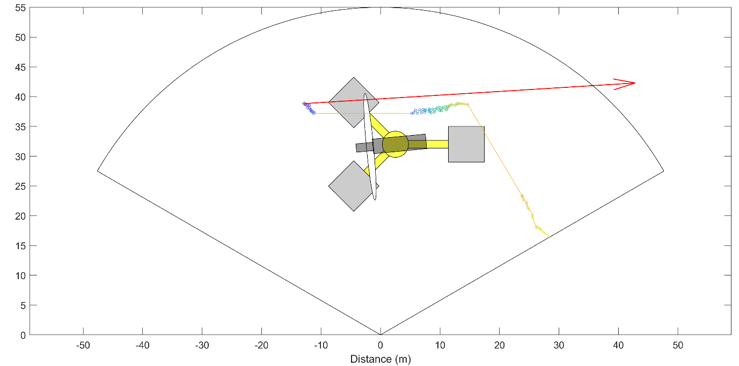
The animal is detected on both sonars and swims across the edge of the RSA in the horizontal plane on the far side of the nacelle (not detected by movement detector). The animal exhibits a significant deviation off the flowline indicating active swimming downstream of the RSA.

Hd/uid | Date/Time (UTC) | Flow speed (m/s) | RPM | CS | CRISP | Sonars | Track det DS | Masked region | Active swim
31/727 | 2022-11-30 01:19:10 | 2.4 | 14.8 | 4 | 15 | Both | No | No | No

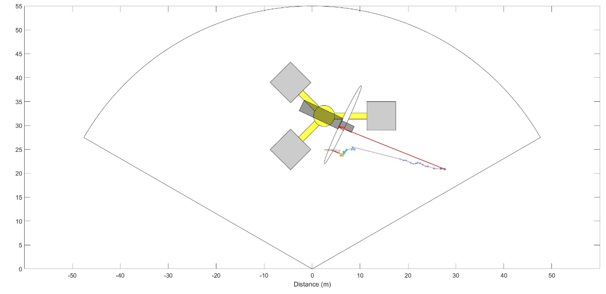
The track is detected primarily on the upper sonar moving towards the RSA, before changing direction approximately 3 metres from the RSA. The track moves through the RSA in the horizontal plane and increasingly becomes visible on lower sonar. Some false detections generated by turbine blades. Animal is visible moving downstream of the RSA, but this part of the track is not detected by the movement detector.

Hd/uid | Date/Time (UTC) | Flow speed (m/s) | RPM | CS | CRISP | Sonars | Track det DS | Masked region | Active swim
19/848 | 2022-08-27 00:34:06 | -1.8 | 13.8 | 4 | 13 | Upper* | Yes | No | No

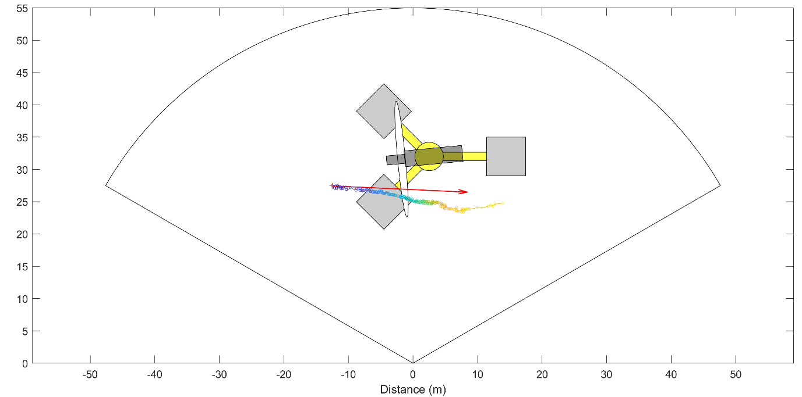
The track moves through the RSA in the horizontal plane; however, the lower sonar was not operational during this event and it is not possible to determine the depth of the track.

Hd/uid | Date/Time (UTC) | Flow speed (m/s) | RPM | CS | CRISP | Sonars | Track det DS | Masked region | Active swim
19/657 | 2022-08-24 18:47:35 | 2.4 | 11.4 | 2 | 12 | Lower | Yes¹ | No | Yes

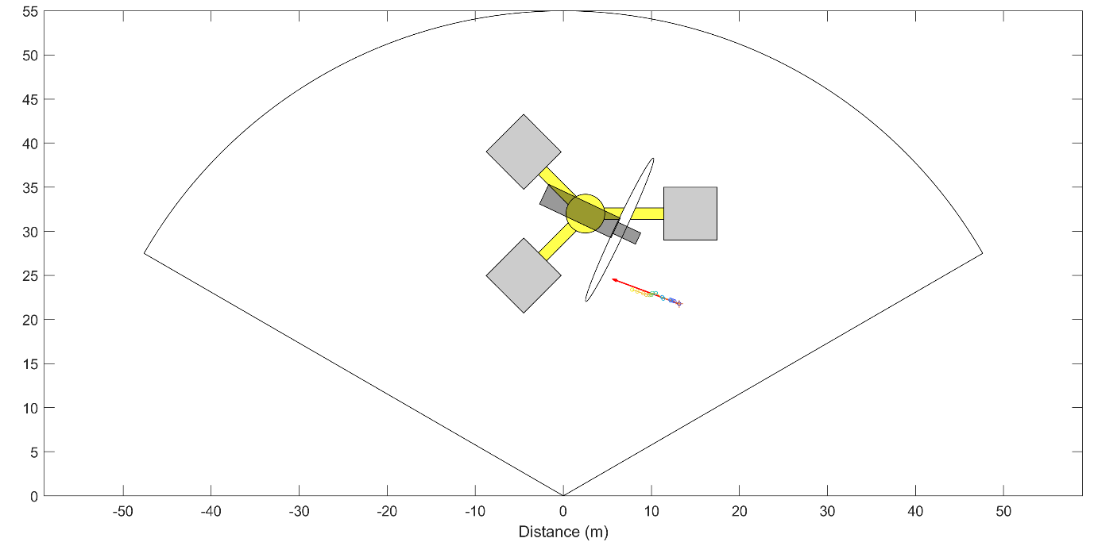
The track was exclusively detected on the lower sonar. It goes through the RSA in the horizontal plane; however, this is not detected by the movement detector but is visible in the raw sonar data. It is visible downstream of the RSA displaying signs of active swimming on the lower sonar.

Hd/uid | Date/Time (UTC) | Flow speed (m/s) | RPM | CS | CRISP | Sonars | Track det DS | Masked region | Active swim
23/2926 | 2022-11-21 17:56:48 | 3.0 | 15.3 | 2 | 12 | Upper+ | Yes | Yes | No

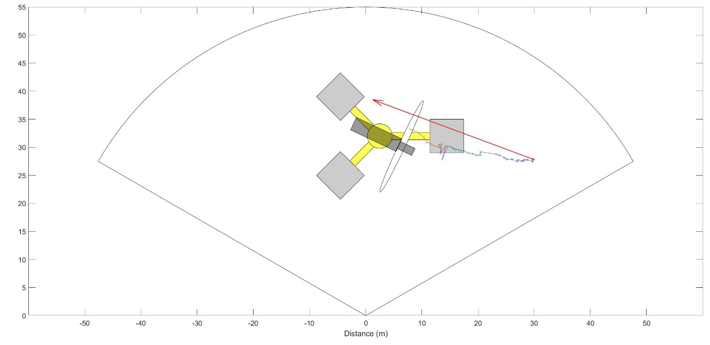
Track is detected upstream of the RSA on the upper sonar. A small number of false detections present on the lower sonar, manually determined to be caused by seabed features. Track enters a masked region to the far side the nacelle. The track is visible downstream of the RSA in the raw data but is not detected by the movement detector. Hind flippers observed moving downstream of the RSA in the raw sonar data.

Hd/uid | Date/Time (UTC) | Flow speed (m/s) | RPM | CS | CRISP | Sonars | Track det DS | Masked region | Active swim
31/1112 | 2022-12-04 00:12:58 | -2.6 | 14.9 | 3 | 12 | Upper | Yes | No | Yes

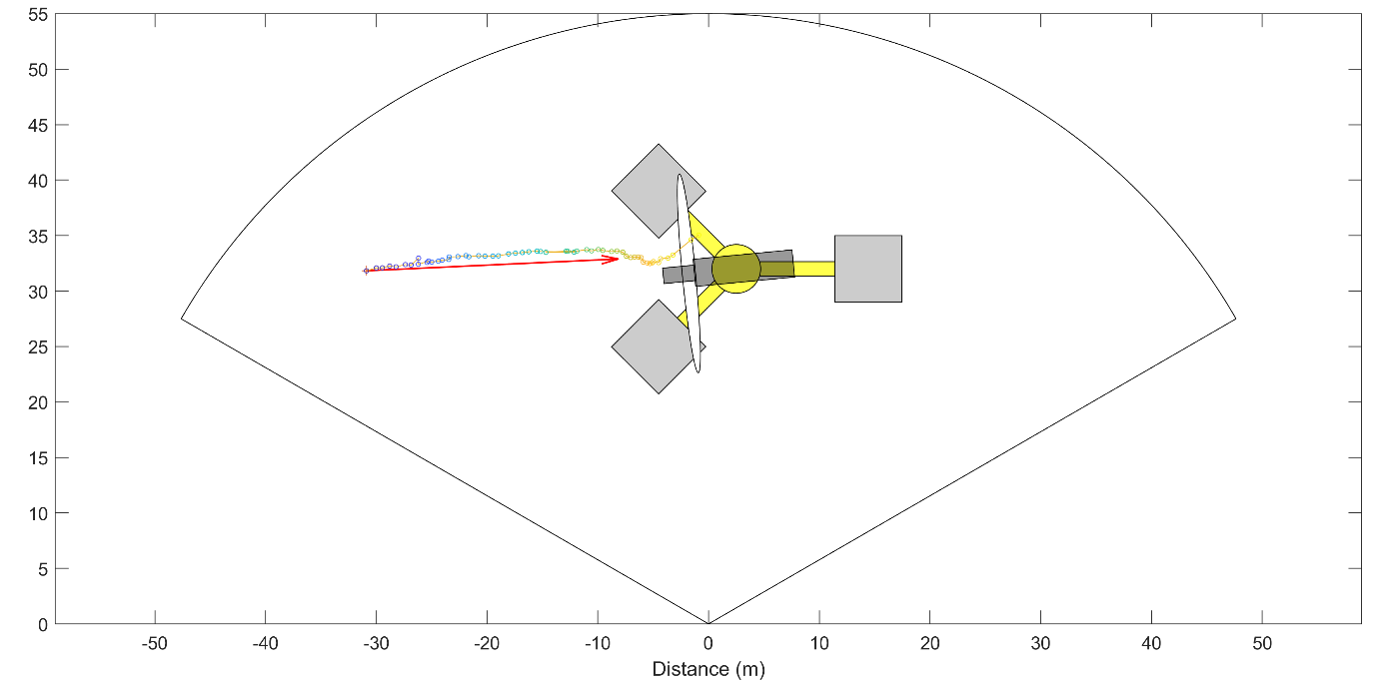
The track is detected on the upper sonar, with a number of false detections on the lower sonar. It moves up to the RSA in the horizontal plane, moves perpendicular to the blades and is visible swimming actively away downstream from the RSA; this was not detected by the movement detector.

Hd/uid | Date/Time (UTC) | Flow speed (m/s) | RPM | CS | CRISP | Sonars | Track det DS | Masked region | Active swim
33/199 | 2023-01-08 04:47:27 | -1.7 | 8.1 | 3 | 12 | Upper+ | Yes | No | Unsure

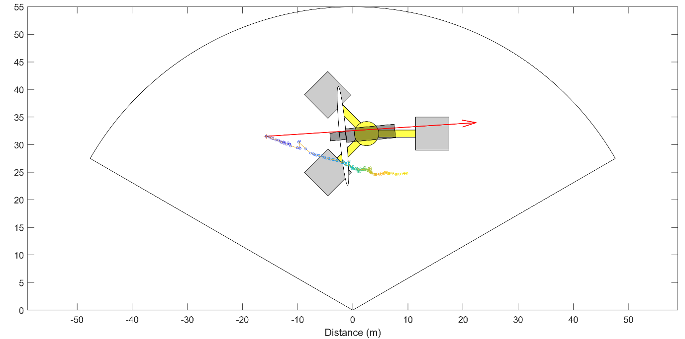
The track goes through the RSA in the horizontal plane. It is detected downstream of the RSA on the upper sonar, with some undulations in the target immediately downstream of the RSA. These undulations could have been caused by the change in hydrodynamics rather than active swimming. It disappears from sonar view before displaying further signs of active swimming.

Hd/uid | Date/Time (UTC) | Flow speed (m/s) | RPM | CS | CRISP | Sonars | Track det DS | Masked region | Active swim
33/389 | 2023-01-14 01:17:48 | 2.4 | 12.8 | 2 | 12 | Upper* | Yes/manual | No | No

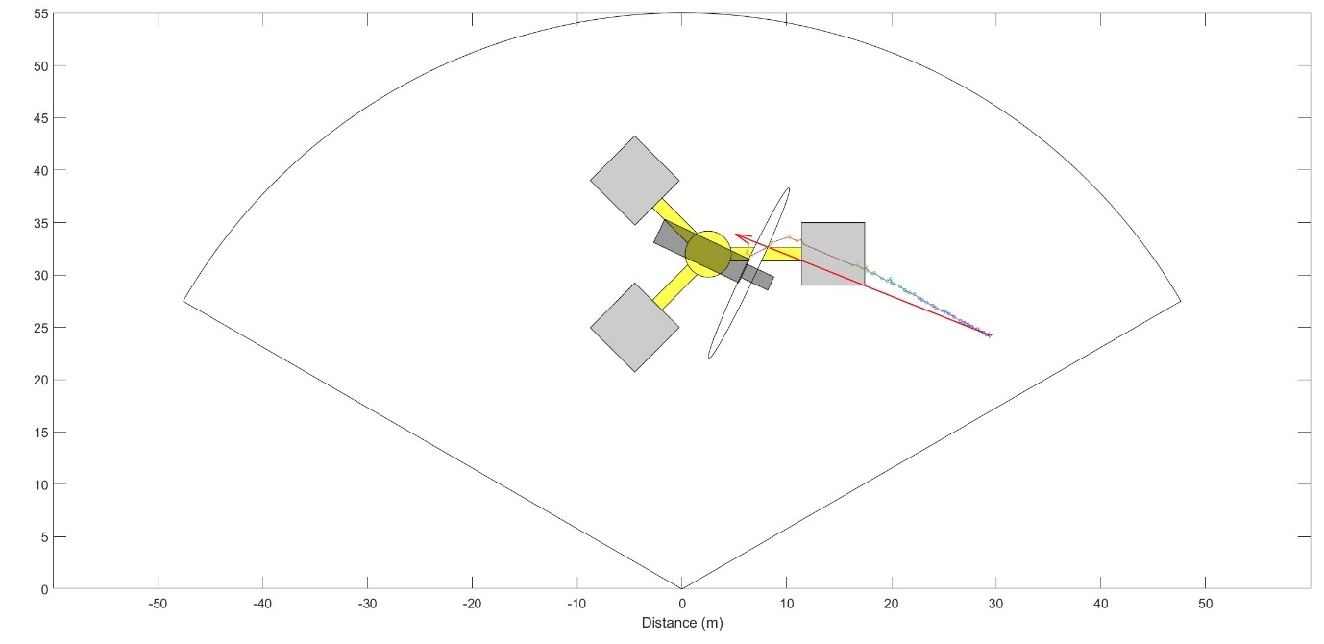
Track is detected on the upper sonar moving through the RSA in the horizontal plane and reappears directly downstream of the RSA before entering a masked region (nacelle). The track downstream of the RSA not detected by the movement detector. False detections on the lower sonar cause by ballast block and seabed features.

Hd/uid | Date/Time (UTC) | Flow speed (m/s) | RPM | CS | CRISP | Sonars | Track det DS | Masked region | Active swim
38/244 | 2023-03-31 05:33:42 | 1.3 | 7.0 | 4 | 12 | Lower+ | Yes/manual | No | No

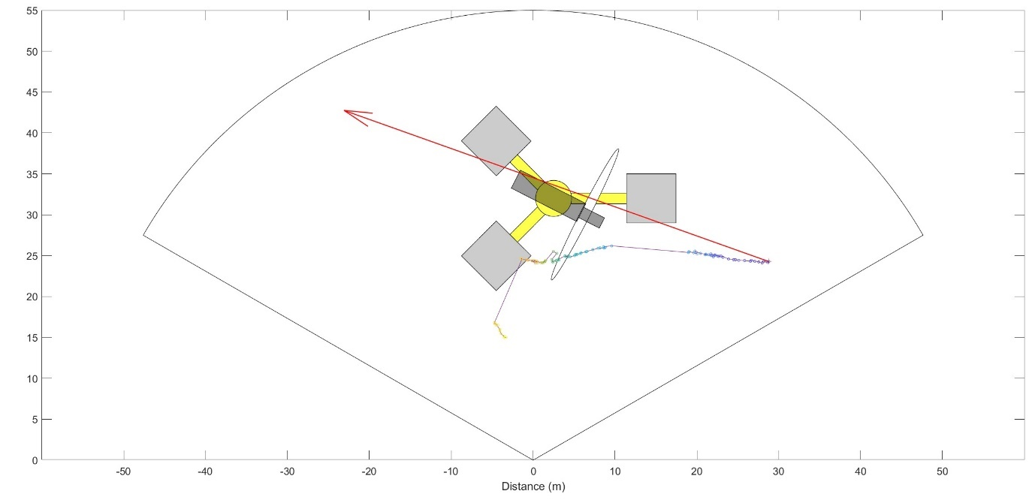
Track is detected upstream of the RSA on the lower sonar, with a small number of false detections on upper sonar caused by sonar interference. Track moves through the RSA in the horizontal plane evidence of active swimming downstream of the RSA with a perpendicular change in direction.

Hd/uid | Date/Time (UTC) | Flow speed (m/s) | RPM | CS | CRISP | Sonars | Track det DS | Masked region | Active swim
38/755 | 2023-04-12 16:40:38 | -1.3 | 8.8 | 3 | 12 | Lower | Yes | No | No
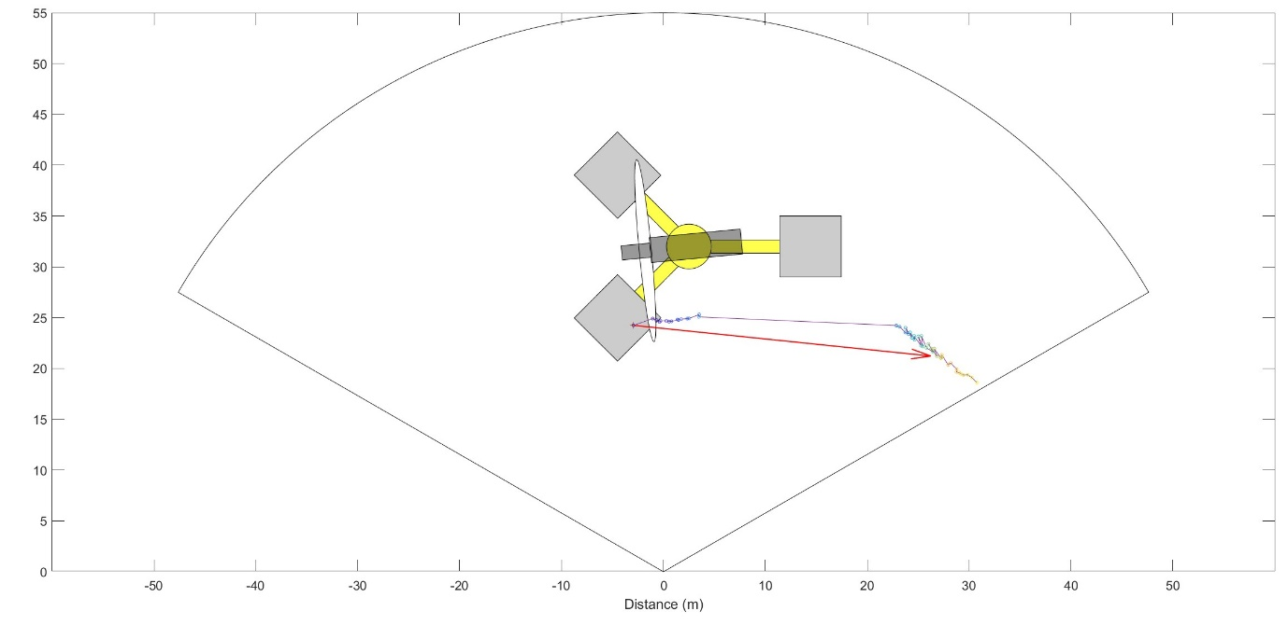
No track visible on either sonar until immediately in front of RSA, then only visible on lower sonar. Appears to swim across RSA, and swims near ballast blocks. Then appears from behind ballast block, evidence of active swimming downstream.

Hd/uid | Date/Time (UTC) | Flow speed (m/s) | RPM | CS | CRISP | Sonars | Track det DS | Masked region | Active swim
38/1253 | 2023-04-21 06:04:16 | 0.3* | 6.1 | 5 | 12 | Lower | Yes¹ | No | Yes
Visible only on lower sonar, so assumed close to bottom with large gap in track caused by animal being masked behind bottom features. Note that this event occurred very close to turbine startup and the nearest flow data is lower than the normal operational threshold. However, the turbine is clearly rotating in the sonar data.

References:
Gillespie, D., Hastie, G., Montabaranom, J., Longden, E., Rapson, K., Holoborodko, A., & Sparling, C. (2023). Automated detection and tracking of marine mammals in the vicinity of tidal turbines using multibeam sonar. Journal of Marine Science and Engineering, 11(11), 2095.
Onoufriou, J., Brownlow, A., Moss, S., Hastie, G., & Thompson, D. (2019). Empirical determination of severe trauma in seals from collisions with tidal turbine blades. Journal of Applied Ecology, 56(7), 1712-1724.

