Supplementary Information for
Spatiotemporal Variability and Tectonic Implications of Very Low-Frequency Earthquakes in the Southwestern Ryukyu Trench
Mamoru Nakamura^{1,2} and Ren Yakabu^{1,3}
¹ Faculty of Science, University of the Ryukyus, Japan.
² Disaster Prevention Research Center for Island Region, University of the Ryukyus, Japan.
³ Nippon Geophysical Prospecting Co., Ltd.

Additional File 2
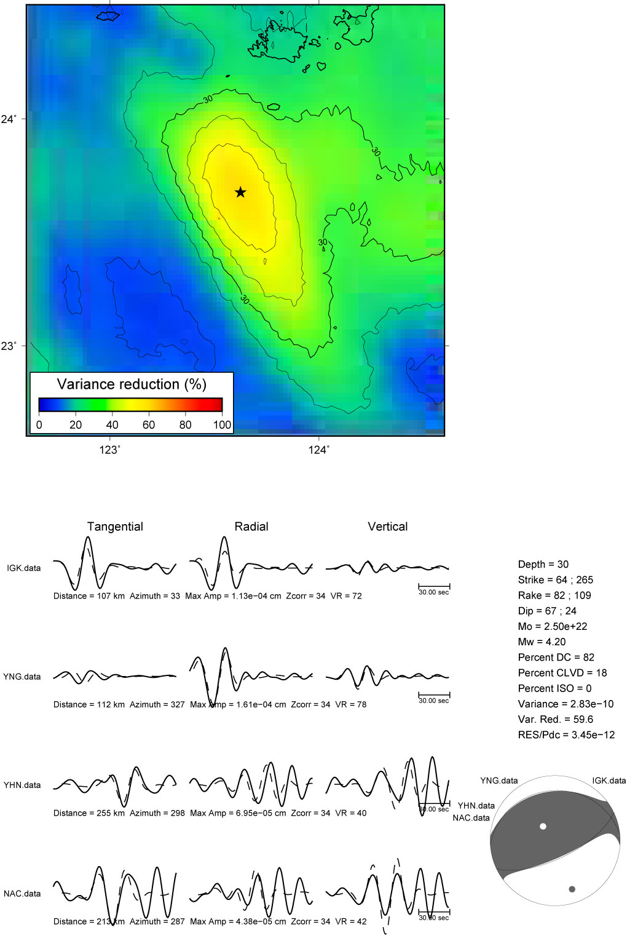
Figure S1. Template VLFE on October 22, 2015, at 20:00. (a) Variance reduction distribution. (b) Observed and synthetic waveforms. (c) CMT solution.
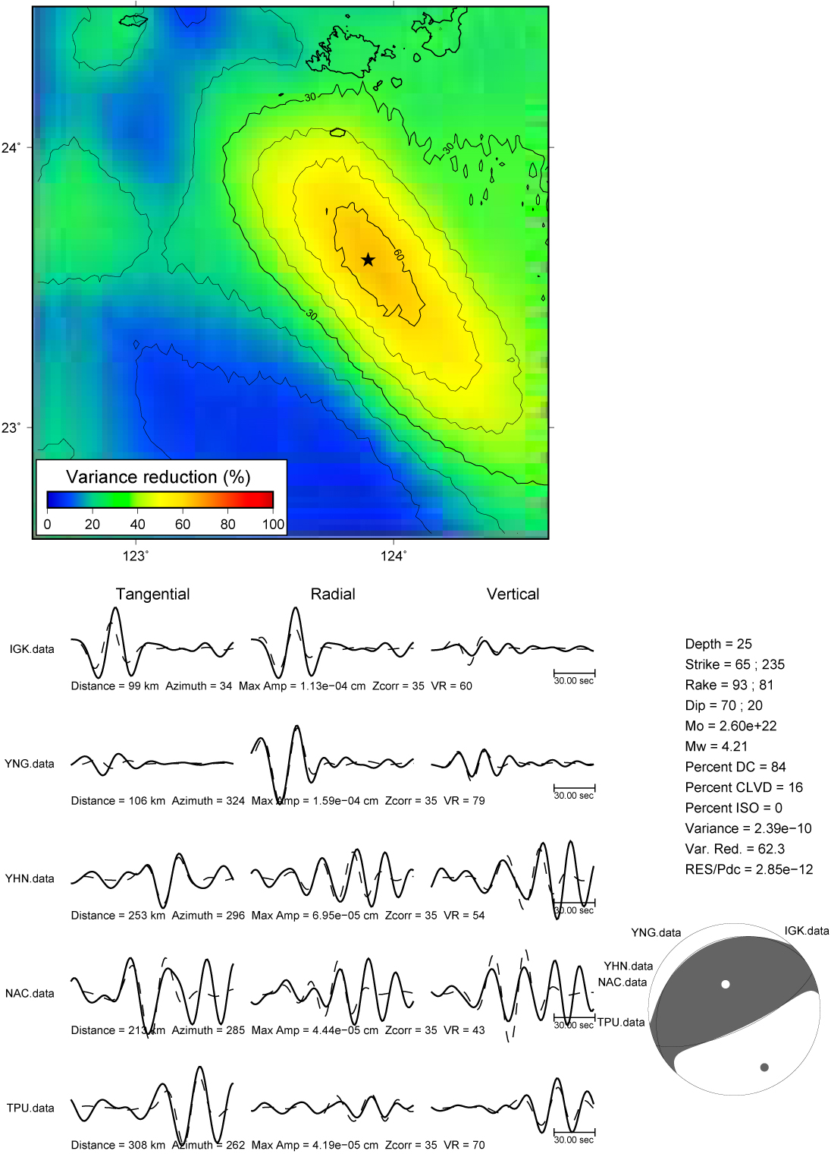
Figure S2. Template VLFE on February 20, 2017, at 03:10. (a) Variance reduction distribution. (b) Observed and synthetic waveforms. (c) CMT solution.

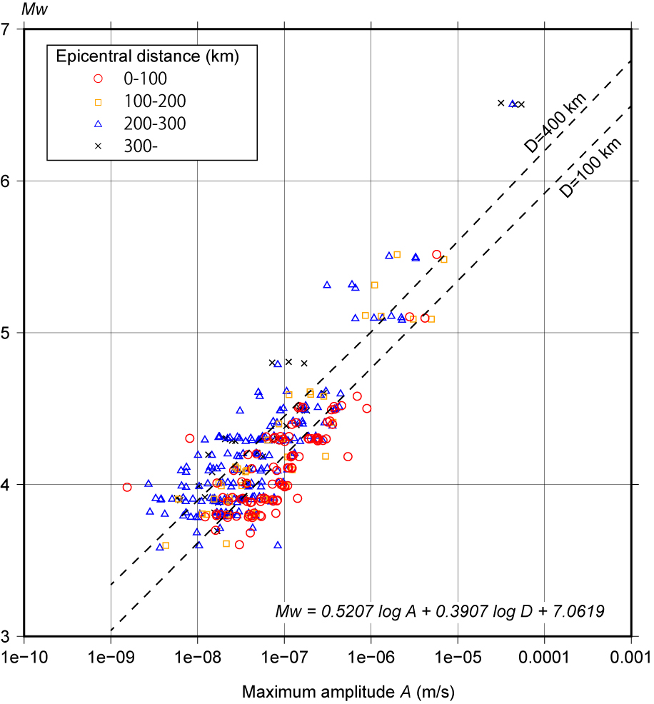
Figure S3. Relationship between moment magnitude and maximum amplitude. Mw: moment magnitude of thrust-type earthquakes southwest of Yonaguni Island. A: maximum amplitude (m/s) in the 0.02–0.05 Hz frequency range. D: epicentral distance (km).

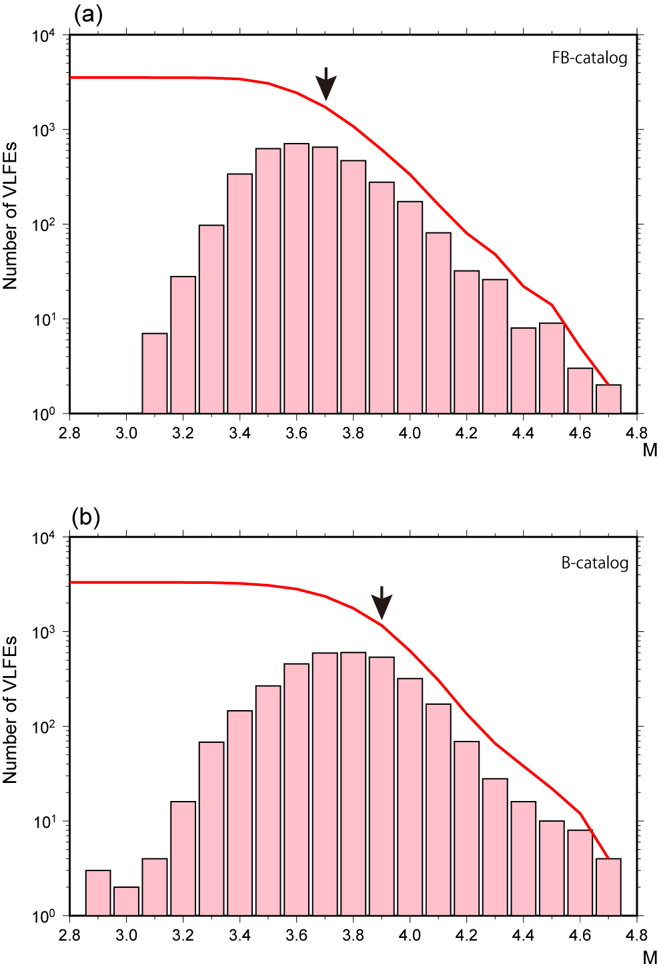
Figure S4. Magnitude–frequency distribution. (a) FB-catalog. Arrows indicate the magnitude of completeness. (b) B-catalog. Arrows indicate the magnitude of completeness.

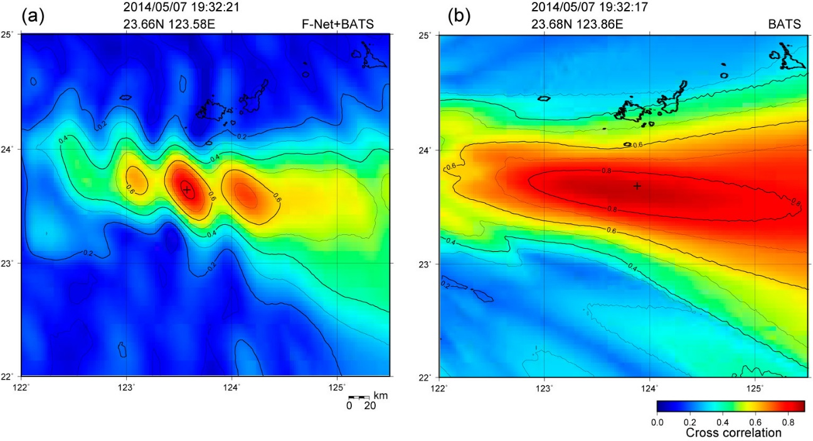
Figure S5. Errors in VLFE epicenter determination. (a) FB-catalog. (b) B-catalog.

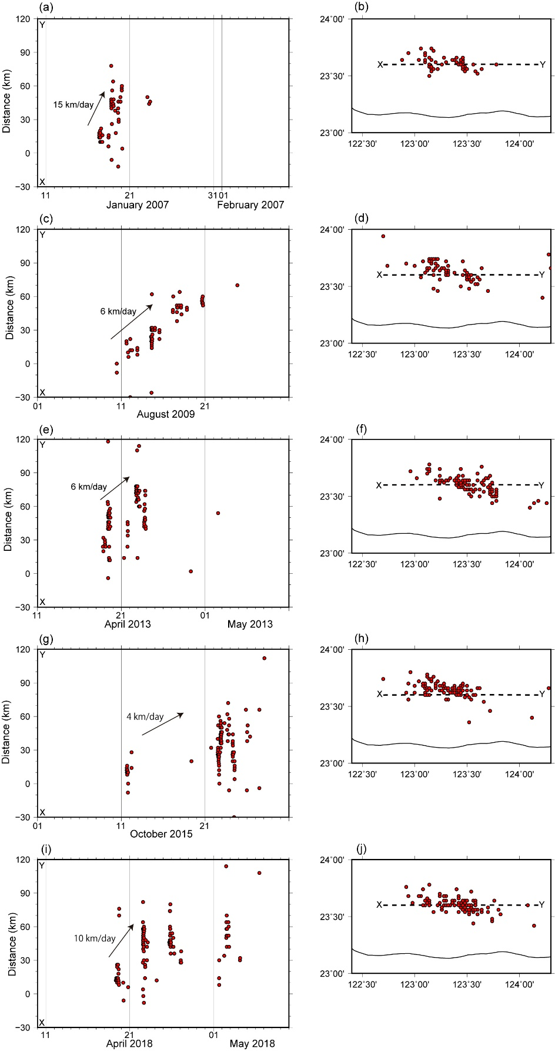
Figure S6. Swarm activity of VLFEs with migration patterns. (a, b) January 2007. (c, d) April 2013. (e, f) October 2015. (g, h) April 2018. Left panels: spatiotemporal distributions; right panels: spatial distributions.
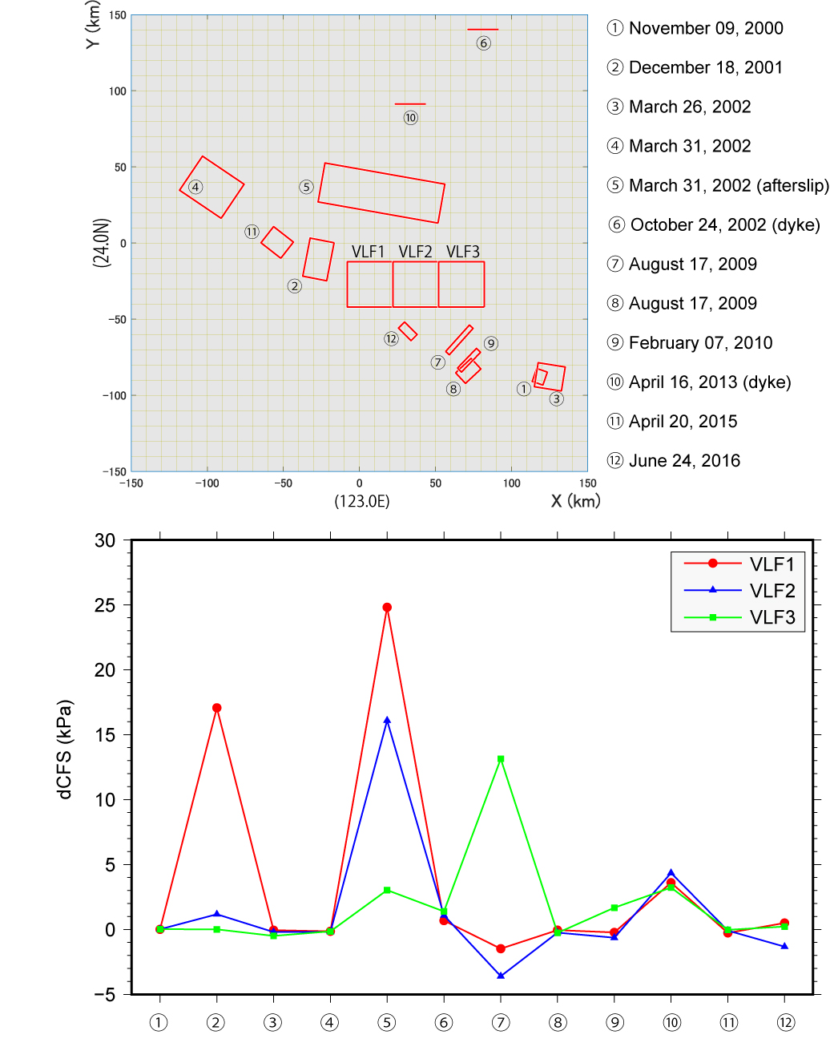
Figure S7. Coulomb stress changes in the VLFE region due to earthquakes, afterslip, and dike intrusion. ΔCFS calculations were performed using Coulomb 3.3 (Lin and Stein 2004; Toda et al. 2005). Regions VLF1 to VLF3 were modeled at 15 km depth, with dimensions of 30 km × 30 km, strike of 270°, and dip of 9°. Stress changes due to thrust-type slip were computed. Fault parameters are listed in Table S3.

