Supplementary Information for

Climate change projected to exacerbate the economic costs of biological invasions

Shimin Gu^{1,†}, Shengnan Chen^{2,†}, Weishan Tu^{1,3}, Lixia Han^{1,4}, Qing Zhang^{1,5,6}, Yanhua Hong⁷, Zhiqiang Lin⁸, Yuanbao Du¹, Wenbo Liao^{2,*}, and Xuan Liu^{1,6,*}

¹ Sate Key Laboratory of Animal Biodiversity Conservation and Integrated Pest Management, Institute of Zoology, Chinese Academy of Sciences, Beijing, 100101, China
² Key Laboratory of Southwest China Wildlife Resources Conservation (Ministry of Education), China West Normal University, Nanchong, 637009, China
³ School of Life Sciences, Division of Life Sciences and Medicine, University of Science and Technology of China, Hefei, 230026, China
⁴ Huazhong Agricultural University, Wuhan, 430000, China
⁵ Laboratory of Island Biogeography and Conservation Biology, College of Life Sciences, Nanjing Normal University, Nanjing, 210023, China
⁶ University of Chinese Academy of Sciences, Beijing, 100049, China
⁷ Key Laboratory for Conserving Wildlife with Small Populations in Yunnan, Southwest Forestry University, Kunming, 650224, China
⁸ College of Life Sciences, Shihezi University, Shihezi, 832003, China

†S.G. and S.C. contribute equally to this work
*To whom correspondence may be addressed. Email: liuxuan@ioz.ac.cn; liaobo_0_0@126.com

Correspond Authors: Xuan Liu, Wenbo Liao
Email: liuxuan@ioz.ac.cn, liaobo_0_0@126.com

This file includes:

Supplementary Fig. 1 to Fig. 14
Supplementary Table 1 to Table 7
Legends for Supplementary Data 1 to Data 10
Supplementary References
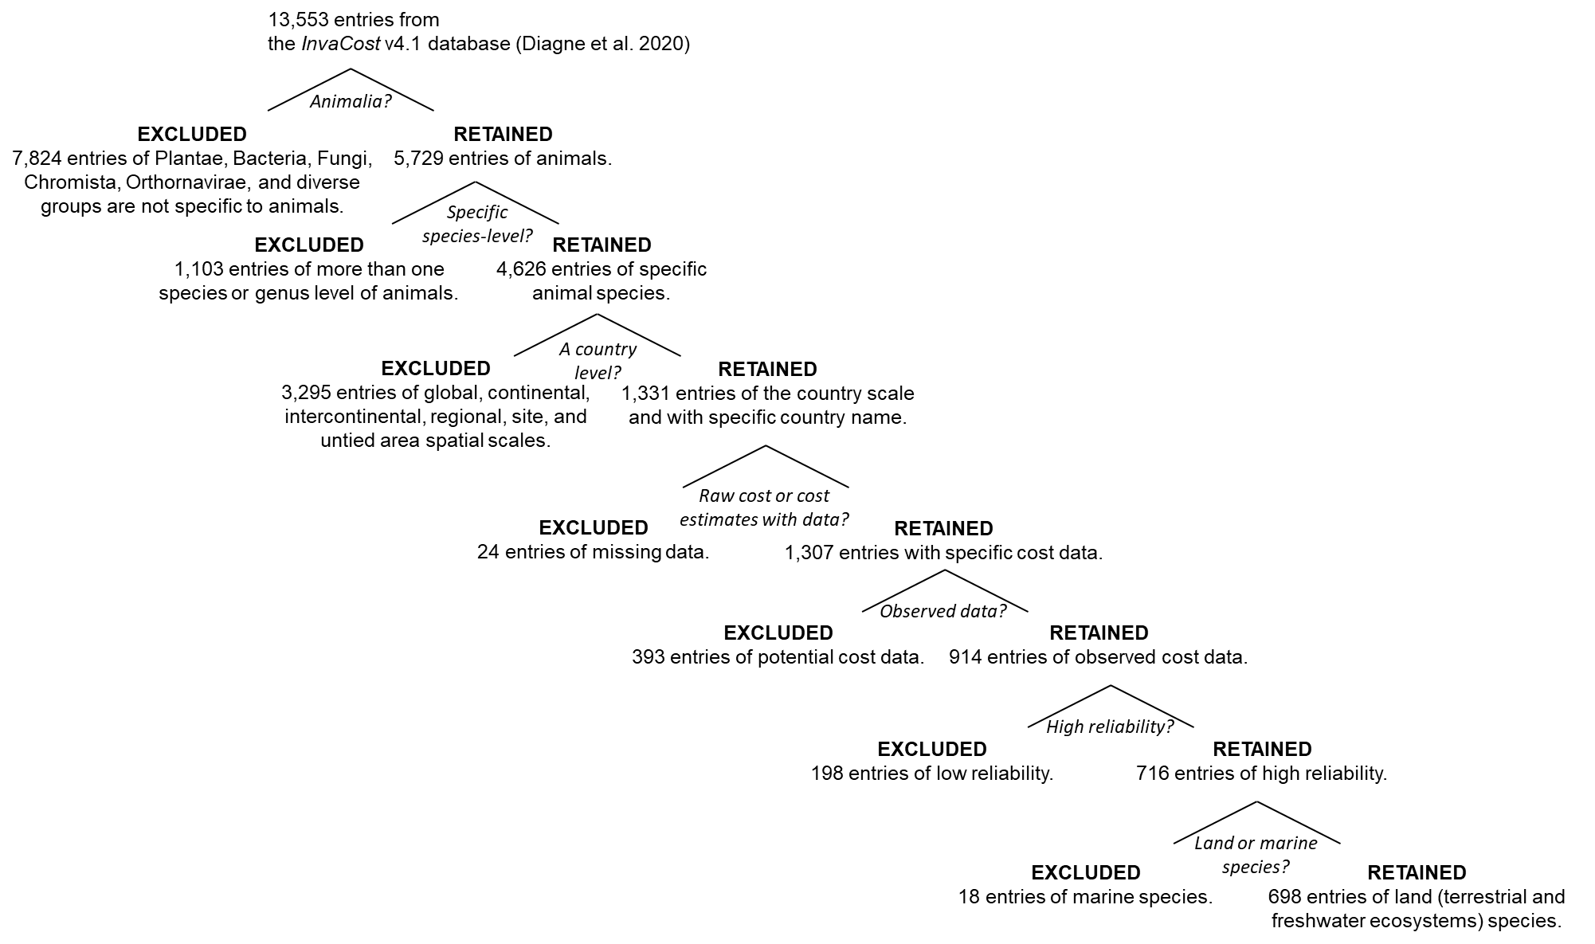

Supplementary Fig. 1 | Flow diagram showing filtering steps from the original InvaCost v4.1 database ¹ to the target sub-dataset of analyses.

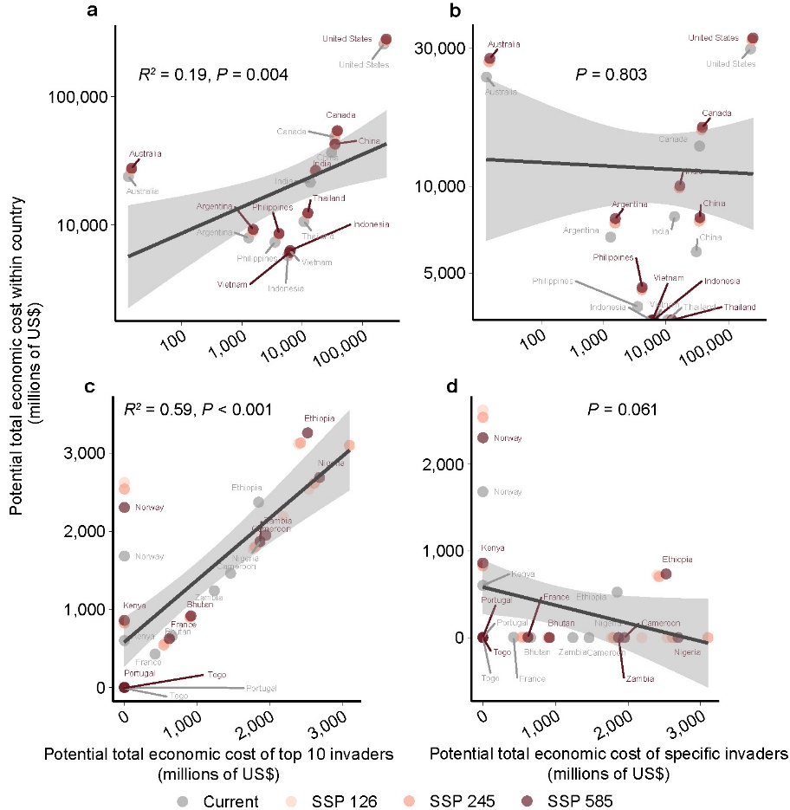

Supplementary Fig. 2 | Relationships of country’s total potential economic costs with the potential economic costs of those global top 10 costliest invaders (a and c) and those country-specific invaders (b and d). (a) and (b) show the relationship for the top ten costliest countries, and (c) and (d) show the relationship for the countries with great increase of potential costs.

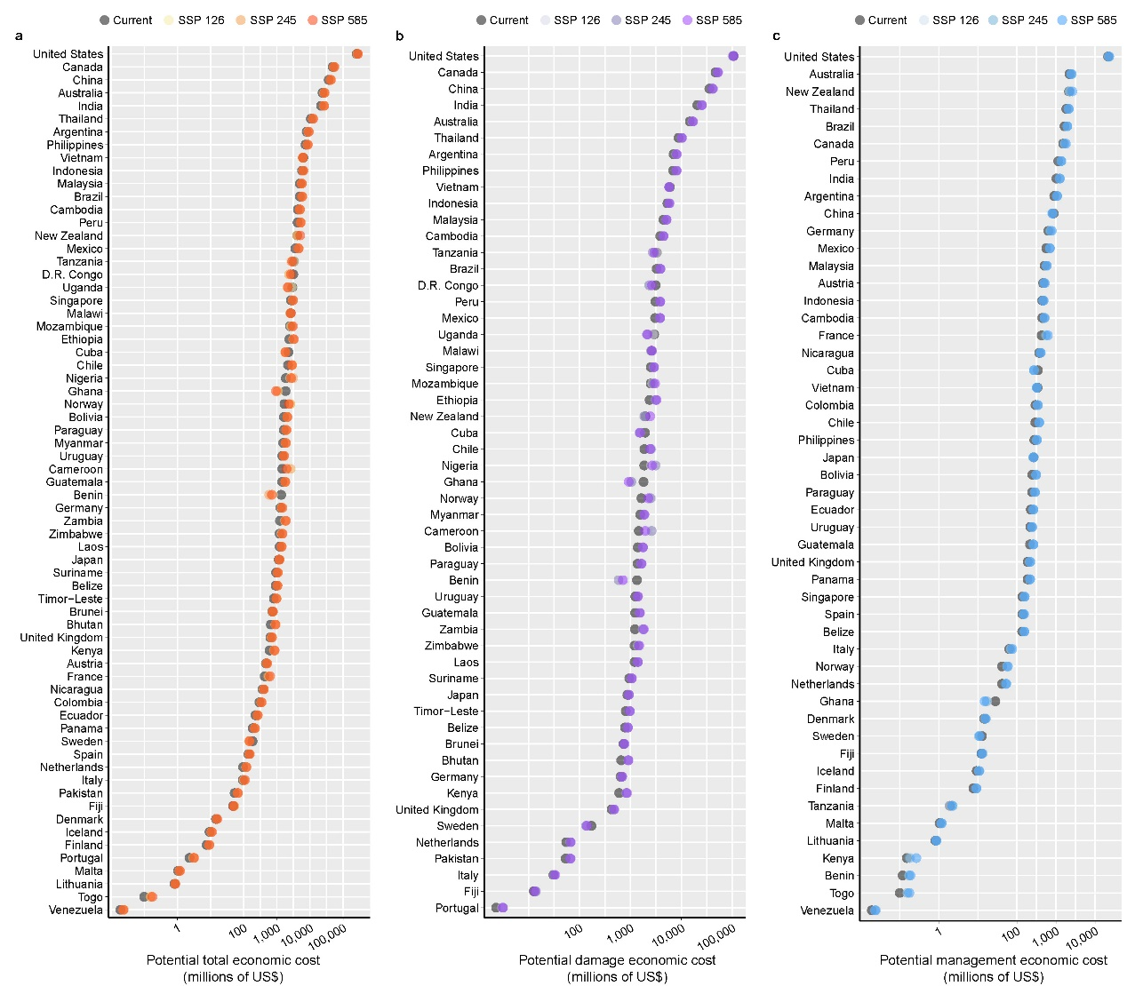

Supplementary Fig. 3 | Rankings of the potential (a) total, (b) damage, and (c) management costs in countries under current and future climatic conditions.

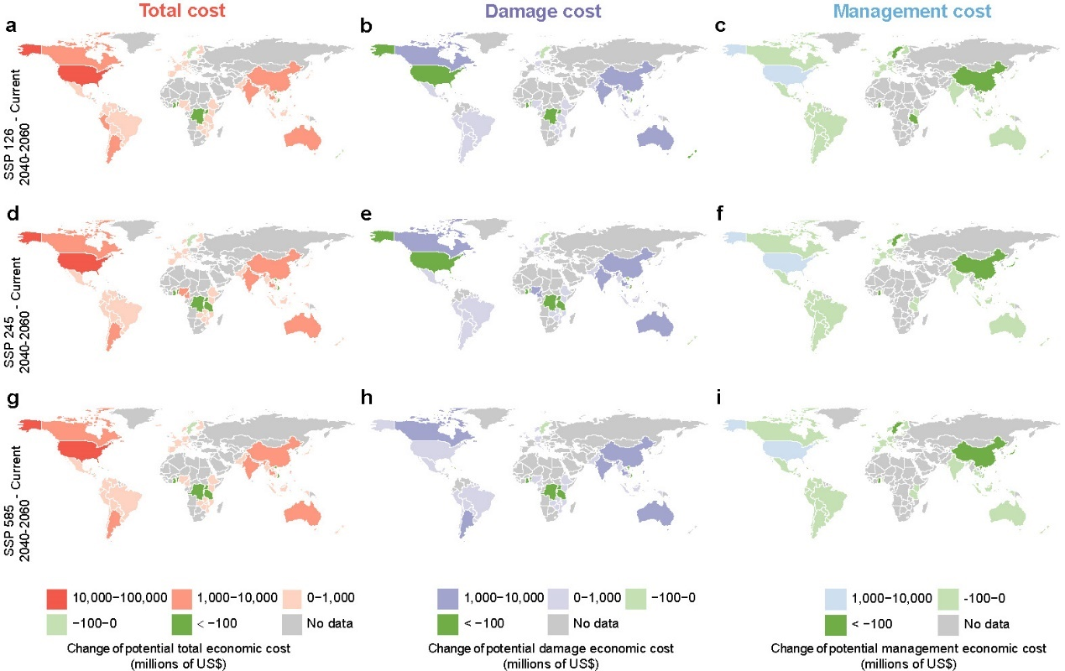

Supplementary Fig. 4 | Geographic distributions of the changes in the potential economic costs. On the basis of the framework shown in Fig. 1, the changes in the current and future potential economic costs were projected under (a-c) SSP 126, (d-f) SSP 245, and (g-i) SSP 585 scenarios.

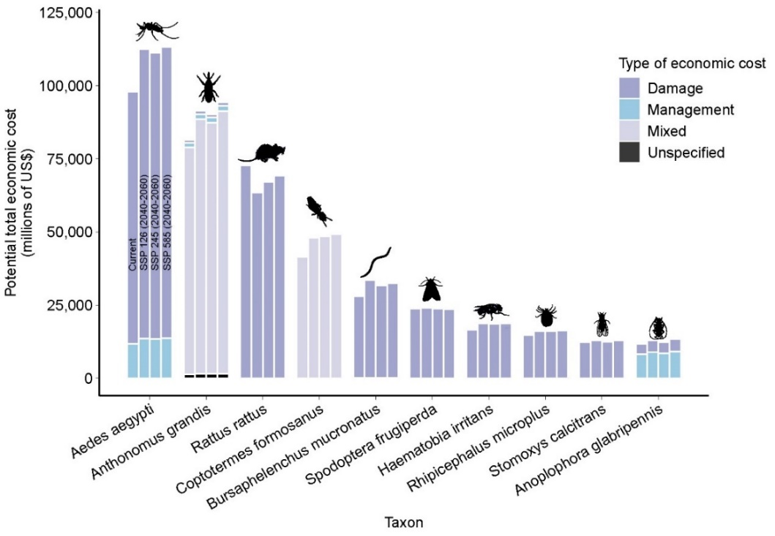

Supplementary Fig. 5 | Top 10 costliest invasive species under current and future climatic and socioeconomic scenarios. The four stacked bars for each species indicate the potential total economic costs under the current, SSP 126, SSP 245, and SSP 585 scenarios. Animal silhouettes were sourced from the PhyloPic database (www.phylopic.org).

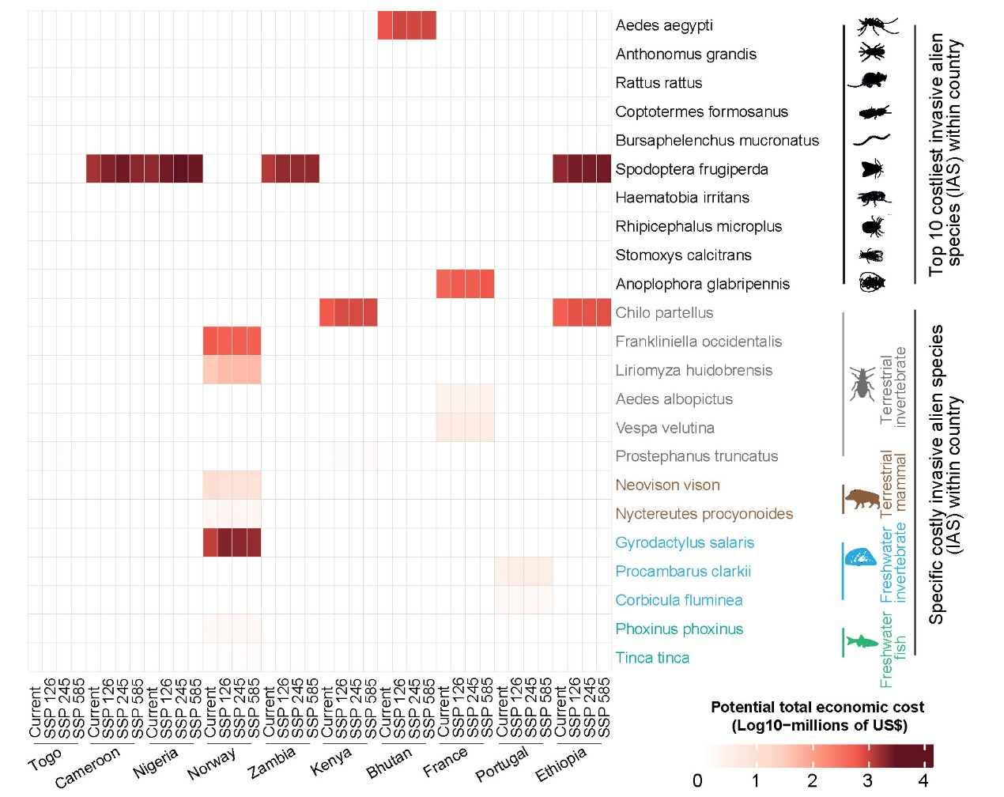

Supplementary Fig. 6 | The top 10 countries with the greatest increases of potential economic costs, the top 10 global costliest invaders, and the country-specific invaders under current and future climatic conditions. The squares filled with colors denote the potential economic costs of invasive animals, and darker colors indicate higher potential economic costs. Animal silhouettes were sourced from the PhyloPic database (www.phylopic.org).

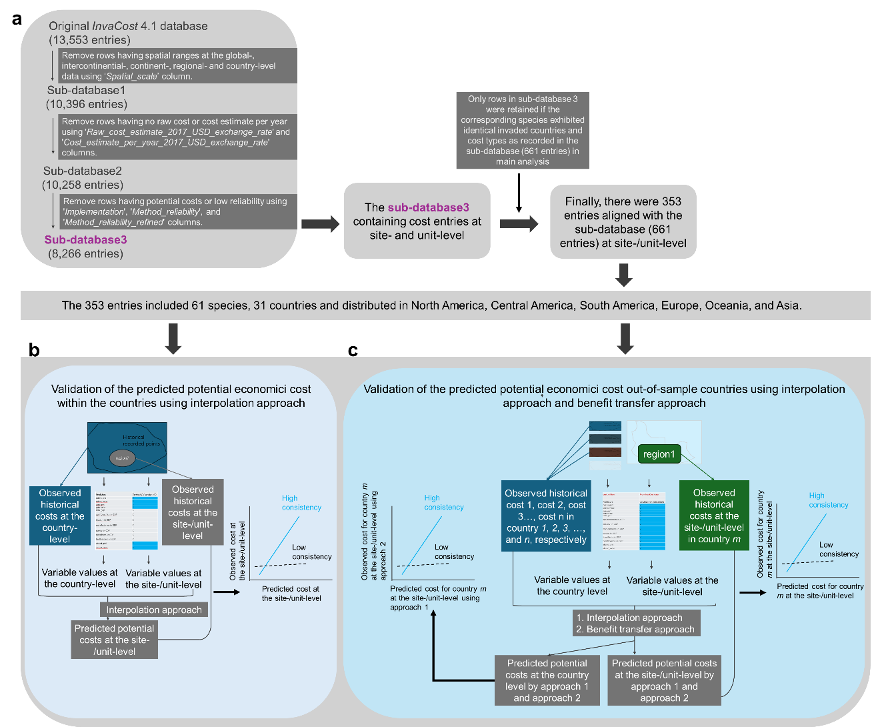

Supplementary Fig. 7 | Analysis flows for the validation of the predicted potential economic costs within the countries with observed economic costs in the main analysis and the out-of-sample countries without observed economic costs in the supplementary analysis (Supplementary Fig. 10). (a) filtering the original InvaCost 4.1 database to get the site-and unit-level datasets. (b) Testing the consistence of predicted and observed economic costs in different regions of the same country based on the interpolation approach. (c) Testing the consistence of predicted and observed economic costs in different regions of the out-of-sample countries based on the interpolation approach and benefit transfer approach. To evaluate potential economic costs of non-native species in out-of-sample countries, we focus on those non-native species that have established feral populations ² according to the SInAS version 2.5 database ^{3,4}, which was generated by applying the most comprehensive workflow and integrating up-to-date several large global databases of non-native species establishment ³. We had further filtered the database in the column ‘degreeOfEstablishment’ to remove only ‘casual’ and ‘absent’ rows and maintain the established status. We had also searched GISD, CABI, fishbase, Google Scholar, and other open sources that were not yet included in the database.

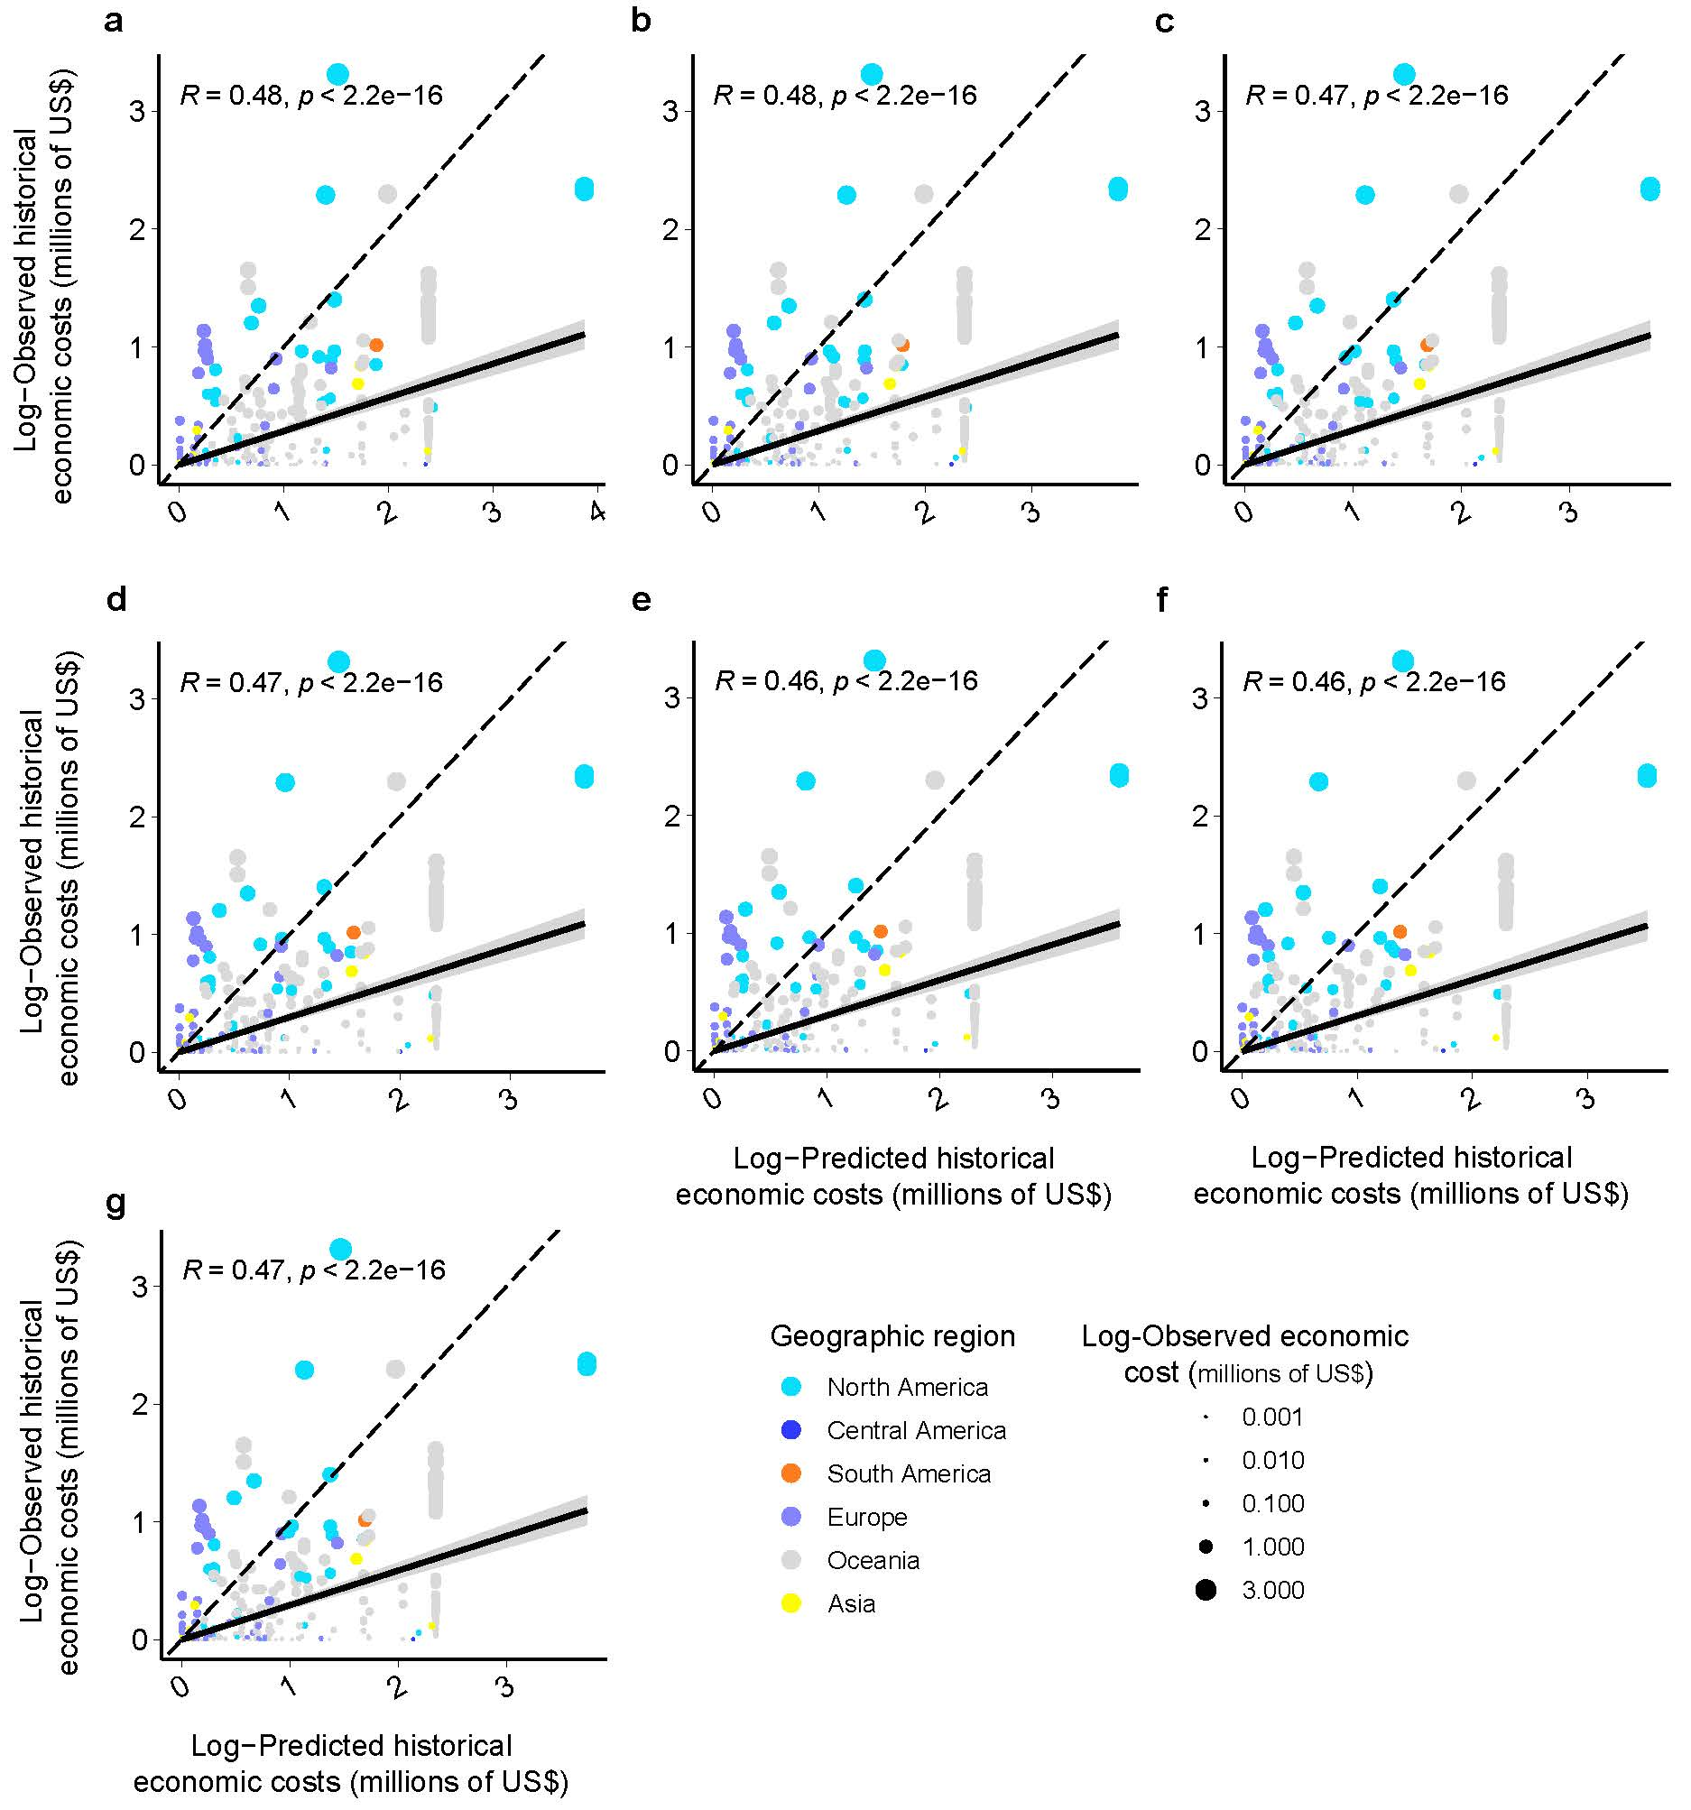

Supplementary Fig. 8 | Assessment of the predictive ability of interpolation approach within the country level by fitting predicted to observed historical economic costs. (a) to (f) were fittings of predicated to observed costs on the basis of different number of independent variables. All fittings in sub plot were exhibited significant predictive power. This indicated the interpolation approach had good predictive performance. (g) was the averages for the all modeling outputs. The black solid line was the regression line fitted based on linear model, and the gray shadow represented the 95% confidence interval of the regression line. The black regression line was closer to black dashed line, which indicated a better fitting.

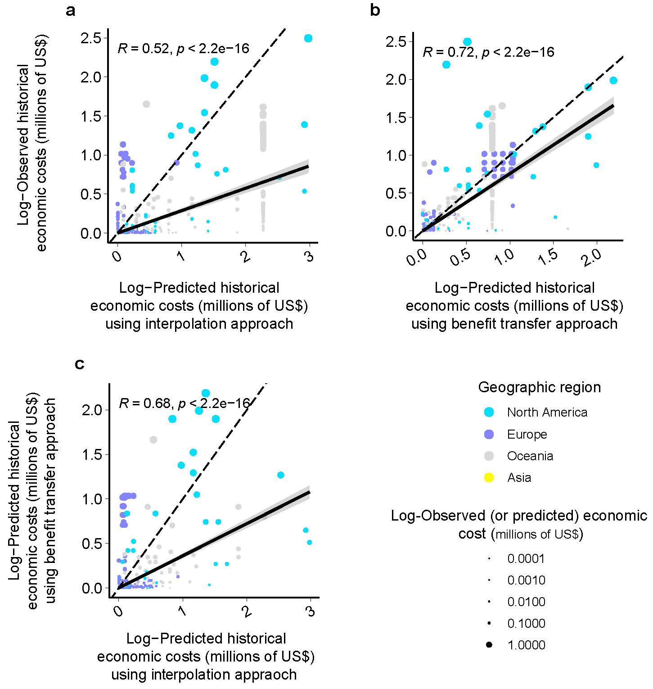

Supplementary Fig. 9 | Assessment of the predictive ability of interpolation approach and benefit transfer approach in out-of-sample countries by fitting predicted to observed historical economic costs. (a) and (b) were fittings predicated to observed costs on the basis of the interpolation and benefit transfer approaches, respectively. (c) was a fitting of predicated costs by interpolation and benefit transfer approaches. The black solid line was the regression line fitted based on linear model, and the gray shadow represented the 95% confidence interval of the regression line. The black regression line was closer to black dashed line, which indicated a better fitting.

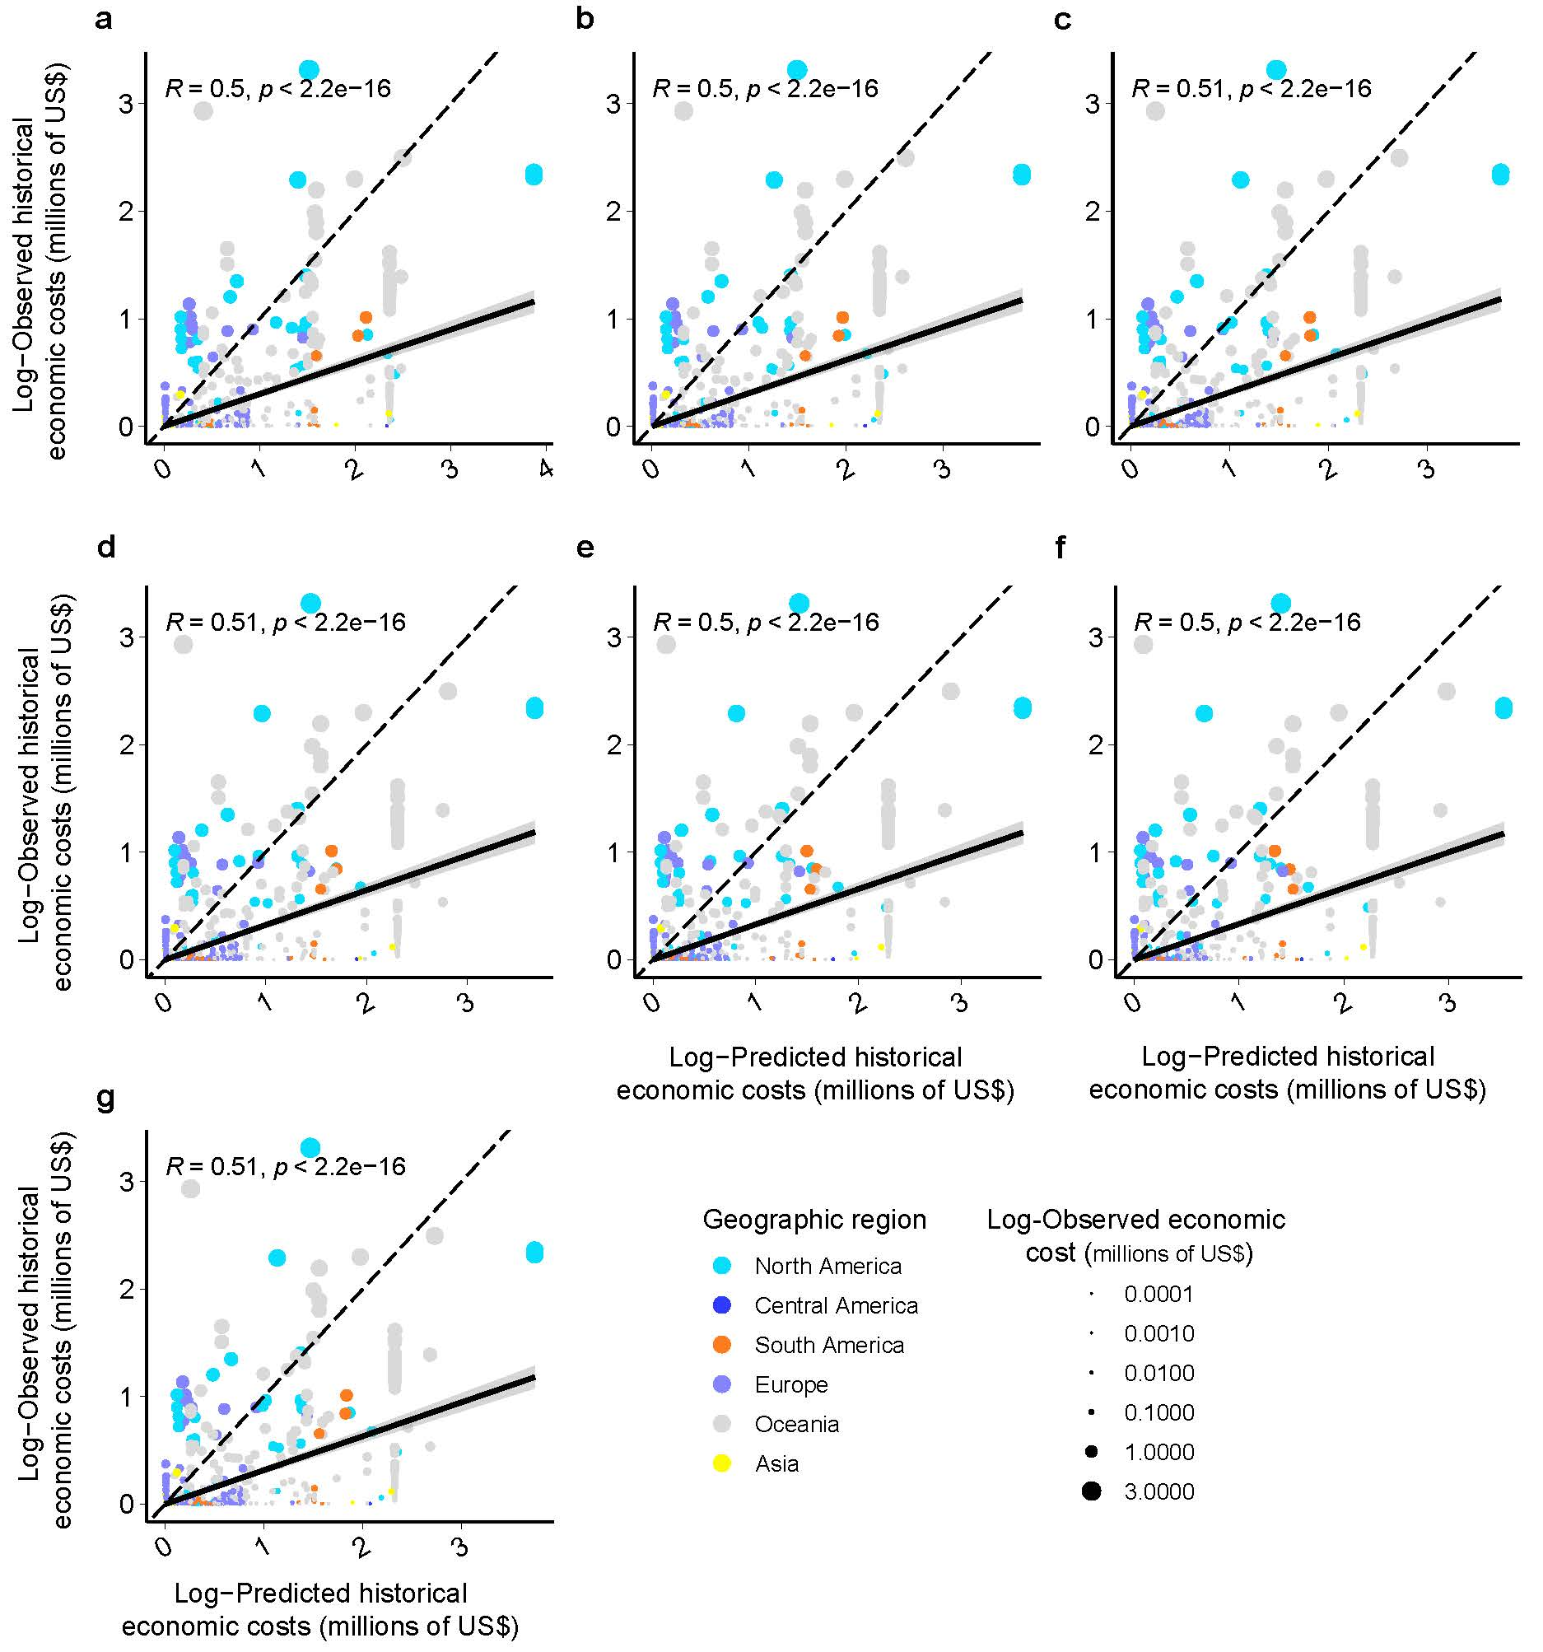

Supplementary Fig. 10 | Assessment of the predictive ability of interpolation approach in out-of-sample countries by fitting predicted to observed historical economic costs. (a) to (f) were fittings of predicated to observed costs on the basis of different number of independent variables. All fittings in sub plot were exhibited significant predictive power. This indicated the interpolation approach had good predictive performance. (g) was the averages for the all modeling outputs. The black solid line was the regression line fitted based on linear model, and the gray shadow represented the 95% confidence interval of the regression line. The black regression line was closer to black dashed line, which indicated a better fitting.

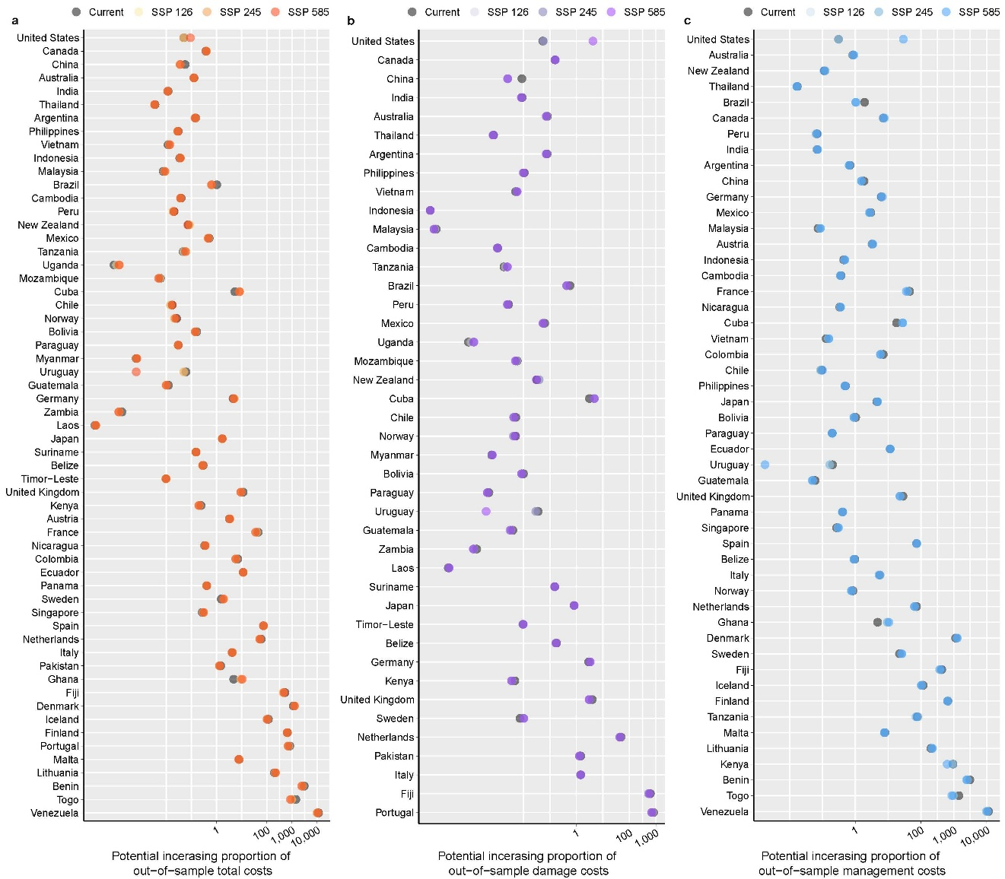

Supplementary Fig. 11 | Rankings of the potential increasing proportion of (a) total, (b) damage, and (c) management costs in out-of-sample countries under current and future climatic conditions. The rankings of countries is based on the potential economic costs predicted within countries. The Out-of-sample denote animal species in countries that have already been reported their establishments but have not been evaluated their economic costs. Then, these animal species and the interpolation approach (Supplementary Fig. 7) were used to predicted their extra potential economic costs. Corresponding to each country and cost type, we calculated ratios of potential out-of-sample costs to potential costs within counties, which was used to represent the increased proportion of potential costs (Supplementary Data 10).

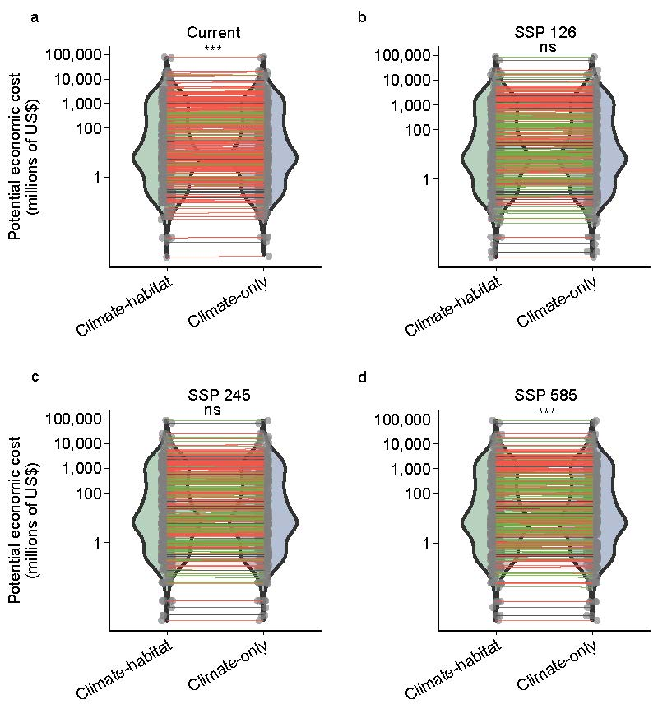

Supplementary Fig. 12 | Comparisons of the potential economic costs with and without filtering by habitats under current and future climate change conditions. The ‘Climate-habitat’ model denotes that the population distributions of non-native species were filtered by their reported adaptative habitat types. The ‘Climate-only’ model denotes that there were no filtration and considering the maximum occupied areas based on their climatic niches. The potential costs were predicted using climate-habitat model and climate-only model under (a) the current climatic and socioeconomic conditions and the (b) SSP 126, (c) SSP 245, (d) SSP 585 scenarios. In a–d, the red lines indicate an increase in the potential economic costs in the current and future under the various SSP scenarios; the green lines indicate decreasing trends; the gray lines indicate no changes. The differences of predicted costs on the basis of two models that were tested using the Wilcoxon paired test (*P < 0.05, **P < 0.01, and ***P < 0.001).

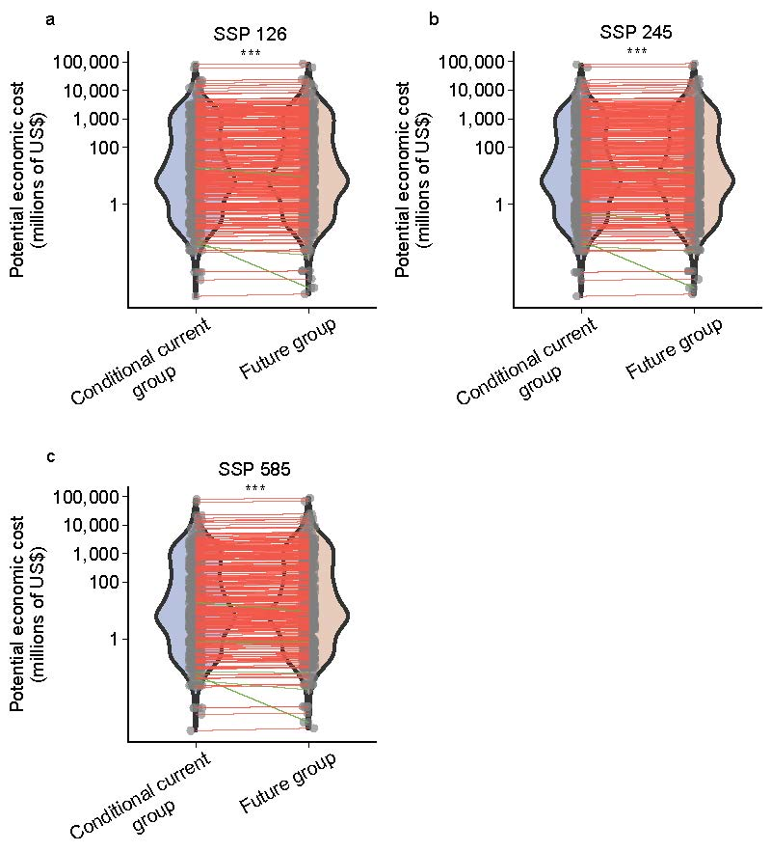

Supplementary Fig. 13 | Comparisons of the potential economic costs with and without GDP and human population density growth under future climate change conditions. The ‘Conditional current group’ denotes neither GDP nor human population density growth under the future climates and maintaining the current condition. The ‘Future group’ denotes both GDP and human population density growth as predictions under future climatic scenarios. The potential costs were predicted under (a) SSP 126, (b) SSP 245, (c) SSP 585 scenarios. In a–c, the red lines indicate an increase in the potential economic costs in the future under the various SSP scenarios; the green lines indicate decreasing trends; the gray lines indicate no changes. The differences of predicted costs on the basis of two models that were tested using the Wilcoxon paired test (*P < 0.05, **P < 0.01, and ***P < 0.001).

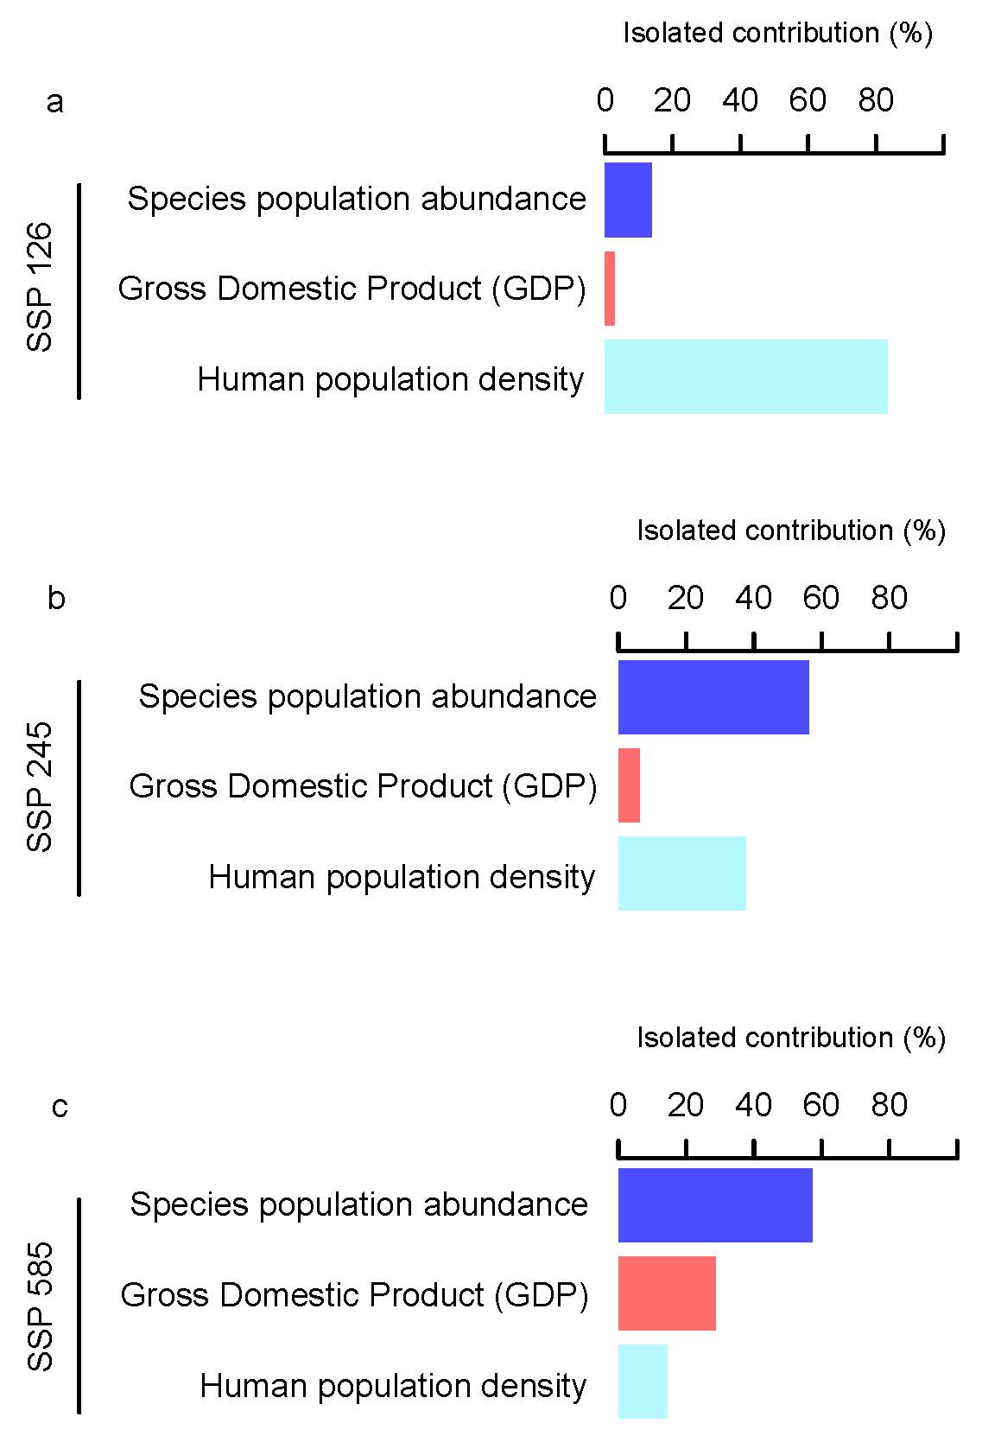

Supplementary Fig. 14 | Independent contribution of the changing habitat-filtered species population abundance, GDP and human population density to economic cost predictions.

Supplementary Table 1 | Basic assumptions for modeling predictions of current and future potential economic costs of invasive animals. The modeling steps consist with each part of component in the Framework in Fig. 1.
modeling steps | assumptions and references
(a) Filter source data of non-native species' economic cost | We assume the retention of 129 invasive animal species can still live in the wilds and not been eliminated in the invaded counties before 2060. Because it is difficult and even unfeasible to completely eradicate non-native species once they are successfully invasion ⁵.
(b) Determine socioeconomic factors - quantify importance of impacted sector | We assume the average of importance (%) of sectors (e.g., agriculture, forestry, fishing, manufacturing, health expenditure, etc) in GDP in the year of 2000, 2010, and 2020 that can be used to represent the importance of impacted sector for the countries. It is because no assessable data showing the potential trends of future conditions of their importance ⁶.
(b) Determine socioeconomic factors - occupied grid number | We assume the gird with attribute values (e.g., GDP and human population density) above than zero that would be counted, which is better to represent the high probability of effects of socioeconomic factors on the invaders.
(b) Determine ecological factors - available habitat | We assume when species that have already adapted to specific habitat types, these species will still actively occupy these same habitats in the future. Because when species adapt and thrive in diverse environments through ecological niches and evolutionary strategies. It is commonly for species to long-term occupy adapted habitats over time ^{7,8}.
(b) Determine ecological factors - species distribution modeling | We assume species currently occupies only a subset of its “realized” niche and will expand its range over time to occupy additional areas where the climate is suitable. Because climate change can open up portions of a species' fundamental niche that are currently inaccessible. Many species may expand their range to climatic suitability areas ⁹.
(b) Determine ecological factors - species distribution modeling | Due to the potential interactions with other species and disperses for some of species are less known in the future, we assume the potential distribution ranges and population abundance are highly necessary for assessing their potential economic costs. Because impact risks of non-native species can vary with their range size and abundance of invaded populations ^{10,11}.
(c) Predictions of current and future potential economic costs within country | We assume management, infrastructure, cultural and legal conditions in a same country are much more similar than in different countries. There are indeed studies found governmental boundaries often align with cultural groups, making management, infrastructure, and legal conditions within the same country more cohesive compared to across different countries ^{12,13}.

Supplementary Table 2 | Difference and proportional changes of future to current potential total economic costs. The ‘SSP 126 – Current’, ‘SSP 245 – Current’, and ‘SSP 585 – Current’ in the heading were future (SSP 126, SSP 245, and SSP 585) minus current potential total economic costs, respectively. The proportional change was the minus value ratio to the current potential economic costs.
Continent | Country name | SSP 126 - Current | Prop. change  of SSP 126 to Current |  |  | SSP 245 - Current | Prop. change  of SSP 245 to Current | SSP 585 - Current | Prop. change of SSP 585 to Current
South America | Argentina | 1032.845 | 0.130 |  |  | 1027.404 | 0.129 | 1309.356 | 0.165
Oceania | Australia | 3182.311 | 0.133 |  |  | 3074.566 | 0.129 | 3803.05 | 0.159
Europe | Austria | 44.06 | 0.094 |  |  | 21.14 | 0.045 | 47.444 | 0.101
Central America | Belize | 125.938 | 0.137 |  |  | 126.147 | 0.137 | 126.491 | 0.138
Africa | Benin | -585.824 | -0.434 |  |  | -763.746 | -0.566 | -641.235 | -0.475
Asia | Bhutan | 251.394 | 0.382 |  |  | 242.367 | 0.368 | 258.225 | 0.392
South America | Bolivia | 421.02 | 0.256 |  |  | 419.684 | 0.256 | 437.56 | 0.266
South America | Brazil | 962.733 | 0.195 |  |  | 870.984 | 0.177 | 907.723 | 0.184
Asia | Brunei | 38.106 | 0.052 |  |  | 10.844 | 0.015 | 32.042 | 0.044
Asia | Cambodia | 693.941 | 0.162 |  |  | 645.879 | 0.151 | 709.139 | 0.166
Africa | Cameroon | 724.741 | 0.495 |  |  | 1151 | 0.787 | 487.878 | 0.334
North America | Canada | 5613.758 | 0.116 |  |  | 4462.939 | 0.092 | 6046.652 | 0.125
South America | Chile | 795.932 | 0.366 |  |  | 708.141 | 0.326 | 652.884 | 0.3
Asia | China | 7100.73 | 0.194 |  |  | 5093.908 | 0.139 | 6194.407 | 0.169
South America | Colombia | 43.322 | 0.145 |  |  | 41.794 | 0.14 | 47.456 | 0.159
Central America | Cuba | -460.501 | -0.203 |  |  | -484.317 | -0.213 | -450.051 | -0.198
Africa | Democratic Republic of the Congo | -716.582 | -0.228 |  |  | -793.432 | -0.253 | -475.346 | -0.151
Europe | Denmark | 0.946 | 0.065 |  |  | 0.903 | 0.062 | 1.404 | 0.097
South America | Ecuador | 35.719 | 0.157 |  |  | 35.002 | 0.154 | 38.354 | 0.169
Africa | Ethiopia | 745.391 | 0.314 |  |  | 758.599 | 0.32 | 885.649 | 0.373
Oceania | Fiji | 4.459 | 0.094 |  |  | 3.893 | 0.082 | 1.753 | 0.037
Europe | Finland | 1.469 | 0.192 |  |  | 1.422 | 0.186 | 1.553 | 0.203
Europe | France | 150.724 | 0.352 |  |  | 118.132 | 0.276 | 196.946 | 0.46
Europe | Germany | 148.192 | 0.116 |  |  | 107.262 | 0.084 | 187.287 | 0.146
Africa | Ghana | -754.358 | -0.411 |  |  | -783.679 | -0.427 | -893.944 | -0.487
Central America | Guatemala | 335.873 | 0.231 |  |  | 328.723 | 0.226 | 345.486 | 0.237
Europe | Iceland | 1.369 | 0.147 |  |  | 1.285 | 0.138 | 1.601 | 0.172
Asia | India | 4936.392 | 0.229 |  |  | 4682.239 | 0.218 | 5191.918 | 0.241
Asia | Indonesia | 524.749 | 0.091 |  |  | 367.356 | 0.064 | 559.04 | 0.097
Europe | Italy | 8.632 | 0.092 |  |  | 7.22 | 0.077 | 15.135 | 0.161
Asia | Japan | 72.281 | 0.063 |  |  | 50.717 | 0.044 | 67.686 | 0.059
Africa | Kenya | 231.771 | 0.385 |  |  | 225.549 | 0.374 | 258.66 | 0.429
Asia | Laos | 191.701 | 0.159 |  |  | 184.679 | 0.153 | 196.24 | 0.163
Europe | Lithuania | 0.038 | 0.047 |  |  | 0.035 | 0.043 | 0.045 | 0.055
Africa | Malawi | -10.63 | -0.004 |  |  | -45.92 | -0.018 | 55.554 | 0.021
Asia | Malaysia | 719.073 | 0.145 |  |  | 669.163 | 0.135 | 758.939 | 0.153
Europe | Malta | 0.121 | 0.116 |  |  | 0.113 | 0.108 | 0.139 | 0.133
North America | Mexico | 929.635 | 0.257 |  |  | 882.769 | 0.244 | 923.677 | 0.255
Africa | Mozambique | 193.825 | 0.078 |  |  | 349.828 | 0.14 | 549.633 | 0.22
Asia | Myanmar | 315.262 | 0.202 |  |  | 274.864 | 0.176 | 328.533 | 0.211
Europe | Netherlands | 23.305 | 0.243 |  |  | 22.96 | 0.239 | 24.773 | 0.258
Oceania | New Zealand | -3.713 | -0.001 |  |  | 26.92 | 0.007 | 940.01 | 0.228
Central America | Nicaragua | 35.174 | 0.095 |  |  | 33.455 | 0.09 | 37.659 | 0.102
Africa | Nigeria | 670.618 | 0.359 |  |  | 1231.098 | 0.659 | 821.328 | 0.44
Europe | Norway | 939.76 | 0.558 |  |  | 857.024 | 0.509 | 622.184 | 0.37
Asia | Pakistan | 13.34 | 0.25 |  |  | 12.565 | 0.236 | 13.386 | 0.251
Central America | Panama | 28.992 | 0.155 |  |  | 30.593 | 0.163 | 30.448 | 0.163
South America | Paraguay | 303.065 | 0.186 |  |  | 289.892 | 0.178 | 321.657 | 0.198
South America | Peru | 1014.574 | 0.239 |  |  | 975.351 | 0.23 | 985.408 | 0.232
Asia | Philippines | 1168.422 | 0.159 |  |  | 1108.186 | 0.151 | 1254.994 | 0.171
Europe | Portugal | 0.708 | 0.306 |  |  | 0.863 | 0.373 | 0.821 | 0.355
Asia | Singapore | 371.736 | 0.14 |  |  | 378.206 | 0.142 | 434.734 | 0.164
Europe | Spain | 11.85 | 0.086 |  |  | 9.189 | 0.067 | 14.367 | 0.104
South America | Suriname | 109.732 | 0.116 |  |  | 111.275 | 0.117 | 118.518 | 0.125
Europe | Sweden | -37.134 | -0.201 |  |  | -38.888 | -0.211 | -33.457 | -0.181
Africa | Tanzania | 25.45 | 0.008 |  |  | -558.346 | -0.169 | -372.827 | -0.113
Asia | Thailand | 1614.642 | 0.151 |  |  | 1547.296 | 0.145 | 1771.441 | 0.166
Asia | Timor-Leste | 183.539 | 0.227 |  |  | 168.156 | 0.208 | 160.712 | 0.198
Africa | Togo | 0.058 | 0.584 |  |  | 0.056 | 0.565 | 0.076 | 0.764
Africa | Uganda | -153.214 | -0.052 |  |  | -821.75 | -0.28 | -766.671 | -0.261
Europe | UK | 70.443 | 0.111 |  |  | 64.719 | 0.102 | 87.264 | 0.138
South America | Uruguay | 187.007 | 0.127 |  |  | 144.652 | 0.098 | 189.432 | 0.129
North America | USA | 12970.366 | 0.05 |  |  | 15453.93 | 0.06 | 23890.242 | 0.093
South America | Venezuela | 0.004 | 0.213 |  |  | 0.005 | 0.274 | 0.004 | 0.214
Asia | Vietnam | -175.465 | -0.028 |  |  | -237.652 | -0.038 | -200.656 | -0.032
Africa | Zambia | 532.722 | 0.43 |  |  | 561.279 | 0.453 | 629.642 | 0.508
Africa | Zimbabwe | 192.172 | 0.159 |  |  | 225.139 | 0.186 | 280.426 | 0.232
Number of studied countries |  |  | 67 | 67 |  |  | 67
Percentage of countries with increasing costs (%) |  |  | 86.567 | 86.567 |  |  | 88.060
Averaged percentage of increased costs (%) |  |  | 19.556±12.595 | 19.734±15.444 |  |  | 21.011±13.048
Minimum percentage of increase (%) |  |  | 0.769 | 0.652 |  |  | 2.138
Maximum percentage of increase (%) |  |  | 58.408 | 78.688 |  |  | 76.411

Supplementary Table 3 | Difference comparison between future to current potential total, damage, and management economic costs of the countries. The Wilcoxon paired-test was used to compare the difference between country’s future (SSP 126, SSP 245, and SSP 585) and current potential economic costs, respectively. The wilcox_test function in rstatix (v.0.7.2) package ¹⁴ was used to conduct the Wilcoxon paired-test. ‘n’ was the number of paired countries; ‘V’ was the non-parametric statistical parameter; ‘P’ was the probability value describing the likely of significant difference between the future and current costs. There was significant difference when the ‘P’ value was less than 0.05.
Cost category | Future scenario  compared to current | Wilcoxon paired-test
 |  | n | V | P
Total cost | SSP 126 | 67 | 297 | 1.47E-07
Total cost | SSP 245 | 67 | 369 | 1.53E-06
Total cost | SSP 585 | 67 | 323 | 3.50E-07
damage cost | SSP 126 | 53 | 254 | 4.48E-05
damage cost | SSP 245 | 53 | 320 | 4.71E-04
damage cost | SSP 585 | 53 | 225 | 1.44E-05
management cost | SSP 126 | 50 | 119 | 5.72E-07
management cost | SSP 245 | 50 | 138 | 1.46E-06
management cost | SSP 585 | 50 | 125 | 7.71E-07

Supplementary Table 4 | Difference of invaders’ future to current potential total economic costs. The ‘SSP 126 – Current’, ‘SSP 245 – Current’, and ‘SSP 585 – Current’ in table heading were future (SSP 126, SSP 245, and SSP 585) minus current potential total economic costs, respectively.
Species scientific name | Country name | SSP 126 – Current | SSP 245 – Current | SSP 585 – Current
Adelges piceae | Canada | 1070.901 | 928.207 | 1067.873
Adelges tsugae | United States | -2.473 | -3.187 | -2.721
Aedes aegypti | Argentina | 212.172 | 202.643 | 211.771
Aedes aegypti | Australia | 1.077 | 0.831 | 1.276
Aedes aegypti | Belize | 125.938 | 126.147 | 126.491
Aedes aegypti | Bhutan | 251.394 | 242.367 | 258.225
Aedes aegypti | Bolivia | 421.02 | 419.684 | 437.56
Aedes aegypti | Brazil | 962.736 | 871.064 | 907.459
Aedes aegypti | Brunei | 38.106 | 10.844 | 32.042
Aedes aegypti | Cambodia | 693.941 | 645.879 | 709.139
Aedes aegypti | Canada | 74.103 | 64.756 | 90.618
Aedes aegypti | Chile | 564.333 | 512.124 | 554.488
Aedes aegypti | China | -188.608 | -210.622 | -147.105
Aedes aegypti | Colombia | 43.322 | 41.794 | 47.456
Aedes aegypti | Cuba | -453.996 | -477.446 | -443.805
Aedes aegypti | Ecuador | 35.719 | 35.002 | 38.354
Aedes aegypti | Guatemala | 335.873 | 328.723 | 345.486
Aedes aegypti | India | 2873.731 | 2669.518 | 3013.81
Aedes aegypti | Indonesia | 524.749 | 367.356 | 559.04
Aedes aegypti | Laos | 191.701 | 184.679 | 196.24
Aedes aegypti | Malaysia | 719.073 | 669.163 | 758.939
Aedes aegypti | Mexico | 834.644 | 794.611 | 859.679
Aedes aegypti | Myanmar | 315.262 | 274.864 | 328.533
Aedes aegypti | Nicaragua | 35.174 | 33.455 | 37.659
Aedes aegypti | Panama | 28.992 | 30.593 | 30.448
Aedes aegypti | Paraguay | 303.065 | 289.892 | 321.657
Aedes aegypti | Peru | 922.762 | 869.133 | 879.457
Aedes aegypti | Philippines | 587.875 | 558.11 | 620.795
Aedes aegypti | Singapore | 371.736 | 378.206 | 434.734
Aedes aegypti | Suriname | 109.732 | 111.275 | 118.518
Aedes aegypti | Thailand | 1614.642 | 1547.296 | 1771.441
Aedes aegypti | Timor-Leste | 183.539 | 168.156 | 160.712
Aedes aegypti | United States | 1853.607 | 1587.514 | 2110.045
Aedes aegypti | Uruguay | 187.007 | 144.652 | 189.432
Aedes aegypti | Vietnam | -175.465 | -237.652 | -200.656
Aedes albopictus | France | 0.098 | 0.043 | 0.113
Aedes albopictus | Italy | 0.065 | 0.026 | 0.063
Aedes albopictus | Spain | 0.077 | 0.053 | 0.086
Aedes albopictus | United States | 0.013 | -0.104 | 0.154
Aedes camptorhynchus | New Zealand | 62.179 | 42.847 | 92.031
Agrilus planipennis | Canada | 2.47 | 1.727 | 4.096
Agrilus planipennis | United States | 56.778 | 38.648 | 59.573
Aleurodicus rugioperculatus | India | 0 | 0 | 0
Alopochen aegyptiaca | Netherlands | 0.211 | 0.208 | 0.222
Anastrepha fraterculus | Argentina | 16.826 | 17.336 | 15.183
Anolis carolinensis | Japan | -0.023 | -0.023 | -0.033
Anopheles darlingi | Peru | 91.813 | 106.219 | 105.951
Anoplophora chinensis | Italy | 6.404 | 5.306 | 11.701
Anoplophora glabripennis | Austria | 44.06 | 21.14 | 47.444
Anoplophora glabripennis | Canada | 774.233 | 429.47 | 1038.647
Anoplophora glabripennis | France | 150.325 | 117.824 | 196.487
Anoplophora glabripennis | Germany | 103.178 | 67.42 | 130.731
Anoplophora glabripennis | United States | 140.189 | -88.688 | 284.8
Anthonomus grandis | Argentina | 28.04 | 26.874 | 33.284
Anthonomus grandis | United States | 9926.873 | 8787.676 | 12782.25
Arion lusitanicus | Sweden | -35.256 | -36.757 | -31.846
Bactrocera philippinensis | Australia | 307.214 | 296.304 | 54.391
Bactrocera tryoni | Australia | -52.439 | -28.487 | -22.396
Bemisia tabaci | United Kingdom | -1.19 | -1.19 | -1.19
Boiga irregularis | United States | 0.428 | 0.371 | 0.46
Branta canadensis | United Kingdom | 0.209 | 0.343 | 0.529
Bruchus pisorum | China | 5.382 | 4.824 | 5.693
Bursaphelenchus mucronatus | China | 5551.714 | 3663.608 | 4490.78
Bursaphelenchus mucronatus | Japan | 0.81 | -0.352 | 0.042
Bursaphelenchus mucronatus | Sweden | 0.083 | -0.136 | 0.094
Cactoblastis cactorum | Mexico | 94.943 | 88.115 | 63.915
Callosciurus erythraeus | Japan | 0.223 | 0.195 | 0.209
Camelus dromedarius | Australia | 3.256 | 2.211 | 6.771
Cameraria ohridella | Germany | 3.462 | 3.043 | 3.977
Canis lupus | Australia | 171.963 | 249.41 | 206.416
Canis lupus | United States | 603.187 | 597.741 | 596.155
Capra hircus | Australia | 27.69 | 22.929 | 28.07
Capra hircus | New Zealand | 1.007 | 0.945 | 2.847
Castor canadensis | Chile | 0.364 | 0.375 | 0.019
Ceratitis capitata | Argentina | 45.366 | 47.301 | 48.36
Ceutorhynchus obstrictus | Canada | 276.307 | 262.885 | 309.46
Chelydra serpentina | Japan | 0.005 | 0 | 0.005
Chilo partellus | Ethiopia | 195.554 | 179.349 | 210.37
Chilo partellus | Kenya | 231.733 | 225.523 | 258.546
Chilo partellus | Malawi | 208.462 | 182.285 | 225.321
Chilo partellus | Tanzania | 258.427 | 240.227 | 277.421
Cochliomyia hominivorax | Australia | 1340.841 | 1413.256 | 2006.724
Coptotermes formosanus | United States | 6694.364 | 7130.952 | 7921.816
Coptotermes gestroi | Fiji | 4.459 | 3.893 | 1.753
Corbicula fluminea | Portugal | 0.159 | 0.152 | 0.051
Cydia pomonella | China | 1620.713 | 1681.958 | 1882.795
Cygnus olor | United Kingdom | 0.089 | 0.082 | 0.109
Daktulosphaira vitifoliae | Australia | 0.423 | 0.447 | 0.377
Daktulosphaira vitifoliae | China | 0.962 | 0.62 | 1.019
Dendroctonus micans | United Kingdom | 0.34 | 0.337 | 0.389
Dreissena polymorpha | United Kingdom | 1.528 | 1.55 | 2.016
Dreissena polymorpha | United States | 1041.106 | 930.993 | 1197.809
Drosophila suzukii | United States | 10.107 | 5.729 | 10.099
Elatobium abietinum | United Kingdom | 3.713 | 3.258 | 4.428
Ephestia kuehniella | Germany | -5.265 | -7.336 | -3.825
Equus caballus | Australia | 0.158 | 0.162 | 0.194
Felis catus | Australia | 1064.338 | 828.98 | 1171.05
Felis catus | Spain | 0.045 | 0.037 | 0.059
Frankliniella occidentalis | Norway | -114.244 | -61.483 | -84.237
Globodera rostochiensis | Japan | -0.896 | -0.984 | -0.186
Gyrodactylus salaris | Norway | 1039.841 | 904.148 | 689.351
Haematobia irritans | Canada | 2125.7 | 1913.324 | 2033.841
Halotydeus destructor | Australia | 77.915 | 72.026 | 91.645
Hemitragus jemlahicus | New Zealand | 0.35 | 0.429 | 1.007
Herpestes javanicus | Japan | 0.404 | 0.366 | 0.341
Hyblaea puera | Mexico | 0.027 | 0.023 | 0.021
Hypera postica | United States | 198.401 | 296.712 | 396.026
Hyphantria cunea | China | 1.569 | 1.327 | 1.648
Hypothenemus hampei | India | 14.941 | 11.413 | 15.584
Leptinotarsa decemlineata | China | 10.37 | 9.084 | 10.405
Leptinotarsa decemlineata | Finland | 1.469 | 1.422 | 1.553
Leptinotarsa decemlineata | United Kingdom | 6.457 | 6.5 | 6.22
Limnoperna fortunei | Argentina | 2.602 | 2.395 | 2.731
Limnoperna fortunei | Brazil | -0.003 | -0.08 | 0.264
Linepithema humile | Japan | -0.09 | -0.318 | -0.331
Linepithema humile | New Zealand | -0.12 | 0.037 | 0.395
Liriomyza huidobrensis | Norway | 15.645 | 16.223 | 18.392
Liriomyza sativae | China | 136.873 | 10.295 | -11.022
Lissachatina fulica | Cuba | -6.504 | -6.871 | -6.245
Listronotus bonariensis | New Zealand | -7.08 | 23.069 | 383.393
Lithobates catesbeianus | United Kingdom | -0.063 | -0.07 | -0.05
Lymantria dispar | Canada | 505.438 | 465.606 | 568.936
Lymantria dispar | New Zealand | -99.659 | -124.626 | 87.482
Lymantria dispar | United States | 383.763 | 334.475 | 429.591
Maconellicoccus hirsutus | Mexico | 0.016 | 0.015 | 0.017
Muntiacus reevesi | Japan | 0.126 | 0.082 | 0.151
Mus musculus | Australia | 3.595 | 2.093 | 3.357
Mustela erminea | New Zealand | 0.608 | 0.566 | 2.041
Myiopsitta monachus | United Kingdom | 0.264 | 0.265 | 0.346
Myiopsitta monachus | United States | 0.109 | 0.043 | 0.058
Myocastor coypus | Italy | 1.834 | 1.611 | 2.904
Myocastor coypus | Japan | 0.368 | -0.472 | -0.025
Neovison vison | Chile | 4.316 | 4.311 | 4.749
Neovison vison | Denmark | 0.82 | 0.79 | 1.226
Neovison vison | Germany | 3.106 | 3.168 | 3.42
Neovison vison | Iceland | 1.369 | 1.285 | 1.601
Neovison vison | Norway | -1.704 | -2.055 | -1.589
Neovison vison | Spain | 10.733 | 8.211 | 13.053
Neovison vison | Sweden | -1.668 | -1.695 | -1.442
Neovison vison | United Kingdom | 0.13 | 0.125 | 0.163
Nilaparvata lugens | Japan | 53.088 | 44.754 | 54.996
Nyctereutes procyonoides | Denmark | 0.126 | 0.113 | 0.178
Nyctereutes procyonoides | Lithuania | 0.038 | 0.035 | 0.045
Nyctereutes procyonoides | Norway | 0.103 | 0.106 | 0.126
Nyctereutes procyonoides | Sweden | -0.293 | -0.3 | -0.262
Ondatra zibethicus | Germany | 42.361 | 39.701 | 51.175
Ondatra zibethicus | Netherlands | 11.604 | 11.058 | 12.043
Ondatra zibethicus | United Kingdom | 5 | 4.495 | 5.533
Oryctolagus cuniculus | Australia | 130.523 | 117.911 | 126.914
Oryctolagus cuniculus | Germany | 1.089 | 1.033 | 1.45
Oryctolagus cuniculus | United Kingdom | 39.924 | 36.813 | 50.252
Oxyura jamaicensis | United Kingdom | 1.643 | 1.653 | 2.101
Pacifastacus leniusculus | Japan | 0.724 | 0.762 | 0.737
Pacifastacus leniusculus | United Kingdom | 0.878 | 0.798 | 1.091
Paguma larvata | Japan | 10.847 | 8.675 | 8.849
Paracoccus marginatus | India | 223.933 | 231.073 | 214.487
Pectinophora gossypiella | United States | 12.129 | 15.432 | 21.157
Petromyzon marinus | Canada | 245.196 | 257.045 | 271.842
Petromyzon marinus | United States | 7.298 | 7.067 | 8.56
Phascolarctos cinereus | Australia | 0.048 | 0.044 | 0.055
Phasianus colchicus | Germany | 0.262 | 0.232 | 0.359
Phenacoccus solenopsis | India | 1823.787 | 1770.234 | 1948.036
Phoxinus phoxinus | Norway | 0.087 | 0.061 | 0.105
Phthorimaea operculella | China | 21.825 | 10.792 | 20.095
Pomacea canaliculata | Philippines | 580.547 | 550.077 | 634.2
Procambarus clarkii | Italy | 0.33 | 0.277 | 0.466
Procambarus clarkii | Portugal | 0.549 | 0.71 | 0.77
Procyon lotor | Japan | 6.255 | 5.268 | 3.897
Prostephanus truncatus | Benin | 0.056 | 0.053 | 0.069
Prostephanus truncatus | Kenya | 0.039 | 0.026 | 0.114
Prostephanus truncatus | Togo | 0.058 | 0.056 | 0.076
Pseudorasbora parva | United Kingdom | 0.789 | 0.728 | 0.754
Psittacula krameri | Netherlands | 11.491 | 11.694 | 12.508
Psittacula krameri | Pakistan | 13.34 | 12.565 | 13.386
Psittacula krameri | United Kingdom | 0.045 | 0.044 | 0.052
Raoiella indica | Mexico | 0.005 | 0.004 | 0.046
Rattus exulans | New Zealand | -0.06 | -0.375 | 0.391
Rattus norvegicus | Malta | 0.121 | 0.113 | 0.139
Rattus norvegicus | United Kingdom | 8.084 | 7.371 | 10.62
Rattus rattus | Australia | 0.608 | 0.457 | 0.473
Rattus rattus | United States | -9301.77 | -5654.87 | -3480.72
Rhinella marina | Australia | 1.028 | -0.725 | 0.781
Rhipicephalus microplus | United States | 1336.919 | 1449.262 | 1523.879
Rhynchophorus ferrugineus | Spain | 0.994 | 0.888 | 1.168
Scirtothrips perseae | United States | 9.338 | 18.161 | 31.251
Sciurus carolinensis | United Kingdom | 3.974 | 3.631 | 5.011
Sirex noctilio | Argentina | 1.206 | 2.316 | 2.022
Sirex noctilio | Australia | 22.494 | 15.234 | 16.668
Solenopsis invicta | Australia | 3.165 | 2.777 | 4.395
Solenopsis invicta | China | -60.071 | -77.977 | -59.901
Solenopsis invicta | Japan | 0.173 | -7.435 | -1.325
Spodoptera frugiperda | Benin | -585.88 | -763.799 | -641.304
Spodoptera frugiperda | Cameroon | 724.741 | 1151 | 487.878
Spodoptera frugiperda | Democratic Republic of the Congo | -716.582 | -793.432 | -475.346
Spodoptera frugiperda | Ethiopia | 549.837 | 579.25 | 675.279
Spodoptera frugiperda | Ghana | -754.358 | -783.679 | -893.944
Spodoptera frugiperda | Malawi | -219.092 | -228.204 | -169.767
Spodoptera frugiperda | Mozambique | 193.825 | 349.828 | 549.633
Spodoptera frugiperda | Nigeria | 670.618 | 1231.098 | 821.328
Spodoptera frugiperda | Tanzania | -232.944 | -798.949 | -650.511
Spodoptera frugiperda | Uganda | -153.214 | -821.75 | -766.671
Spodoptera frugiperda | Zambia | 532.722 | 561.279 | 629.642
Spodoptera frugiperda | Zimbabwe | 192.172 | 225.139 | 280.426
Stomoxys calcitrans | Canada | 539.411 | 139.92 | 661.339
Sus scrofa | Argentina | 726.634 | 728.538 | 996.005
Sus scrofa | Australia | 7.856 | 9.96 | 26.079
Sus scrofa | Chile | 268.016 | 218.618 | 134.726
Teia anartoides | New Zealand | 0.242 | 48.402 | 225.779
Thrips palmi | United Kingdom | -1.37 | -2.014 | -1.112
Tinca tinca | Norway | 0.032 | 0.024 | 0.036
Trachemys scripta | Japan | 0.064 | 0.044 | 0.08
Trichosurus vulpecula | New Zealand | 38.665 | 35.481 | 144.013
Trogoderma granarium | Tanzania | -0.033 | 0.376 | 0.264
Varroa jacobsoni | New Zealand | 0 | 0 | 0
Vespa velutina | France | 0.301 | 0.265 | 0.347
Vespa velutina | Japan | 0.205 | 0.153 | 0.279
Vespula germanica | Chile | -41.098 | -27.287 | -41.098
Vespula vulgaris | New Zealand | 0.155 | 0.146 | 0.631
Vulpes vulpes | Australia | 70.558 | 68.745 | 79.81
Xenopus laevis | Venezuela | 0.004 | 0.005 | 0.004
Number of samples |  | 220 | 220 | 220
Percentage of samples with increase costs (%) |  | 0.85 | 0.832 | 0.864

Supplementary Table 5 | Summary of terrestrial invertebrates, mammals, and other taxa in impacting the types of sectors.
Category of human health and Public & social welfare sectors (yes/no/unknown) | Terrestrial invertebrates and mammals impacted sectors | Number of samples | Number of types of impacted sectors | Category of human health and Public & social welfare sectors (yes/no/unknown) | other taxa impacted sectors | Number of samples | Number of types of impacted sectors
no | Authorities-Stakeholders | 202 | 1 | no | Authorities-Stakeholders | 42 | 1
no | Agriculture | 191 | 1 | no | Agriculture | 10 | 1
yes | Authorities-Stakeholders/Health/Public and social welfare | 50 | 3 | no | Environment/Fishery | 2 | 2
no | Authorities-Stakeholders/Health | 36 | 2 | no | Fishery | 2 | 1
yes | Public and social welfare | 29 | 1 | no | Authorities-Stakeholders/Fishery | 1 | 2
yes | Health | 27 | 1 | yes | Authorities-Stakeholders/Public and social welfare | 1 | 2
no | Forestry | 18 | 1 | yes | Public and social welfare | 1 | 1
no | Environment | 12 | 1 | unknown | Unspecified | 1
yes | Agriculture/Public and social welfare | 9 | 2
yes | Authorities-Stakeholders/Public and social welfare | 7 | 2
yes | Health/Public and social welfare | 5 | 2
no | Agriculture/Authorities-Stakeholders | 3 | 2
unknown | Unspecified | 3
no | Agriculture/Environment | 2 | 2
yes | Agriculture/Environment/Health/Public and social welfare | 2 | 4
no | Agriculture/Forestry | 1 | 2
no | Authorities-Stakeholders/Environment | 1 | 2
no | Authorities-Stakeholders/Forestry | 1 | 2
yes | Environment/Fishery/Public and social welfare | 1 | 3
no | Fishery | 1 | 1
Total number of samples |  | 601 |  |  |  | 60
Percentages of samples related to human health and Public & social welfare sectors |  | 130 (21.6%) |  |  |  | 2 (3.3%)
Average of number of types |  |  | 1.842 |  |  |  | 1.429
Standard deviation of number of types |  |  | 0.83421 |  |  |  | 0.535

Supplementary Table 6 | Bioclimatic variables for estimating species potential distributions.
Taxonomic group | number of predictors | Details of variables used to estimate species potential distributions | References
Amphibians and reptiles | 8 | annual average temperature, temperature seasonality, maximum temperature of the warmest month, minimum temperature of the coldest month, annual precipitation, precipitation seasonality, precipitation of the wettest quarter, and precipitation of the driest quarter | Araújo MB, Nogués-Bravo D, Diniz-Filho JAF, Haywood AM, Valdes PJ, Rahbek C. Quaternary climate changes explain diversity among reptiles and amphibians. Ecography 2008, 31(1): 8-15.
Birds | 6 | temperature seasonality, maximum temperature of the warmest month, minimum temperature of the coldest month, precipitation of the wettest month, precipitation of the driest month, and precipitation seasonality | (1) Barbet-Massin M, Jetz W. The effect of range changes on the functional turnover, structure and diversity of bird assemblages under future climate scenarios. Global Change Biology 2015, 21(8): 2917-2928.  (2) Ferger SW, Schleuning M, Hemp A, Howell KM, Bohning-Gaese K. Food resources and vegetation structure mediate climatic effects on species richness of birds. Global Ecology and Biogeography 2014, 23(5): 541-549.  (3) Thuiller W, Pironon S, Psomas A, Barbet-Massin M, Jiguet F, Lavergne S, et al. The European functional tree of bird life in the face of global change. Nature Communications 2014, 5: 3118.
Mammals | 10 | annual average temperature, mean temperature of the wettest quarter, mean temperature of the driest quarter, mean temperature of the warmest quarter, mean temperature of the coldest quarter, annual precipitation, precipitation of the wettest quarter, precipitation of the driest quarter, precipitation of the warmest quarter, and precipitation of the coldest quarter | (1) Li Y, Li X, Sandel B, Blank D, Liu Z, Liu X, et al. Climate and topography explain range sizes of terrestrial vertebrates. Nature Climate Change 2015, 6(5): 498-502.  (2) Visconti P, Bakkenes M, Baisero D, Brooks T, Butchart SHM, Joppa L, et al. Projecting global biodiversity indicators under future development scenarios. Conservation Letters 2016, 9(1): 5-13.
Terrestrial invertebrates | 6 | mean diurnal range, maximum temperature of the warmest month, minimum temperature of the coldest month, annual precipitation, precipitation of the wettest month, and precipitation of the driest month | (1) Hill MP, Gallardo B, Terblanche JS. A global assessment of climatic niche shifts and human influence in insect invasions. Global Ecology and Biogeography 2017, 26(6): 679-689.  (2) Fournier A, Penone C, Pennino MG, Courchamp F. Predicting future invaders and future invasions. Proceedings of the National Academy of Sciences of the United States of America 2019, 116(16): 7905-7910.
Freshwater fishes | 8 | mean diurnal range, temperature seasonality, maximum temperature of the warmest month, precipitation of the wettest month, precipitation of the driest month, precipitation seasonality, precipitation of the warmest quarter, and precipitation of the coldest quarter | Kärcher O, Frank K, Walz A, Markovic D. Scale effects on the performance of niche-based models of freshwater fish distributions. Ecological Modelling 2019, 405: 33-42.
Freshwater invertebrates | 4 | maximum temperature of the warmest month, minimum temperature of the coldest month, precipitation of the wettest quarter, and precipitation of the driest quarter | Zhang ZX, Kass JM, Mammola S, Koizumi I, Li XC, Tanaka K, et al. Lineage-level distribution models lead to more realistic climate change predictions for a threatened crayfish. Diversity and Distributions 2021, 27(4): 684-695.

Supplementary Table 7 | Difference comparison between future to current potential economic costs of taxa. The Wilcoxon paired-test was used to compare the difference between future (SSP 126, SSP 245, and SSP 585) and current potential economic costs of the taxonomic group, respectively. The wilcox_test function in rstatix (v.0.7.2) package ¹⁴ was used to conduct the Wilcoxon paired-test. ‘n’ was the number of paired countries; ‘V’ was the non-parametric statistical parameter; ‘P’ was the probability value describing the likely of significant difference between the future and current costs. There was significant difference when the ‘P’ value was less than 0.05.
Costs of taxonomic group | Future scenario  compared to current | Wilcoxon paired-test
 |  | n | V | P
All taxa | SSP 126 | 661 | 29325 | 9.36E-60
 | SSP 245 | 661 | 37040 | 3.99E-49
 | SSP 585 | 661 | 28960 | 2.77E-60
Terrestrial invertebrates | SSP 126 | 327 | 9754 | 2.03E-23
 | SSP 245 | 327 | 11164 | 5.84E-20
 | SSP 585 | 327 | 9517 | 4.99E-24
Terrestrial mammals | SSP 126 | 274 | 892 | 1.51E-42
 | SSP 245 | 274 | 1964 | 8.12E-38
 | SSP 585 | 274 | 1115 | 1.54E-41
Freshwater invertebrates | SSP 126 | 23 | 1 | 3.26E-05
 | SSP 245 | 23 | 2 | 3.72E-05
 | SSP 585 | 23 | 0 | 2.85E-05
Birds | SSP 126 | 16 | 0 | 4.72E-04
 | SSP 245 | 16 | 0 | 4.72E-04
 | SSP 585 | 16 | 0 | 4.72E-04
Amphibians | SSP 126 | 6 | 2 | 8.45E-02
 | SSP 245 | 6 | 20 | 5.23E-02
 | SSP 585 | 6 | 2 | 8.45E-02
Reptiles | SSP 126 | 11 | 19 | 2.21E-01
 | SSP 245 | 11 | 19 | 2.21E-01
 | SSP 585 | 11 | 19 | 2.21E-01
Freshwater fishes | SSP 126 | 4 | 0 | 9.75E-02
 | SSP 245 | 4 | 0 | 9.75E-02
 | SSP 585 | 4 | 0 | 9.75E-02

Supplementary Data 1: Rankings of predicted current and future potential economic costs in descending order at the species level.

Supplementary Data 2: The number of grids occupied by the population distribution of animal species in invaded countries under current and future climatic scenarios.

Supplementary Data 3: The utilization of various habitats by different animal species groups.

Supplementary Data 4: The first reported time of part of animal species in their invaded countries.

Supplementary Data 5: Selected sub-datasets on the basis of filtering steps showing in Supplementary Fig. 1

Supplementary Data 6: Database and literature sources of determining geographical coordinates for the animal species.

Supplementary Data 7: Population abundance data for the animal species.

Supplementary Data 8: Entry’s ID in InvaCost v4.1 database, species name, taxonomic classification, and country name in final sub-dataset using data analyses.

Supplementary Data 9: Goodness of fit for abundance-based SDMs and these recorded sixteen failed predictions.

Supplementary Data 10: Predicted potential out-of-sample economic costs in countries under current and future climatic conditions.

Supplementary References

1. Diagne, C. et al. InvaCost, a public database of the economic costs of biological invasions worldwide. Scientific Data 7, 277 (2020). https://doi.org:10.1038/s41597-020-00586-z
2. Henry, M. et al. Unveiling the hidden economic toll of biological invasions in the European Union. Environmental Sciences Europe 35, 43 (2023). https://doi.org:10.1186/s12302-023-00750-3
3. Seebens, H. et al. A workflow for standardising and integrating alien species distribution data. NeoBiota 59 (2020). https://doi.org:10.3897/neobiota.59.53578
4. Seebens, H. SInAS database of regional alien species checklists (2.5) [Data set]. Zenodo. https://doi.org/10.5281/zenodo.10038256. (2023).
5. García-Díaz, P. et al. Management Policies for Invasive Alien Species: Addressing the Impacts Rather than the Species. BioScience 71, 174-185 (2020). https://doi.org:10.1093/biosci/biaa139
6. Foerster, A. T., Hornstein, A., Sarte, P.-D. G. & Watson, M. W. Aggregate Implications of Changing Sectoral Trends. Journal of Political Economy 130, 3286-3333 (2022). https://doi.org:10.1086/720763
7. Hanson, J. O. et al. Global conservation of species’ niches. Nature 580, 232-234 (2020). https://doi.org:10.1038/s41586-020-2138-7
8. Troia MJ, e. a. Species traits and reduced habitat suitability limit efficacy of climate change refugia in streams. Nature Ecology & Evolution (2019).
9. Chevalier, M., Broennimann, O. & Guisan, A. Climate change may reveal currently unavailable parts of species’ ecological niches. Nature Ecology & Evolution (2024). https://doi.org:10.1038/s41559-024-02426-4
10. Strayer, D. L. Non-native species have multiple abundance–impact curves. Ecology and Evolution 10, 6833-6843 (2020). https://doi.org:https://doi.org/10.1002/ece3.6364
11. Wang, S., Li, W., Zhang, J., Luo, Z. & Li, Y. Alien range size, habitat breadth, origin location, and domestication of alien species matter to their impact risks. Integrative Zoology 00, 1-15 (2024). https://doi.org:https://doi.org/10.1111/1749-4877.12837
12. Braun, T. in Compliance Norms in Financial Institutions: Measures, Case Studies and Best Practices (ed Tomasz Braun) 257-284 (Springer International Publishing, 2019).
13. Peterson, M. F. & Søndergaard, M. Countries, Within-Country Regions, and Multiple-Country Regions in International Management: A Functional, Institutional, and Critical Event (FICE) Perspective. Management International Review 54, 781-800 (2014). https://doi.org:10.1007/s11575-014-0228-1
14. Kassambara, A. rstatix: Pipe-Friendly Framework for Basic Statistical Tests. R package version 0.7.2. (2023). https://doi.org:https://rpkgs.datanovia.com/rstatix/

