Polyfunctional perovskite oxides optimized for efficient CO₂ splitting against oxidative impurity via chemical looping
Xiangbiao Liao^{1†}, Yanhui Long^{2†}, Yan Chen^{1,3†}, Amirali Zangiabadi⁴, Hua Wang², Qinggang Liu⁵, Kongzhai Li^{2,6*}, Xi Chen^{1,7*}
¹Earth Engineering Center; Center for Advanced Materials for Energy and Environment, Department of Earth and Environmental Engineering, Columbia University, New York, NY 10027, USA
²State Key Laboratory of Complex Nonferrous Metal Resources Clean Utilization Engineering; Faculty of Chemical Engineering, Kunming University of Science and Technology, Kunming 650093, China
³International Center for Applied Mechanics, State Key Laboratory for Strength and Vibration of Mechanical Structures, School of Aerospace, Xi’an Jiaotong University, Xi’an 710049, China
⁴Department of Applied Physics and Applied Mathematics, Columbia University, New York, NY 10027, USA
⁵Department of Chemistry, Tsinghua University, Beijing, P. R. China
⁶Faculty of Metallurgical and Energy Engineering, Kunming University of Science and Technology, Kunming 650093, China
⁷School of Chemical Engineering, Northwest University, Xi’an 710069, P.R. China
*Correspondence to: Email: Kongzhai Li (kongzhai.li@foxmail.com), Xi Chen (xichen@columbia.edu)

Synthesis of LaNi_{x}Fe_{1-x}O₃-_{x} oxygen carriers

LaNi_{x}Fe_{1-x}O₃-_{x} oxides were prepared by a sol-gel method. The required amounts of La(NO₃)₃·6H₂O, Fe(NO₃)₃·9H₂O and Ni(NO₃)₂·6H₂O were added into deionized water with stirring to prepare a mixed solution. Then citric acid was added into the solution with a citric acid /nitrates molar ratio of 1.05. Thereafter, the resulting solution was allowed to evaporate by stirring at 70 °C until a viscous gel was obtained. The gel was dried at 120 °C for 12 h and then calcinated at 800 °C for 3 h under air atmosphere. Before testing, the prepared LaNi_{x}Fe_{1-x}O₃-_{δ} is crushed and sieved to the desired sizes (20–40 meshes).

Characterizations

The crystal phases of the prepared catalysts were identified using a powder X-ray diffractometer (Rigaku D/max-R) with Cu Ka radiation (λ = 0.15406 nm). The X-ray tube was operated at 40 kV and 40 mA. The XRD patterns were recorded for 2θ values ranging from 20° to 90° at a scanning rate of 1°/min.

The X-ray photoelectron spectroscopy (XPS) experiments were carried out on a Thermo fisher Scientific K-Alpha⁺ system equipped with a monochromatic Al-Ka X-rays source. Spectra were registered after purging the samples at ambient temperature in vacuum (residual pressure < 10⁻⁷ Pa). An electron flood gun compensated sample charging during the measurement. The C 1 s signal at 284.8 eV was used as an internal standard for calibration of the XPS-signals.

H₂ temperature-programmed reduction (H₂-TPR) was performed on a ChemBET Pulsar & TPR/TPD apparatus (Quantachrome Instruments) with a thermal conductivity detector (TCD). Prior to each experiment, the sample (100 mg) was pre-treated in flowing pure He (30 mL/min) at 573 K for 1 h and then cooled to room temperature (RT). Thereafter, the temperature was increased at a rate of 10 K/min to 673 K in flowing 10%H₂/Ar (25 mL/min).

The X-ray absorption spectra (XAS) were collected on the beamline BL01C1 in NSRRC, and were provided technical support by Ceshigo Research Service “www.ceshigo.com”. The radiation was monochromatized by a Si (111) double-crystal monochromator. XANES and EXAFS data reduction and analysis were processed by Athena software. The BL01C1 beamline takes 2 mrad of radiation from the tip of the left wing of the horizontal radiation fan of the superconducting wavelength-shifter (SWLS) X-ray source. The energy resolution(E/E), evaluated from the rocking curves of the double crystal Si (1 1 1) monochromator, was (1.7–3.0) × 10−4 at an energy of 6–33 keV. The ion chamber was filled with a mixture of gaseous nitrogen and helium, used to measure the incident beam intensity (I0). Meanwhile, a mixture of argon and nitrogen gases was introduced to measure the transmitted beam intensity (It). The first inflection point of the FeK-edge (7112 eV) XAS of iron metal foil was identified for energy calibration.
In situ diffuse reflectance infrared Fourier transform spectroscopy (in situ DRIFTS) experiments were conducted on a Thermo Scientific Nicolet IS50 spectrometer, equipped with a Harrick Scientific DRIFT cell and a mercury−cadmium− telluride MCT detector cooled by liquid N₂. All of the samples were pretreated at 400 °C for 1 h under an Ar stream, warmed to 750 °C, and then cooled to the desired temperature to obtain a background spectrum, which was then subtracted from the sample spectrum for each measurement. After a background spectrum was measured from 100 to 750 °C under Ar, samples were held sequentially with the temperature from 100 to 750 °C under a CH₄, CO₂ or CO₂/O₂ flow with a heating rate of 10 °C·min⁻¹.
Activity Test
Temperature programmed reduction with CH₄ (CH₄-TPR). CH₄-TPR experiment was performed on a micro-reactor system (CATLAB, produced by Hiden Analytical Co., England) using 5vol%CH₄/Ar mixture as reducing agent with a flow rate of 50 mL·min⁻¹ and 100 mg oxygen carriers. The temperature was raised from room temperature to 900 °C at a heating rate of 10 °C·min⁻¹, and the compositions of outlet gas during the reaction were monitored by an online mass spectrometry.
Isothermal reaction with methane. The evaluation of oxygen carrier activity for selectivity oxidation of methane was carried out on an atmospheric pressure fixed bed reactor. The pellet oxygen carriers (2 g) with a size of 20-40 mesh was placed into the reactor (a quartz tube with 19 mm inside diameter). The oxygen carriers were firstly heated in pure N₂ with a temperature ramp of 10 °C·min⁻¹ from RT to 800 °C, and then the methane (5vol% CH₄/N₂) flowed through the reactor for reacting with the oxygen carriers. The outlet gases were monitored by a NDIR gas analyzer (GASBOARD-3100, Wuhan cubic optoelectronic Co., Ltd) and a gas chromatograph (Agilent 7890) with a TCD detector and two capillary columns (HP-PLOT 5A and HP-PLOT-Q).
CO₂ splitting reaction. After the isothermal reaction with methane at 800 °C, pure N₂ (99.99%) was introduced to purge the reactor for 15 min instead of the CH₄. Then the CO₂ was flowed (5vol% CO₂/N₂) through the reactor for regenerating with the oxygen carriers. The reaction temperature in the entire process was maintained at 800 °C. The outlet gases were monitored by a NDIR gas analyzer (GASBOARD-3100, Wuhan cubic optoelectronic Co., Ltd).
Oxidative impurities reaction. After the isothermal reaction with methane at 800 °C, pure N₂ (99.99%) was introduced to purge the reactor for 15 min instead of the CH₄. Then CO₂ (5vol% CO₂/N₂) and O₂ (1vol% O₂/N₂) co-feed into the reactor system, and the experiment procedure is as same as that for the CO₂ splitting reaction.
Isotope experiment. After the isothermal reaction with methane at 800 °C was finished, pure N₂ (99.99%) was introduced to purge the reactor for 15 min instead of the CH₄. Then pure CO₂ (99.99vol% CO₂) and ¹⁸O₂ (99vol% ¹⁸O₂) diluted by Ar (99.999vol% Ar) were co-introduced into the reactor to regenerate the reduced oxygen carriers, which was accompanied the analysis of the outlet gas by the mass spectrometer.
Successive chemical looping reforming testing. After the monolithic oxygen carrier (2.0 g) is reduced by methane (100 mL·min⁻¹) for 5 min, the heated steam is taken into the reactor by N₂ carrier (100 mL·min⁻¹) to regenerate the oxygen carrier. These redox cycles were separated by a purge with pure N₂ (100 mL·min⁻¹) for 5 min to avoid mixing the gases arising during the two steps.
Calculation formulas
CH₄ conversion:
$$X_{{CH}_{4}}(\%)=\frac{\int_{0}^{t}{C_{CH4,in}dt}×F-\int_{0}^{t}{C_{CH4,out}dt}×F}{\int_{0}^{t}{C_{CH4,in}dt}×F} (1)$$
CO selectivity:
$$S_{CO}\left(\%\right)=\frac{\int_{0}^{t}{C_{CO,out}dt}×F}{\int_{0}^{t}{C_{co,out}dt}×F+\int_{0}^{t}{C_{{CO}_{2},out}dt}×F} (2)$$
Ratio of H₂/CO:
$$R=\frac{\int_{0}^{t}{C_{H_{2},out}dt}×F}{\int_{0}^{t}{C_{CO,out}dt}×F} (3)$$
Syngas yield:
$$y_{syngas}=\frac{\int_{0}^{t}{C_{CO,out}dt}×F+\int_{0}^{t}{C_{H_{2},out}dt}×F}{R×m_{oxygen carrier}} \left(Only for POM step\right) (4)$$
CO yield in CO₂ splitting:
$$y_{CO}=\frac{\int_{0}^{t}{C_{CO,out}dt}×F}{R×m_{oxygen carrier}} \left(Only for {CO}_{2} splitting step\right) (5)$$
Where C is real time concentration of gas, F is the gas flow rate, R is the volume of gas in an ideal state (22.4 L·mol⁻¹).
Ab initio simulations
All spin-polarized density functional theory (DFT) calculations were performed via QUANTUM ESPRESSO.[1] The generalized gradient approximation (GGA) with PBE (Perdew-Burke-Ernzerh) parametrization was adopted for the exchange-correlation functional.[2] Ultrasoft pseudopotentials were used to describe electron-ion interaction, a plane-wave cutoff energy of 55 Ry was used for electron wavefunctions, and the Brillouin zone was sampled by a 4 × 4 × 1 Γ-centered Monkhorst-Pack k-point grids.[3] The system convergence was tested for cutoff energy and k-point mesh. All configurations were optimized via the conjugate gradient method (CG) until the energy change and all forces were converged within 5 ×10⁻⁶ eV and 10⁻² eVÅ⁻¹, respectively. A 4 atomic layers structure with the bottom 2 layers fixed was used to model the LaFeO₃(110) surface with the thickness of the vacuum layer set as 20 Å. A van der Waals (vdW) correction was taken into account with semiempirical Grimme’s DFT-D3 method[4]. The climbing image-nudged elastic band (CI-NEB) method was adopted to search minimum energy paths and calculate the energy barrier of the CO₂ decomposition.[10] To account for strong on-site Coulomb repulsion among the localized 3d electrons for Fe and Ni atoms, a U Hubbard-like correction is introduced into the DFT energy functional (DFT+U) for each oxidation state.[5] Here, the U parameter is set to 6.40 eV for Ni atom.[6] For Fe atoms, the U parameter is set to 4.62 eV according to the previous calculations of LaFeO₃.[7] The adsorption energy (E_{ad}) of CO₂ was calculated as,
$$E_{ad}=E\left(surf+{CO}_{2}\right)-E\left(surf\right)-E\left({CO}_{2}\right)$$
where $E\left(surf+{CO}_{2}\right)$ stands for the total energy of one CO₂ molecule adsorbed on the surface, $E\left(surf\right)$ and $E({CO}_{2})$ are the energies of a clean surface and CO₂ molecule, respectively. The Gibbs free energy was calculated as,
$$G\left(T\right)=E_{DFT}+E_{ZPE}-TS$$
where $E_{DFT}$, $E_{ZPE}$, and S represent the potential energy, zero-point energy, and entropy, respectively. Here, the temperature T was set as 1100.0 K according to the experiments.

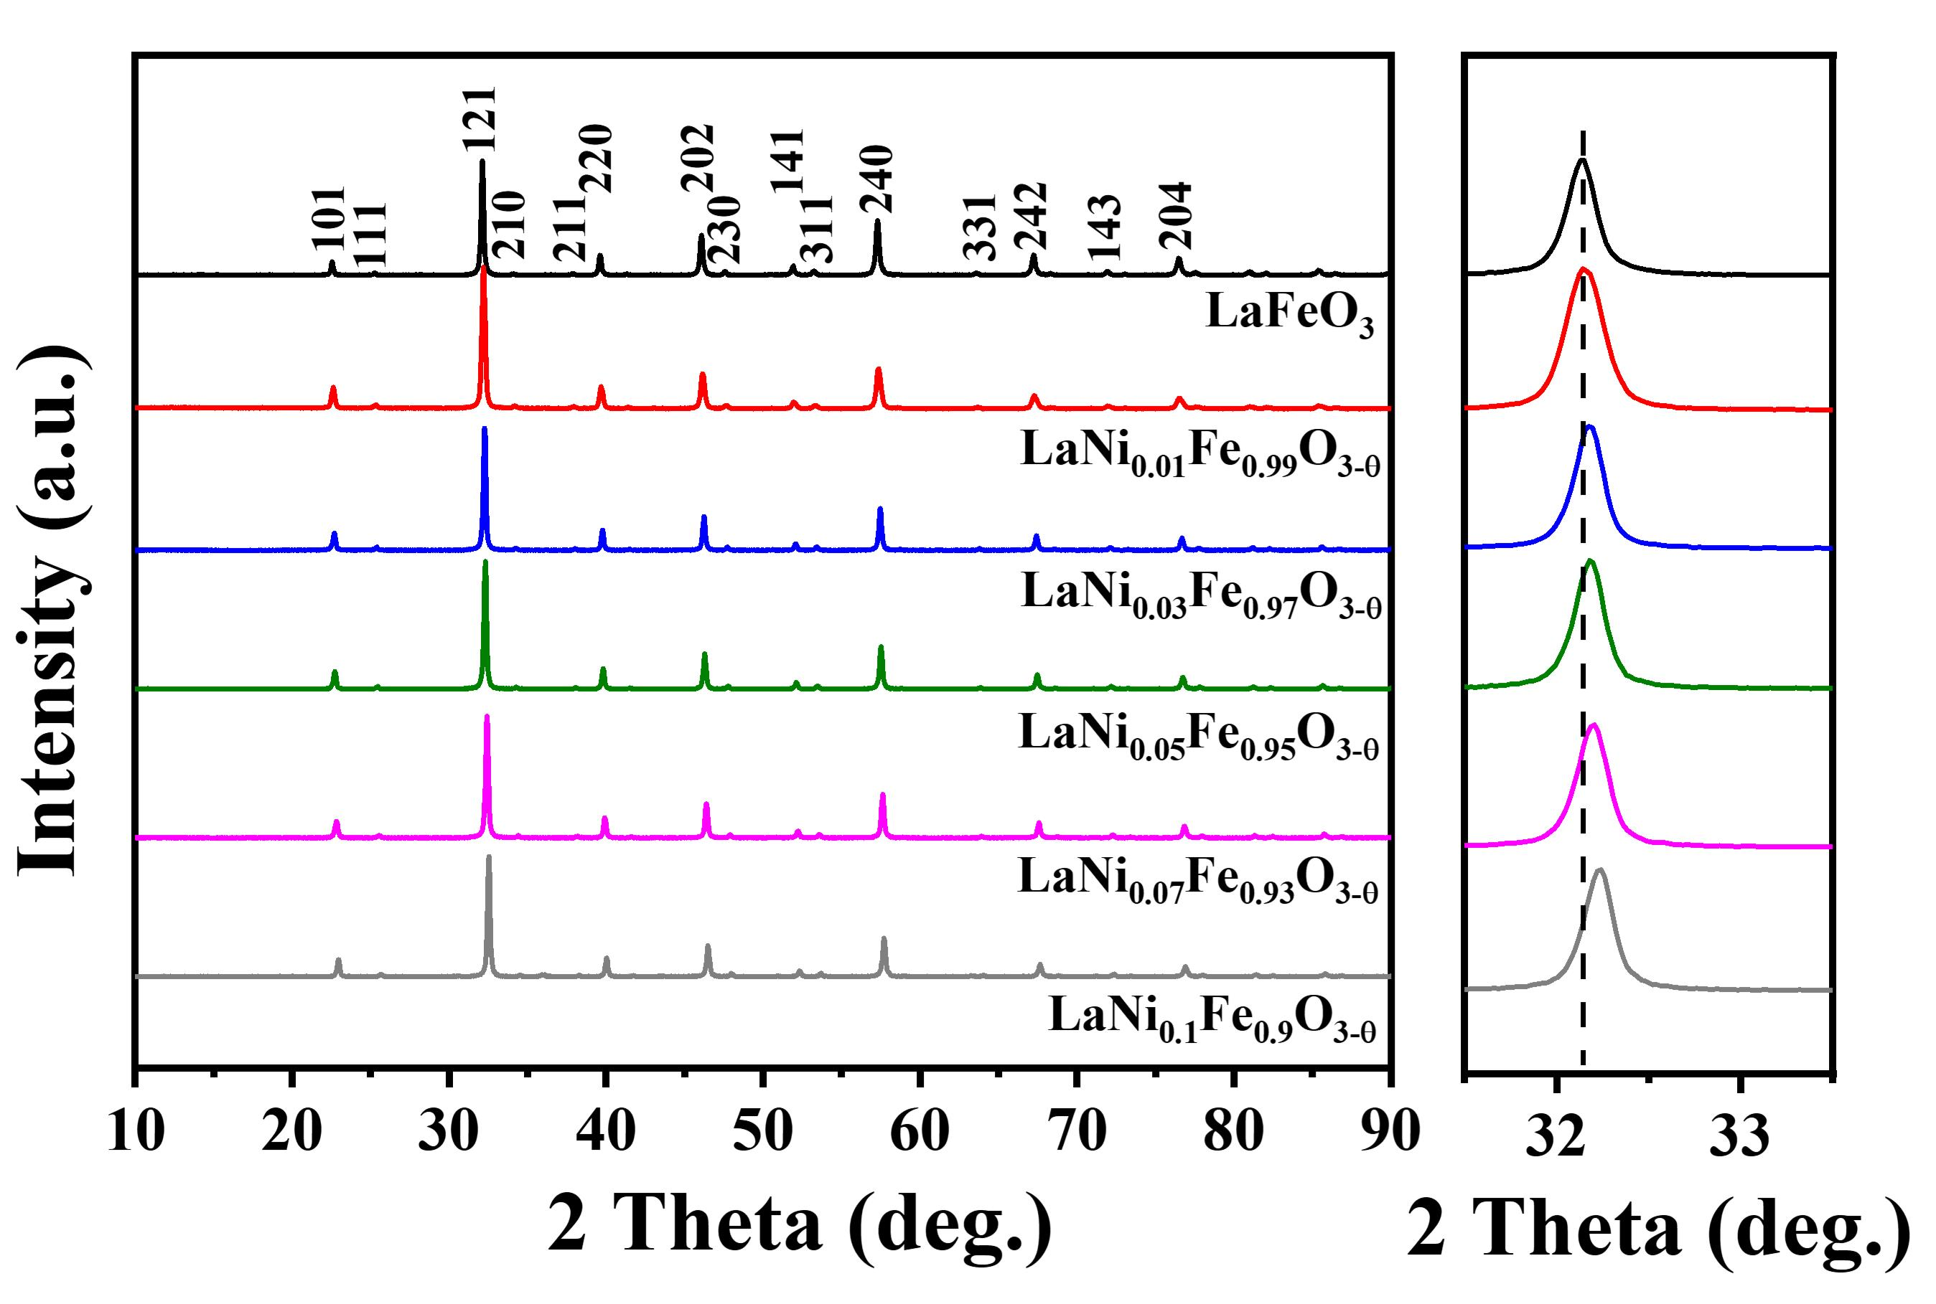
Figure S1. XRD patterns of the prepared LaNi_{x}Fe_{1-x}O_{3-δ} oxygen carrier
Figure S1 shows the XRD patterns of the synthesized LaNi_{x}Fe_{1-x}O_{3-δ} oxygen carriers. All the samples showed only the diffraction peak of perovskite phase of LaFeO₃, and no impurity was observed.

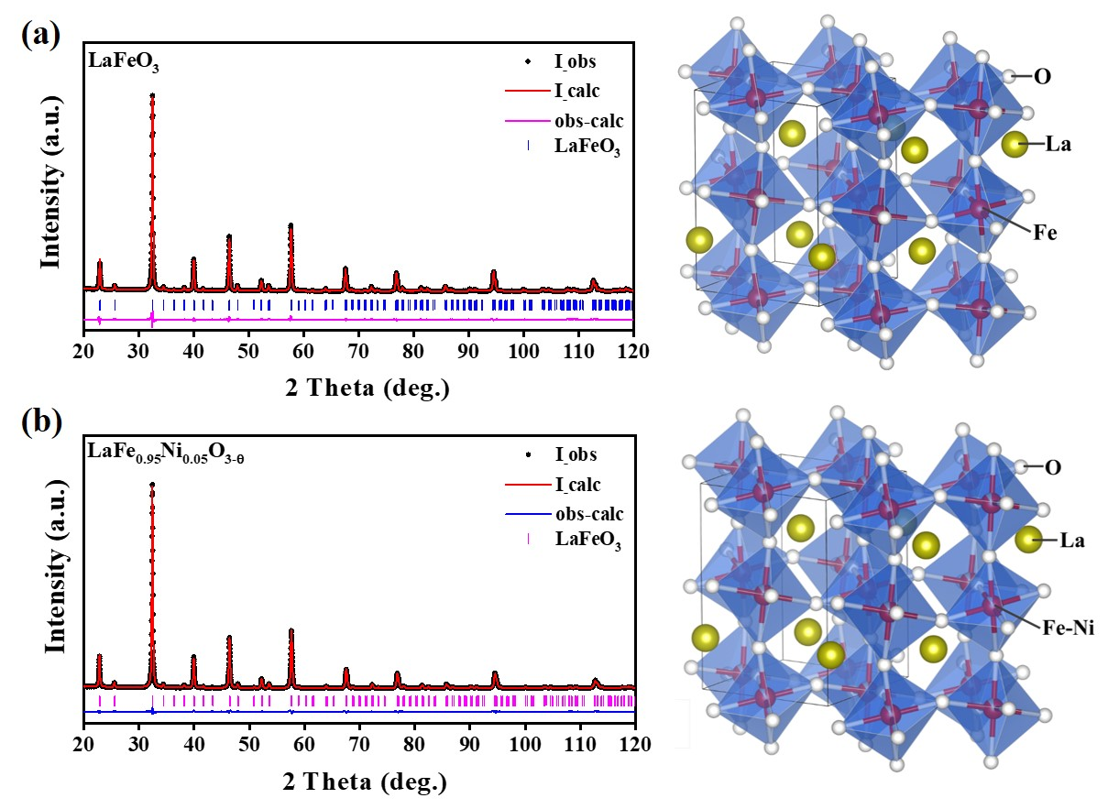
Figure S2. Rietveld refinement results of XRD patterns: (a) LaFeO₃, (b) LaNi_{0.05}Fe_{0.95}O_{3-δ}
Table S1 LaFeO₃ and LaNi₀.₀₅Fe_{0.95}O_{3-δ} lattice parameters and refinement factors
 | a (Å) | b (Å) | c (Å) | R_{p}(%) | R_{wp}(%) | χ²
LaFeO₃ | 5.5721 | 7.8655 | 5.5637 | 3.12 | 4.06 | 1.2
LaNi_{0.05}Fe_{0.95}O_{3-δ} | 5.5761 | 7.8768 | 5.5731 | 2.23 | 2.86 | 1.4
In order to explore the structural changes of perovskite caused by Ni doping in LaNi₀.₀₅Fe_{0.95}O_{3-δ} in more detail, we calculated the XRD patterns of the initial synthesized samples of LaFeO₃ and LaNi₀.₀₅Fe_{0.95}O_{3-δ} by Rietveld refinement, and the results are shown in Figure S1. Table S1 shows the crystal data and refined results of LaFeO₃ and LaNi₀.₀₅Fe_{0.95}O_{3-δ}. From the refined results, it can be seen that the R_{wp} of the two samples is less than 10%, and the χ² is about 1, which shows that the fitted results of the theoretical model are in good agreement with the actual test data, and the refined results are highly reliable. Therefore, through Rietveld refinement calculation, the form of Ni doping in LaNi₀.₀₅Fe_{0.95}O_{3-δ} sample is to replace part of Fe³⁺ ions in perovskite phase. Interestingly, the lattice parameters (A, B, c) of LaNi₀.₀₅Fe_{0.95}O_{3-δ} are larger than those of pure LaFeO₃. This is because the radius of Ni²⁺ (0.069 nm) is larger than that of Fe³⁺ (0.0645 nm), which results in the increase of the average ion radius of B site.
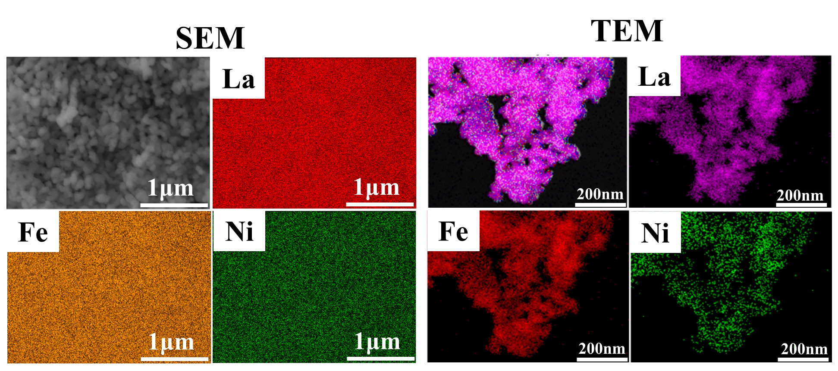
Figure S3. SEM and TEM element mapping of the LaNi_{0.05}Fe_{0.95}O_{3-δ} sample.

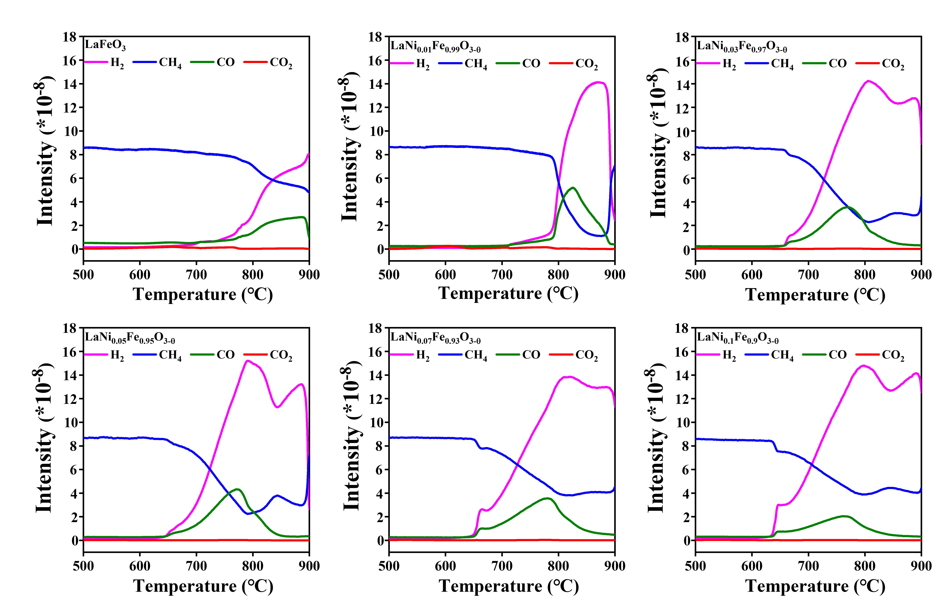
Figure S4. CH₄-TPR profiles of the LaNi_{x}Fe_{1-x}O_{3-δ} samples

Figure S5. H₂-TPR profiles of the LaNi_{x}Fe_{1-x}O_{3-δ} oxygen carriers.

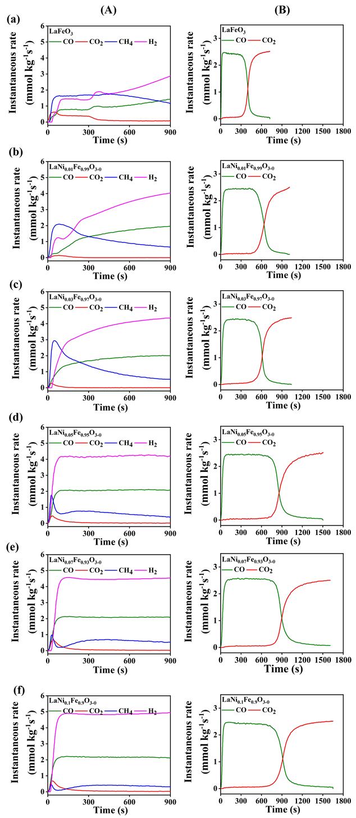
Figure S6. Temporal gaseous products concentrations for LaNi_{x}Fe_{1-x}O_{3-δ} during CH₄ reduction step (A) and CO₂ splitting step(B): (a) LaFeO₃, (b) LaNi₀.₀₁Fe_{0.99}O_{3-δ}, (c) LaNi₀.₀₃Fe_{0.97}O_{3-δ}, (b) LaNi₀.₀₅Fe_{0.95}O_{3-δ}, (b) LaNi₀.₀₇Fe_{0.93}O_{3-δ}, (b) LaNi₀.₁Fe_{0.9}O_{3-δ}

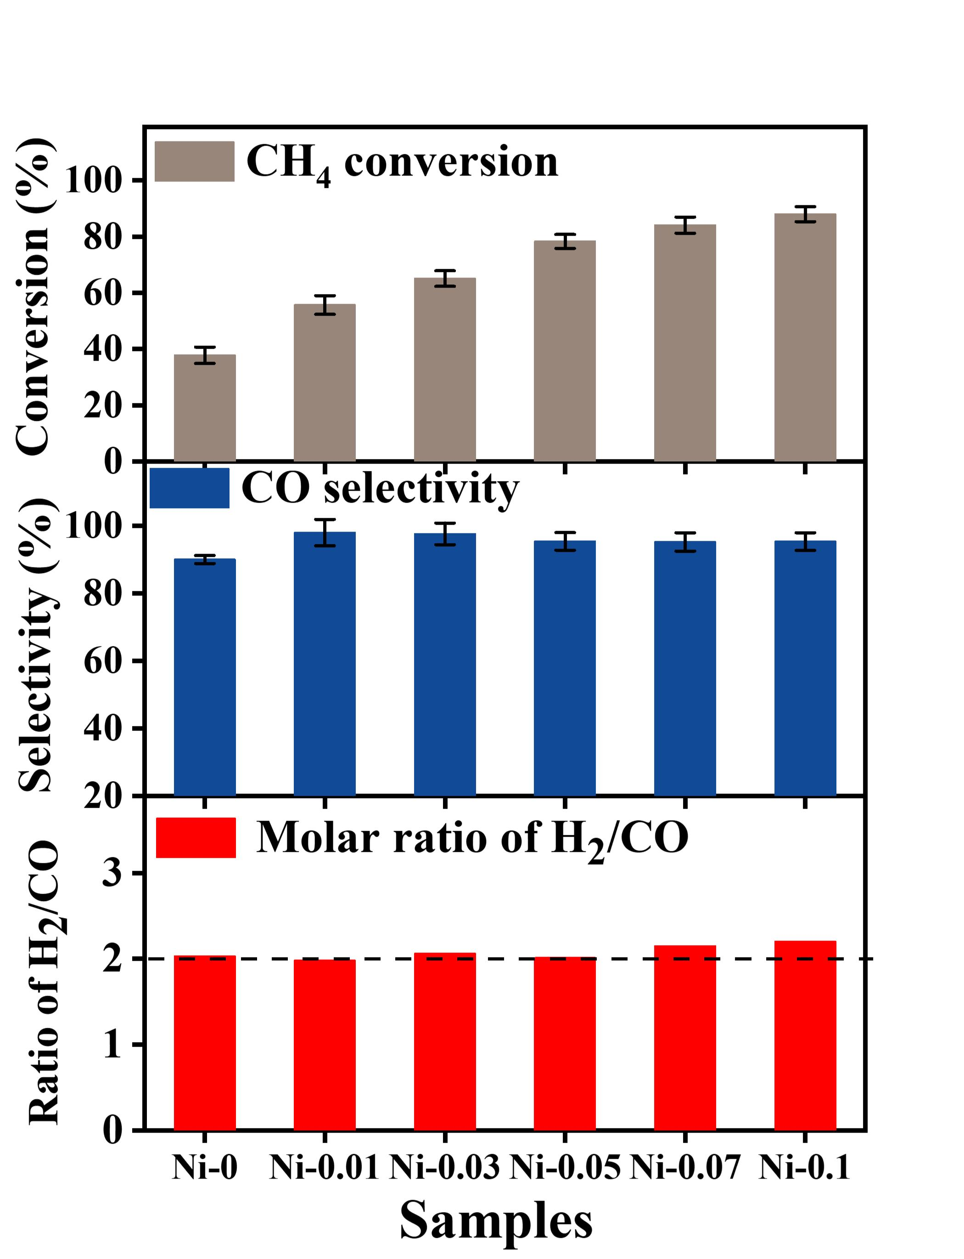
Figure S7. CH₄ conversion, CO selectivity and H₂/CO ratio in methane oxidation step over different LaNi_{x}Fe_{1-x}O_{3-δ} oxygen carriers.

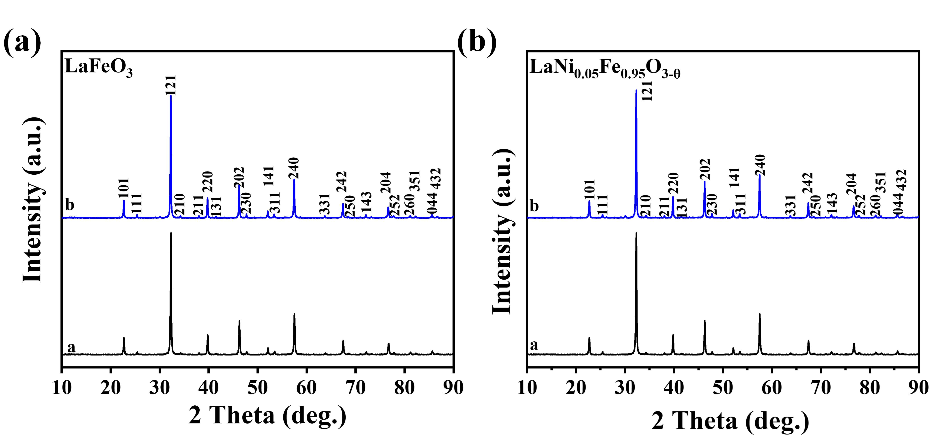
Figure S8. XRD patterns of the fresh (a) and recycled (b) LaFeO₃ and LaNi_{0.05}Fe_{0.95}O_{3-δ}oxygen carriers.

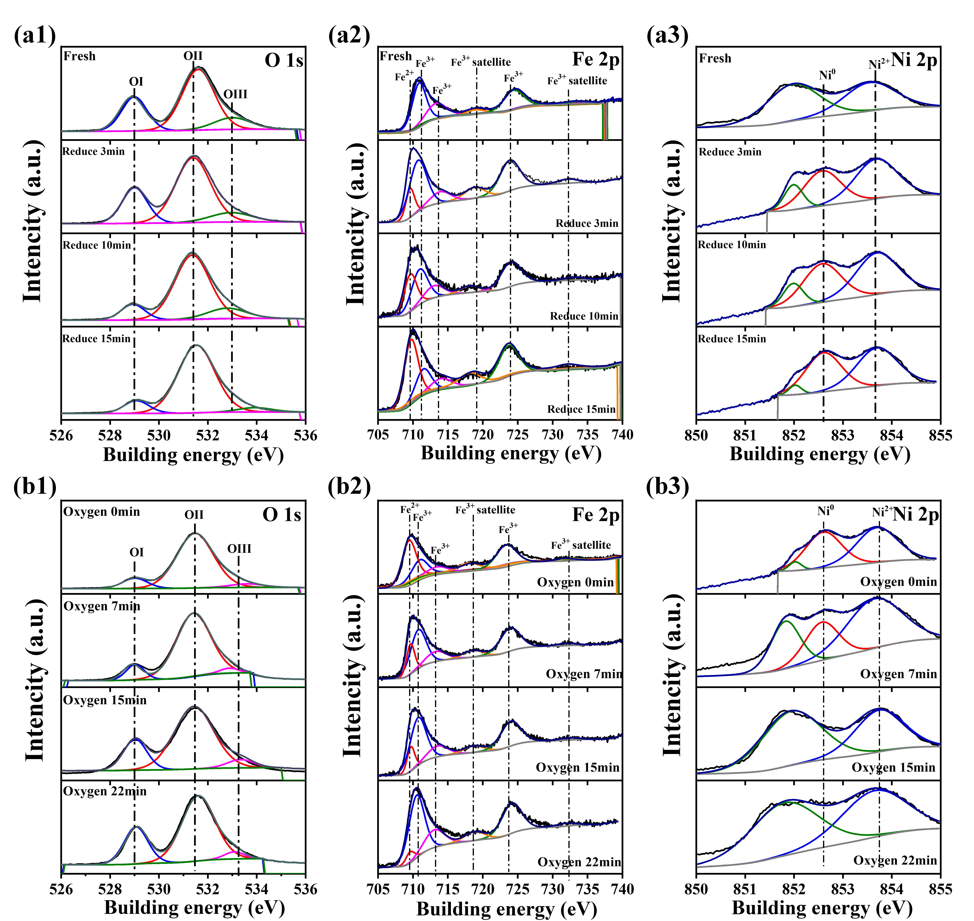
Figure S9. O1s (1), Fe 2p (2) and Ni 2p (3) XPS maps of LaNi_{0.05}Fe_{0.95}O_{3-δ} oxygen carrier in the CH₄ conversion process and CO₂ splitting process: (a) CH₄ conversion process; (b) CO₂ splitting process

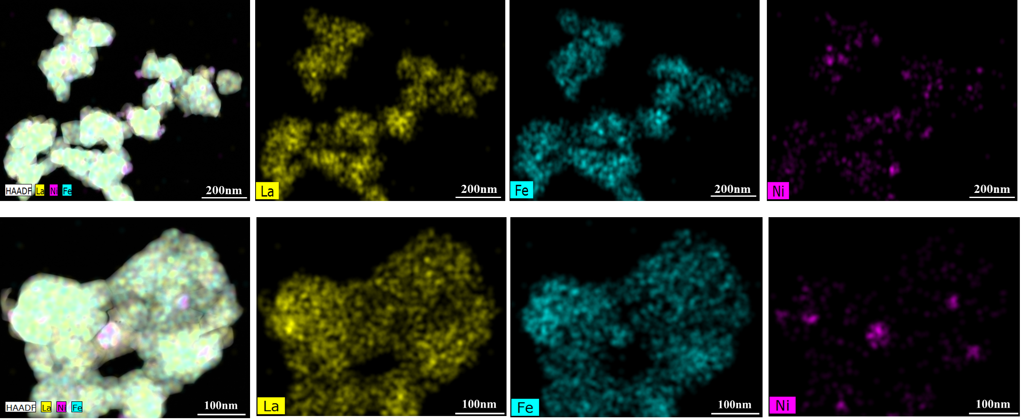
Figure S10. ADF-STEM images and corresponding EELS elemental maps of LaNi_{0.05}Fe_{0.95}O_{3-δ} of reduced 3 min
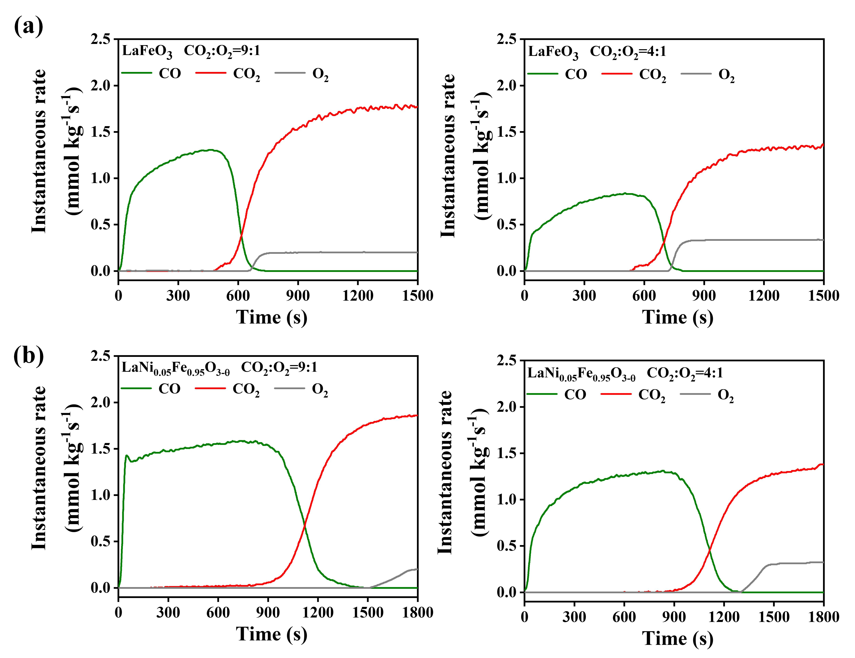
Figure S11. The effect of O₂ concentration on the CO₂ splitting over LaFeO₃ and LaNi₀.₀₅Fe_{0.95}O_{3-δ} in CL-DR: (a) LaFeO₃, (b) LaNi₀.₀₅Fe_{0.95}O_{3-δ}

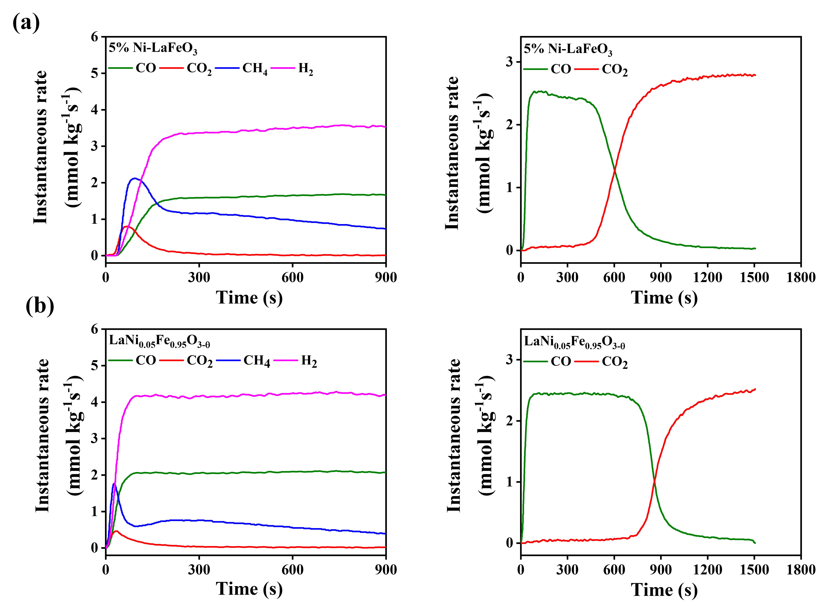
Figure S12. Temporal gaseous products concentrations for 5%Ni-LaFeO₃ (a) LaNi_{0.05}Fe_{0.95}O_{3-δ} (b) during CH₄ reduction step and CO₂ splitting step.

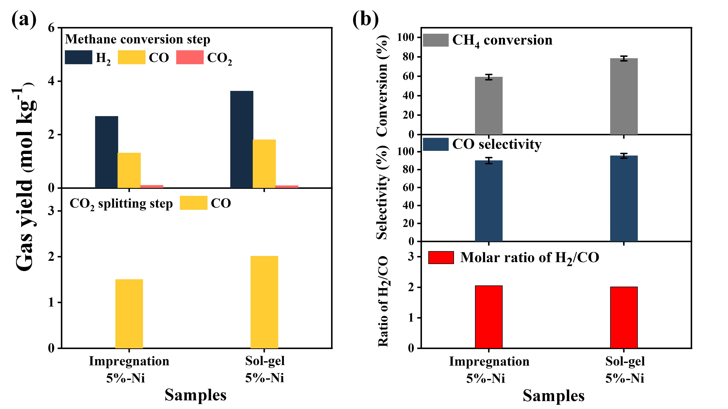
Figure S13. (a) Yields of H₂, CO and CO₂ in methane oxidation step and CO yield in CO₂ splitting step over 5%Ni-LaFeO₃ and LaNi_{0.05}Fe_{0.95}O_{3-δ}; (b) CH₄ conversion, CO selectivity and H₂/CO ratio in methane reduce step

Figure S14. Typical curves of H₂/CO/CO₂/CH₄ concentration during reduction over 5%Ni-LaFeO₃ (a) and LaNi_{0.05}Fe_{0.95}O_{3-δ} (b)

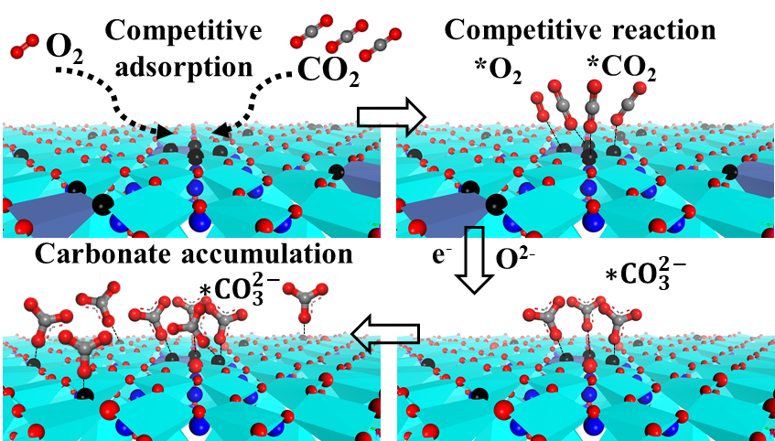
Figure S15. Mechanism schematic of co-splitting CO₂ and oxygen the reduced LaFeO₃ (110) surfaces.

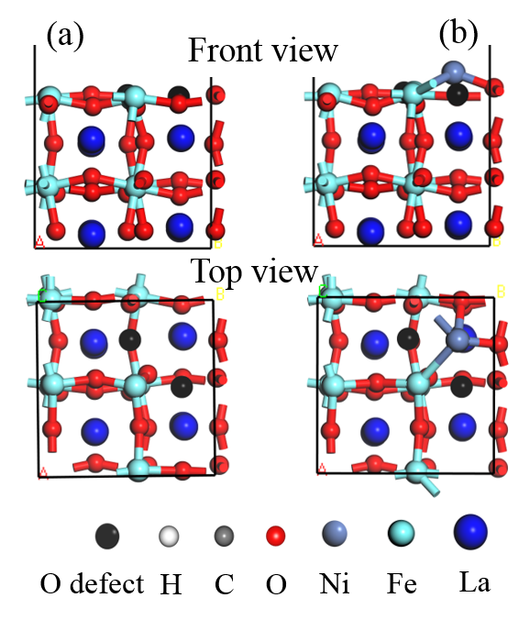
Figure S16. Optimized atomic structures of the reduced LaFeO₃ (110) surface (a) without or (b) with Ni adatom. The reduced LaFeO₃ (110) surface is modeled with 2 oxygen vacancies (black color).

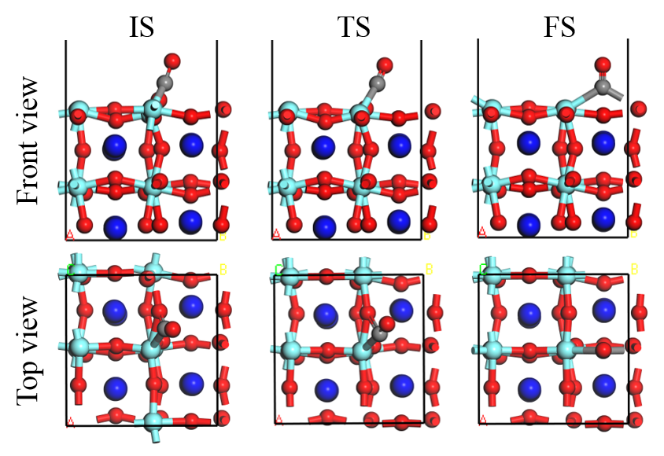
Figure S17. Optimized atomic structures of (a) initial state, (b) transition state and (c) final state for CO₂ decomposition on the reduced LaFeO₃ (110) surface.

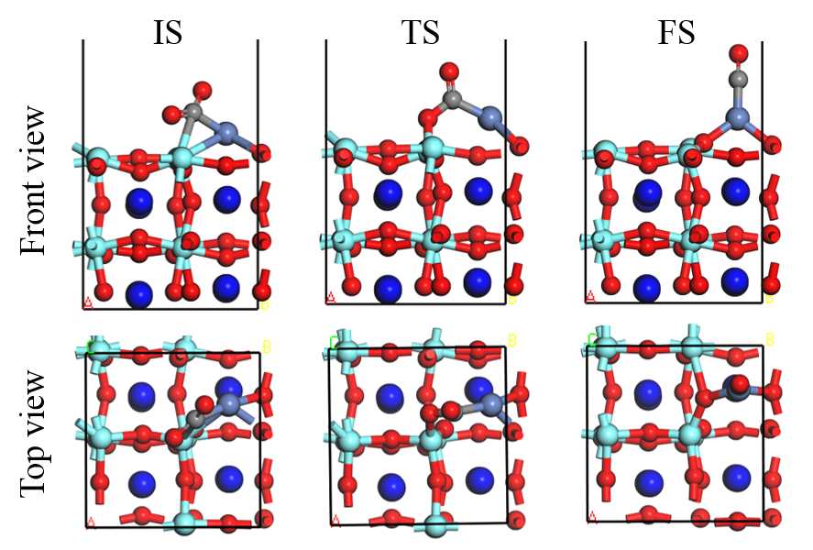
Figure S18. Optimized atomic structures of (a) initial state, (b) transition state and (c) final state for CO₂ decomposition on the reduced LaFeO₃ (110) surface with Ni adatom.

Figure S19. CO₂-TPO profiles of the LaFeO₃ and LaNi_{0.05}Fe_{0.95}O_{3-δ} oxygen carriers

Reference:
[1] Giannozzi P, Baroni S, Bonini N, Calandra M, Car R, Cavazzoni C, Ceresoli D, Chiarotti G L, Cococcioni M, Dabo I, Dal Corso A, de Gironcoli S, Fabris S, Fratesi G, Gebauer R, Gerstmann U, Gougoussis C, Kokalj A, Lazzeri M, Martin-Samos L, Marzari N, Mauri F, Mazzarello R, Paolini S, Pasquarello A, Paulatto L, Sbraccia C, Scandolo S, Sclauzero G, Seitsonen A P, Smogunov A, Umari P and Wentzcovitch R M 2009 QUANTUM ESPRESSO: a modular and open-source software project for quantum simulations of materials J Phys Condens Matter 21 395502
[2] Perdew J P, Ruzsinszky A, Csonka G I, Vydrov O A, Scuseria G E, Constantin L A, Zhou X and Burke K 2008 Restoring the density-gradient expansion for exchange in solids and surfaces Phys Rev Lett 100 136406
[3] Monkhorst H J and Pack J D 1976 Special points for Brillouin-zone integrations Phys Rev B 13 5188
[4] Grimme S, Antony J, Ehrlich S and Krieg H 2010 A consistent and accurate ab initio parametrization of density functional dispersion correction (DFT-D) for the 94 elements H-Pu J Chem Phys 132 154104
[5] Anisimov V I, Zaanen J and Andersen O K 1991 Band theory and Mott insulators: Hubbard U instead of Stoner I Phys Rev B 44 943
[6] Wang L, Maxisch T and Ceder G 2006 Oxidation energies of transition metal oxides within the GGA+ U framework Phys Rev B 73 195107
[7] Boateng I W, Tia R, Adei E, Dzade N Y, Catlow C R A and De Leeuw N H 2017 A DFT+ U investigation of hydrogen adsorption on the LaFeO 3 (010) surface Physical Chemistry Chemical Physics 19 7399-409

