Supplementary Material
The Association of Healthy Lifestyle and Socioeconomic Status with Kidney Stone Occurrence: A Cross-Sectional Study

Guoqiang Huang^{1*}, Shuangquan Lin^{1*}, Kaiwen Xiao^{1*}, KeChen ¹, Fei Gong¹, Chao Hu^{1#} and Xiongbing Lu^{1#}

¹Department of Urology, The Second Affiliated Hospital of Nanchang University, Nanchang, 330000, China.

Corresponding author: Chao Hu^{1#} and Xiongbing Lu^{1#}
E-mail: ndefy05026@ncu.edu.cn;

Supplementary Figures
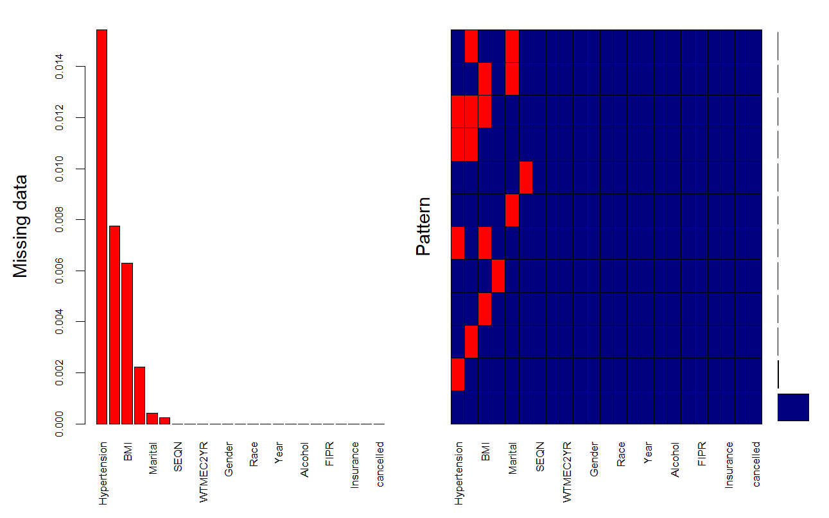
Supplementary Figure S1. Missing data of included participants.

Supplementary Tables
Supplementary Table S1. The classifications of variables related to socioeconomic status.
Covariates | Classifications
FIPR | <1; 1 to < 4; ≥4
Occupation | Employment (including retirees and students); unemployment.
Educational level | below high school (less than 9th grade or 9-11th grade including 12th grade with no diploma); high school (high school graduate, GED, or equivalent); and college or above (college, AA degree or above)
Health insurance | private health insurance (private health insurance, Medi-Gap, or single-service plan); public health insurance (Medicare, Medicaid, State Children’s Healthcare Plan, military healthcare, Indian Health Service, State Sponsored Health Plan, or other government programme); no health insurance
Abbreviations: FIPR, the ratio of family income to poverty.

Supplementary Table S2 Associations of lifestyle score with kidney stone.
 | Model 5 |  | Model 6 |  | Model 7
 | β (95% CI) | P-Value | β(95% CI) | P-Value | β (95% CI) | P-Value
lifestyle score
Very Poor | reference | reference | reference | reference | reference | reference
Poor | -0.30 (-0.61, -0.01) | 0.054 | -0.36(-0.68, -0.06) | 0.023 | -0.28(-0.60, 0.02) | 0.077
Fair | -0.18 (-0.49, 0.11) | 0.200 | -0.40(-0.71, - 0.11) | 0.010 | -0.33(-0.65, -0.04) | 0.034
Good | 0.00 (-0.32, 0.31) | ＞0.900 | -0.21(-0.54, 0.10) | 0.200 | -0.17(-0.51, 0.14) | 0.300
Excellent | -0.38(-0.86,0.11) | 0.120 | -0.56(-1.00, -0.06) | 0.025 | -0.54(-1.00, -0.04) | 0.029
Abbreviations: CI: Confidence interval.
Model 5: Unadjusted for covariates.
Model 6: Adjusted for sex, age, race, marital status.
Model 7: Adjusted for sex, age, race, marital status, BMI, diabetes, and hypertension.

