SUPPORTING INFORMATION

Two-dimensional graphene nanoplatelets incorporated PEO/PLA polymer mixture for the enhanced electrochemical performance of quasi-solid polymer electrolytes
Ankan Gobinda Choudhuryª, Gayathri Viswanathanª, Elamathy Balamoorthy^{a,b}, Geetha Nagarajan^{c}, Duraisamy Kumaresan^{a,b,*}, Thirugnasambandam G. Manivasagam^{a,b,*}

ª Department of Chemical Engineering and Materials Science, Amrita School of Engineering, Amrita Vishwa Vidyapeetham, Coimbatore, India
^{b} Centre of Excellence in Advanced Materials and Green Technologies (CoE-AMGT), Amrita School of Engineering, Amrita Vishwa Vidyapeetham, Coimbatore, India
^{c} Department of Electrical and Electronics Engineering, Amrita School of Engineering, Amrita Vishwa Vidyapeetham, Coimbatore, India
* Email (s): k_duraisamy@cb.amrita.edu, gm_thiru@cb.amrita.edu

S1. Elemental mapping of PEO/PLA-N fibrous polymer blend
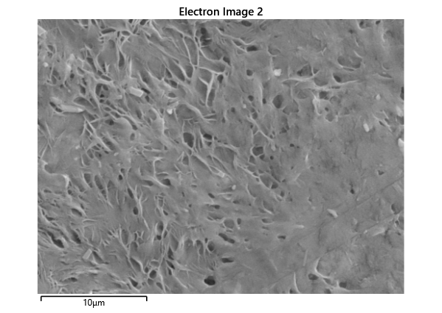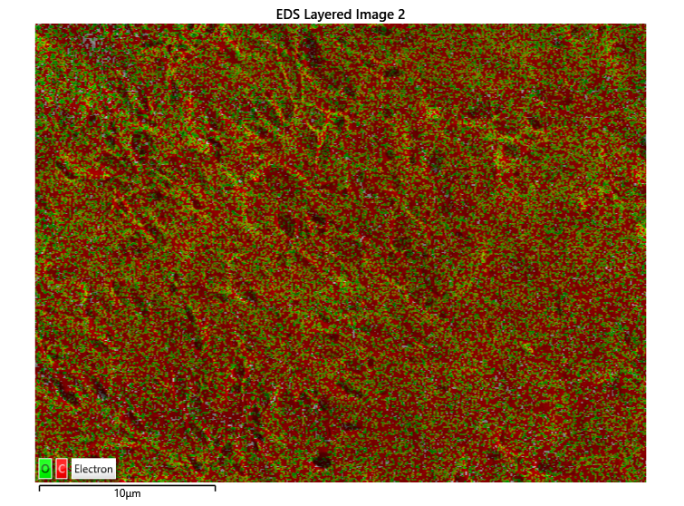
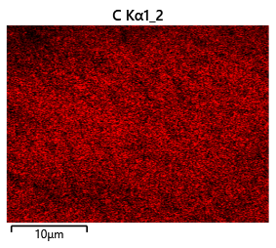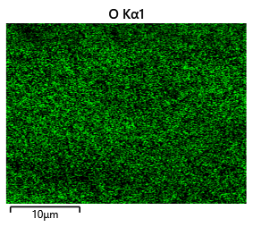

S2 Differential capacity plots from GCD of GNP 0 and GNP 2

