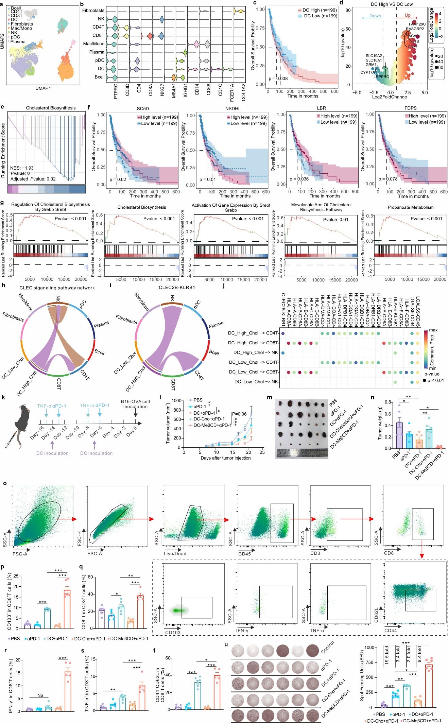
Extended data Figure 1. DCs cholesterol regulation correlates with immune function in melanoma and enhances vaccine efficacy in vivo. (a) UMAP plot displaying the major cell types distribution in melanoma patients. (b) Violin plot showed marker genes' expression levels in each cell type. (c) Kaplan-Meier survival curve of DC immune infiltration (ssGSEA method) in TCGA-SKCM. (d) Differential volcano plots of high and low DC immune infiltration patient groups. (e) GSEA enrichment analysis of high and low DC immune infiltration patient groups. (f) Kaplan-Meier curves of cholesterol-related genes in melanoma patients. (g) GSEA was performed to analyze the enrichment of cell membrane cholesterol homeostasis-related pathways in the high-infiltration DC group. (h) CLEC signaling network. (i) Chord diagram of ligand-receptor pairs in the CLEC signaling network. (j) Comparison of significant ligand-receptor pairs between DC and T cells. The color of the dots reflects the communication probability, and the size of the dots represents the calculated P-value. Blank cells indicate zero communication probability. (k) Schematic of the model for vaccine-mediated tumor prevention and treatment protocol. There were n = 6 mice per treatments: (1) PBS; (2) αPD-1; (3) DC vaccine+αPD-1; (4) DC-Cho+αPD-1; (5) DC-MeβCD+αPD-1. (l) Statistical analysis of subcutaneous tumor size of B16F10 melanoma-bearing mice treated with different formulations. (m) Physical images of in vitro tumor size in B16F10 melanoma-bearing mice treated with different formulations. (n) Statistical analysis of tumor weight of B16F10 melanoma-bearing mice treated with different formulations. (o) Flow cytometry gate strategy for differentiating CD8⁺CD103⁺ T Cells from CD8⁺ T Cells. (p) Flow cytometry analysis of the percentage of CD103⁺ T cells among CD8⁺ T cells. (q) Flow cytometry analysis of the percentage of CD8⁺ T cells among CD3⁺ T cells. (r) Flow cytometry analysis of the percentage of IFN-γ⁺ T cells among CD8⁺ T cells. (s) Flow cytometry analysis of the percentage of TNF-α⁺ T cells among CD8⁺ T cells. (t) Flow cytometry analysis of the percentage of effector memory T cells (CD44⁺CD62L⁻) among CD8⁺ T cells. Data are presented as mean ± SEM, and the statistical significance was analyzed via one-way ANOVA. (u) Elispot assay to detect the number of IFN-γ⁺ spots produced by mouse splenocytes in B16F10 melanoma-bearing mice treated with different formulations after antigen stimulation. Statistical analysis of the number of IFN-γ⁺ spots produced by mouse splenocytes in B16F10 melanoma-bearing mice treated with different formulations after antigen stimulation.
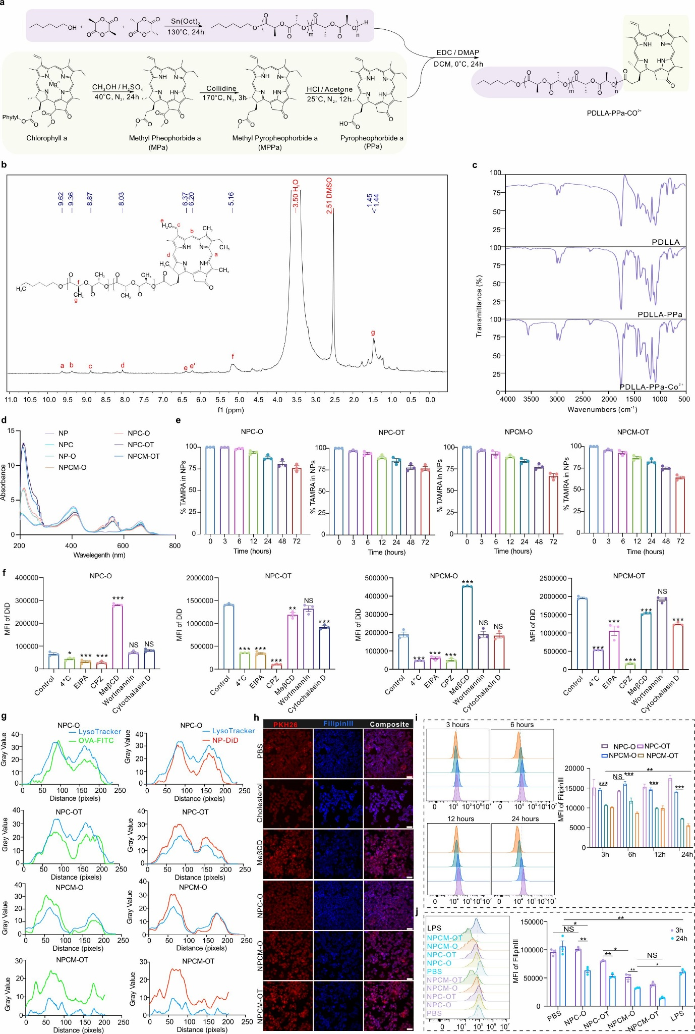
Extended data Figure 2. Characterization of nanovaccine formulations, uptake mechanisms, and membrane cholesterol modulation in APCs. (a) Schematic diagram of the synthesis process of PDLLA-PPa-Co²⁺. (b) ¹H NMR spectra of PDLLA-PPa-Co²⁺ in DMSO-d_{6.} (c) Fourier transform infrared Spectroscopy (FTIR) of PDLLA, PDLLA-PPa, and PDLLA-PPa-Co²⁺. (d) Ultraviolet-visible (UV-Vis) absorption spectra of NP, NPC (NP + CpG), NP-O (NP + OT-I/OT-II peptide), NPC-O (NP + CpG + OT-I/OT-II peptide), NPC-OT (NP + CpG + OT-I/OT-II peptide + TATk peptide), NPCM-O (NP + CpG + MeβCD + OT-I/OT-II peptide), and NPCM-OT (NP + CpG + MeβCD + OT-I/OT-II peptide + TATk peptide). (e) Identification of changes in the amount of antigen peptide carried by nanovaccines of different formulations (OT-I peptide covalently coupled to TAMRA dye) after incubation with saline containing 10% mouse serum at 37℃ for different times. (f) Relative fluorescence intensity of nanovaccines internalized by APCs under different inhibition strategies. Chlorpromazine (CPZ): inhibitor of lattice protein-mediated endocytosis. 5-(N-ethyl-nisopropyl) amiloride (EIPA): inhibitor of macrophage-type endocytosis. MeβCD: inhibitor of cyclodextrin-mediated endocytosis (cytosolic caveolar invagination process). Wortmannin: an autophagy inhibitor. Cytochalasin D: giant cytosolic drink-mediated endocytosis. 4℃: energy-dependent. (g) Quantitative analysis of colocalization between DIO or TAMRA-labeled peptide and lysosomes in DC2.4 after incubation with different formulations using Pearson's correlation coefficient. Line scan profiles were generated using ImageJ software to evaluate the colocalization between LysoTracker (blue) and OVA-FITC (green) or NP-DiD (red) in the NPC-O, NPC-OT, NPCM-O, and NPCM-OT groups. The fluorescence intensity (gray value) along a selected linear region is plotted against distance (pixels). Higher overlap of the intensity peaks indicates stronger colocalization between lysosomes and the antigens or NPs. (h) Confocal imaging to identify the relative cholesterol concentrations in DC2.4 cell membranes after 3-hour incubation with different formulations. The scale bar is 10 μm. (i) Statistical analysis of the relative concentration of cell membrane cholesterol in RAW264.7 cells incubated with different formulations for different times. Filipin III was used to stain the cell membrane cholesterol. (j) Flow cytometry to statistically analyze the changes in cell membrane cholesterol content after maturation of BMDC incubated with different formulations. Data are presented as mean ± SEM, and the statistical significance was analyzed via one-way ANOVA. *P <0.05, **P <0.01, ***P <0.001, and NS: not significant.
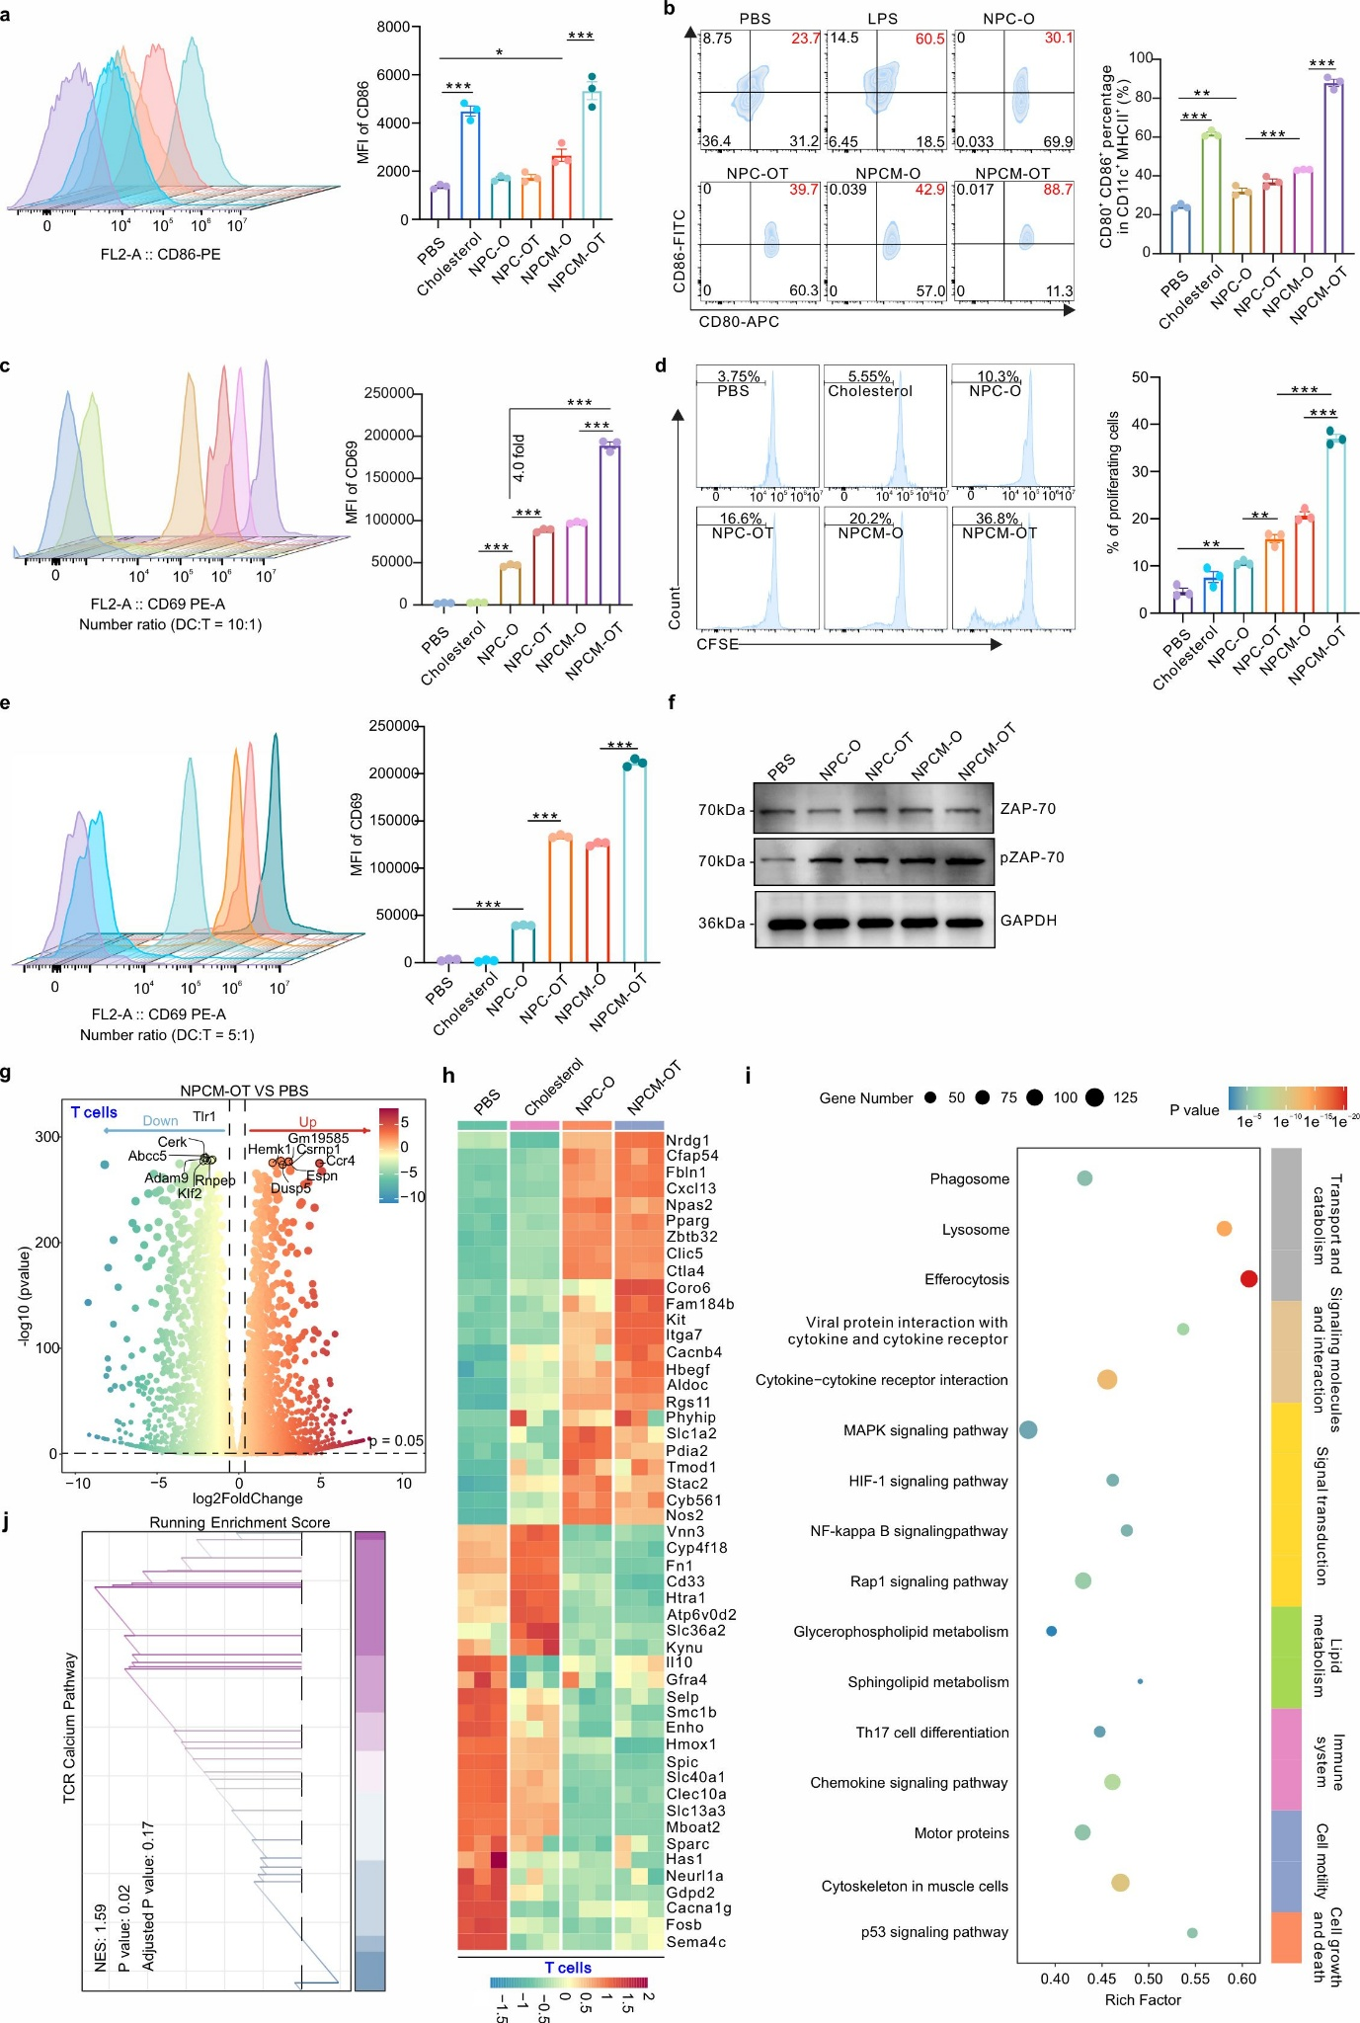
Extended data Figure 3. Nanovaccine-mediated activation of DCs and OT-I T cells, and transcriptomic insights into DC–T cell immune synapse formation. (a) Ability of the indicated nanovaccine in mediating the expression of CD86 in BMDC. (b) Ability of the indicated nanovaccine in mediating the activation of BMDC. (c) Ability of the indicated nanovaccine in mediating the activation of OT-I T cells after incubation with BMDC (DC to T cell ratio of 10:1). (d) Ability of the indicated nanovaccine in mediating OT-I T cell proliferation after incubation with BMDC (DC to T cell number ratio of 5:1). (e) Ability of the indicated nanovaccine in mediating OT-I T cell activation after incubation with BMDCs (DC to T cell number ratio of 5:1). Data are presented as mean ± SEM, and the statistical significance was analyzed via one-way ANOVA. *P <0.05, **P <0.01, ***P <0.001, and NS: not significant. (f) Western blotting was performed to assess the strength of DC-T cell immunological synapse formation mediated by nanovaccines of different compositions. ZAP-70 is an activated TCR downstream signaling pathway molecule, and the intensity of ZAP-70 phosphorylation determines the intensity of MHC-TCR complex formation. (g-j) Transcriptomics to identify the expression genes and changes in relevant signaling pathways mediating OT-I T cell activation after incubation of the indicated nanovaccines with BMDCs (DC to T cell number ratio of 10:1). (g) Volcano plot of DEGs in NPCM-OT group vs. PBS group. (h) Heat maps of the selected DEGs based on the results of (g) in the PBS, cholesterol, NPC-O, and NPCM-OT groups. (i) KEGG pathway enrichment of the DEGs in the PBS, cholesterol, NPC-O, and NPCM-OT groups. (j) GSEA of the NPCM-OT-treated OT-I T cells.
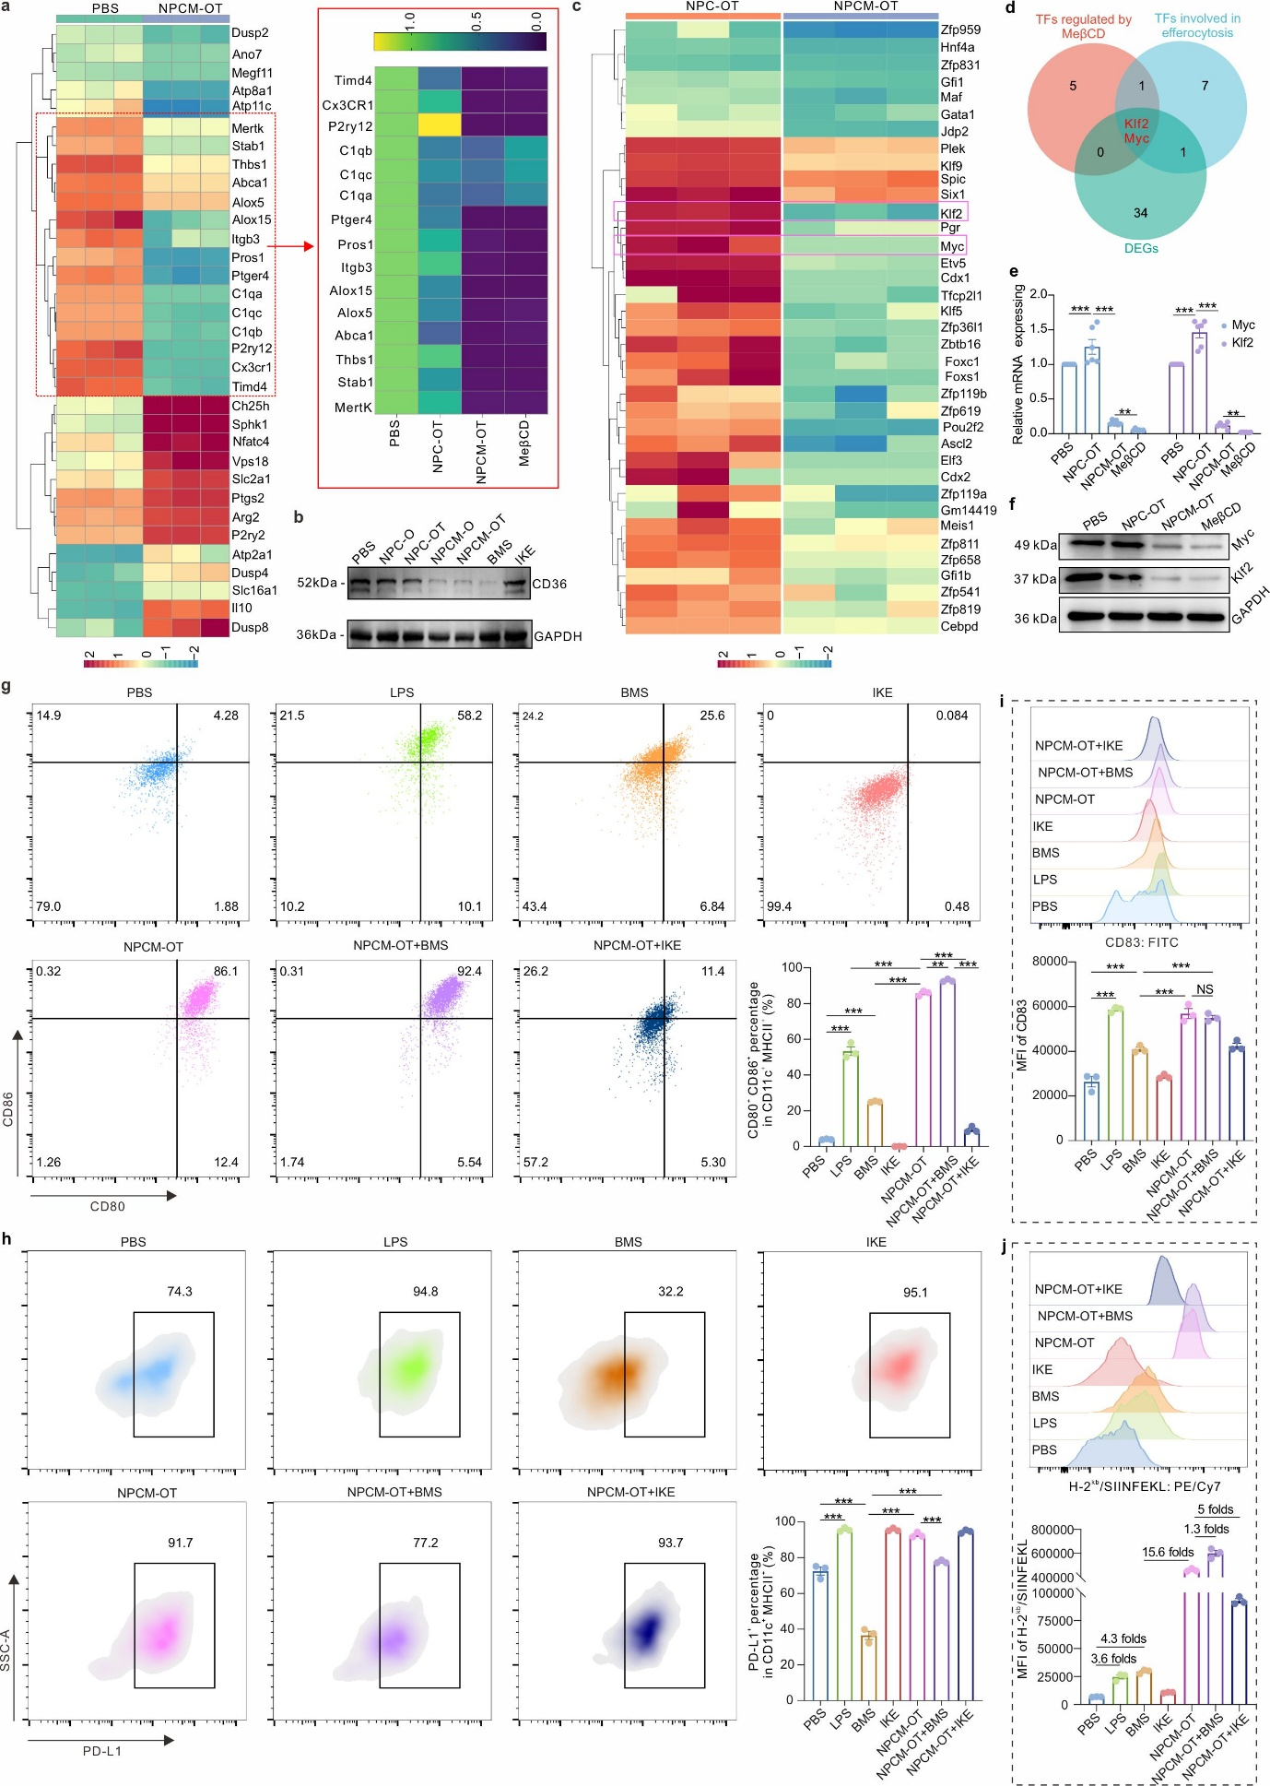
Extended data Figure 4. Inhibition of efferocytosis by NPCM-OT regulated Klf2/Myc expression and enhanced DC activation and antigen presentation. (a) Quantitative PCR to characterize the effects of nanovaccines with different formulations on gene expression of molecules of the effrocytosis-related signaling pathway in BMDC. (b) Western blotting experiments were performed to assess the expression of the effrocytosis-related receptor CD36 in DC2.4 cells after being infused with nanovaccines of different formulations. (c) Heat map of differentially expressed transcription factor-related genes in the NPCM-OT and NPC-OT groups; (d) Venn diagram identifying transcription factors (klf2 and Myc) presence in all three gene sets: those regulated by MeβCD, those associated with efferocytosis, and the DEGs identified in Fig. (c). (e) Quantitative PCR to assess the effects of the indicated treatment on the expression of Myc and klf2 genes in BMDCs. (f) Western blotting to identify the effects of the indicated treatment on the expression of Myc and klf2 proteins in BMDCs. The effects of efferocytosis on antigen presentation and co-stimulatory molecule expression in BMDCs. (g) NPCM-OT promoted BMDC activation by inhibiting efferocytosis. (h) Effects of inhibiting efferocytosis on PD-L1 expression in BMDCs. (i) NPCM-OT promoted CD83 expression in BMDCs by inhibiting efferocytosis. (j) NPCM-OT enhanced MHC-peptide complex presentation on the BMDC cell membrane by inhibiting efferocytosis.
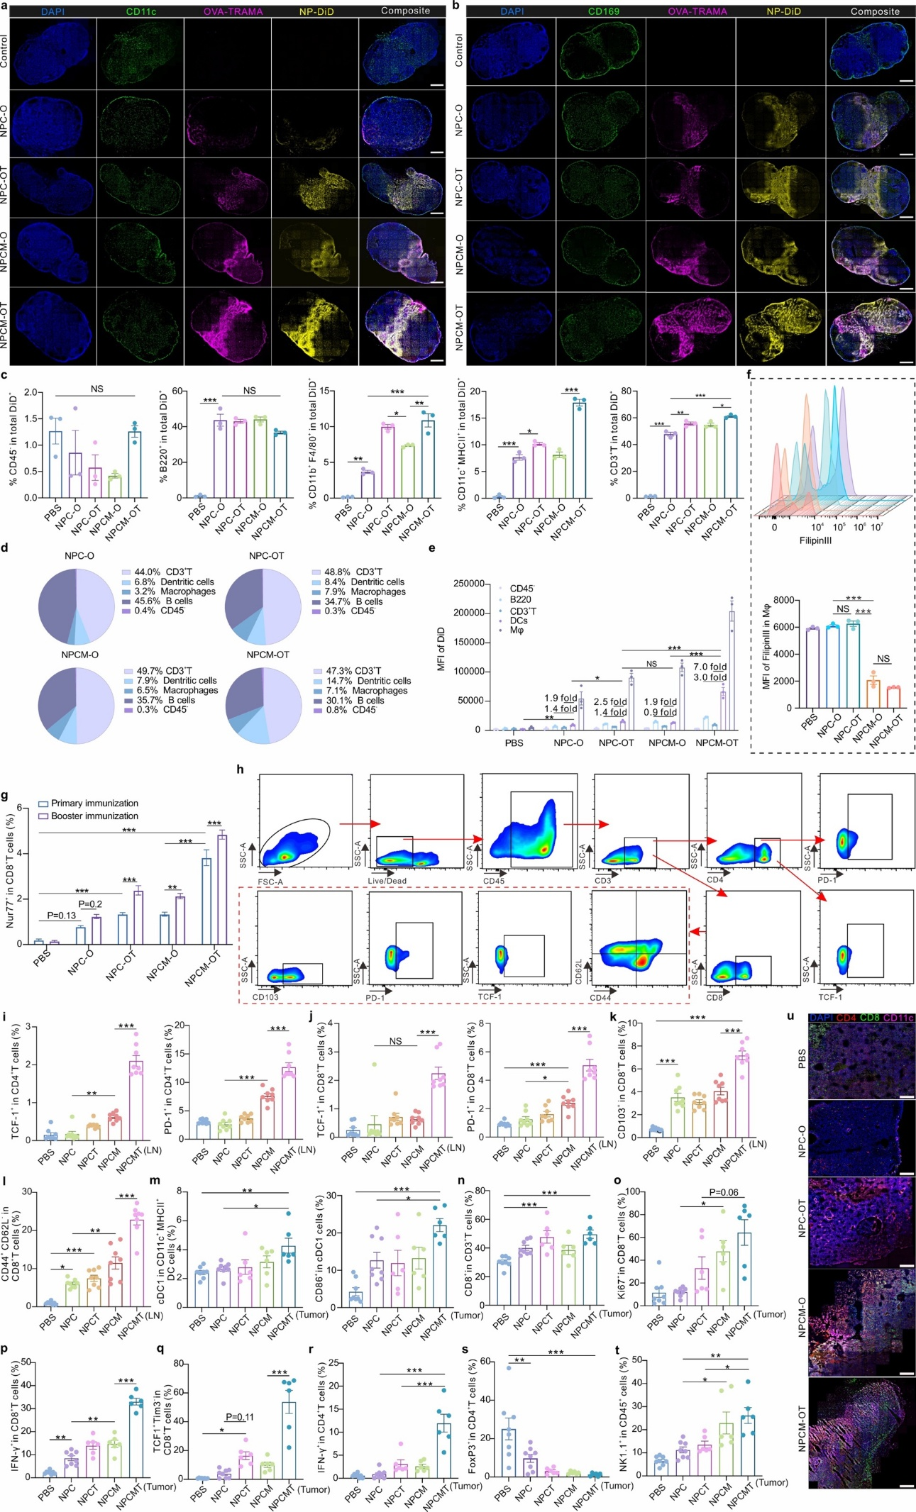
Extended data Figure 5. Lymph node delivery, antigen uptake, and immunological remodeling induced by nanovaccines in draining lymph nodes and TIME. (a) Immunofluorescence assay to identify the fluorescence co-localization of antigens/nanocarrier and DCs in the indicated nanovaccine group in the lymph node. The scale bar is 200 μm. Blue represents the nucleus, green represents the DCs, yellow represents the nanocarrier, and pink represents the antigen peptide. The scale bar is 200 μm. (b) Immunofluorescence assay to identify the ability of the indicated nanovaccine to subcapsular macrophages in the indicated nanovaccine group in the lymph node. Blue represents the nucleus, green represents the CD169 signal (subcapsular macrophages), yellow represents the nanovaccine, and pink represents the antigen peptide. The scale bar is 200 μm. (c) Statistical analysis of the proportion of cells that have ingested the indicated nanovaccine in different cell subpopulations. (d) Fan charts analyzing the number of different cells that have ingested the indicated nanovaccine as a proportion of total cells that have ingested the nanovaccine. (e) Statistical analysis of fluorescence intensity of different cell subpopulations that have ingested the indicated nanovaccine. Data are presented as mean ± SEM, and the statistical significance was analyzed via one-way ANOVA. *P <0.05, **P <0.01, ***P <0.001, and NS: not significant. (f) Flow cytometry to identify the changes in the cell membrane surface cholesterol content of lymph node macrophages after the indicated nanovaccine injection. (g) Evaluating the effects of different times of NPCM-OT immunization on the proportion of antigen-specific T cells in lymph nodes. Data are presented as mean ± SEM (N = 5 mice per group), and the statistical significance was analyzed via one-way ANOVA. *P <0.05, **P <0.01, ***P <0.001, and NS: not significant. (h) The gating strategy was used to analyze different immune cells in the TIME of a B16 subcutaneous tumor model. (i-u) Effects of advanced immunization with the indicated nanovaccine on the proportion and number of immune cell subsets in draining lymph nodes and TIME when reaching the endpoint of the tumor prevention experiment. (i) Statistical analysis of the proportion of LN’s TCF-1⁺CD4⁺ T cells and LN’s PD-1⁺CD4⁺ T cells in total CD4⁺ T cells. (j) Statistical analysis of the proportion of LN’s TCF-1⁺CD8⁺ T cells and LN’s PD-1⁺CD8⁺ T cells in total CD8⁺ T cells. (k) Statistical analysis of the proportion of LN’s CD103⁺CD8⁺ T cells in total CD8⁺ T cells. (l) Statistical analysis of the proportion of LN’s CD44⁺CD8⁺ T cells in total CD8⁺ T cells. (m) Statistical analysis of the proportion of TIME’s XCR-1⁺ DCs in total DCs and statistics of the proportion of TIME’s CD86⁺ cDC1 in total cDC1. (n) Statistical analysis of the proportion of TIME’s CD8⁺ T cells in total CD3⁺ T cells. (o) Statistical analysis of the proportion of TIME’s Ki67⁺ T cells in total CD8⁺ T cells. (p) Statistical analysis of the proportion of TIME’s IFN-γ⁺ T cells in total CD8⁺ T cells. (q) Statistical analysis of the proportion of TIME’s TCF-1⁺ TIM-3⁻ T cells in total CD8⁺ T cells. (r) Statistical analysis of the proportion of TIME’s IFN-γ⁺ T cells in total CD4⁺ T cells. (s) Statistical analysis of the proportion of TIME’s Treg cells (FoxP3⁻ ) in total CD4⁺ T cells. (t) Statistical analysis of the proportion of TIME’s NK1.1⁺ immune cells in total CD45⁺ immune cells. (u) Immunofluorescence to identify the CD4⁺ T cells, CD8⁺ T cells, and CD11c⁺ DCs infiltration in the TIME of different mouse groups after advanced immunization with the indicated nanovaccine. The scale bar is 200 μm. Blue represents the nucleus, green represents CD8⁺ T cells, red represents CD4⁺ T cells, and pink represents CD11c⁺ DCs. Data are presented as mean ± SEM (n = 6 mice per group), and the statistical significance was analyzed via one-way ANOVA. *P <0.05, **P <0.01, ***P <0.001, and NS: not significant.

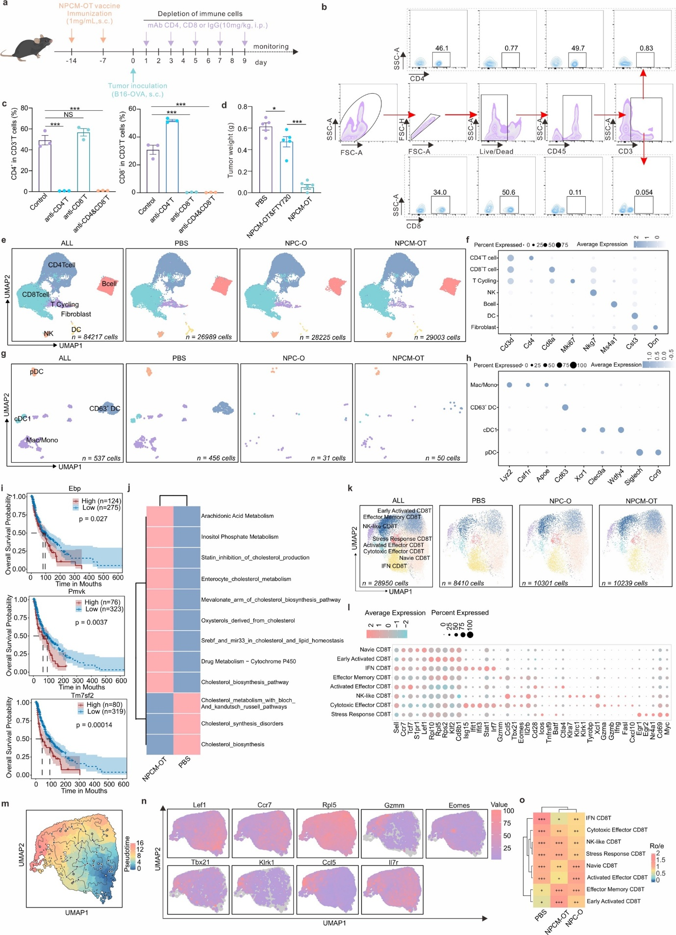
Extended data Figure 6. T cell dependence of NPCM-OT antitumor efficacy and single-cell transcriptomic analysis of lymph node immune remodeling and metabolic reprogramming. (a-c) Characterization of the depletion effect using CD4⁺ T cells or CD8⁺ T cells knockout antibodies. (a) Schematic representation of B16-OVA subcutaneous tumor model construction and timing of the injection of knockout antibody and NPCM-OT. (b) Gating strategy for analyzing the effects of CD4⁺ T cells and CD8⁺ T cells elimination in peripheral blood. (c) Proportion of CD4⁺ T cells and CD8⁺ T cells in peripheral blood was identified in the indicated treatment group (n = 3 mice per group). (d) Characterization of the effects of FTY720 on the weight of B16-OVA subcutaneous tumors in mice immunized with NPCM-OT (n = 6 mice per group). Data are presented as mean ± SEM, and the statistical significance was analyzed via one-way ANOVA. *P <0.05, **P <0.01, ***P <0.001, and NS: not significant. (e-h) Unsupervised cluster analysis of lymph node single cell data from different treatment groups and gene annotation information for different subpopulations of cells. (e) UMAP plots of 84,217 single cells from 9 lymph node (LN) samples categorized into 7 major cell types. Cells from each treatment are shown separately. (f) Dot plots of marker gene expression levels in each cell type. (g) UMAP plots of myeloid cells, shown separately for each treatment. (h) Dot plot of marker gene expression levels in myeloid cell types. (i-o) Single-cell RNA sequencing to characterize changes in metabolic pathways of CD63⁺ DC cells in lymph nodes from different treatment groups and changes in different T-cell subsets. (i) Differential analysis of metabolic pathways of CD63⁺ DC cells in NPCM-OT and PBS groups. (j) KM curve analysis of cholesterol metabolism-related gene expression in TCGA-SKCM. (k) Dimensional reduction clustering determined eight functionally distinct CD8⁺ T cell subsets. (l) Gene markers of eight functionally distinct CD8⁺ T cell subsets. (m) Pseudo-temporal direction of CD8⁺ T cells predicted using Monocle3. (n) UMAP plots of differentiation fate differential genes. (o) Ro/e enrichment analysis of CD8⁺ T cells in different treatment groups.
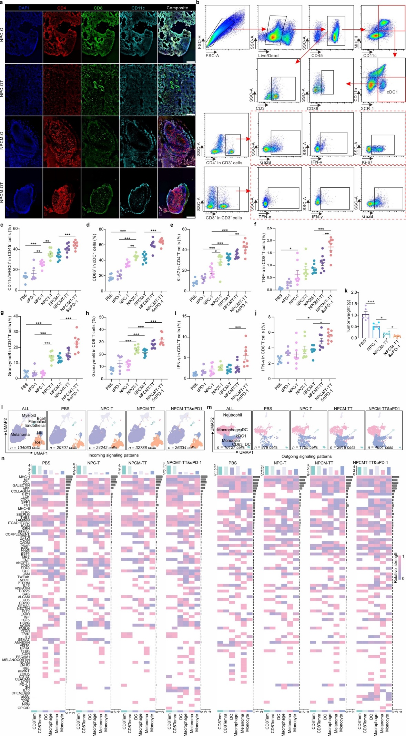
Extended data Figure 7. Immune remodeling in lung metastasis and subcutaneous melanoma models after nanovaccine treatment and single-cell analysis of immune-tumor interactions. (a) Immunofluorescence assay to identify the infiltration of immune cells in lung metastasis models of the indicated treatment groups at day 12. Blue represents the nucleus, red represents CD4⁺ T cells, green represents CD8⁺ T cells, and cyan represents CD11c⁺ DCs. The scale bar is 200 μm. (b) Gating strategy for analyzing immune cell subpopulations in TIME for the B16F10 lung metastasis model. (c-j) Effects of the indicated treatment on the proportion of immune cell subsets in TIME when reaching the endpoint in the treatment of lung metastases. (c) Statistical analysis of the proportion of CD11c⁺MHC-II⁺ immune cells (DCs and macrophages) in total CD45⁺ immune cells. (d) Statistical analysis of the proportion of activated cDC1s in total cDC1s. (e) Statistical analysis of the proportion of Ki67⁺ T cells in total CD4⁺ T cells. (f) Statistical analysis of the proportion of TNF-α⁺ T cells in total CD8⁺ T cells. (g) Statistical analysis of the proportion of GazB⁺ T cells in total CD4⁺ T cells. (h) Statistical analysis of the proportion of GazB⁺ T cells in total CD8⁺ T cells. (i) Statistical analysis of the proportion of IFN-γ⁺ T cells in total CD4⁺ T cells. (j) Statistical analysis of the proportion of IFN-γ⁺ T cells in total CD8⁺ T cells. Data are presented as mean ± SEM (n = 8 mice per group), and the statistical significance was analyzed via one-way ANOVA. *P <0.05, **P <0.01, ***P <0.001, and NS: not significant. (k) Statistical analysis of tumor weights in the B16F10 subcutaneous tumor treatment model after two injections of the different formulations. (l) UMAP plots of 104,063 single cells from 12 melanoma samples categorized into 7 major cell types. Cells from each treatment are shown separately. (m) UMAP plots of myeloid cells, shown separately for each treatment. (n) Identification of the altered incoming and outgoing signaling patterns of tumor cells or related immune cells in the tumor area from different treatment groups.

