Supplementary information file

Bar-cas12a, a novel and rapid method for plant species authentication: a case of Phyllanthus species
Kittisak Buddhachat^{1,2,*}, Suphaporn Paenkaew¹, Nattaporn Sripairoj¹, Yash Munnalal Gupta¹, Waranee Pradit³ and Siriwadee Chomdej^{3,*}
nt of Biology, Faculty of Science, Naresuan University, Phitsanulok, 65000, Thailand
²Center of Excellence in Research for Agricultural Biotechnology, Department of Agricultural Science, Faculty of Agriculture, Natural Resources and Environment, Naresuan University, Phitsanulok, 65000, Thailand
³Research Center in Bioresources for Agriculture, Industry and Medicine, Department of Biology, Faculty of Science, Chiang Mai University, Chiang Mai 50200 Thailand

*Corresponding author
Kittisak Buddhachat, Ph.D
Department of Biology, Faculty of Science, Naresuan University, Phitsanulok, Thailand
E-mail : kittisakbu@nu.ac.th

Siriwadee Chomdej, Ph.D
Department of Biology, Faculty of Science, Chiang Mai University, Chiang Mai, 50200, Thailand
E-mail : siriwadee@yahoo.com

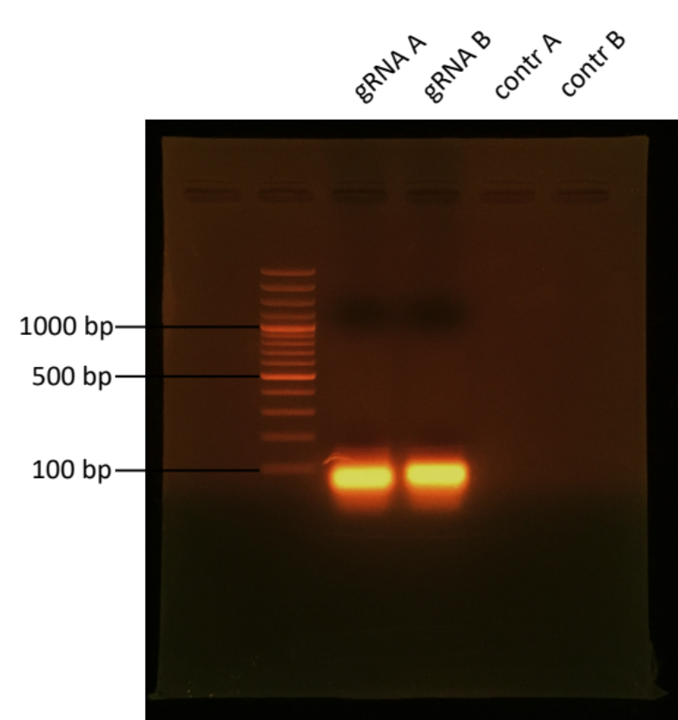

Figure S1 The synthesis of gRNA-A and gRNA-B by in vitro transcription with T7 RNA polymerase.
The synthesized gRNAs were detected by 1.5% agarose gel electrophoresis under 1X TAE buffer with 120 V for 30 min and the products were stained by EtBr and visualized under a UV transilluminator.

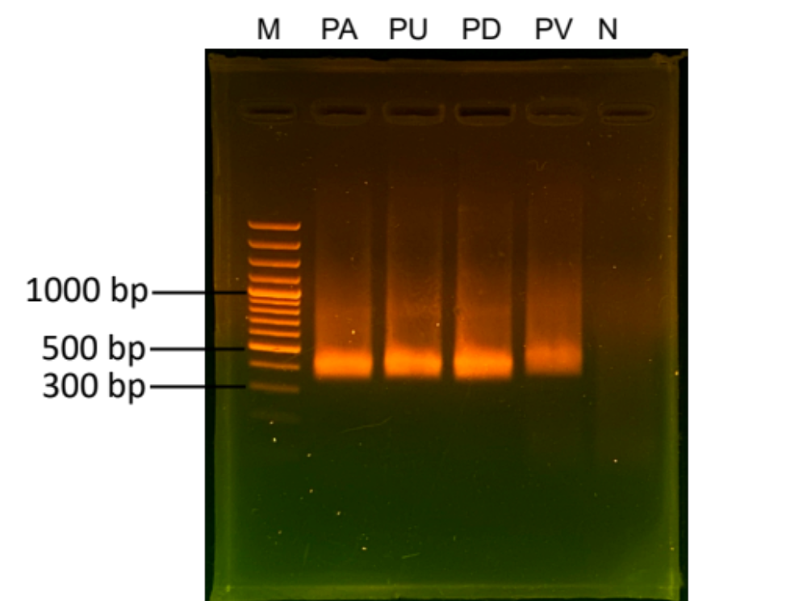

Figure S2 DNA amplification of various Phyllanthus species by RPA on trnL loci.
DNA’s four species of Phyllanthus were used for DNA amplification by RPA. The RPA products were subjected by 1.5% agarose gel electrophoresis under 1X TAE buffer with 120 V for 30 min and RPA products were stained by EtBr and visualized under a UV transilluminator. These RPA products obtained were used as DNA targets for further evaluating the specificity of Bar-cas12a assay to authenticate P. amarus. Phyllanthus amarus (PA), Phyllanthus urinaria (PU), Phyllanthus debilis (PD), Phyllanthus virgatus (PV)

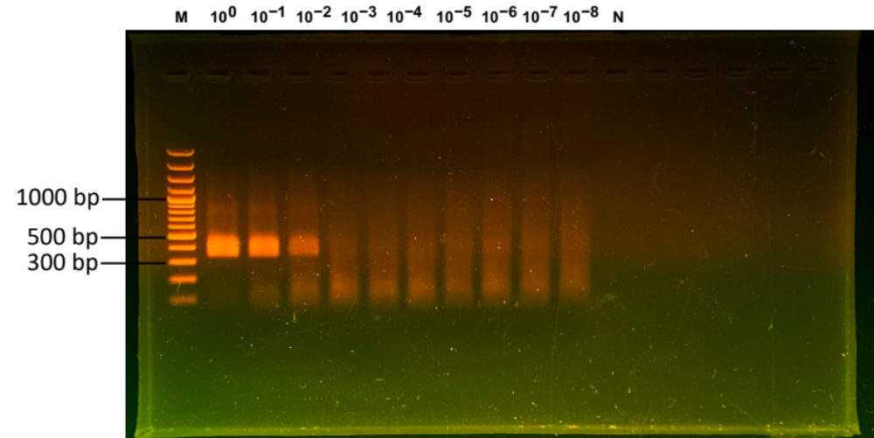

Figure S3 DNA amplification of Phyllanthus amarus in different concentrations by RPA on trnL loci.
DNA’s of P. amarus was diluted from 80 ng to 8 ag for DNA amplification by RPA. The RPA products were subjected by 1.5% agarose gel electrophoresis under 1X TAE buffer with 120 V for 30 min and RPA products were stained by EtBr and visualized under a UV transilluminator. These RNA products obtained were used as DNA targets for further evaluating the sensitivity of Bar-cas12a assay to authenticate P. amarus.

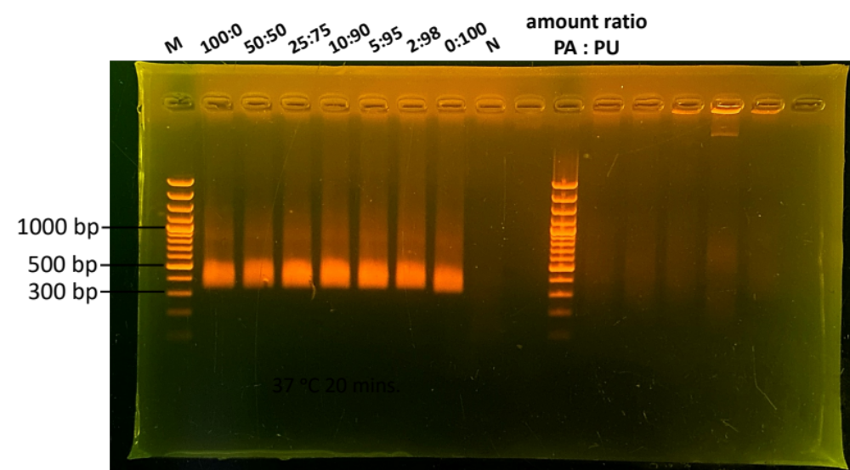

Figure S4 DNA amplification of Phyllanthus amarus in Phyllanthus urinaria-contaminated samples by RPA on trnL loci.
Different amount ratios of P. amarus (PA) to P. urinaria (PU) were done in various percentage of contamination ranging from 100%:0% – 0%:100% of PA:PU. These admixtures were used as templates for DNA amplification by RPA. The RPA products were subjected by 1.5% agarose gel electrophoresis under 1X TAE buffer with 120 V for 30 min and RPA products were stained by EtBr and visualized under a UV transilluminator. These RPA products were used for further validating species authentication of P. amarus in samples adulterated with P. urinaria.

