Supplementary Material

Summary of the clinical history of the patient previous to COVID-19
A 23-year-old patient with severe humoral immunodeficiency was clinically diagnosed with X-linked agammaglobulinaemia in 2000. He presented with repetitive bacterial infections of the upper respiratory tract, corneal ulcers, and immunoglobulin deficiency based on low IgG 414.00 mg/dL (normal range 736–1900), low IgA < 6.67 mg/dL (normal range 90–474), and low IgM < 4.17 mg/dL (normal range 50–415).

Microbiological testing
List of microbiological pathogens tested in bronchoalveolar lavage (BAL) samples of the patient by molecular diagnostics before his admission in the intensive care unit (ICU) (all of them with a negative result):
day50; day87: Chlamydia pneumoniae; Mycoplasma pneumoniae; Legionella pneumophila; Haemophilus influenzae; Streptococcus pneumoniae; Pneumocystis jirovecci; Parainfluenza virus types 1, 2, 3, 4; Respiratory syncytial virus type A, B; Influenza A virus subtype H1N1, H1N1-2009, H3N2, A, B; Adenovirus, Human Coronavirus type 229E, NL63, OC43; Human Bocavirus, Human metapneumovirus, Rhinovirus, Enterovirus, Citomegalovirus.

Urinary antigen tests and blood cultures were also performed on samples routinely collected from the patient throughout the course of infection.

Materials and methods

Clinical sample collection, viral detection, and sequencing
The study was conducted at the University Hospital Nuestra Senora de Candelaria (HUNSC) (Santa Cruz de Tenerife, Spain). Nasopharyngeal (NP) swab and BAL samples were collected regularly from the patient while he was in the hospital (14th April - 10th September 2020). A urine, a faeces and two blood samples were also collected from the patient during the course of infection. RNA was extracted using the Zymo Quick DNA/RNA kit (Zymo Research). RT-qPCR analysis was conducted using various commercial RT-qPCR alternatives and a threshold Ct below 40 cycles was considered positive as described elsewhere [1].

Next-generation sequencing of viral genomes and lineage assignation
For Illumina sequencing, libraries were prepared following the COVIDSeq Test protocol, and sequencing was conducted using a NextSeq 550 (Illumina, Inc.). Consensus sequences and variant calling against the reference (NC_045512.2) [2] were obtained using the DRAGEN COVIDSeq Test v1.2.2 pipeline (Illumina, Inc.) as described elsewhere [3]. For nanopore sequencing, libraries were prepared using the midnight protocol v.4 [4,5] and sequenced for 48 h using a MinION device and a R9.4 flow cell. The RAMPART (v.1.2.0) software package was used for real-time monitoring of the sequencing experiment. Reads were basecalled using Guppy 4.2.2 (high-accuracy mode) and analysed using the ARTIC pipeline (https://github.com/artic-network/artic-ncov2019). Reads were first filtered by length (250-1500 bp). Consensus sequences were then generated using nanopolish for variant calling with a normalized coverage of 200X. Pangolin (v.2.3.2) was used for PANGO lineage assignment and Nextclade (v.0.14.4) for clade assignment, mutation calling and sequence quality checks.

Culturing of SARS-CoV-2 viral specimens
On day 50, a patient BAL specimen was assessed for active viral replication. In brief, 200 µL of the sample, which was previously supplemented with antibiotics (penicillin and streptomycin) and the antifungal drug amphotericin B to avoid bacterial and fungi growth, was directly inoculated on a conventional tube with a monolayer of Vero-E6 cells (Vircell) without medium. Spin inoculation was performed at 54 x g for 45 min. Inoculum was removed and cell growth medium (MEM supplemented with antibiotics) was added to the cells. Tubes were incubated at 37 °C and 5% CO₂. Cytopathic effects were observed after 6 days from inoculation. RT-qPCR was performed to confirm the presence of SARS-CoV-2 as described elsewhere [6].

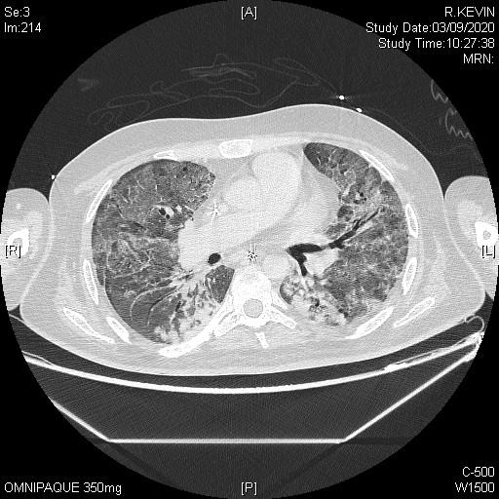
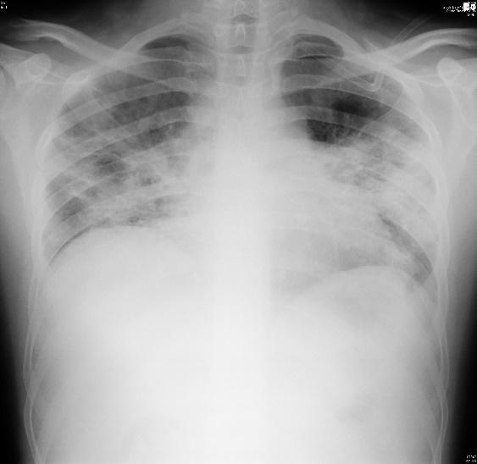

Supplementary Figure 1. Image findings of pneumonia during the ICU stay. Posteroanterior chest X-ray image taken during the ICU admission of the patient (left) and whole-body computed tomography taken on day 142 showing multiple peripheral ground-glass opacities (right) indicative of bilateral pneumonia.

Supplementary References
1. Alcoba-Florez J, Gil-Campesino H, Artola DG-M de, et al. Sensitivity of different RT-qPCR solutions for SARS-CoV-2 detection. Int J Infect Dis 2020; 99:190–192.
2. Wu F, Zhao S, Yu B, et al. A new coronavirus associated with human respiratory disease in China. Nature 2020; 579:265–269.
3. Alcoba-Florez J, Lorenzo-Salazar JM, Gil-Campesino H, et al. Monitoring the rise of the SARS-CoV-2 lineage B.1.1.7 in Tenerife (Spain) since mid-December 2020. J Infect 2021; 82:e1–e3.
4. Freed NE, Vlková M, Faisal MB, Silander OK. Rapid and Inexpensive Whole-Genome Sequencing of SARS-CoV-2 using 1200 bp Tiled Amplicons and Oxford Nanopore Rapid Barcoding. Biol Methods Protoc 2020; 5:bpaa014.
5. Freed N, Silander O. nCoV-2019 sequencing protocol (RAPID barcoding, 1200bp amplicon). 2020. Available at: https://dx.doi.org/10.17504/protocols.io.bh7hj9j6.
6. Sandoval Torrientes M, Castelló Abietar C, Boga Riveiro J, et al. A novel single nucleotide polymorphism assay for the detection of N501Y SARS-CoV-2 variants. J Virol Methods 2021; 294:114143.

