Anexure-I
Table 5 Summary of Mix Proportions for M30 Concrete (per m³)
Mix Type | Cement (kg) | SCM (kg) | Water (kg) | FA (kg) | CA (kg) | SP (% of binder) | SP (kg) | W/B Ratio
NAC (Control) | 400 | – | 168 | 650 | 1240 | 1.00% | 4 | 0.42
RAC + TRCA | 400 | – | 160 | 630 | 1220 | 1.00% | 4 | 0.4
RAC + TRCA + 15% Fly Ash | 340 | 60 (Fly Ash) | 160 | 630 | 1220 | 1.00% | 4 | 0.4
RAC + TRCA + 10% Silica Fume | 360 | 40 (Silica Fume) | 160 | 630 | 1220 | 1.20% | 4.8 | 0.4
RAC + TRCA + 2% Nano-Silica | 392 | 8 (Nano-Silica) | 160 | 630 | 1220 | 1.50% | 6 | 0.4

Table 6 Final Mix (NAC – Control)
Material | Quantity (kg/m³)
Cement | 400
Water | 168
Fine Aggregate | 650
Coarse Aggregate | 1240
Superplasticizer | 4
Water/Cement Ratio | 0.42
Cement Testing:-
Material Details
Type: Ordinary Portland Cement (OPC) 53 Grade
Conforming Standard: IS 12269:2013
Source: UltraTech Cement (Factory-sealed bag)
Table 7 Cement Testing
Test Name | Standard Method | Result | Permissible Limit (IS 12269:2013)
Fineness (90 Micron Sieve) | IS 4031 (Part 1) | 6.5% retained | ≤ 10%
Standard Consistency | IS 4031 (Part 4) | 30% | -
Initial Setting Time | IS 4031 (Part 5) | 130 minutes | ≥ 30 minutes
Final Setting Time | IS 4031 (Part 5) | 270 minutes | ≤ 600 minutes
Compressive Strength (3 days) | IS 4031 (Part 6) | 28.2 MPa | ≥ 27 MPa
Compressive Strength (7 days) | IS 4031 (Part 6) | 41.5 MPa | ≥ 37 MPa
Soundness (Le Chatelier) | IS 4031 (Part 3) | 2.0 mm | ≤ 10 mm
Fine Aggregate (Sand) Testing
Material Details
Type: Natural river sand
Zone: Zone II as per IS 383:2016
Source: Local riverbed supplier (washed and sieved)
Table 8 Fine Aggregate (Sand) Testing
Test Name | Standard Method | Result | Specification Limit (IS 383:2016)
Specific Gravity | IS 2386 (Part 3) | 2.64 | 2.5–2.8
Water Absorption | IS 2386 (Part 3) | 1.25% | ≤ 2%
Fineness Modulus | IS 2386 (Part 1) | 2.65 | Zone II: 2.6–2.9
Bulk Density (Loose) | IS 2386 (Part 3) | 1420 kg/m³ | -
Bulk Density (Compacted) | IS 2386 (Part 3) | 1610 kg/m³ | -
Silt Content | IS 2386 (Part 2) | 2.00% | ≤ 8%

Step-by-Step Mix Design (Control Mix – NAC)
1. Target Mean Strength (fck)
= 30 + 1.65 × 5 = 38.25 MPa
2. Water-Cement Ratio (W/C)
Assume 0.42 (for high strength, confirmed with trial).
3. Water Content
For 75–100 mm slump, 20 mm aggregate: base = 186 kg
With SP → reduce by 10% = 186 – 18.6 ≈ 168 kg
4. Cement Content
Cement = Water / W/C = 168 / 0.42 = 400 kg (OK > min 300 kg for M30)
5. Fine Aggregate % (Zone II sand)
From IS 10262 Table 9 → Assume 35% FA
CA = 0.65 × (1 – entrapped air 0.02) × 2400 = 1528.8 kg
FA = 0.35 × (1 – 0.02) × 2400 = 823.2 kg
After trial & adjustments → use:
FA = 650 kg
CA = 1240 kg
6. Superplasticizer (PCE)
1.0% of binder = 4 kg

PHOTOGRAPHS
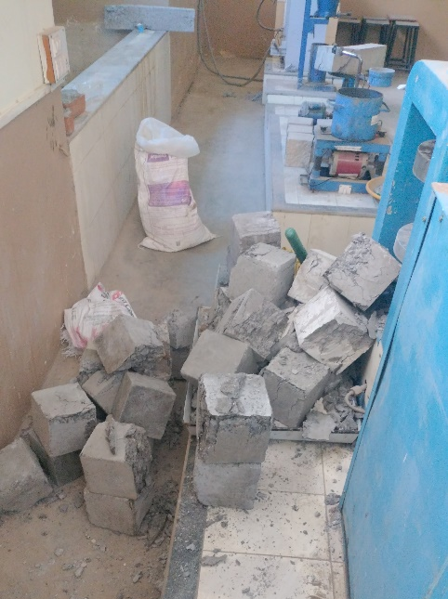
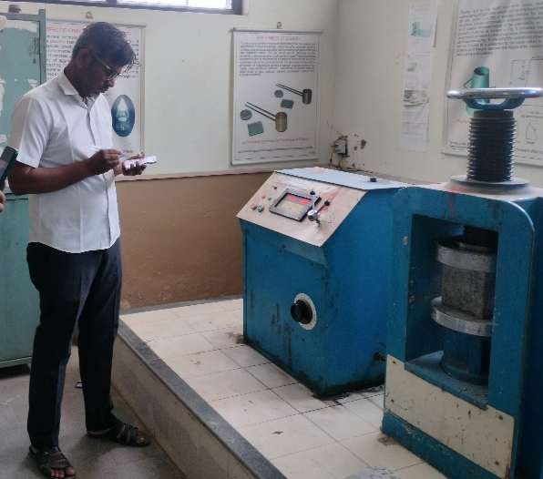
Figure 8 corresponding author Dr. Pravin Ankushrao Nikam Age 37 yeola, Maharashtr, Birth date 5/10/1987
