Table 1: List of Primer used in the study: F1 -Forward primer, R1-Reverse primer
S.No. | Gene Name | Sequence | Tm ˚C | Base pairs
1 | OsCOPT7 F1 | GGACGTGACGATCCTGTTTG | 56.08 | 20
2 | OsCOPT7 R1 | TCGAGGTACTGGTAGAAGGC | 55.29 | 20
3 | OsMDHAR4-1 F1 | GTACAACGAACACGGCATTG | 57.3 | 20
4 | OsMDHAR4-1 R1 | TTTCCCCACTGGATGTAAGC | 57.3 | 20
5 | OsDHAR1 F1 | CCTTTATCAACGGGCAGAAC | 57.3 | 20
6 | OsDHAR1 R1 | AAATGCTCCAGAGCAACCTG | 57.3 | 20
7 | Os GR1 F1 | TCAACATTCCTGGGAAGGAG | 57.3 | 20
8 | Os GR1 R1 | CAATATATCCGCCACCAAGG | 57.3 | 20
9 | OsYSL15 F1 | TGCGGTAATCACCATACCGA | 55.93 | 20
10 | OsYSL15 R1 | AAGAGAGCGATCTTGCCGTA | 55.96 | 20
1 | Os actin11F1 | CAGCCACACTGTCCCCATCTA | 55.00 | 20
2 | Os actin11R1 | AGCAAGGTCGAGACGAAGGA | 55.00 | 20

Fig 1- Screening of green synthesized (GS) and Market procured (MP) CuO NPs
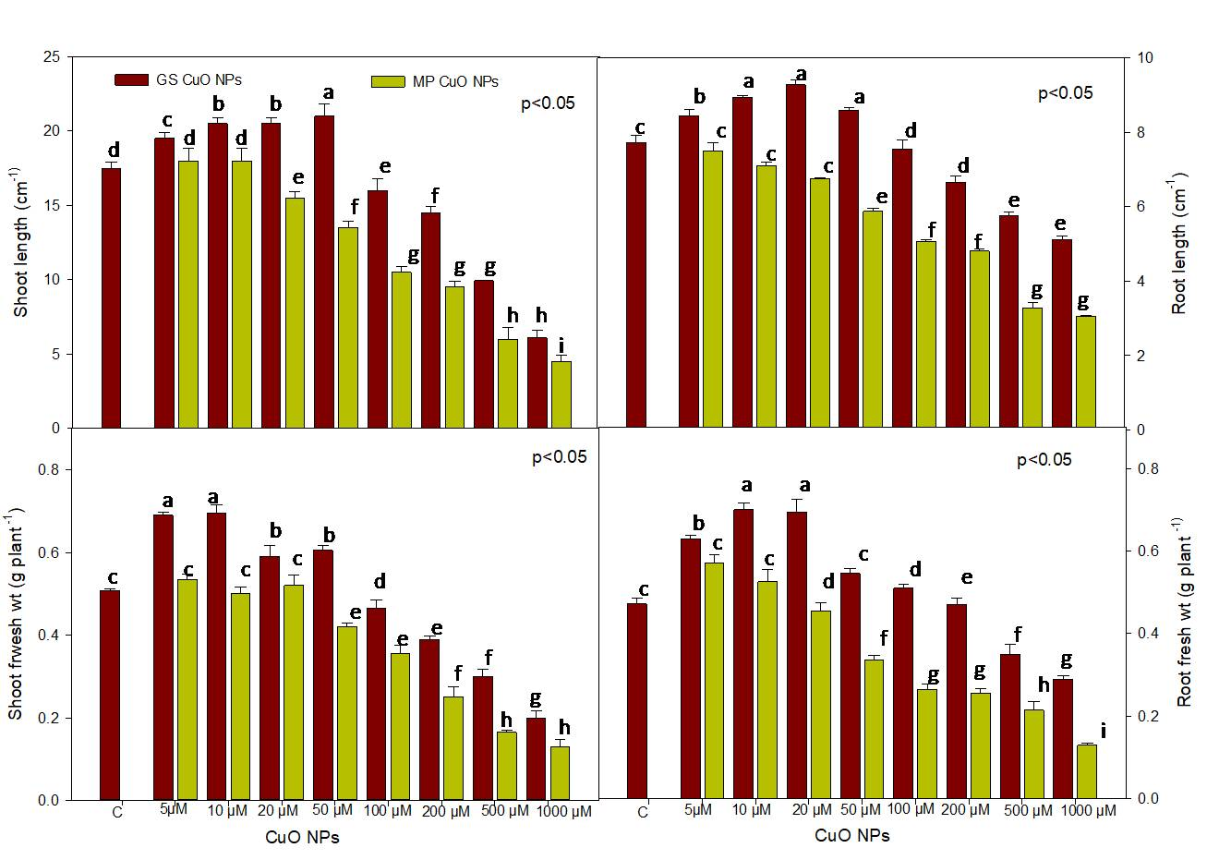

Fig 2- Screening of green synthesized (GS) and Market procured (MP) FeO NPs
