Supplementary Information

Fire-Driven Trend Reversal in U.S. Ozone Exposure and Air Quality Progress

Weizhi Deng¹, Jun Wang^{1,*}, Meng Zhou^{2,*}, Xi Chen¹, Xiaodong Wu³, Huanxin Zhang¹, Jason B. Cohen⁴, Jing Wei⁵, Arlindo da Silva², Guy P. Brasseur^{6,7}, Claire Granier^{8,9}, Laurence Rouil¹⁰

¹Department of Chemical & Biochemical Engineering, The University of Iowa, Iowa City, IA, 52242, USA

²Global Modeling and Assimilation Office, NASA Goddard Space Flight Center, Greenbelt, MD, 20771, USA

³Department of Electrical & Computer Engineering, The University of Iowa, Iowa City, IA, 52242, USA

⁴School of Environment and Spatial Informatics, China University of Mining and Technology, Xuzhou, China

⁵Department of Atmospheric and Oceanic Science, Earth System Science Interdisciplinary Center, University of Maryland, College Park, MD, USA

⁶Atmospheric Chemistry Observations and Modeling Laboratory, National Center for Atmospheric Research, Boulder, CO, USA

⁷Environmental Modeling Group, Max Planck Institute for Meteorology, Hamburg, Germany

⁸Laboratoire d’Aérologie, CNRS, Université de Toulouse, 31013 Toulouse, France

⁹NOAA/Chemical Sciences Laboratory/CIRES, University of Colorado, Boulder, CO 80221, USA

¹⁰European Centre for Medium-Range Weather Forecasts, Robert-Schuman-Platz 3, 53175 Bonn, Germany

*Correspondence to: Jun Wang (jun-wang-1@uiowa.edu), Meng Zhou (mzhou16@umbc.edu)

Table of Contents

Supplementary Text 3
Text S1: Feature importance 3
Supplementary Table 4
Table S1: Performance of ML studies predicting MDA8 O₃ 4
Table S2: Target and features used for deep learning 5
Supplementary Figure 6
Figure S1: Out-of-station 5-fold cross-validation results for MLP-predicted MDA8 6
Figure S2: Time series of GFED4s dry matter burned during fire season and estimated fire-elevated warm-season MDA8 levels in the Western USA 6
Figure S3: Histogram of the EPA daily MDA8 measurements and their corresponding weight coefficient used in the cost function during MLP training 7
Figure S4: Feature importance calculated using the SHAP approach 7
References 8

Supplementary Text

Text S1: Feature importance
The relative feature importance is quantified using the Shapley Additive Explanations (SHAP) approach (Figure S4) [1]. The most influential feature is the MDA8 derived from CAMS, contributing 20.7% to the overall magnitude of model predictions. Higher values of CAMS MDA8 are positively associated with the predicted MDA8 levels. The second most significant feature is the all-sky shortwave downwelling flux from CERES (7.8% contribution), which also positively impacts MDA8 predictions, highlighting the role of high-energy photons in driving the photolysis of NO₂ to form O₃. The third important feature is the CAMS surface HCHO concentration (7.6% contribution), where higher values are predominantly negatively associated with MDA8 predictions. On the other hand, CAMS surface NO₂ concentration (4.1% contribution, ranked tenth) is overall positively associated with MDA8 predictions. This combination may suggest that O₃ formation is in general NOx-limited over CONUS in the past two decades, explaining the decline of O₃ as a result of regulated NOx reduction. The fourth ranked feature is the 2-m temperature from ERA5 (6.8% contribution), demonstrating the possible role of temperature in affecting reaction rates. The fifth ranked feature is the day of year (6.4% contribution), consistent with the seasonal cycle of surface O₃ with peaks mostly in spring and summer. Local- and large-scale topography features, such as ASTER elevation (5.9% contribution, ranked sixth) and open water fraction (5.3% contribution, ranked seventh) also play a role predicting MDA8. Other features provide more nuanced contributions, reflecting the complex interplay of factors impacting MDA8 levels.

Supplementary Table

Table S1: Performance of ML studies predicting MDA8 O₃.
Reference | Region | Study period | Resolution | Method | R² | RMSE | Best-fit
[2] | CONUS | 2019 | 4 km | Convolutional neural network | 0.90 (sampleª)  0.83 (station^{b}) | 3.88 ppb (sample)  4.91 ppb (station) | Not given
[3] | China | 2016-2020 | 10 km | Convolutional neural network | 0.88 (sample)  0.85 (station) | 7.84 ppb^{c} (sample)  8.66 ppb (station) | y = 0.86x + 6.65 (ppb) (sample)  y = 0.84x + 7.24 (ppb) (station)
[4] | China | 2013-2020 | 10 km | Extreme random trees | 0.87 (sample)  0.80 (station) | 8.57 ppb (sample)  10.57 ppb (station) | y = 0.87x + 5.91 (ppb) (sample)
[5] | China | 2013-2017 | 10 km | Extreme gradient boosting | 0.78 (sample)  0.64 (station) | 10.76 ppb (sample)  13.66 ppb (station) | x = 1.00y – 1.90 (ppb)^{d} (sample)  x = 0.99y + 0.50 (ppb) (station)
[6] | CONUS | 2000-2016 | 1 km | Ensemble of neural network, random forest, and gradient boost | 0.91 (station, monthly^{e}) | 4.67 ppb (station, monthly^{e}) | y = 0.99x + 0.65 (ppb) (station, monthly^{e})
[7] | CONUS | 2000-2012 | 1 km | Neural network | 0.76 (station) | 7.36 ppb (station) | y = 0.99x + 1.20 (ppb) (station)
[8] | China | 2000-2021 | 1 km | Deep forest | 0.89 (sample)  0.84 (station) | 7.90 ppb (sample)  9.39 ppb  (station) | y = 0.86x + 6.52 (ppb) (sample)  y = 0.83x + 7.95 (ppb) (station)
This study | CONUS | 2003-2023 | 1 km | Multi-layer perceptron with custom cost function | 0.88 (sample)  0.80 (station) | 4.99 ppb (sample)  6.35 ppb (station) | y = 0.98x + 0.98 (ppb) (sample)  y = 0.90x + 3.92 (ppb) (station)
ª The statistics is based on out-of-sample cross-validation.
^{b} The statistics is based on out-of-station cross-validation.
^{c} Unit conversion factor for ozone: 1 $μ$g/m³ = 0.5011 ppb at 20 °C and 1013 hPa.
^{d} The study regresses observation (x) against prediction (y).
^{e} The statistics in the study is based on monthly average MDA8.

Table S2: Target and features used for deep learning.
 | Variable | Description | Unit | Spatial resolution | Temporal resolution | Data source | References
Ground measurement | MDA8 | Maximum daily 8-hour ozone | ppb | Point source | Daily | US EPA
Satellite remote sensing | SWF | All-sky surface shortwave downwelling flux | W⋅m⁻² | 1°×1° | Daily | CERES | [9]
Satellite remote sensing | NTL | Night-time light intensity | nW⋅cm⁻²⋅sr⁻¹ | 375 m | Annual | VIIRS | [10]
Satellite remote sensing | NDVI | Normalized difference vegetation index | / | 1 km | Monthly | MODIS | [11]
Satellite remote sensing | LU | Land use type | / | 500 m | Annual | MODIS | [12]
Satellite remote sensing | DEM | Elevation | m | 30 m | Static | ASTER | [13]
 | POP | Population count | persons | 1 km | Annual | LandScan | [14]
Model reanalysis | MDA8 | Derived maximum daily 8-hour ozone | ppb | 0.75°×0.75° | Daily | CAMS  CAMS | [15]
Model reanalysis | TO3 | Total column ozone | kg⋅m⁻² | 0.75°×0.75° | 3-hourly | CAMS  CAMS | [15]
Model reanalysis | NO2 | Surface nitrogen dioxide | kg⋅kg⁻¹ | 0.75°×0.75° | 3-hourly | CAMS | [15]
Model reanalysis | HCHO | Surface formaldehyde | kg⋅kg⁻¹ | 0.75°×0.75° | 3-hourly | CAMS | [15]
Model reanalysis | T2M | Air temperature at 2 m | K | 0.1°×0.1° | Hourly | ERA5 | [16]
Model reanalysis | DPD | Dew point depression at 2 m | K | 0.1°×0.1° | Hourly | ERA5 | [16]
Model reanalysis | U10 | Zonal wind at 10 m | m⋅s⁻¹ | 0.1°×0.1° | Hourly | ERA5 | [16]
Model reanalysis | V10 | Meridional wind at 10 m | m⋅s⁻¹ | 0.1°×0.1° | Hourly | ERA5 | [16]
Model reanalysis | BLH | Boundary layer height | m | 0.25°×0.25° | Hourly | ERA5 | [17]
Auxiliary | DOY | Day of year
Auxiliary | FWATER | Fraction of open water

Supplementary Figure

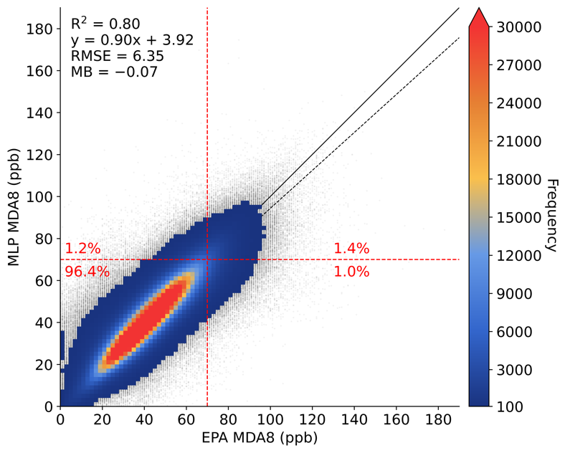
Figure S1: Out-of-station 5-fold cross-validation results for MLP-predicted MDA8, compared against EPA measurements over CONUS for the period 2003-2023. The black solid line is 1:1 line, the black dashed line is best-fit regression line, and the red dashed lines are the 2015 NAAQS standard. Color represents data density.

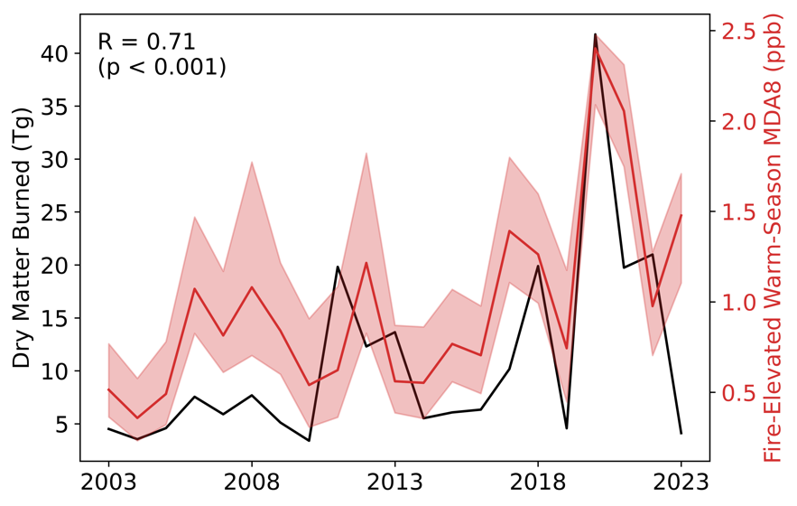
Figure S2: Time series of GFED4s dry matter burned during fire season (black line) and estimated fire-elevated warm-season MDA8 levels (red line with uncertainty range) in the Western USA. Their correlation coefficients are annotated on the top left.

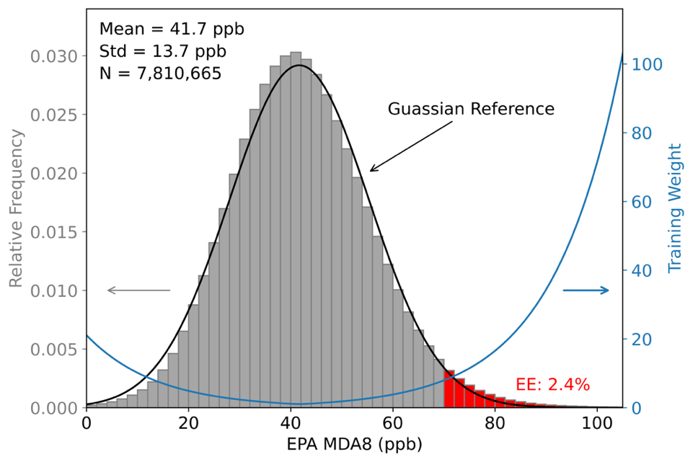

Figure S3: Histogram of the EPA daily MDA8 measurements ($\hat{y}$ in Eq. 1) from 2003 to 2023 (grey), and their corresponding absolute weight coefficient ($W$ in Eq. 1) used in the cost function during MLP training (blue). The black line is the reference Gaussian distribution. EE stands for exceedance events (highlighted in red).
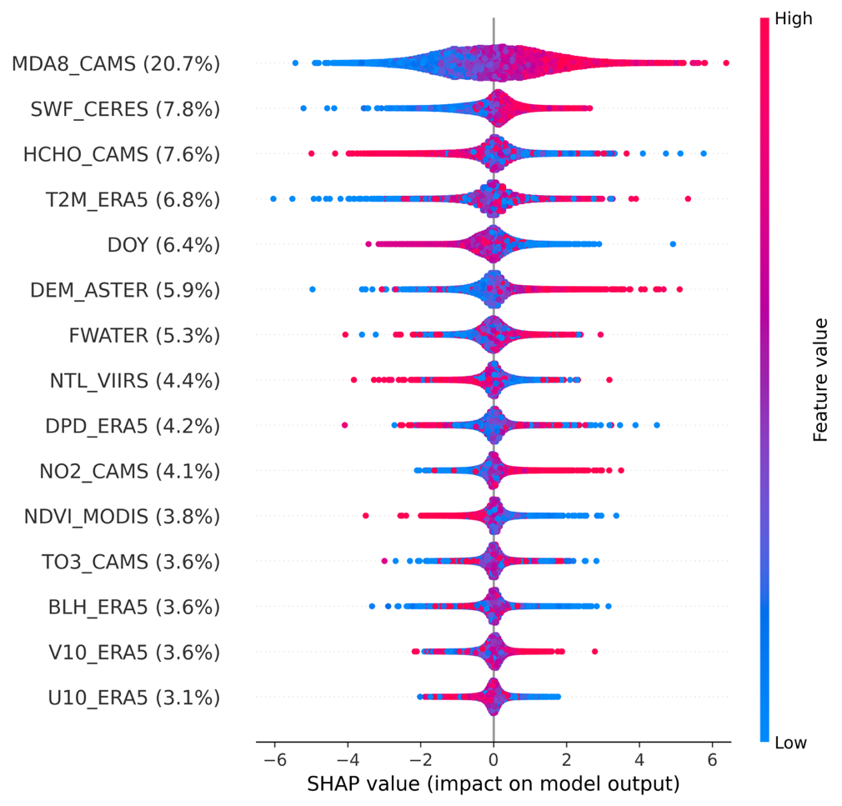
Figure S4: Feature importance calculated using the SHAP approach. Features are ranked by their relative importance (only the top 15 features are displayed). Each dot represents a case in the test sets, with the color indicating the value of the respective feature, and the SHAP value indicates its contribution to the target value. Percentages reflect the relative importance of each feature, calculated as the mean absolute SHAP value divided by the sum across all features. Please refer to Table S2 for acronyms.

References:

1. Scott, M. and L. Su-In, A unified approach to interpreting model predictions. Advances in neural information processing systems, 2017. 30: p. 4765-4774.
2. Ghahremanloo, M., Y. Choi, and Y. Lops, Deep learning mapping of surface MDA8 ozone: The impact of predictor variables on ozone levels over the contiguous United States. Environmental Pollution, 2023. 326: p. 121508.
3. Mu, X., et al., Full-coverage spatiotemporal estimation of surface ozone over China based on a high-efficiency deep learning model. International Journal of Applied Earth Observation and Geoinformation, 2023. 118: p. 103284.
4. Wei, J., et al., Full-coverage mapping and spatiotemporal variations of ground-level ozone (O3) pollution from 2013 to 2020 across China. Remote Sensing of Environment, 2022. 270: p. 112775.
5. Liu, R., et al., Spatiotemporal distributions of surface ozone levels in China from 2005 to 2017: A machine learning approach. Environment International, 2020. 142: p. 105823.
6. Requia, W.J., et al., An Ensemble Learning Approach for Estimating High Spatiotemporal Resolution of Ground-Level Ozone in the Contiguous United States. Environmental Science & Technology, 2020. 54(18): p. 11037-11047.
7. Di, Q., et al., A hybrid model for spatially and temporally resolved ozone exposures in the continental United States. Journal of the Air & Waste Management Association, 2017. 67(1): p. 39-52.
8. Yang, Z., et al., Two-decade surface ozone (O3) pollution in China: Enhanced fine-scale estimations and environmental health implications. Remote Sensing of Environment, 2025. 317: p. 114459.
9. Doelling, D.R., et al., Geostationary Enhanced Temporal Interpolation for CERES Flux Products. Journal of Atmospheric and Oceanic Technology, 2013. 30(6): p. 1072-1090.
10. Elvidge, C.D., et al., VIIRS night-time lights. International Journal of Remote Sensing, 2017. 38(21): p. 5860-5879.
11. Didan, K. MYD13A3 MODIS/Aqua Vegetation Indices Monthly L3 Global 1km SIN Grid V006. 2015; Available from: https://doi.org/10.5067/MODIS/MYD13A3.006.
12. Friedl, M. and D. Sulla-Menashe. MCD12Q1 MODIS/Terra+Aqua Land Cover Type Yearly L3 Global 500m SIN Grid V006. 2019; Available from: https://doi.org/10.5067/MODIS/MCD12Q1.006.
13. Team, N.M.A.J.S.a.U.S.J.A.S. ASTER Global Digital Elevation Model V003. 2019; Available from: https://doi.org/10.5067/ASTER/ASTGTM.003.
14. Sims, K., et al. LandScan Global 2022. 2023; Available from: landscan.ornl.gov.
15. Inness, A., et al., The CAMS reanalysis of atmospheric composition. Atmos. Chem. Phys., 2019. 19(6): p. 3515-3556.
16. Muñoz Sabater, J. ERA5-Land hourly data from 1950 to present. 2019; Available from: https://www.doi.org/10.24381/cds.e2161bac.
17. Hersbach, H., et al., The ERA5 global reanalysis. Quarterly Journal of the Royal Meteorological Society, 2020. 146(730): p. 1999-2049.

