Additional files
Table. S1 Baseline characteristics of patients providing serum samples.
 | Control (n=25) | COVID-19 (n=28) | PCPF (n=26)
Sex（Male/Female） | 15/10 | 16/12 | 16/10
Age (Mean±SD) | 37.5±8.1 | 46.9±11.3 | 53.5±14.7

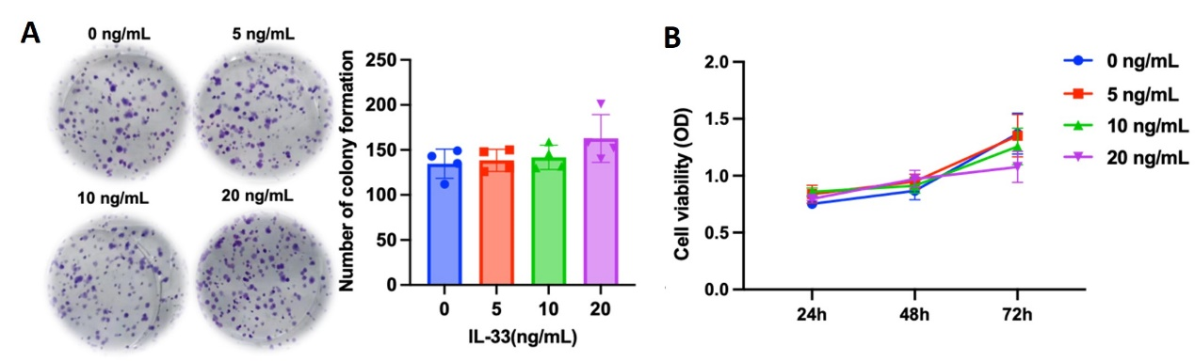

Figure. S1 IL-33 does not alter proliferative capacity of A549 cells. (A) Colony formation assay following 48 h treatment with graded concentrations of exogenous recombinant IL-33 protein. (B) Cell viability assessed by CCK-8 assay. ns=not significant (P>0.05, one-way ANOVA).

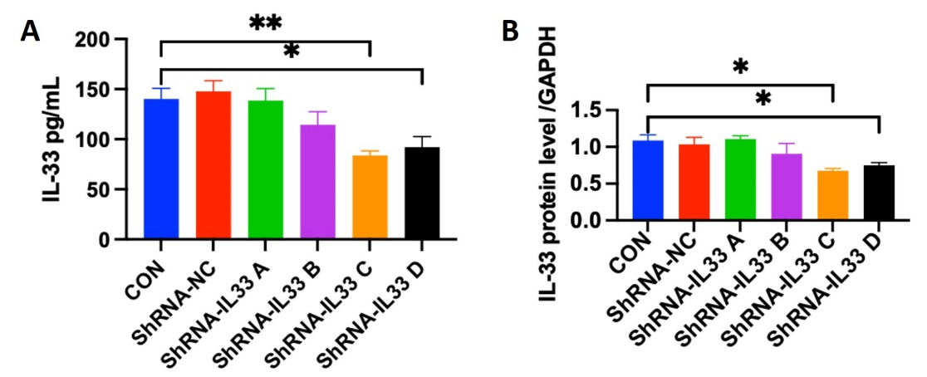
Figure. S2 shRNA-mediated stable knockdown A549 cell lines were established. (A) IL-33 quantified by ELISA. (B) Quantification of IL-33 protein expression. Significance denoted as *P<0.05, **P<0.01.

Supplementary file of the Gels and Blots image(s) with markers:
Protein molecular weights were determined using pre-stained markers (Yamei™ WJ103).
Fig.2E
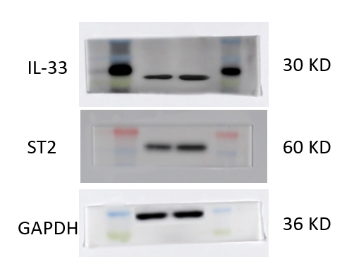
Fig.3E
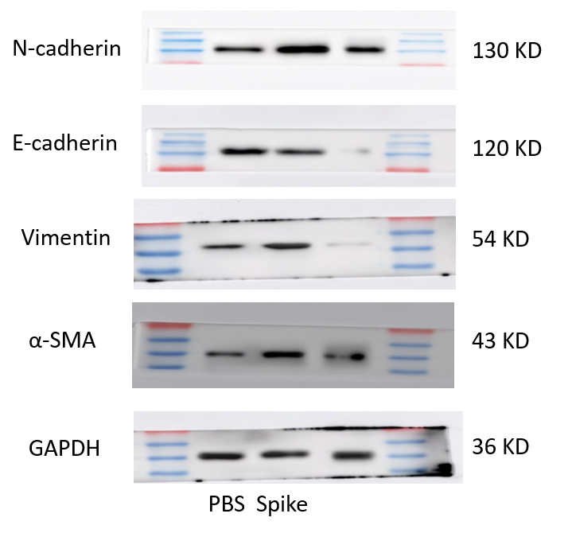

Fig.4C
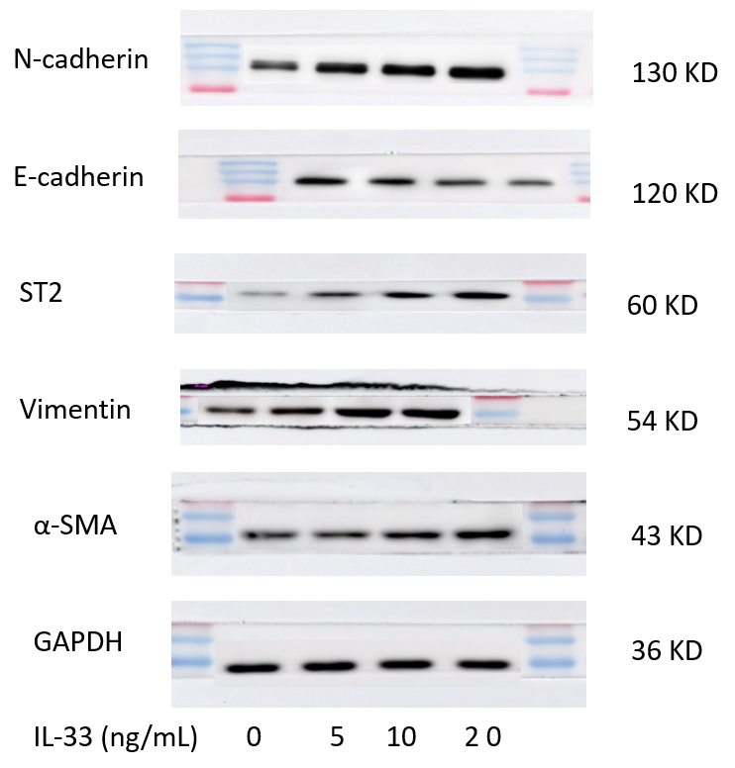
Fig.5B
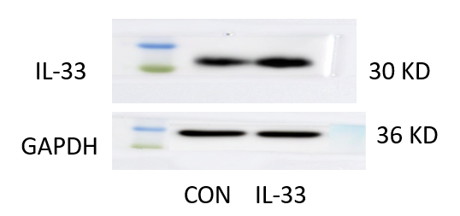

Fig.5E
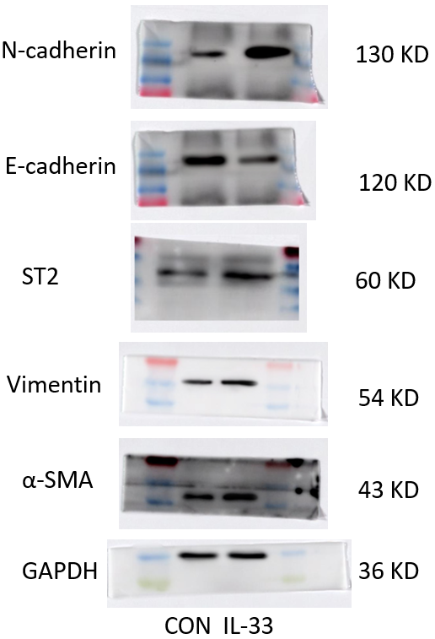
Fig.6B
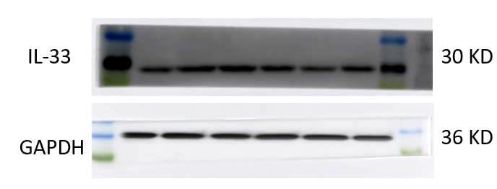

Fig.6C
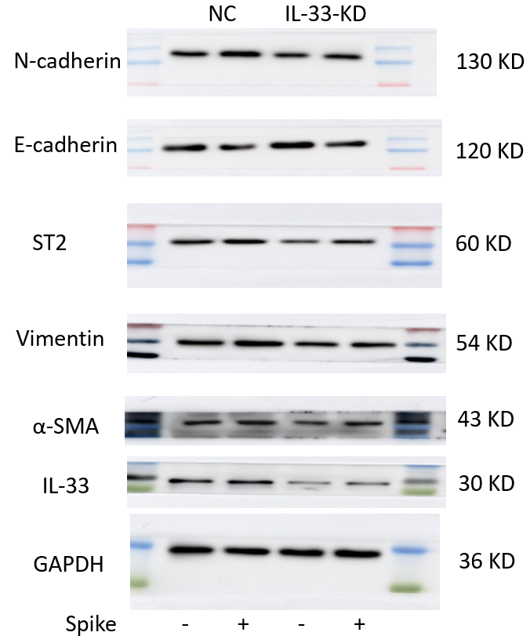
Fig.7A
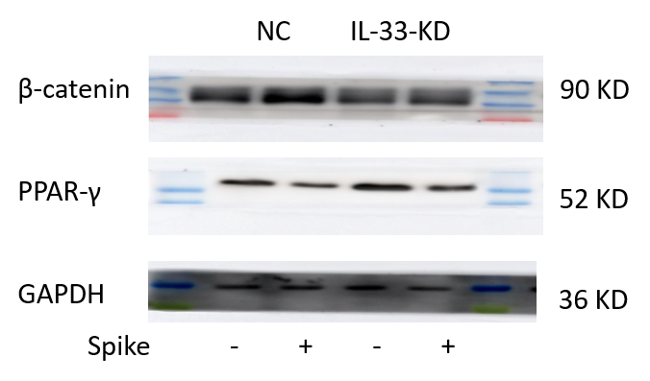

Fig.7B
