Supplementary Appendix

Transoral Outlet Reduction for Dumping Syndrome after Roux-En-Y Gastric Bypass: A Systematic Review and Meta-Analysis
Supplementary Tables
Title | Page
Supplementary Table 1: Search strategy used in each database searched. | 2
Supplementary Table 2: Quality assessment of the included studies in the meta-analysis. | 3

Supplementary Figures:
Title | Page
Supplementary Figure 1: Leave-one-out sensitivity analysis for clinical success. | 4
Supplementary Figure 2: Leave-one-out sensitivity analysis for repeat TORe. | 5
Supplementary Figure 3: Funnel plot for publication bias assessment for clinical success. | 6

Supplementary Table 1: Search strategy used in each database searched.
Database | Search Strategy | Articles retrieved
PubMed | ((("transoral"[All Fields] OR "transorally"[All Fields]) AND ("outlet"[All Fields] OR "outlets"[All Fields]) AND ("reduction"[All Fields] OR "reductions"[All Fields])) OR ("gastrojejunal"[All Fields] AND ("revise"[All Fields] OR "revised"[All Fields] OR "revisers"[All Fields] OR "revises"[All Fields] OR "revising"[All Fields] OR "revision"[All Fields] OR "revisions"[All Fields]))) AND ("dumping syndrome"[MeSH Terms] OR ("dumping"[All Fields] AND "syndrome"[All Fields]) OR "dumping syndrome"[All Fields]) | 18
Embase | ('transoral outlet reduction'/exp OR 'transoral outlet reduction' OR (transoral AND outlet AND ('reduction'/exp OR reduction))) AND ('dumping syndrome'/exp OR 'dumping syndrome' OR (('dumping'/exp OR dumping) AND ('syndrome'/exp OR syndrome))) | 57
Web of Science | ((transoral outlet reduction) OR (gastrojejunal revision)) AND (dumping syndrome) | 26

Supplementary Table 2: Quality assessment of the included studies in the meta-analysis.
Observational studies | Selection |  |  |  | Comparability | Outcome |  |  | Overall risk of bias
Observational studies | Representativeness of the exposed cohort | Selection of non-exposed cohort | Ascertainment of exposure | Demonstration that outcome of interest was not present at start of study | Comparability of the cohorts on the basis of design or analysis | Assessment of outcome | Was follow up long enough for outcomes to occur | Adequacy of follow up cohorts | Overall risk of bias
Lovis, 2024 |  |  |  |  |  | 
Petchers, 2022
Pontecorvi, 2023
Relly, 2021
Tsai, 2020
Vargas, 2020 |  |  |  |  |  |  | 
() low risk of bias, () High risk of bias, () Unclear risk of bias

Supplementary Figure 1: Leave-one-out sensitivity analysis for clinical success.

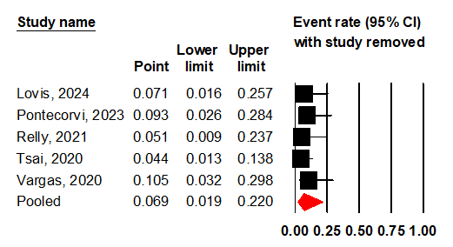
Supplementary Figure 2: Leave-one-out sensitivity analysis for repeat TORe.

Supplementary Figure 3: Funnel plot for publication bias assessment for clinical success.

