Table 2 The most common active secondary metabolites detected in SCGs extract, along with their retention time (RT), name, class, molecular formula, and structure.
Retentions time  (min) | Name | Class of compound | MFG Formula | Solvent used for extraction | Molecular structure
Alkaloid compound
7.7  (m/z:195.0876) | Caffeine | Xanthine alkaloid compound | C₈ H₁₀ N₄ O₂ | Ethanol; Methanol; Water; Glycerol/methanol | 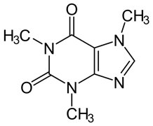
0.733  (m/z: 179.0569) | Paraxanthine | Xanthine alkaloid compound | C₇ H₈ N₄ O₂ | Methanol; Water | 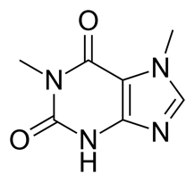
Phenolic compound
0.747  (m/z: 193.0696) | Quinic acid | Quinic acids and derivatives | C₇ H₁₂ O₆ | Ethanol; Methanol; Water; Glycerol/methanol | 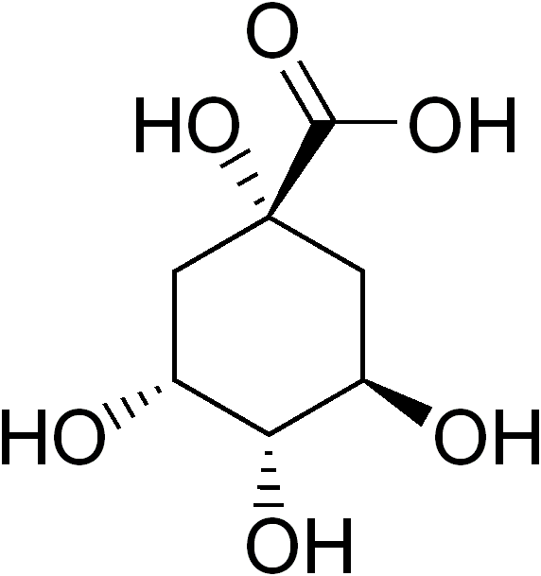
9.141  (m/z: 193.0506) | Ferulic acid | Hydroxycinnamic acids | C₁₀ H₁₀ O₄ | Ethanol | 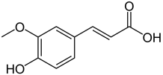
7.297  (m/z : 353.0891) | Cis-5-Caffeoylquinic acid | Quinic acids and derivatives | C₁₆ H₁₈ O₉ | Ethanol; Methanol; Water; Glycerol/methanol | 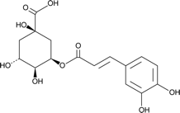
8.593  (m/z:  367.1034) | 3-O-Feruloylquinic acid | Quinic acids and derivatives | C₁₇ H₂₀ O₉ | Water; Ethanol | 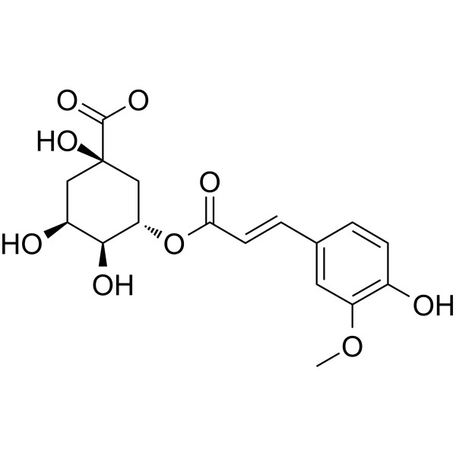
8.655  (335.0774) | 4-Caffeoyl-1,5-quinolactone | Quinic acids and derivatives | C₁₆ H₁₆ O₈ | Ethanol; methanol; water; Glycerol/methanol | 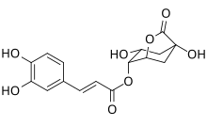
Diterpenes
11.974  (m/z: 329.1771) | Gibberellin A15 | Dicarboxylic acid anion | C₂₀ H₂₆ O₅ | Ethanol; methanol; Glycerol/methanol; Glycerol/ethanol | 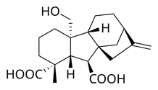

Table 3 List of most prevalent secondary metabolites along with their functional groups and molecular structure
Functional group | Secondary metabolite | Molecular structure
Ketone | 2-Keto Valeric Acid | 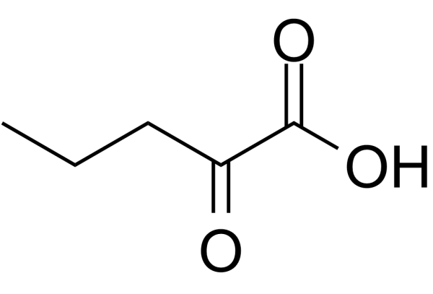
Ketone | Methyl Acetoacetate | 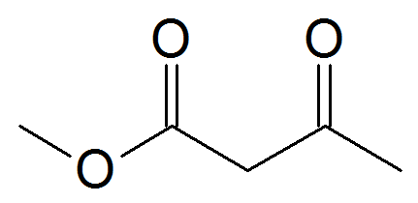
Ketone | 5-Hydroxy-7-(4-hydroxy-3-methoxyphenyl)-1-Phenyl-3-Heptanone | 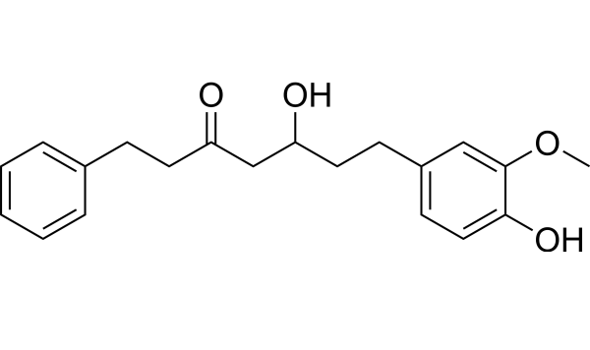
Ketone | 8-Oxo-Nonanoic Acid | 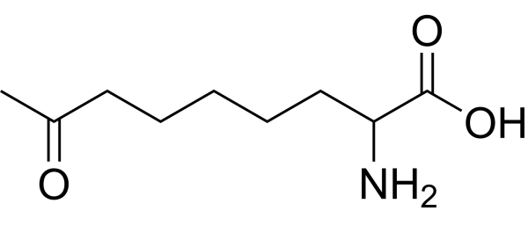
Ketone | (R)-2,3-Dihydroxy-Isovalerate | 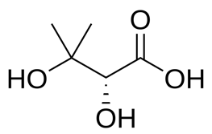
Ketone | 2,3-Dihydroxy-3-Methylbutyric Acid | 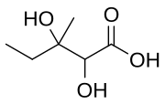
Carboxylic acid | Cis-5-Caffeoylquinic Acid | 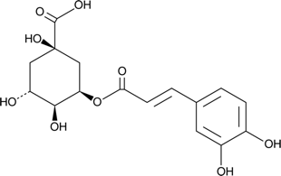
Carboxylic acid | 4-Caffeoyl-1,5-Quinolactone | 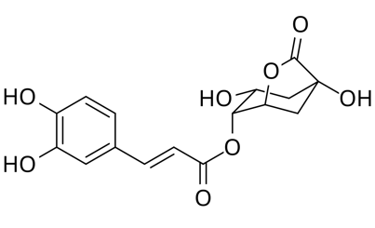
Carboxylic acid | Citric Acid | 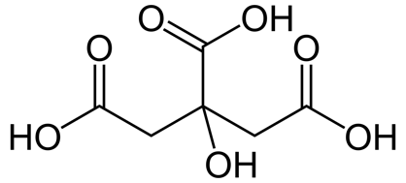
Carboxylic acid | Glutaconic Acid | 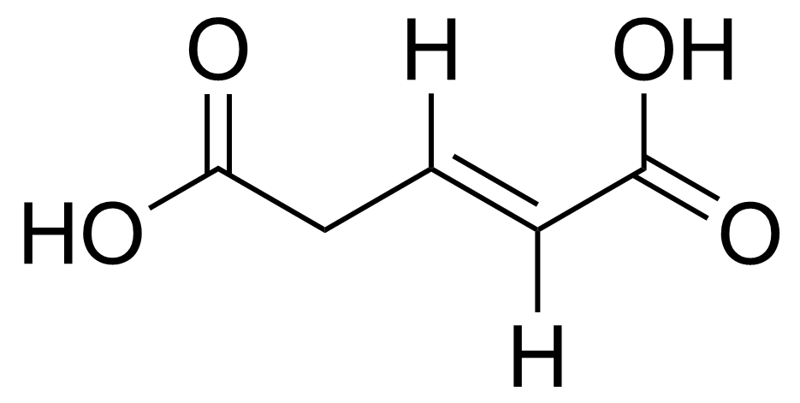
Carboxylic acid | 3α,12α-Dihydroxy-5β-chol-8(14)-En-24-oic Acid | 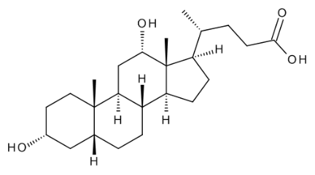
Carboxylic acid | Hexacosanedioic Acid | 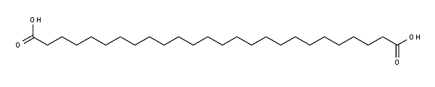
Carboxylic acid | (R)-(Homo)2-Citrate | 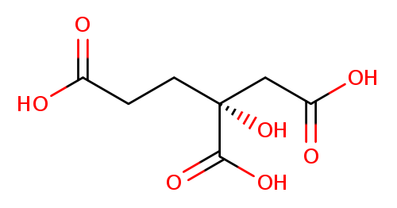
Carboxylic acid | 3-O-Feruloylquinic Acid
Carboxylic acid | Gibberellin A15 | 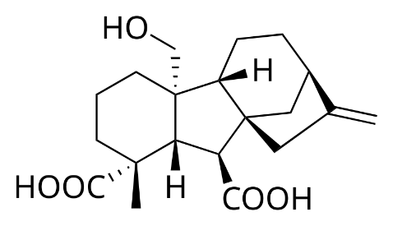
Carboxylic acid | Acetyl Tributyl Citrate | 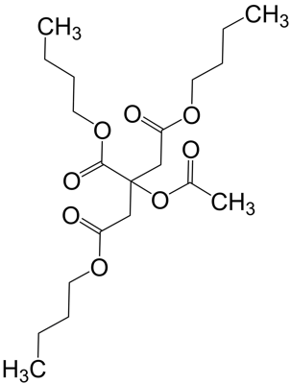
Carboxylic acid | 14-Methylheptadecanoic Acid | 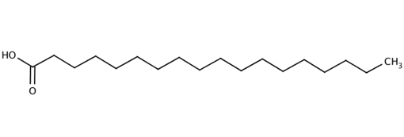
Carboxylic acid | 2-Hexyl-Decanoic Acid | 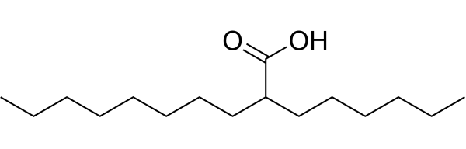
Carboxylic acid | L-Malic Acid | 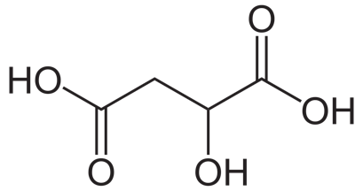
Lactone | Erythrono-1,4-Lactone | 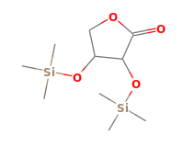
Lactone | 4,5-Dihydroxyhexanoic Acid Lactone | 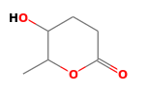
Ester | Sorbitan Palmitate | 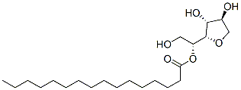
Ester | S-Ethyl Thioacetate | 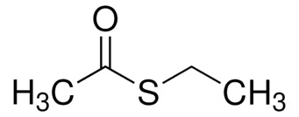
Aldehyde | Muconic Dialdehyde | 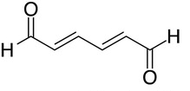
Furan | Levofuraltadone | 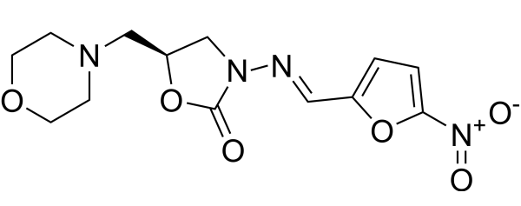
Phenols | 4-Hydroxyphenylglyoxylate | 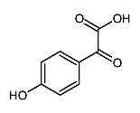
Phenols | 4-(2-hydroxypropoxy)-3,5-Dimethyl-Phenol | 