Table of contents
Fig. S1 Transmission spectra of top and bottom DBRs.
Fig. S2 Variation of the Al composition at the interfaces between the GaN template, Al_{0.8}Ga_{0.2}N pre-crack layer and Al_{0.65}Ga_{0.35}N healing layer.
Fig. S3 The origin of small protrusions after the self-terminated etching.
Fig. S4 Bowing of the as-grown and processed wafers.
Fig. S5 Raman spectra of E₂ (high) phonon mode of GaN templates in the as-grown and processed wafers.
Fig. S6 Cross-sectional SEM image of DUV-VCSELs.
Fig. S7 Estimation of pump power density in consideration of the transmission through the top DBR at 266 nm.
Fig. S8 The wavelength difference between the stimulated and spontaneous peaks.
Fig. S9 Typical stimulated emission spectra in the four quadrants of the 4 inch wafer.
Fig. S10 Calculated cavity reflection spectra for the lasing wavelength of 284.8 and 286.7 nm, respectively.
Fig. S11 Plan-view SEM image of the DUV-VCSEL array.
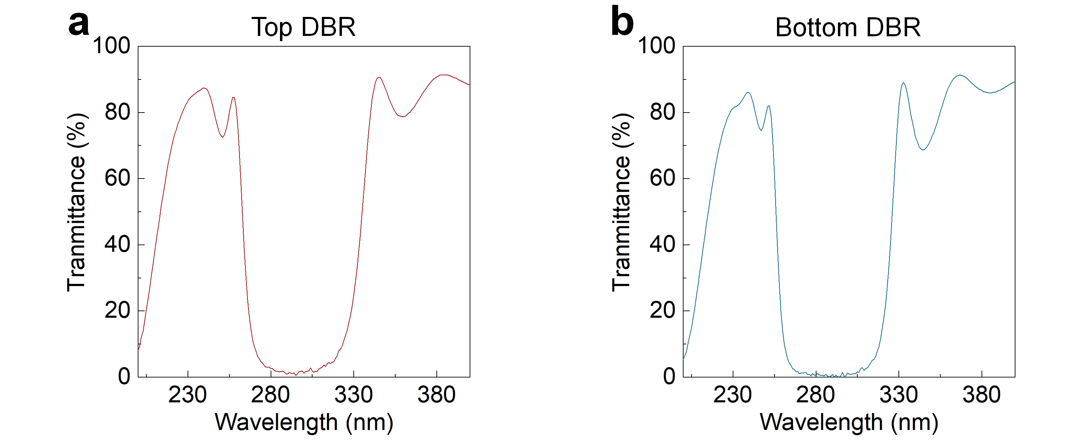
Fig. S1 Transmission spectra of top and bottom DBRs. a, Top DBR. b, Bottom DBR.
The transmission spectra of the top and bottom DBRs at normal incidence are depicted in Fig. S1a and S1b, respectively, where the stopband widths reach ~70 nm for both spectra. The transmissivity is 1.55% and 0.36% at 285 nm in the top and bottom DBRs, respectively. The slight inconsistency between the transmissivity and corresponding reflectivity (in Fig. 1e and 1f) is attributed to the absorption inside the DBRs.
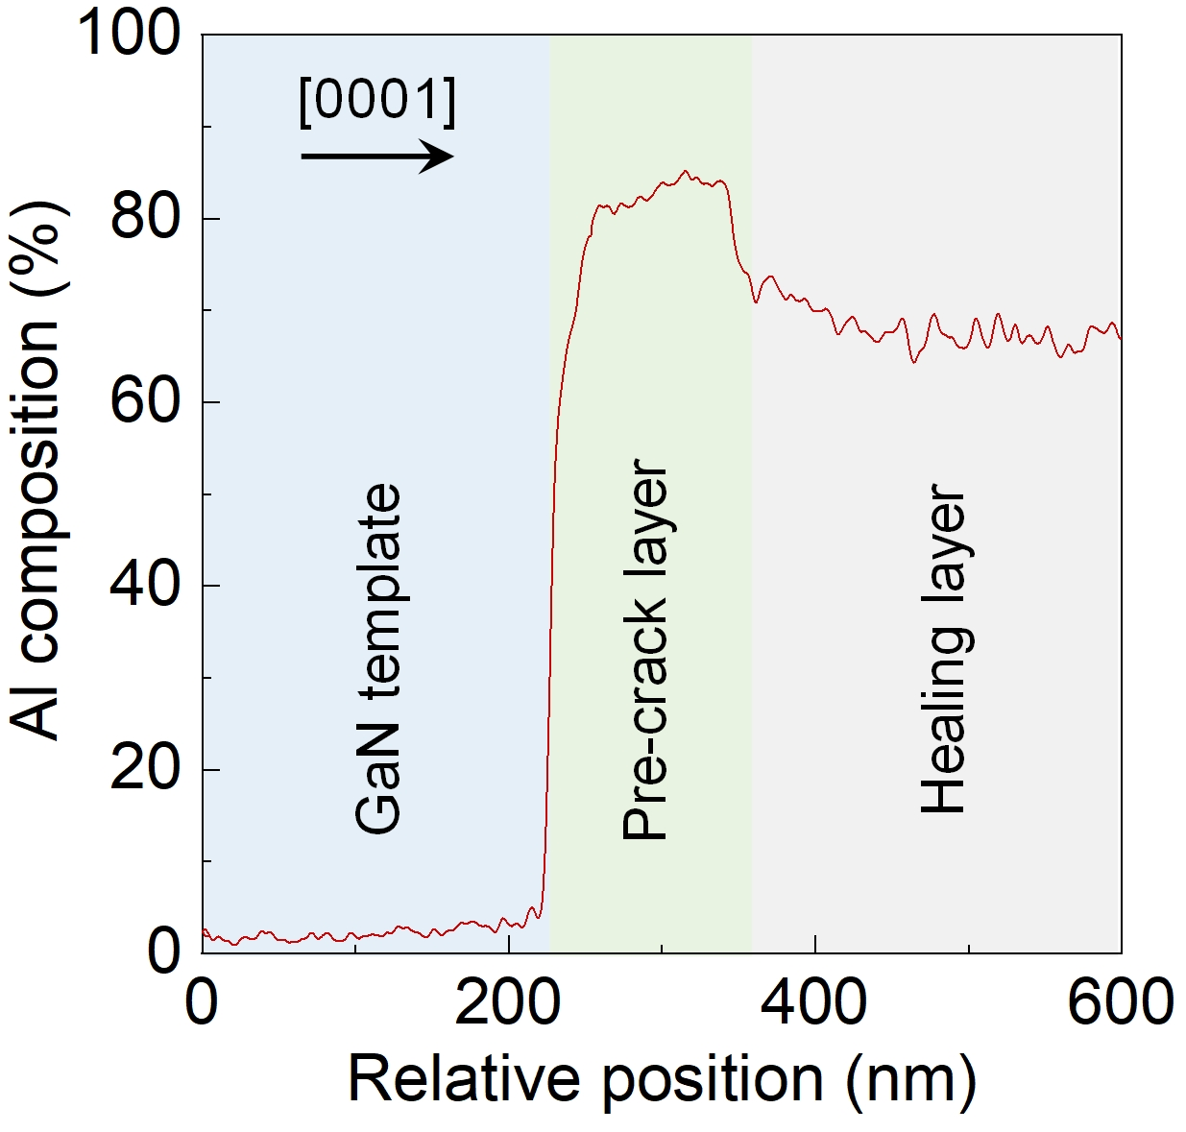
Fig. S2 Variation of the Al composition (EDS) at the interfaces between the GaN template, Al_{0.8}Ga_{0.2}N pre-crack layer and Al_{0.65}Ga_{0.35}N healing layer.
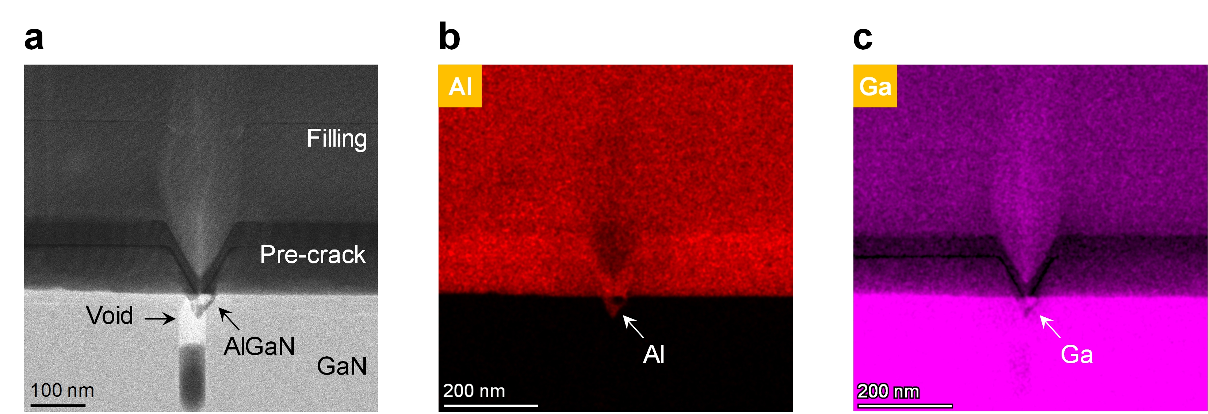
Fig. S3 The origin of small protrusions after the self-terminated etching. a, Cross-sectional STEM image of the filled-up pre-crack. b,c, Distribution of Al and Ga atoms around the pre-crack in Panel a. Copyright © 2024, authors.
Details about the healing of pre-cracks in the DUV framework based on GaN templates were described in our previous research¹. It has been found that the tensile strain-induced cracks run through the Al_{0.8}Ga_{0.2}N pre-crack layer, and even propagate to the GaN template, resulting in the voids as show in Fig. S3a. In the subsequent growth of the healing layer, the pre-cracks are filled, while the voids in GaN are reserved. It should be noted that the void in Panel a is partially filled, in particular around the interface between the pre-crack layer and GaN template, since there are evident Al and Ga signals inside the void according to the EDS mapping measurements in Fig. S3b and S3c, respectively. That explains the origin of the small protrusions after the self-terminated etching in Fig. 2f.
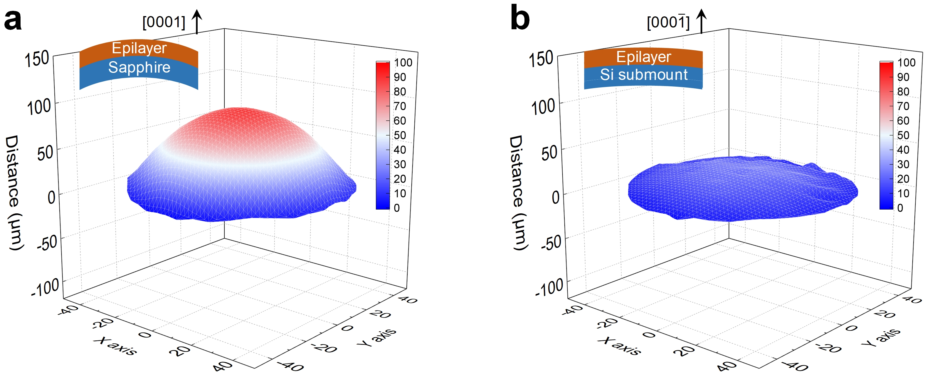
Fig. S4 Bowing of the as-grown and processed wafers. a, As-grown wafer. b, Processed wafer.
According to the Stoney’s equation, the residual stress in the epilayer is proportional to the curvature². Consequently, the bow values of the as-grown and processed wafers are measured (EtaMax Plato) to reveal the variation of the residual stress owing to the processes of bonding and LLO, as shown in Fig. S4a and S4b, respectively. Convex bending can be observed in both wafers, where the bow values are 90 and 25 μm in the as-grown and processed wafer, respectively. In other words, the residual stress is released in the processes of bonding and LLO.
Fig. S5 Raman spectra of E₂ (high) phonon mode of GaN templates in the as-grown and processed wafers.
The stress in GaN templates is modulated after the processes of bonding and LLO, according to the Raman shift in Fig. S5. A black dash line is plotted at 567.6 cm⁻¹, corresponding to the theoretical position of E₂ (high) phonon mode in freestanding GaN³. It is found that the E₂ (high) peak in the as-grown wafer locates at 569.5 cm⁻¹, indicating a compressive stress in the GaN template, consistent with the convex shape in Fig. S4a. While the stress is released in the processed wafer, where a tensile stress in the GaN template is even demonstrated.
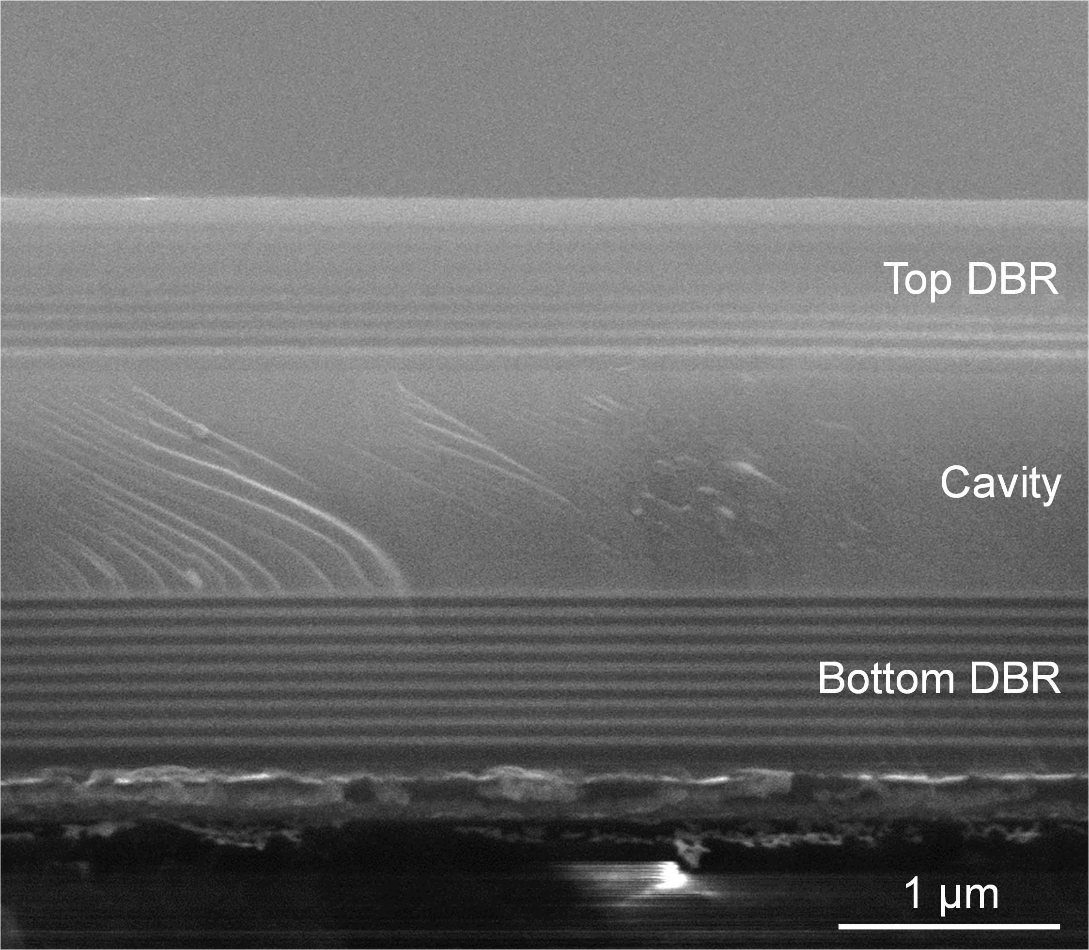
Fig. S6 Cross-sectional SEM image of DUV-VCSELs.
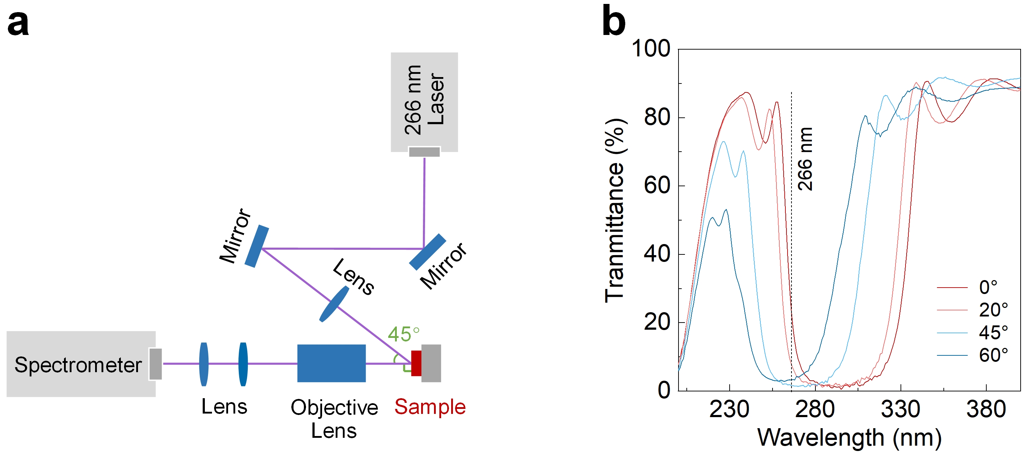
Fig. S7 Estimation of pump power density in consideration of the transmission through the top DBR at 266 nm. a, Schematic illustration of the optical configuration for the optically pumping measurements. b, Transmission spectra of the top DBR at different incidence angles.
The 266 nm pump laser in this study is inevitably reflected and absorbed by the top DBR. Therefore, the effective pump power density shown in Fig. 4d and 4e is calculated by considering the transmission of the top DBR at 266 nm. Figure S7a shows the schematic illustration of the optical configuration for pumping, where the laser is incident obliquely with an angle of 45°. The transmission spectra of the top DBR are then measured at different incidence angles (Fig. S7b), and evident spectral shift with respect to the angle can be observed. Finally, the transmittance for the 266 nm laser is determined to be 1.56% with an incidence angle of 45°. The pump power density in the main manuscript is calculated by multiplying this transmittance.
Fig. S8 The detuning between the resonance wavelength and gain peak.
In order to study the detuning between the resonance wavelength and gain peak, the room-temperature PL spectra of the processed MQWs is performed as shown in Fig. S8, before the deposition of the top DBR. In consideration of the 1.56% transmittance for the 266 nm laser through the top DBR, the pump power density is set as 0.006 MW/cm², corresponding to the threshold of 0.38 MW/cm² for DUV-VCSELs. Then it is found than the gain peak is perfectly matched with resonance wavelength (285.6 nm), leading to a low threshold.
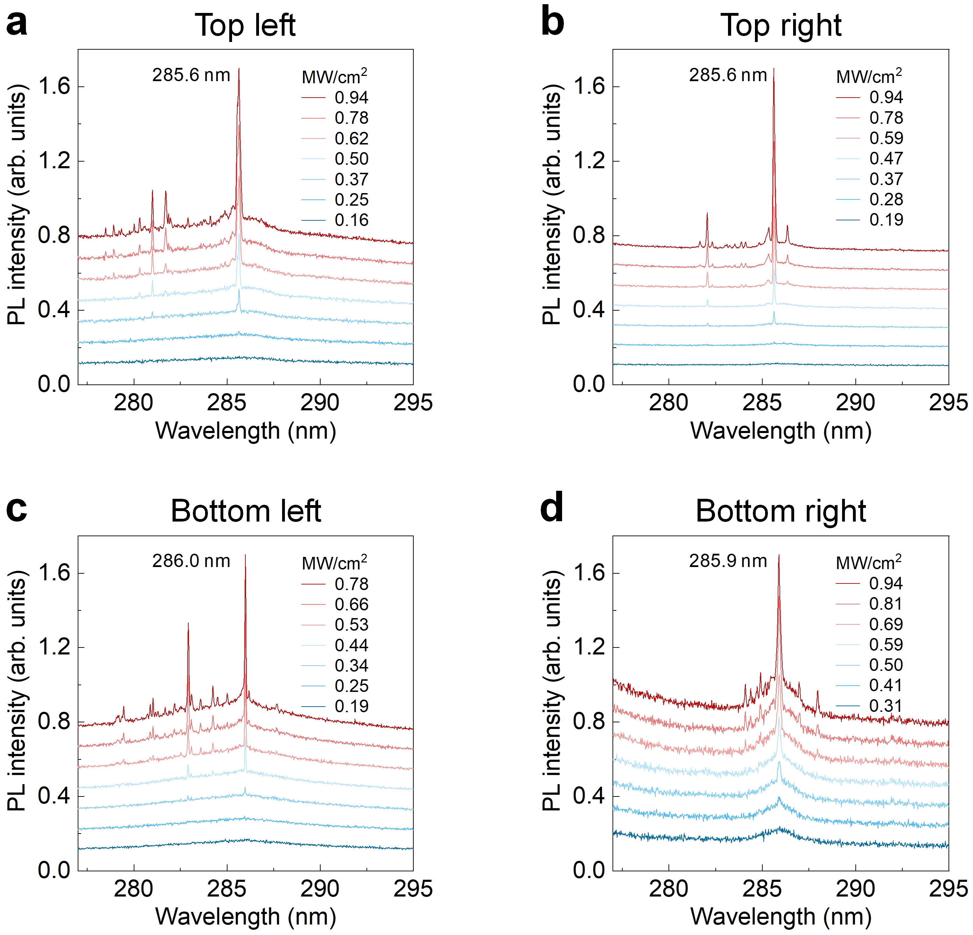
Fig. S9 Typical stimulated emission spectra in the four quadrants of the 4 inch wafer. a, Top left. b, Top right. c, Bottom left. d, Bottom right.
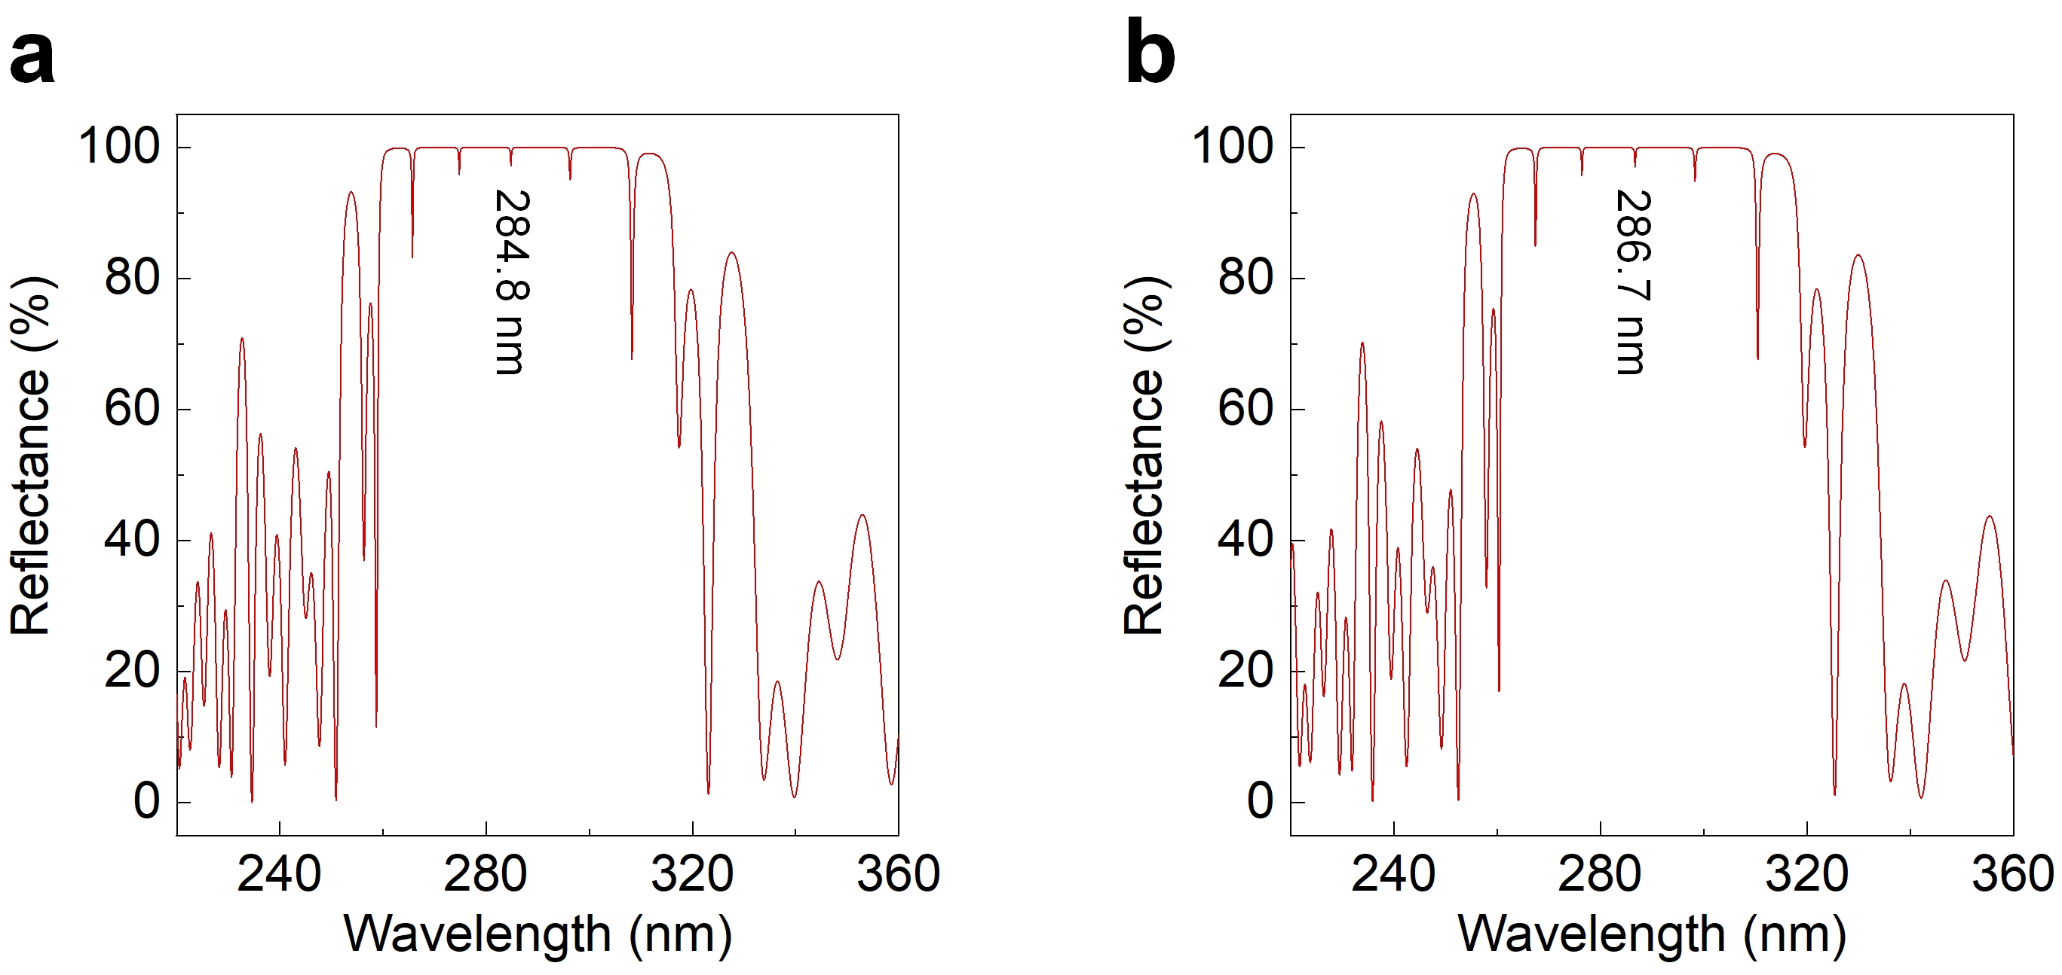
Fig. S10 Calculated cavity reflection spectra for different lasing wavelengths. a, 284.8 nm. b, 286.7 nm.
It is convinced that the etching depth difference of the Al_{0.8}Ga_{0.2}N pre-crack layer across the 4 inch wafer should be primarily responsible for the uniformity of the lasing wavelength. Herein the cavity reflection spectra are calculated by only varying the Al_{0.8}Ga_{0.2}N thickness. It is found that the lasing wavelength of 284.8 and 286.7 nm corresponds to the Al_{0.8}Ga_{0.2}N thickness of 78.5 and 87.2 nm, respectively. In other words, there is a cavity length variation of 8.7 nm, ~0.81% of the total length.
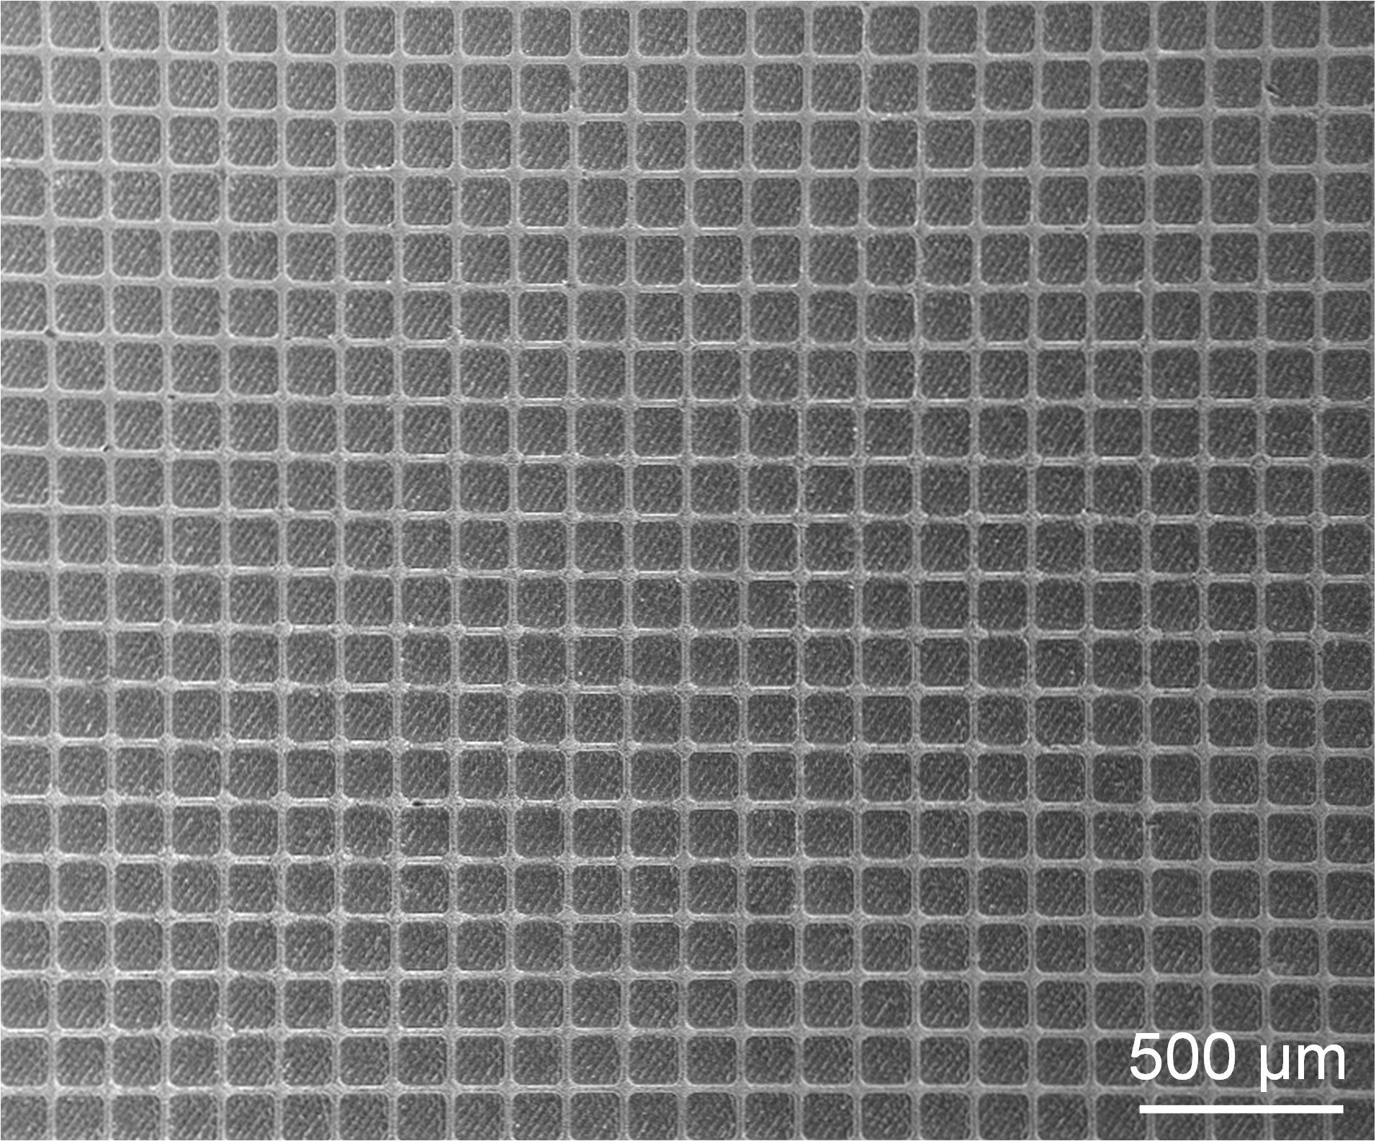
Fig. S11 Plan-view SEM image of the DUV-VCSEL array.
Figure S11 presents the plan-view SEM image of the DUV-VCSEL array, where the size of the devices is designed as 130×130 μm², with an interval of 12 μm.
References
- Wang, J., Ji, C., Lang, J., Xu, F., Zhang, L., Kang, X., Qin, Z., Yang, X., Tang, N., Wang, X., Ge, W. & Shen, B. Wafer-scale vertical injection III-nitride deep-ultraviolet light emitters. Nat. Commun. 15, 9398 (2024).
- Chou, T.-L., Yang, S.-Y. & Chiang, K.-N. Overview and applicability of residual stress estimation of film–substrate structure. Thin Solid Films 519, 7883 (2011).
- Davydov, V. Y., Kitaev, Y. E., Goncharuk, I. N., Smirnov, A. N., Graul, J., Semchinova, O., Uffmann, D., Smirnov, M. B., Mirgorodsky, A. P. & Evarestov, R. A. Phonon dispersion and Raman scattering in hexagonal GaN and AlN. Phys. Rev. B 58, 12899 (1998).

