Supplemental Materials
Detailed Analytic Plan
All focus groups were conducted in Hindi and were digitally recorded by me. They were first transcribed into Hindi and then translated into English. I then double-checked the obtained transcript against the original recording in Hindi to ensure that the English version captures the Hindi recording in its entirety. In this round, I also added periods of silence when the girls were quiet in response to a discussion prompt for a considerable time. I followed Boor et al.’s (2001) guidelines for transcription. All recorded speech was transcribed verbatim, including hesitations, repetitions, and pauses, to reflect natural speech patterns. Nonverbal cues such as laughter, silence, and significant gestures (e.g., all girls raising their hands) were also noted to preserve the context and flow of discussion. The goal was to produce transcripts that closely represented the original focus group interactions.
I organized my data analysis approach around my two research sub-questions. In understanding question 1a (What are the attributes and aspects of sense of belonging to school for historically underrepresented adolescent girls in rural India?), I decided to look and code for words, sentences, and phrases that signal what school sense of belonging means for the girls, what the words are they use to describe it, and what aspects they associate school sense of belonging. Here an attribute is an inherent quality that describes sense of belonging, while an aspect is a particular angle or component through which it can be examined or understood. For question1b (How is the notion of sense of belonging to school affected by structural determinants of gender inequality?), I decided to look and code for the spaces where they experience or do not experience sense of belonging and factors that seem to affect sense of belonging to school. In doing so, I used a combination of both participants themselves, seeing their experiences as affecting their school sense of belonging, as well as my own interpretation during the process of coding.
My overall analysis process drew upon the phronetic iterative approach by Sarah Tracy (2019), which is an iterative data analysis approach that fluctuates between grounded analysis of qualitative data (such as interviews, participant observation field notes, documents, and visuals) and existing literature and theory. For step one, based on research questions 1a and 1b, I open coded the transcript, specifically coding for words, sentences, phrases, or paragraphs that hinted toward the four dimensions of school sense of belonging, namely: words used to describe it, associated aspects, space where it is (or is not) experienced, and factors that influence it. In doing so, I relied on both inductive and deductive coding; the complete code list of 49 codes is in Appendix C under the four categories of school sense of belonging definition/attributes, sense of belonging/ related aspects, place belonging, and intersectionality (politics of belonging). This step was undertaken with transcripts from two sites.
Once this was done, as part of Step two, I recoded the first two transcripts and coded the remaining transcripts. Minor additions were made to the code list (Appendix C). Based on the recoding, I used the code mapping technique from Anfara et al. (2002) for category creation to answer each sub-question and rely on an iterative process (Anfara et al., 2002). This process required me to go back and forth between the data to understand how codes fit under one of the four categories as part of the second iteration of pattern variables (Table 2.1). I then regrouped them to answer the two research questions as part of the third iteration.
I used a computer-assisted qualitative data analysis software MAXQDA to undertake analysis for this study. Within MAXQDA, I relied on both vertical retrieval of codes within a transcript as well as horizontal retrieval of codes across transcripts. In the exploratory phase, I relied on the results from the code matrix browser from MAXQDA to display a horizontal retrieval of codes across the five school sites (Figure 2.1). I found that codes pertaining to society, gender, and belonging showed maximum frequency in occurrence across the transcripts.

Table 2.1
Overall Code Mapping Approach
1a: What are attributes and examples of sense of belonging to school for historically underrepresented adolescent girls in rural India? |  | 1b: How is the notion of sense of belonging to school affected by structural determinants of gender inequality?
Third iteration: application to data
Conceptualization of sense of belonging to school among historically underrepresented adolescent girls in rural India
Second iteration: pattern variables
1a. Attributes of sense of belonging | 1b. Aspects associated with sense of belonging | 2a. Spaces where sense of belonging is experienced or not | 2b. Factors affecting sense of belonging
First iteration: initial codes/surface content analysis
Togetherness (D)  Acceptance (D)  Support (D)  Comfort (D)  Part of group (D)  Love (I)  Anger (I)  Scared (I)  Feeling strange (I)  Lonely (I)  Access to school (I)  Friends (D)  Liking (I)  Transition (D)  Help/care (D) | Respect (I)  Silence (I)  Safety (I)  Mobility (I)  Aspirations (I)  Academic Performance (I)  Fight (I)  No teaching (I)  Activities (I)  Girls together (I)  Resources (I)  Hard work (I)  Rights (I) | School (I)  Peers (D)  Hostel (I)  Classroom (I)  Teachers (D)  New in school (I)  Home/outside of school (I)  Parents (D)  Siblings (I)  Relatives (I)  Neighbours (I)  Household chores (I)  Society/world (I) | Gender (D)  Caste (D)  Religion (D)  Urban/Rural (D)  Poverty (D)  Expectations (I)  Investment in education (I)  Skin color/race (I)  Violence (I)
Data | Data | Data | Data
Note: Here ‘I’ refers to Inductive coding and ‘D’ refers to Deductive coding.

Figure 2.1
Horizontal Retrieval of Codes Across School Sites
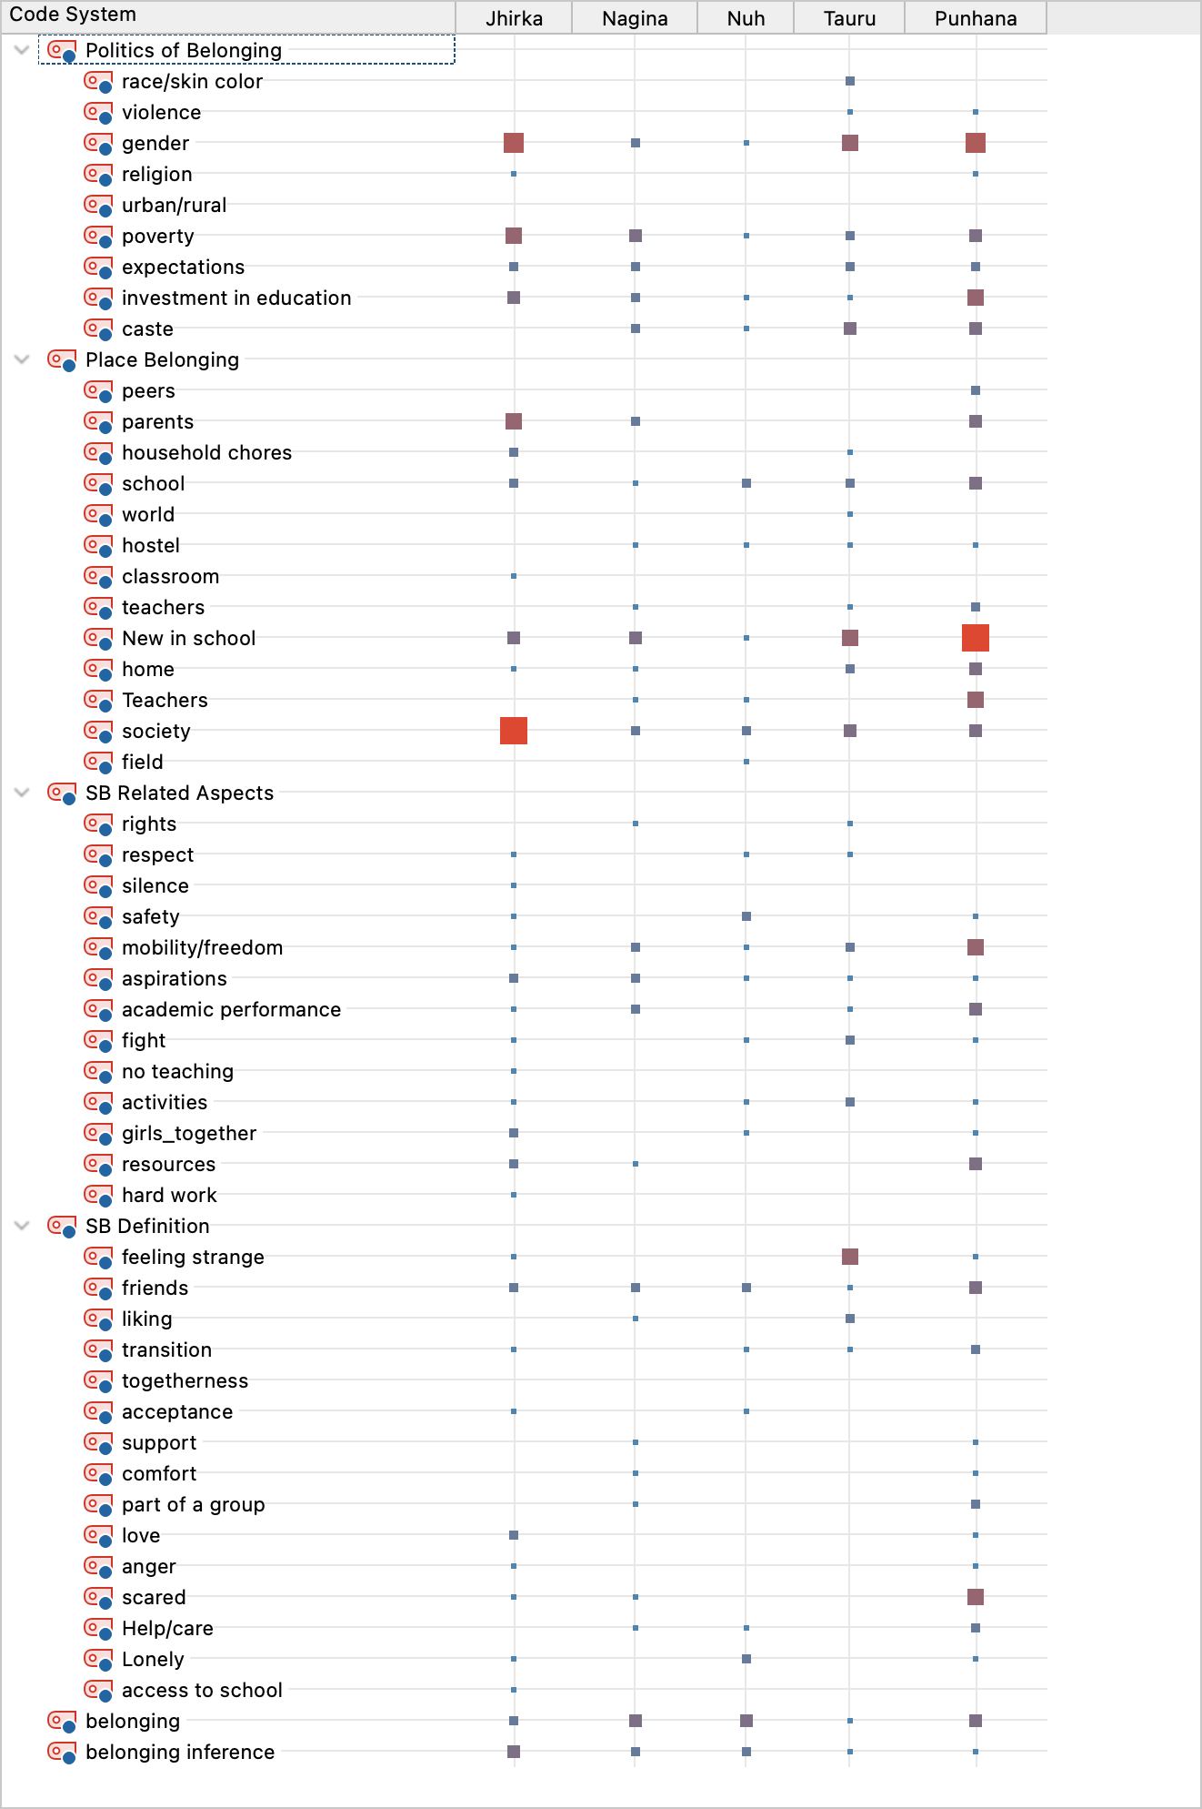

I then studied the codes’ colocation and relationships both within and across transcripts to compare actors and situations. I achieved this by first gathering a vertical retrieval of codes using the code matrix functionality and then horizontal retrieval of codes through the code relations browser. This helped me understand the locations of codes within transcripts, their density, and the paragraphs/responses where they occur together. Across the transcripts, I observed significant associations between sense of belonging and the remaining codes (Figure 2.2). Association is defined as two codes intersecting and appearing in the same sentence or paragraph. The maximum density of associations is displayed in Table 2.2. A detailed version is also provided in Appendix D. Here, the first and second iteration categories are defined according to the Anfara et al., (2002) code mapping approach discussed previously. Thereafter, I used the code density maps functionality to observe which codes are clustered across transcripts and whether they depict a pattern.
Figure 2.2
Code Matrix Browser Displaying Themes Associated with School Sense of Belonging
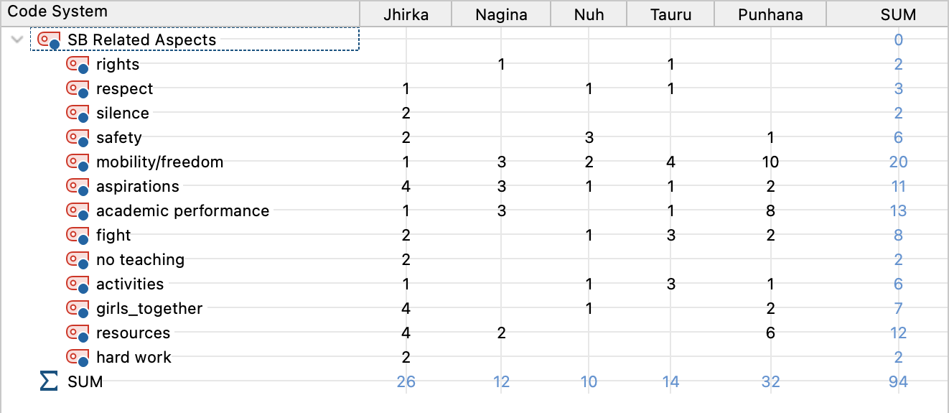

Table 2.2
Association Between School Sense of Belonging Code and Other Codes

Code Associations | Number of Associations
First Iteration Categories
low sense of belonging*gender | 24
low sense of belonging*new in school | 34
low sense of belonging*society | 39
society*gender | 17
Second Iteration Categories
low sense of belonging*politics of belonging | 58
low sense of belonging*place belonging | 116
high sense of belonging*place belonging | 55
low sense of belonging*belonging related aspects | 46
society*politics of belonging | 44

Credibility in this process was ensured by extensive note-keeping and returning to data in the process to check whether the interpretation is true to the data and the features identified are corroborated by other interviews (Elo et al., 2014). Note-keeping was done through memos documenting the process and recording the reflection on the emergent themes. Memos are “a researcher’s record of analysis, thoughts, interpretations, questions and directions for further data collection” (Strauss & Corbin, 1990). Additionally, I also presented my preliminary findings to a team of people working with the community in India to evaluate whether my interpretations were right and whether the results matched the reality. Termed “face validity,” this approach has been used to estimate the trustworthiness of studies, especially in single-author studies (Cavanagh, 1997; Downe-Wamboldt, 1992; Hickey & Kipping, 1996).

APPENDIX A
PARTICIPANT LIST FOR FOCUS GROUP DISCUSSIONS
*All names have been changed.
S.No. | Participant | Gender | Grade | School | Site
1 | Rukhsar | Female | Sixth | Kasturba Gandhi Balika Vidyalaya | Nuh
2 | Janista | Female | Sixth | Kasturba Gandhi Balika Vidyalaya | Nuh
3 | Khushi | Female | Sixth | Kasturba Gandhi Balika Vidyalaya | Nuh
4 | Nicee | Female | Sixth | Kasturba Gandhi Balika Vidyalaya | Tauru
5 | Muskaan | Female | Sixth | Kasturba Gandhi Balika Vidyalaya | Tauru
6 | Tarannum | Female | Sixth | Kasturba Gandhi Balika Vidyalaya | Tauru
7 | Imrana | Female | Sixth | Kasturba Gandhi Balika Vidyalaya | Nagina
8 | Kumkum | Female | Sixth | Kasturba Gandhi Balika Vidyalaya | Nagina
9 | Anjali | Female | Sixth | Kasturba Gandhi Balika Vidyalaya | Nagina
10 | Shifa | Female | Sixth | Kasturba Gandhi Balika Vidyalaya | Punhana
11 | Shabnam | Female | Sixth | Kasturba Gandhi Balika Vidyalaya | Punhana
12 | Yafra | Female | Sixth | Kasturba Gandhi Balika Vidyalaya | Punhana
13 | Safrana | Female | Sixth | Kasturba Gandhi Balika Vidyalaya | Ferozpur Jhirka
14 | Anju | Female | Sixth | Kasturba Gandhi Balika Vidyalaya | Ferozpur Jhirka
15 | Seheen | Female | Sixth | Kasturba Gandhi Balika Vidyalaya | Ferozpur Jhirka
16 | Saima | Female | Seven | Kasturba Gandhi Balika Vidyalaya | Nuh
17 | Rakhi | Female | Seven | Kasturba Gandhi Balika Vidyalaya | Nuh
18 | Farhana | Female | Seven | Kasturba Gandhi Balika Vidyalaya | Nuh
19 | Nisha | Female | Seven | Kasturba Gandhi Balika Vidyalaya | Tauru
20 | Kirti | Female | Seven | Kasturba Gandhi Balika Vidyalaya | Tauru
21 | Asifatullah | Female | Seven | Kasturba Gandhi Balika Vidyalaya | Tauru
22 | Chanchal | Female | Seven | Kasturba Gandhi Balika Vidyalaya | Nagina
23 | Muskaan | Female | Seven | Kasturba Gandhi Balika Vidyalaya | Nagina
24 | Sofia | Female | Seven | Kasturba Gandhi Balika Vidyalaya | Nagina
25 | Arfina | Female | Seven | Kasturba Gandhi Balika Vidyalaya | Punhana
26 | Anjali | Female | Seven | Kasturba Gandhi Balika Vidyalaya | Punhana
27 | Mumtaz | Female | Seven | Kasturba Gandhi Balika Vidyalaya | Punhana
28 | Nazrana | Female | Seven | Kasturba Gandhi Balika Vidyalaya | Ferozpur Jhirka
29 | Anu | Female | Seven | Kasturba Gandhi Balika Vidyalaya | Ferozpur Jhirka
30 | Farzana | Female | Seven | Kasturba Gandhi Balika Vidyalaya | Ferozpur Jhirka
31 | Yabisa | Female | Eight | Kasturba Gandhi Balika Vidyalaya | Nuh
32 | Sanya | Female | Eight | Kasturba Gandhi Balika Vidyalaya | Nuh
33 | Aarti | Female | Eight | Kasturba Gandhi Balika Vidyalaya | Nuh
34 | Nisha | Female | Eight | Kasturba Gandhi Balika Vidyalaya | Tauru
35 | Rohitana | Female | Eight | Kasturba Gandhi Balika Vidyalaya | Tauru
36 | Nirmal | Female | Eight | Kasturba Gandhi Balika Vidyalaya | Tauru
37 | Shivani | Female | Eight | Kasturba Gandhi Balika Vidyalaya | Nagina
38 | Ajroona | Female | Eight | Kasturba Gandhi Balika Vidyalaya | Nagina
39 | Janista | Female | Eight | Kasturba Gandhi Balika Vidyalaya | Nagina
40 | Pooja | Female | Eight | Kasturba Gandhi Balika Vidyalaya | Punhana
41 | Muskan | Female | Eight | Kasturba Gandhi Balika Vidyalaya | Punhana
42 | Sanjeeda | Female | Eight | Kasturba Gandhi Balika Vidyalaya | Punhana
43 | Nazrana | Female | Eight | Kasturba Gandhi Balika Vidyalaya | Ferozpur Jhirka
44 | Saima | Female | Eight | Kasturba Gandhi Balika Vidyalaya | Ferozpur Jhirka
45 | Dilsana | Female | Eight | Kasturba Gandhi Balika Vidyalaya | Ferozpur Jhirka
46 | Anjali | Female | Nine | Kasturba Gandhi Balika Vidyalaya | Nuh
47 | Sonam | Female | Nine | Kasturba Gandhi Balika Vidyalaya | Nuh
48 | Sabra | Female | Nine | Kasturba Gandhi Balika Vidyalaya | Nuh
49 | Rimsa | Female | Nine | Kasturba Gandhi Balika Vidyalaya | Tauru
50 | Preeti | Female | Nine | Kasturba Gandhi Balika Vidyalaya | Tauru
51 | Jhumri | Female | Nine | Kasturba Gandhi Balika Vidyalaya | Tauru
52 | Gulabsa | Female | Nine | Kasturba Gandhi Balika Vidyalaya | Nagina
53 | Satywati | Female | Nine | Kasturba Gandhi Balika Vidyalaya | Nagina
54 | Unjila | Female | Nine | Kasturba Gandhi Balika Vidyalaya | Nagina
55 | Mohsina | Female | Nine | Kasturba Gandhi Balika Vidyalaya | Punhana
56 | Kajal | Female | Nine | Kasturba Gandhi Balika Vidyalaya | Punhana
57 | Rukhsaar | Female | Nine | Kasturba Gandhi Balika Vidyalaya | Punhana
58 | Zeenat | Female | Nine | Kasturba Gandhi Balika Vidyalaya | Ferozpur Jhirka
59 | Poonam | Female | Nine | Kasturba Gandhi Balika Vidyalaya | Ferozpur Jhirka
60 | Farhana | Female | Nine | Kasturba Gandhi Balika Vidyalaya | Ferozpur Jhirka

APPENDIX B
FOCUS GROUP PROTOCOL

Preparing for the interview:

- Find a place where you can sit with the groups of students in privacy, with the help of the teacher, where disturbance is minimum. If this is someplace outside the classroom, make sure that it is a shady and comfortable area.

- Introduce yourself, the purpose and the process to the students:
  - Hello everyone, my name is XXX and today I wanted to talk to you about your feelings and experiences in school. I am very interested in knowing more about you.
  - We will sit in a group and chat on several topic and this process should take between 1 hour and 30 minutes
  - All your responses are confidential and will not be shared with anyone. Your name will not appear anywhere, so there will be no way to identify if something specific was said by you.
  - If you need to be somewhere else and do not wish to continue, you can let me know now.
  - You can choose not to answer or to skip any question.
  - Also, ask me if you don’t understand any questions.
  - When the discussion is over, please respect the privacy of your fellow group members and do not repeat comments others make during our discussion to anyone outside of this group.
  - We are audio recording this discussion today so we don’t have to take detailed notes. Does anyone have any objection to audio recording it?
  - Only people working on this project will ever hear any of the recordings, read the notes we take or have access to the questionnaire you complete. Your participation is voluntary and confidential, and you may refuse to comment on any question that is asked. Nothing you say about yourself, a particular person, or facility will ever be made public or reported in any way that will allow you to be identified. Your participation today will not affect the care that you receive. So feel free to say whatever is on your mind.
  - Before we begin I want to emphasize that the reason I am here today is to better understand your experiences in school and in life. There are no right or wrong answers. We want to hear what you think. During the discussion, I’m not planning on doing most of the talking.
  - Before we begin, are there any questions?

- Script: Belonging means acceptance as a member or part. Sense of belonging is a human need, just like the need for food and shelter. Feeling that you belong is very important in seeing value in school.

  - What does belongingness mean to you?
  - When do you think/feel you belong? Can you share some examples?
  - When do you feel you don’t belong? Can you share some examples?
  - Do you feel you belong in your school? In your home? In the society?
  - Do you sometimes feel that you don’t belong because you are a girl?
  - Do you sometimes feel that you don’t belong because you are poor?
  - Do you sometimes feel that you don’t belong because you are Muslim?
  - Do you sometimes feel that you don’t belong because you are Dalit? (Does poverty and gender shape their perceptions and experiences of stigmatization and isolation?)
  - Does you teacher’s behavior change the way you belong?
  - Does this affect how you live your life or perform at school or set goals for yourself?
  - In your society, who succeeds? And why?
  - Who are your role models?

After the focus group discussion:

Finally, is there anything I haven’t asked you that I should have? Or anything that you would like to add?

Thank you very much for helping us out today. Your feedback will be very useful to us. It is all right to talk to others about what we discussed here today, but please remember to respect each other’s privacy, and don’t mention anyone’s name outside this room.

If you would like more information about the study, or if you would like to discuss any of these issues further, please don’t hesitate to contact me at XXX: 8874441637.

Now, you are free to go.
Thank you very much.
Have a good day!
APPENDIX C
CODE LIST—INDUCTIVE AND DEDUCTIVE APPROACH

- Sense of Belonging Definition/Attributes
- Togetherness (D)
- Acceptance (D)
- Support (D)
- Comfort (D)
- Part of group (D)
- Love (I)
- Anger (I)
- Scared (I)
- Feeling strange (I)
- Lonely (I)
- Access to school (I)
- Friends (D)
- Liking (I)
- Transition (D)
- Help/care (D)

- Sense of Belonging: Related Aspects
- Respect (I)
- Silence (I)
- Safety(I)
- Mobility (I)
- Aspirations (I)
- Academic Performance (I)
- Fight (I)
- No teaching(I)
- Activities (I)
- Girls together (I)
- Resources (I)
- Hard work (I)
- Rights (I)

- Place Belonging
- School (I)
- Peers (D)
- Hostel (I)
- Classroom (I)
- Teachers (D)
- New in school (I)
- Home/outside of school (I)
- Parents (D)
- Siblings (I)
- Relatives (I)
- Neighbours (I)
- Household chores (I)
- Society/world (I)

- Intersectionality (Politics of Belonging)
- Gender (D)
- Caste (D)
- Religion (D)
- Urban/Rural (D)
- Poverty (D)
- Expectations (I)
- Investment in education (I)
- Skin color/race (I)
- Violence (I)

APPENDIX D
INTERSECTION BETWEEN SENSE OF BELONGING TO SCHOOL AND OTHER CODES

