Additional file 1
High-throughput screening of higher α-amylase producing Bacillus licheniformis by fluorescence-activated droplet sorting
Huiling Yuan^{1,2,3}, Ran Tu^{1,2}, Xinwei Tong⁴, Yuping Lin^{1,2}, and Qinhong Wang^{1,2,*}

¹Key Laboratory of Systems Microbial Biotechnology, Tianjin Institute of Industrial Biotechnology, Chinese Academy of Sciences, Tianjin, 300308, China
²National Center of Technology Innovation for Synthetic Biology, Tianjin, 300308, China
³University of Chinese Academy of Sciences, Beijing 100049, China
⁴Shandong Longkete Enzyme Preparations Co., Ltd., Linyi, 276400, China

*Correspondence:
Dr. Qinhong Wang
E-mail: wang_qh@tib.cas.cn
32 West 7th Avenue, Tianjin Airport Economic Area, Tianjin 300308, China
Tel: +86-22-24821950; Fax: +86-22-24821950

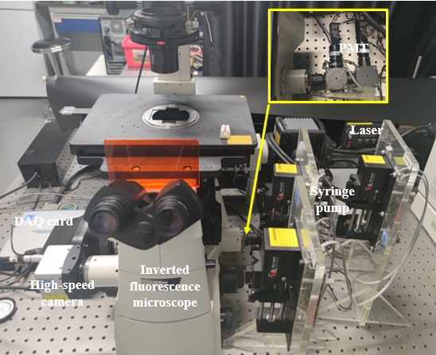

Fig. S1 Photograph of the droplet microfluidic platform.

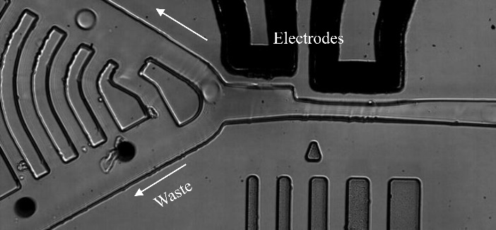

Fig. S2 Individual frame from the high-speed video during sorting of the mixed droplets.
The fluorescent droplets (light droplets) containing 1 μM fluorescein in 0.1 M Tris-HCl were deflected into the upper channel by the sorting electrodes, while the nonfluorescent droplets (dark droplets) containing 1% w/w bromophenol blue flowed into the bottom channel.

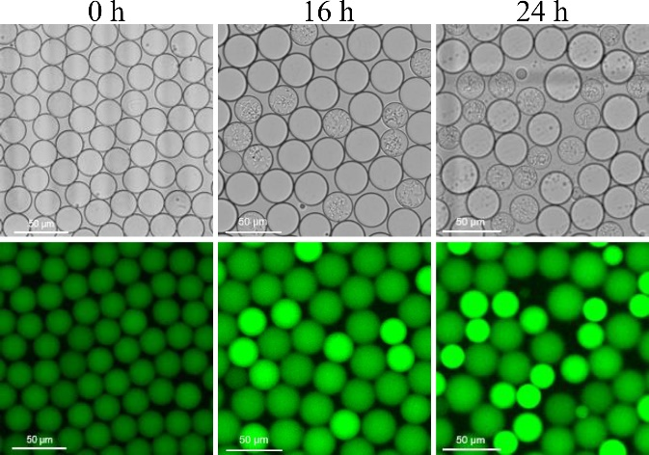
Fig. S3 Fluorescence images of microdroplets after generation, 16 h and 24 h of incubation at 37℃.

Fig. S4 The lethality curve of B. licheniformis wild type strain by ARTP treatment. Data represent the mean of triplicate samples, and the error bars represent standard deviations.

Mov. S1 High-speed video of fluorescence-based sorting of droplets. A binary mixture of fluorescent droplets (light droplets) and nonfluorescent droplets (dark droplets) was reinjected into the sorting device at a throughput of 300 droplets per second. The fluorescent droplets containing 1 μM fluorescein in 0.1 M Tris-HCl and the nonfluorescent droplets containing 1% wt/wt bromophenol blue. The fluorescent droplets with signals above the threshold were selectively deflected into the upper channel by dielectrophoresis, and the nonfluorescent droplets flowed into the bottom channel in the absence of an electric field.

