Supplementary Figure 1: Participant inclusion flow diagram
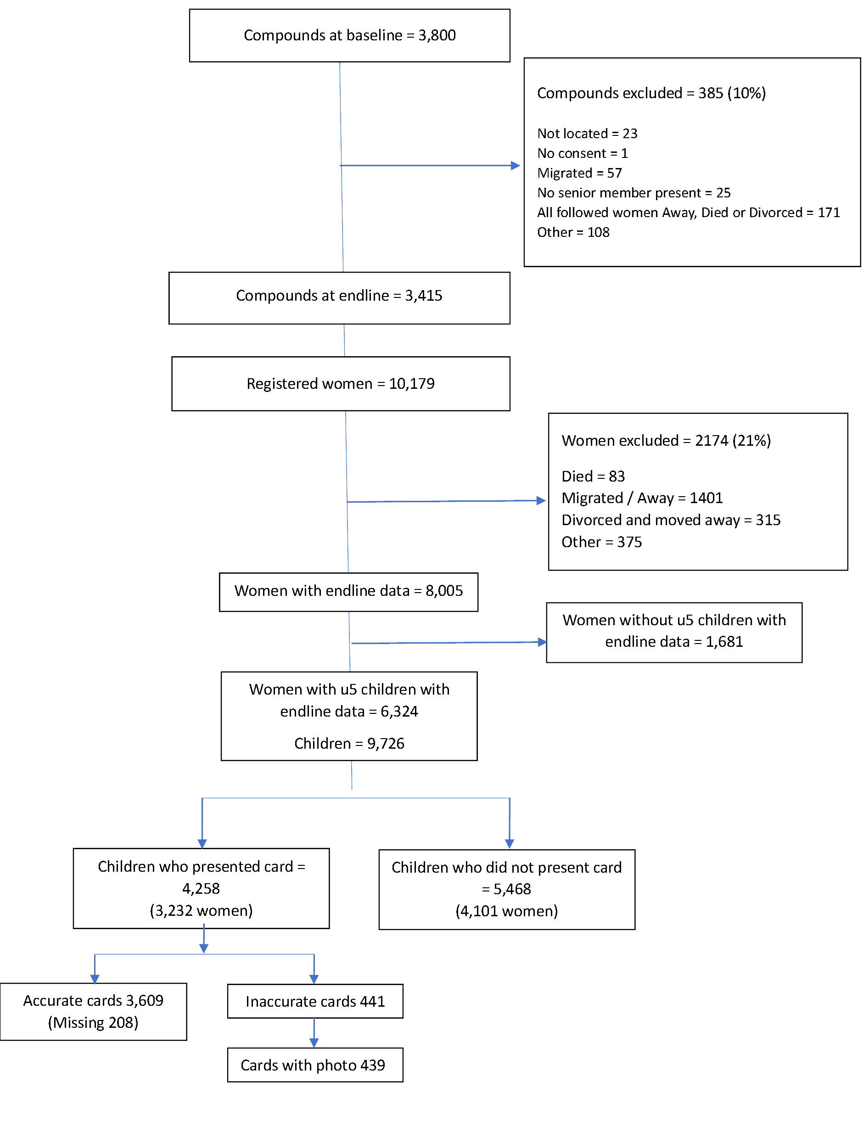

Supplementary File S1: Vignette Scenarios used for FGDs and IDIs
Note – all names and case scenarios were made up
Good morning everyone, thank you for agreeing to participate in the activity. We will be discussing some issues, many of which can be easily denied but are events we have seen ourselves and have discovered are going on in several communities around us. We will like to hear your thoughts on why these things are happening so we can collectively think of a way to solve the problems.
- A certain Nurse Hadiza once went to the Masaya community, close to Katuka to vaccinate children. When she arrived at Mallam Abdullahi's compound, she met Mariam, Mallam Abdullahi's wife, who has two children named Isah and Musa. Isah, who is five years old, has stopped collecting child vaccines, but Musa was due for one. The nurse asked for Musa's card, but Mariam couldn't find it; instead, she found the card for the older son (Isah) and gave the Nurse. Musa was vaccinated by the Nurse and his vaccination was recorded in his brother’s card. I will like you to take your time to reflect and this and tell us similar occurrences that you have witnessed in our locality.
  - What could have been responsible for this kind of action happening around us?
  - What did the health care workers do in similar situation like this.? (recycling older children’s cards)

- Nurse Sakina was conducting a vaccination outreach in the Sabon Gari community of Katanga. When she arrived at Mallam Hussaini's compound, she vaccinated the children without asking for their vaccine cards
  - Tell us about similar situations like this that has happened in your community or a nearby community and what you did when that happened.
  - What is your opinion about this practice? (Vaccinated without documenting)

- Farida Ishaqu brought her twin sons, Hassan and Hussaini, to Gwazaye Hospital in Dumbal, but upon arrival, she realized she had left Hassan's immunization cards at home. Although the nurse on duty vaccinated both children, she recorded the vaccinations on Hussaini's card.
  - We have seen this happen very well, so what do you do when this happens and what steps have the nurses been taking? (multi persons on a single vaccination card)

- Nurse Fatima, who was dispatched by her hospital supervisor to provide vaccinations to children in Gidan Tsika, a community located in Shuwarin, instead collected the children's cards from the mothers and proceeded to write on them without administering any vaccines. She then departed the community without providing any vaccination services to the children.
  - What do you do when you see Nurses doing something similar(documented without vaccinating)
  - What was the nurses explanation when you asked what they were trying to do

- In Fake, a woman gave birth to twin girls, Maida and Maimuna, at a hospital where there was no child vaccine card available. However, Nurse Quadri, one of the nurses on duty went ahead and vaccinated the babies and then recorded the details on a piece of paper which they gave to the mother. (substitution in case of card stock out)
  - We heard similar things have been happening here, what do you as parents do when there is no card available and what do the Nurses do themselves.

- Once upon a time in a small village near Maje town, there lived a mother with two young children, Kabiru and Kamoru, who were both three years old and the same gender. Unfortunately, one of the children fell ill with a fever and passed away. The deceased child had a more complete vaccination card than their surviving sibling. When healthcare workers visited the village, they offered some money as a reward for children with up-to-date vaccine records. The mother was then faced with a difficult decision: use the vaccination card of the surviving child, which was not up-to-date, or use the more complete vaccination card of the child who had passed away.
  - What do mothers in this community do in this type of situation. (Using a dead child's vaccine card for a living child). Why?

Supplemental Table 1: Characteristics of FGD and IDI participants
Characteristics of participants for the FGD
 |  | Men (n=16) | Women (n=17)
Age |  | 33 to 55 | 16 to 49
Occupation | Trader | 1 | 6
 | Skilled Manual Labour | 3 | 4
 | Farmer | 5 | 2
 | Unskilled Manual Labour | 4 | 3
 | Civil servant | 2 | 2
 | Student | 1 | 0
Characteristics of participants for the HCW-IDI (n=4)
 | (n=4)
Age | 25 to 31
Religion | Islam (All)
Qualification | Diploma (All)
Year of experience | 2 to 5 years
Marital status | 1 Married, 3 Single

Supplemental Table 2: Caregiver’s recall by child’s age
 | Has the caregiver confirmed that the vaccine card is accurate
Child’s age | Not accurate  N (row %) | Accurate  N (row %) | Not sure  N (row%) | Total  N (%)
0-11 months | 65 (5.5) | 1068 (90.4) | 48 (4.1) | 1181 (100)
12-23 months | 141 (13.7) | 844 (81.9) | 45 (4.4) | 1030 (100)
24-59 months | 235 (11.5) | 1697 (82.9) | 115 (5.6) | 2047 (100)
 |  |  |  | Chi-square p-value= <0.001

Supplemental Table 3: Multivariable Logistic Regression Analysis of Under-reporting in Child Vaccination Cards Using Maternal-Level Clustering
 | Outcome: child vaccine card inaccurate (under-reporting of any antigen)
 | Unadjusted (each variable considered separately) |  |  |  | Adjusted (all variables included in one multivariable model)
Variables | Odds ratio | 95% confidence interval |  | p-value | Odds ratio | 95% confidence interval |  | p-value
Caregiver’s age
Less than 25 years | ref |  |  |  | ref
25 - 34 years | 1.12 | (0.93 | 1.34) | 0.232 | 1.15 | (0.92 | 1.45) | 0.215
35 years and above | 1.01 | (0.82 | 1.26) | 0.901 | 1.08 | (0.82 | 1.44) | 0.564
Age at first marriage
Less than 16 years | ref |  |  |  | ref
16 years and above | 1.02 | (0.86 | 1.21) | 0.810 | 1.03 | (0.86 | 1.24) | 0.713
Level of education
None | ref |  |  |  | ref
Informal/religious/Formal | 0.87 | (0.72 | 1.05) | 0.144 | 0.95 | (0.76 | 1.12) | 0.393
Number of children alive
Less than 3 | ref |  |  |  | ref
3 – 4 children | 1.04 | (0.84 | 1.29) | 0.681 | 0.94 | (0.73 | 1.20) | 0.634
5 children and above | 1.01 | (0.82 | 1.24) | 0.911 | 0.91 | (0.68 | 1.21) | 0.515
Number of under-5 children
Just 1 | ref |  |  |  | ref
2 and above | 1.11 | (0.93 | 1.32) | 0.234 | 1.07 | (0.88 | 1.29) | 0.479
Occupation
Not working/Housewife | ref |  |  |  | ref
Farming/Manual labour | 0.83 | (0.66 | 1.05) | 0.115 | 0.61 | (0.68 | 2.80) | 0.072
Business/ professional/TBA | 0.82 | (0.64 | 1.06) | 0.130 | 0.59 | (0.86 | 3.70) | 0.068
Earn Income
Earn nothing | ref |  |  |  | ref
Earn something | 0.90 | (0.72 | 1.13) | 0.381 | 1.51 | (0.87 | 2.60) | 0.143
Have co-wife
None/Only wife | ref |  |  |  | ref
More than one | 1.14 | (0.97 | 1.34) | 0.113 | 1.09 | (0.92 | 1.30) | 0.292
Child birth-order
Singleton | ref |  |  |  | ref
Multiple | 0.95 | (0.54 | 1.66) | 0.865 | 0.98 | (0.53 | 1.79) | 0.946
Child’s age
Less than 1 year | ref |  |  |  | ref
12 – 24 months | 0.63 | (0.50 | 0.79) | <0.001 | 0.63 | (0.49 | 0.80) | <0.001
25 months and above | 0.66 | (0.54 | 0.81) | <0.001 | 0.66 | (0.53 | 0.81) | <0.001
Morbidity (sick in the last 2 weeks)
No | ref |  |  |  | ref
Yes | 0.69 | (0.57 | 0.83) | <0.001 | 0.71 | (0.59 | 0.86) | <0.001
Care seeking facility type
PHC | ref |  |  |  | ref
Secondary | 0.97 | (0.75 | 1.26) | 0.822 | 1.02 | (0.78 | 1.34) | 0.852
Tertiary | 0.63 | (0.39 | 1.02) | 0.060 | 0.75 | (0.45 | 1.25) | 0.273

Supplemental Table 4: Multivariable Logistic Regression Analysis of Over-reporting in Child Vaccination Cards Using Maternal-Level Clustering
 | Outcome: child vaccine card inaccurate (over-reporting of any antigen)
 | Unadjusted (each variable considered separately) |  |  |  | Adjusted (all variables included in one multivariable model)
Variables | Odds ratio | 95% confidence interval |  | p-value | Odds ratio | 95% confidence interval |  | p-value
Caregiver’s age
Less than 25 years | ref |  |  |  | ref
25 - 34 years | 0.82 | (0.57 | 1.17) | 0.284 | 0.74 | (0.46 | 1.16) | 0.186
35 years and above | 0.98 | (0.64 | 1.50) | 0.933 | 0.81 | (0.45 | 1.45) | 0.478
Age at first marriage
Less than 16 years | ref |  |  |  | ref
16 years and above | 1.07 | (0.77 | 1.47) | 0.695 | 1.11 | (0.78 | 1.57) | 0.564
Level of education
None | ref |  |  |  | ref
Informal/Religious/Formal | 1.03 | (0.71 | 1.49) | 0.869 | 1.04 | (0.70 | 1.56) | 0.843
Number of children alive
Less than 3 | ref |  |  |  | ref
3 – 4 children | 1.21 | (0.79 | 1.83) | 0.370 | 1.53 | (0.95 | 2.44) | 0.079
5 children and above | 1.15 | (0.76 | 1.76) | 0.488 | 1.54 | (0.87 | 2.73) | 0.133
Number of under-5 children
Just 1 | ref |  |  |  | ref
2 and above | 0.70 | (0.50 | 0.97) | 0.033 | 0.64 | (0.44 | 0.92) | 0.015
Occupation
Not working/Housewife | ref |  |  |  | ref
Farming/Manual labour | 1.30 | (0.81 | 2.06) | 0.267 | 4.91 | (1.10 | 21.95) | 0.037
Business/ professional/TBA | 1.36 | (0.83 | 2.21) | 0.218 | 5.21 | (1.12 | 24.15) | 0.035
Earn Income
Earn nothing | ref |  |  |  | ref
Earn something | 0.99 | (0.65 | 1.53) | 0.989 | 0.22 | (0.06 | 0.91) | 0.036
Have co-wife
None/Only wife | ref |  |  |  | ref
More than one | 0.97 | (0.71 | 1.34) | 0.875 | 0.97 | (0.68 | 1.39) | 0.895
Child birth-order
Singleton | ref |  |  |  | ref
Multiple | 1.77 | (0.73 | 4.32) | 0.206 | 1.91 | (0.71 | 5.14) | 0.200
Child’s age
Less than 1 year | ref |  |  |  | ref
12 – 24 months | 0.92 | (0.59 | 1.44) | 0.712 | 0.97 | (0.59 | 1.56) | 0.893
25 months and above | 1.07 | (0.74 | 1.55) | 0.723 | 1.11 | (0.74 | 1.66) | 0.606
Morbidity (sick in the last 2 weeks)
No | ref |  |  |  | ref
Yes | 1.37 | (0.96 | 1.95) | 0.080 | 1.36 | (0.94 | 1.98) | 0.098
Care seeking facility type
PHC | ref |  |  |  | ref
Secondary | 0.97 | (0.56 | 1.69) | 0.919 | 0.94 | (0.55 | 1.61) | 0.820
Tertiary | 1.62 | (0.61 | 4.27) | 0.333 | 1.29 | (0.42 | 4.01) | 0.655

