Gut Dysbiosis in a Murine Model of Cutaneous Lupus Erythematosus Correlates with Infiltration of Antigen-Specific T cells and Antigen Presenting Cells in Skin

Haley Neff1, Ümmügülsüm Yıldız-Altay1, Nuha Salam1, Doyle V. Ward2, Dominique Shepard3, Zaida G Ramirez-Ortiz3, Jillian M Richmond1,4*

Supplemental Figures & Legends:
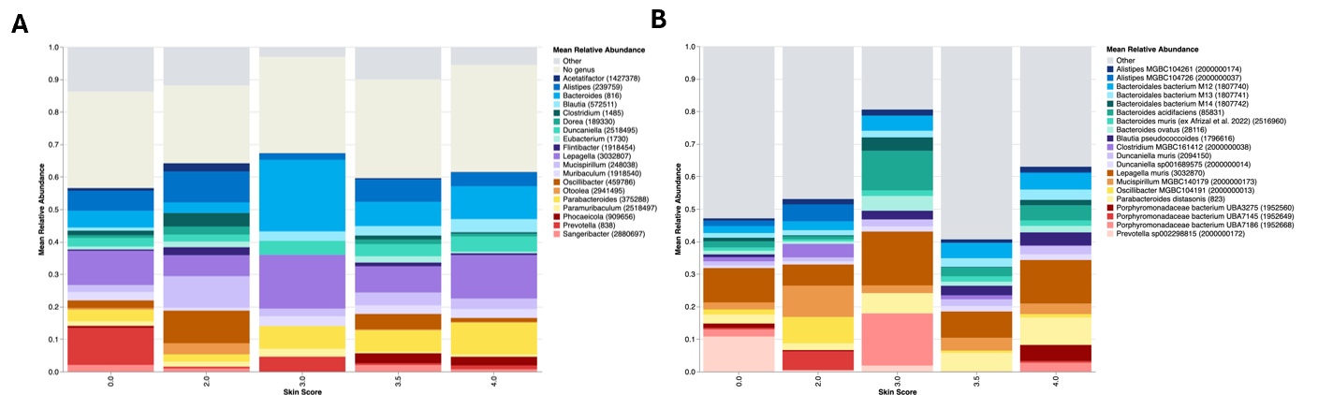
Figure S1. Relative abundance plots by skin score. A. Relative abundance plot of top 20 genera and B. top 10 species binned by skin score (n= 19 score 0, n = 1 score 2, n = 1 score 3.0, n = 2 score 3.5, and n = 5 score 4 mice).

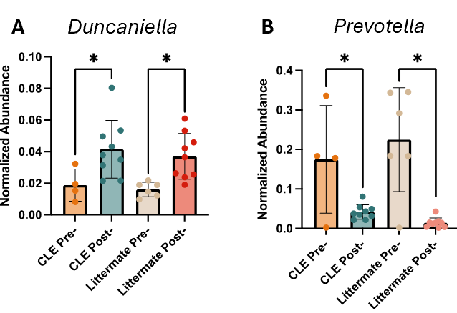
Figure S2. Relative abundance of some genera increased after irradiation, while others decreased. A. Abundance of genus Duncaniella pre- and post-irradiation by experimental group. B. Abundance of genus Prevotella pre- and post-irradiation by experimental group. * indicates p < 0.05.

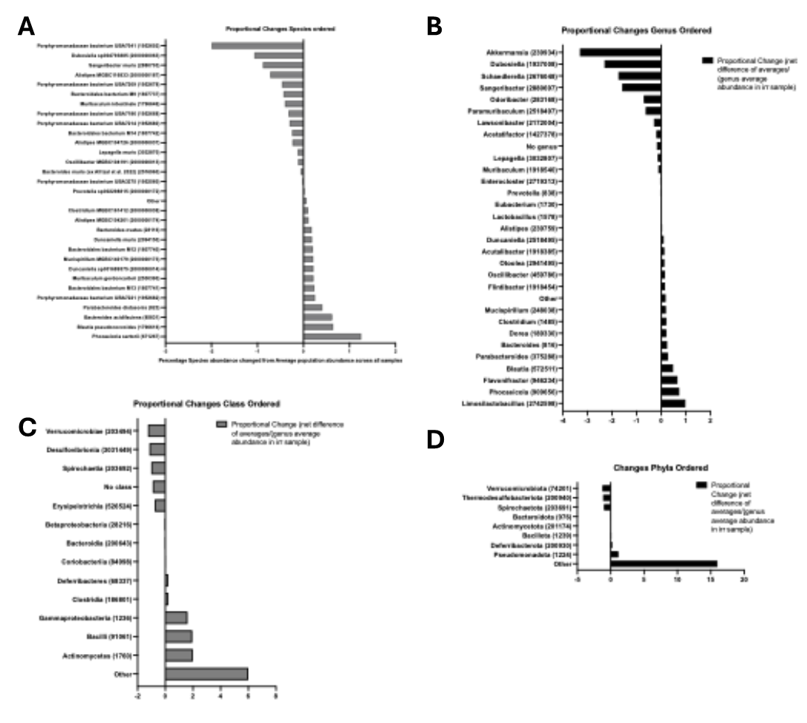
Figures S3. Proportional changes in abundance of specific taxa (A. species, B. genus, C. class, D. phyla) in irradiated CLE compared to irradiated littermate mice.

