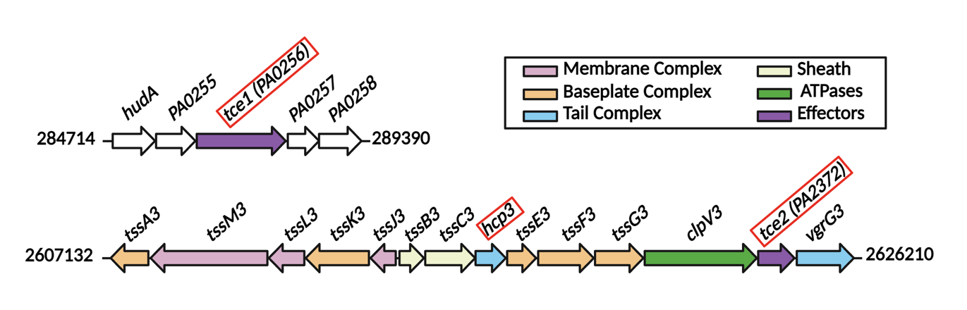

Supplementary Figure 1. The native arrangement of the H3-T6SS associated genes within the Pseudomonas aeruginosa genome. The arrows represent the genes encoding for the T6SS membrane complex (pink), baseplate complex (orange), tail complex (blue), contractile sheath (yellow), ATPases (green) and effectors (purple). The genes for our two newly identified Type VI Secretion System associated Cysteine protease Effector (Tce) proteins are labelled tce1 and tce2 alongside their gene locus IDs, PA0256 and PA2372 respectively.

Supplementary Figure 2. Cryo-EM processing pipeline of the Hcp3-Tce1 complex. The data processing produced an electron density map at an overall resolution of 3.8Å.

Supplementary Figure 3. Resolution analysis of the Hcp3-Tce1 complex. a Local resolution estimation of the Hcp3-Tce1 map obtained using ChimeraX. The colour code indicates that the local resolutions across the map range predominantly at values below 4Å. b Euler angle distributions for the overall cryo-EM map dataset. c Gold Standard Fourier Shell Correlation (GSFSC) for the final map, and map-vs-model validation using the full map and the experimental model. d The Hcp3-Tce1 model within the electron density map, Tce1is displayed alongside one of the Hcp3 monomers. A more detailed fitting of the secondary structures along with residue side chains from Tce1 α1 (residues 130-140) and Hcp3-C β3 (residues 57-62).

