Supplementary

Negr1 Deficiency Alters Glutamate Signalling and Kynurenine Pathway in a Mouse Model of Psychiatric Disorders

Carolin Kuuskmäe^{1*}, Kaie Mikheim¹, Narges Mohammadrahimi¹, Kalle Kilk², Maria Kaare¹, Mohan Jayaram¹, German Ilnitski¹, Este Leidmaa¹, Mari-Anne Philips¹, Eero Vasar¹
¹Department of Physiology, Institute of Biomedicine and Translational Medicine, University of Tartu, Tartu, Estonia.
²Department of Biochemistry, Institute of Biomedicine and Translational Medicine, University of Tartu, Tartu, Estonia.
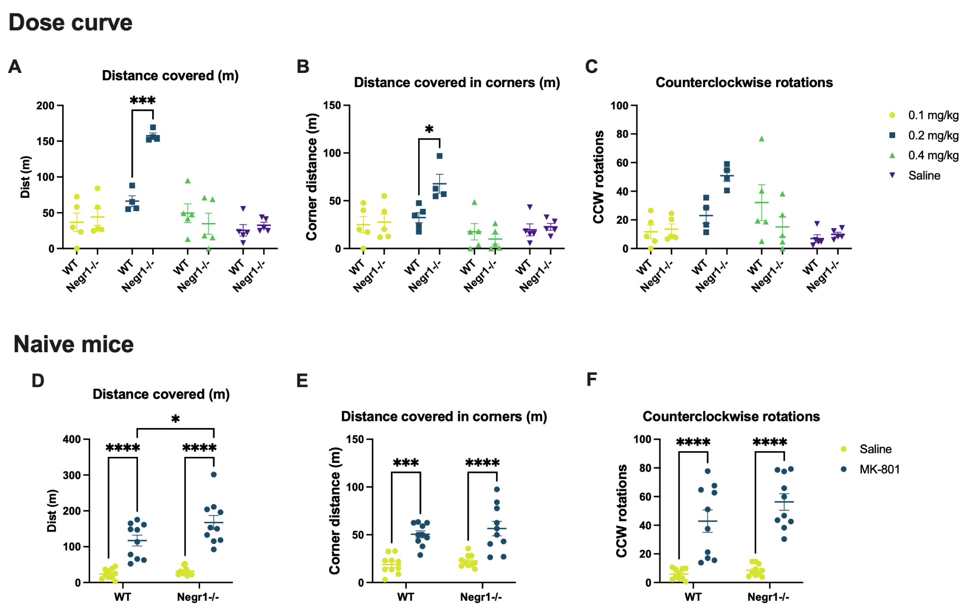
Fig. S1. Dose–response effects of MK-801 (0.1–0.4 mg/kg) in wild-type (WT) and Negr1-deficient male mice, and the effect of MK-801 (0.2 mg/kg) in an independent cohort of drug-naive male mice from both genotypes. The figure shows: (A) total distance covered, (B) distance covered in corners, and (C) number of counterclockwise rotations (n = 4–5 per group). Data are presented as mean ± SEM. Statistical analysis was performed using ordinary two-way ANOVA followed by Tukey's HSD test. *p < 0.05, ***p < 0.0001.
Based on these results, 0.2 mg/kg was selected as the most appropriate dose. (Note: Data for clockwise rotations were not usable; therefore, total rotation counts could not be calculated.)
(D) In a repeated MK-801 administration paradigm, Negr1-deficient male mice exhibited a blunted behavioural response over time. Because the mice in the repeated administration group had previously received a single MK-801 dose during the dose–response test (7 days prior), they were not fully drug-naive. We hypothesised that the heightened acute response to MK-801 is specific to drug-naive Negr1-deficient mice.
To test this, the acute administration experiment was repeated in an independent cohort of drug-naive male mice (n = 8–10, age 2.5 months). Supporting our hypothesis, Negr1-deficient mice in this new cohort again displayed an enhanced motor response, as indicated by increased total distance covered (p < 0.05).
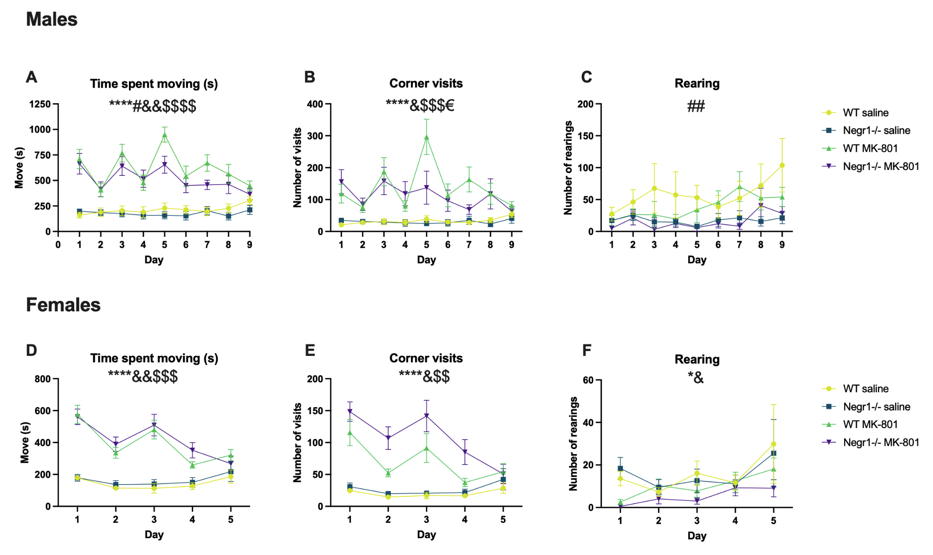
Fig. S2. Effects of MK-801 on the behaviour of wild-type (WT) and Negr1-deficient mice. The figure shows: (A, D) time spent moving, (B, E) number of corner visits, and (C, F) number of rearings in both male and female mice. Each dot represents the daily average per animal (males: n = 10; females: n = 8–16). Error bars indicate SEM. Main effects were analysed using three-way ANOVA followed by Tukey’s HSD test. Statistical significance is indicated by symbols above the graphs: * - treatment, # - genotype, & - day, $ - day and treatment interaction, € - genotype and treatment interaction. One symbol - p < 0.05, two symbols - p < 0.01, three symbols - p < 0.001, four symbols p < 0.0001.

Effect of repeated treatment with MK-801 (0.2 mg/kg) on locomotor activity in male wild-type and Negr1-deficient mice (Fig. S1)
Day 1: MK-801 significantly increased locomotor activity in both wild-type (WT) and Negr1^{-/-} mice versus saline controls. Time spent moving was elevated in both genotypes (WT: p < 0.0001; Negr1^{-/-}: p < 0.001), as were corner visits (WT: p < 0.05; Negr1^{-/-}: p < 0.01). No significant changes were observed in the number of rearings.
Day 2: A reduced locomotor response was observed following the second MK-801 administration. Nonetheless, time spent moving remained elevated in both WT and Negr1^{-/-} mice (p < 0.05). Increased corner visits were observed only in Negr1^{-/-} mice (p < 0.05). The number of rearings remained unchanged.
Day 3: MK-801 again induced strong stimulation, particularly in WT mice. Time spent moving increased significantly (WT: p < 0.00001; Negr1^{-/-}: p < 0.001), as did corner visits (WT: p < 0.01; Negr1^{-/-}: p < 0.05).
Day 4: Stimulatory effects began to decline. Time spent moving was modestly elevated (WT: p < 0.05; Negr1^{-/-}: p < 0.01), with increased corner observed only in Negr1^{-/-} mice (p < 0.05). Rearings continued to show no significant differences.
Day 5: WT mice exhibited peak locomotor activity (time spent moving: p < 1×10⁻⁷; corner visits: p < 0.001), while Negr1^{-/-} mice showed no further increase or even reductions in activity, resulting in significant genotype differences in both time spent moving and corner visits (p < 0.05). Rearings remained unaffected.
Day 6: MK-801 effects diminished further. WT mice showed reduced locomotor activity and fewer corner entries; Negr1^{-/-} mice exhibited an additional decline, furthering Day 2 levels.
Days 7–9: Continued MK-801 administration led to a progressive attenuation of locomotor effects. By Day 9, activity levels had significantly declined in both genotypes compared to Days 3 and 5. In contrast, rearing behaviour appeared to increase slightly but did not reach statistical significance.
Effect of Repeated Treatment with MK-801 (0.2 mg/kg) on Locomotor Activity in Female Wild-Type and Negr1-Deficient Mice (Fig. S1)
Day 1: Similar to males, MK-801 significantly increased locomotor activity in both wild-type (WT) and Negr1^{-/-} females (p < 0.001) along with elevated corner visits (WT: p < 0.05; Negr1^{-/-}: p < 0.01). In contrast to males, rearings also increased significantly (WT: p < 0.05; Negr1^{-/-}: p < 0.0001).
Day 2: A reduced response was observed, although time spent moving remained elevated in both genotypes (p < 0.05). Increased corner visits were noted only in Negr1^{-/-} mice (p < 0.01). Rearings showed no significant change.
Day 3: Unlike in males, MK-801 did not fully restore the initial stimulatory effect in females. Locomotion remained modestly elevated (WT and Negr1^{-/-}: p < 0.05), but only Negr1^{-/-} mice showed increased corner visits (p < 0.05). The number of rearings remained unchanged.
Days 4 and 5: Both locomotion and corner visits declined to near saline-treated control levels, with a marked reduction compared to Day 1. Rearings showed a slight, non-significant increase. The diminishing behavioural response indicated the development of tolerance to MK-801, leading to termination of treatment in females after Day 5.
Gender Differences in Response to MK-801
By Day 5, clear sex-dependent differences in behavioural responses emerged, prompting direct comparisons with Day 1.
Time spent in locomotion: On Day 5, wild-type males showed increased locomotion compared to Day 1 (p < 0.05), unlike Negr1^{-/-} males. WT males also displayed greater activity than Negr1^{-/-} males (p < 0.05). In contrast, both WT and Negr1^{-/-} females showed significant reduction in locomotion compared to Day 1 (WT: p < 0.01; Negr1^{-/-}: p < 0.0001), and their activity levels were significantly lower than those of their male counterparts (WT: p < 1×10⁻⁵; Negr1^{-/-}: p < 0.01).
Corner visits: WT males exhibited increased corner visits on Day 5 (p < 0.05), while Negr1^{-/-} males showed no change. Among females, Negr1^{-/-} mice showed a significant reduction in corner visits (p < 0.001), and WT females showed a milder reduction (p < 0.05). On Day 5, WT female mice responded less than WT males (p < 0.01), while no sex difference was observed in the Negr1^{-/-} group.
Rearings: Negr1^{-/-} males treated with saline had fewer rearings on Day 5 compared to Day 1 (p < 0.01); other male groups showed no significant changes. Among females, WT mice treated with MK-801 exhibited increased rearings (p < 0.01). No other significant effects on rearing behaviour were observed.
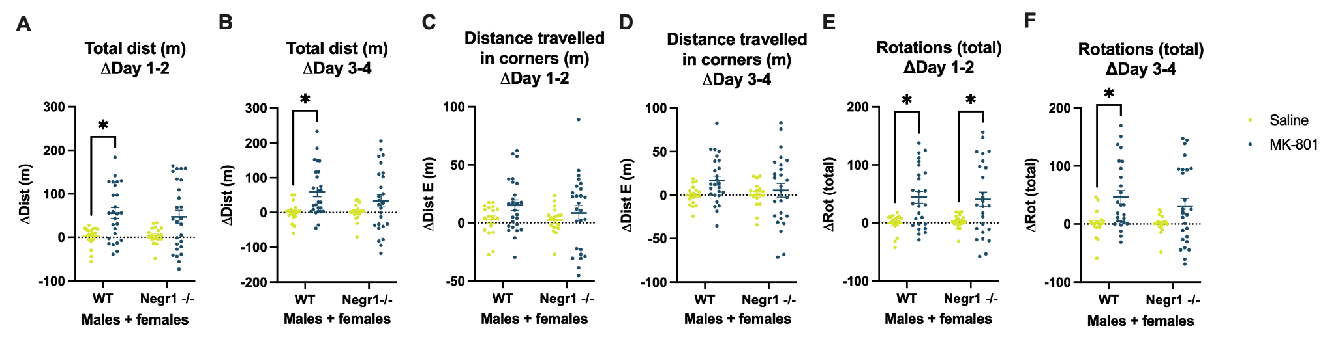
Fig. S3. Blunted progression of rapid behavioural tolerance during every-other-day MK-801 administration in Negr1-deficient mice. MK-801-induced locomotor activity and stereotypic behaviour progressively declined on alternating days during chronic treatment in both male and female mice. Delta values for Days 1–2 (A, C, E) and Days 3–4 (B, D, F) represent changes in activity between each pair of treatment days. Compared to wild-type (WT) controls, Negr1^{-/-} mice showed smaller reductions in behavioural responses, indicating a blunted progression of rapid behavioural tolerance. These genotype-dependent differences suggest altered NMDA receptor sensitivity in Negr1^{-/-} mice.

Table S1. Three-way ANOVA results for MK-801 effect on wild-type (WT) and Negr1-deficient mice’s behaviour.

Total distance covered (m) - males | ANOVA table | DF | F (DFn, DFd) | P value
 | Day | 8 | F (2.694, 96.99) = 5.835 | P=0.0016
 | Treatment | 1 | F (1, 36) = 138.4 | P<0.0001
 | Genotype | 1 | F (1, 36) = 5.023 | P=0.0313
 | Day x Treatment | 8 | F (8, 288) = 7.000 | P<0.0001
 | Day x Genotype | 8 | F (8, 288) = 1.530 | P=0.1462
 | Treatment  x Genotype | 1 | F (1, 36) = 2.234 | P=0.1437
 | Day x Treatment  x Genotype | 8 | F (8, 288) = 1.180 | P=0.3106
Total distance covered (m) - females | Day | 4 | F (1.796, 79.04) = 6.528 | P=0.0033
 | Treatment | 1 | F (1, 44) = 46.94 | P<0.0001
 | Genotype | 1 | F (1, 44) = 0.5909 | P=0.4462
 | Day x Treatment | 4 | F (4, 176) = 7.053 | P<0.0001
 | Day x Genotype | 4 | F (4, 176) = 0.2328 | P=0.9196
 | Treatment  x Genotype | 1 | F (1, 44) = 0.08840 | P=0.7676
 | Day x Treatment  x Genotype | 4 | F (4, 176) = 0.3140 | P=0.8684
Distance covered in corners (m) - males | Day | 8 | F (2.465, 88.73) = 1.069 | P=0.3579
 | Treatment | 1 | F (1, 36) = 106.9 | P<0.0001
 | Genotype | 1 | F (1, 36) = 4.963 | P=0.0322
 | Day x Treatment | 8 | F (8, 288) = 1.798 | P=0.0772
 | Day  x Genotype | 8 | F (8, 288) = 0.8253 | P=0.5808
 | Treatment  x Genotype | 1 | F (1, 36) = 4.178 | P=0.0483
 | Day x Treatment  x Genotype | 8 | F (8, 288) = 1.122 | P=0.3485
Distance covered in corners (m) - females | Day | 4 | F (2.452, 107.9) = 3.776 | P=0.0187
 | Treatment | 1 | F (1, 44) = 54.54 | P<0.0001
 | Genotype | 1 | F (1, 44) = 0.02133 | P=0.8845
 | Day x Treatment | 4 | F (4, 176) = 3.662 | P=0.0068
 | Day x Genotype | 4 | F (4, 176) = 0.6053 | P=0.6594
 | Treatment  x Genotype | 1 | F (1, 44) = 0.06169 | P=0.8050
 | Day x Treatment  x Genotype | 4 | F (4, 176) = 0.5096 | P=0.7288
Total rotations made - males | Day | 8 | F (3.102, 111.7) = 8.656 | P<0.0001
 | Treatment | 1 | F (1, 36) = 146.8 | P<0.0001
 | Genotype | 1 | F (1, 36) = 4.594 | P=0.0389
 | Day x Treatment | 8 | F (8, 288) = 9.988 | P<0.0001
 | Day x Genotype | 8 | F (8, 288) = 1.205 | P=0.2955
 | Treatment  x Genotype | 1 | F (1, 36) = 0.6735 | P=0.4172
 | Day x Treatment  x Genotype | 8 | F (8, 288) = 0.8226 | P=0.5832
Total rotations made - females | Day | 4 | F (1.989, 87.52) = 6.128 | P=0.0033
 | Treatment | 1 | F (1, 44) = 38.75 | P<0.0001
 | Genotype | 1 | F (1, 44) = 0.9073 | P=0.3460
 | Day x Treatment | 4 | F (4, 176) = 6.800 | P<0.0001
 | Day x Genotype | 4 | F (4, 176) = 0.1165 | P=0.9765
 | Treatment  x Genotype | 1 | F (1, 44) = 0.2287 | P=0.6349
 | Day x Treatment  x Genotype | 4 | F (4, 176) = 0.2100 | P=0.9326
Time spent moving - males | Day | 8 | F (2.197, 79.09) = 4.840 | P=0.0085
 | Treatment | 1 | F (1, 36) = 165.5 | P<0.0001
 | Genotype | 1 | F (1, 36) = 5.680 | P=0.0226
 | Day x Treatment | 8 | F (8, 288) = 6.114 | P<0.0001
 | Day x Genotype | 8 | F (8, 288) = 1.026 | P=0.4162
 | Treatment  x Genotype | 1 | F (1, 36) = 1.310 | P=0.2600
 | Day x Treatment  x Genotype | 8 | F (8, 288) = 0.7307 | P=0.6643
Time spent moving - females | Day | 4 | F (2.003, 88.15) = 5.935 | P=0.0038
 | Treatment | 1 | F (1, 44) = 43.82 | P<0.0001
 | Genotype | 1 | F (1, 44) = 0.2711 | P=0.6052
 | Day x Treatment | 4 | F (4, 176) = 5.963 | P=0.0002
 | Day x Genotype | 4 | F (4, 176) = 0.2666 | P=0.8991
 | Treatment  x Genotype | 1 | F (1, 44) = 0.001680 | P=0.9675
 | Day x Treatment  x Genotype | 4 | F (4, 176) = 0.2989 | P=0.8784
Corner visits - males | Day | 8 | F (3.360, 121.0) = 3.456 | P=0.0150
 | Treatment | 1 | F (1, 36) = 59.92 | P<0.0001
 | Genotype | 1 | F (1, 36) = 1.351 | P=0.2528
 | Day x Treatment | 8 | F (8, 288) = 4.028 | P=0.0001
 | Day x Genotype | 8 | F (8, 288) = 2.036 | P=0.0423
 | Treatment  x Genotype | 1 | F (1, 36) = 0.9624 | P=0.3331
 | Day x Treatment  x Genotype | 8 | F (8, 288) = 1.623 | P=0.1178
Corner visits - females | Day | 4 | F (1.840, 80.97) = 3.451 | P=0.0401
 | Treatment | 1 | F (1, 44) = 24.53 | P<0.0001
 | Genotype | 1 | F (1, 44) = 2.020 | P=0.1623
 | Day x Treatment | 4 | F (4, 176) = 4.059 | P=0.0036
 | Day x Genotype | 4 | F (4, 176) = 0.2445 | P=0.9127
 | Treatment  x Genotype | 1 | F (1, 44) = 0.8043 | P=0.3747
 | Day x Treatment  x Genotype | 4 | F (4, 176) = 0.4590 | P=0.7658
Rearing - males | Day | 8 | F (1.918, 69.05) = 1.786 | P=0.1767
 | Treatment | 1 | F (1, 36) = 1.234 | P=0.2739
 | Genotype | 1 | F (1, 36) = 10.92 | P=0.0022
 | Day x Treatment | 8 | F (8, 288) = 0.4400 | P=0.8964
 | Day x Genotype | 8 | F (8, 288) = 0.7590 | P=0.6393
 | Treatment  x Genotype | 1 | F (1, 36) = 0.7762 | P=0.3841
 | Day x Treatment  x Genotype | 8 | F (8, 288) = 0.7576 | P=0.6405
Rearing - females | Day | 4 | F (2.015, 88.68) = 4.329 | P=0.0158
 | Treatment | 1 | F (1, 44) = 4.616 | P=0.0372
 | Genotype | 1 | F (1, 44) = 0.4215 | P=0.5196
 | Day x Treatment | 4 | F (4, 176) = 1.966 | P=0.1017
 | Day x Genotype | 4 | F (4, 176) = 0.4282 | P=0.7882
 | Treatment  x Genotype | 1 | F (1, 44) = 0.3252 | P=0.5714
 | Day x Treatment  x Genotype | 4 | F (4, 176) = 0.1625 | P=0.9570

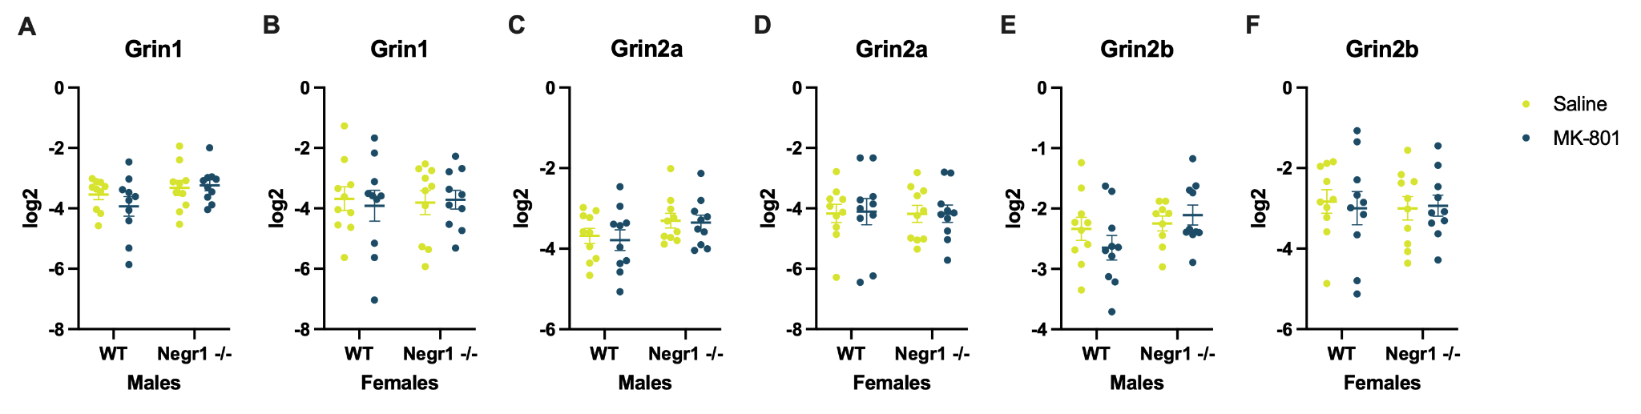
Fig. S4. NMDA receptor-related gene expression in the ventral striatum of mice. The figure shows gene expression of Grin1 (A, B), Grin2a (C, D), Grin2b (E, F) in both male and female mice. Each graph includes four groups: WT mice injected with physiological solution (saline), WT mice injected with MK-801, Negr1-deficient mice injected with physiological solution, Negr1-deficient mice injected with MK-801. No statistically significant differences were found between the four groups. However, a significant sex difference was found in the expression of Grin2a (F1,72 = 10.40, p < 0.01), Grin2b (F1,72 = 11.99, p < 0.001). Each group included n = 8–10 mice. Data are presented as mean ± SEM. Statistical analysis was conducted using ordinary two-way ANOVA followed by Tukey’s HSD test. WT – wild-type.

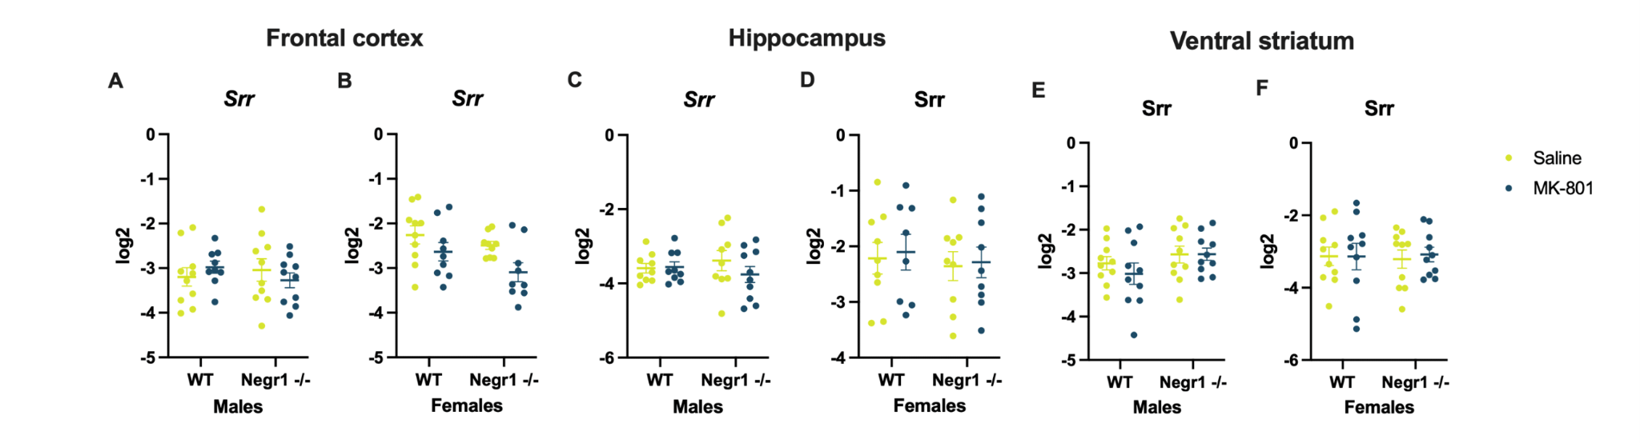
Fig. S5. Srr expression in different regions of the mouse brain. The figure shows Srr gene expression in both male and female mice across three brain regions: frontal cortex (A, B), hippocampus (C, D), and ventral striatum (E, F). Each graph includes four groups: wild-type (WT) mice injected with saline, WT mice injected with MK-801, Negr1-deficient mice injected with saline, and Negr1-deficient mice injected with MK-801. No statistically significant differences were observed between the four groups in any of the brain regions. Each group included n = 8–10 mice. Data are presented as mean ± SEM. Statistical analysis was performed using ordinary two-way ANOVA followed by Tukey’s HSD test.

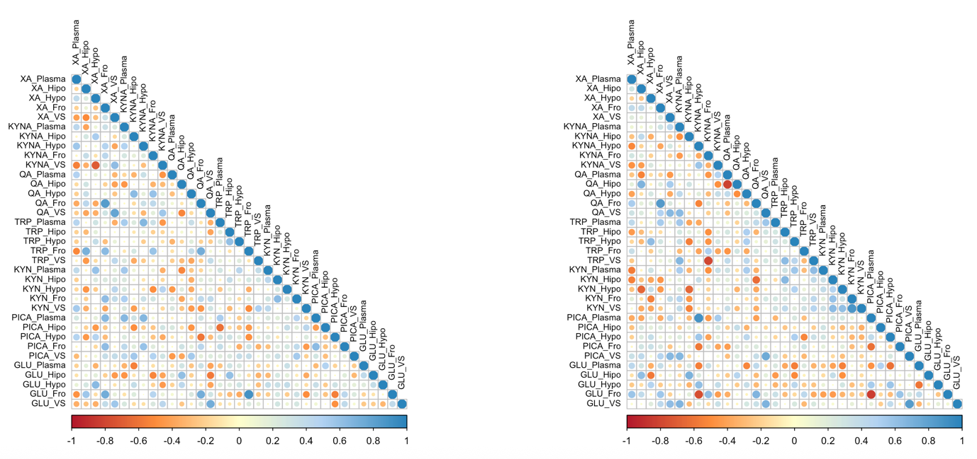
Fig. S6. Correlations among kynurenine pathway metabolites, tryptophan, and glutamate in male mice. Data are shown for five regions: frontal cortex (Fro), hippocampus (Hipo), hypothalamus (Hypo), ventral striatum (VS), and blood plasma (Plasma). Seven metabolites relevant to the study were included in the correlation analysis: KYNA – kynurenic acid, KYN – kynurenine, TRP – tryptophan, QA – quinolinic acid, PICA – picolinic acid, XA – xanthurenic acid, and GLU – glutamate. Correlation matrices are presented for wild-type mice (left) and Negr1^{-/-} mice (right).
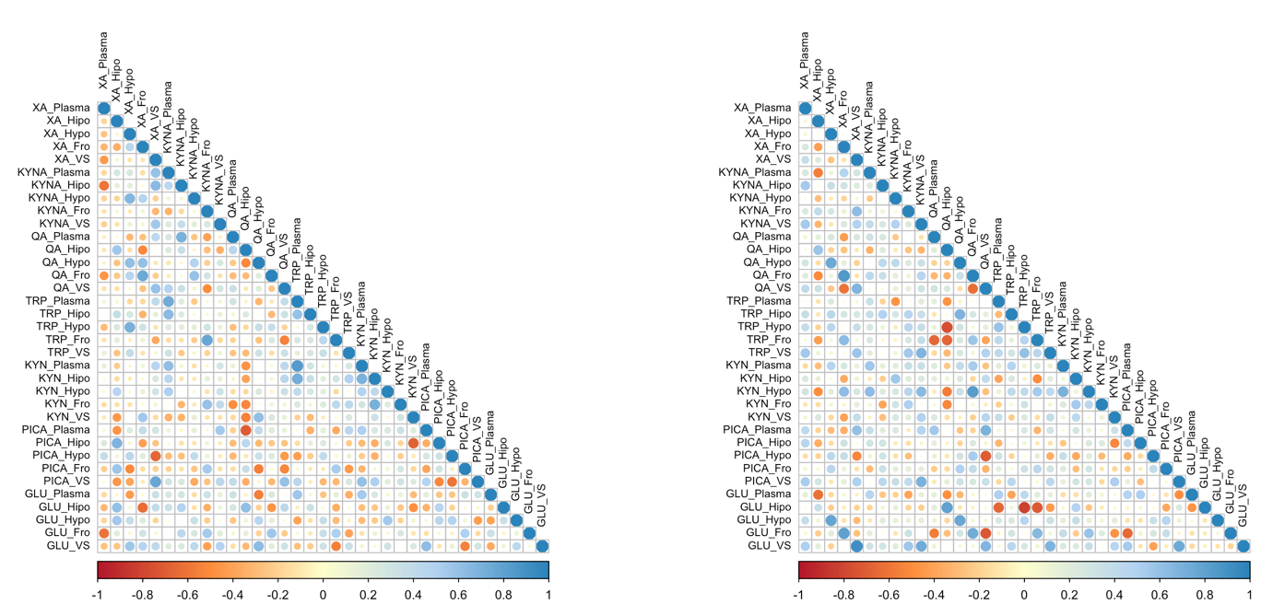
Fig. S7. Correlations among kynurenine pathway metabolites, tryptophan, and glutamate in female mice. Data are shown for five regions: frontal cortex (Fro), hippocampus (Hipo), hypothalamus (Hypo), ventral striatum (VS), and blood plasma (Plasma). Seven metabolites most relevant to the study were included in the correlation analysis: KYNA – kynurenic acid, KYN – kynurenine, TRP – tryptophan, QA – quinolinic acid, PICA – picolinic acid, XA – xanthurenic acid, and GLU – glutamate. Correlation matrices are presented for wild-type mice (left) and Negr1^{-/-} mice (right).

Table S2. Significant correlations among kynurenine pathway metabolites, tryptophan, and glutamate in male wild-type (WT) mice. Correlation data are presented for five regions: frontal cortex (Fro), hippocampus (Hipo), hypothalamus (Hypo), ventral striatum (VS), and blood plasma (Plasma). Seven metabolites most relevant to the study were included in the analysis: KYNA – kynurenic acid, KYN – kynurenine, TRP – tryptophan, QA – quinolinic acid, PICA – picolinic acid, XA – xanthurenic acid, and GLU – glutamate.

Variable_1 | Variable_2 | Correlation | P_Value
KYNA_Hypo | XA_Plasma | 0.566958 | 0.034496
KYNA_VS | XA_Plasma | -0.54248 | 0.045043
KYN_VS | XA_Plasma | 0.549295 | 0.041897
TRP_Fro | XA_Hipo | 0.701554 | 0.00517
GLU_Fro | XA_Hipo | 0.568364 | 0.033952
KYNA_VS | XA_Hypo | -0.70716 | 0.004677
KYN_Plasma | XA_Hypo | 0.597542 | 0.024031
GLU_Hypo | XA_Hypo | 0.641085 | 0.013485
QA_Fro | XA_Fro | 0.837661 | 0.000184
TRP_Fro | XA_Fro | 0.648712 | 0.012081
KYN_Fro | XA_Fro | 0.626565 | 0.016499
PICA_Plasma | XA_Fro | 0.658443 | 0.010455
Variable_1 | Variable_2 | Correlation | P_Value
PICA_Fro | XA_Fro | 0.623856 | 0.017114
GLU_Fro | XA_Fro | 0.723132 | 0.003472
KYNA_VS | XA_VS | 0.628992 | 0.015963
QA_VS | XA_VS | 0.779777 | 0.001006
GLU_VS | XA_VS | 0.566213 | 0.034787
KYN_Plasma | KYNA_Plasma | 0.550631 | 0.0413
PICA_Plasma | KYNA_Plasma | 0.655356 | 0.010951
QA_Hypo | KYNA_Hipo | 0.631185 | 0.015489
PICA_VS | KYNA_Hipo | 0.556023 | 0.038952
GLU_Plasma | KYNA_Hipo | -0.54344 | 0.044588
XA_Plasma | KYNA_Hypo | 0.566958 | 0.034496
TRP_Plasma | KYNA_Hypo | 0.664055 | 0.009598
PICA_Plasma | KYNA_Hypo | 0.663077 | 0.009743
PICA_Fro | KYNA_Hypo | 0.597594 | 0.024016
QA_Hypo | KYNA_Fro | 0.595404 | 0.024673
TRP_Fro | KYNA_Fro | 0.584178 | 0.028259
XA_Plasma | KYNA_VS | -0.54248 | 0.045043
XA_Hypo | KYNA_VS | -0.70716 | 0.004677
XA_VS | KYNA_VS | 0.628992 | 0.015963
QA_VS | KYNA_VS | 0.561633 | 0.036616
GLU_Hipo | QA_Hipo | 0.617638 | 0.018591
KYNA_Hipo | QA_Hypo | 0.631185 | 0.015489
KYNA_Fro | QA_Hypo | 0.595404 | 0.024673
PICA_VS | QA_Hypo | 0.542745 | 0.044917
XA_Fro | QA_Fro | 0.837661 | 0.000184
TRP_Fro | QA_Fro | 0.721911 | 0.003554
PICA_Hypo | QA_Fro | -0.59197 | 0.025733
GLU_Fro | QA_Fro | 0.726629 | 0.003244
XA_VS | QA_VS | 0.779777 | 0.001006
KYNA_VS | QA_VS | 0.561633 | 0.036616
GLU_Hipo | QA_VS | -0.5701 | 0.033288
GLU_VS | QA_VS | 0.724612 | 0.003374
KYNA_Hypo | TRP_Plasma | 0.664055 | 0.009598
PICA_Hipo | TRP_Plasma | -0.61682 | 0.018791
TRP_Hypo | TRP_Hipo | 0.602871 | 0.022485
GLU_Hipo | TRP_Hipo | 0.607966 | 0.021078
TRP_Hipo | TRP_Hypo | 0.602871 | 0.022485
XA_Hipo | TRP_Fro | 0.701554 | 0.00517
XA_Fro | TRP_Fro | 0.648712 | 0.012081
KYNA_Fro | TRP_Fro | 0.584178 | 0.028259
QA_Fro | TRP_Fro | 0.721911 | 0.003554
GLU_Fro | TRP_Fro | 0.893497 | 0.0000167
XA_Hypo | KYN_Plasma | 0.597542 | 0.024031
KYNA_Plasma | KYN_Plasma | 0.550631 | 0.0413
KYN_Fro | KYN_Hipo | 0.630437 | 0.01565
XA_Fro | KYN_Fro | 0.626565 | 0.016499
KYN_Hipo | KYN_Fro | 0.630437 | 0.01565
PICA_VS | KYN_Fro | 0.545619 | 0.043573
XA_Plasma | KYN_VS | 0.549295 | 0.041897
XA_Fro | PICA_Plasma | 0.658443 | 0.010455
KYNA_Plasma | PICA_Plasma | 0.655356 | 0.010951
KYNA_Hypo | PICA_Plasma | 0.663077 | 0.009743
PICA_Fro | PICA_Plasma | 0.637615 | 0.014163
TRP_Plasma | PICA_Hipo | -0.61682 | 0.018791
QA_Fro | PICA_Hypo | -0.59197 | 0.025733
GLU_Fro | PICA_Hypo | -0.55681 | 0.03862
XA_Fro | PICA_Fro | 0.623856 | 0.017114
KYNA_Hypo | PICA_Fro | 0.597594 | 0.024016
PICA_Plasma | PICA_Fro | 0.637615 | 0.014163
KYNA_Hipo | PICA_VS | 0.556023 | 0.038952
QA_Hypo | PICA_VS | 0.542745 | 0.044917
KYN_Fro | PICA_VS | 0.545619 | 0.043573
KYNA_Hipo | GLU_Plasma | -0.54344 | 0.044588
QA_Hipo | GLU_Hipo | 0.617638 | 0.018591
QA_VS | GLU_Hipo | -0.5701 | 0.033288
TRP_Hipo | GLU_Hipo | 0.607966 | 0.021078
XA_Hypo | GLU_Hypo | 0.641085 | 0.013485
XA_Hipo | GLU_Fro | 0.568364 | 0.033952
XA_Fro | GLU_Fro | 0.723132 | 0.003472
QA_Fro | GLU_Fro | 0.726629 | 0.003244
TRP_Fro | GLU_Fro | 0.893497 | 0.0000167
PICA_Hypo | GLU_Fro | -0.55681 | 0.03862
XA_VS | GLU_VS | 0.566213 | 0.034787
QA_VS | GLU_VS | 0.724612 | 0.003374

Table S3. Significant correlations among kynurenine pathway metabolites, tryptophan, and glutamate in male Negr1^{-/-} mice. Correlation data are presented for five regions: frontal cortex (Fro), hippocampus (Hipo), hypothalamus (Hypo), ventral striatum (VS), and blood plasma (Plasma). Seven metabolites most relevant to the study were included in the analysis: KYNA – kynurenic acid, KYN – kynurenine, TRP – tryptophan, QA – quinolinic acid, PICA – picolinic acid, XA – xanthurenic acid, and GLU – glutamate.

Variable_1 | Variable_2 | Correlation | P_Value
KYN_Plasma | XA_Plasma | -0.56162 | 0.045787
GLU_Fro | XA_Plasma | 0.573069 | 0.04063
QA_Hipo | XA_Hipo | 0.684953 | 0.009785
KYN_Hypo | XA_Hipo | -0.66581 | 0.012985
GLU_Hipo | XA_Hipo | 0.61687 | 0.024719
TRP_Hypo | XA_Hypo | 0.629257 | 0.021206
KYN_Fro | XA_Hypo | -0.55728 | 0.047863
GLU_Hipo | XA_Hypo | -0.57502 | 0.039795
QA_Fro | XA_Fro | 0.841471 | 0.000311
GLU_Fro | XA_Fro | 0.569263 | 0.042296
QA_VS | XA_VS | 0.651838 | 0.015775
PICA_VS | XA_VS | 0.657478 | 0.014599
GLU_VS | XA_VS | 0.624851 | 0.02241
QA_VS | KYNA_Plasma | 0.648407 | 0.016524
TRP_VS | KYNA_Plasma | 0.664163 | 0.013292
PICA_VS | KYNA_Plasma | 0.668468 | 0.012498
GLU_VS | KYNA_Plasma | 0.673262 | 0.011657
KYN_Hypo | KYNA_Hipo | -0.65432 | 0.015248
GLU_Hipo | KYNA_Hipo | 0.69217 | 0.008749
KYNA_VS | KYNA_Hypo | 0.570911 | 0.041569
PICA_Plasma | KYNA_Hypo | 0.896552 | 0.0000332
PICA_Hypo | KYNA_Hypo | 0.569698 | 0.042103
PICA_Fro | KYNA_Hypo | -0.58448 | 0.035922
GLU_Plasma | KYNA_Hypo | -0.5546 | 0.049176
GLU_Hypo | KYNA_Hypo | 0.612295 | 0.026119
GLU_Fro | KYNA_Hypo | -0.76984 | 0.002084
TRP_VS | KYNA_Fro | -0.79494 | 0.001163
GLU_Fro | KYNA_Fro | 0.624224 | 0.022585
KYNA_Hypo | KYNA_VS | 0.570911 | 0.041569
QA_Hipo | QA_Plasma | -0.81836 | 0.000627
XA_Hipo | QA_Hipo | 0.684953 | 0.009785
QA_Plasma | QA_Hipo | -0.81836 | 0.000627
XA_Fro | QA_Fro | 0.841471 | 0.000311
KYN_Hipo | QA_Fro | -0.63968 | 0.018551
Variable_1 | Variable_2 | Correlation | P_Value
GLU_Fro | QA_Fro | 0.679601 | 0.010611
XA_VS | QA_VS | 0.651838 | 0.015775
KYNA_Plasma | QA_VS | 0.648407 | 0.016524
TRP_Plasma | QA_VS | 0.56108 | 0.046043
PICA_VS | QA_VS | 0.743177 | 0.003602
GLU_VS | QA_VS | 0.684694 | 0.009824
QA_VS | TRP_Plasma | 0.56108 | 0.046043
TRP_VS | TRP_Hipo | 0.632578 | 0.020331
KYN_Hipo | TRP_Hipo | 0.65742 | 0.014611
XA_Hypo | TRP_Hypo | 0.629257 | 0.021206
KYN_Plasma | TRP_Hypo | 0.569741 | 0.042084
KYNA_Plasma | TRP_VS | 0.664163 | 0.013292
KYNA_Fro | TRP_VS | -0.79494 | 0.001163
TRP_Hipo | TRP_VS | 0.632578 | 0.020331
KYN_Plasma | TRP_VS | 0.621527 | 0.023351
XA_Plasma | KYN_Plasma | -0.56162 | 0.045787
TRP_Hypo | KYN_Plasma | 0.569741 | 0.042084
TRP_VS | KYN_Plasma | 0.621527 | 0.023351
QA_Fro | KYN_Hipo | -0.63968 | 0.018551
TRP_Hipo | KYN_Hipo | 0.65742 | 0.014611
KYN_Fro | KYN_Hipo | 0.594963 | 0.031957
KYN_VS | KYN_Hipo | 0.636276 | 0.019389
XA_Hipo | KYN_Hypo | -0.66581 | 0.012985
KYNA_Hipo | KYN_Hypo | -0.65432 | 0.015248
KYN_VS | KYN_Hypo | 0.61585 | 0.025026
XA_Hypo | KYN_Fro | -0.55728 | 0.047863
KYN_Hipo | KYN_Fro | 0.594963 | 0.031957
KYN_VS | KYN_Fro | 0.879846 | 0.0000731
KYN_Hipo | KYN_VS | 0.636276 | 0.019389
KYN_Hypo | KYN_VS | 0.61585 | 0.025026
KYN_Fro | KYN_VS | 0.879846 | 0.0000731
KYNA_Hypo | PICA_Plasma | 0.896552 | 0.0000332
PICA_Fro | PICA_Plasma | -0.61065 | 0.026638
GLU_Fro | PICA_Plasma | -0.83904 | 0.000336
KYNA_Hypo | PICA_Hypo | 0.569698 | 0.042103
GLU_Plasma | PICA_Hypo | -0.61978 | 0.023858
GLU_Hypo | PICA_Hypo | 0.573868 | 0.040287
KYNA_Hypo | PICA_Fro | -0.58448 | 0.035922
PICA_Plasma | PICA_Fro | -0.61065 | 0.026638
GLU_Fro | PICA_Fro | 0.580901 | 0.037353
XA_VS | PICA_VS | 0.657478 | 0.014599
KYNA_Plasma | PICA_VS | 0.668468 | 0.012498
QA_VS | PICA_VS | 0.743177 | 0.003602
GLU_VS | PICA_VS | 0.832352 | 0.000415
KYNA_Hypo | GLU_Plasma | -0.5546 | 0.049176
PICA_Hypo | GLU_Plasma | -0.61978 | 0.023858
GLU_Hypo | GLU_Plasma | -0.59831 | 0.030763
XA_Hipo | GLU_Hipo | 0.61687 | 0.024719
XA_Hypo | GLU_Hipo | -0.57502 | 0.039795
KYNA_Hipo | GLU_Hipo | 0.69217 | 0.008749
KYNA_Hypo | GLU_Hypo | 0.612295 | 0.026119
PICA_Hypo | GLU_Hypo | 0.573868 | 0.040287
GLU_Plasma | GLU_Hypo | -0.59831 | 0.030763
XA_Plasma | GLU_Fro | 0.573069 | 0.04063
XA_Fro | GLU_Fro | 0.569263 | 0.042296
KYNA_Hypo | GLU_Fro | -0.76984 | 0.002084
KYNA_Fro | GLU_Fro | 0.624224 | 0.022585
QA_Fro | GLU_Fro | 0.679601 | 0.010611
PICA_Plasma | GLU_Fro | -0.83904 | 0.000336
PICA_Fro | GLU_Fro | 0.580901 | 0.037353
XA_VS | GLU_VS | 0.624851 | 0.02241
KYNA_Plasma | GLU_VS | 0.673262 | 0.011657
QA_VS | GLU_VS | 0.684694 | 0.009824
PICA_VS | GLU_VS | 0.832352 | 0.000415

Table S4. Significant correlations among kynurenine pathway metabolites, tryptophan, and glutamate in female wild-type (WT) mice. Correlation data are presented for five regions: frontal cortex (Fro), hippocampus (Hipo), hypothalamus (Hypo), ventral striatum (VS), and blood plasma (Plasma). Seven metabolites most relevant to the study were included in the analysis: KYNA – kynurenic acid, KYN – kynurenine, TRP – tryptophan, QA – quinolinic acid, PICA – picolinic acid, XA – xanthurenic acid, and GLU – glutamate.

Variable_1 | Variable_2 | Correlation | P_Value
KYNA_Hipo | XA_Plasma | -0.59545 | 0.02466
GLU_Fro | XA_Plasma | -0.60368 | 0.022258
QA_Hipo | XA_Hipo | 0.560746 | 0.036979
PICA_Hipo | XA_Hipo | 0.684782 | 0.006891
PICA_Fro | XA_Hipo | 0.577817 | 0.030456
GLU_Hipo | XA_Hipo | 0.602913 | 0.022473
GLU_Hypo | XA_Hipo | 0.550251 | 0.041469
KYNA_Hypo | XA_Hypo | 0.667121 | 0.009153
QA_Hypo | XA_Hypo | 0.613144 | 0.019717
TRP_Hypo | XA_Hypo | 0.705713 | 0.004801
GLU_VS | XA_Hypo | 0.560349 | 0.037142
QA_Hypo | XA_Fro | 0.603659 | 0.022263
QA_Fro | XA_Fro | 0.75355 | 0.001857
KYN_VS | XA_Fro | 0.550192 | 0.041495
GLU_Hipo | XA_Fro | -0.63794 | 0.014098
KYNA_Plasma | XA_VS | 0.59494 | 0.024814
Variable_1 | Variable_2 | Correlation | P_Value
KYNA_Hipo | XA_VS | 0.648778 | 0.012069
KYNA_VS | XA_VS | 0.558918 | 0.037734
QA_VS | XA_VS | 0.593734 | 0.025184
PICA_Hypo | XA_VS | -0.66143 | 0.009992
PICA_VS | XA_VS | 0.769368 | 0.001295
XA_VS | KYNA_Plasma | 0.59494 | 0.024814
TRP_Plasma | KYNA_Plasma | 0.73373 | 0.002817
TRP_Hipo | KYNA_Plasma | 0.645006 | 0.012748
KYN_Plasma | KYNA_Plasma | 0.61528 | 0.019176
XA_Plasma | KYNA_Hipo | -0.59545 | 0.02466
XA_VS | KYNA_Hipo | 0.648778 | 0.012069
QA_Plasma | KYNA_Hipo | 0.705316 | 0.004835
XA_Hypo | KYNA_Hypo | 0.667121 | 0.009153
QA_Fro | KYNA_Hypo | 0.593978 | 0.025109
TRP_Fro | KYNA_Fro | 0.768838 | 0.001311
KYN_Fro | KYNA_Fro | 0.597736 | 0.023973
PICA_Fro | KYNA_Fro | 0.546214 | 0.043298
GLU_Fro | KYNA_Fro | 0.546362 | 0.04323
XA_VS | KYNA_VS | 0.558918 | 0.037734
PICA_Plasma | KYNA_VS | 0.549107 | 0.041981
KYNA_Hipo | QA_Plasma | 0.705316 | 0.004835
XA_Hipo | QA_Hipo | 0.560746 | 0.036979
KYN_VS | QA_Hipo | -0.54628 | 0.04327
PICA_Plasma | QA_Hipo | -0.70344 | 0.005
GLU_Hipo | QA_Hipo | 0.613847 | 0.019538
XA_Hypo | QA_Hypo | 0.613144 | 0.019717
XA_Fro | QA_Hypo | 0.603659 | 0.022263
KYN_VS | QA_Hypo | 0.612797 | 0.019806
PICA_Fro | QA_Hypo | -0.55046 | 0.041377
GLU_Plasma | QA_Hypo | -0.55051 | 0.041353
GLU_VS | QA_Hypo | 0.638113 | 0.014064
XA_Fro | QA_Fro | 0.75355 | 0.001857
KYNA_Hypo | QA_Fro | 0.593978 | 0.025109
GLU_Fro | QA_Fro | 0.567442 | 0.034308
XA_VS | QA_VS | 0.593734 | 0.025184
TRP_Fro | QA_VS | -0.54414 | 0.044262
PICA_VS | QA_VS | 0.590942 | 0.026055
KYNA_Plasma | TRP_Plasma | 0.73373 | 0.002817
TRP_Hipo | TRP_Plasma | 0.597261 | 0.024115
KYN_Plasma | TRP_Plasma | 0.841933 | 0.000159
KYN_Hipo | TRP_Plasma | 0.729975 | 0.003037
GLU_Plasma | TRP_Plasma | 0.561707 | 0.036586
KYNA_Plasma | TRP_Hipo | 0.645006 | 0.012748
TRP_Plasma | TRP_Hipo | 0.597261 | 0.024115
XA_Hypo | TRP_Hypo | 0.705713 | 0.004801
KYNA_Fro | TRP_Fro | 0.768838 | 0.001311
QA_VS | TRP_Fro | -0.54414 | 0.044262
GLU_VS | TRP_Fro | -0.55212 | 0.040641
KYNA_Plasma | KYN_Plasma | 0.61528 | 0.019176
TRP_Plasma | KYN_Plasma | 0.841933 | 0.000159
KYN_Hipo | KYN_Plasma | 0.699695 | 0.005342
PICA_VS | KYN_Plasma | 0.600443 | 0.02318
GLU_Plasma | KYN_Plasma | 0.540479 | 0.045998
TRP_Plasma | KYN_Hipo | 0.729975 | 0.003037
KYN_Plasma | KYN_Hipo | 0.699695 | 0.005342
KYN_Fro | KYN_Hipo | 0.708435 | 0.00457
GLU_Hypo | KYN_Hypo | 0.552705 | 0.040385
KYNA_Fro | KYN_Fro | 0.597736 | 0.023973
KYN_Hipo | KYN_Fro | 0.708435 | 0.00457
XA_Fro | KYN_VS | 0.550192 | 0.041495
QA_Hipo | KYN_VS | -0.54628 | 0.04327
QA_Hypo | KYN_VS | 0.612797 | 0.019806
PICA_Hipo | KYN_VS | -0.67797 | 0.007705
KYNA_VS | PICA_Plasma | 0.549107 | 0.041981
QA_Hipo | PICA_Plasma | -0.70344 | 0.005
GLU_VS | PICA_Plasma | 0.62387 | 0.017111
XA_Hipo | PICA_Hipo | 0.684782 | 0.006891
KYN_VS | PICA_Hipo | -0.67797 | 0.007705
XA_VS | PICA_Hypo | -0.66143 | 0.009992
PICA_VS | PICA_Hypo | -0.59397 | 0.025112
XA_Hipo | PICA_Fro | 0.577817 | 0.030456
KYNA_Fro | PICA_Fro | 0.546214 | 0.043298
QA_Hypo | PICA_Fro | -0.55046 | 0.041377
GLU_VS | PICA_Fro | -0.54758 | 0.042674
XA_VS | PICA_VS | 0.769368 | 0.001295
QA_VS | PICA_VS | 0.590942 | 0.026055
KYN_Plasma | PICA_VS | 0.600443 | 0.02318
PICA_Hypo | PICA_VS | -0.59397 | 0.025112
QA_Hypo | GLU_Plasma | -0.55051 | 0.041353
TRP_Plasma | GLU_Plasma | 0.561707 | 0.036586
KYN_Plasma | GLU_Plasma | 0.540479 | 0.045998
XA_Hipo | GLU_Hipo | 0.602913 | 0.022473
XA_Fro | GLU_Hipo | -0.63794 | 0.014098
QA_Hipo | GLU_Hipo | 0.613847 | 0.019538
XA_Hipo | GLU_Hypo | 0.550251 | 0.041469
KYN_Hypo | GLU_Hypo | 0.552705 | 0.040385
XA_Plasma | GLU_Fro | -0.60368 | 0.022258
KYNA_Fro | GLU_Fro | 0.546362 | 0.04323
QA_Fro | GLU_Fro | 0.567442 | 0.034308
XA_Hypo | GLU_VS | 0.560349 | 0.037142
QA_Hypo | GLU_VS | 0.638113 | 0.014064
TRP_Fro | GLU_VS | -0.55212 | 0.040641
PICA_Plasma | GLU_VS | 0.62387 | 0.017111
PICA_Fro | GLU_VS | -0.54758 | 0.042674

Table S5. Significant correlations among kynurenine pathway metabolites, tryptophan, and glutamate in female Negr1^{-/-} mice. Correlation data are shown for five regions: frontal cortex (Fro), hippocampus (Hipo), hypothalamus (Hypo), ventral striatum (VS), and blood plasma (Plasma). Seven metabolites most relevant to the study were included in the analysis: KYNA – kynurenic acid, KYN – kynurenine, TRP – tryptophan, QA – quinolinic acid, PICA – picolinic acid, XA – xanthurenic acid, and GLU – glutamate.

Variable_1 | Variable_2 | Correlation | P_Value
QA_Hipo | XA_Hipo | 0.579929 | 0.009174
KYN_Hypo | XA_Hipo | -0.49451 | 0.02013
QA_Hypo | XA_Hypo | 0.756827 | 0.005696
GLU_Hypo | XA_Hypo | 0.77497 | 0.024292
QA_Fro | XA_Fro | 0.856982 | 0.000512
TRP_Fro | XA_Fro | 0.63519 | 0.031335
KYN_Hypo | XA_Fro | 0.626909 | 0.010607
GLU_Fro | XA_Fro | 0.806961 | 0.000749
QA_VS | XA_VS | 0.672041 | 0.001717
PICA_Plasma | XA_VS | 0.604395 | 0.037378
GLU_VS | XA_VS | 0.910404 | 0.0000136
KYN_Fro | KYNA_Fro | 0.501611 | 0.034509
PICA_VS | KYNA_VS | 0.693428 | 0.005634
GLU_VS | KYNA_VS | 0.732663 | 0.003201
TRP_Fro | QA_Plasma | -0.65507 | 0.013999
GLU_Fro | QA_Plasma | -0.56387 | 0.036334
XA_Hipo | QA_Hipo | 0.579929 | 0.009174
TRP_Fro | QA_Hipo | -0.66883 | 0.049417
KYN_Hypo | QA_Hipo | -0.56593 | 0.020493
GLU_Hipo | QA_Hipo | 0.795657 | 0.003979
XA_Hypo | QA_Hypo | 0.756827 | 0.005696
TRP_Hipo | QA_Hypo | 0.687532 | 0.020054
GLU_Hypo | QA_Hypo | 0.766569 | 0.001972
XA_Fro | QA_Fro | 0.856982 | 0.000512
QA_VS | QA_Fro | -0.62561 | 0.027548
TRP_Fro | QA_Fro | 0.57507 | 0.027681
KYN_Plasma | QA_Fro | 0.532915 | 0.033257
KYN_Hypo | QA_Fro | 0.820008 | 0.001337
PICA_Hypo | QA_Fro | 0.53558 | 0.036978
GLU_Fro | QA_Fro | 0.733996 | 0.004563
XA_VS | QA_VS | 0.672041 | 0.001717
QA_Fro | QA_VS | -0.62561 | 0.027548
KYN_VS | QA_VS | 0.449625 | 0.024711
PICA_Plasma | QA_VS | 0.690854 | 0.012858
Variable_1 | Variable_2 | Correlation | P_Value
PICA_Hypo | QA_VS | -0.7071 | 0.013851
GLU_Fro | QA_VS | -0.72552 | 0.024138
GLU_VS | QA_VS | 0.67066 | 0.005671
TRP_Hypo | TRP_Plasma | 0.583556 | 0.014665
TRP_VS | TRP_Plasma | 0.410861 | 0.04227
GLU_Plasma | TRP_Plasma | 0.50403 | 0.037605
GLU_Hipo | TRP_Plasma | -0.66892 | 0.019567
QA_Hypo | TRP_Hipo | 0.687532 | 0.020054
TRP_Plasma | TRP_Hypo | 0.583556 | 0.014665
TRP_VS | TRP_Hypo | 0.609352 | 0.020493
GLU_Hipo | TRP_Hypo | -0.81569 | 0.001116
XA_Fro | TRP_Fro | 0.63519 | 0.031335
QA_Plasma | TRP_Fro | -0.65507 | 0.013999
QA_Hipo | TRP_Fro | -0.66883 | 0.049417
QA_Fro | TRP_Fro | 0.57507 | 0.027681
GLU_Hipo | TRP_Fro | -0.71606 | 0.005788
GLU_Fro | TRP_Fro | 0.653524 | 0.013788
TRP_Plasma | TRP_VS | 0.410861 | 0.04227
TRP_Hypo | TRP_VS | 0.609352 | 0.020493
QA_Fro | KYN_Plasma | 0.532915 | 0.033257
KYN_Hypo | KYN_Plasma | 0.700072 | 0.006241
XA_Hipo | KYN_Hypo | -0.49451 | 0.02013
XA_Fro | KYN_Hypo | 0.626909 | 0.010607
QA_Hipo | KYN_Hypo | -0.56593 | 0.020493
QA_Fro | KYN_Hypo | 0.820008 | 0.001337
KYN_Plasma | KYN_Hypo | 0.700072 | 0.006241
GLU_Fro | KYN_Hypo | 0.581728 | 0.047674
KYNA_Fro | KYN_Fro | 0.501611 | 0.034509
QA_VS | KYN_VS | 0.449625 | 0.024711
XA_VS | PICA_Plasma | 0.604395 | 0.037378
QA_VS | PICA_Plasma | 0.690854 | 0.012858
GLU_Fro | PICA_Plasma | -0.64214 | 0.024359
QA_Fro | PICA_Hypo | 0.53558 | 0.036978
QA_VS | PICA_Hypo | -0.7071 | 0.013851
KYNA_VS | PICA_VS | 0.693428 | 0.005634
GLU_VS | PICA_VS | 0.755694 | 0.002685
TRP_Plasma | GLU_Plasma | 0.50403 | 0.037605
QA_Hipo | GLU_Hipo | 0.795657 | 0.003979
TRP_Plasma | GLU_Hipo | -0.66892 | 0.019567
TRP_Hypo | GLU_Hipo | -0.81569 | 0.001116
TRP_Fro | GLU_Hipo | -0.71606 | 0.005788
XA_Hypo | GLU_Hypo | 0.77497 | 0.024292
QA_Hypo | GLU_Hypo | 0.766569 | 0.001972
XA_Fro | GLU_Fro | 0.806961 | 0.000749
QA_Plasma | GLU_Fro | -0.56387 | 0.036334
QA_Fro | GLU_Fro | 0.733996 | 0.004563
QA_VS | GLU_Fro | -0.72552 | 0.024138
TRP_Fro | GLU_Fro | 0.653524 | 0.013788
KYN_Hypo | GLU_Fro | 0.581728 | 0.047674
PICA_Plasma | GLU_Fro | -0.64214 | 0.024359
XA_VS | GLU_VS | 0.910404 | 0.0000136
KYNA_VS | GLU_VS | 0.732663 | 0.003201
QA_VS | GLU_VS | 0.67066 | 0.005671
PICA_VS | GLU_VS | 0.755694 | 0.002685

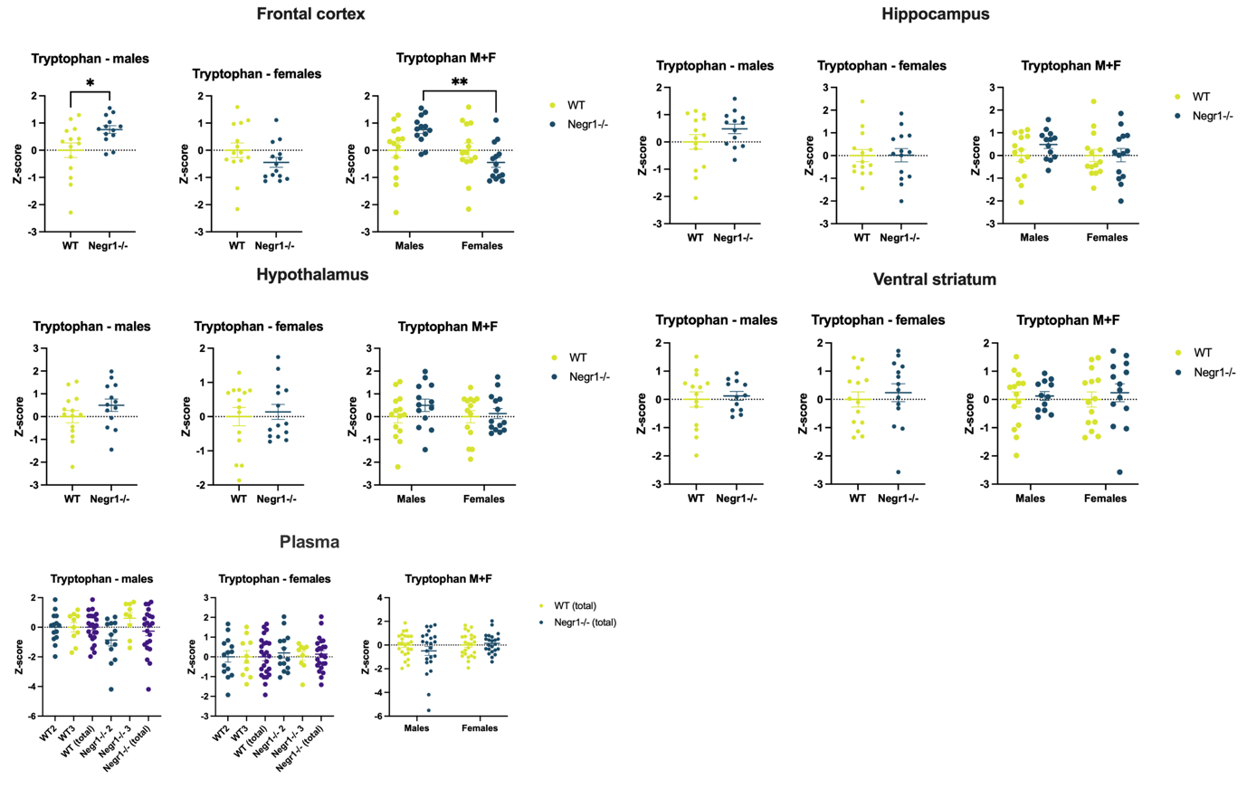
Fig. S8. Differences in the tryptophan levels between wild-type (WT) and Negr1-deficient mice across four brain regions (frontal cortex, hippocampus, hypothalamus, ventral striatum) and blood plasma. Significant differences in tryptophan levels were seen in the frontal cortex between male WT and Negr1^{-/-} mice, and between male and female Negr1^{-/-} mice. Notably, tryptophan levels were elevated in Negr1^{-/-} males while showing a slight decrease in Negr1^{-/-} females. Data are presented as mean ± SEM, n = 12 - 14. Plasma data were obtained from cohort 2 (5-month-olds) and cohort 3 (7-month-olds); brain data are from cohort 2 only. Statistical analysis: unpaired t-test for separate male and female genotype comparisons, one-way ANOVA for plasma, and ordinary two-way ANOVA with Tukey’s HSD test for combined-sex analysis. * – p < 0.05, ** – p < 0.001.

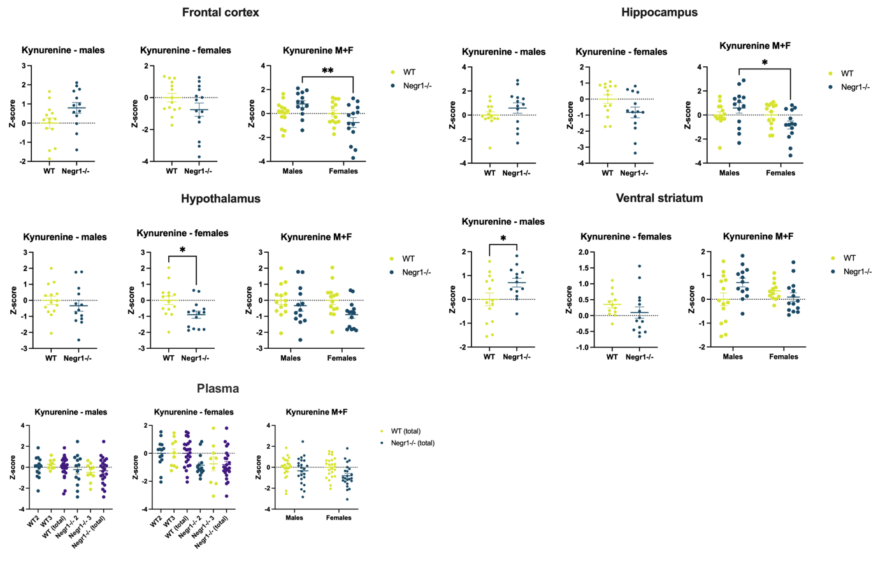
Fig. S9. Differences in the kynurenine levels between wild-type (WT) and Negr1-deficient mice across four brain regions (frontal cortex, hippocampus, hypothalamus, ventral striatum) and blood plasma. Most notable differences were between male and female Negr1-deficient mice in the frontal cortex and hippocampus, where kynurenine levels were increased in males and decreased in females. Although the difference was not statistically significant compared to WT mice, it was significant between genders. In the hypothalamus, there was a significant decrease in the kynurenine levels of female Negr1^{-/-} mice and in the ventral striatum, there was a significant increase in male Negr1^{-/-} mice. Data represents mean ± SEM, n = 12 - 14. Plasma data is from cohort 2 (5-month-olds) and cohort 3 (7-month-olds); brain data is only from cohort 2. Unpaired t-test was used for the separate male and female genotype analysis (one-way ANOVA for plasma) and ordinary two-way ANOVA (Tukey HSD test) when both sexes were together. * - p-value < 0.05, ** - p-value < 0.001.
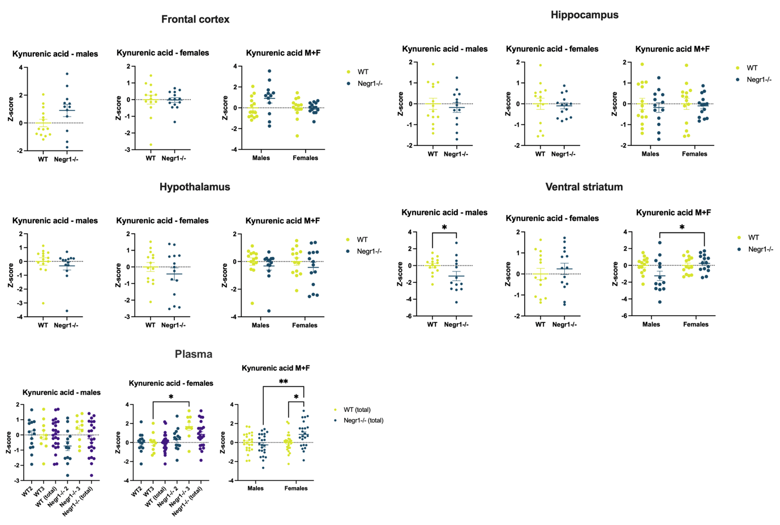
Fig. S10. Differences in the kynurenic acid levels between wild-type (WT) and Negr1-deficient mice across four brain regions (frontal cortex, hippocampus, hypothalamus, ventral striatum) and blood plasma. In the ventral striatum, the kynurenic acid levels were significantly decreased in male Negr1^{-/-} mice, while no difference was observed between WT and mutant female mice. In contrast, plasma kynurenic acid levels were significantly increased in female Negr1^{-/-} mice, with no corresponding difference between WT and Negr1^{-/-} males. Data represents mean ± SEM, n = 12 - 14. Plasma data is from cohort 2 (5-month-olds) and cohort 3 (7-month-olds); brain data is only from cohort 2. Unpaired t-test was used for the separate male and female genotype analysis (one-way ANOVA for plasma) and ordinary two-way ANOVA (Tukey HSD test) when both sexes were together. * - p-value < 0.05, ** - p-value < 0.001.
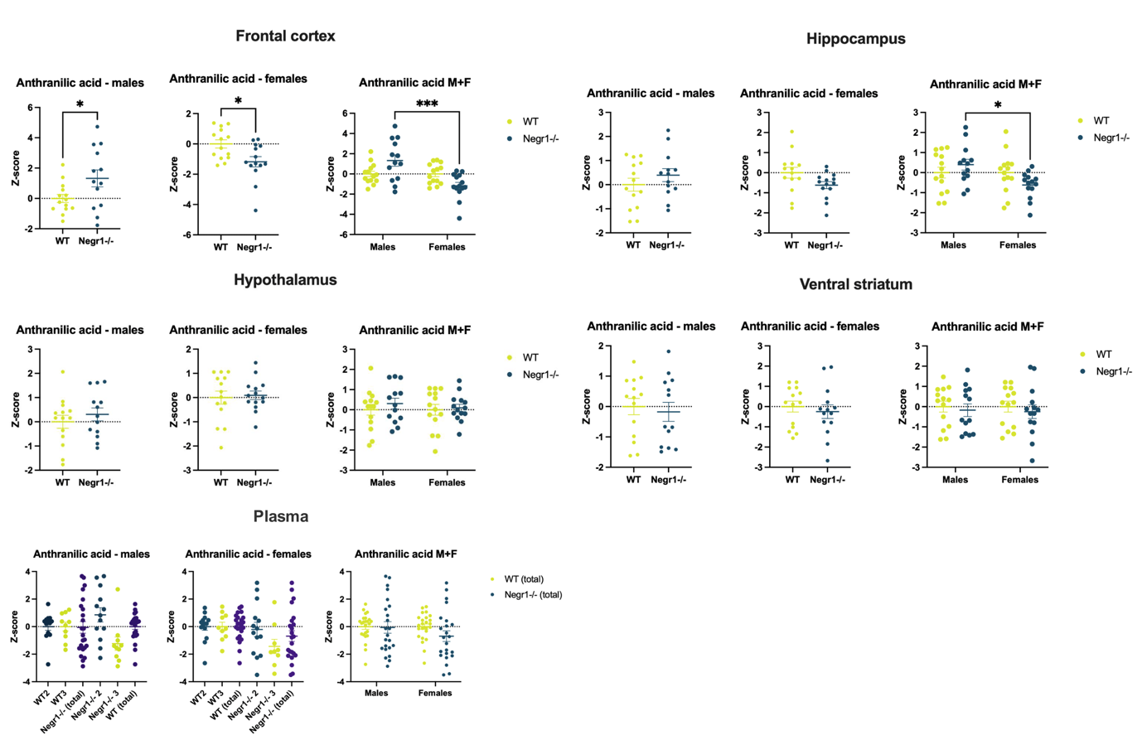
Fig. S11. Differences in the anthranilic acid levels between wild-type (WT) and Negr1-deficient mice across four brain regions (frontal cortex, hippocampus, hypothalamus, ventral striatum) and blood plasma. In the frontal cortex, the anthranilic acid levels had significantly increased in male and decreased in female Negr1-deficient mice. The same trend could be seen in the hippocampus. Data represents mean ± SEM, n = 12 - 14. Plasma data is from cohort 2 (5-month-olds) and cohort 3 (7-month-olds); brain data is only from cohort 2. Unpaired t-test was used for the separate male and female genotype analysis (one-way ANOVA for plasma) and ordinary two-way ANOVA (Tukey HSD test) when both sexes were together. * - p-value < 0.05, *** - p-value < 0.0001.
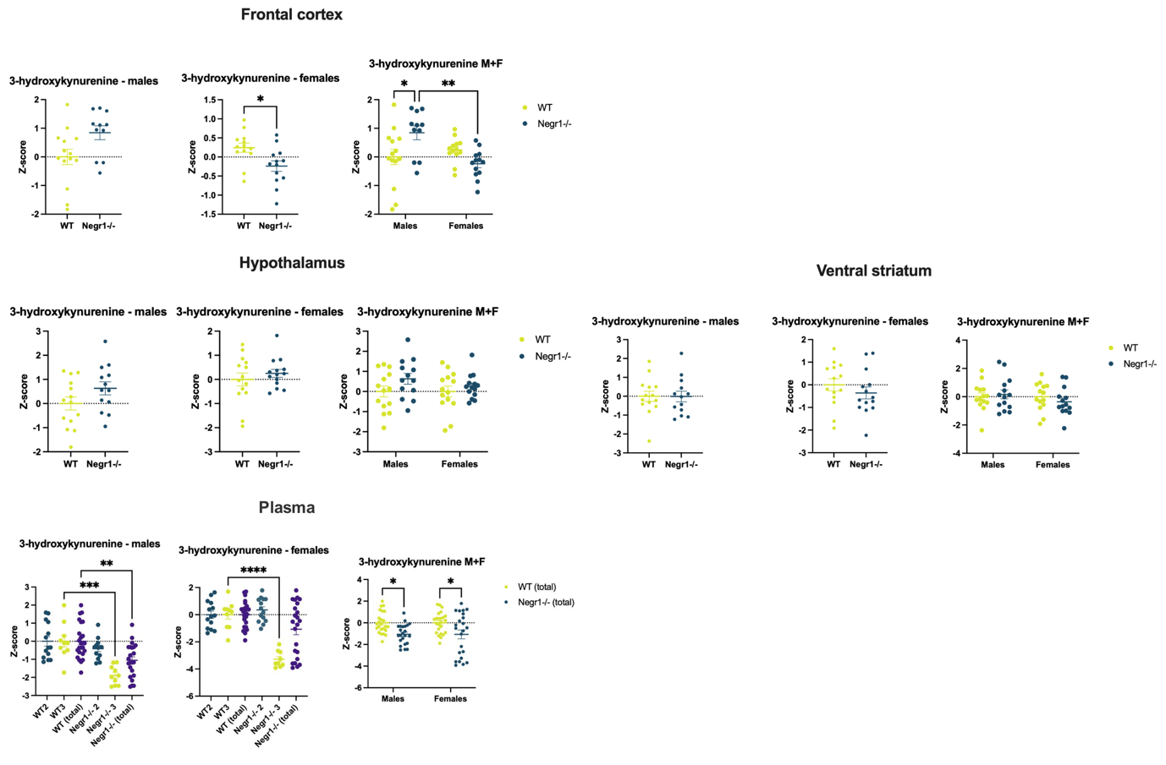
Fig. S12. Differences in the 3-hydroxykynurenine levels between wild-type (WT) and Negr1-deficient mice across three brain regions (frontal cortex, hypothalamus, ventral striatum) and blood plasma. 3-hydroxykynurenine displayed interesting results in the frontal cortex - metabolite levels were increased in male Negr1^{-/-} mice but decreased in female Negr1^{-/-} mice compared to the WT mice. In the blood plasma, 3-hydroxykynurenine levels were significantly diminished in both male and female Negr1^{-/-} mice from cohort 3. In the hippocampus, the results were not up to standard and were excluded. Data represents mean ± SEM, n = 12 - 14. Plasma data is from cohort 2 (5-month-olds) and cohort 3 (7-month-olds); brain data is only from cohort 2. Unpaired t-test was used for the separate male and female genotype analysis (one-way ANOVA for plasma) and ordinary two-way ANOVA (Tukey HSD test) when both sexes were together. * - p-value < 0.05, ** - p-value < 0.001, *** - p-value < 0.0001, **** - p-value < 0.00001.
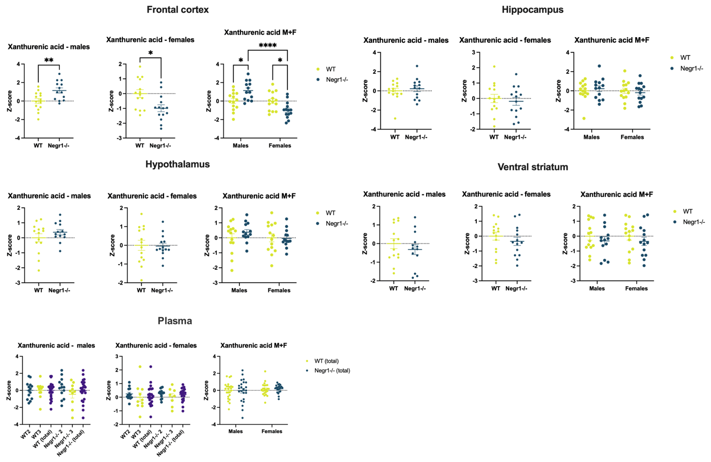
Fig. S13. Differences in the xanthurenic acid levels between wild-type (WT) and Negr1-deficient mice across four brain regions (frontal cortex, hippocampus, hypothalamus, ventral striatum) and blood plasma. Like with most other kynurenine pathway metabolites, xanthurenic acid levels were increased in male Negr1^{-/-} mice, while the opposite was true for female mice in the frontal cortex. Data represents mean ± SEM, n = 12 - 14. Plasma data is from cohort 2 (5-month-olds) and cohort 3 (7-month-olds); brain data is only from cohort 2. Unpaired t-test was used for the separate male and female genotype analysis (one-way ANOVA for plasma) and ordinary two-way ANOVA (Tukey HSD test) when both sexes were together. * - p-value < 0.05, ** - p-value < 0.001. **** - p-value < 0.00001.

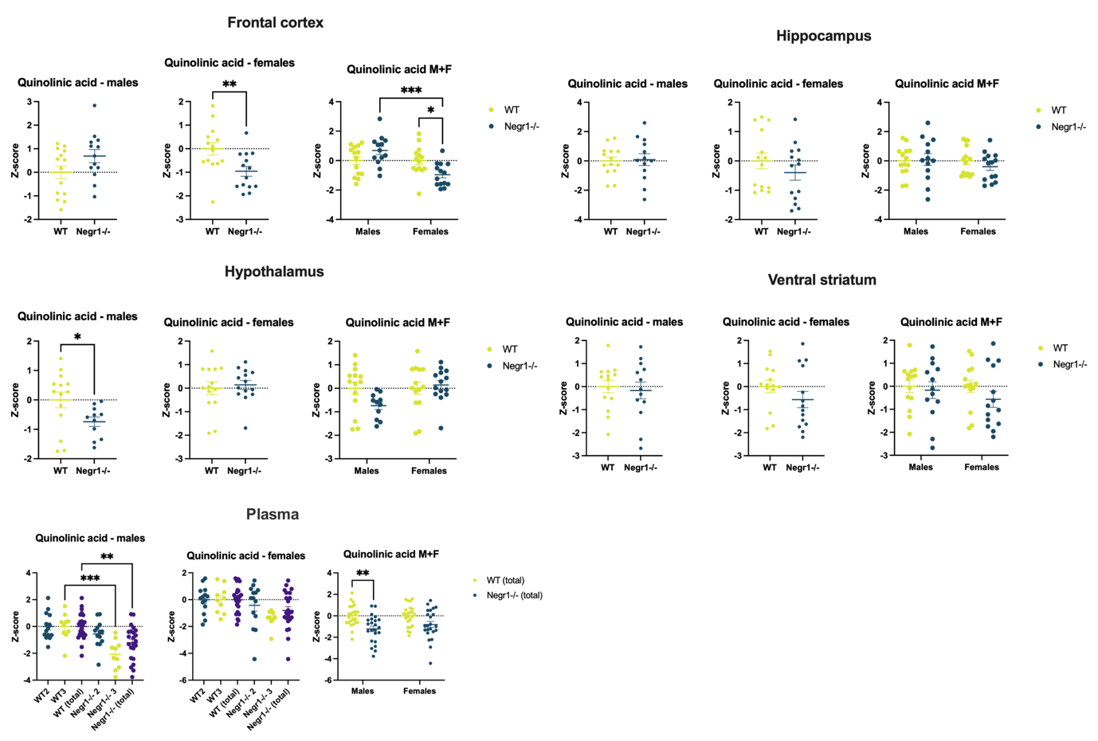
Fig. S14. Differences in the quinolinic acid levels between wild-type (WT) and Negr1-deficient mice across four brain regions (frontal cortex, hippocampus, hypothalamus, ventral striatum) and blood plasma. In the frontal cortex, the quinolinic acid levels were significantly decreased in female Negr1^{-/-} mice but slightly increased in males. However, in the hypothalamus and blood plasma, quinolinic acid levels were strongly decreased in male Negr1^{-/-} mice, while there was no change in the female metabolite levels. Data represents mean ± SEM, n = 12 - 14. Plasma data is from cohort 2 (5-month-olds) and cohort 3 (7-month-olds); brain data is only from cohort 2. Unpaired t-test was used for the separate male and female genotype analysis (one-way ANOVA for plasma) and ordinary two-way ANOVA (Tukey HSD test) when both sexes were together. * - p-value < 0.05, ** - p-value < 0.001. *** - p-value < 0.0001.

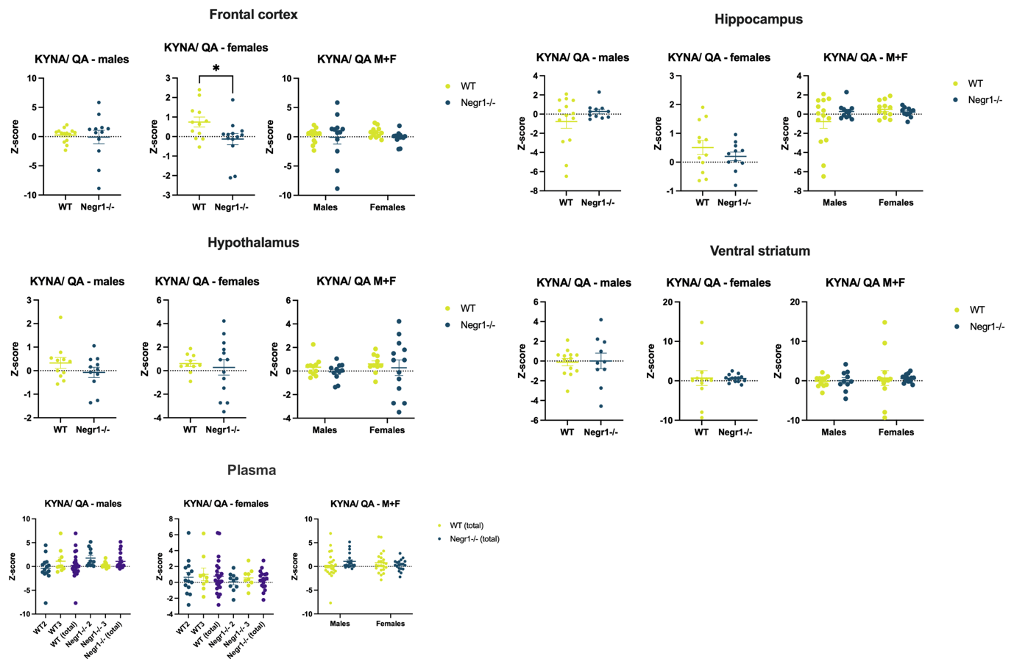
Fig. S15. Differences in the kynurenic acid/ quinolinic acid ratio between wild-type (WT) and Negr1-deficient mice across four brain regions (frontal cortex, hippocampus, hypothalamus, ventral striatum) and blood plasma. The only significant difference in the kynurenic acid/ quinolinic acid ratio was in the frontal cortex of female mice - there was a significant decrease in the ratio of Negr1^{-/-} mice compared to WT mice. Data represents mean ± SEM, n = 12 - 14. Plasma data is from cohort 2 (5-month-olds) and cohort 3 (7-month-olds); brain data is only from cohort 2. Unpaired t-test was used for the separate male and female genotype analysis (one-way ANOVA for plasma) and ordinary two-way ANOVA (Tukey HSD test) when both sexes were together. * - p-value < 0.05.

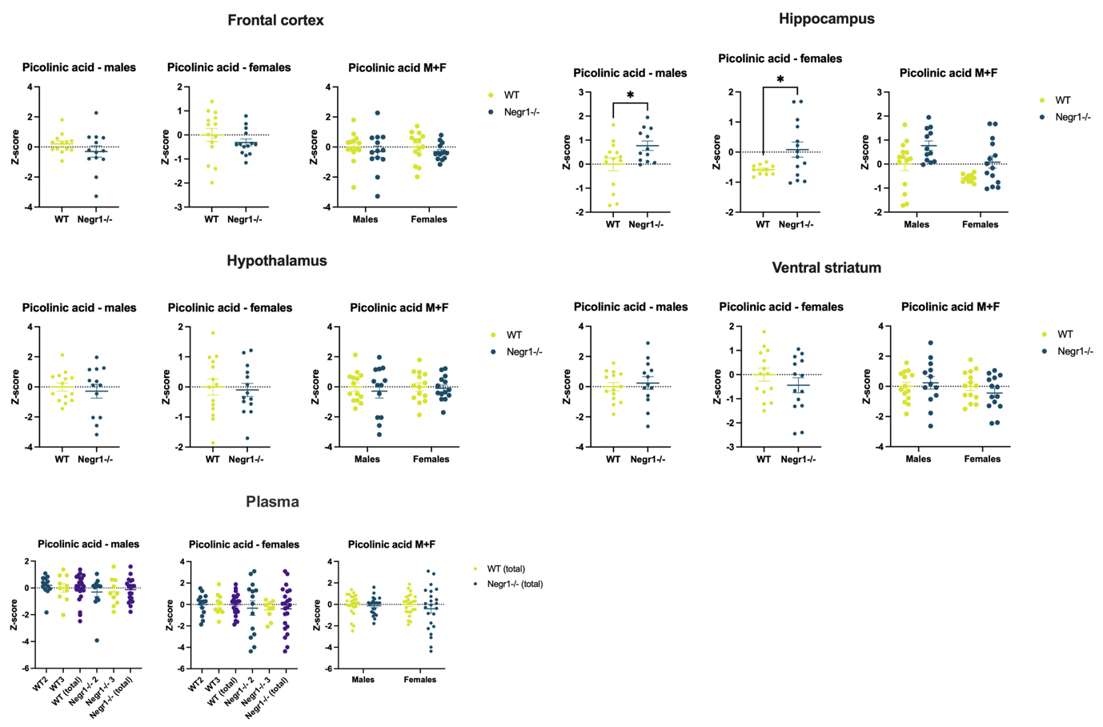
Fig. S16. Differences in the picolinic acid levels between wild-type (WT) and Negr1-deficient mice across four brain regions (frontal cortex, hippocampus, hypothalamus, ventral striatum) and blood plasma. Picolinic acid levels were increased in both male and female Negr1^{-/-} mice in the hippocampus compared to their WT counterparts. Data represents mean ± SEM, n = 12 - 14. Plasma data is from cohort 2 (5-month-olds) and cohort 3 (7-month-olds); brain data is only from cohort 2. Unpaired t-test was used for the separate male and female genotype analysis (one-way ANOVA for plasma) and ordinary two-way ANOVA (Tukey HSD test) when both sexes were together. * - p-value < 0.05.
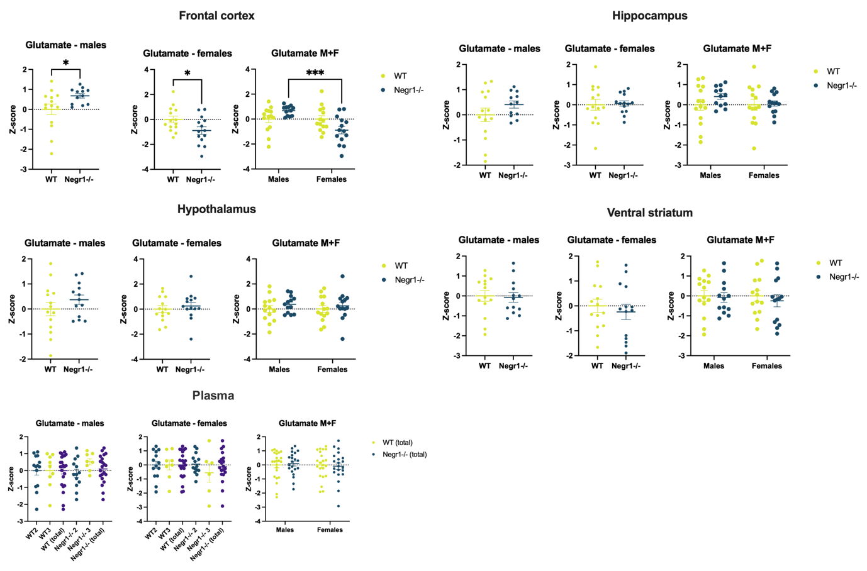
Fig. S17. Differences in the glutamate levels between wild-type (WT) and Negr1-deficient mice across four brain regions (frontal cortex, hippocampus, hypothalamus, ventral striatum) and blood plasma. Similarly to most kynurenine pathway metabolites, glutamate levels were significantly increased in male Negr1^{-/-} mice and decreased in females in the frontal cortex. Data represents mean ± SEM, n = 12 - 14. Plasma data is from cohort 2 (5-month-olds) and cohort 3 (7-month-olds); brain data is only from cohort 2. Unpaired t-test was used for the separate male and female genotype analysis (one-way ANOVA for plasma) and ordinary two-way ANOVA (Tukey HSD test) when both sexes were together. * - p-value < 0.05, *** - p-value < 0.0001.

Table S6. Primer sequences.

Hprt_mm_F | GCAGTACAGCCCCAAAATGG
Hprt_mm_R | AACAAAGTCTGGCCTGTATCCAA
Grin1_mm_F | GTTCTTCCGCTCCGGCTTTG
Grin1_mm_R | CGAACCCATGTCTTATCCAGGTC
Grin2a_mm_F | TGCAAGTTACACAGCCAACCTG
Grin2a_mm_R | ATCGGAAAGGCGGAGAATAGTC
Grin2b_mm_F | TCATTTCTGCTCAGACTCTCACC
Grin2b_mm_R | TCAATGGATGGGCCAAACTGG
Srr_mm_F | AGAAGCCCAAAGCCGTAGTTAC
Srr_mm_R | TGCAGTTGGGAGCTGTTTGG

