Supplementary Information
SI Table 1. SNP samples per population and subpopulation, with reference to population size in source populations. Coordinate resolution has been reduced due to the USFWS listing status of P. imberbis.

SI Table 2. Pairwise gene flow values and corresponding pairwise geographic distances. Minimum and maximum values in bold.
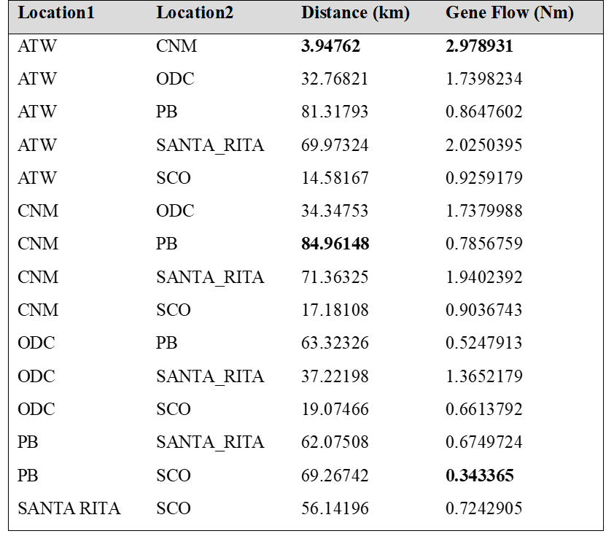

SI Table 3. Mean F_{ST}, mean Gene Flow, and mean geographical distance by population.
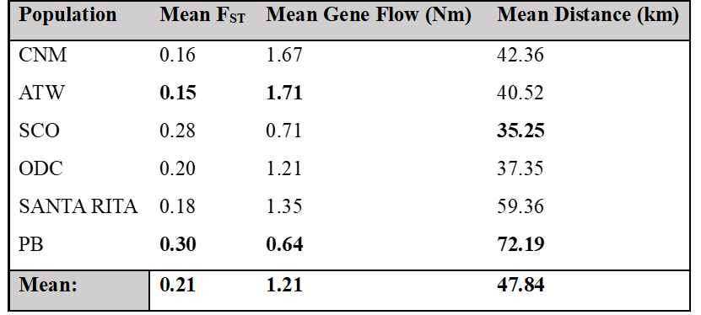

SI Table 4. Within population genetic diversity estimates by population and subpopulation (Inbreeding coefficient (Fis), number of private alleles, nucleotide diversity, expected heterozygosity). Estimated population size and number of individuals samples (n) included.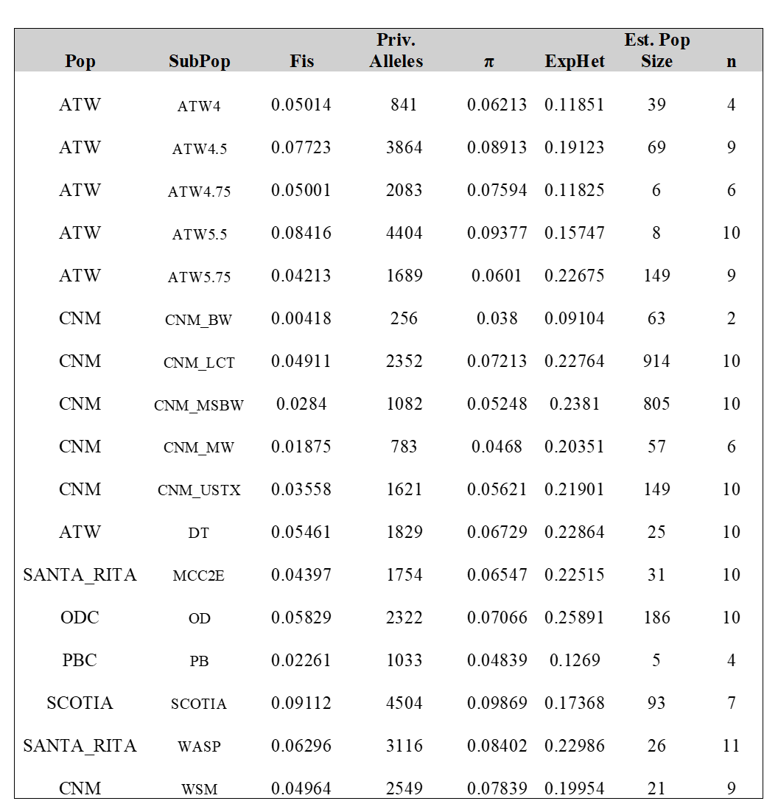

SI Table 5. Pairwise measures of gene flow (Nm) between groups. Higher values indicate higher levels of gene flow. Values are low overall. Minimum and maximum values in bold.
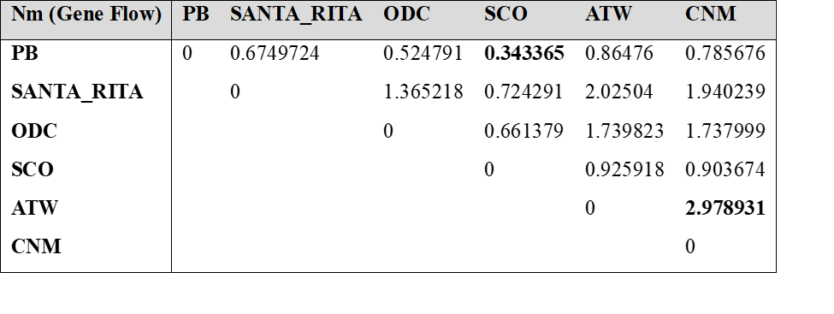

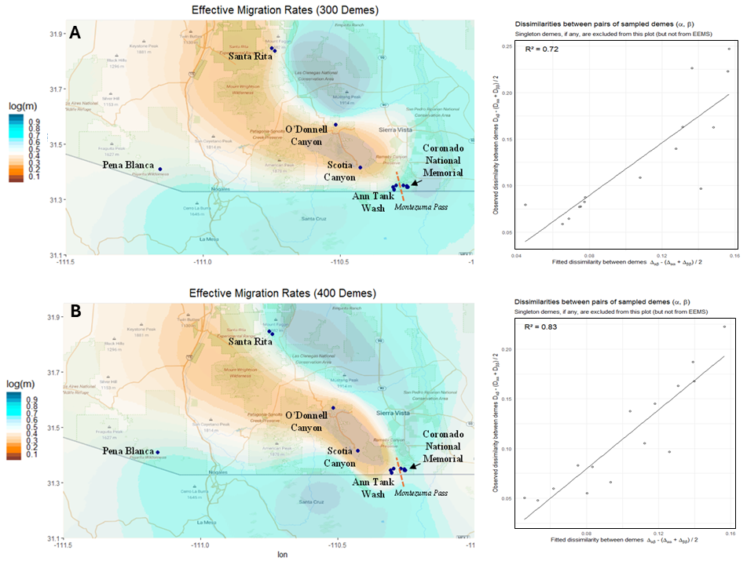

SI Figure 1. Effective migration surfaces for 300 demes (A) and 400 demes (B) with fit between observed and modelled dissimilarity between demes. Each deme represents a subset of the population assumed to be well-mixed genetically, meaning individuals within a deme are more genetically similar to each other compared to those in different demes. Here, log(m) denotes the effective migration rate on the log10 scale, relative to the overall migration rate across the habitat. (Thus log(m) = 1 corresponds to effective migration that is 10-fold faster than the average.) Differences between 300 demes (top) and 400 demes (bottom) demonstrates a shift in migration resistance on Montezuma pass between CNM and ATW populations.

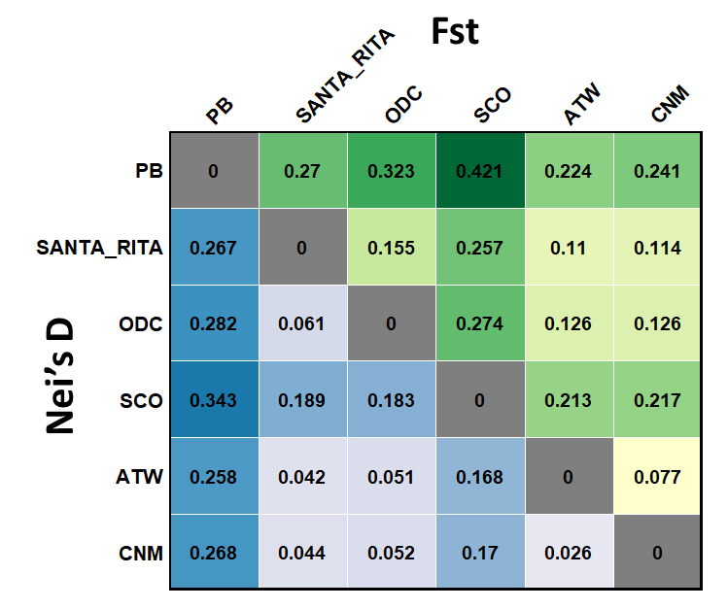

SI Figure 2: A matrix comparing two metrics of genetic dissimilarirt, Fst and Nei’s Diversity metric, between the 6 populations of interest. Scotia Canyon demonstrates the highest average dissimilarity from all other populations.

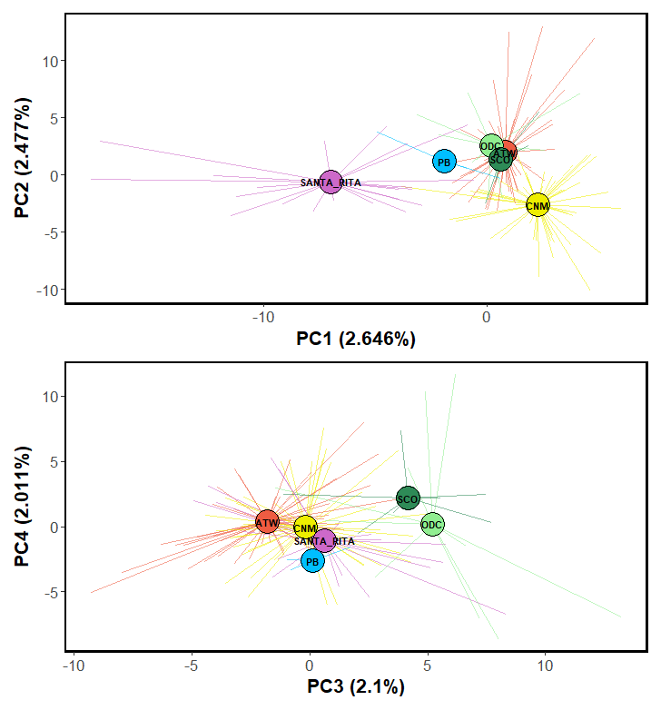
SI Figure 3: Principle Components Analysis (PCA) “Fireworks” plot of the 6 studied populations for the purpose of visualizing population structure along first 4 PCA axes.

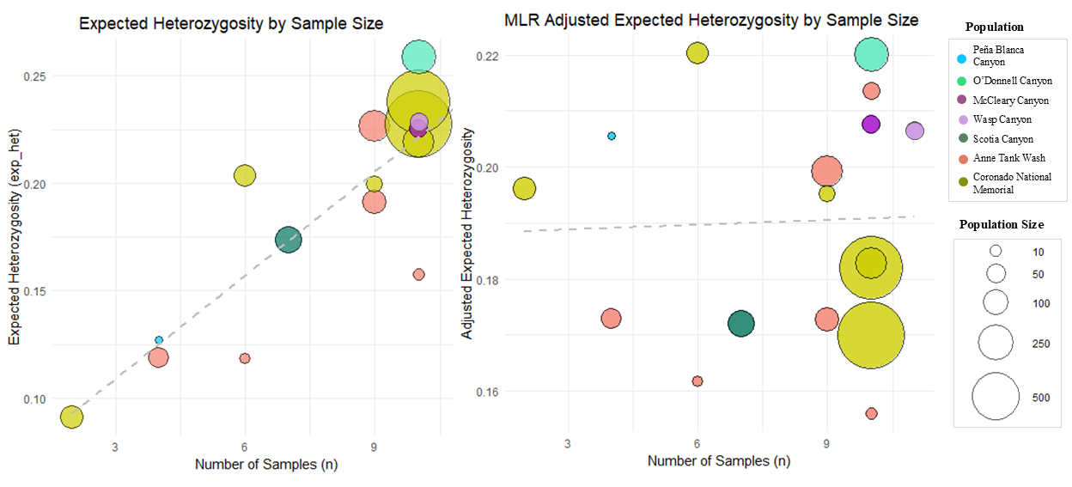

SI Figure 4: Subpopulation estimates of expected heterozygosity. Subpopulations are represented as individual circles color-coded to their population and scaled to match the estimated size of the subpopulation based on demographic surveys. (Left) Raw output Π values with linear regression line showing relationship between sample size, population size, and expected heterozygosity. (Right) Π values are weighted by sample size and population size using a multiple linear regression to account for sample size and estimated population size, uniform standard error applied. Scotia Canyon is an outlier when visualized with adjusted expected heterozygosity.

