Supplementary information
Key Role of Oxidising Species Driving Water Oxidation Revealed by Time Resolved Optical and X-ray Spectroscopies
Caiwu Liang,^{a,b*} Lucas Garcia Verga,ª Benjamin Moss,^{b,#} Santosh Kumar,^{c} Soren B. Scott^{e}, Mark Turner,^{d} Pilar Ferrer,^{c} Veronica Celorrio,^{c} Dave C. Grinter,^{c} Yemin Tao,ª Sid Halder,ª Yifeng Wang,ª Cindy Tseng,ª Guangmeimei Yang,^{b} Georg Held,^{c} Sarah J Haigh,^{d} Aron Walsh,^{a*} Ifan E.L. Stephens,^{a*} James R. Durrant,^{b*} Reshma R Rao^{a*}
ª Department of Materials, Imperial College London, London SW72AZ, United Kingdom
^{b} Department of Chemistry, Centre for Processable Electronics, Imperial College London, White City Campus, London W12 0BZ, United Kingdom
^{c} Diamond Light Source, Harwell Science and Innovation Campus, Didcot OX11 0DE, United Kingdom
^{d} Department of Materials, University of Manchester, Manchester M13 9PL, United Kingdom
^{e} Department of Chemistry, University of Copenhagen, 2100 Copenhagen, Denmark
# Current Address: Division of Chemistry and Chemical Engineering, California Institute of Technology, Pasadena, California 91125, United States
* Corresponding Authors:
E-mail: c.liang20@imperial.ac.uk (Dr. Caiwu Liang)
E-mail: a.walsh@imperial.ac.uk (Prof. Aron Walsh)
E-mail: i.stephens@imperial.ac.uk (Prof. Ifan E.L. Stephens)
E-mail: j.durrant@imperial.ac.uk (Prof. James R. Durrant)
E-mail: reshma.rao@imperial.ac.uk (Dr. Reshma R Rao)

DFT Calculations
Spin-polarised density functional theory calculations were performed using the Vienna ab-initio Simulation Package (VASP)¹ ²and the projector-augmented wave (PAW) method.^{3, 4} We employed the Perdew, Burke and Ernzerhof exchange-correlation functional⁵or all the calculations with and without the inclusion of Hubbard U correction using the rotationally invariant DFT+U formalism proposed by Dudarev et al.⁶ with a U=2.0 eV⁷ for the d states of Ir atoms. The (110) surface of an IrO₂ rutile structure was modelled with a symmetric 3x1 slab with at least 30 Å of vacuum and six atomic layers, of which the two central layers were fixed in the optimized bulk geometry. Adsorbates were symmetrically placed on both sides of the slab at Ir_{Cus} and Ir_{Bri} sites. The calculations were performed with a plane wave energy 500 eV and a 3x4x1 k-points mesh for the Brillouin zone integration. The convergence criteria were set to 10⁻⁴ eV for the electronic self-consistent iteration and 0.025 eV/ Å for the atomic forces on all atoms during ionic relaxations. The computational hydrogen electrode was used to consider the effect of the applied potential⁸ and the free energy changes as a function of applied potential were defined as:
∆Gads(U) = E_{ads}^{DFT} + ZPE + ∫CdT – T∆S – neU (1)
where n is the number of electrons for the considered reaction, and the ZPE, ∫CdT, and T∆S terms were obtained from vibrational frequencies calculated via DFT used within the thermochemistry module from the atomic simulation environment package using the harmonic limit⁹ (see Supplementary Table S1).
Supplementary Table S1: Energy corrections used for each system. The values are given considering adsorbates on the 6 available cus and bri sites.
System | ZPE | ∫CdT | T∆S | Total
*H₂O_{cus}+*H_{bri} | 6.00 | 0.34 | 0.56 | 5.78
*H_{bri} | 1.87 | 0.03 | 0.04 | 1.86
*H_{cusi} | 1.40 | 0.03 | 0.04 | 1.39
*H_{cus}+*H_{bri} | 3.27 | 0.06 | 0.07 | 3.25
*OH_{cus}+*H_{bri} | 4.14 | 0.27 | 0.45 | 3.96
*OH_{cus} | 2.23 | 0.27 | 0.46 | 2.04
*O_{cus} | 0.44 | 0.19 | 0.33 | 0.30

As illustrated in Fig. S1 and Table S2, the inclusion of the Hubbard +U term does not alter the main insights from the calculations. Thus, for simplicity, the results in the main manuscript do not include this term. For the calculation of Bader charges¹⁰, we increased the k-point mesh to 6x8x1, changed the convergence criteria for the electronic self-consistent iteration to 10⁻⁵ eV and doubled the number of grid points in the FFT grid along all lattice vectors. Fig. S1 also shows how the different surface states are chosen to represent the redox transitions. Table S2 shows that the change in average Bader charge related to redox transition 3 happens on the oxygen adsorbed on the Ir_{CUS} site, with the charges on O_{bri} atoms remaining almost unchanged.
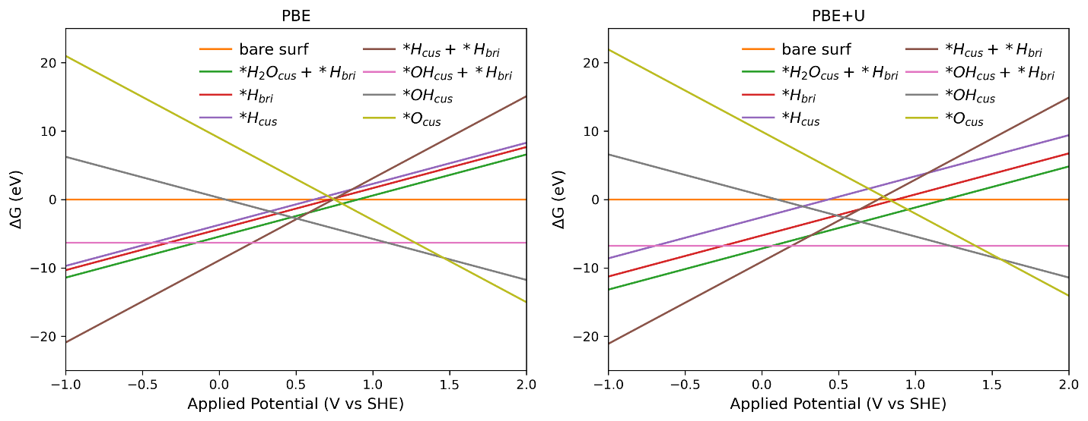
Figure S1 Surface Pourbaix diagrams of the IrO₂ surface calculated with PBE and PBE+U.

Supplementary Table S2: Average change in Bader charges for Ir_{cus}, Ir_{bri}, O_{cus}, and O_{bri} atoms present at the rutile IrO₂ surfaces during each redox reaction calculated with PBE and PBE+U, where positive (negative) numbers indicate an increase (decrease) in the number of electrons.
PBE
 | Ir_{cus} | Ir_{bri} | O_{cus} | O_{bri}
*H₂O_{cus}+*H_{bri} -> *OH_{cus}+*H_{bri} | -0.43 | 0.13 | 0.15 | 0.06
*OH_{cus}+*H_{bri} -> *OH_{cus} | -0.20 | -0.07 | -0.11 | -0.06
*OH_{cus} -> *O_{cus} | -0.04 | 0.05 | -0.17 | -0.04
PBE+U
 | Ir_{cus} | Ir_{bri} | O_{cus} | O_{bri}
*H₂O_{cus}+*H_{bri} -> *OH_{cus}+*H_{bri} | -0.58 | 0.02 | 0.17 | 0.08
*OH_{cus}+*H_{bri} -> *OH_{cus} | -0.09 | -0.10 | -0.07 | -0.07
*OH_{cus} -> *O_{cus} | 0.01 | 0.04 | -0.26 | -0.05

Fig. S2 shows the projected density of states for initial and final surface states of each redox transition. The states near the Fermi level are dominated by Ir states for the first redox transition. For the remaining redox transitions, both Ir (d) and O(p) states are present near the Fermi level, explaining why electron depletion from O atoms becomes more important at higher potentials.
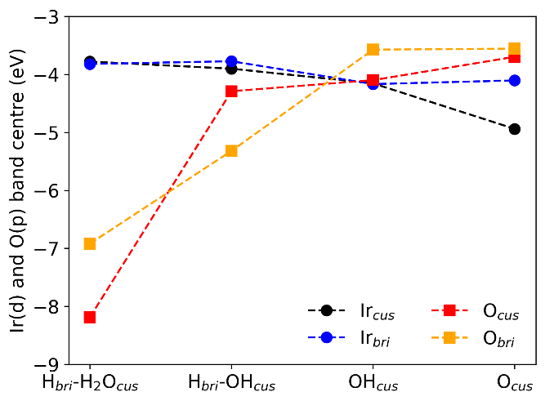
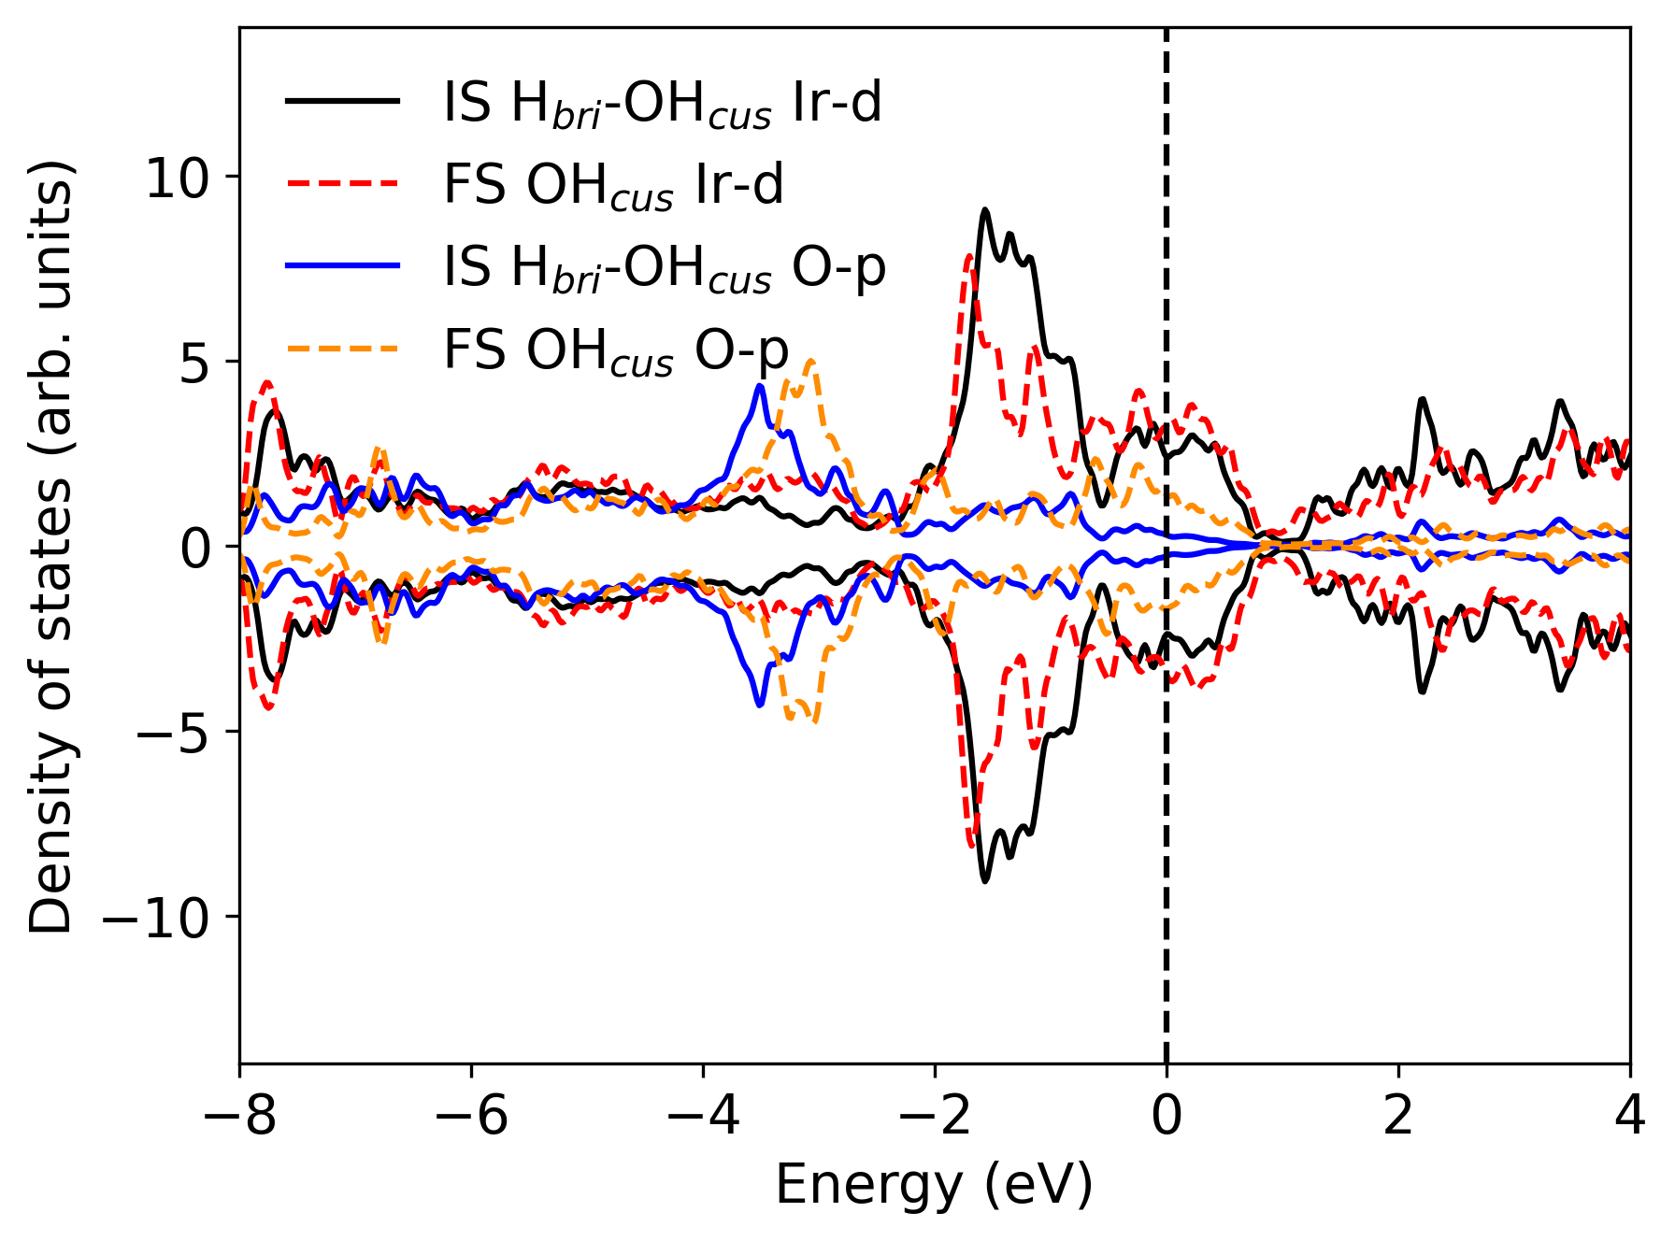
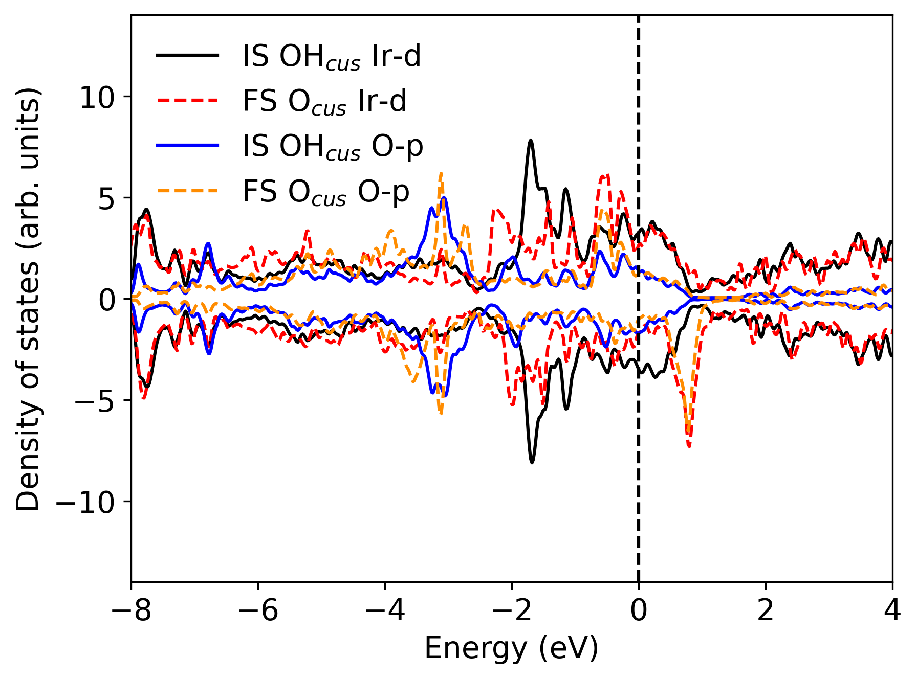
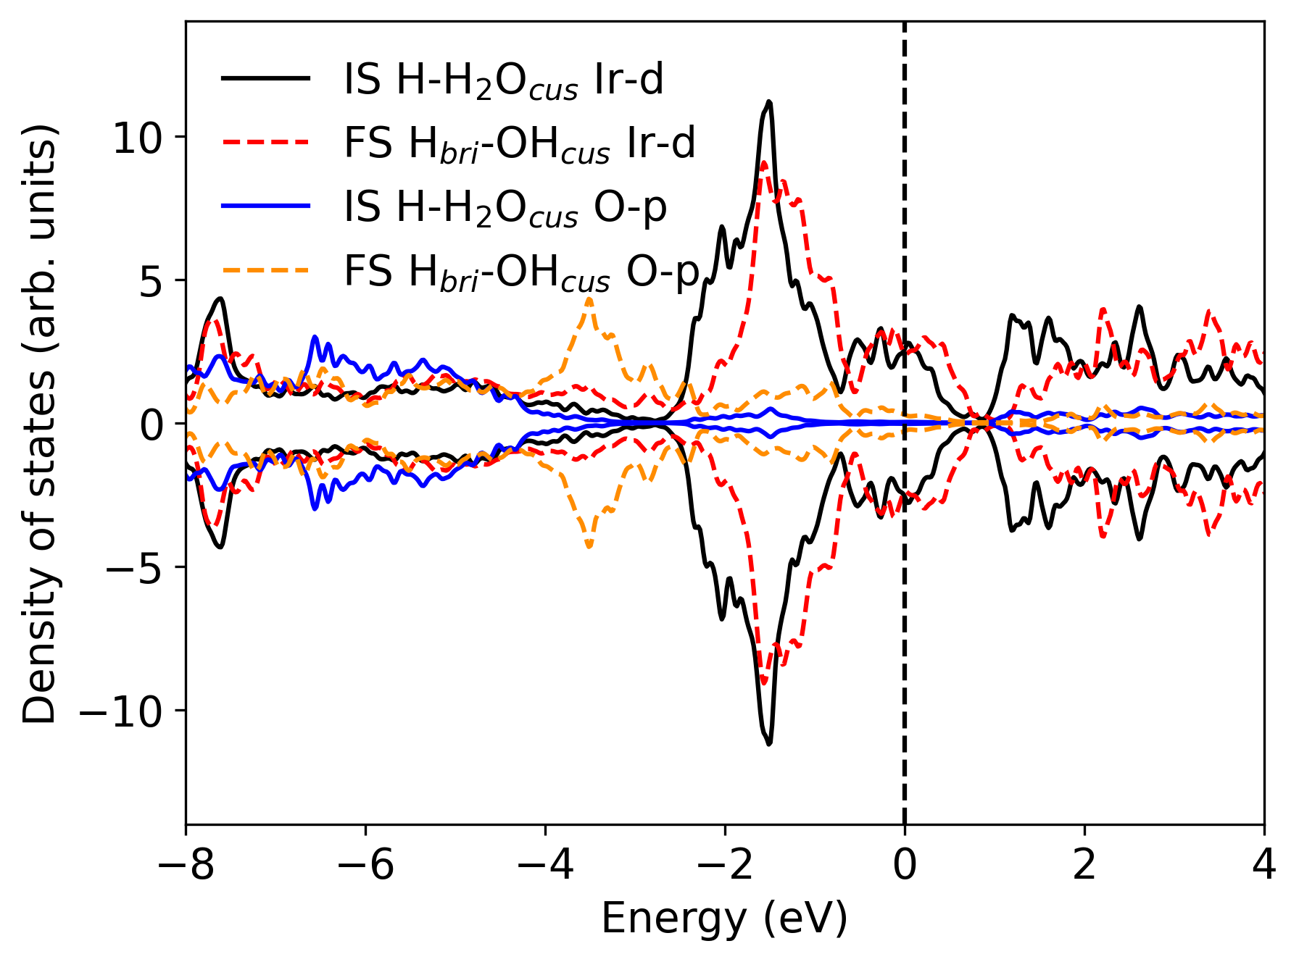
A
Redox Transition 1
Redox Transition 2
B
Redox Transition 3
C
D

Figure S2: Projected density of states (pDOS) for initial (IS) and final (FS) surface states of each redox transition. Black and red lines respectively show the Ir (5d) and O(2p) pDOS for the initial state, while blue and yellow lines show the Ir (5d) and O(2p) pDOS for the final state. For completeness, the d and p band centres for Ir and O are also presented separately for CUS and Bri sites.

Structure of IrO_{x}
The electrodeposited film was scraped from the FTO substrate and suspended in methanol. The suspension was sonicated to produce a finer nanoparticle dispersion and then drop-cast onto a holey carbon TEM grid. TEM imaging was acquired using a Thermo Fisher Talos F200 electron microscope operating with a 200 kV acceleration voltage. To minimise the total electron fluence on the sample of interest, a sacrificial nanoparticle was used for initial lens alignment adjustments and focussing. An electron flux of 5 e⁻ Å⁻² s⁻¹ was then administered to identify a region of interest, and the same electron flux was used to refine the focus. An electron flux of 100 e⁻ Å⁻² s⁻¹ and a 1 s exposure time were used for acquisition giving a cumulative electron fluence of ca. 100 e⁻ Å⁻². The selected area electron diffraction pattern was acquired from an undamaged region of interest using the same instrumentation and with a total electron fluence of < 100 e⁻ Å⁻². STEM EDS was acquired using the Talos Super-X detector system.
Transmission electron microscopy (TEM) serves as a valuable tool for atomic-scale imaging of electrocatalysts. However, the susceptibility of iridium oxides to electron-beam damage necessitates careful monitoring of the cumulative electron fluence to ensure accurate structural characterisation. Limiting the total electron fluence to ca. 500 e⁻ Å⁻² supported the TEM acquisition in Fig. S3 without imposing any observable structural change. The lack of well-defined lattice fringes in the micrograph suggests no crystalline domain exists in the specimen and the absence of well-defined spots/rings of intensity in the fast-Fourier transform (FFT) or electron diffraction supports this conclusion.
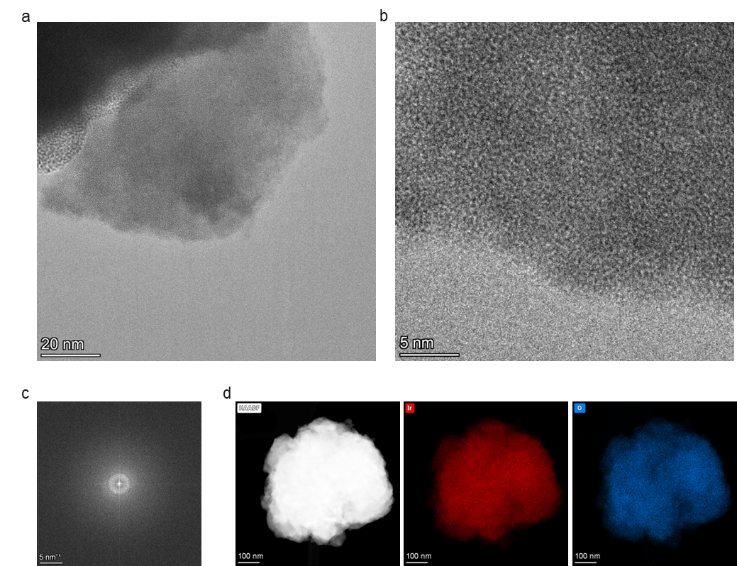

Figure S3 (a-b) TEM images showing the amorphous structure of electrodeposited IrO_{x}. The particles were stripped off from FTO after electrodeposition. To ensure the stripping of materials, the IrO_{x} was deposited with a higher thickness from 5000 s of electrodeposition. (c) The fast-Fourier transform (FFT) of the image in b (d) EDS Elemental mapping in STEM showing the uniform O and Ir distribution.

Optical absorption spectroscopy
Operando optical spectroscopy was performed on ~1 cm × 1 cm IrOx samples on FTO substrates using a custom-built three-electrode setup. A 10 mW tungsten-halogen light source (Thorlabs SLS201L with SLS201C collimator) illuminated the sample, and transmitted light was collected via a 1 cm liquid light guide (Edmund Optics) and directed to a spectrometer (Andor Kymera 193i) with a CCD camera (Andor iDus Du420A-BEX2-DD), cooled to –80 °C for improved signal-to-noise. Light was collimated and refocused using two 5 cm plano-convex lenses (Edmund Optics). The Autolab potentiostat controlled the potential in potentiostatic mode, with 10 s equilibration at each step. Optical spectra were collected by averaging 30 acquisitions (~30 ms each), and current was recorded simultaneously using custom LabView software.
The methodology and associated programming scripts for spectral deconvolution were first established in our previous work.^{11, 12} Briefly, the deconvolution process involves three key steps: (1) extraction of individual absorption spectra for distinct species via differential analysis; (2) application of linear combination fitting across spectra collected at all measured potentials to quantify the contribution of each species; and (3) experimental determination of extinction coefficients, followed by conversion of absorbance to species concentrations using the Lambert–Beer law. Detailed protocols for each step are provided in our earlier publications, and the open-source deconvolution scripts used for data analysis in this study are available (https://github.com/Caiwu-L/Paper_amorphous-IrOx_vs_Rutile_IrO2). The resulting spectra and deconvolution outcomes from this study are presented below:

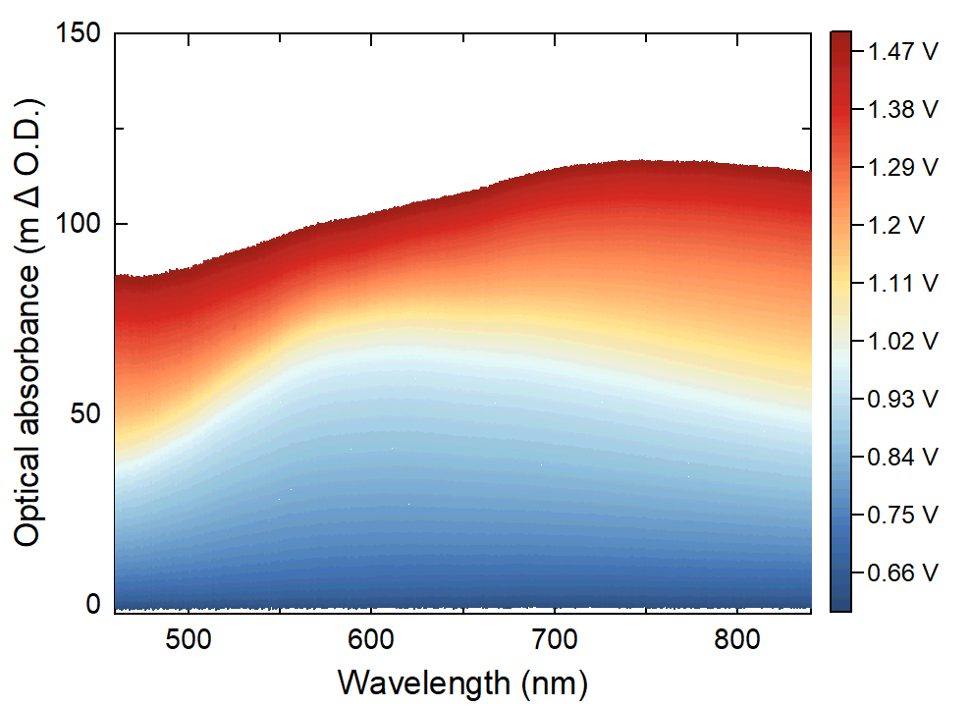
Figure S4 Absorption spectra of amorphous IrO_{x} in 0.1 M HClO₄ during a linear sweep scan from 0.6 V to 1.5 V_{RHE} and 0.5 to 1.5 V_{RHE}, respectively, at a scan rate of 1 mV s⁻¹ (iR corrected). Absorption changes were recorded at every 1 mV. The absorption changes are calculated with respect to the absorption at 0.6 V.

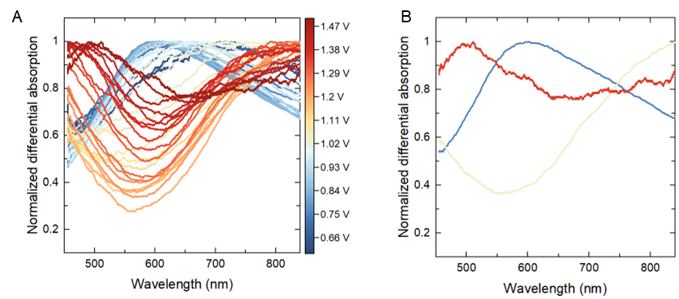
Figure S5 A) Differential analysis of absorption spectra for amorphous IrO_{x} at every 20 mV. The differential absorption spectra are obtained by subtracting adjacent spectra and normalizing the maximum absorbance to unity, representing a change in absorbance that corresponds to a potential change of 20 mV. B) Extracted spectra for individual redox transitions in amorphous IrO_{x}. The absorption spectra for redox transition 1 (light blue), 2 (light yellow) and 3 (red) in amorphous IrO_{x} are extracted from the potential regime where the shapes of the spectra in c are invariant, corresponding to differential spectra between 0.8 and 0.78 V_{RHE}, 1.18 and 1.16 V_{RHE}, and 1.5 and 1.48 V_{RHE}, respectively.

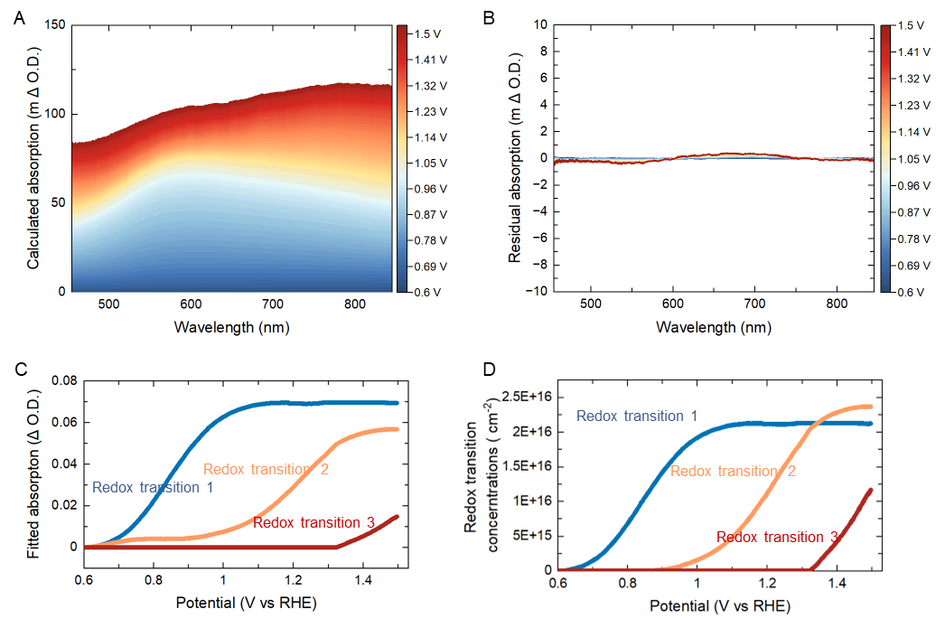
Figure S6. Deconvolution result for IrO_{x} in 0.1 M HClO₄. (A) Calculated differential absorption spectra of IrO_{x} in acid at every 1 mV during a linear sweep scan from 0.6 V to 1.50 V_{RHE}. (B) Fitting residuals between calculated spectra and experimental spectra at each potential. (C) Calculated absorption at the peak wavelength of each redox transition as a function of potential. (D) Densities of redox transitions for IrO_{x} that have occurred as a function of the potential. The conversion of absorption into the densities of redox transitions is based on the measured extinction coefficient obtained from our previous works^{11, 12}

Operando near-edge X-ray absorption fine structure spectroscopy (NEXAFS)
Near-edge X-ray absorption fine structure (NEXAFS) measurements were performed at B07 beamline (B branch) at Diamond light source.¹³ The in-situ cell used for measurements have been described in detail in reference.¹⁴ This cell uses a 100 nm thick Si₃N₄ (silicon nitride) window. This window serves dual purposes: i) it allows X-rays to penetrate the samples while reducing their path length in the liquid phase, thereby minimizing attenuation, and ii) it maintains the pressure differential between the ambient pressure in the electrolyte and the high vacuum in the measurement chamber (operating around 10⁻⁴ mbar). The Si₃N₄ window used in our measurements is fabricated by Silson Ltd, with a 7.5×7.5 mm² silicon frame which is 381 micrometre thick and a window size of 1×1 mm², thickness of 100 nm. This Si₃N₄ membrane is coated with a 10 nm Ti adhesive layer and a 10 nm Au conductive layer for electric conduction to the sample. The IrO_{x} is directly electrodeposited onto the Au layer using the same method as for electrodeposition on FTO.^{11, 12} The Si₃N₄ membrane is sealed with a 5 mm ID (internal diameter) O-ring and a 1 mm thick lid. Electric contact to the sample is made through four Au pins, connecting from the top part to the bottom part of the cell, labelled as working electrode (WE) in Fig. S7, a Pt wire and a micro Ag/AgCl with sealing lids are used as counter and reference electrodes. The potential of Ag/AgCl electrode is calibrated with a custom-made reversible hydrogen electrode. The electrolyte (0.1 M HClO₄) is flowed in and out of the cell using a micro-syringe (Hamilton Microlab 500 syringe pump) with a flow rate of around 10 μL s^{–1}. The electrolyte flow tube and connections to the working, reference, and counter electrodes are integrated through a specially designed lid (DN63 CF flange) of the chamber, enabling it to maintain a high vacuum environment. The O K-edge spectra were calibrated using the pre-edge of water at 535 eV and normalized to the post-edge region at around 540 eV for the in-situ sample, and normalized to around 570 eV for the ex-situ sample .¹⁵
Fig. S8 compares the normalised O-K-edge spectra for amorphous IrO_{x} deposited on a gold-coated SiN_{x} substrate with a standard rutile IrO₂ powder (Alfa) attached to carbon tape. The O-K-edge spectra for the substrate were also measured as a control. SiN_{x} substrate shows negligible absorption in the O-K-edge region (Fig. S9), while carbon tape has oxygen absorption features only at an energy higher than 531 eV. In the lower energy region between 527 to 531 eV, both amorphous IrO_{x} and the standard IrO₂ show clear absorption peaks, which are assigned to electronic transitions from O 1s into the hybridization of O 2p and Ir 5d t_{2g} states in previous study.¹⁶ Amorphous IrO_{x} exhibits a broader and less intense peak in the 528 to 530.5 eV range, in contrast to rutile IrO₂, which features a sharp peak at approximately 530.2 eV. This discrepancy aligns with the findings of Pfeifer et al.,^{17, 18} suggesting that the additional absorption below 530 eV in amorphous IrO_{x} can be attributed to oxygen that has less bonding than 3 Ir, compared to the dominant bulk O²⁻ in rutile IrO₂, which absorbs around 530 eV. The barely observed peaks at around 530 eV indicate there is barely μ-3 lattice oxygen, confirming it’s very short and highly amorphous nature. The measurements in total electron yield (TEY) mode, which offers enhanced surface sensitivity¹⁹, also produced spectra that closely resemble those from total fluorescence yield (TFY) mode, further confirming the uniform oxygen species in IrO_{x} .

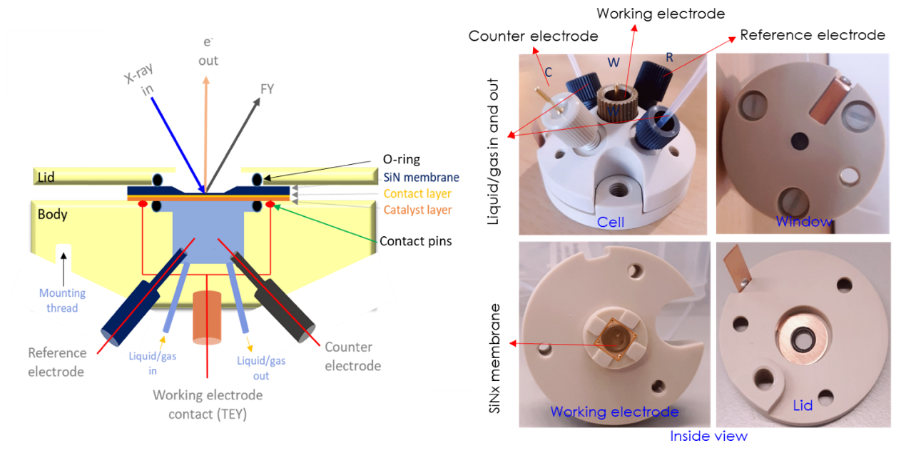

Figure S7 Left: schematic showing the structure of the cell designed. Right: the image of the cell used. WE CE and RE represent the working electrode, counter electrode and reference electrode. These cell design was adapted from previous work by Kumar et al.¹⁴.

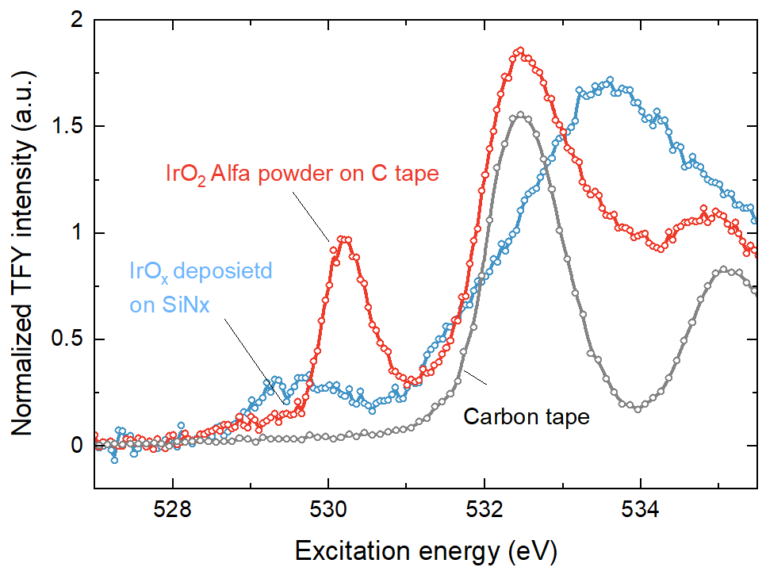

Figure S8 Comparison of the O K-edges of amorphous IrO_{x} deposited on gold-coated SiN_{x} substrate and commercial rutile-type IrO₂ powder (Alfa). The amorphous IrO_{x} shows an additional pre-edge feature at around 529.2 eV and less intensity at 530.2 eV, where rutile IrO₂ has a sharp resonance. The data is normalized to the fluorescence at the post edge at ~550 eV

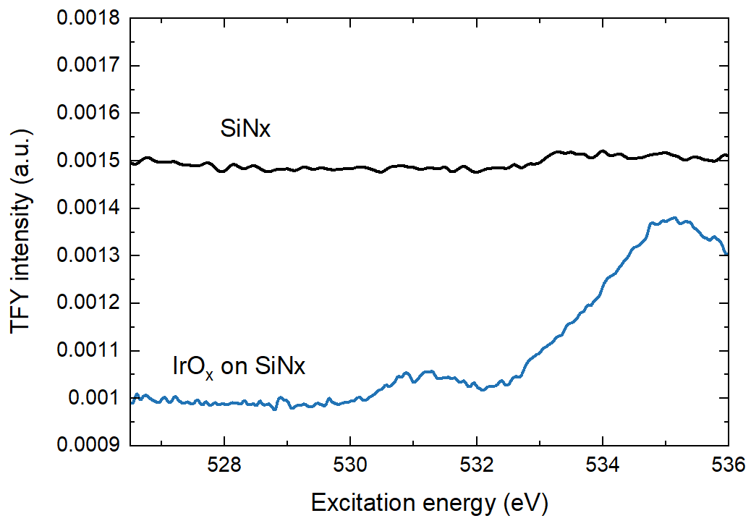

Figure S9 Comparison of the O K-edges date of amorphous IrO_{x} deposited on gold coated SiN_{x} substrate and the bare substrate as a control.
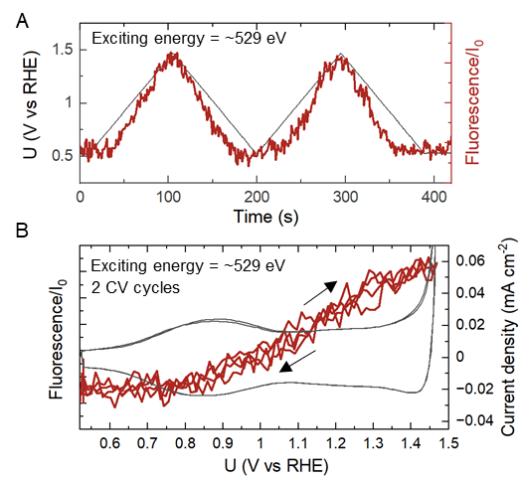

Figure S10 (a) The O-K-edge NEXAFS fluorescence intensity changes at a fixed exciting energy of ~529.0 eV across two cycles of CVs from 0.5 V_{RHE} to approximately 1.47 V_{RHE} at a scan rate of 10 mV s^{–1}, in 0.1 M HClO₄ electrolyte. (b) Comparing the current density and the change in fluorescence intensity at ~529.0 eV as a function of potential, as derived from (a).

Probing dynamic Ir oxidation/reduction at fixed energy
In time-resolved X-ray spectroscopy, the fluorescence intensity is continuously monitored at a fixed beam energy while performing electrochemical measurements. Fig. S11a shows the white line peak position of XANES spectra shift to higher energy with increasing potential, suggesting higher oxidation states. This shift in peak position leads to a decrease in intensity at energy before peak (as shown by dash line at 11218 eV), an increase at energy after peak (as shown by the dashed line at 11222 eV) and a negligible change at energy of post edge (energy that beyond Ir-L₃ edge). Fig. S11b illustrates how the fluorescence intensity changes at specific energies (11218, 11222, and 12150 eV) across two cycles of CV from 0.5 V_{RHE} to approximately 1.44 V_{RHE}. The intensity variations at fixed energies of 11218 and 11222 eV closely follow the applied potential, while the intensity at 12150 eV is independent of potential, corroborating the observations from Fig. S11a. Fig. S11c further shows the fluorescence intensity at 11222 eV changes as a function of potential for two 2 CV cycles. It is clear that the oxidation and reduction of iridium are highly reversible, with the forward scan almost identical to the backward scan within 2 cycles. Furthermore, the increase in fluorescence signal with rising potential becomes less pronounced at high potential (>1.4V_{RHE}). These changes in fluorescence intensity can be converted to oxidation state using a calibrated relation between the raw intensity at a given energy and the oxidation states, which is determined from the peak position of XANES spectra.
Fig. S12a compares the Ir average oxidation state and fluorescence at 11222 eV, as a function of potential. The trends of increase in fluorescence closely align with that of Ir oxidation states. This leads to an almost linear correlation of oxidation state and fluorescence intensity at 11222 eV (Fig. S12b), with a fitted relation as follows:
 | $$\text{Fluorescence= 0.004 × }\text{Ir}\text{ oxidation state – 0.0058}$$ | (2)
This equation suggests that for each unit increase in oxidation state, the fluorescence intensity at 11222 eV increases by around 0.004. However, it is worth noting that this linear relationship, while generally holds true across experiments, the exact parameters in the fitted linear equation are specific to the measurements conducted at the same spot of the sample, same beamline and at the same period of beamtime. This is because the raw fluorescence intensity at fixed energy could be affected by factors that are unrelated to oxidation states, including variations in samples, probe positions and beam energy source. Therefore, while we discuss the fluorescence data in relation to oxidation states, one should caution against directly converting fluorescence intensity to specific oxidation states without considering these variables. A similar method combining electrochemistry with time-resolved XAS was employed by Dau and co-works²⁰ to track oxidation-state changes in cobalt catalysts.

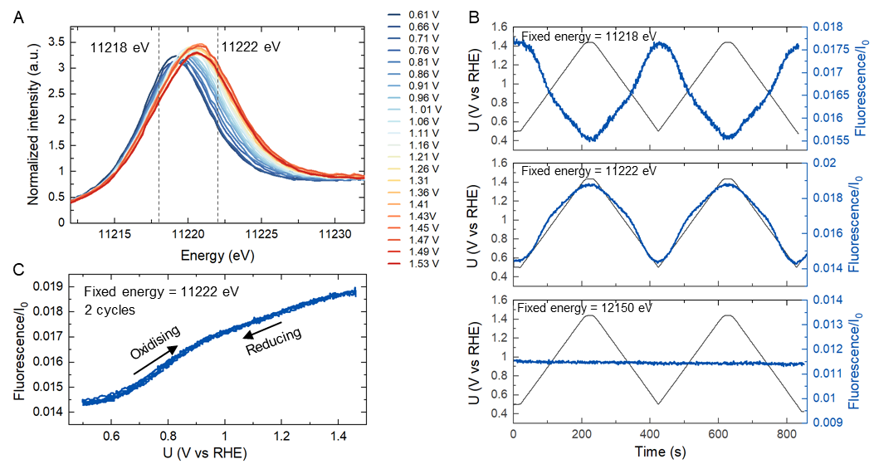

Figure S11 (A) Ir L₃-edge XANES region of IrO_{x} on FTO measured at different potentials in 0.1 M HClO₄, adapted from Fig. 2B in the main manuscript. Dashed lines indicate the intensity change at a fixed energy of 11218 eV and 11222 eV. (B) The fluorescence intensity changes at specific energies (top- 11218 eV, middle-11222 eV, and bottom-12150 eV) across two cycles of cyclic voltammetry (CV) from 0.5 V_{RHE} to approximately 1.44 V_{RHE} at a scan rate of 10 mV s^{–1}, in 0.1 M HClO₄ electrolyte. (C) change of fluorescence intensity at 11222 eV as a function of potential, obtained from the middle panel of (B)

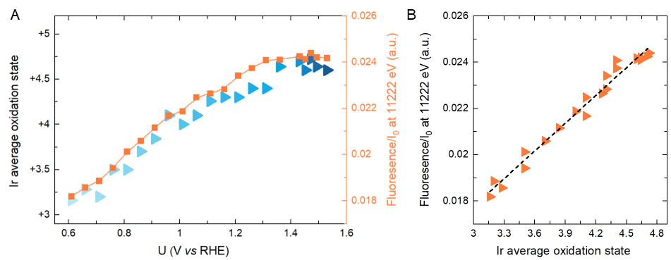

Figure S12 (A) Comparison of average iridium oxidation state (left y-axis) with fluorescence at a fixed energy of 11222 eV (right y-axis) as a function of potential. (B) Correlation between fluorescence at 11222 eV and average Ir oxidation state. The dashed line indicates a linear regression fit of the data.

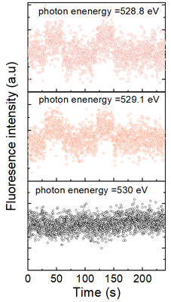

Figure S 13 Change in oxygen fluorescence intensity at different exciting energy for step potential measurements from 1.1 to 1.27 V_{RHE}.

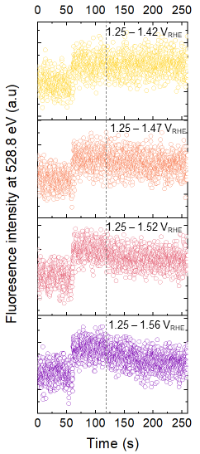

Figure S14 Change in oxygen fluorescence intensity at 528.8 eV during open circuit potential decay measurement at different applied potential. The decay rate of signal increase with increasing potential.

Electrochemical-mass spectrometry—Quantifying oxygen molecules release during OCP decay
The oxygen signal is measured in two sequential procedures. The first measurement- open circuit potential (OCP) decay, involved stepping up the potential from 1.4 V_{RHE} to 1.46 V_{RHE}, holding it for 10 s, then switching to open circuit to allow the redox states accumulated at high potential to relax naturally. The second measurement, step potential measurement, served as a control measurement for OCP decay. After holding potential at 1.46V_{RHE} for 10 s, the potential is stepped back to 1.4 V_{RHE} to actively reduce the redox states accumulated at 1.46 V_{RHE} to the same level of 1.4 V_{RHE}. These measurements were performed in sequence on the same sample without interruption, differing only in how the potential was returned to its starting level – either through an external circuit or by switching to an open circuit to allow natural relaxation. As shown in Fig. S15a, distinct increase in O₂ signal is observed when the potential raised from 1.4 V_{RHE} to 1.44 V_{RHE}, which then gradually returned to its baseline level after stepping back the potential to 1.4 V_{RHE}. The delay in the return of oxygen signal back to baseline is attributed to the diffusion time required for oxygen to move from the electrode surface to the mass spectrometer, varying from a few seconds to tens of seconds and depend on the oxygen concentration. ^{21, 22} Interestingly, following this step potential measurement, an open circuit decay measurement shows a significantly larger oxygen signal in comparison. This indicates the release of additional oxygen during the open circuit decay compared to step potential measurements. To eliminate the possibility of a time-dependent artefact or irreversible change in materials on oxygen signal recording, the sequence of experiments was reversed, performing an open circuit decay measurement before the step potential experiment. The results, as shown in Fig. S15b, consistently exhibit increased oxygen release during open circuit decay, confirming the observation that extra oxygen is released during open circuit potential.
To quantify the additional oxygen released during open circuit decay, we calibrated EC-MS signals to the actual amounts of oxygen using the relation of OER current and oxygen signal on a clean polycrystalline Pt surface. Based on previous findings from Cherevko, Mayrhofer and co-workers²³, Pt shows minimal dissolution under constant current operation after ~1000 s. Thus, by pre-stabilizing Pt surface to minimize the dissolution, we can assume an OER Faraday efficiency of approximately 100% on Pt. This assumption allows us to use the charge passed through the reaction to determine the amount of O₂ produced, thereby correlating it with the ECMS-detected signal. Fig. S16a illustrates the result of calibration experiment, where the current over specific periods (shown as dark rectangular area) are integrated to charge and compare with the EC-MS detected signal. Fig. S16b illustrates a linear correlation between the electrochemical mass spectrometry (EC-MS) detected signal, measured in nanocoulombs (nC), and the quantity of oxygen produced, quantified in nanomoles (nmol). This linear relationship yielded a calibrated sensitivity factor, represented by the fitted slope, of approximately 0.109 nC/nmol. This sensitivity factor enabled us to accurately convert EC-MS signals into oxygen amounts for all subsequent experiments, providing a clear and direct method for quantifying oxygen release.
The amount of extra oxygen release during open circuit decay is calculated by comparing the detected oxygen between step potential and open circuit potential decay measurement. To enhance the visibility of the oxygen signal decay during open circuit, we extended the potential holding time for both measurements from 10 seconds to 60 seconds before shifting to open circuit (Fig. S16c). This led to a more stable oxygen flux in the mass spectrometer, providing a clearer baseline from which the subsequent decay could be more distinctly observed. The potential, current and oxygen signal data for the two measurements are then overlapped for comparison (Fig. S16d). Prior to 120 seconds, the potential and current were almost identical in both operations. However, differences emerged after 120 seconds. During step potential, a cathodic current peak corresponding to the reduction of accumulated states was observed, while in open circuit potential decay, no current was recorded. Between 120 and 330 seconds, there was a noticeable increase in oxygen release during the open circuit decay measurements compared to that of step potentials measurements. This increase could not be solely attributed to the diffusion of oxygen produced between 60 and 120 seconds. The disparity in oxygen levels over time is further illustrated in the bottom panel of Figure S12d, showing a net oxygen production of approximately 0.698 nmol cm⁻² during open circuit decay (as calculated by integrating the O₂ signal from 120 to 330 seconds).
The same phenomenon was observed for different applied potential steps including potential steps 1.4-1.42 V_{RHE}, 1.4-1.42 V_{RHE}, 1.4-1.45 V_{RHE}, 1.4-1.46 V_{RHE}, 1.4-1.47 V_{RHE} and 1.4-1.48 V_{RHE} (Fig. S17 and Fig. S18). As step potential increases, the net amount of oxygen produced during open circuit potential clearly increases.
To further understand this link, we quantify the concentration of O⁻¹ at different potentials and compare it with the corresponding amount of oxygen produced during open circuit potential decay. The concentration of O⁻¹ is inferred from the integration of cathodic current peak observed when the potential is stepped back, representing the charge required to revert all high-potential-accumulated O⁻¹ back to its O⁻² state at start potential. We note that the difference between open circuit decay and step potential measurements is negligible for potentials lower than approximately 1.415 V_{RHE}. Therefore, the potential range starting from 1.415 V_{RHE} was selected for charge integration. This ensures that we are examining the charge specifically related to active O⁻¹ that can produce oxygens molecule while minimizing influences from charges associated with high oxidation iridium sites inactive towards the OER or those species contributing to oxygen release on a timescale longer than the experiment period or below the detection limit of EC-MS. The integration of charge at different potentials is shown in Fig. S19. These integrated charge densities are used as O⁻¹ concentration and compared to the oxygen amount detected in open circuit decay.

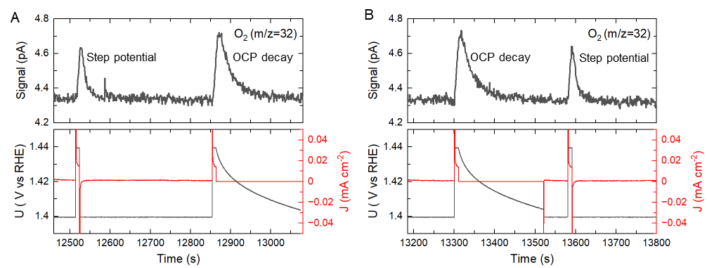

Figure S15 O₂ detection during open circuit potential (OCP) decay. (A) O₂ (m/z = 32) signals detected in EC-MS for step potential measurements from 1.40 to 1.44 V_{RHE} and for a subsequent OCP decay measurement with the same potential steps and holding time. This Figure is also shown is the main text (B) Same measurement but with a reverse order of step potentials and OCP decay measurement.

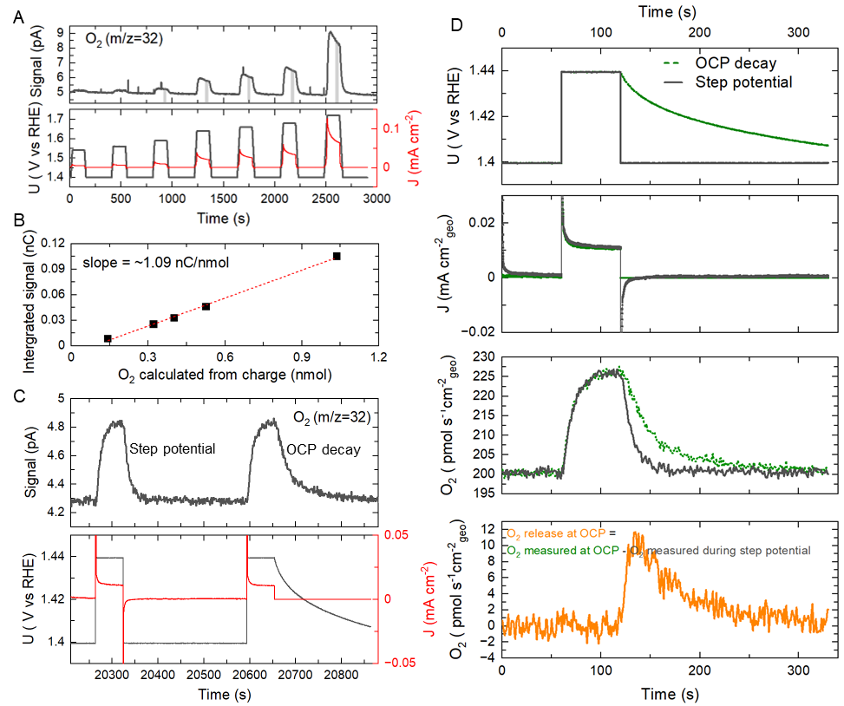

Figure S16 Quantification of O₂ during open circuit potential (OCP) decay. (A) Potential, current and oxygen signal collected in calibration experiment on a clean Pt electrode surface (B) OER calibration curve for Pt electrode. (C) Potential, current and O₂ signal in step potential measurements and OCP decay measurements. (D) Comparison of applied potential during OCP and step potentials (top panel), the corresponding current density (second top panel), calibrated O₂ signal detected (second bottom) and the net rate of O₂ release during OCP decay. The O₂ release at OCP is calculated by the subtraction of calibrated O₂ signal from OCP decay with that from step potential measurement.

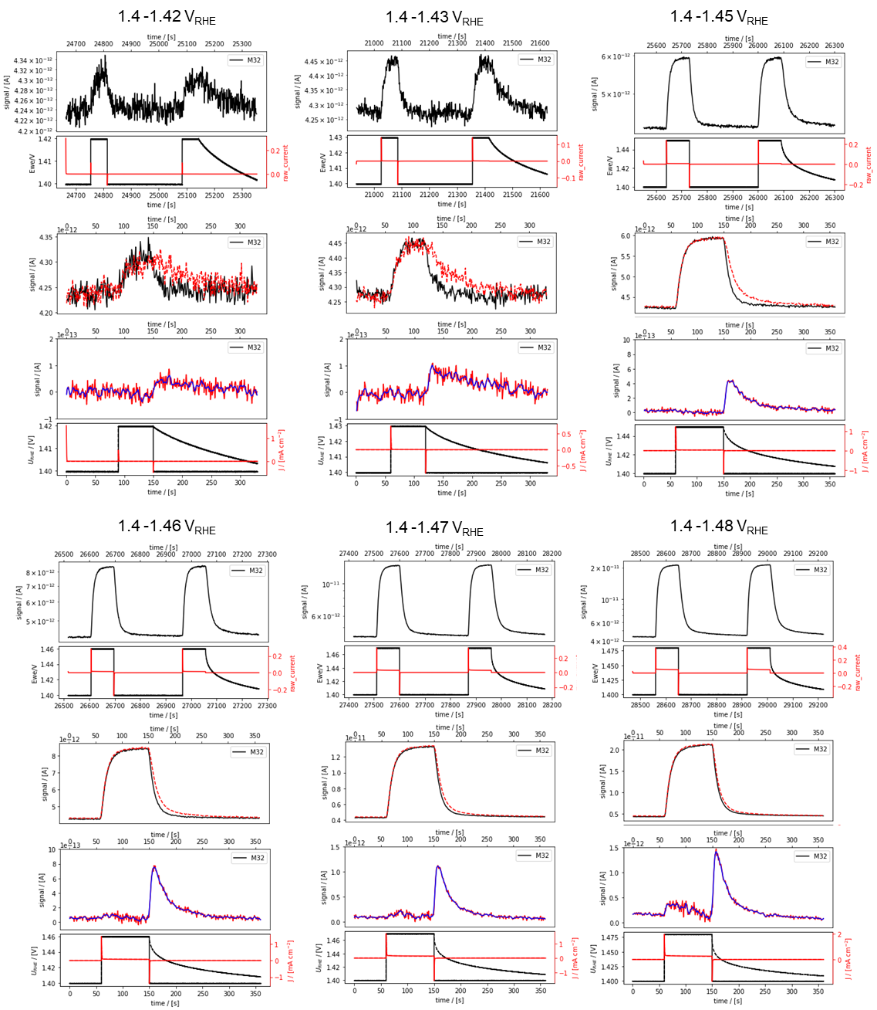

Figure S17 Quantification of O₂ during open circuit potential (OCP) decay-measurement 1. Comparison of applied potential, the corresponding current density (second top panel), calibrated O₂ signal detected (second bottom) and the net rate of O₂ release during OCP decay and step potentials measurements at a series of potentials. The O₂ release at OCP is calculated by the subtraction of calibrated O₂ signal from OCP decay with that from step potential measurement.

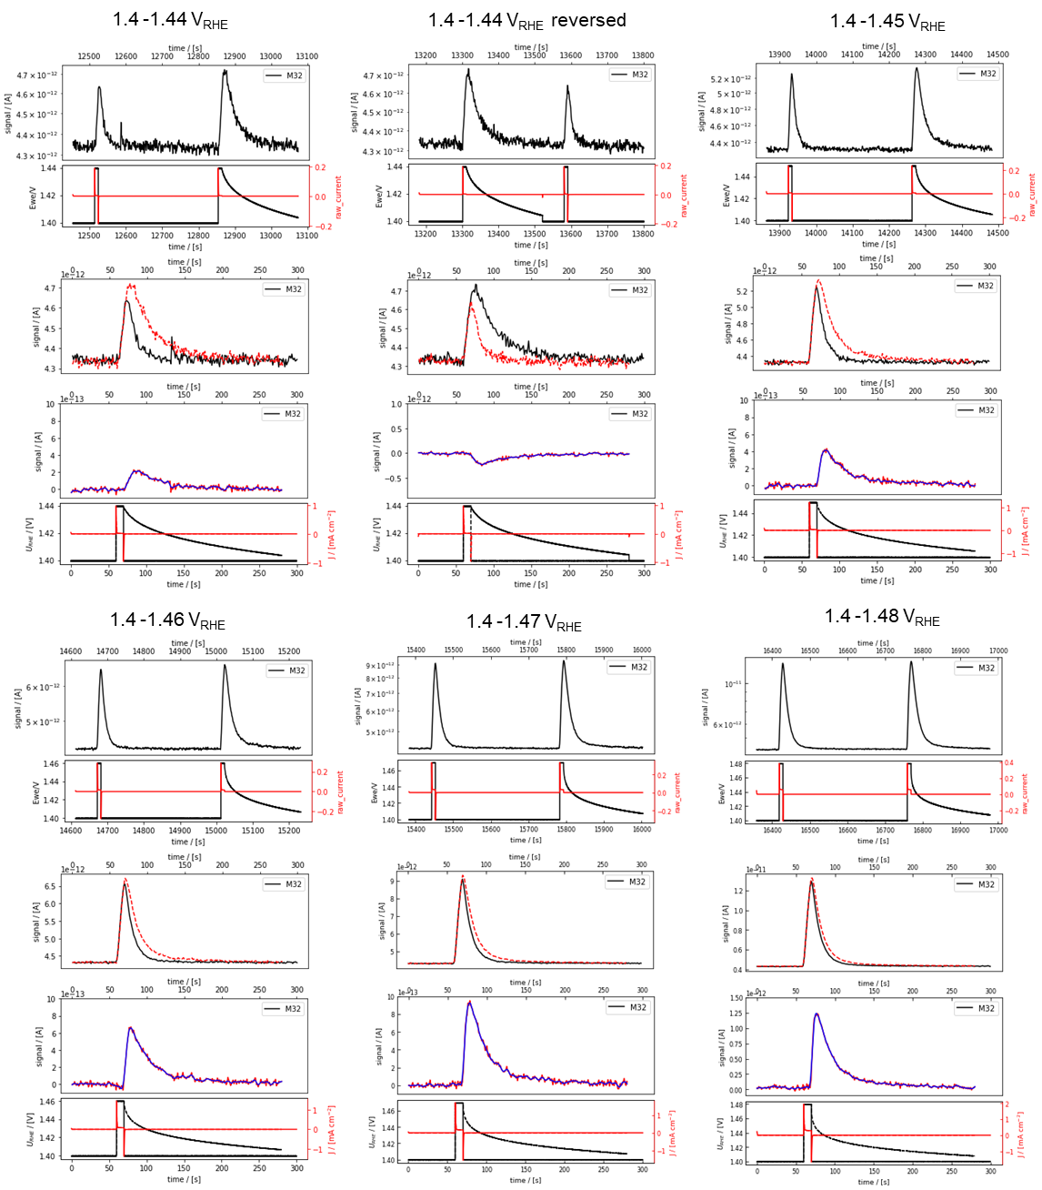

Figure S18 Quantification of O₂ during open circuit potential (OCP) decay-measurement 2. Comparison of applied potential, the corresponding current density (second top panel), calibrated O₂ signal detected (second bottom) and the net rate of O₂ release during OCP decay and step potentials measurements at a series of potentials. The O₂ release at OCP is calculated by the subtraction of calibrated O₂ signal from OCP decay with that from step potential measurement.
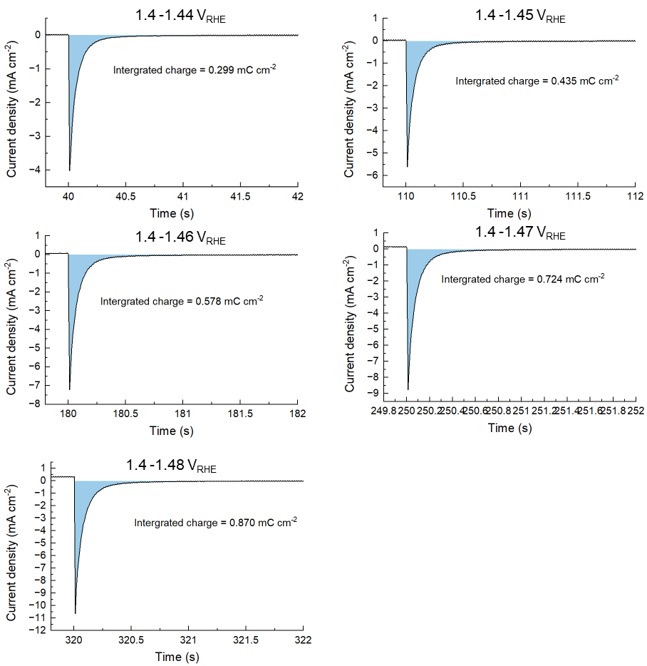

Figure S19 Integration of cathodic current spike during step potential measurements, starting from 1.415 V_{RHE} to various higher potentials and back to 1.415 V_{RHE}. This cathodic peak indicates the charge required to reduce the accumulated O¹⁻ back to O²⁻ at 1.415 V_{RHE}, a potential chosen based on the absence of significant oxygen release observed below this threshold during OCP decay.

Referencess
(1) Kresse, G.; Furthmüller, J. Efficient iterative schemes for ab initio total-energy calculations using a plane-wave basis set. Physical Review B 1996, 54 (16), 11169-11186. DOI: 10.1103/PhysRevB.54.11169.
(2) Kresse, G.; Hafner, J. Ab initio molecular dynamics for open-shell transition metals. Physical Review B 1993, 48 (17), 13115-13118. DOI: 10.1103/PhysRevB.48.13115.
(3) Kresse, G.; Joubert, D. From ultrasoft pseudopotentials to the projector augmented-wave method. Physical Review B 1999, 59 (3), 1758-1775. DOI: 10.1103/PhysRevB.59.1758.
(4) Blöchl, P. E. Projector augmented-wave method. Physical Review B 1994, 50 (24), 17953-17979. DOI: 10.1103/PhysRevB.50.17953.
(5) Perdew, J. P.; Burke, K.; Ernzerhof, M. Generalized Gradient Approximation Made Simple. Physical Review Letters 1996, 77 (18), 3865-3868. DOI: 10.1103/PhysRevLett.77.3865.
(6) Dudarev, S. L.; Botton, G. A.; Savrasov, S. Y.; Humphreys, C. J.; Sutton, A. P. Electron-energy-loss spectra and the structural stability of nickel oxide: An LSDA+U study. Physical Review B 1998, 57 (3), 1505-1509. DOI: 10.1103/PhysRevB.57.1505.
(7) Ping, Y.; Galli, G.; Goddard, W. A., III. Electronic Structure of IrO2: The Role of the Metal d Orbitals. The Journal of Physical Chemistry C 2015, 119 (21), 11570-11577. DOI: 10.1021/acs.jpcc.5b00861.
(8) Nørskov, J. K.; Rossmeisl, J.; Logadottir, A.; Lindqvist, L.; Kitchin, J. R.; Bligaard, T.; Jónsson, H. Origin of the Overpotential for Oxygen Reduction at a Fuel-Cell Cathode. The Journal of Physical Chemistry B 2004, 108 (46), 17886-17892. DOI: 10.1021/jp047349j.
(9) Hjorth Larsen, A.; Jørgen Mortensen, J.; Blomqvist, J.; Castelli, I. E.; Christensen, R.; Dułak, M.; Friis, J.; Groves, M. N.; Hammer, B.; Hargus, C.; et al. The atomic simulation environment—a Python library for working with atoms. Journal of Physics: Condensed Matter 2017, 29 (27), 273002. DOI: 10.1088/1361-648X/aa680e.s
(11) Liang, C.; Rao, R. R.; Svane, K. L.; Hadden, J. H. L.; Moss, B.; Scott, S. B.; Sachs, M.; Murawski, J.; Frandsen, A. M.; Riley, D. J.; et al. Unravelling the effects of active site density and energetics on the water oxidation activity of iridium oxides. Nature Catalysis 2024, 7 (7), 763-775. DOI: 10.1038/s41929-024-01168-7.
(12) Liang, C.; Katayama, Y.; Tao, Y.; Morinaga, A.; Moss, B.; Celorrio, V.; Ryan, M.; Stephens, I. E. L.; Durrant, J. R.; Rao, R. R. Role of Electrolyte pH on Water Oxidation for Iridium Oxides. Journal of the American Chemical Society 2024, 146 (13), 8928-8938. DOI: 10.1021/jacs.3c12011.
(13) Held, G.; Venturini, F.; Grinter, D. C.; Ferrer, P.; Arrigo, R.; Deacon, L.; Quevedo Garzon, W.; Roy, K.; Large, A.; Stephens, C.; et al. Ambient-pressure endstation of the Versatile Soft X-ray (VerSoX) beamline at Diamond Light Source. Journal of Synchrotron Radiation 2020, 27 (5), 1153-1166. DOI: 10.1107/s1600577520009157.
(14) Kumar, S.; Counter, J. J. C.; Grinter, D. C.; Spronsen, M. A. V.; Ferrer, P.; Large, A.; Orzech, M. W.; Jerzy Wojcik, P.; Held, G. An electrochemical flow cell for operando XPS and NEXAFS investigation of solid–liquid interfaces. Journal of Physics: Energy 2024, 6 (3), 036001. DOI: 10.1088/2515-7655/ad54ee.
(15) Drevon, D.; Görlin, M.; Chernev, P.; Xi, L.; Dau, H.; Lange, K. M. Uncovering The Role of Oxygen in Ni-Fe(OxHy) Electrocatalysts using In situ Soft X-ray Absorption Spectroscopy during the Oxygen Evolution Reaction. Scientific Reports 2019, 9 (1), 1532. DOI: 10.1038/s41598-018-37307-x.
(16) Tsai, H. M.; Babu, P. D.; Pao, C. W.; Chiou, J. W.; Jan, J. C.; Krishna Kumar, K. P.; Chien, F. Z.; Pong, W. F.; Tsai, M.-H.; Chen, C.-H.; et al. Comparison of electronic structures of RuO2 and IrO2 nanorods investigated by x-ray absorption and scanning photoelectron microscopy. Applied Physics Letters 2007, 90 (4). DOI: 10.1063/1.2430929 (acccessed 3/14/2024).
(17) Pfeifer, V.; Jones, T. E.; Velasco Velez, J. J.; Massue, C.; Greiner, M. T.; Arrigo, R.; Teschner, D.; Girgsdies, F.; Scherzer, M.; Allan, J.; et al. The electronic structure of iridium oxide electrodes active in water splitting. Phys Chem Chem Phys 2016, 18 (4), 2292-2296. DOI: 10.1039/c5cp06997a.
(18) Pfeifer, V.; Jones, T. E.; Wrabetz, S.; Massue, C.; Velasco Velez, J. J.; Arrigo, R.; Scherzer, M.; Piccinin, S.; Havecker, M.; Knop-Gericke, A.; et al. Reactive oxygen species in iridium-based OER catalysts. Chem Sci 2016, 7 (11), 6791-6795. DOI: 10.1039/c6sc01860b.
(19) Velasco‐Velez, J. J.; Pfeifer, V.; Hävecker, M.; Weatherup, R. S.; Arrigo, R.; Chuang, C. H.; Stotz, E.; Weinberg, G.; Salmeron, M.; Schlögl, R.; et al. Photoelectron Spectroscopy at the Graphene–Liquid Interface Reveals the Electronic Structure of an Electrodeposited Cobalt/Graphene Electrocatalyst. Angewandte Chemie International Edition 2015, 54 (48), 14554-14558. DOI: 10.1002/anie.201506044.
(20) Pasquini, C.; Liu, S.; Chernev, P.; Gonzalez-Flores, D.; Mohammadi, M. R.; Kubella, P.; Jiang, S.; Loos, S.; Klingan, K.; Sikolenko, V.; et al. Operando tracking of oxidation-state changes by coupling electrochemistry with time-resolved X-ray absorption spectroscopy demonstrated for water oxidation by a cobalt-based catalyst film. Analytical and Bioanalytical Chemistry 2021, 413 (21), 5395-5408. DOI: 10.1007/s00216-021-03515-0.
(21) Trimarco, D. B.; Scott, S. B.; Thilsted, A. H.; Pan, J. Y.; Pedersen, T.; Hansen, O.; Chorkendorff, I.; Vesborg, P. C. K. Enabling real-time detection of electrochemical desorption phenomena with sub-monolayer sensitivity. Electrochimica Acta 2018, 268, 520-530. DOI: https://doi.org/10.1016/j.electacta.2018.02.060.
(22) Scott, S. B.; Rao, R. R.; Moon, C.; Sørensen, J. E.; Kibsgaard, J.; Shao-Horn, Y.; Chorkendorff, I. The low overpotential regime of acidic water oxidation part I: the importance of O2 detection. Energy & Environmental Science 2022, 15 (5), 1977-1987, 10.1039/D1EE03914H. DOI: 10.1039/D1EE03914H.
(23) Cherevko, S.; Zeradjanin, A. R.; Topalov, A. A.; Kulyk, N.; Katsounaros, I.; Mayrhofer, K. J. J. Dissolution of Noble Metals during Oxygen Evolution in Acidic Media. ChemCatChem 2014, 6 (8), 2219-2223. DOI: 10.1002/cctc.201402194.

