Supplement for
Title:
Alpha-synuclein deposition patterns in Alzheimer’s disease: association with cortical amyloid beta and variable tau load

Authors:
Antonia Neubauer^{1,2}, Doris Weissenbrunner ^{1,2}, Susanna Pekrun ^{1,2}, Sigrun Roeber^{1,2}, Viktoria Ruf ^{1,2}, Paul Feyen^{1,2}, Felix L. Strübing^{1,2}, Jochen Herms^{1,2,3}
Affiliations:
¹Center for Neuropathology and Prion Research, Ludwig Maximilians University of Munich, Munich, Germany
²German Center for Neurodegenerative Diseases (DZNE), Munich, Germany
³Munich Cluster for Systems Neurology (SyNergy), Munich, Germany

Corresponding author:
Antonia.Neubauer@med.uni-muenchen.de

Table 1 Overview of 28 annotated regions with size and annotation comments as well as the attribution to a region cluster. Representative areas without artifacts or large blood vessels were selected for all regions. For cortical regions, the annotation is aligned vertically to the brain surface to cover all cortical layers. “Number” refers to the numbering in Fig. 1 of the main manuscript. One “tile” equals 4096*4096 pixels (900 x 900 µm²). Cerebellar regions and the olfactory bulb were not included in region clusters due to the limited number of available stainings in these regions
Number | Region | Comment | Label size (approximately) | Region cluster
1 | middle frontal gyrus | at the level of the nucleus accumbens | 3x0.5 tiles | cortical
2 | sulcus of middle frontal gyrus | at the level of the nucleus accumbens | 3x0.5 tiles | cortical
3 | cingulate gyrus, rostral (anterior) part |  | 3x0.5 tiles | cortical
4 | sulcus between cingulate and superior frontal gyrus | on the side of frontal gyrus | 3x0.5 tiles | cortical
5 | long and short insular gyri | at the level of basal ganglia with putamen, globus pallidus and corpus of the caudate nucleus | 3x0.5 tiles | cortical
6 | edge between ventral and dorsal claustrum |  | 1x1 tile | subcortical
7 | putamen |  | 1x1 tile | subcortical
8 | superior temporal gyrus | at the level of the amygdala | 3x0.5 tiles | cortical
9 | sulcus between superior and middle temporal gyrus on the side of the middle gyrus | at the level of the amygdala | 3x0.5 tiles | cortical
10 | middle temporal gyrus | at the level of the amygdala | 3x0.5 tiles | cortical
11 | amygdala (lateral nucleus) | at the level of (trans-)entorhinal cortex | 1x1 tile | amygdala-entorhinal
12 | entorhinal cortex |  | 3x0.5 tiles | amygdala-entorhinal
13 | parietal gyrus | inferior parietal lobulus at the level of the splenium | 3x0.5 tiles | cortical
14 | mediodorsal nucleus of thalamus | at the level of substantia nigra | 1x1 tile | subcortical
15 | lateral nucleus of thalamus | at the level of substantia nigra | 1x1 tile | subcortical
16 | substantia nigra, pars compacta | representative areas avoiding pigmented neurons | 2 x 0.25 tiles | brainstem
17 | CA4 region of hippocampus | at the level of the lateral geniculate nucleus | 1x1 tile | hippocampal
18 | CA3 region of hippocampus | at the level of the lateral geniculate nucleus | 1x1 tile | hippocampal
19 | CA2 region of hippocampus | at the level of the lateral geniculate nucleus | 1x1 tile | hippocampal
20 | CA1 region of hippocampus | at the level of the lateral geniculate nucleus | 1x1 tile | hippocampal
21 | subiculum | at the level of the lateral geniculate nucleus | 1x1 tile | hippocampal
22 | parahippocampal gyrus | at the level of the lateral geniculate nucleus | 3x0.5 tiles | hippocampal
23 | striate area gyrus | Broca areal 17 | 3x0.5 tiles | cortical
24 | striate area sulcus | Broca areal 17 | 3x0.5 tiles | cortical
25 | cerebellar cortex | at the level of the dentate nucleus | 1x1 tile
26 | cerebellum, dentate nucleus |  | 1x1 tile
LC | locus coeruleus | representative areas avoiding pigmented neurons | 2 x 0.25 tiles | brainstem
OB | olfactory bulb |  | 1x1 tile
LC locus coeruleus, OB olfactory bulb

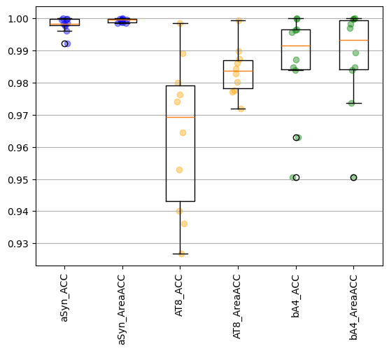
Fig. 1 Accuracy of the ilastik random forest pixel classifiers tested with ten test images. For each staining, namely alpha-Synuclein (aSyn), tau (AT8), and Amyloid β (bA4), the accuracy was calculated as follows: ACC = (true positive pixels + true negative pixels) / all pixels. Thus, a value close to 1 is a perfect match. As an additional index, the area-accuracy was measured as an accuracy of the absolute pixel values independent of the pixel localization: AreaACC = 1 - (|Ground truth covered area - predicted covered area| / all pixels)

Table 2 Comparison of the α-syn, tau, and Aβ covered area between αSyn- vs. αSyn+ groups with multiple linear regression without correction for age, sex, and subject ID, and with linear mixed effects models with correction for these factors. Effect size (β) and p-value are presented, respectively
Region cluster | α-syn  β, p (uncor.) | α-syn  β, p (age, sex, ID cor.) | tau  β, p (uncor.) | tau  β, p (age, sex, ID cor.) | Aβ  β, p (uncor.) | Aβ  β, p (age, sex, ID cor.)
cortical | β=0.010, p=0.003 | β=0.009, p=0.15 | β=-0.009, p=0.46 | β=-0.016, p=0.68 | β=0.023, p<0.001 | β=0.014, p=0.33
subcortical | β=0.003, p=0.025 | β=0.003, p=0.07 | β=0.003, p=0.68 | β=-0.003, p=0.69 | β=0.015, p=0.022 | β=0.012, p=0.33
hippocampal | β=0.005, p=0.003 | β=0.005, p=0.07 | β=-0.017, p=0.22 | β=-0.015, p=0.68 | β=0.010, p=0.016 | β=0.007, p=0.48
Amygdala-entorhinal | β=0.014, p<0.001 | β=0.013, p<0.001 | β=-0.046, p=0.11 | β=-0.044, p=0.29 | β=-0.003, p=0.69 | β=-0.003, p=0.85
brainstem | β=0.005, p=0.003 | β=0.005, p=0.07 | β=-0.003, p=0.64 | β=-0.002, p=0.69 | β=0.002, p=0.69 | β=-0.0005, p=0.85
All p-values were FDR corrected. Significant p-values were labeled in bold. cor. corrected, FDR false discovery rate, ID subject ID, p p-value, uncor. Uncorrected

Table 3 Comparison of the α-syn covered area between αSyn- vs. αSyn+ groups with multiple linear regression controlling and not controlling for age and sex
Region name | n (αSyn-) | n (αSyn+) | Median [IQR] [%] of αSyn- cases | Median [IQR] [%] of αSyn+ cases | p (uncor.) | p (age, sex cor.)
medial frontal gyrus | 8 | 39 | 0.001 [0.0005; 0.0019] | 0.034 [0.0058; 0.15] | 0.5 | 0.53
frontal sulcus | 8 | 38 | 0.001 [0.0004; 0.0017] | 0.039 [0.0049; 0.27] | 0.47 | 0.47
cingulate gyrus | 8 | 34 | 0.0021 [0.0002; 0.0048] | 0.23 [0.0515; 1.34] | 0.35 | 0.32
cingulate sulcus | 8 | 35 | 0.0009 [0.0006; 0.0024] | 0.23 [0.0113; 1.26] | 0.35 | 0.32
parietal gyrus | 7 | 39 | 0.0013 [0.0005; 0.0022] | 0.0596 [0.0028; 0.28] | 0.35 | 0.32
superior temporal gyrus | 9 | 38 | 0.0007 [0.0004; 0.0024] | 0.19 [0.012; 0.53] | 0.4 | 0.38
temporal sulcus | 9 | 37 | 0.001 [0.0005; 0.0068] | 0.19 [0.023; 0.73] | 0.39 | 0.37
medial temporal gyrus | 9 | 35 | 0.0021 [0.0003; 0.0037] | 0.102 [0.015; 0.46] | 0.38 | 0.35
occipital gyrus | 1 | 10 | 0.006 [0.006; 0.006] | 0.0043 [0.0012; 0.055] | 0.66 | 0.32
occipital sulcus | 1 | 10 | 0.0032 [0.0032; 0.0032] | 0.0037 [0.002; 0.096] | 0.66 | 0.61
insula cortex | 5 | 33 | 0.0005 [0.0004; 0.0057] | 0.4092 [0.027; 1.35] | 0.35 | 0.32
claustrum | 9 | 36 | 0.0002 [0.0001; 0.0014] | 0.16 [0.017; 0.42] | 0.35 | 0.32
putamen | 9 | 38 | 0.0037 [0.0001; 0.0086] | 0.059 [0.016; 0.49] | 0.35 | 0.32
hippocampus CA1 | 5 | 30 | 0.0004 [0.0001; 0.0008] | 0.15 [0.012; 0.48] | 0.37 | 0.32
hippocampus CA2 | 5 | 29 | 0.0001 [0.0001; 0.0041] | 0.58 [0.094; 1.32] | 0.35 | 0.32
hippocampus CA3 | 5 | 28 | 0.0003 [0.0003; 0.001] | 0.10 [0.017; 0.35] | 0.35 | 0.32
hippocampus CA4 | 5 | 30 | 0.0008 [0.0004; 0.0011] | 0.046 [0.0048; 0.31] | 0.35 | 0.32
subiculum | 5 | 30 | 0.0008 [0.0005; 0.0066] | 0.16 [0.038; 0.78] | 0.35 | 0.32
parahippocampal gyrus | 5 | 29 | 0.0011 [0.0004; 0.0038] | 0.24 [0.022; 0.79] | 0.35 | 0.32
thalamus medial nucl. | 2 | 12 | 0.0005 [0.0002; 0.0007] | 0.026 [0.012; 0.13] | 0.4 | 0.32
thalamus ventrolat. nucl. | 2 | 11 | 0.0007 [0.0004; 0.0011] | 0.024 [0.0022; 0.11] | 0.47 | 0.32
cerebellar cortex | 0 | 7 | nan [nan; nan] | 0.0011 [0.0002; 0.0023] | nan | nan
cerebellum dentate nucl. | 0 | 7 | nan [nan; nan] | 0.006 [0.0024; 0.0065] | nan | nan
substantia nigra | 17 | 33 | 0.0047 [0.0008; 0.0064] | 0.37 [0.027; 1.1] | 0.004 | 0.005
locus coeruleus | 19 | 39 | 0.0014 [0.0005; 0.0044] | 0.11 [0.014; 0.36] | 0.35 | 0.32
amygdala | 27 | 37 | 0.0006 [0.0001; 0.0117] | 1.01 [0.415; 2.04] | 0.004 | 0.005
entorhinal gyrus | 27 | 33 | 0.0019 [0.0008; 0.0052] | 0.46 [0.14; 1.16] | 0.013 | 0.023
olfactory bulb | 9 | 15 | 0.0009 [0.0003; 0.0272] | 0.51 [0.32; 0.89] | 0.014 | 0.023
All p-values were FDR corrected. Significant p-values and the three highest median α-syn loads of the αSyn+ group were labeled in bold. cor. corrected, FDR false discovery rate, IQR interquartile range, nan not enough values available, p p-value, uncor. Uncorrected

Table 4 Comparison of the tau covered area between αSyn- vs. αSyn+ groups with multiple linear regression controlling and not controlling for age and sex
Region name | n (αSyn-) | n (αSyn+) | Median [IQR] [%] of αSyn- cases | Median [IQR] [%] of αSyn+ cases | p (uncor.) | p (age, sex cor.)
medial frontal gyrus | 22 | 34 | 18.8 [12.4; 23] | 15.5 [6.2; 22.6] | 0.88 | 0.9
frontal sulcus | 23 | 31 | 21.5 [11.7; 25.5] | 15.1 [4.8; 23.9] | 0.88 | 0.77
cingulate gyrus | 12 | 28 | 13.7 [6; 20.5] | 15.4 [5.5; 25.4] | 0.88 | 0.98
cingulate sulcus | 12 | 27 | 12 [8.1; 21.7] | 13.1 [6.2; 22.1] | 0.97 | 0.9
parietal gyrus | 8 | 15 | 11.3 [7.6; 15.9] | 22.5 [11.7; 28.4] | 0.72 | 0.77
superior temporal gyrus | 28 | 42 | 17.4 [11.4; 23.3] | 14.4 [9.5; 22.3] | 0.88 | 0.9
temporal sulcus | 27 | 41 | 21.3 [16.1; 26.9] | 16.8 [11.4; 24.5] | 0.72 | 0.77
medial temporal gyrus | 28 | 39 | 18.7 [14.1; 25.3] | 17.7 [10.1; 25.7] | 0.88 | 0.9
occipital gyrus | 25 | 41 | 4.6 [1.8; 7.8] | 3.9 [0.5; 7.8] | 0.88 | 0.9
occipital sulcus | 25 | 41 | 6.9 [2.7; 10.2] | 4.9 [1.3; 11.9] | 0.93 | 0.98
insula cortex | 6 | 16 | 15.9 [12.1; 22.3] | 22.3 [11.4; 24.9] | 0.88 | 0.9
claustrum | 8 | 19 | 7.3 [5.8; 9.8] | 6.6 [3.1; 12.6] | 0.97 | 0.9
putamen | 9 | 19 | 2.5 [1.5; 4.2] | 1.8 [0.5; 4.2] | 0.97 | 0.9
hippocampus CA1 | 23 | 38 | 24.2 [16; 26.3] | 19.6 [15.7; 27.6] | 0.88 | 0.9
hippocampus CA2 | 21 | 36 | 25.9 [14.6; 30.3] | 21.9 [14; 32.2] | 0.88 | 0.9
hippocampus CA3 | 23 | 35 | 12.8 [6.2; 19.1] | 16.2 [6.2; 21.3] | 0.88 | 0.9
hippocampus CA4 | 22 | 38 | 13.3 [5.8; 19.8] | 11.9 [5.9; 20.3] | 0.97 | 0.98
subiculum | 23 | 38 | 32.1 [26; 36.4] | 26.3 [17.7; 35.4] | 0.6 | 0.72
parahippocampal gyrus | 21 | 37 | 18.2 [15.2; 21.2] | 16.8 [10.1; 24] | 0.91 | 0.98
thalamus medial nucl. | 11 | 17 | 1.5 [0.6; 3.5] | 1.6 [0.5; 3.5] | 0.88 | 0.98
thalamus ventrolat. nucl. | 11 | 17 | 0.5 [0.2; 1] | 1 [0.3; 1.4] | 0.88 | 0.9
cerebellar cortex | 4 | 14 | 0 [0; 0] | 0 [0; 0.1] | 0.91 | 0.9
cerebellum dentate nucl. | 4 | 14 | 0.1 [0; 0.1] | 0 [0; 0.1] | 0.88 | 0.9
substantia nigra | 15 | 24 | 2.4 [0.018; 4.2] | 1.6 [1.1; 2.5] | 0.88 | 0.9
locus coeruleus | 20 | 31 | 2.4 [0.017; 3.5] | 2.2 [1.5; 3.1] | 0.97 | 0.98
amygdala | 21 | 33 | 25.9 [0.188; 35.8] | 19.8 [12.7; 31.7] | 0.88 | 0.85
entorhinal gyrus | 21 | 30 | 26.8 [0.176; 32.7] | 18.7 [11.5; 25.4] | 0.65 | 0.77
olfactory bulb | 10 | 14 | 5.6 [0.037; 10.3] | 6.8 [3.5; 8.5] | 0.97 | 0.98
All p-values were FDR corrected. The three highest median tau loads of αSyn+ and αSyn- groups were labeled in bold. cor. corrected, FDR false discovery rate, IQR interquartile range, p p-value, uncor. Uncorrected

Table 5 Comparison of the Aβ covered area between αSyn- vs. αSyn+ groups with multiple linear regression controlling and not controlling for age and sex
Region name | n (αSyn-) | n (αSyn+) | Median [IQR] [%] of αSyn- cases | Median [IQR] [%] of αSyn+ cases | p (uncor.) | p (age, sex cor.)
medial frontal gyrus | 20 | 37 | 3.6 [2.8; 5.8] | 4.9 [2.9; 9.5] | 0.36 | 0.57
frontal sulcus | 21 | 34 | 6.4 [3.9; 11.3] | 6.5 [4.6; 13.8] | 0.65 | 0.99
cingulate gyrus | 0 | 4 | nan [nan; nan] | 1.9 [1.6; 2.3] | nan | nan
cingulate sulcus | 0 | 4 | nan [nan; nan] | 3.5 [2.3; 5.1] | nan | nan
parietal gyrus | 15 | 26 | 4.7 [3.4; 6.1] | 7.7 [4.4; 9.2] | 0.39 | 0.57
superior temporal gyrus | 14 | 28 | 3.7 [1.6; 5.8] | 5.9 [3.4; 9] | 0.36 | 0.57
temporal sulcus | 13 | 27 | 5 [2.9; 7.3] | 6.5 [4.5; 11.3] | 0.34 | 0.57
medial temporal gyrus | 14 | 27 | 4.5 [3.3; 5.4] | 5.4 [3.2; 10.9] | 0.36 | 0.57
occipital gyrus | 24 | 37 | 2.7 [1.7; 4.8] | 3.5 [1.9; 8.5] | 0.34 | 0.57
occipital sulcus | 24 | 37 | 3.2 [2.3; 5] | 4.5 [2.4; 9.7] | 0.34 | 0.57
insula cortex | 4 | 27 | 1.5 [1; 2.1] | 5.3 [4; 8.5] | 0.34 | 0.57
claustrum | 4 | 27 | 0.7 [0.4; 0.9] | 2.1 [1; 4] | 0.34 | 0.57
putamen | 4 | 28 | 0.7 [0.4; 0.8] | 1.5 [0.8; 4.5] | 0.36 | 0.57
hippocampus CA1 | 17 | 39 | 0.9 [0.6; 1.8] | 1.2 [0.2; 2.7] | 0.44 | 0.57
hippocampus CA2 | 15 | 36 | 0.2 [0; 0.5] | 0.2 [0; 0.8] | 0.44 | 0.57
hippocampus CA3 | 17 | 35 | 0.6 [0; 1.5] | 1.1 [0; 2.6] | 0.36 | 0.57
hippocampus CA4 | 17 | 39 | 1.2 [0.2; 1.5] | 1.1 [0.4; 2.5] | 0.92 | 0.99
subiculum | 17 | 39 | 1.2 [0.6; 3.3] | 2.2 [1.1; 5.2] | 0.39 | 0.57
parahippocampal gyrus | 15 | 38 | 1.6 [0.6; 2.9] | 3.6 [1; 5] | 0.34 | 0.57
thalamus medial nucl. | 6 | 19 | 0.4 [0.3; 1.3] | 1.3 [0.1; 3.6] | 0.44 | 0.57
thalamus ventrolat. nucl. | 6 | 19 | 0.3 [0.2; 1.3] | 1.2 [0.1; 2.1] | 0.44 | 0.57
cerebellar cortex | 24 | 35 | 0.8 [0.1; 1.4] | 0.6 [0; 1.9] | 0.44 | 0.57
cerebellum dentate nucl. | 24 | 35 | 0 [0; 0.3] | 0 [0; 0.6] | 0.44 | 0.57
substantia nigra | 24 | 28 | 0.8 [0.3; 1.5] | 0.6 [0.3; 1.6] | 0.81 | 0.99
locus coeruleus | 2 | 4 | 0.1 [0; 0.1] | 0.8 [0.6; 1.1] | 0.44 | 0.99
amygdala | 8 | 16 | 2.5 [1.5; 2.9] | 1.8 [0.6; 3.5] | 0.98 | 0.99
entorhinal gyrus | 8 | 15 | 2.1 [1.5; 3.5] | 1.5 [1; 2.1] | 0.65 | 0.76
olfactory bulb | 0 | 1 | nan [nan; nan] | 2.8 [2.8; 2.8] | nan | nan
All p-values were FDR corrected. The three highest median Aβ loads of αSyn+ and αSyn- groups were labeled in bold. cor. corrected, FDR false discovery rate, IQR interquartile range, nan not enough values available, p p-value, uncor. Uncorrected

Table 6 Available n, median and interquartile range of α-syn covered area of α-syn subgroups
Region cluster | n (αSyn+A) | Median [IQR] [%] of αSyn+A | n (αSyn+B) | Median [IQR] [%] of αSyn+B | n (αSyn+C) | Median [IQR] [%] of αSyn+C
cortical | 108 | 0.0038 [0.0011; 0.017] | 45 | 0.067 [0.022; 0.12] | 186 | 0.43 [0.10; 1.44]
subcortical | 34 | 0.005 [0.0011; 0.020] | 6 | 0.059 [0.050; 0.11] | 53 | 0.31 [0.12; 0.58]
hippocampal | 59 | 0.014 [0.0026; 0.13] | 24 | 0.062 [0.020; 0.24] | 87 | 0.58 [0.19; 1.11]
amygdala-entorhinal | 28 | 0.47 [0.118; 0.86] | 7 | 0.088 [0.044; 0.38] | 33 | 1.28 [0.58; 3.24]
brainstem | 26 | 0.0076 [0.0039; 0.091] | 9 | 0.643 [0.35; 1.078] | 37 | 0.41 [0.092; 1.09]
The highest median α-syn covered area of each subgroup was labeled in bold. IQR interquartile range

Table 7 Available n, median and interquartile range of tau covered area of α-syn subgroups
Region cluster | n (αSyn+A) | Median [IQR] [%] of αSyn+A | n (αSyn+B) | Median [IQR] [%] of αSyn+B | n (αSyn+C) | Median [IQR] [%] of αSyn+C
cortical | 120 | 17.6 [9.9; 24.6] | 44 | 4.0 [0.5; 10.9] | 186 | 12.6 [4.4; 23.4]
subcortical | 32 | 1.6 [0.6; 5.2] | 6 | 1.0 [0.3; 2.5] | 32 | 1.9 [0.5; 6.1]
hippocampal | 81 | 18.9 [10.4; 27.2] | 30 | 9.6 [3.2; 15.1] | 105 | 20.8 [13.7; 28.6]
amygdala-entorhinal | 20 | 20.6 [14.9; 30.1] | 5 | 11.1 [9.9; 17.2] | 36 | 20.5 [12.1; 31.4]
brainstem | 21 | 1.9 [1.1; 2.6] | 7 | 1.3 [0.9; 1.8] | 27 | 2.1 [1.5; 3.1]
The highest median tau covered area of each subgroup was labeled in bold. IQR interquartile range

Table 8 Available n, median and interquartile range of Aβ covered area of α-syn subgroups
Region cluster | n (αSyn+A) | Median [IQR] [%] of αSyn+A | n (αSyn+B) | Median [IQR] [%] of αSyn+B | n (αSyn+C) | Median [IQR] [%] of αSyn+C
cortical | 97 | 4.7 [3.4; 9.4] | 30 | 4.0 [2.2; 5.8] | 152 | 6.1 [3.0; 10.3]
subcortical | 34 | 1.9 [1.0; 3.8] | 10 | 0.8 [0.4; 1.8] | 47 | 1.3 [0.2; 2.8]
hippocampal | 81 | 1.4 [0.4; 3.7] | 22 | 0.5 [0.0; 1.9] | 117 | 1.2 [0.3; 3.3]
amygdala-entorhinal | 8 | 0.9 [0.5; 1.5] | 6 | 1.5 [0.6; 2.0] | 15 | 2.0 [1.2; 2.9]
brainstem | 10 | 1.0 [0.4; 1.7] | 5 | 0.5 [0.5; 0.6] | 17 | 0.8 [0.1; 2.0]
The highest median Aβ covered area of each subgroup was labeled in bold. IQR interquartile range

Table 9 Comparison of αSyn- cases vs. α-syn positive subgroups namely αSyn+A, amygdala predominant, αSyn+B, brainstem predominant, and αSyn+C, cortical α-syn subgroups. These groups were compared pairwise with multiple linear regression correcting only for the specific brain region names (uncor.), correcting additionally for age and sex or as a linear mixed effects model with an additional random factor for the subject ID. Effect size (β) and p-value are presented, respectively. Columns A and B indicate which pairs were compared in each row
Region cluster | A | B | α-syn β, p, uncor. | α-syn β, p, age, sex cor. | α-syn β, p, age, sex, ID cor. | tau  β, p, uncor. | tau  β, p, age, sex cor. | tau  β, p, age, sex, ID cor. | Aβ  β, p, uncor. | Aβ  β, p, age, sex cor. | Aβ  β, p, age, sex, ID cor.
cortical | 1 | 2a | β<0.001, p=0.047 | β<0.001, p=0.007 | β<0.001, p=0.22 | β=0.02, p=0.1 | β=0.031, p=0.004 | β=0.02, p=0.47 | β=0.019, p=0.014 | β=0.018, p=0.037 | β=0.017, p=0.77
cortical | 1 | 2b | β<0.001, p<0.001 | β<0.001, p<0.001 | β<0.001, p<0.001 | β=-0.037, p<0.001 | β=-0.035, p<0.001 | β=-0.038, p=0.09 | β=-0.003, p=0.59 | β=-0.002, p=0.77 | β=-0.003, p=0.91
cortical | 1 | 2c | β=0.006, p<0.001 | β=0.006, p<0.001 | β=0.006, p=0.05 | β=-0.003, p=0.43 | β=-0.008, p=0.022 | β=-0.008, p=0.42 | β=0.009, p<0.001 | β=0.007, p=0.01 | β=0.005, p=0.77
cortical | 2a | 2b | β=0.001, p<0.001 | β=0.001, p=0.004 | β=0.001, p=0.09 | β=-0.095, p<0.001 | β=-0.109, p<0.001 | β=-0.106, p=0.07 | β=-0.025, p=0.09 | β=-0.024, p=0.19 | β=-0.024, p=0.77
cortical | 2a | 2c | β=0.008, p<0.001 | β=0.01, p<0.001 | β=0.01, p=0.022 | β=-0.015, p=0.037 | β=-0.024, p<0.001 | β=-0.018, p=0.41 | β=0.004, p=0.44 | β=0.001, p=0.82 | β>-0.001, p=1
cortical | 2b | 2c | β=0.015, p=0.007 | β=0.016, p=0.004 | β=0.015, p=0.25 | β=0.06, p=0.001 | β=0.034, p=0.11 | β=0.046, p=0.42 | β=0.03, p=0.036 | β=0.018, p=0.34 | β=0.018, p=0.77
subcortical | 1 | 2a | β<0.001, p=0.16 | β<0.001, p=0.06 | β<0.001, p=0.09 | β=0.002, p=0.75 | β=0.005, p=0.6 | β=0.004, p=0.73 | β=0.022, p=0.025 | β=0.022, p=0.048 | β=0.019, p=0.77
subcortical | 1 | 2b | β<0.001, p<0.001 | β<0.001, p<0.001 | β<0.001, p<0.001 | β=-0.007, p=0.37 | β=-0.009, p=0.26 | β=-0.008, p=0.42 | β=0.003, p=0.35 | β=0.004, p=0.34 | β=0.004, p=0.77
subcortical | 1 | 2c | β=0.002, p=0.005 | β=0.002, p=0.006 | β=0.002, p=0.022 | β=0.002, p=0.66 | β=-0.004, p=0.34 | β=-0.004, p=0.47 | β=0.004, p=0.24 | β=0.002, p=0.57 | β=0.002, p=0.81
subcortical | 2a | 2b | β<0.001, p=0.21 | β<0.001, p=0.66 | β<0.001, p=0.63 | β=-0.018, p=0.37 | β=-0.024, p=0.22 | β=-0.024, p=0.24 | β=-0.016, p=0.29 | β=-0.012, p=0.48 | β=-0.006, p=0.91
subcortical | 2a | 2c | β=0.002, p=0.002 | β=0.002, p=0.004 | β=0.002, p=0.021 | β=0.002, p=0.75 | β=-0.01, p=0.26 | β=-0.008, p=0.42 | β=-0.004, p=0.33 | β=-0.005, p=0.34 | β=-0.004, p=0.77
subcortical | 2b | 2c | β=0.006, p=0.12 | β=0.005, p=0.15 | β=0.005, p=0.19 | β=0.02, p=0.5 | β=0.003, p=0.94 | β=0.003, p=0.95 | β=0.004, p=0.67 | β=-0.007, p=0.58 | β=-0.007, p=0.82
hippocampal | 1 | 2a | β=0.001, p=0.005 | β=0.001, p=0.012 | β=0.001, p=0.11 | β=-0.012, p=0.45 | β=-0.009, p=0.6 | β=-0.008, p=0.84 | β=0.014, p=0.025 | β=0.012, p=0.09 | β=0.012, p=0.77
hippocampal | 1 | 2b | β=0.001, p=0.005 | β=0.002, p<0.001 | β=0.002, p<0.001 | β=-0.048, p<0.001 | β=-0.047, p<0.001 | β=-0.046, p=0.07 | β=-0.001, p=0.61 | β>-0.001, p=0.97 | β=0.001, p=0.94
hippocampal | 1 | 2c | β=0.003, p<0.001 | β=0.003, p<0.001 | β=0.003, p=0.002 | β=0.001, p=0.75 | β=-0.001, p=0.88 | β>-0.001, p=0.97 | β=0.002, p=0.08 | β=0.001, p=0.48 | β=0.001, p=0.87
hippocampal | 2a | 2b | β=0.001, p=0.17 | β=0.001, p=0.06 | β=0.001, p=0.16 | β=-0.084, p=0.001 | β=-0.1, p<0.001 | β=-0.1, p=0.12 | β=-0.017, p=0.24 | β=-0.012, p=0.48 | β=-0.01, p=0.91
hippocampal | 2a | 2c | β=0.004, p<0.001 | β=0.004, p<0.001 | β=0.004, p<0.001 | β=0.008, p=0.37 | β=0.005, p=0.6 | β=0.005, p=0.76 | β=-0.003, p=0.32 | β=-0.005, p=0.3 | β=-0.005, p=0.77
hippocampal | 2b | 2c | β=0.007, p=0.005 | β=0.008, p=0.004 | β=0.008, p=0.022 | β=0.1, p<0.001 | β=0.1, p<0.001 | β=0.1, p=0.014 | β=0.01, p=0.24 | β=0.005, p=0.57 | β=0.003, p=0.91
amygdala-entorhinal | 1 | 2a | β=0.008, p<0.001 | β=0.007, p=0.001 | β=0.007, p=0.001 | β=-0.031, p=0.37 | β=-0.001, p=0.98 | β=-0.001, p=0.98 | β=-0.013, p=0.24 | β=-0.012, p=0.34 | β=-0.012, p=0.77
amygdala-entorhinal | 1 | 2b | β=0.001, p<0.001 | β=0.001, p<0.001 | β=0.001, p<0.001 | β=-0.059, p=0.07 | β=-0.066, p=0.021 | β=-0.069, p=0.09 | β=-0.006, p=0.34 | β=-0.004, p=0.48 | β=-0.004, p=0.77
amygdala-entorhinal | 1 | 2c | β=0.007, p<0.001 | β=0.008, p<0.001 | β=0.008, p<0.001 | β=-0.013, p=0.22 | β=-0.016, p=0.08 | β=-0.015, p=0.24 | β<0.001, p=0.95 | β=0.001, p=0.82 | β=0.001, p=0.91
amygdala-entorhinal | 2a | 2b | β=-0.006, p=0.24 | β=-0.003, p=0.66 | β=-0.003, p=0.63 | β=-0.091, p=0.18 | β=-0.175, p=0.06 | β=-0.181, p=0.12 | β=0.002, p=0.83 | β=0.003, p=0.82 | β=0.003, p=0.91
amygdala-entorhinal | 2a | 2c | β=0.007, p=0.014 | β=0.009, p=0.004 | β=0.008, p=0.017 | β=-0.004, p=0.75 | β=-0.018, p=0.31 | β=-0.018, p=0.45 | β=0.007, p=0.32 | β=0.01, p=0.34 | β=0.01, p=0.77
amygdala-entorhinal | 2b | 2c | β=0.02, p=0.046 | β=0.022, p=0.032 | β=0.022, p=0.06 | β=0.08, p=0.23 | β=0.09, p=0.16 | β=0.1, p=0.25 | β=0.012, p=0.39 | β=0.014, p=0.48 | β=0.014, p=0.77
brainstem | 1 | 2a | β<0.001, p=0.008 | β=0.001, p=0.005 | β=0.001, p=0.021 | β=-0.007, p=0.33 | β=-0.005, p=0.46 | β=-0.005, p=0.54 | β=0.002, p=0.61 | β=0.003, p=0.58 | β=0.004, p=1
brainstem | 1 | 2b | β=0.004, p<0.001 | β=0.004, p<0.001 | β=0.004, p<0.001 | β=-0.007, p=0.18 | β=-0.009, p=0.06 | β=-0.008, p=0.2 | β=-0.003, p=0.35 | β=-0.003, p=0.48 | β=nan, p=nan
brainstem | 1 | 2c | β=0.003, p=0.001 | β=0.003, p=0.002 | β=0.003, p=0.022 | β=0.001, p=0.74 | β=0.001, p=0.74 | β=0.001, p=0.73 | β=0.001, p=0.46 | β=-0.001, p=0.71 | β=-0.001, p=0.87
brainstem | 2a | 2b | β=0.007, p<0.001 | β=0.007, p<0.001 | β=0.007, p<0.001 | β=-0.008, p=0.37 | β=-0.011, p=0.26 | β=-0.009, p=0.42 | β=-0.008, p=0.27 | β=-0.009, p=0.34 | β=-0.009, p=1
brainstem | 2a | 2c | β=0.004, p=0.008 | β=0.004, p=0.005 | β=0.005, p=0.049 | β=0.005, p=0.33 | β=0.003, p=0.58 | β=0.003, p=0.54 | β=0.001, p=0.83 | β=-0.003, p=0.52 | β=-0.003, p=0.77
brainstem | 2b | 2c | β<0.001, p=0.98 | β<0.001, p=0.93 | β=0.003, p=0.72 | β=0.017, p=0.28 | β=0.014, p=0.39 | β=0.014, p=0.42 | β=0.008, p=0.37 | β=0.002, p=0.82 | β=0.002, p=0.91
All p-values were FDR corrected. Significant p-values were labeled in bold. cor. corrected, FDR false discovery rate, ID subject ID, nan not enough values available, p p-value, uncor. uncorrected

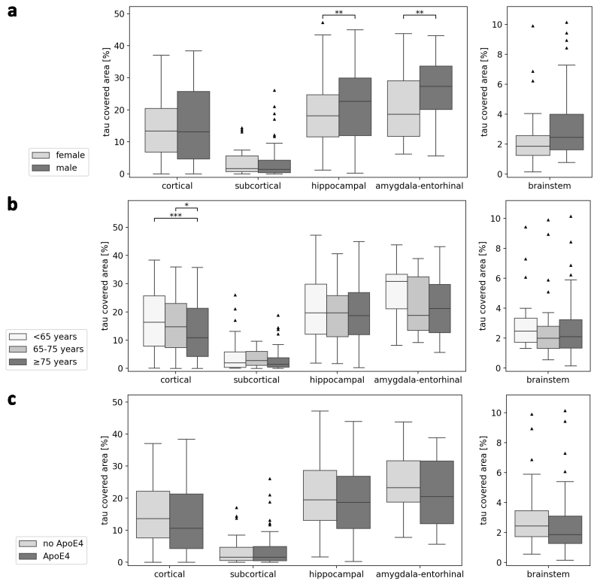
Fig. 2 Tau load split up by (a) sex, (b) age at death and (c) ApoE genotype in Alzheimer’s disease cases. Statistics were calculated with multiple linear regression across region clusters correcting for specific region names and with false discovery rate correction but without age or sex correction. ApoE4 means that at least one ApoE4 allele is apparent

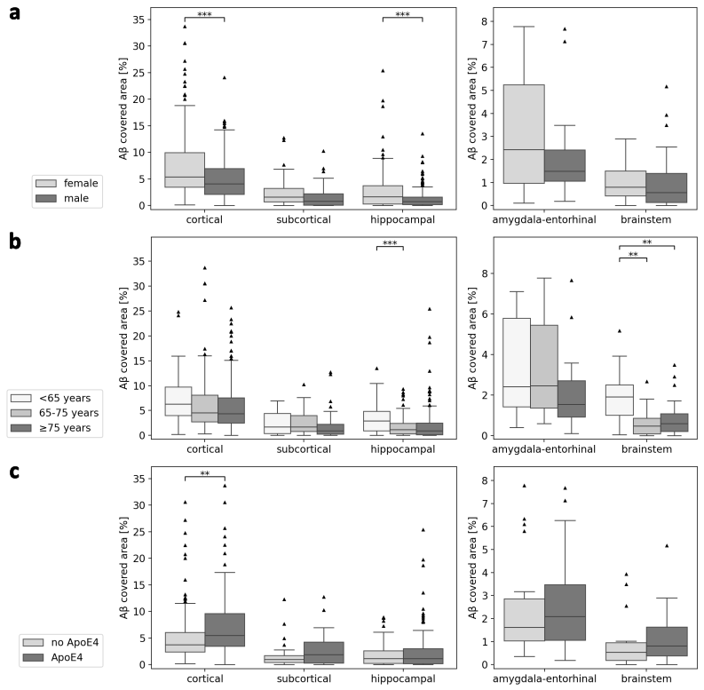
Fig. 3 Aβ load split up by (a) sex, (b) age at death and (c) ApoE genotype in Alzheimer’s disease cases. Statistics were calculated with multiple linear regression across region clusters correcting for specific region names and with false discovery rate correction but without age or sex correction. ApoE4 means that at least one ApoE4 allele is apparent

