Supplementary information

Screening and diagnosis algorithm

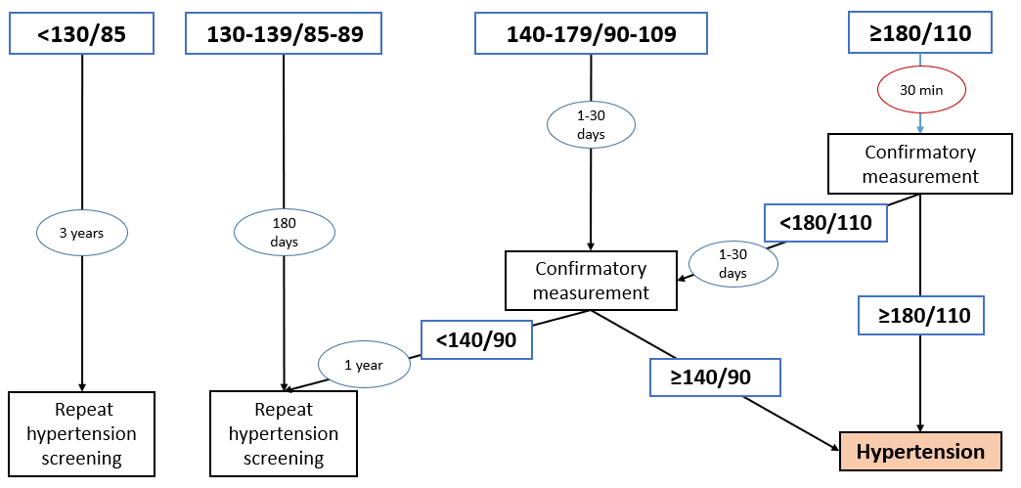

Supplementary information figure 1 Hypertension screening and diagnosis algorithm applied in all villages. People reporting the use of antihypertensive medication were considered as having hypertension independent of blood pressure values. People with hypertension and a blood pressure ≥140/90 were enrolled in the trial.

Intervention treatment algorithm
At every visit, the CHW documented the current medication, adherence, and BP values. If no contraindications were present, CHWs offered a fixed-dose combination pill containing amlodipine and hydrochlorothiazide according to the algorithm of the Lesotho Standard Treatment Guidelines⁵⁰ (extended data figure 3). Participants with a BP ≥140/90 mmHg under high-dose amlodipine/hydrochlorothiazide or with contraindications against amlodipine/hydrochlorothiazide or refusing medications offered by the CHW, were referred to the closest health facility. Follow-up visits for BP check-ups were scheduled after one months if the dose was adjusted during the index visit or after two months if the dose was not adjusted.
Participants with high CVD risk, and no contraindications were offered atorvastatin 10mg. High CVD risk among people with hypertension was defined as having a history of stroke or myocardial infarction, having diabetes or chronic kidney disease or being ≥50 years old and currently smoking or having a BMI ≥ 30 kg/m².
Participants with a history of myocardial infarction or stroke were offered aspirin 100mg.

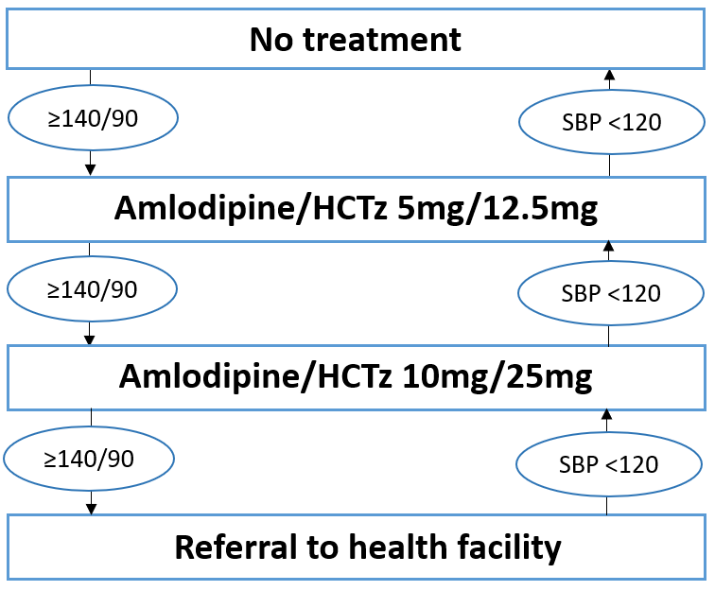
Supplementary information figure 2 Hypertension treatment algorithm applied by CHWs in the intervention villages. HCTz: hydrochlorothiazide; SBP: Systolic blood pressure.

