Supplementary Material for “Signals of an increasing drought condition in the Central Andes” by Nogueira et al. 2025

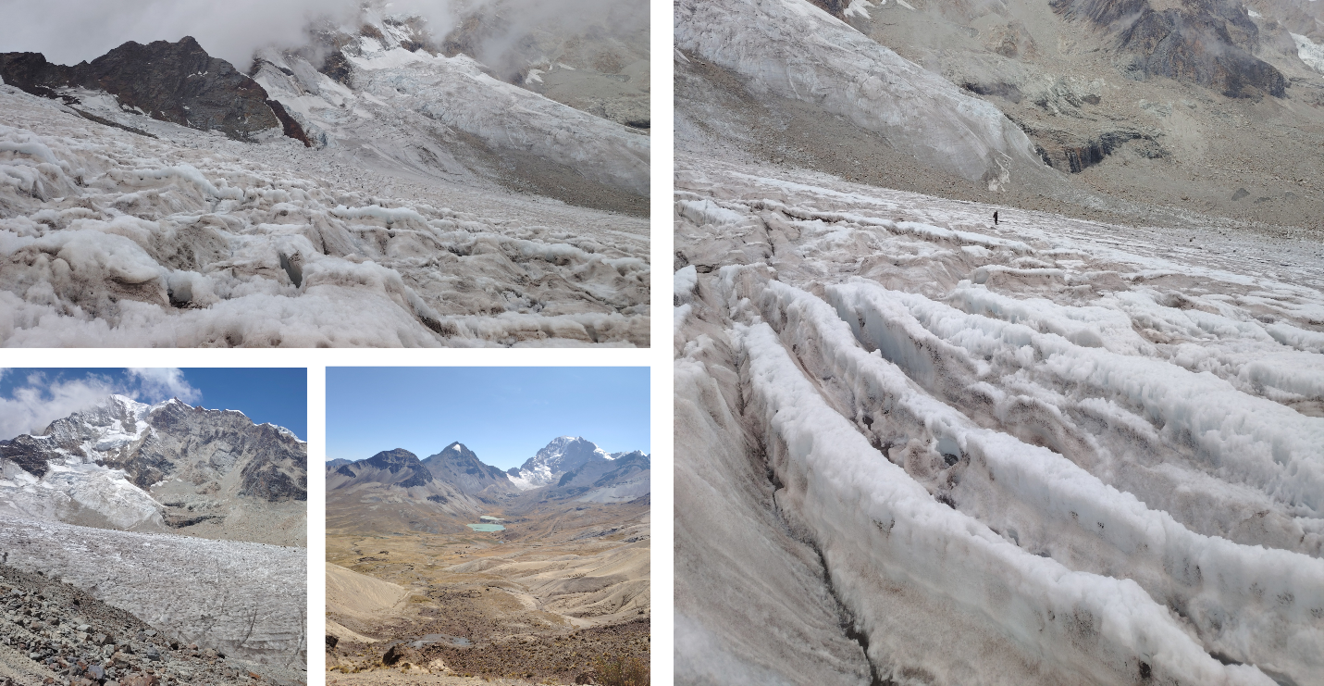
Figure S1. Wind-blown mineral deposits on the Huayna Potosí West glacier (October 2024), illustrating extensive coverage of grey-brown aeolian sediments across ice surfaces and crevasses, leading to visible surface darkening and reduced albedo.

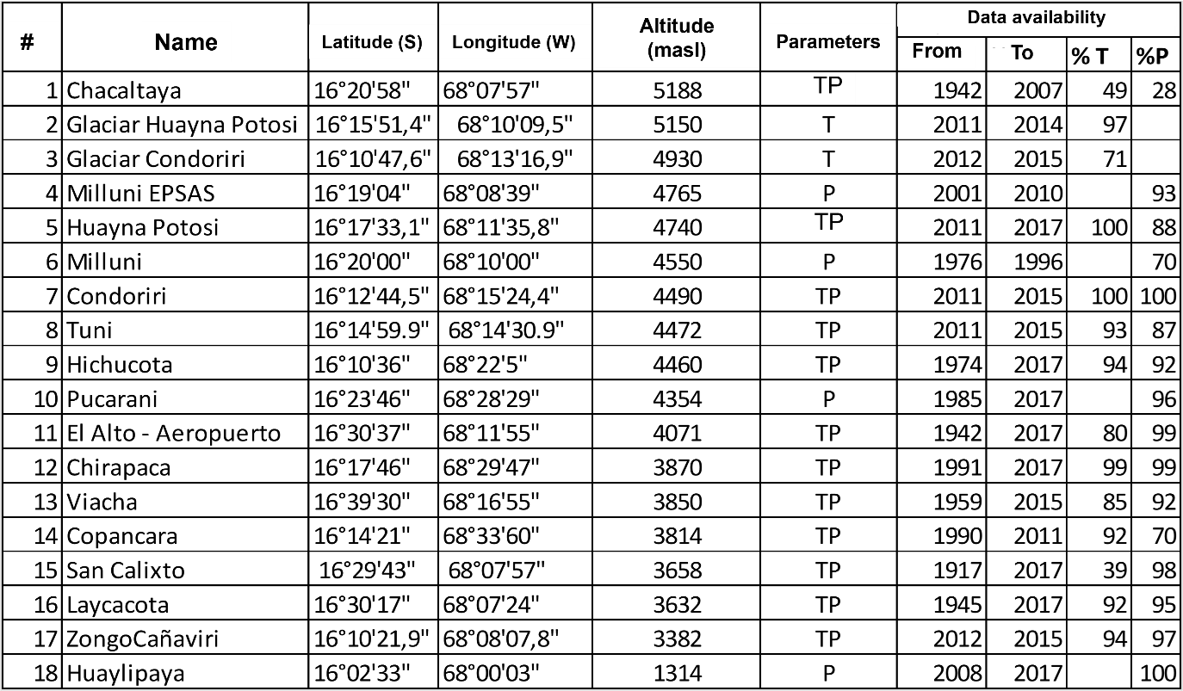
Table S1 – Metadata of the meteorological stations within a 50 km radius of Lake Tuni.

Figure S2 – (a) Temperature and (b) Precipitation anomaly from weather stations within a 50 km radius from Lake Tuni; and (c) Yearly Standardized Precipitation Evapotranspiration Index (SPEI) over the region -17.15, -69.25; -15.25, -67.25.
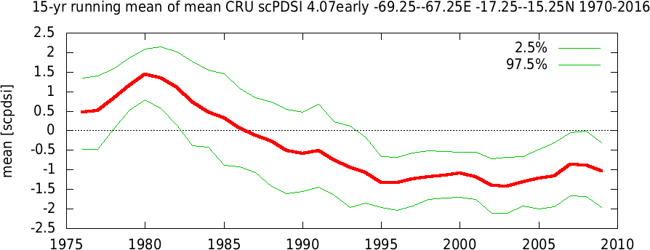
a
b
c
d
e
f
Figure S3 – (a – e) Palmer Drought Severity Index (PDSI) evolution from 1970 to 2014 for northwestern South America and (f) PDSI 15-year running mean for 17.25, -69.25; 15.25, -67.25 based on the CRU database.
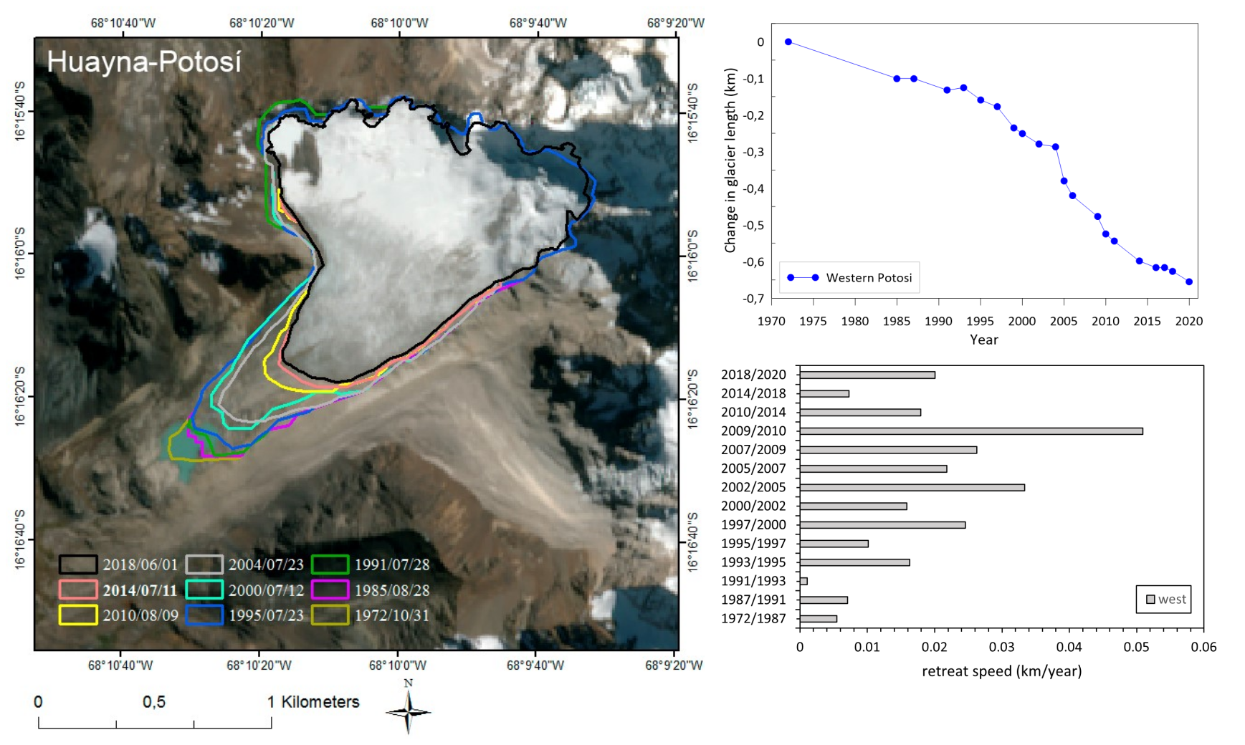
Figure S4 – (a) Huayna Potosi West glacier extension based on remote sensing imagery analysis from 1972 to 2018. (b) Changes in glacier length and (c) retreat speed.

Figure S5 – (a) Condoriri glacier extension based on remote sensing imagery analysis from 1975 to 2018. (b) Changes in glacier length and (c) retreat speed.

Figure S6 – (a) Jist'aña glacier extension based on remote sensing imagery analysis from 1975 to 2018. (b) Changes in glacier length and (c) retreat speed.

Figure S7 – Multiproxy record over time, showing microcharcoal particle concentration and average size (left, black and red lines), vegetation and hydrological variability indicators (Cyperaceae/Poaceae and Wetland/Open Vegetation indices, orange and blue), magnetic susceptibility (black line), and sediment provenance indices (Submontane/Montane and Submontane/Andean indices, green and magenta). Blue shading indicates increased input of allochthonous material.

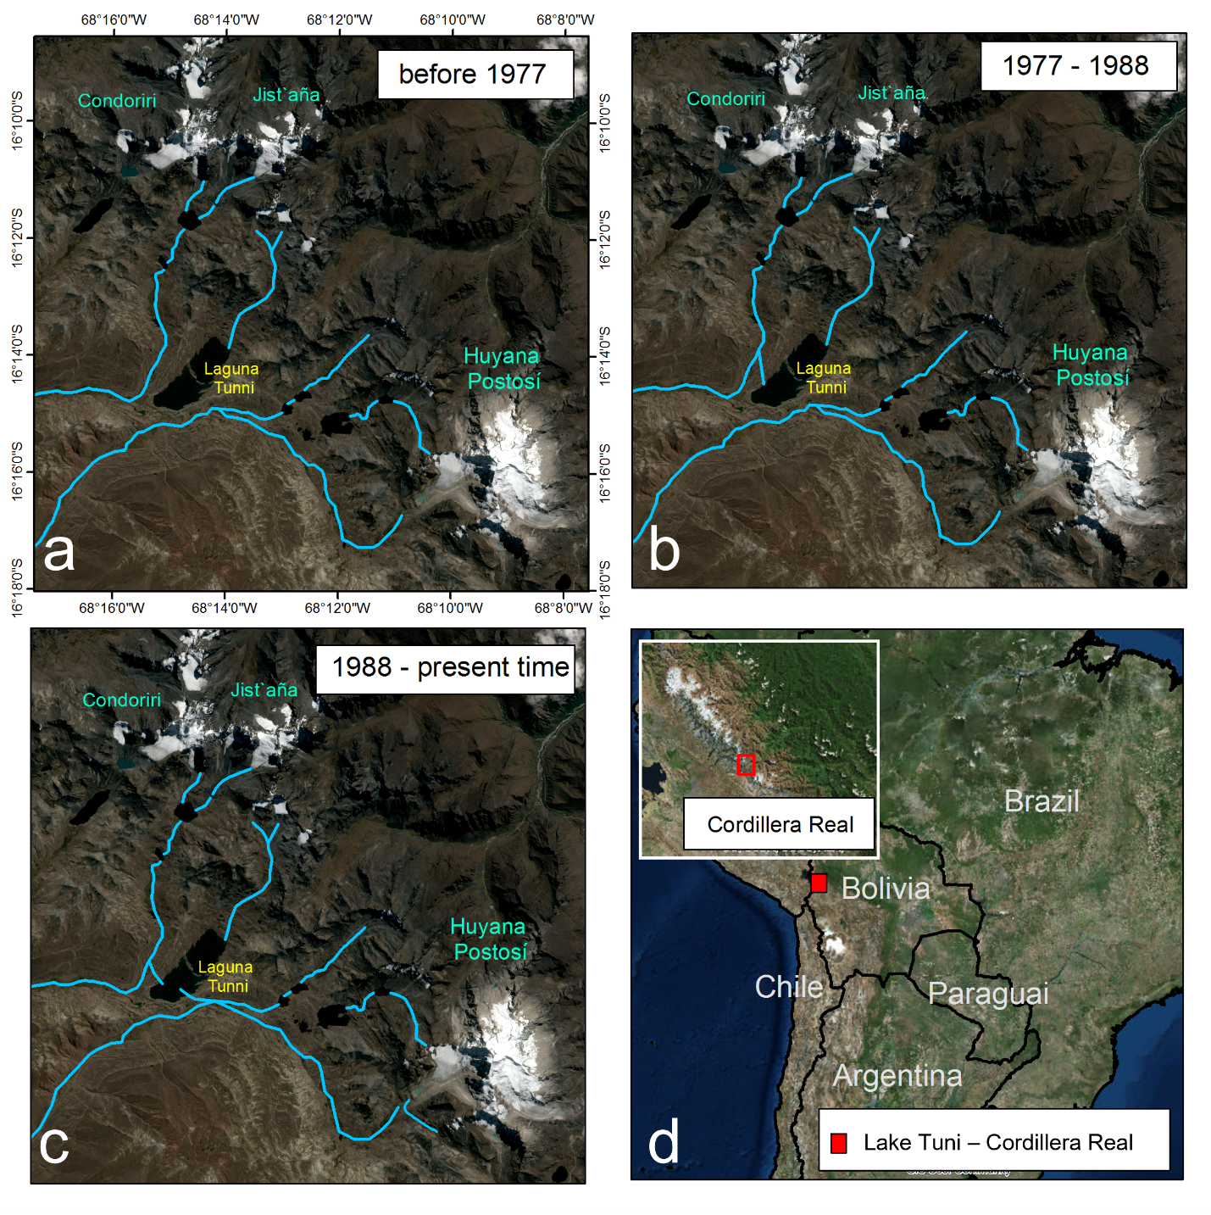Figure S8: Evolution of meltwater flowpaths feeding the proglacial Laguna Tuni in the Cordillera Real, Bolivia. Panels (a), (b), and (c) show the drainage networks (in blue) before 1977, between 1977 and 1988, and from 1988 to the present, respectively. The maps highlight the emergence of new meltwater pathways over time, consistent with enhanced glacial retreat and redistribution of runoff from the Condoriri, Jist’aña, and Huayna Potosí glacierized massifs. Panel (d) locates the study area within the Central Andes, with the red box indicating the Cordillera Real and the Laguna Tuni basin.

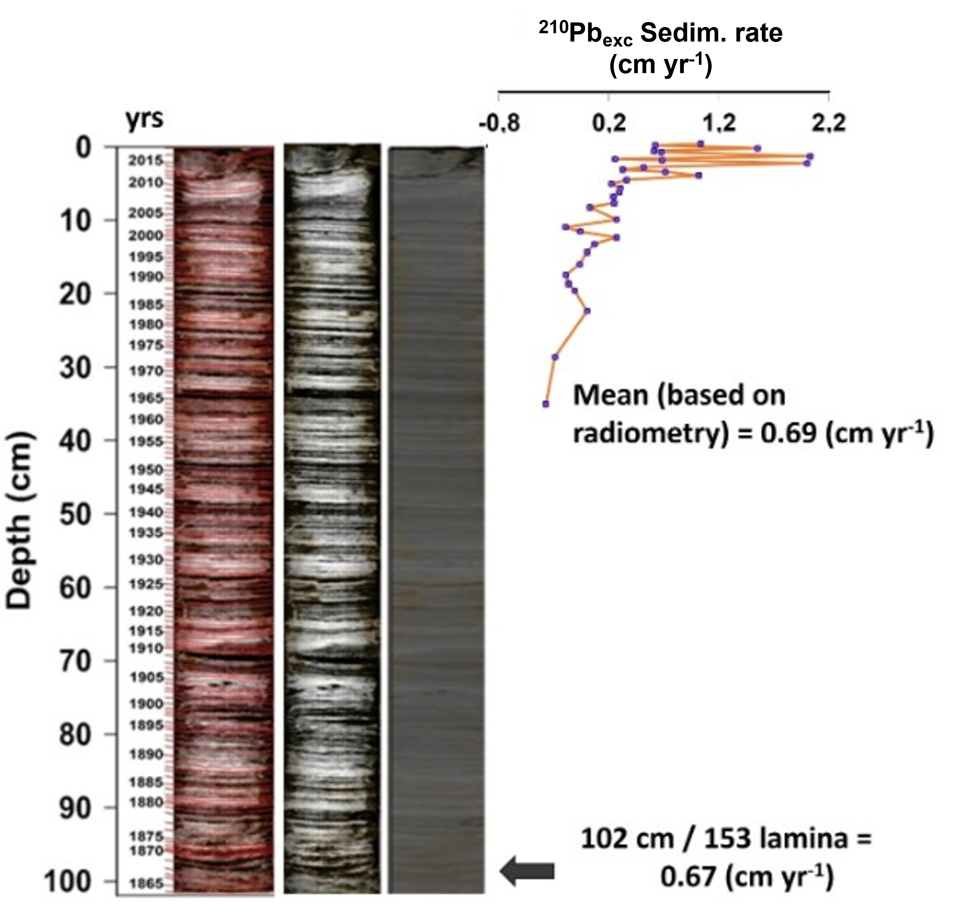
Figure S9: Sediment core chronology of Lake Tuni. In the upper part the estimate based on CRS model based on ²¹⁰Pb excess; In the bottom part, laminae counting over the 102 cm of the core.

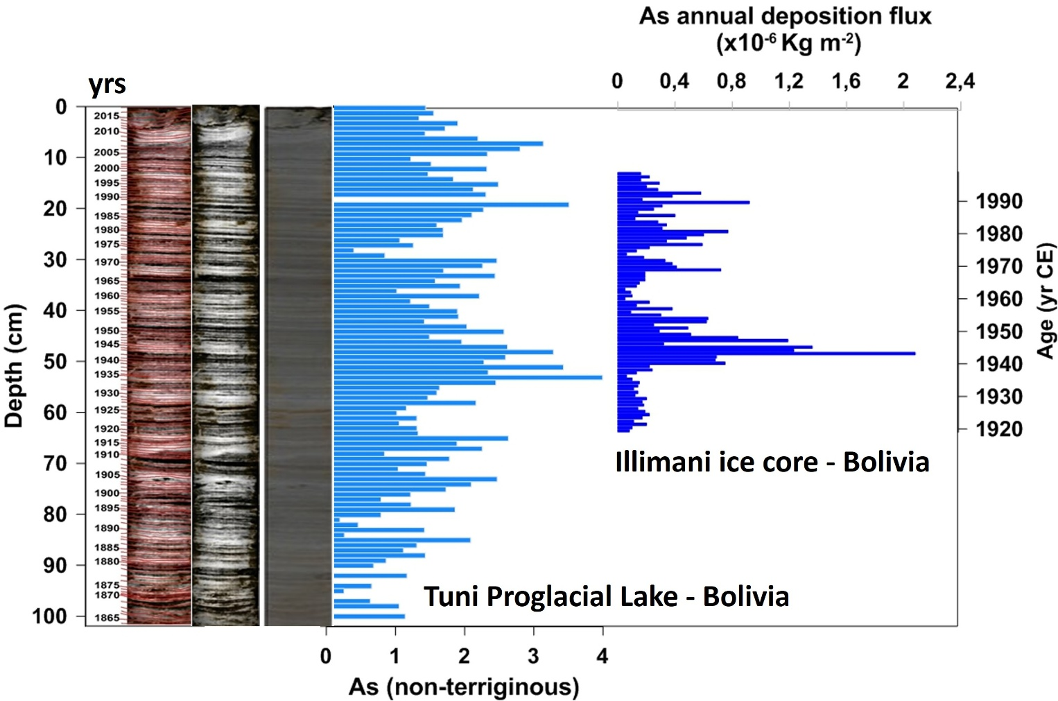
Figure S10: Comparison of As (non-terrigenous) along the Tuni sediment core (this issue) and dated total deposition flux of As at Nevado Illimani ice core (16°37’S, 67°46’W, 6350 m a.s.l.), situated in central-eastern Bolivian Andes (Cordillera Real), Correia (2003).

