Graphical Abstract
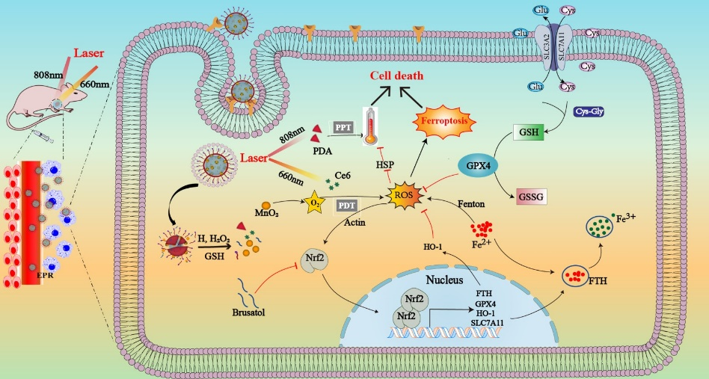
By combining boosted ROS levels and inhibition of antioxidation in tumor cells, synergistic phototherapy is greatly enhanced. Increasing ROS levels was achieved by relieving hypoxia with MnO₂, it activated antioxidation was avoided by inhibiting Nrf2 with brusatol, which simultaneously induces ferroptosis, markedly improving the therapeutic effects in the phototherapy.

