Supplementary Data
Integration strategy of ROS Boosting and Antioxidation Inhibiting Initiates Ferroptosis to Enhance Phototherapic Effect on Tumor
Weiwei Tao^{a, c}, Neng Wang^{f}, Jie Ruanª, Yue Huª, Chao Wang^{b}, Chuntao Che^{d}, Dongdong Sun^{a,} *, Jinao Duan^{c,} *, Ming Zhao^{c,} *
ª Department of Integrated Chinese and Western Medicine, School of Chinese Medicine & School of Integrated Chinese and Western Medicine, Nanjing University of Chinese Medicine, Nanjing 210023, China
b Institute of Functional Nano & Soft Materials (FUNSOM), Jiangsu Key Laboratory for Carbon-based Functional Materials and Devices, Soochow University, Suzhou 215123, China
^{c} Jiangsu Collaborative Innovation Center of Chinese Medicinal Resources Industrialization, and National and Local Collaborative Engineering Center of Chinese Medicinal Resources Industrialization and Formulae Innovative Medicine, Nanjing University of Chinese Medicine, Nanjing 210023, China
^{d} Department of Pharmaceutical Sciences, College of Pharmacy, University of Illinois at Chicago, Chicago, IL 60612, USA
^{f} Institute of Advanced Synthesis, School of Chemistry and Molecular Engineering, Jiangsu National Synergetic Innovation Center for Advanced Materials, Nanjing Tech University, Nanjing 211800, China

*Corresponding Author(s): Ming Zhao, mingzhao@njucm.edu.cn; Dongdong Sun, sundd@njucm.edu.cn; Jinao Duan, dja@njucm.edu.cn

Experimental section
Materials. Tetraethoxysilane (TEOS, 98%), hexyltriethoxysilane (HTES, 98%) KMnO₄ (≥ 99%), ammonium hydroxide (NH₃·H₂O), dopamine hydrochloride (DA·HCl, 98%), hydrogen peroxide (H₂O₂, 30%), 9,10-anthracenediyl-bis(methylene)dimalonic acid (ABDA), Hoechst (98%), phalloidin (98%), 4’,6-diamidino-2-phenylindole dihydrochloride (DAPI), and 2’,7’-dichlorodihydrofluorescein diacetate (DCFH-DA, ≥ 97%) were purchased from Sigma-Aldrich. 3-(4,5-Dimethylthiazol-2-yl)-2,5-diphenyltetrazolium bromide (MTT, 98%) was purchased from Invitrogen. Chlorin e6 (Ce6, 98%) was supplied by Xi’an Ruixi Biological Technology. Brusatol was purchased from Tauto Biotech (Shanghai, China). Hydrochloric acid (HCl, 36%–38%), ethanol (≥ 99.7%) and dimethyl sulfoxide (DMSO, > 99.8%) were purchased from Sinopharm Chemical Reagent Company. FA-PEG-SH (M_{w} = 3,400 Da, 95%) and HO-PEG-SH (M_{w} = 3,400 Da, 95%) were supplied by Shanghai Aladdin Chemistry Company. The pancreatic cancer cell line Mia-PaCa-2 was obtained from the China Center for Type Culture Collection (CCTCC). All reagents were used as received without any purification. Aqueous dilutions were prepared with deionized (DI) H₂O. All other chemicals and reagents were of the highest quality commercially available and were used as received.
Materials characterization. Transmission electron microscopy (TEM; HT7800, Hitachi, acceleration voltage = 100 kV) was applied to characterize the morphology and structure of the nanoparticles (NPs). UV–vis spectra were measured with a PerkinElmer Lambda 750 UV–vis-NIR spectrophotometer. The sizes and zeta potentials of the NPs were determined with a Malvern Zetasizer (Zetasizer Nano ZS, Malvern, UK). Dissolved O₂ was measured with an oxygen probe (JPBJ-608 portable Dissolved Oxygen Meters, Shanghai REX Instrument Factory). The flow cytometry assay was performed on a flow cytometer (Guava easyCyteTM). Confocal images were obtained by confocal laser scanning microscopy (Olympus IX 70 inverted microscope).
Release of Ce6 and brusatol. The release of Ce6 from the BSMCPF NPs was monitored by UV-vis spectroscopy. To investigate the influence of the PDA coating on the release rate, 1 mL of BSMCPF NPs (Ce6 = 32.5 μg mL⁻¹) and 1 mL of BSMC NPs (Ce6 = 32.5 μg mL⁻¹) were dialyzed against PBS (pH=5.5, 9 mL). At different pH values (5.5 and 7.4) in the absence or presence of 100 μM H₂O₂, 1 mL of BSMCPF NPs was dialyzed against PBS (9 mL) to examine the triggered release of Ce6 in the simulated tumor microenvironment. At predetermined time points in the above experiments, the amount of released Ce6 was determined by UV-vis analysis by detecting the changes in UV-vis spectrum at 410 nm.
The release of brusatol was determined by the dialysis method. Specifically, BS NPs or BSMP NPs were dispersed in release medium (PBS containing 5% Tween 80, pH 7.4) with stirring. At different time points, the release of brusatol was measured by UV-vis analysis by detecting the changes in absorption at 280 nm.
Cell culture. The pancreatic cancer cell line Mia-PaCa-2 was cultured in Dulbecco’s modified Eagle medium (DMEM) supplemented with 10% fetal bovine serum, 1% antibiotics and 5% CO₂ at 37 °C under a humidified atmosphere.
Electron microscopy analysis. Mia-PaCa-2 cells or tumor tissues were fixed in 2.5% glutaraldehyde followed by 1% osmium tetroxide. Subsequently, the tissues were dehydrated in an alcohol series, embedded and finally sliced for electron microscopy.
Fluorescence and IR images. IR images of the mice were obtained with an IR thermal camera 12 h postinjection, and the center of the tumor area was exposed to an NIR laser (808 nm, 2.0 W cm⁻²) for 10 min. Thermal images were captured every two minutes with an IR camera (TiS55, Fluke). Fluorescence images of the mice were acquired with an NIR imaging system at different time intervals postinjection. The major organs (i.e., heart, liver, spleen, kidney, and lung) and tumors were imaged 24 h postinjection.

Figure S1-S21:
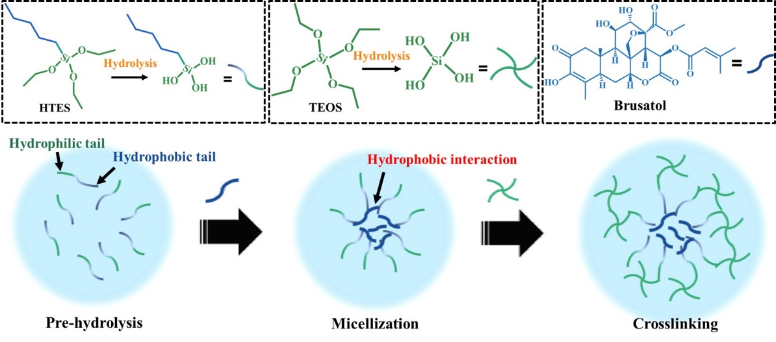
Figure. S1. Schematics illustrating the loading of brusatol into the silica network by the surfactant-assisted coassembly method.
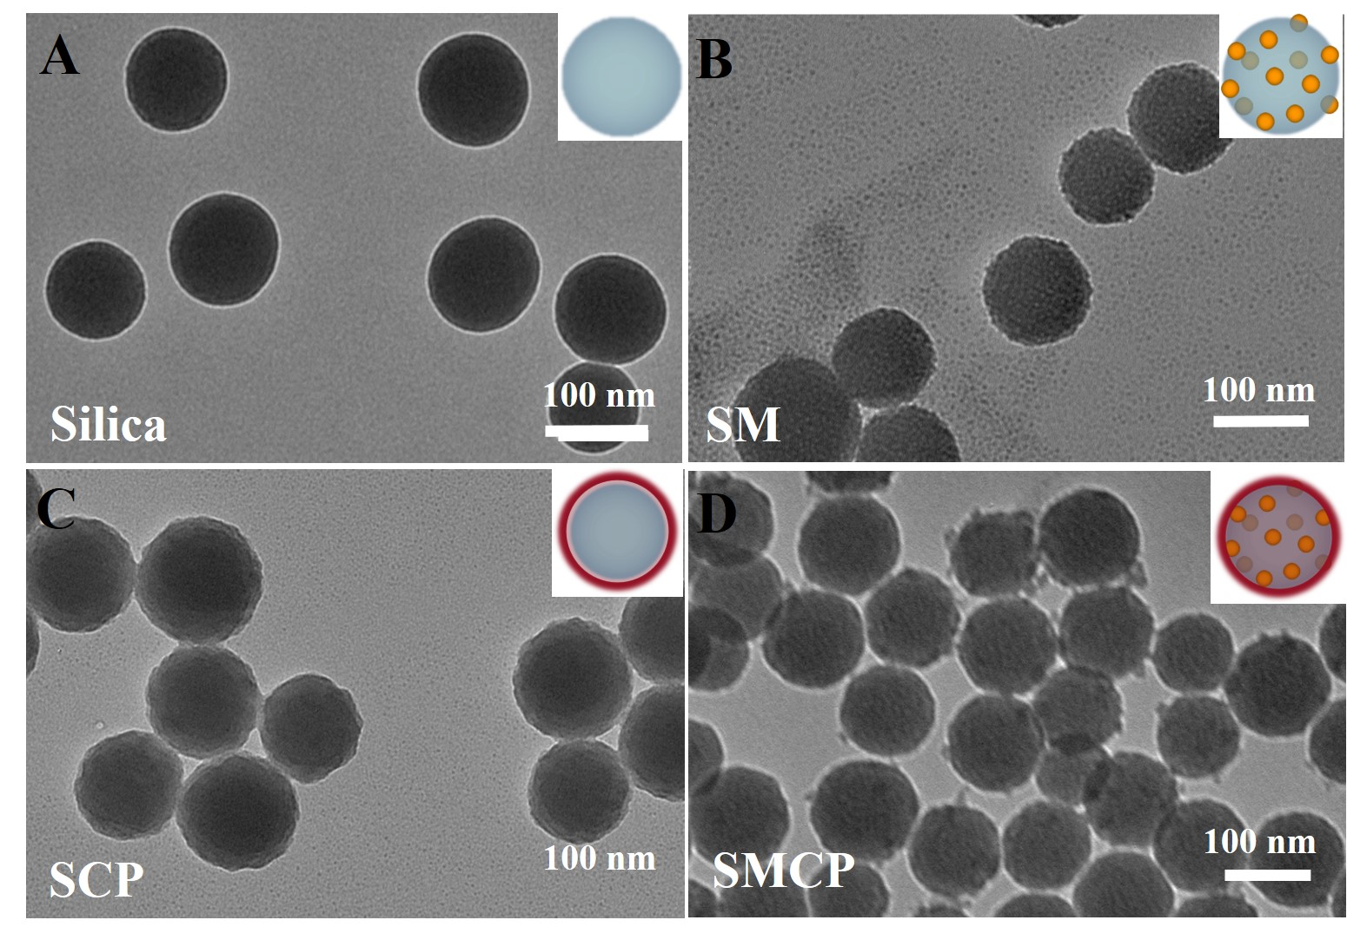
Figure. S2. TEM picture and schematic diagrams of (A) silica NPs, (B) SM NPs, (C) SCP NPs, and (E) SMCP NPs.

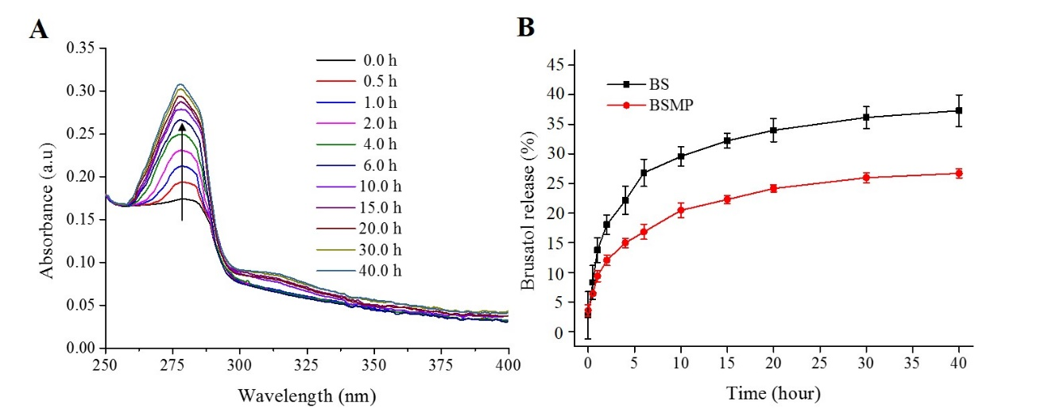
Figure. S3. (A) Temporal change in the UV-vis absorption spectra during the brusatol release experiment. (B) Controlled release of brusatol from BS and BSMP.

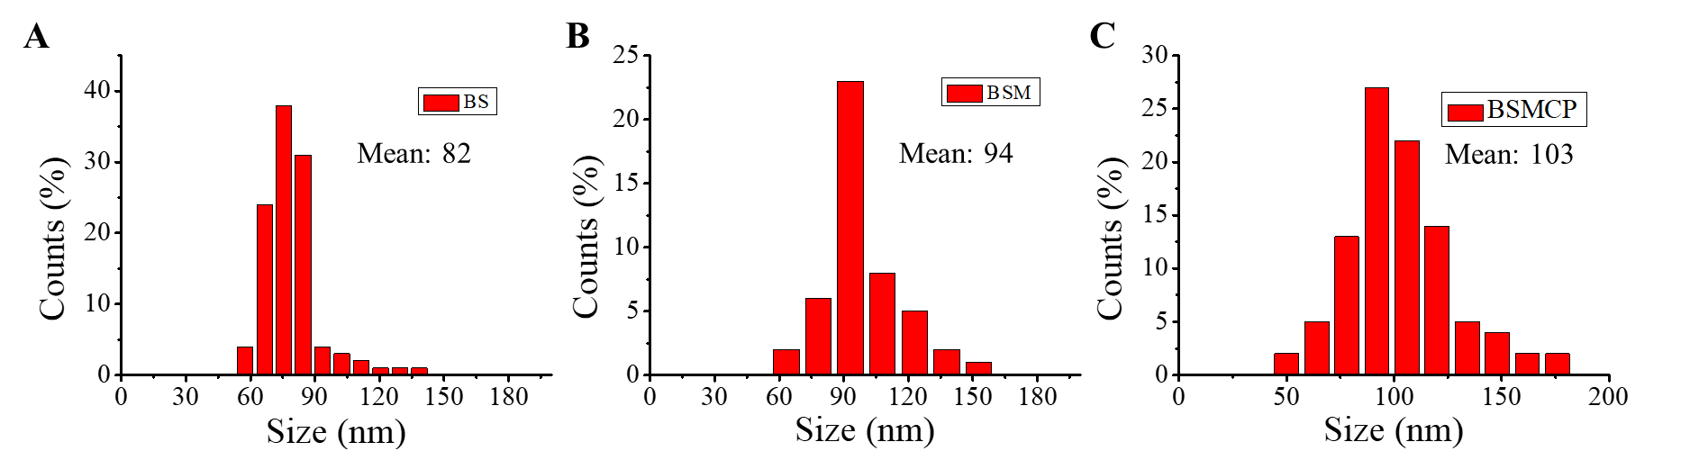
Figure. S4. Size distribution of (A) BS NPs, (B) BSM NPs and (C) BSMCP NPs counted from TEM images.
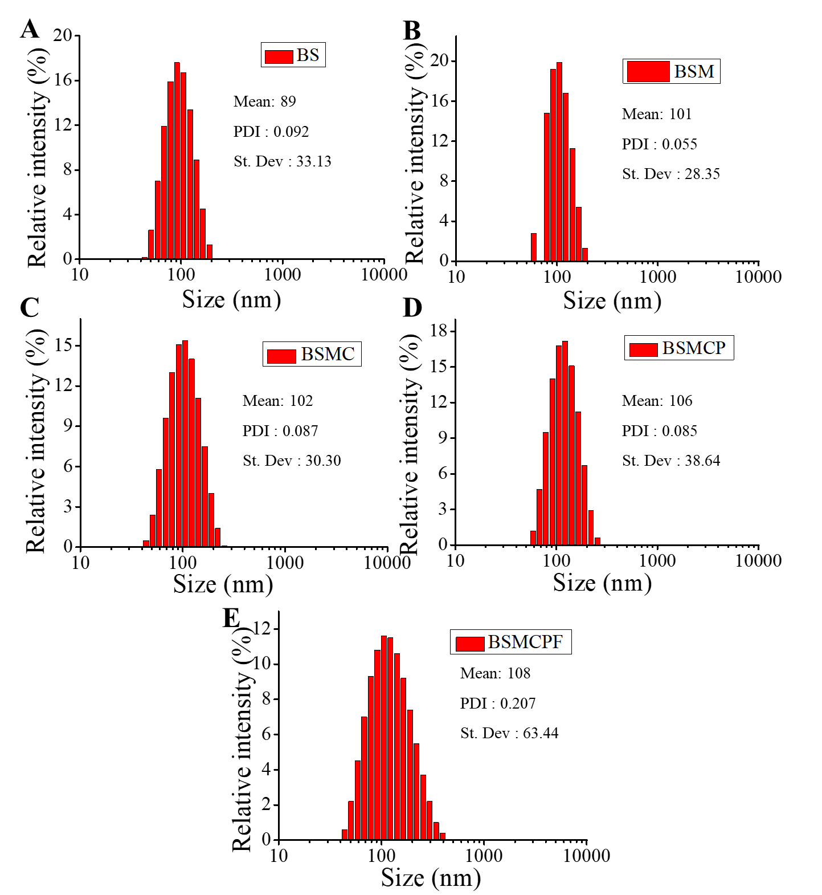
Figure. S5. The size distribution of (A) BS NPs, (B) BSM NPs, (C) BSMC NPs, (D) BSMCP NPs and (E) BSMCPF NPs counted from DLS analysis.

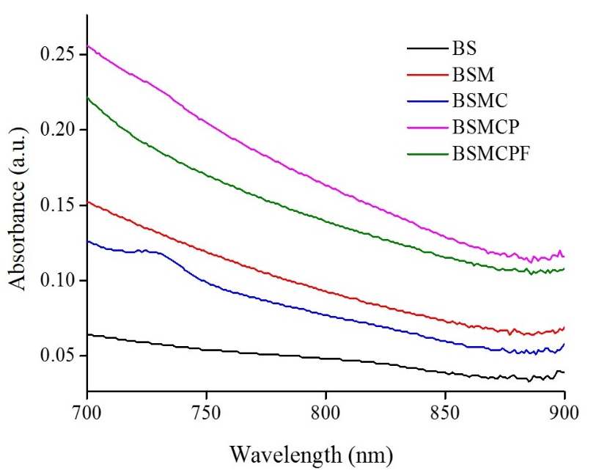
Figure. S6. Magnified UV-vis absorption curves of the different NPs in the NIR region.

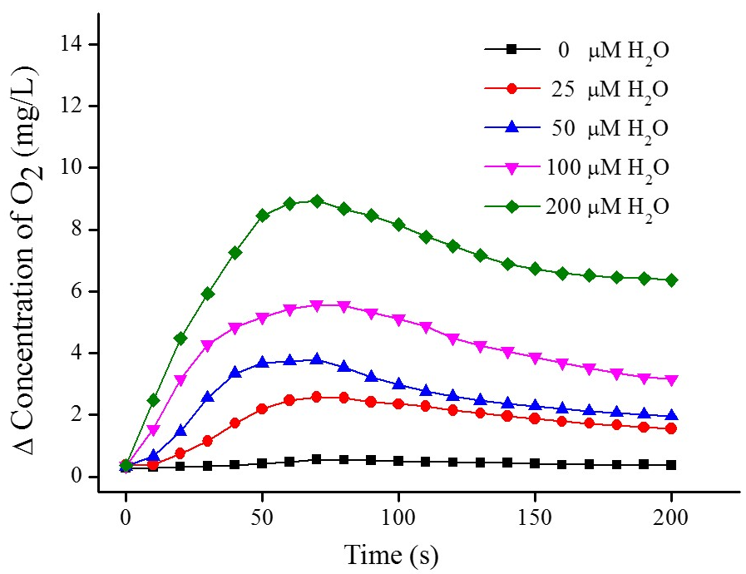
Figure. S7. Oxygen generation performance of the BSMCPF NPs under different concentrations of H₂O₂.

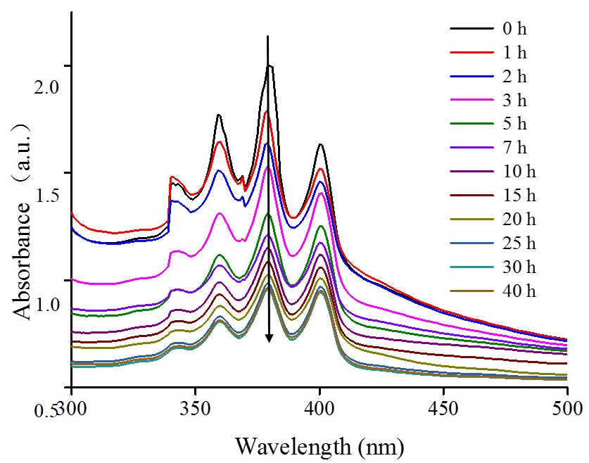
Figure. S8. Time-dependent change in the UV-vis absorption of ABDA for the detection of ROS produced by the BSMCPF NPs under 660 nm laser irradiation.

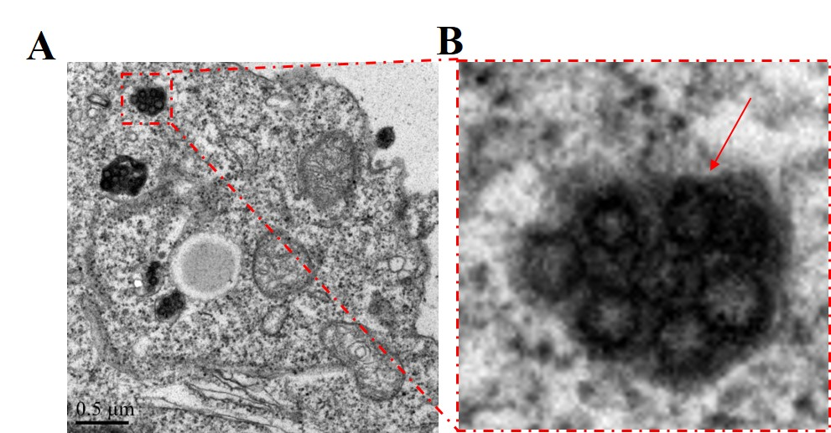
Figure. S9. (A) Low magnification TEM images of the intracellular SCPF NPs. (B) High magnification TEM images of the intracellular SCPF NPs.

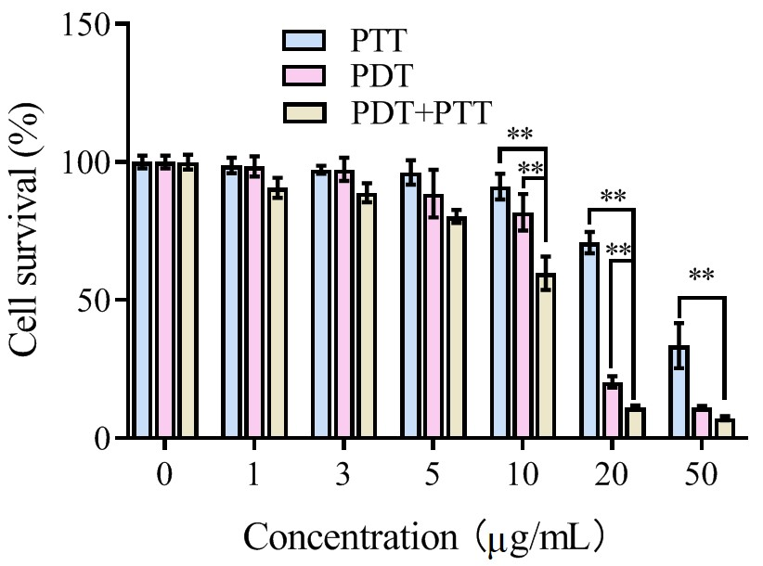
Figure. S10. Viability of Mia-PaCa-2 cells after incubation with various concentrations of SMCPF NPs for 4 h with irradiation.

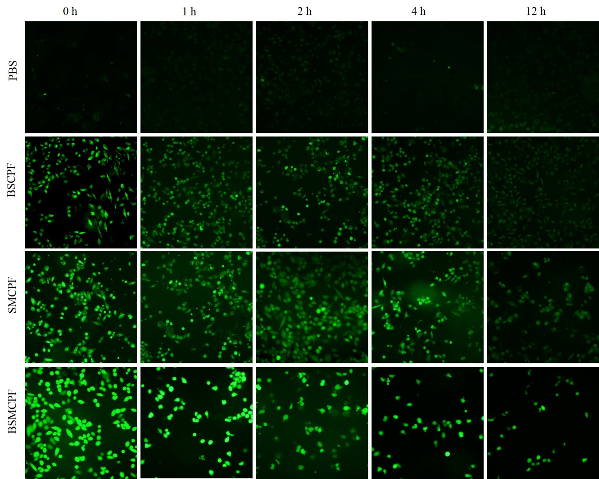
Figure. S11. CLSM images of intracellular ROS generation in Mia-PaCa-2 cells treated with different samples at different time points.

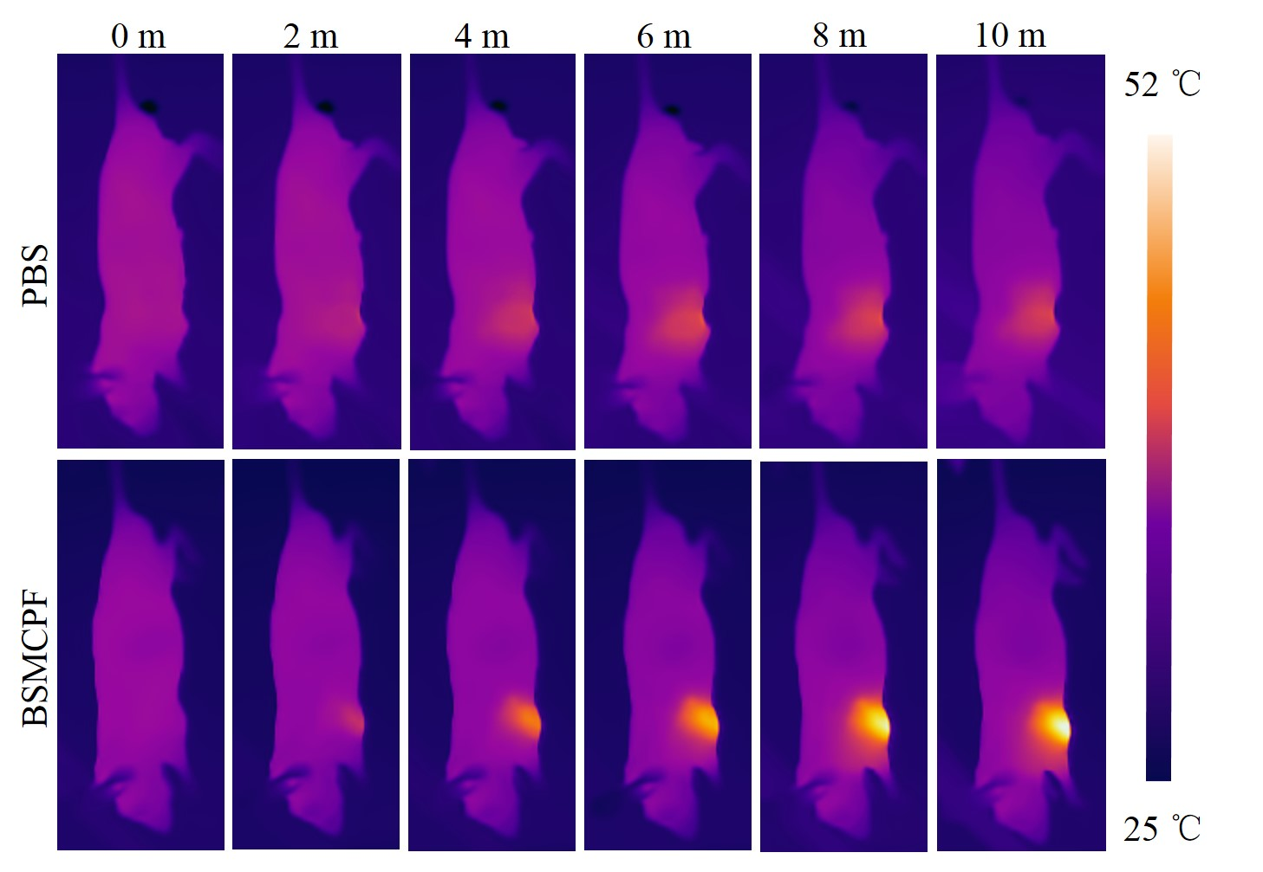
Figure. S12. IR thermal imaging of tumors after exposure to an 808 nm laser (2 W cm⁻²) for 10 min after injection of PBS or BSMCPF NPs.

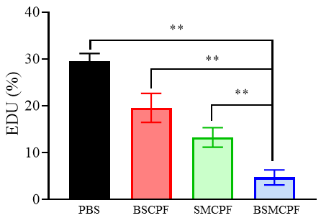
Figure. S13. Statistical histogram of EDU for the detection of cell proliferation in Mia-PaCa-2 cells treated with PBS, BSCPF NPs, SMCPF NPs and BSMCPF NPs.

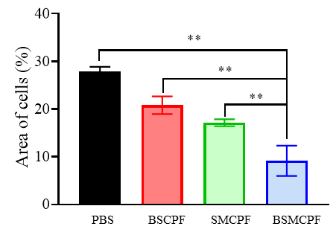
Figure. S14. Statistical histogram of the cell migration area in Mia-PaCa-2 cells treated with PBS, BSCPF NPs, SMCPF NPs and BSMCPF NPs.

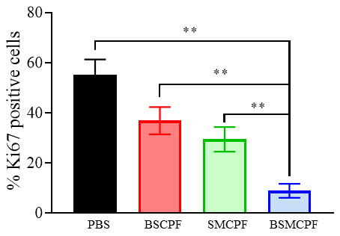
Figure. S15. Statistical histogram of Ki67 staining for tumor proliferation in Mia-PaCa-2 cells treated with PBS, BSCPF NPs, SMCPF NPs and BSMCPF NPs.

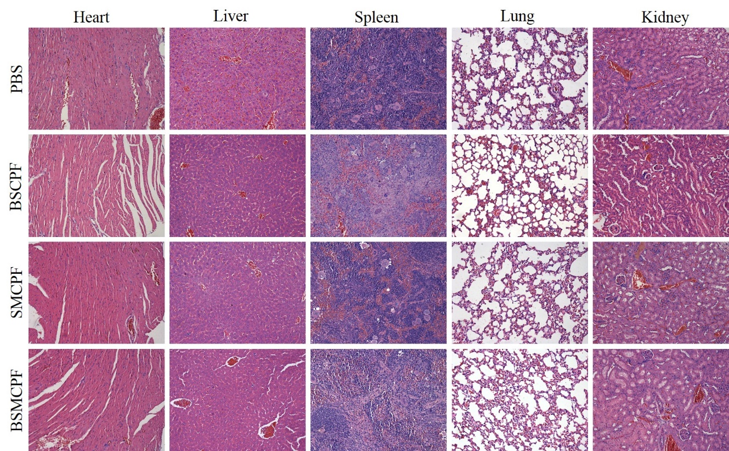
Figure. S16. H&E stained images H&E stained images of the major organs from the PBS, BSCPF, SMCPF, and BSMCPF groups.

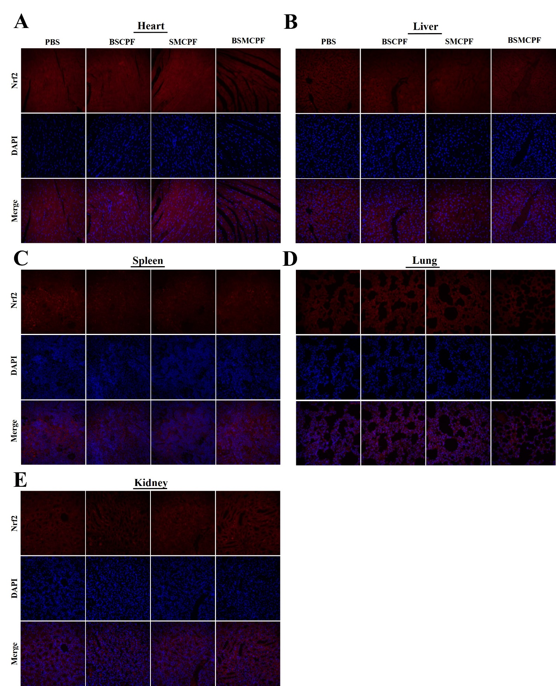
Figure. S17. Nrf2 immunofluorescence of the major organs, including (A) Heat, (B) Liver, (C) Spleen, (D) Lung, (E) Kidney, from the PBS, BSCPF, SMCPF and BSMCPF groups.
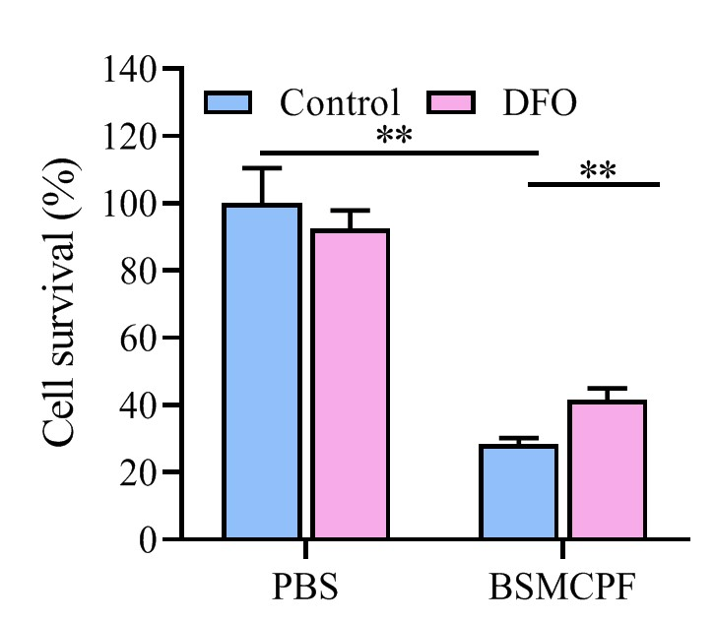
Figure. S18. Statistical histogram of the cell survival rates with or without DFO.

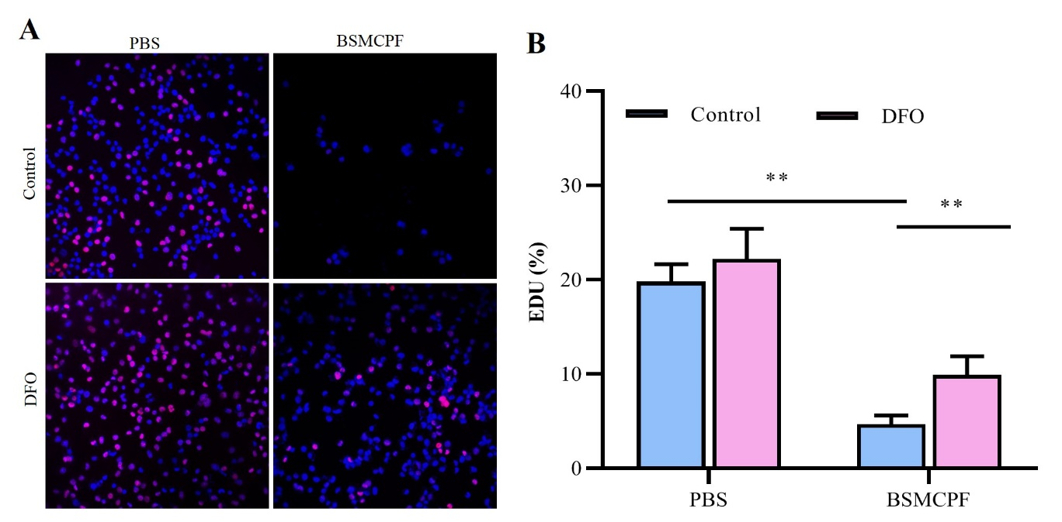
Figure. S19. (A) Detection of cell proliferation in Mia-PaCa-2 cells by an EDU assay. (B) Statistical histogram of EDU with or without DFO.
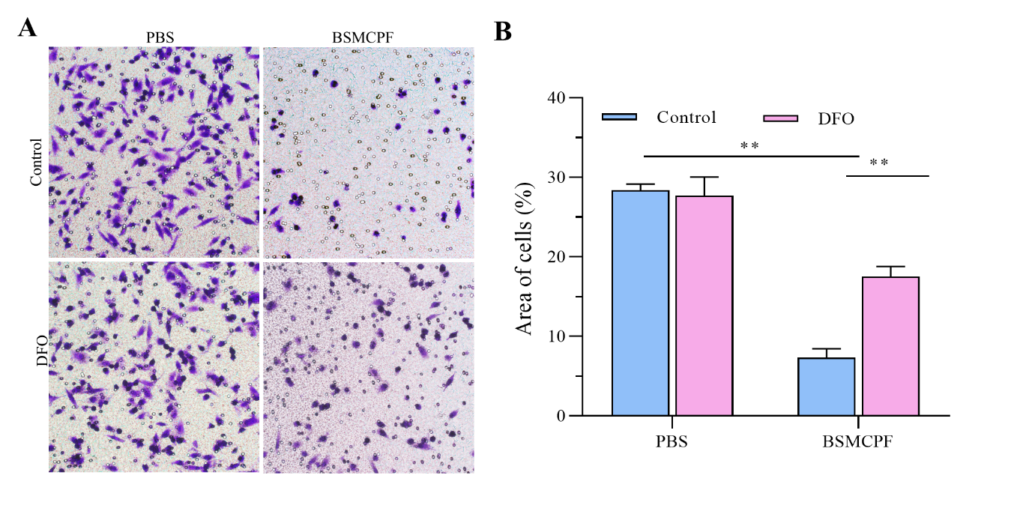
Figure. S20. (A) Detection of the area of invasion in Mia-PaCa-2 cells treated with PBS or BSMCPF NPs with or without DFO. (B) Statistical histogram of the invasion area.
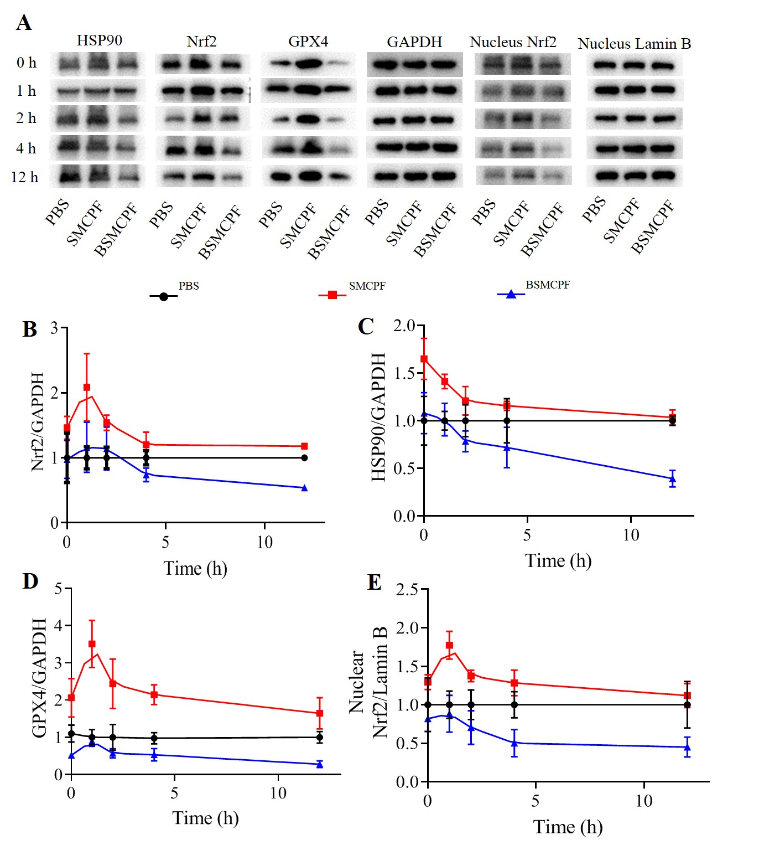
Figure. S21. (A) WB of the expression of Nrf2 and its downstream proteins in Mia-PaCa-2 cells treated with PBS, SMCPF NPs and BSMCPF NPs at different time points. (B-E) Statistical trend of the proteins expression levels over time.

