Supplementary Information
Half-Quantized Layer Hall Effect as a Probe of Quantized Axion Field

Jiayuan Hu^{1†}, Binbin Wang^{1†}, Humian Zhou^{2†}, Tongtong Jia³, Zheng Sun³, Chang Liu³, Bo Zhang³, Dong Qian³, Tingxin Li³, X. C. Xie², Yunchuan Kong¹, Chui-Zhen Chen^{4,5*} and Di Xiao^{1*}

¹Huawei Technologies Co., Ltd., Shanghai 201206, China
²International Center for Quantum Materials, School of Physics, Peking University, Beijing 100871, China
³Key Laboratory of Artificial Structures and Quantum Control (Ministry of Education), Tsung-Dao Lee Institute, School of Physics and Astronomy, Shanghai Jiao Tong University, Shanghai 200240, China
⁴Interdisciplinary Center for Theoretical Physics and Information Sciences, Fudan University, Shanghai 200433, China
⁵Hefei National Laboratory, Hefei 230088, China
⁶School of Physical Science and Technology, Soochow University, Suzhou 215006, China
⁷Institute for Advanced Study, Soochow University, Suzhou 215006, China

†These authors contribute equally to this work.
*Emails: czchen@suda.edu.cn, xiaodi12@hisilicon.com

Contents:
- Basic characterization of the MBE grown CBV sandwich heterostructures
- Geometries of the Hall bar devices
- Symmetrization and anti-symmetrization of the transport data
- Theoretical model of magnetization switching behavior in CBV and VBC Devices
- Quantization deviation analysis
- Discussion on other AHC mechanisms
- Estimation of the exchange gap sizes
- Characteristics of all devices measured in this study

- Basic characterization of the MBE grown CBV sandwich heterostructures
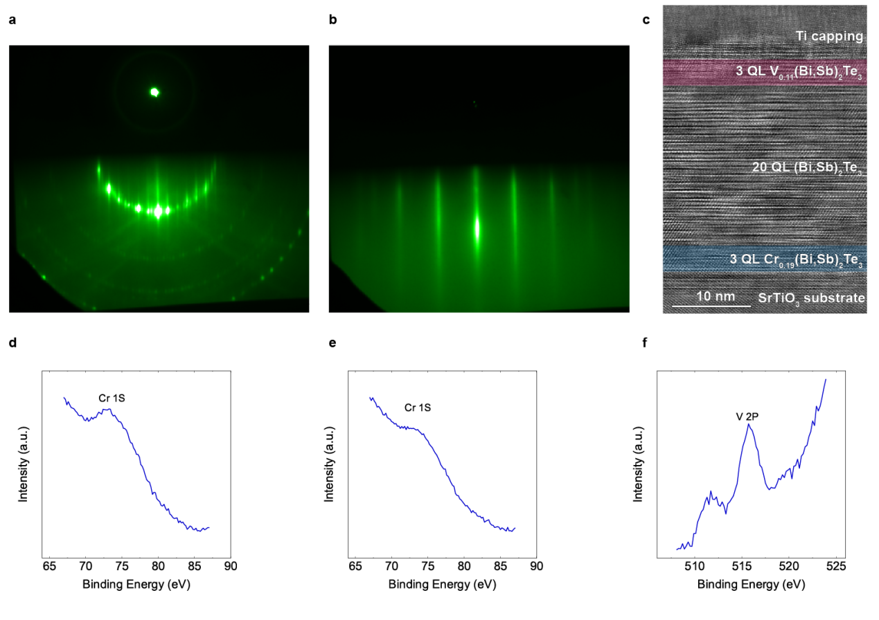
Fig. S1 | Characterization of the MBE grown CBV sandwich heterostructures. a, RHEED pattern of a typical 2-step annealed SrTiO3 substrate prior to MBE growth of TI films. b, RHEED pattern of a CBV sample (m = 10, x = 0.19, y = 0.11, η = 0.83) after finishing the growth. The sharp and streaky 1x1 pattern is a sign of high-quality TI film. c, A transmission electron microscopy (TEM) image of a CBV sample (m = 20, x = 0.19, y = 0.11, η = 0.83). The signals from Cr (marked by blue region) and V (pink region) doping elements under the energy-dispersive spectroscopy are dim due to the dilute doping concentrations. The titanium capping on the surface caused intermixing of Ti and TI, obscuring the layered structure near the V-doped region. d, e, f, XPS data for the doping concentrations of calibration samples (with nominally the same growth parameters with Devices studied in the main text), with fitting results of d x = 0.19, e x = 0.34, and f y = 0.11. The lower V concentration of Device C1 y = 0.03 is estimated according to the beam equivalent pressure (BEP) measurement instead.

- Geometries of the Hall bar devices
As described in Methods, each scratched Hall bar dimensions (width W and length L) was measured using the optical microscope imaging system prior to low temperature transport measurements (a device is shown in Fig. S2). We first conduct symmetrization and anti-symmetrization of the original data, as described in Section iii of the Supplementary Information (SI), for $R_{xx}={V_{xx}}/{I_{ex}}$, $R_{yx}={V_{yx}}/{I_{ex}}$, respectively. $Here,$ $V_{xx}$ is the longitudinal voltage, $V_{yx}$ is the Hall voltage, and $I_{ex}$ is the excitation current (~10 nA). The (anti)symmetrized resistance data are then converted to resistivity using the relations $ρ_{xx}=\frac{W}{L}R_{xx}$ and $ρ_{yx}=R_{yx}$. Small measurement errors in the device geometries are inevitable. We estimate that the resulting uncertainty in the $σ_{xy}$ ($σ_{xy}$is calculated using $σ_{xy}=ρ_{xy}/(ρ_{xx}^{2}+ρ_{xy}^{2}))$ is less than 1.0%, suggesting that the observed deviations from half-quantization in the half-quantized layer Hall effect (HQLHE) state are likely due to other mechanisms as discussed in the main text and SI section v.
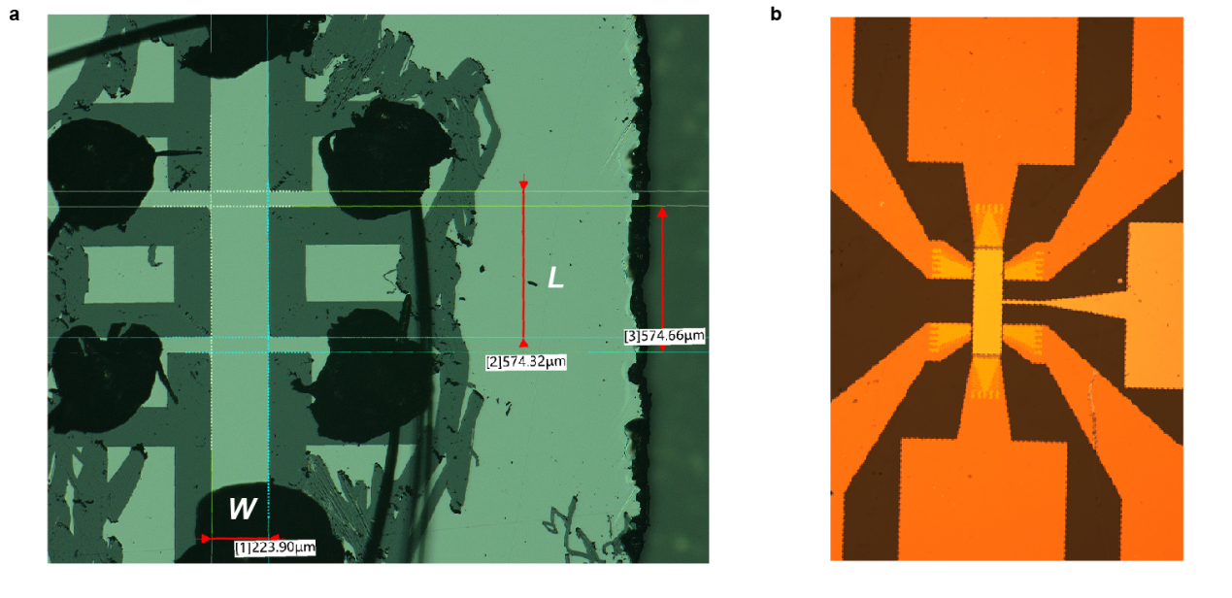
Fig. S2 | Optical images of 2 type of Hall bar devices. a, Tungsten tip scratched Hall bar on a SrTiO₃ substrate. The dimensions were measured by the optical imaging system, as indicated by the labels. The width W is 223.9 μm, and the length L is averaged 574.5 μm. b, Dual-gated Hall bar device fabricated through standard optical lithography, dry etching, and metal deposition processes.

- Symmetrization and anti-symmetrization of the transport data
We employ standard symmetrization and anti-symmetrization procedures on the magneto-transport data to eliminate the mixing of longitudinal and Hall voltage signals. Unlike in the QAH case where the bulk is strictly insulating, the HQLHE exhibits a finite longitudinal conductance (usually 2~4 $h/{e^{2}}$), which will largely change the measured value of Hall resistance due to imperfect device geometries. As described above, although the Hall bar devices are carefully etched or scratched, such mixing can still occur due to the slight misalignment. Note that when the device is at the CNP (axion insulator), even small variations in temperature (a few mK) during measurements may introduce instability in the resistance data (e.g. some curves in Fig. S3a and Fig. S4a). However, these variations do not affect the calculated conductance results (both $σ_{xx}$ and $σ_{xy}$ almost vanish near CNP).
Therefore, the raw data are processed using the following procedures. For the magnetic field scan:
$$R_{xx}\left(μ_{0}H;→\right)=\frac{1}{2}\left[R_{xx}\left(μ_{0}H;→\right)+R_{xx}\left({-μ}_{0}H;←\right)\right];$$
$$R_{yx}\left(μ_{0}H;→\right)=\frac{1}{2}\left[R_{yx}\left(μ_{0}H;→\right)-R_{yx}\left({-μ}_{0}H;←\right)\right].$$
here, $→$ and $←$ denote the scanning direction of the magnetic field, and $μ_{0}H$ is the magnetic field. See Fig. S3 for an example of symmetrization and anti-symmetrization of Device A1’s (m = 20 QL, x = 0.19, y = 0.11, η = 0.83) data of magnetic field scan.
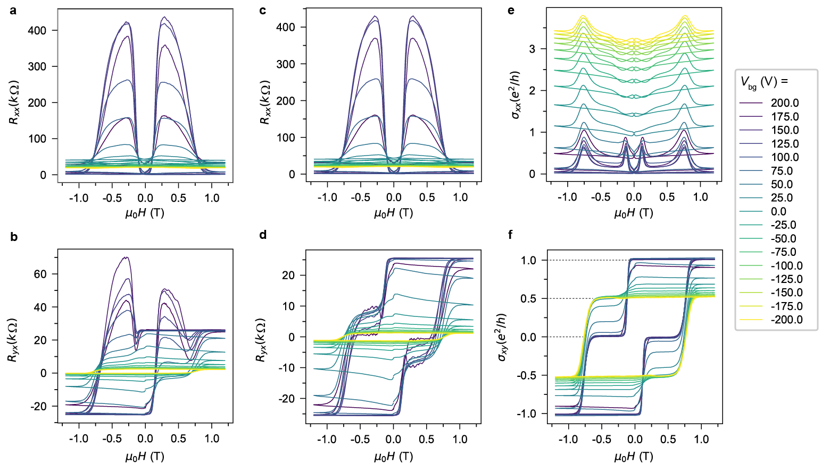
Fig. S3 | Symmetrization and anti-symmetrization of the magnetic field scan data. a, b, The original $R_{xx}$ and $R_{yx}$ vs magnetic field data for Device A1, measured at various bottom gate voltage $V_{bg}$. c, d, $R_{xx}$ and $R_{yx}$ vs magnetic field, after symmetrization and anti-symmetrization, respectively. e, f, $σ_{xx}$ and $σ_{xy}$ vs magnetic field calculated from processed data in c and d.

For the bottom gate voltage scan at zero magnetic field, in addition to the mixing effect of longitudinal and Hall data, the bottom gate dielectric SrTiO3 itself has some hysteresis effect. We overcome this effect by training the bottom gate from 200 V to -200 V several times before taking the data. We also take at least two traces of data at the same scanning speed and direction in order to check if these two runs of data overlap well. Then we choose the last run as the final accepted raw data. For the final process of symmetrization/anti-symmetrization:
$$R_{xx}\left(V_{bg};↑\right)=\frac{1}{2}\left[R_{xx}\left(V_{bg};↑\right)+R_{xx}\left(V_{bg};↓\right)\right];$$
$$R_{yx}\left(V_{bg};↑\right)=\frac{1}{2}\left[R_{yx}\left(V_{bg};↑\right)-R_{yx}\left(V_{bg};↓\right)\right].$$
where $↑$ and $↓$ denotes one magnetization configuration and its time-reversal counterpart, and $V_{bg}$ is the bottom gate voltage. See Fig. S4 for an example of symmetrization and anti-symmetrization of Device A1’s data of bottom gate voltage scan. The magnetic field were trained from parallel (+1.2 T) to antiparallel (-0.4 T to 0; configuration $↑$) to take data, then trained to parallel (-1.2 T) and finally to antiparallel (+0.4 T to 0; configuration $↓$) to take the second half of data.
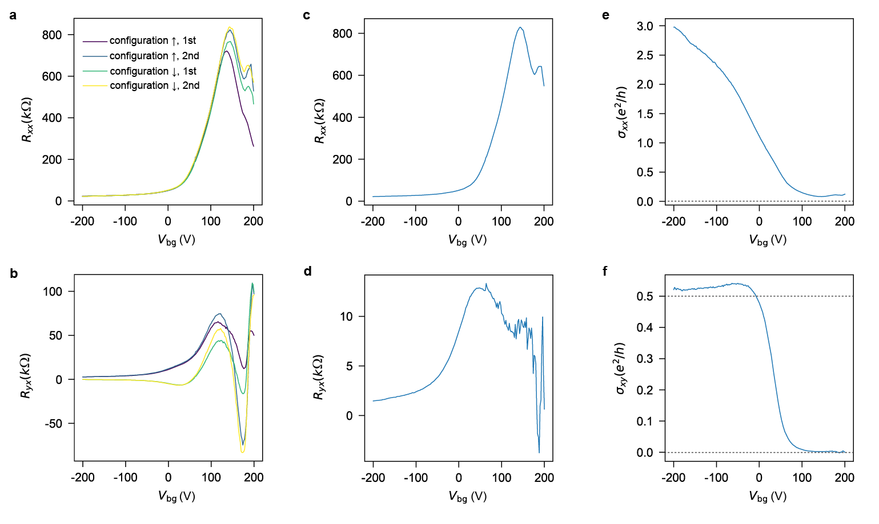
Fig. S4 | Symmetrization and anti-symmetrization of the transport data. a, b, The original $R_{xx}$ and $R_{yx}$ vs bottom gate voltage $V_{bg}$ data of Device A1. After gate training, 2 consecutive runs were taken from 200 V to -200V at each magnetic configuration. Here $↑$($↓$) denotes antiparallel with surface magnetization direction pointing outwards (inwards). c, d, $R_{xx}$ and $R_{yx}$ vs bottom gate voltage data after symmetrization and anti-symmetrization from the 2nd scan in a and b respectively. e, f, $σ_{xx}$ and $σ_{xy}$ vs bottom gate voltage calculated from processed data in c and d.

- Theoretical model of magnetization switching behavior in CBV and VBC Devices
In the CBV device A1, where both the top and bottom surfaces exhibit well-defined ferromagnetic order, the magnetization switching behavior of each surface ($M_{i}$, where $i=t,b$) is described by:
$$\begin{matrix}M_{i}^{<}=m_{i}tanh⁡\left(\frac{H+H_{C,i}}{H_{0,i}}\right) \text{and}{ M}_{i}^{>}=m_{i}tanh⁡\left(\frac{H-H_{C,i}}{H_{0,i}}\right),\end{matrix}$$
where “<” and “>” denote the positive-to-negative and negative-to-positive field sweeps, respectively. ${μ_{0}H}_{C,t}=0.12 T$ and ${μ_{0}H}_{C,b}=0.76T$ are the coercive fields of the top (V-doped) and bottom (Cr-doped) surfaces. ${μ_{0}H}_{0,t}={μ_{0}H}_{0,b}=0.05T$ characterizes the field scale for magnetization saturation. $m_{t}=0.3$ and $m_{b}=0.6$ represent the saturation magnetizations of the top and bottom surfaces, respectively.
In the VBC device C1, reduced V-doping level leads to a mixed state of weak ferromagnetism and superparamagnetism. Therefore, the magnetization of the bottom surface (the V-doped surface) is modeled by:
$$M_{b}^{<}=m_{b}\left[ptanh⁡\left(\frac{H+H_{C,b}}{H_{0,b}}\right)+(1-p)tanh⁡\left(\frac{H}{H_{1,b}}\right)\right]$$
and
$$M_{b}^{>}=m_{b}\left[ptanh⁡\left(\frac{H-H_{C,b}}{H_{0,b}}\right)+(1-p)tanh⁡\left(\frac{H}{H_{1,b}}\right)\right],$$
where $\text{p}$ represents the fraction of ferromagnetic contribution. Unlike the bottom surface, the top surface (the Cr-doped surface) exhibits purely ferromagnetic behavior, hence the magnetization is modeled by:
$$M_{t}^{<}=m_{t}tanh⁡\left(\frac{H+H_{C,t}}{H_{0,t}}\right) \text{and} M_{t}^{>}=m_{t}tanh⁡\left(\frac{H-H_{C,t}}{H_{0,t}}\right),$$
where $m_{t}$ is the saturation magnetization, $H_{C,t}$ is the coercive field, and $H_{0,t}$ characterizes the field scale for the Cr-doped surface. In our numerical simulations of the magnetic field dependence of the Hall conductance in the VBC device, we adopt the following parameters based on experimental observations: ${μ_{0}H}_{C,t}=0.12T$, ${μ_{0}H}_{C,b}=0.45T$, ${μ_{0}H}_{0,t}=0.1T$, ${μ_{0}H}_{0,b}=0.3T$, ${μ_{0}H}_{1,b}=0.1T$, $m_{t}=0.3$, $m_{b}=0.3$, and $p=0.4$. Note that these parameters are used as an example to qualitatively demonstrate the dependence of $σ_{xy}$ on the magnetic field.

- Quantization deviation analysis
We attribute the quantization deviations in both HQLHE and QAHE to quasi-1D helical edge conduction channels. Additional conductance peaks near QAHE’s $σ_{xy}={e^{2}}/h$ plateau and AHC deviation with $\left|σ_{xy}\right|>{e^{2}}/{2h}$ often coexist in the CBV axion insulator devices. Fig. S5 depicted a typical behavior described above. Intriguingly, there are conductance fluctuations that are most prominent when the bottom gate voltage locates near the AHC peaks ($V_{bg}=-100 V$ and $40 V$ in Fig. S5g), and almost vanish near QAHE plateau ($V_{bg}=-20 V$ Fig. S5h and i). This can be understood from the presence of quasi-1D helical edge conductions. Note that the magnetic doping on the top and bottom surfaces does not introduce any gap on the side surfaces. Therefore, these channels are more likely to form when the device’s side surfaces become larger as the spacer thickness increases, due to weakened confinement effect. The presence of this additional transport features is occasional, which can be explained by the Fermi level’s accidental crossing with the energy levels on the side surfaces. These conductance fluctuations gradually fade away at temperature above ~1 K, which suggests that they are quantum effect potentially related to universal quantum fluctuations¹, instead of thermal noise. Detailed study of these conductance fluctuations is beyond the scope of this work and will be reported elsewhere.
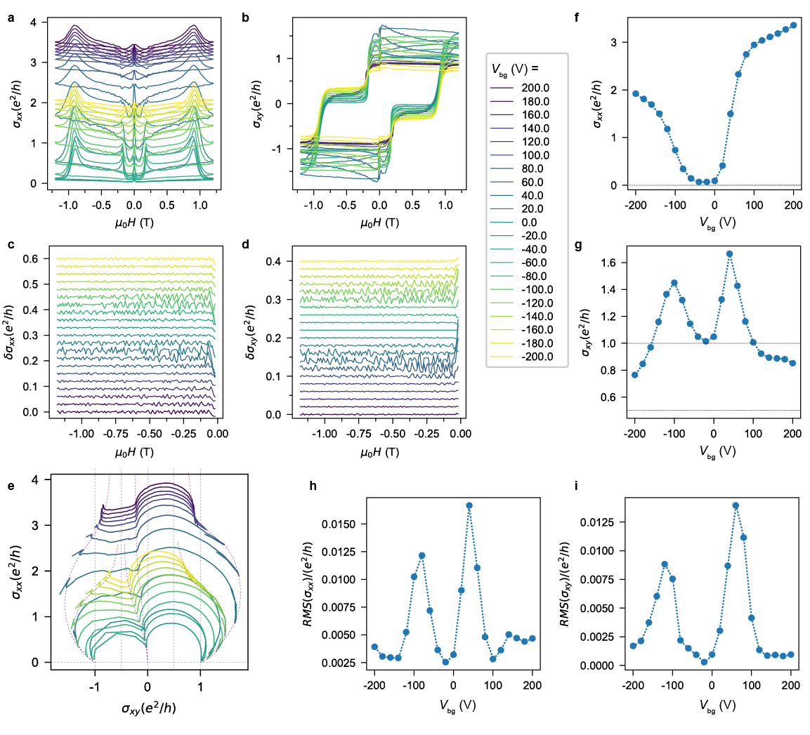
Fig. S5 | Deviation from quantization, conductance peaks and quantum fluctuations caused by quasi-1D helical edge conduction. a, b, The longitudinal conductance $σ_{xx}$ (a) and Hall conductance $σ_{xy}$ (b) vs magnetic field data of a CBV Device A10 (x = 0.19, y = 0.11, m = 10, η = 0.73) and c, d, The conductance fluctuations extracted from data in a and b by subtracting a smoothed background. e, RGFD of Device A10 reveals the trend of the flow towards HQLHE on both electron and hole doped regimes as the bottom gate voltage tuning away from the CNP. The fixed point ${e^{2}}/h(-1.0, 0)$ and (0, 0) flow towards points along $σ_{xy}=-{e^{2}}/{2h}$, while the fixed point ${e^{2}}/h(+1.0, 0)$ flowing towards points along $σ_{xy}=+{e^{2}}/{2h}$. f, g, The longitudinal conductance $σ_{xx}$ (a) and Hall conductance $σ_{xy}$ (b) at zero magnetic field vs bottom gate voltage. The QAH with $σ_{xx}=0$, $σ_{xy}={e^{2}}/h$ is present at CNP with $V_{bg}=-25 V$. There are additional conductance peaks on both sides of the C = 1 plateau. h, i, the root mean square (RMS) of the conductance fluctuations, exhibiting the most prominent fluctuations locates near the 2 additional conductance peaks.

To study the influence of helical edge states on the quantization deviation of the experimentally measured Hall conductance, we construct a conductor network model^{2–5} for a system of size $L_{x}×L_{y}$ with Hall conductivity $σ_{xy}$ and longitudinal conductivity $σ_{xx}$. When the sample size exceeds the dephasing length $l_{ϕ}$, quantum coherence is lost at larger scales. Thus, the system can be treated as a network of independent classical resistive blocks, each of size $L_{0}$ (where $L_{0}>l_{ϕ}$). Since quantum interference effects are negligible beyond $l_{ϕ}$, these blocks behave as classical resistors connected via Ohm's law. Within the Landauer formalism, we model the network by introducing transmission coefficients $T_{p,q}$ between adjacent blocks $\text{p}$ and $\text{q}$ (see Fig. S6a). For nearest-neighbor blocks in the bulk, the transmission is symmetric: $T_{p,q}=T_{q,p}=t_{n}$. However, at the edges, chirality and helical modes introduce asymmetry: we have $T_{p+{\hat{e}}_{x},p}=t_{n}+t_{\text{1D}}$ and $T_{p,p+{\hat{e}}_{x}}=t_{n}+t_{\text{1D}}+t_{d}$ in the upper edge, and $T_{p+{\hat{e}}_{x},p}=t_{n}+t_{\text{1D}}+t_{d}$ and $T_{p,p+{\hat{e}}_{x}} =t_{n}+t_{\text{1D}}$ in the lower edge. Here, $p+{\hat{e}}_{x}$ denotes the block to the right of $\text{p}$. The transmission coefficients originate from three distinct conduction channels: $t_{n}=\frac{h}{e^{2}}σ_{xx}$ (bulk metallic channels), $t_{d}=\frac{h}{e^{2}}σ_{xy}$ (chiral edge channels), and $t_{\text{1D}}=MT/(1-T)$ (helical edge channels). Here, $M$ counts the number of helical edge modes, and $T$ gives the electron transmission probability between nearest-neighbor blocks through these helical edge channels.
Given the transmission coefficients between blocks, the six-terminal measured Hall conductivity $σ_{xy}^{\text{exp}}$ can be numerically calculated using the six-terminal Landauer-Büttiker formalism. According to Landauer-Büttiker formula⁶, the current in the lead p can be expressed as:
$$I_{p}=\frac{e^{2}}{h}\sum_{q≠p}{ }\left(T_{qp}V_{p}-T_{pq}V_{q}\right)$$
where $V_{p}$ is the voltage in the lead p. In our calculations, the real lead 1 and the real lead 4 act as current electrodes and other real leads act as voltage electrodes. Thus, the longitudinal current $I_{1}=-I_{4}≡I_{x}$ when an external bias is applied between lead 1 and lead 4 with $V_{1}=V/2$ and $V_{4}=-V/2$. The net current of the blocks is zero due to current conversation. Combining Landauer-Büttiker formula with those boundary conditions in the real and the blocks, one can calculate the voltage of each real lead and the longitudinal current $I_{x}$. Then the Hall resistance $ρ_{xy}=(V_{2}-V_{6})/I_{x}$ and longitudinal resistance $ρ_{xx}=(V_{2}-V_{3})/I_{x}(L_{y}/L)$ will be obtained. The six-terminal measured Hall conductivity is given by $σ_{xy}^{\text{exp}}=ρ_{xy}/(ρ_{xx}^{2}+ρ_{xy}^{2})$.
As shown in Fig.S6b, nonzero $t_{\text{1D}}$ causes $σ_{xy}^{\text{exp}}$ to exceed $σ_{xy}$, explaining the deviation from quantized Hall conductance in experimental measurements. $σ_{xy}^{\text{exp}}/σ_{xy}$ first goes up and then drops as $t_{n}$ increases. When $t_{n}≫t_{\text{1D}}$, the influence of $t_{\text{1D}}$ on the transport is negligible so $σ_{xy}^{\text{exp}}/σ_{xy}=1$. In order to explain the peak of Hall conductance peaks near QAHE’s in Fig.S5g, we numerically calculate the intrinsic Hall conductance $σ_{xy}$ of the magnetic TI by Kubo formula, and hence calculate the $σ_{xy}^{\text{exp}}$ by Landauer-Büttiker formula (see Fig.S6c). In Fig.S6c, we use $t_{n}=0.45|E_{f}/m_{b}|Θ(|E_{f}|-m_{1})$ with mobility gap $m_{1}=0.07$ to capture the main feature of the longitudinal conductance in experimental results, and $M=4Θ(|V_{b}|-m_{2})$ with fine size gap $m_{2}=0.08$. When $|V_{b}|<m_{2}$, there is no helical edge states, so the measured Hall conductance $σ_{xy}^{\text{exp}}$ is quantized. When $|V_{b}|>m_{2}$, the helical edge states participate in transport and $t_{\text{1D}}$ becomes nonzero. Therefore, we see $σ_{xy}^{\text{exp}}$ first goes up and then drops as $|V_{b}|$ increases.

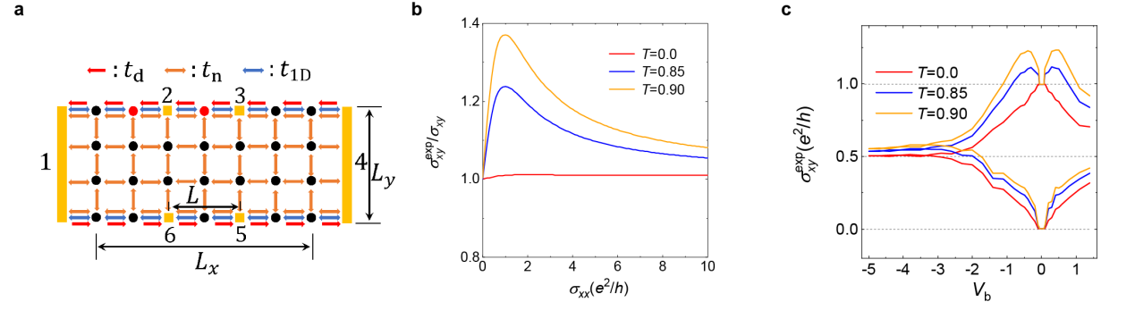
Fig. S6 | Numerical calculations of the anomalous Hall conductance affected by quasi-1D helical edge conduction. a, Schematic plot of the network model with sized $L_{x}×L_{y}$=600$×100$. b, $σ_{xy}^{\text{exp}}/σ_{xy}$as function of $t_{n}$ with helical mode number $M=4$ and $t_{c}=1$. c, $σ_{xy}^{\text{exp}}$ as function of $V_{b}$ for different transmission probability T of quasi-1D helical edge channels.

Most of the transport data discussed in the study originate from the topological surface states on the top, bottom, and side surfaces. In order to reveal the role of bulk carriers, we deliberately decrease the Bi:Sb ratio η of the CBV devices (m = 10 QL, x = 0.19, y = 0.11) so that they shift to the hole-doped regime. Due to the reduced thickness, the hole-doping introduced by Cr is also heavier. The overall transport behaviors of the more heavily hole-doped devices are very similar to that of normal devices, except that they do not exhibit well quantized AHC plateaus.
As shown in Fig. S7, two CBV devices with η = 0.73 and 0.62 does behave like a QAH with $σ_{xy}=±{e^{2}}/h$ plateaus near $V_{bg}$ = 100 V. However, they are much less robust comparing to other devices. Due to the stronger coupling between top and bottom magnetic layers (reduced m = 10 and RKKY mechanism from more carriers in the bulk), the 2-step feature as shown in Fig.2a in the main text now degrades into a loop with 2 kinks near $σ_{xy}=0$. When $V_{bg}$ is tuned towards -200 V, the loops with kinks evolve into single loops, indicating the vanished Hall contribution from the bottom surface states. However, because of the bulk carriers, the AHC now becomes much smaller than ${e^{2}}/{2h}$. Another possible explanation is that the Fermi level at the top VBST layers is near the bottom edge of the exchange gap, such that the bottom gate voltage can drive the Fermi level to slightly crossing the valence bands, giving rise to the reduced AHC.
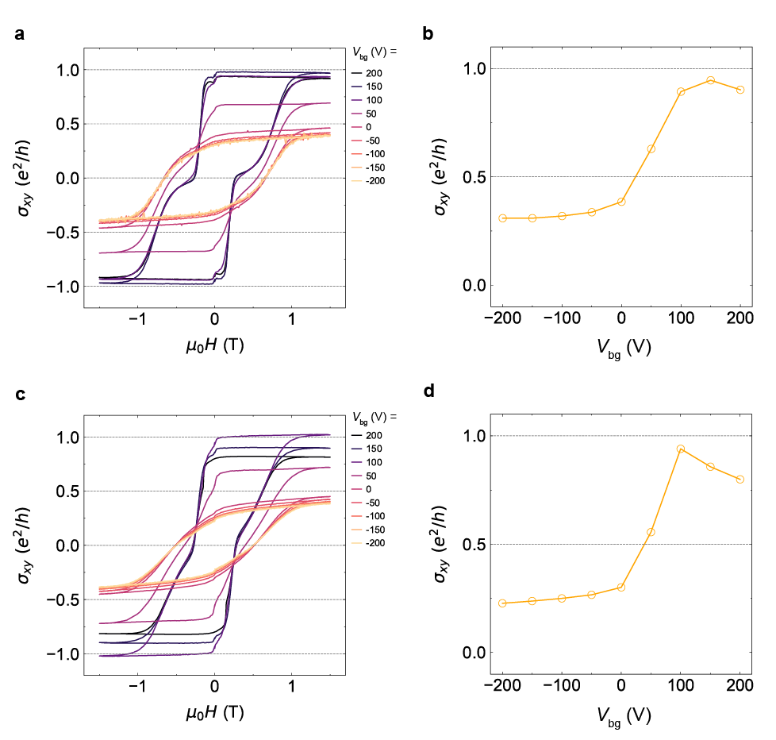
Fig. S7 | Deviation from HQLHE in the presence of bulk carriers. a, Dependence of the Hall conductance $σ_{xy}$ on the magnetic field $μ_{0}H$ of Device A11 (m = 10 QL, x = 0.19, y = 0.11, η = 0.73), measured at different bottom gate voltage $V_{bg}$. b, The dependence of the zero field Hall conductance on $V_{bg}$ with parallel magnetization configuration of Device A11. c, Dependence of the Hall conductance $σ_{xy}$ on the magnetic field $μ_{0}H$ of Device A12 (m = 10 QL, x = 0.19, y = 0.11, η = 0.62), measured at different bottom gate voltage $V_{bg}$. d, The dependence of the zero field Hall conductance on $V_{bg}$ with parallel magnetization configuration of Device A12.

- Discussion on other AHC mechanisms
Contributions to the full AHC can be characterized into three main kinds: intrinsic, skew scattering, and side-jump.⁷ As described in the main text, the HQLHE exhibits significant quantized AHC, which can be naturally explained by the giant Berry curvatures of the topological surface bands (intrinsic AHC $σ_{xy}^{\text{int}}$).
The skew scattering contribution $σ_{xy}^{\text{skew}}$ starts to play a role when the sample is in the “clean limit”, usually with large mean-free path and high-density carriers⁸. The devices in this study with magnetic doping on top and bottom surfaces and near the CNP does not satisfy the “clean limit” condition ($τ≫ℏ/{ε_{F}}$, $τ$ is the relaxation time, $ε_{F}$ is the Fermi energy defined with respect to the CNP). The longitudinal conductance $σ_{xx}$ at $V_{bg}=-200 V$ is around $3.8{e^{2}}/h$ for a film with ~26 nm thickness, which is much smaller comparing to typical skew scattering dominated case $σ_{xx}>{10}^{6}{(Ωcm)}^{-1}$. Moreover, $σ_{xy}^{\text{skew}}$ is proportional to $σ_{xx}$,which clearly does not apply in our cases where the AHC near half-quantization is independent of $σ_{xx}$.
The side jump contribution $σ_{xy}^{\text{sj}}$ is rather complicated in the sense that it is also independent of $σ_{xx}$ and is closely related to the intrinsic Berry curvature in materials with strong spin-orbit coupling. The strong consistency between the experimental AHE data and theoretical models serves as compelling evidence that the intrinsic Berry curvature is the dominant contributor to the observed AHE signals.
We conclude that the dominating mechanism of AHC in this study is intrinsic, similar to the metallic diluted magnetic semiconductor systems, as confirmed by experiments⁹. However, apart from measurement errors, the AHC near the HQLHE regime will be half-quantized only when all the AHC contributions from the bottom surface vanish, which is not always the case in reality. Some of the CBV devices have some extra features near the coercive field of Cr-doped bottom surface in addition to the HQLHE $σ_{xy}=±{e^{2}}/{2h}$ plateaus. Fig. S8 shows several examples of magnetic field scan of Hall and longitudinal traces with the minor loops of Cr-doped bottom surfaces (locate near $σ_{xy}=±{e^{2}}/{2h}$) having opposite anomalous Hall sign comparing to the major loops.
We attribute this effect to the AHC sign reversal effect in magnetic topological insulators, which stems from the intrinsic Berry curvature. First principle calculations of the hole-doped regime of magnetic TI reveal that the band structures and corresponding AHC can be quite complex¹⁰. This sign reversal effect can be generated by introducing an electric field, which is consistent with our observation that it only shows up at large negative bottom gate voltage (strongly hole doped). It also seems challenging to precisely predict at what conditions this effect would occur. Here we show 3 examples in Fig. S8. The size of this reversed AHC is expected to be affected by multiple factors, including the actual valence band structure, electric field by the bottom gate voltage, built-in electric field at the interfaces, etc. Nevertheless, comparing to the large AHC in the HQLHE, this AHC sign reversal effect is quite small (as in Fig. S8b and e) and often negligible (as in Fig. S8h and all other devices presented in this study).

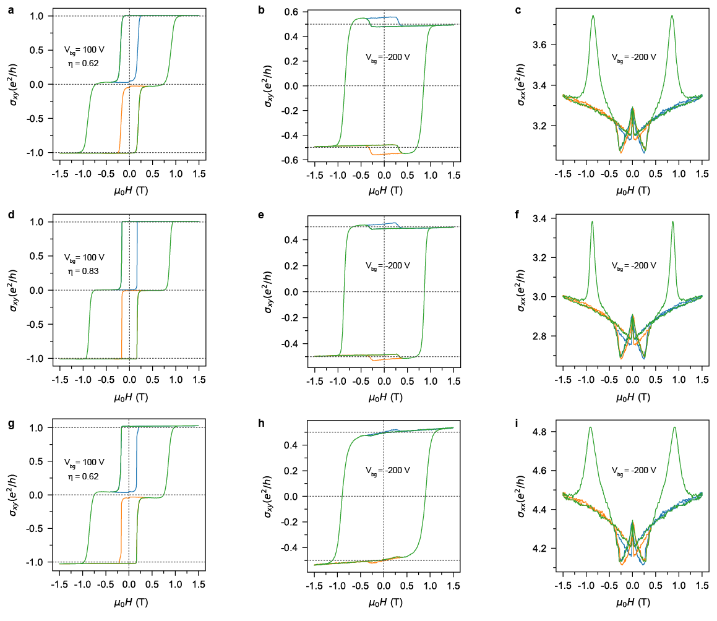
Fig. S8 | Small contributions from AHC sign reversal effect. Device A13 (m = 20 QL, x = 0.19, y = 0.11, η = 0.62): a, b, Major and minor loops of Hall conductance $σ_{xy}$ vs magnetic field at (a) $V_{bg}=100 V$, (b) $V_{bg}=-200 V$. c, Longitudinal conductance $σ_{xx}$ vs magnetic field at $V_{bg}=-200 V$. Device A14 (m = 20 QL, x = 0.19, y = 0.11, η = 0.83): d, e, Major and minor loops of Hall conductance $σ_{xy}$ vs magnetic field at (d) $V_{bg}=100 V$, (e) $V_{bg}=-200 V$. f, Longitudinal conductance $σ_{xx}$ vs magnetic field at $V_{bg}=-200 V$. Device A15 (m = 20 QL, x = 0.19, y = 0.11, η = 0.62): g, h, Major and minor loops of Hall conductance $σ_{xy}$ vs magnetic field at (g) $V_{bg}=100 V$, (h) $V_{bg}=-200 V$. i, Longitudinal conductance $σ_{xx}$ vs magnetic field at $V_{bg}=-200 V$.

- Estimation of the exchange gap sizes
We assume that the Fermi level at the specific magnetic TI surface layers resides near the center of the exchange gap, which give rise to the half-quantized anomalous Hall conductance $σ_{xy}={e^{2}}/{2h}$ at zero temperature. At finite temperatures, thermal excitation promotes charge carriers across the exchange gap, resulting in a measurable deviation of the Hall conductance from its quantized value. When thermal effects preserve both the exchange gap magnitude and Berry curvature topology, the change of temperature-dependent Hall conductance can be written as¹¹:
$Δσ_{xy}=-2\frac{e^{2}}{h}\int_{B.Z.}{\frac{d^{2}k}{{\left(2π\right)}^{2}}}Ω(k)f(E)$,
where $Ω\left(k\right)$ is the wavevector-dependent Berry curvature,$f\left(E\right)$ is the energy-dependent Fermi function. Combining with $E=\sqrt{{(ℏv_{f}k)}^{2}+{(\frac{∆}{2})}^{2}}$and $Ω=\frac{ℏ^{2}v_{f}^{2}∆}{4E^{3}}$, the above equation can be simplified as
$Δσ_{xy}=-∆\frac{e^{2}}{h}\int_{\frac{∆}{2}}^{∞}{dE\frac{f(E)}{E^{2}}}$,
where $∆$ is the heterostructure exchange gap. This equation enables quantitative determination of $∆$ through temperature-dependent Hall conductance measurements. As shown in Fig.4 in the main text, the exchange gap Δ ($0.77 meV$) is extracted through the Hall conductance in the 0.1-3 K regime, where we assume that the exchange gap is almost temperature-independent. At temperatures above 3 K, the AHC values drop more quickly due to thermally activated randomness of the dilute magnetic moments.
Notice that the assumption of the Fermi energy centered at the middle of the exchange gap may not apply to all the devices in this study. In fact, devices with nominally the same doping concentration (usually indicating the same magnetic properties) often gives different Δ values. For example, the extracted Δ values of VBST layers of several different CBV devices with the same vanadium concentration y = 0.11, vary from $0.27\sim 2.3 meV$. We attribute these variations to the different Fermi level positions at the specific surfaces. When the Fermi level is near the gap edges, the extracted Δ value will be much smaller than the actual value. Therefore, the extracted Δ value by this method is only a lower bound on the actual exchange gap sizes. See Extended Data Fig. 7 for two more examples of temperature dependence of HQLHE.

- Characteristics of all devices measured in this study

Devices in the text | Devices structures | m | x | y | $$η$$ | $σ_{xy}$ (${e^{2}}/h$)  (parallel) | $σ_{xy}$ (${e^{2}}/h$)  (antiparallel)
Device A1 (Fig.1 & 2) | CBV | 20 | 0.19 | 0.11 | 0.83 | 0.507 | 0.521
Device B1 (Fig.3) | CBV (dual-gated) | 20 | 0.19 | 0.11 | 0.83 | 0.463 | 0.446
Device C1 (Fig.4) | VBC | 20 | 0.19 | 0.03 | 0.73 | 0.522 | /
Device A2 (Fig.4&ED Fig.5) | CBV | 20 | 0.19 | 0.11 | 0.83 | 0.471 | 0.504
Device A3 (ED Fig.1) | CBV | 20 | 0.36 | 0.11 | 0.83 | 0.768 | 0.351
Device A4 (ED Fig.3) | CBV | 5 | 0.19 | 0.11 | 0.83 | 0.455 | 0.479
Device A5 (ED Fig.3&7) | CBV | 10 | 0.19 | 0.11 | 0.83 | 0.511 | 0.522
Device A6 (ED Fig.3) | CBV | 30 | 0.19 | 0.11 | 0.83 | 0.554 | 0.565
Device A7 (ED Fig.5) | CBV | 20 | 0.19 | 0.11 | 0.83 | 0.497 | 0.501
Device A8 (ED Fig.5) | CBV | 20 | 0.19 | 0.11 | 0.62 | 0.486 | 0.519
Device D1 (ED Fig.6) | CBC | 10 | 0.19 | 0.11 | 0.83 | 0.515 | /
Device D2 (ED Fig.6) | CBC | 20 | 0.19 | 0.11 | 0.83 | 0.538 | /
Device A9 (ED Fig.7) | CBV | 20 | 0.19 | 0.23 | 0.83 | 0.533 | 0.557
Device A10 (SI Fig.5) | CBV | 20 | 0.19 | 0.11 | 0.73 | 0.764 | /
Device A11 (SI Fig.7) | CBV | 10 | 0.19 | 0.11 | 0.73 | 0.301 | /
Device A12 (SI Fig.7) | CBV | 10 | 0.19 | 0.11 | 0.62 | 0.227 | /
Device A13 (SI Fig.8) | CBV | 20 | 0.19 | 0.11 | 0.62 | 0.478 | 0.552
Device A14 (SI Fig.8) | CBV | 20 | 0.19 | 0.11 | 0.83 | 0.496 | 0.519
Device A15 (SI Fig.8) | CBV | 20 | 0.19 | 0.11 | 0.62 | 0.494 | 0.498
Table S1. Device characteristics of all devices measured in the article. All measurements of the AHC $σ_{xy}$ were performed at T = 30 mK and V_{bg} = -200 V except for Device C1 (V_{bg} = 200 V). The averaged AHC of HQLHE in the main text with $σ_{xy}=0.505±0.019 {e^{2}}/h$ is calculated from the data in red (devices with spacer thickness $10≤m≤20$).

1. Akkermans, E. & Montambaux, G. Mesoscopic Physics of Electrons and Photons. (Cambridge University Press, 2007).
2. Kirkpatrick, S. Classical Transport in Disordered Media: Scaling and Effective-Medium Theories. Phys. Rev. Lett. 27, 1722–1725 (1971).
3. Erdös, P. & Haley, S. B. Random-network models of the conductance of disordered condensed matter. Phys. Rev. B 13, 1720–1727 (1976).
4. Zhou, H., Chen, C.-Z., Sun, Q.-F. & Xie, X. C. Dissipative chiral channels, Ohmic scaling, and half-integer Hall conductivity from relativistic quantum Hall effect. Phys. Rev. B 109, 115305 (2024).
5. Zhou, H. et al. Transport Theory of Half-Quantized Hall Conductance in a Semimagnetic Topological Insulator. Phys. Rev. Lett. 129, 096601 (2022).
6. Buttiker, M. Symmetry of electrical conduction. IBM Journal of Research and Development 32, 317–334 (1988).
7. Nagaosa, N., Sinova, J., Onoda, S., MacDonald, A. H. & Ong, N. P. Anomalous Hall effect. Rev. Mod. Phys. 82, 1539–1592 (2010).
8. Onoda, S., Sugimoto, N. & Nagaosa, N. Intrinsic Versus Extrinsic Anomalous Hall Effect in Ferromagnets. Phys. Rev. Lett. 97, 126602 (2006).
9. Chun, S. H. et al. Interplay between Carrier and Impurity Concentrations in Annealed Ga 1-x Mn x As: Intrinsic Anomalous Hall Effect. Phys. Rev. Lett. 98, 026601 (2007).
10. Wang, F. et al. Interface-induced sign reversal of the anomalous Hall effect in magnetic topological insulator heterostructures. Nat Commun 12, 79 (2021).
11. Jain, R. et al. A quantized anomalous Hall effect above 4.2 K in stacked topological insulator/magnet bilayers. Preprint at http://arxiv.org/abs/2412.05380 (2024).

